ARGUS
UniFi Infrastructure Watchtower
Architecture & Functional Specification v1.0
Monitoring, health, VPN/WAN observability, configuration summaries, incident management and NOC wallboard

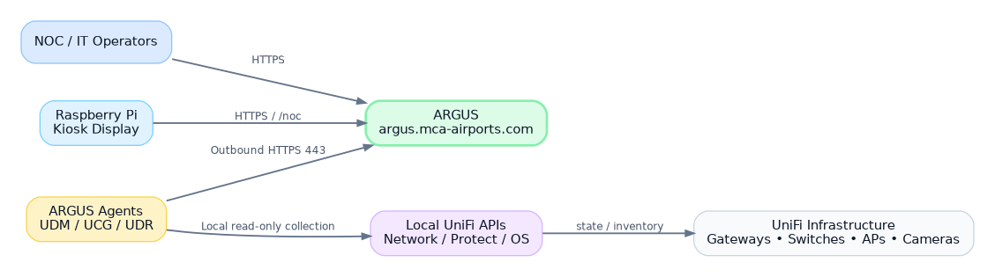
Conceptual system context
Target platform: Ubuntu Server 26.04 on AWS | Public URL: argus.mca-airports.com
Primary visual constraint: NOC/Kiosk views must fit comfortably at 1920×1080 or lower without scrolling.

Document Control
Field | Value
Document | ARGUS Architecture & Functional Specification
Version | 1.0 - Initial architecture baseline
Date | August 12, 2026
Status | Working specification / implementation baseline
Target scale | Approximately 100 UniFi installations at initial rollout
Server | AWS EC2 / Ubuntu Server 26.04
Primary URL | argus.mca-airports.com
Client delivery | MCA-Secure-Downloads-install
Design posture | Read-only observability of UniFi; outbound-only agents

Core design statement
ARGUS observes UniFi. It does not replace Site Manager and it does not make configuration changes to Network or Protect in V1. The system is designed to answer, quickly and visually: Where is the problem? What is failing? Since when? What is affected?

Contents
1. Executive Summary | 15. Backend/API Architecture
2. Scope and Design Principles | 16. AWS Deployment and Operations
3. Functional Architecture | 17. Agent Distribution and Updates
4. Hierarchy and Domain Model | 18. NOC / 1080p UX Requirements
5. Agent Architecture | 19. UI Information Architecture
6. Enrollment, Identity and Security | 20. Storyboards and Screen Specifications
7. Data Acquisition and UniFi Integration | 21. RBAC and Administrative Controls
8. Health Model and State Evaluation | 22. Monitoring Profiles and Thresholds
9. WAN Monitoring | 23. Notifications and Maintenance
10. VPN Monitoring | 24. Resilience and Failure Semantics
11. Device and Protect Monitoring | 25. Testing and Acceptance Criteria
12. Configuration Summary and Change Detection | 26. Rollout Plan
13. Events, Alerts, Incidents and Audit | 27. Roadmap
14. Data Storage and Retention | Appendices

1. Executive Summary
ARGUS is a centralized observability platform for a distributed UniFi estate of roughly 100 installations. A lightweight Agent installed on UDM, UCG and UDR-class consoles performs local read-only inspection of UniFi Network, Protect and console health, then reports normalized state to a public ARGUS server in AWS over outbound HTTPS only.
The platform is deliberately optimized for operational clarity rather than deep performance analytics. Its primary job is to identify unhealthy sites, WANs, VPN tunnels, gateways, switches, access points, cameras and agents; correlate failures into incidents; preserve searchable history; and provide an extremely clear NOC wallboard that remains usable on a Raspberry Pi kiosk at 1920×1080 or lower.
- Agent heartbeat and dead-man monitoring.
- Automatic discovery followed by explicit console approval and device selection.
- WAN and VPN health with both control-plane status and data-plane probes.
- Current-state storage plus state-change/event history instead of storing every repetitive sample.
- Site/network configuration summary with secret redaction and change hashing.
- Incident grouping, acknowledgements, maintenance windows, event logs and immutable audit logs.
- Separate administrative UI and NOC/Kiosk UI.
- One-time enrollment tokens and unique Agent credentials; future mTLS capability.

2. Scope and Design Principles

2.1 V1 scope
- UniFi console enrollment and approval.
- Network / Protect inventory discovery.
- Selective monitoring by device and monitoring profile.
- Console, Agent, WAN, VPN, Network, Protect and device health.
- VPN data-plane probe targets.
- Network configuration summaries: networks/VLANs, WAN metadata, WiFi SSIDs, VPN metadata and high-level firewall-zone counts when available.
- Event, alert, incident and audit models.
- Searchable/filterable logs.
- Light, Dark and System themes.
- NOC route optimized for 1080p kiosk use.
- Email notifications; architecture prepared for Teams/webhooks later.

2.2 Explicit non-goals for V1
- No configuration writes to UniFi Network/Protect.
- No storage of WiFi passwords, VPN PSKs, private keys, RADIUS secrets or administrative passwords.
- No attempt to reproduce every UniFi screen or setting.
- No full L2 topology/root-cause graph in V1.
- No collection of high-volume client traffic analytics unless later required for a specific health rule.

2.3 Design principles
Principle | Implementation consequence
Operational clarity first | Dashboard answers where/what/since-when before exposing detail.
Outbound-only sites | Agents initiate HTTPS; no inbound ports required at customer/site networks.
Read-only UniFi posture | Collector permissions are scoped to monitoring where possible.
State changes over raw samples | Frequent checks update current state; history records meaningful transitions.
Unknown is not Offline | If an Agent disappears, dependent devices become UNKNOWN unless independent evidence proves outage.
Kiosk is a first-class client | /noc is separately designed for 1080p, distance viewing and no scroll.
Scale by profiles | ~100 sites inherit policies rather than being individually hand-tuned.
Security by per-agent identity | Compromise/revocation of one site does not rotate credentials across the estate.

3. Functional Architecture
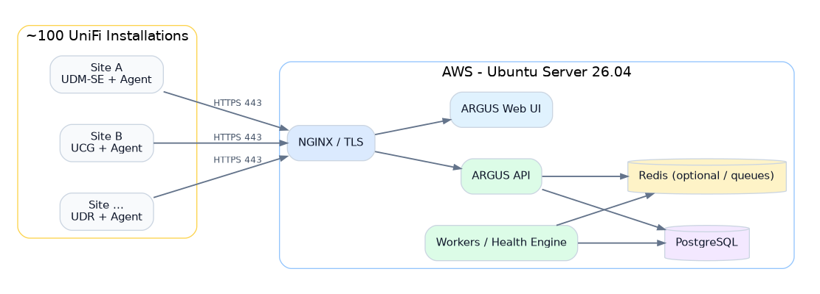
Figure 3.1 - AWS and distributed-site deployment topology
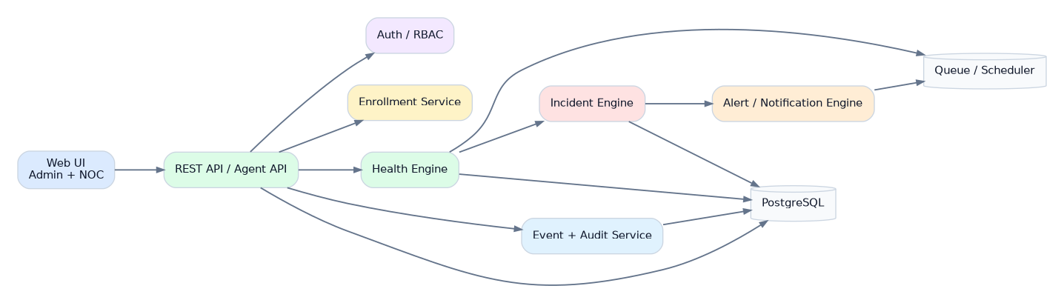
Figure 3.2 - ARGUS server component architecture
The initial deployment may use Docker Compose on a single EC2 instance while preserving service boundaries that can later be separated. PostgreSQL is mandatory. Redis is recommended for queues/scheduling once asynchronous alerting, notification fan-out and command dispatch become active; it can be omitted during the earliest prototype if simplicity is preferred.

3.1 Recommended server components
Component | Responsibility
NGINX | TLS termination, security headers, reverse proxy, static UI delivery.
argus-api | REST endpoints for agents and administrative clients.
argus-web | React/TypeScript administrative and NOC interface.
argus-worker | Scheduled health evaluation, incident correlation, notifications, retention jobs.
PostgreSQL | Persistent relational state, history, incidents, audit and configuration summaries.
Redis | Queue/cache/short-lived coordination when enabled.

4. Hierarchy and Domain Model
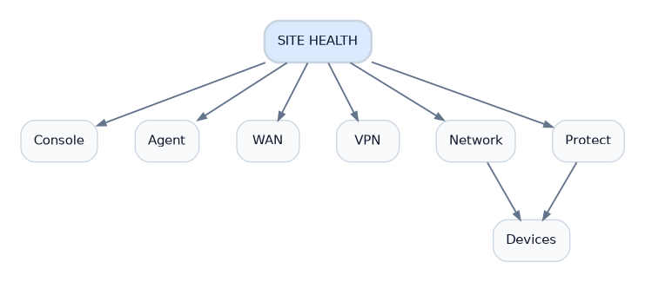
Figure 4.1 - Site health hierarchy
ARGUS should use Site as its primary operational unit. A Site can correspond to an airport terminal, store group, office or other logical installation. A Site normally contains one managed UniFi Console in V1, but the data model must permit multiple consoles if later needed.
Entity | Purpose
Organization | Top-level tenant boundary; initially Master ConcessionAir.
Site | Operational location shown in NOC and health rollups.
Console | UDM/UCG/UDR/other UniFi control-plane host.
Agent | ARGUS software identity associated with a console.
Application | Network, Protect or other locally available UniFi application.
Device | Gateway, switch, AP, camera and selected future UniFi asset.
WAN interface | Internet uplink monitored independently.
VPN tunnel | First-class monitored object with control/data-plane health.
Monitoring profile | Inherited cadence, thresholds and default device-selection rules.

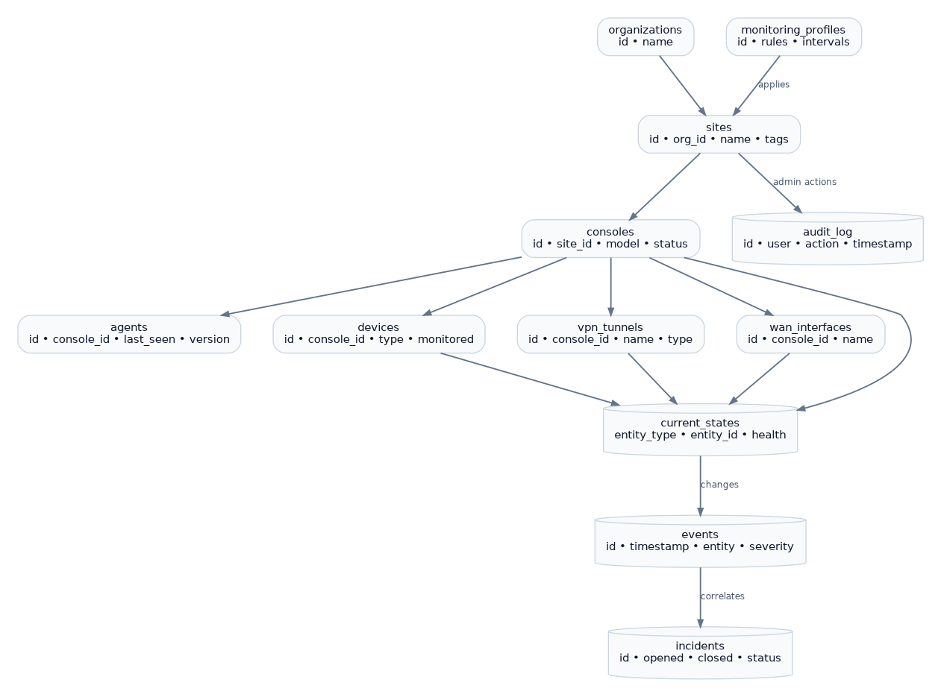
Figure 4.2 - Core relational data model

5. Agent Architecture
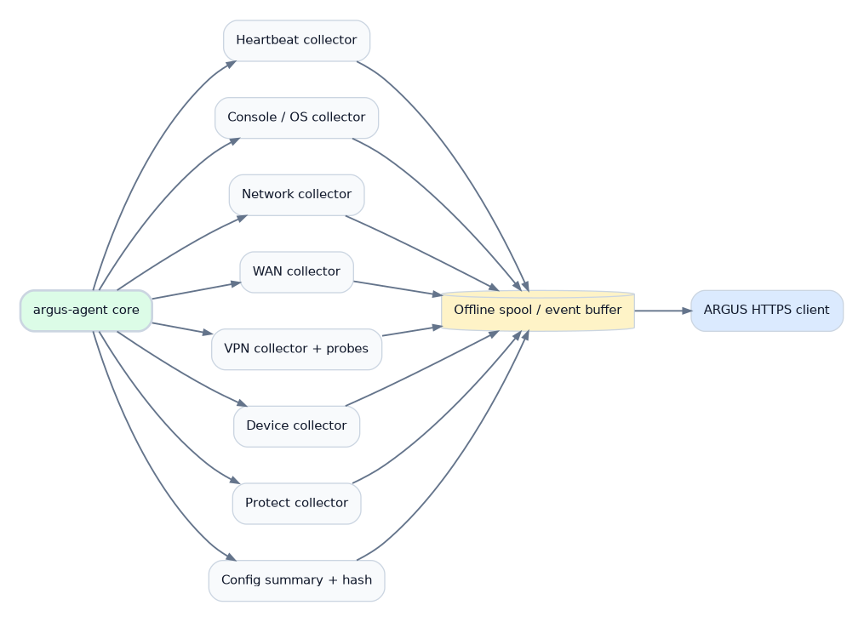
Figure 5.1 - Agent internal components
The Agent should be a small, self-supervising service with a local spool. Python is acceptable for V1 because it accelerates API integration and iteration; a later Go implementation remains possible if a single static binary becomes operationally advantageous.
Collector | Typical cadence | Output
Heartbeat | 15 s + jitter | Agent version, timestamp, console identity, basic availability.
Console / OS | 30-60 s | Console model/version/state and resource-health indicators needed for monitoring.
WAN | 15-30 s | Interface state and approved latency/loss probes.
VPN | 15-30 s | Tunnel state plus optional remote probe results.
Devices | 30-60 s | Selected-device health and reachability/state.
Protect | 30-60 s | Selected camera/device health and recording-relevant state where available.
Inventory | ~5 min incremental / ~1 h full | Discovered devices, applications and metadata.
Config summary | ~15 min or triggered | Normalized non-secret configuration summary and hash.

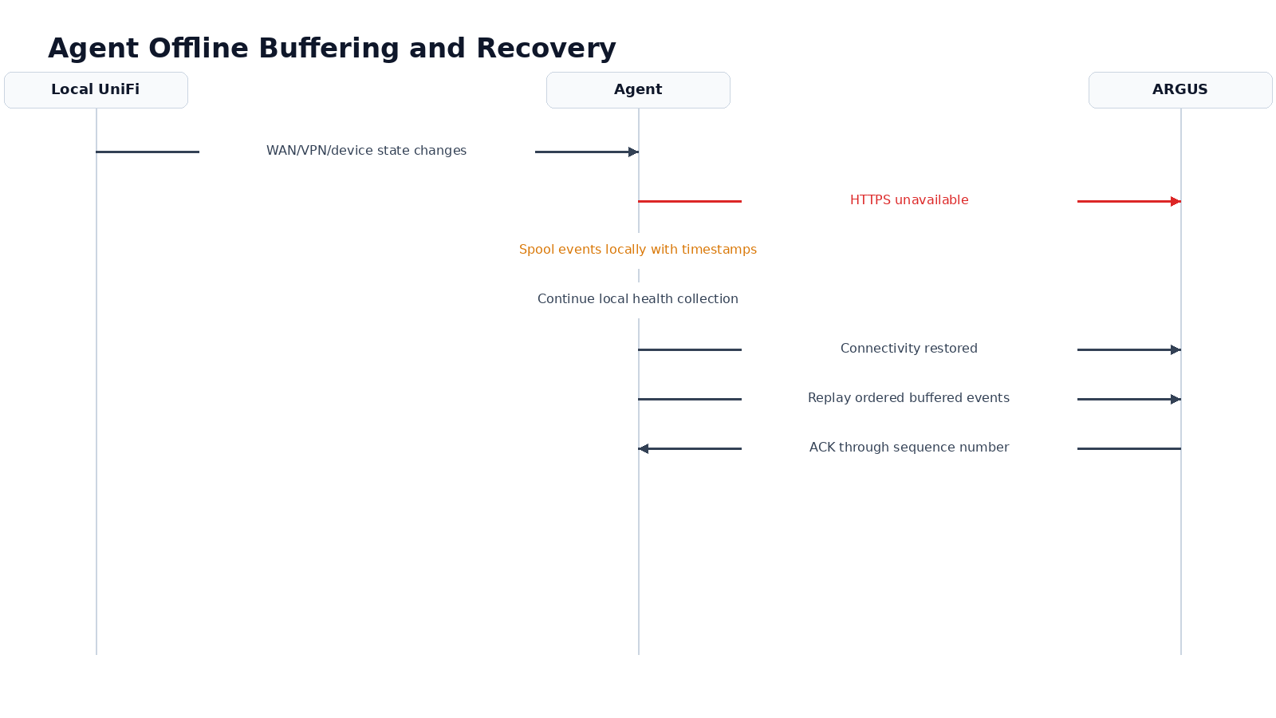
Figure 5.2 - Offline buffering and ordered recovery

6. Enrollment, Identity and Security
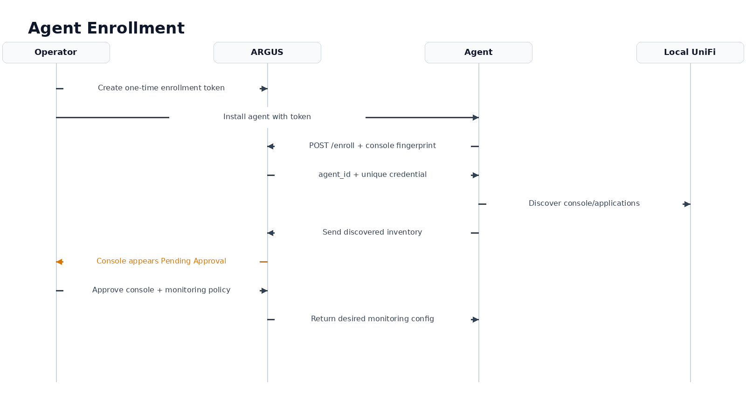
Figure 6.1 - One-time enrollment and approval sequence
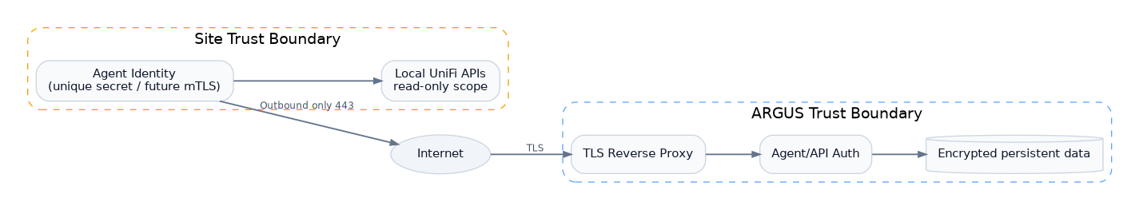
Figure 6.2 - Trust boundaries

6.1 Enrollment model
- Administrator creates an enrollment token with short TTL and activation count (default: 1 use, 24 hours).
- MCA-Secure-Downloads-install deploys the Agent and supplies server URL plus token.
- Agent fingerprints the local console and calls POST /api/v1/enroll over TLS.
- ARGUS returns an Agent ID and unique long-lived credential; the enrollment token is consumed.
- Console appears as Pending Approval with discovered inventory preview.
- Administrator assigns Site and Monitoring Profile, approves the console and optionally selects devices.
- Agent receives its desired monitoring manifest on the next check-in.

6.2 Security controls
- TLS 1.2+ with modern ciphers; TLS 1.3 preferred.
- Unique credential per Agent, stored with restrictive local permissions.
- Credential rotation and immediate revocation supported.
- Future optional mutual TLS with per-Agent client certificates.
- Rate limits and replay protection using request timestamp/nonce or signed sequence.
- Administrative sessions protected by MFA-capable identity design; local break-glass account considered separately.
- Application-level audit for all security-sensitive actions.
- Secrets excluded from configuration snapshots and logs.

7. Data Acquisition and UniFi Integration
ARGUS should prefer official local UniFi APIs and version-specific Network integration documentation exposed by the local UniFi application. Ubiquiti documents that each UniFi Application has local API endpoints, and the official Network API includes local sites, devices/client-oriented resources, networks, WAN interfaces and site-to-site VPN resources. Site Manager can be used later as an independent secondary source for host/site and ISP metrics, but ARGUS must not depend on cloud reachability for primary site health.
Compatibility rule
Collectors must be capability-driven. During enrollment, the Agent records UniFi OS / Network / Protect versions and enables only the collectors supported by that console. Unsupported fields must degrade to “not available” rather than causing a Site failure.

7.1 Primary vs secondary sources
Source | Role in ARGUS
Local UniFi Network API | Primary source for network sites, networks, devices, WAN and VPN metadata/state when exposed by the installed version.
Local Protect interfaces/API | Primary source for camera/device health when available and supported.
Console-local probes | Independent validation for WAN and VPN data-plane health.
UniFi Site Manager API | Optional secondary/correlation source; useful for hosts/sites and ISP metrics, not required for local monitoring.
SNMP | Future fallback/extension for selected metrics or non-UniFi monitoring, not primary in V1.

8. Health Model and State Evaluation
State | Meaning | NOC behavior
HEALTHY | Expected operational state. | Green + “HEALTHY”.
DEGRADED | Functional but abnormal performance/state. | Blue/teal + label; visible but below warnings.
WARNING | Requires review but is not yet a critical outage. | Amber + “WARNING”.
CRITICAL | Confirmed important failure/outage. | Red + “CRITICAL”; highest sort priority.
UNKNOWN | ARGUS cannot determine current condition. | Gray + “UNKNOWN”; never falsely treated as device offline.
DISABLED | Monitoring intentionally disabled or device excluded. | Neutral and excluded from health score.

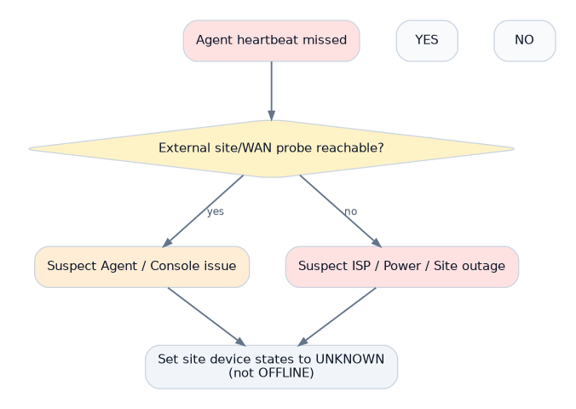
Figure 8.1 - Agent-loss interpretation and UNKNOWN semantics

8.1 Dead-man rules
- Heartbeat target: approximately every 15 seconds with jitter.
- After ~60 seconds without heartbeat: Agent state becomes DEGRADED/WARNING depending on profile.
- After ~90 seconds without heartbeat: Agent becomes CRITICAL and Site dependent health becomes UNKNOWN unless independently known.
- Independent external/WAN probes may classify probable site/ISP/power outage versus Agent/console failure.

9. WAN Monitoring
WAN must be a first-class health component because loss of an uplink can explain Agent/VPN/device behavior. ARGUS should display interface role, operational state, public IP only when policy permits, ISP label, probe latency, packet loss and recent failover state. It should never infer outage from one failed ICMP probe alone; thresholds should require multiple observations or multiple probe targets.
Signal | Purpose
UniFi WAN state | Control-plane view from the console.
External probe from Agent | Confirms data-plane egress.
Latency | Detects significant degradation from baseline/profile threshold.
Packet loss | Detects unstable uplink before full outage.
Failover state | Distinguishes active/standby behavior and WAN transitions.

10. VPN Monitoring
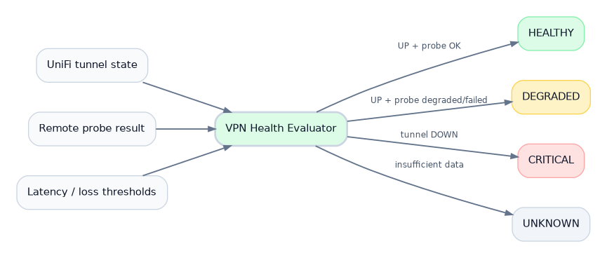
Figure 10.1 - VPN control-plane + data-plane health evaluation
VPN monitoring is explicitly dual-layer. The console’s tunnel state is the control-plane signal; an optional remote probe through the tunnel verifies that traffic can actually traverse it. This avoids declaring a tunnel healthy merely because the VPN subsystem reports “connected”.
Condition | ARGUS result
Tunnel UP + probe OK | HEALTHY
Tunnel UP + elevated latency/loss | DEGRADED or WARNING by thresholds
Tunnel UP + probe repeatedly failed | WARNING/CRITICAL depending on policy; message identifies data-plane failure
Tunnel DOWN | CRITICAL after debounce/grace
Agent unavailable | UNKNOWN unless an independent source confirms tunnel state
Tunnel administratively disabled | DISABLED

11. Device and Protect Monitoring
Discovery and monitoring are separate states. An Agent may discover every switch, AP and camera, but only approved devices (or those selected by a Monitoring Profile rule) contribute to active health and alerting. This prevents test devices and intentionally disconnected assets from polluting the NOC.
- Store minimal identity: stable UniFi ID, name, model, type, console/site association and monitoring flag.
- Store operational state and timestamps separately from static inventory.
- For Protect, prioritize camera reachable/connected and relevant service/recording indicators over video analytics.
- Do not ingest video, thumbnails or recordings into ARGUS V1.

12. Configuration Summary and Change Detection
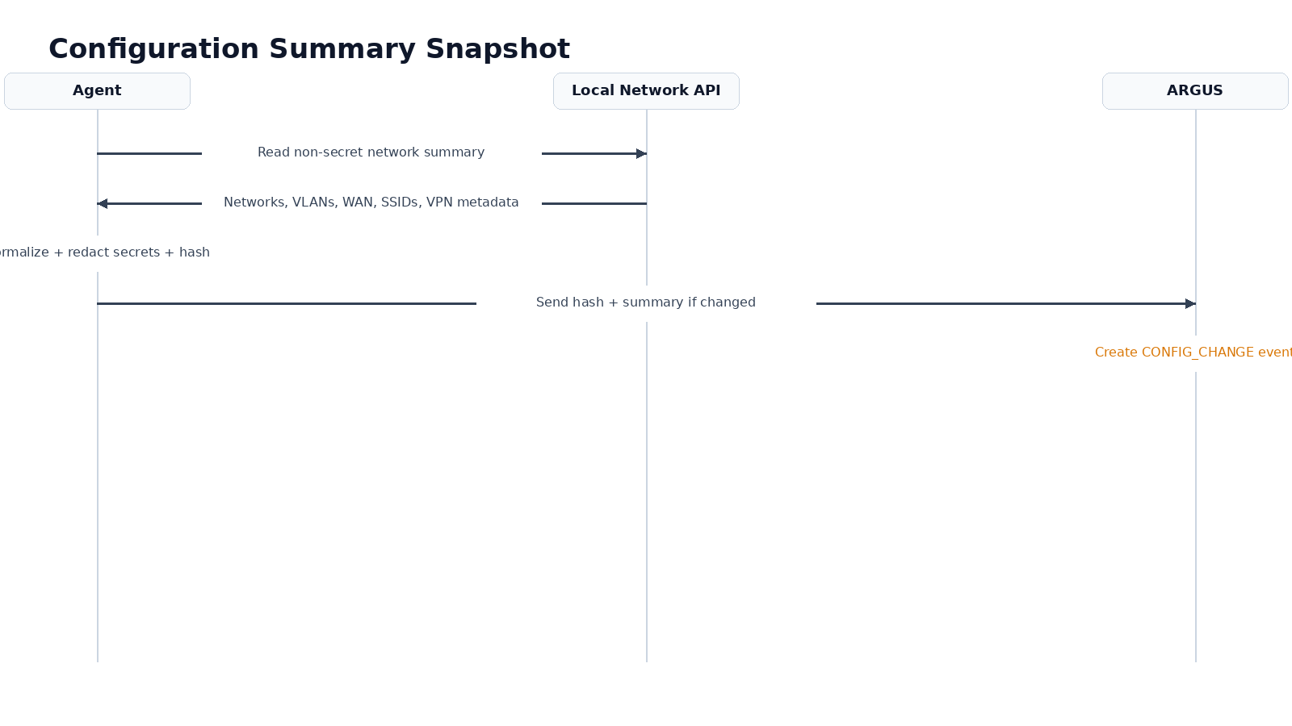
Figure 12.1 - Configuration summary and hash flow
Each Site should expose a concise Network Configuration Summary for support. The Agent normalizes a non-secret subset and calculates a hash. If the hash is unchanged, no duplicate snapshot is written. If it changes, ARGUS stores the new normalized summary and raises a CONFIG_CHANGE event.
Include | Exclude
Network/VLAN names and IDs | WiFi PSKs
Subnets and DHCP enabled/disabled | VPN PSKs
WAN role/state and non-secret addressing metadata | Private keys/cert private material
SSID names and mapped network | RADIUS shared secrets
VPN names, types and remote logical descriptors | Administrative passwords/tokens
High-level firewall-zone/count metadata when supported | Raw config backups in V1

13. Events, Alerts, Incidents and Audit
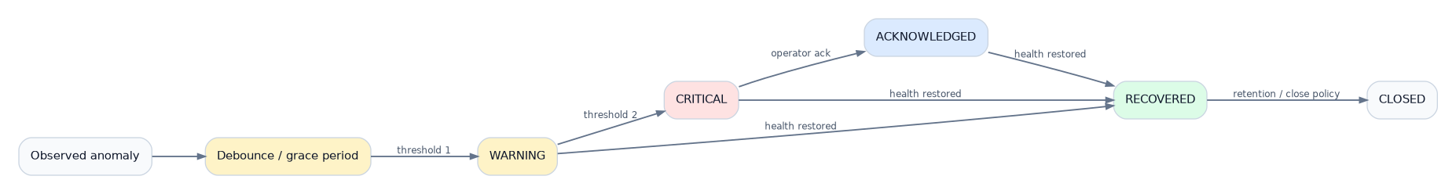
Figure 13.1 - Incident lifecycle
Object | Definition
Event | A timestamped observation or state transition, e.g. VPN_DOWN, DEVICE_RECOVERED, CONFIG_CHANGE.
Alert | A rule outcome requiring operator attention after thresholds/debounce.
Incident | Correlated operational episode with start/end, severity, affected objects and acknowledgement.
Audit | Immutable administrative/security action performed by a user or automation.

Anti-noise rule
Repeated samples that do not change state update “last checked” but do not create new Event rows. An incident remains one incident while repeated failed polls only update its evidence/last_observed timestamp.

14. Data Storage and Retention
Figure 14.1 - Current-state and history retention model
Data class | Suggested retention | Notes
Current state | Indefinite | One latest row per monitored entity/state dimension.
Events | 180 days | Configurable; searchable operational history.
Incidents | 24 months+ | Low volume and high operational value.
Audit | 365 days minimum | Longer if compliance requirements demand.
Availability rollups | 24 months | Store summarized durations/percentages rather than raw polls.
Agent buffered spool | Size/time bounded locally | For example 24-72 hours, with ordered replay and ACK.

15. Backend/API Architecture
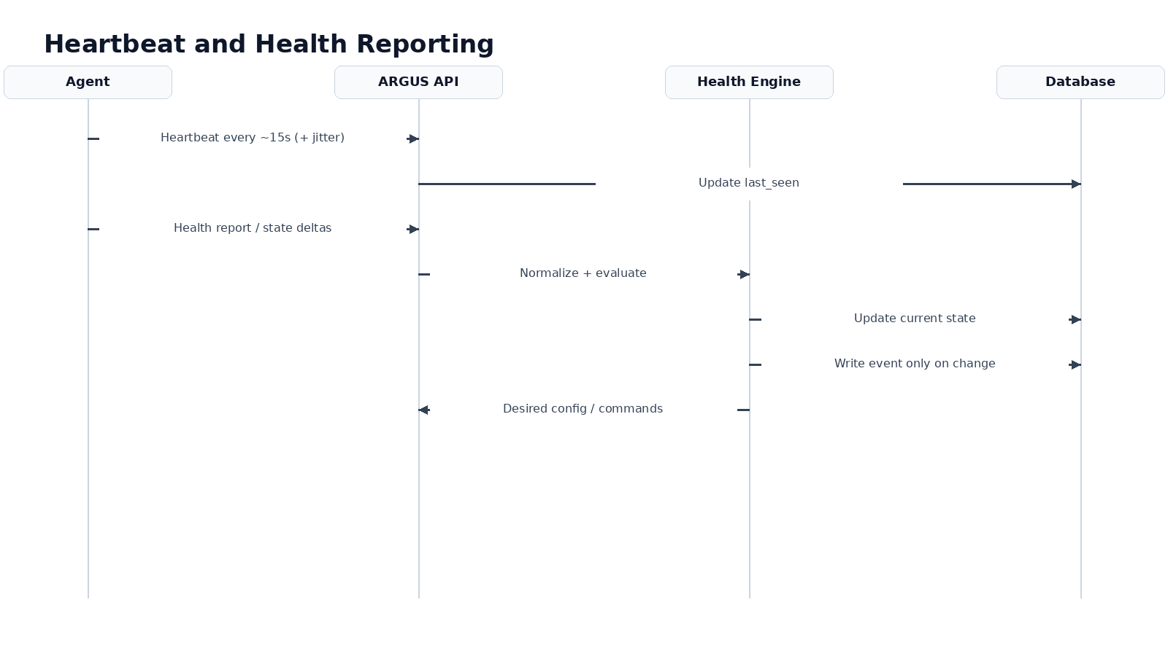
Figure 15.1 - Normal heartbeat and health data flow
All Agent endpoints should be versioned and idempotent where practical. Agent payloads should carry stable entity IDs, source timestamps, sequence numbers and schema version. The server normalizes reports before persistence and health evaluation.

15.1 Conceptual API groups
Path group | Purpose
/api/v1/enroll | One-time Agent enrollment.
/api/v1/agent/heartbeat | Small liveness report.
/api/v1/agent/report | Health/state delta report.
/api/v1/agent/inventory | Discovery/inventory synchronization.
/api/v1/agent/config | Desired monitoring manifest / thresholds / commands.
/api/v1/sites | Administrative site views.
/api/v1/incidents | Incident search, detail and acknowledgements.
/api/v1/events | Filtered event/log retrieval.
/api/v1/admin/* | Users, RBAC, tokens, profiles and settings.

16. AWS Deployment and Operations
- Ubuntu Server 26.04 EC2 instance in a dedicated security group.
- Only required public ingress: TCP/443 (and TCP/80 only if needed for ACME redirect/challenge; DNS-based ACME can avoid it).
- SSH should be restricted through approved administrative controls/VPN/bastion rather than open globally.
- Persistent database volume separated from ephemeral container filesystem.
- Automated encrypted PostgreSQL backups to an AWS-native durable target and periodic restore test.
- CloudWatch or equivalent host-level observability for CPU, disk, memory, instance status and TLS endpoint.
- ARGUS self-health endpoint independent from the main UI where possible.

17. Agent Distribution and Updates
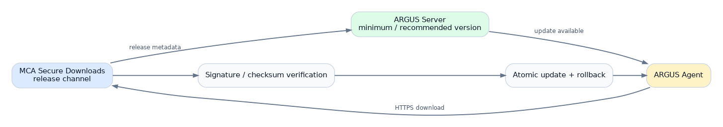
Figure 17.1 - Agent release and update path through MCA Secure Downloads
MCA-Secure-Downloads-install should be the canonical distribution path. Installation must detect supported console/platform, install files with restrictive permissions, register persistence, enroll or accept a supplied token, start the service and verify the first heartbeat. Upgrades should be signed/checksummed, atomic and rollback-capable.
- Stable, optional beta and pinned release channels.
- Server displays installed Agent version per Site.
- Update policy can be manual, staged or automatic by profile.
- No update should destroy the local spool or Agent identity.

18. NOC / 1080p UX Requirements
Hard UI constraint
The primary /noc view must fit entirely inside a browser viewport of 1920×1080 or lower. No vertical or horizontal scroll is allowed in normal wallboard operation.

Requirement | Specification
Viewport | Design baseline 1920×1080; test 1600×900 and 1366×768 fallbacks.
Viewing distance | Primary status readable from approximately 3-5 meters.
Typography | Large KPIs ~40-56 px; site labels ~18-22 px; secondary text >=15-16 px at 1080p.
Status semantics | Color is never the only indicator; pair with text/icon/symbol.
Interaction | No hover-required information; click/tap optional for local operator use.
Sorting | Unhealthy > Unknown > Healthy; longest/most severe incidents first.
Staleness | Persistent “LIVE / last updated” timestamp so frozen displays are obvious.
Focus mode | All / only unhealthy / critical / VPN / WAN / devices.
Rotation | Optional configured sequence of NOC views; pause supported.
Performance | Minimal animation; transitions should not burden Raspberry Pi Chromium.

19. UI Information Architecture
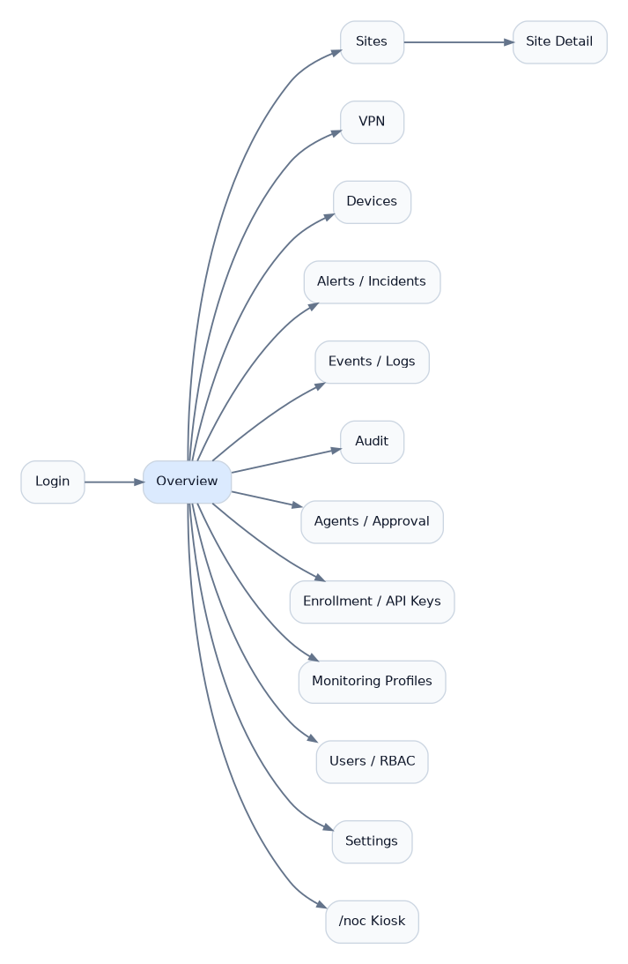
Figure 19.1 - Administrative and NOC navigation map
The product intentionally has two presentation modes: the standard administrative application at the root URL and a dedicated /noc wallboard. Both consume the same normalized backend state, but their density, navigation and interaction patterns are different.

20. Storyboards and Screen Specifications
The following wireframes are conceptual but dimensionally consistent 16:9 references. They are not final branding; they establish hierarchy, density, screen ownership and the information that must be visible without scrolling.

20.1 Login
Minimal secure entry point; branding remains restrained so operational UI loads immediately after authentication.
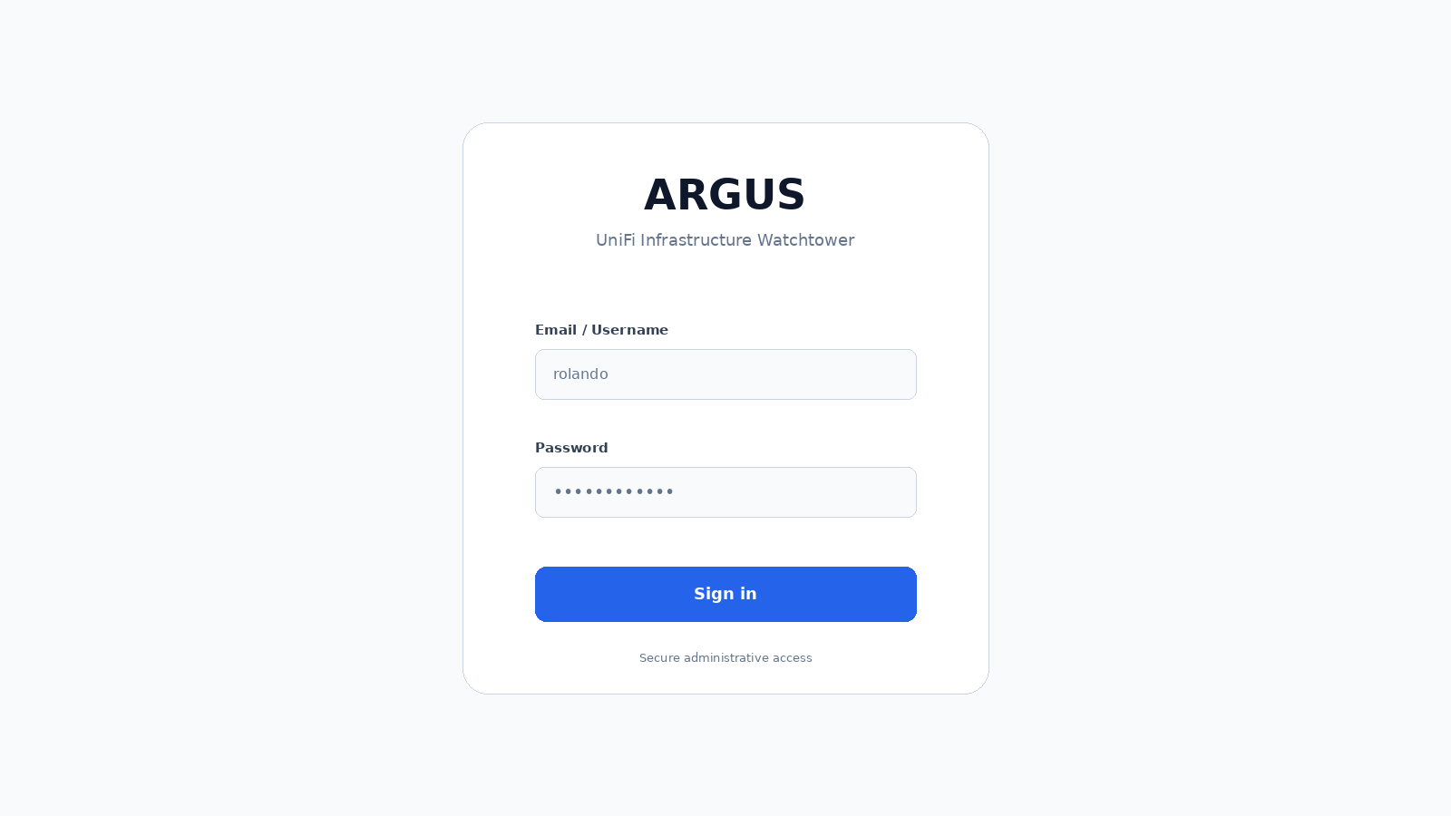
Storyboard 1 - Login

20.2 Administrative overview
Daily desktop dashboard: compact estate summary, site cards and active incidents.
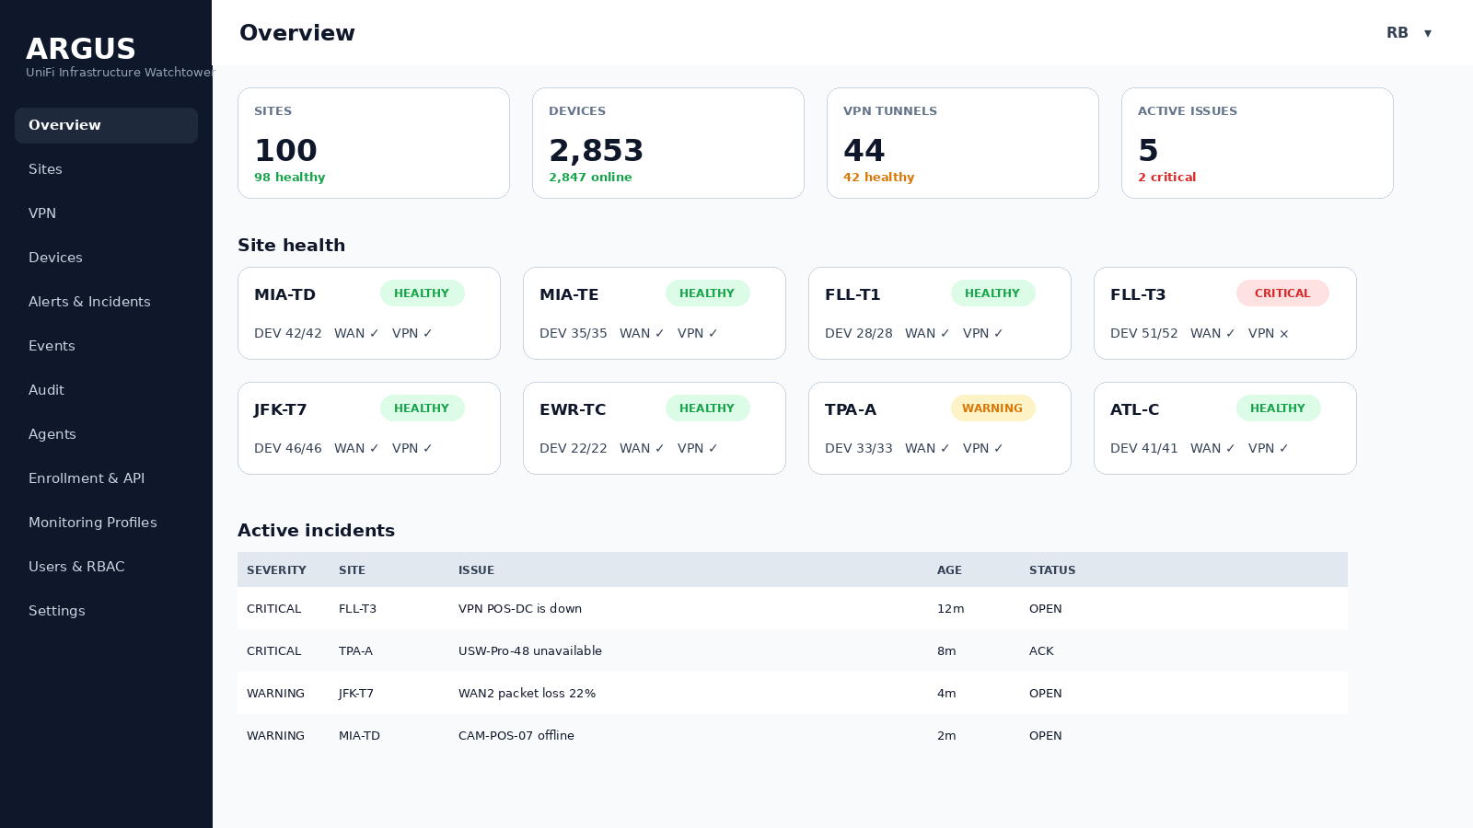
Storyboard 2 - Administrative overview

20.3 NOC global health
Primary TV wallboard: large KPIs, dense site cards and only the most actionable incidents.
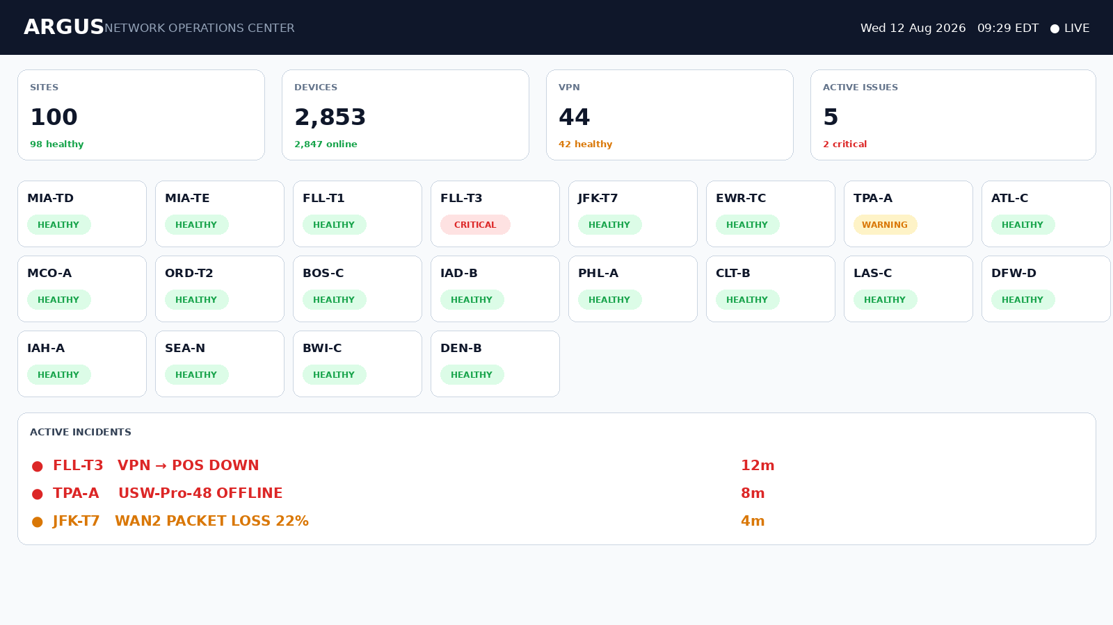
Storyboard 3 - NOC global health

20.4 NOC health matrix
Best at-a-distance diagnostic overview of which health dimension is failing at each site.
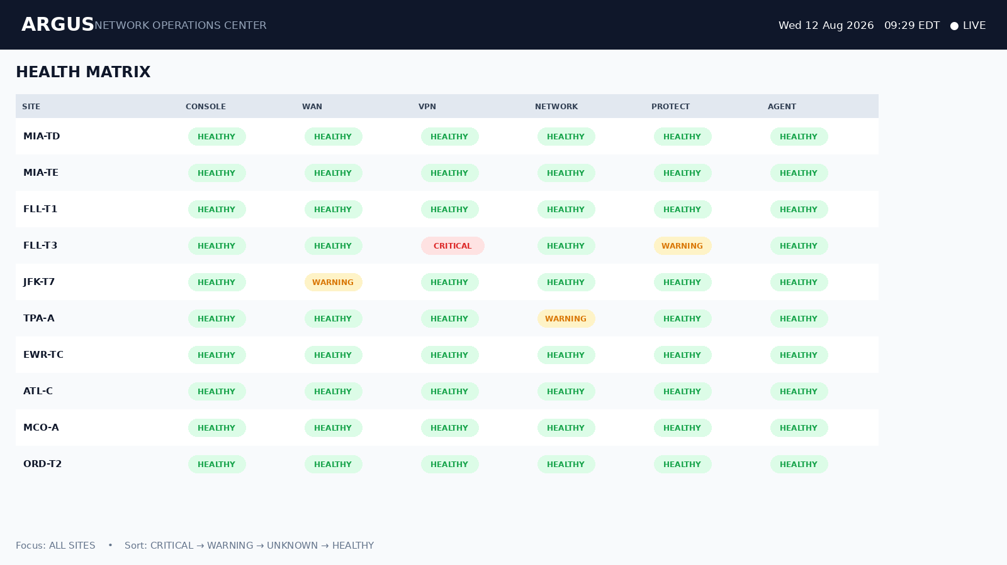
Storyboard 4 - NOC health matrix

20.5 NOC VPN health
Dedicated VPN wallboard with control-plane and data-plane columns.
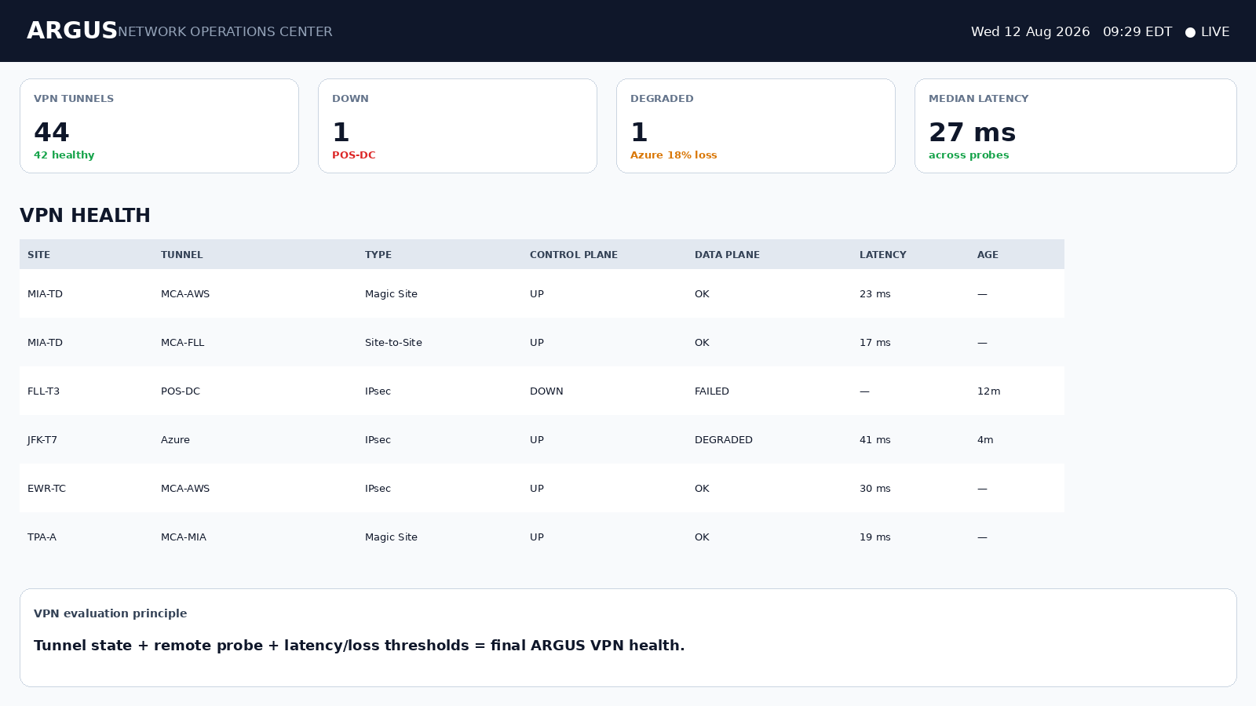
Storyboard 5 - NOC VPN health

20.6 NOC active incidents
Incident-centric rotation view for active operational work.
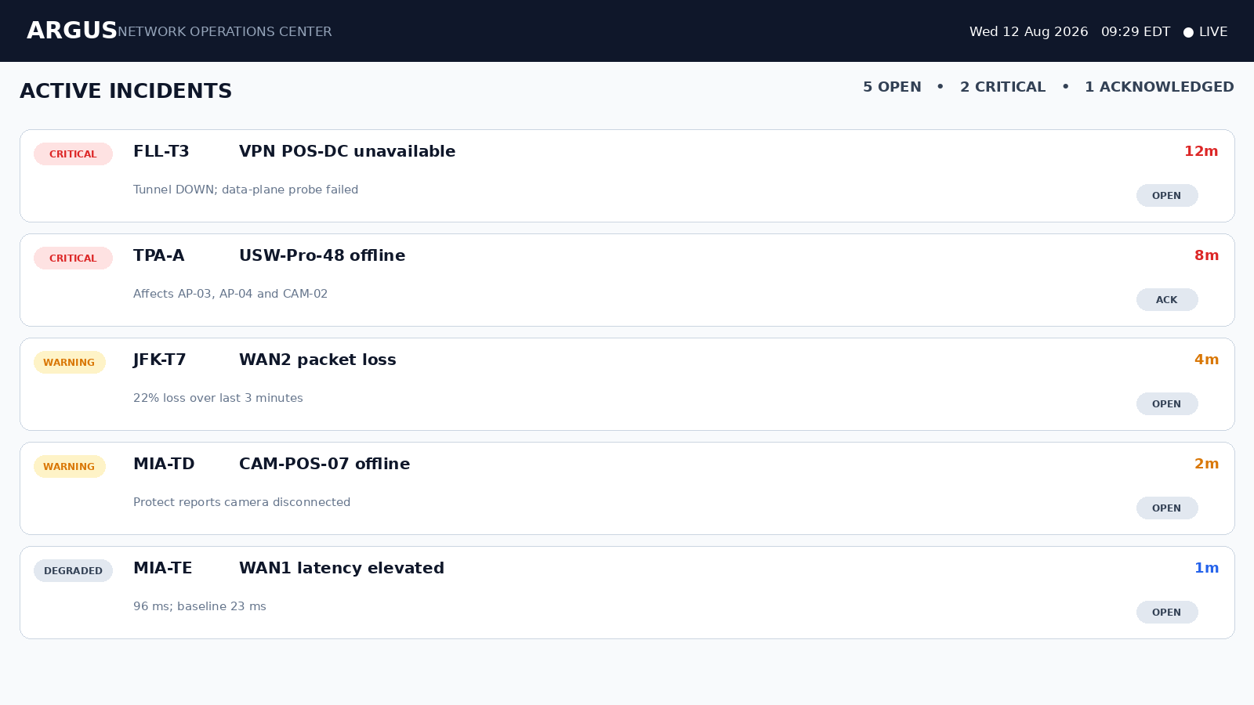
Storyboard 6 - NOC active incidents

20.7 Sites list
Sortable/filterable estate inventory, unhealthy entries automatically prioritized.
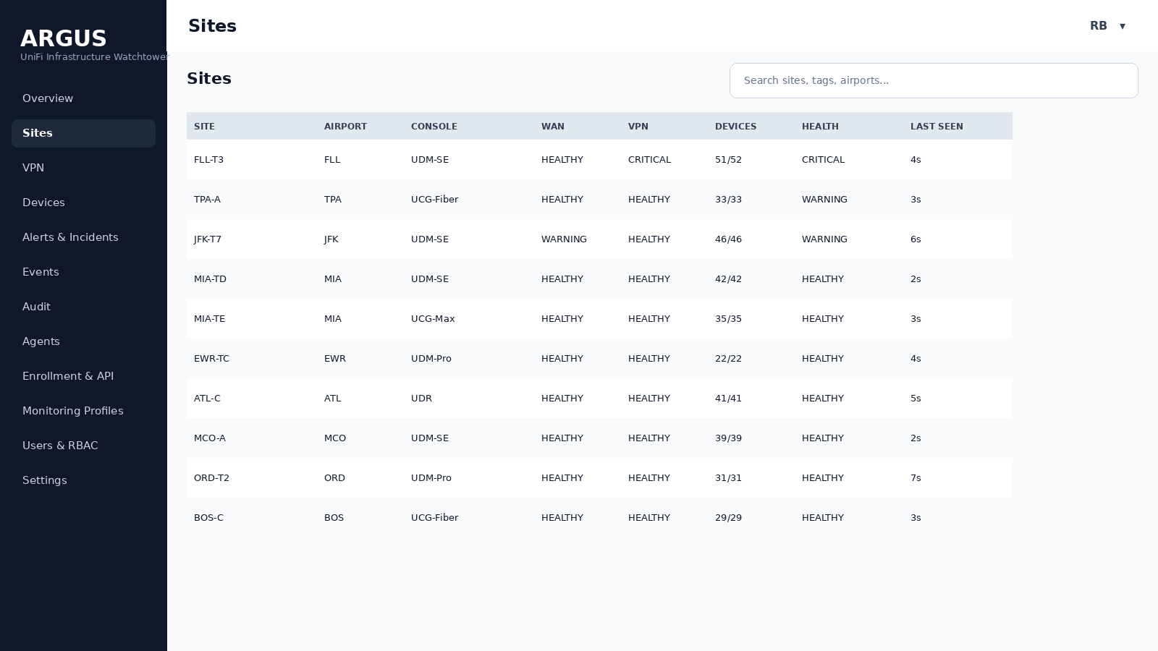
Storyboard 7 - Sites list

20.8 Site overview
Single-click site synopsis: Console, WAN, VPN, Network, Protect and Agent health.
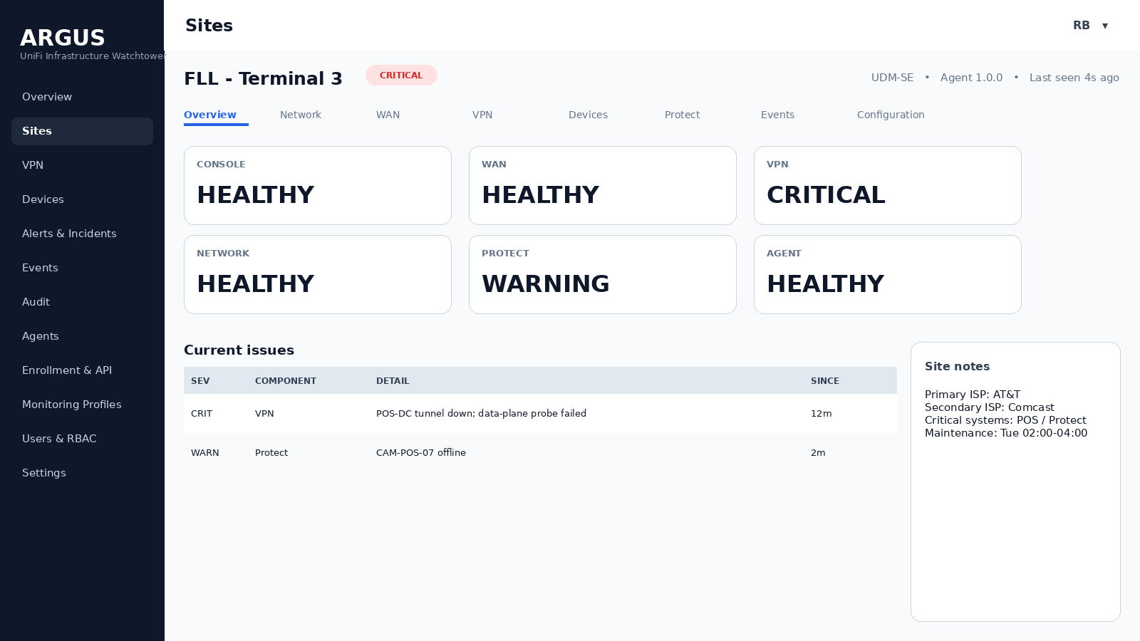
Storyboard 8 - Site overview

20.9 Site network summary
Concise support-oriented network configuration, not a duplicate of UniFi Settings.
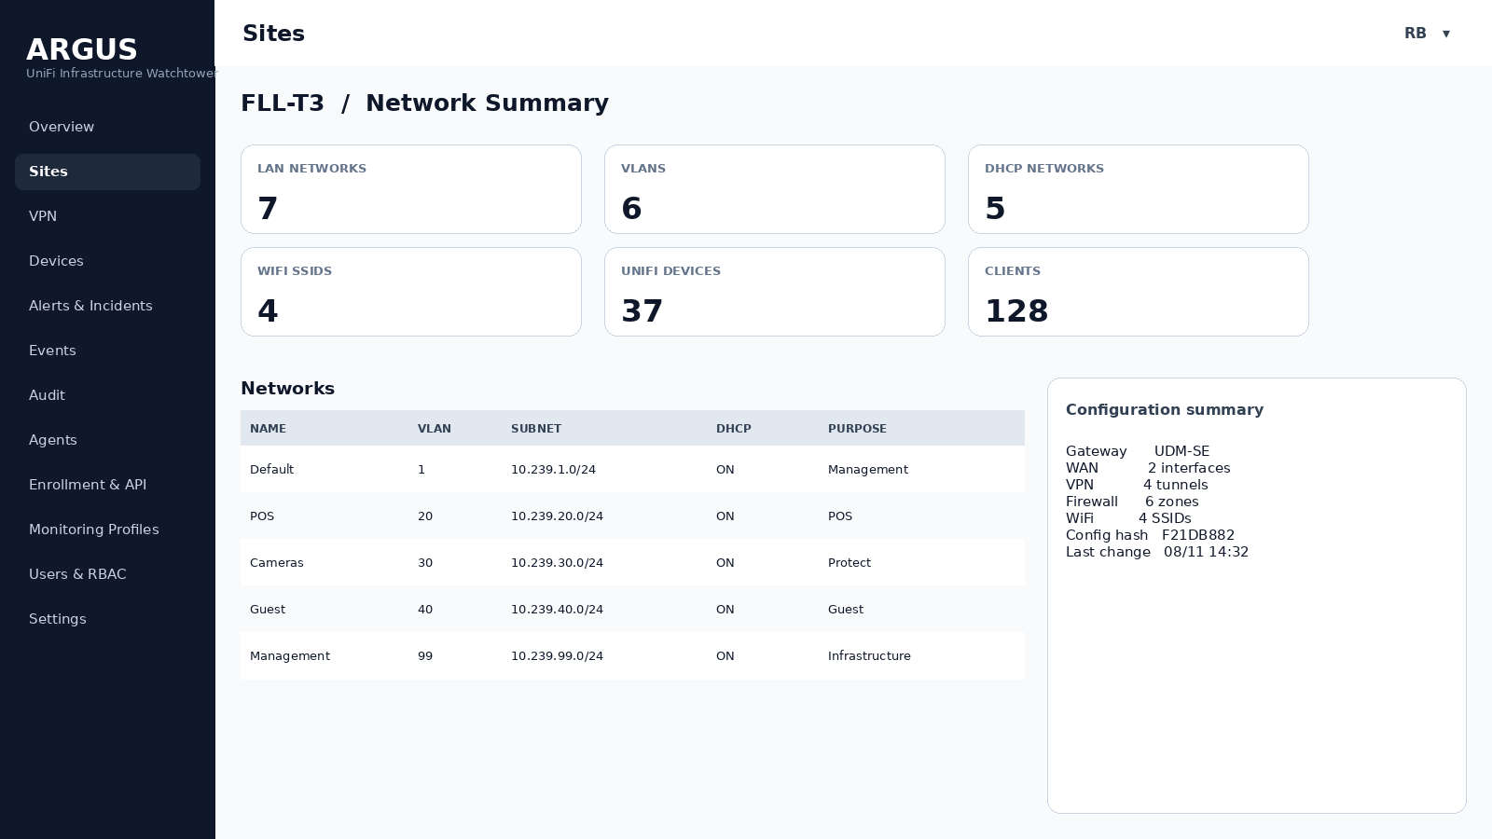
Storyboard 9 - Site network summary

20.10 Site WAN
WAN state, ISP, addressing metadata and probe quality.
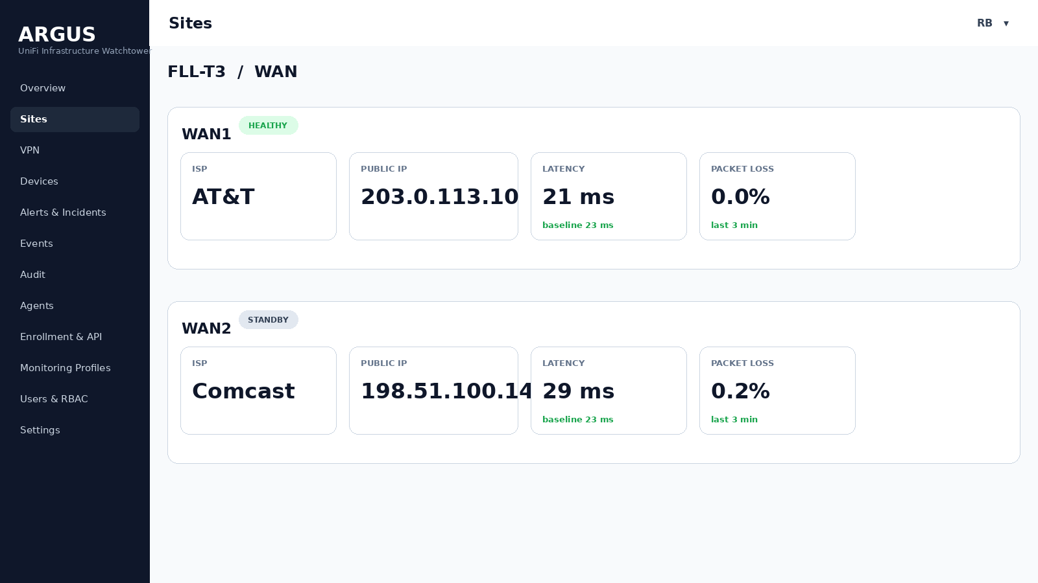
Storyboard 10 - Site WAN

20.11 Site VPN detail
Tunnel inventory and selected-tunnel evidence.
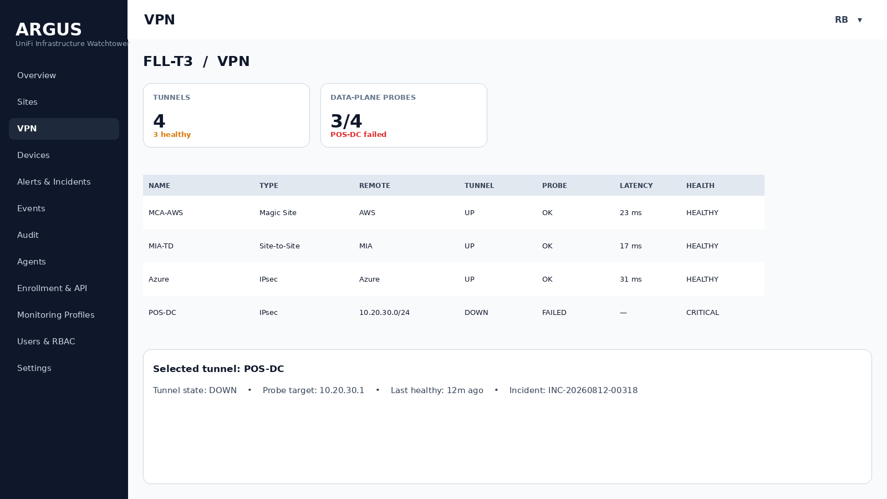
Storyboard 11 - Site VPN detail

20.12 Devices inventory
Unified searchable device list with monitoring inclusion state.
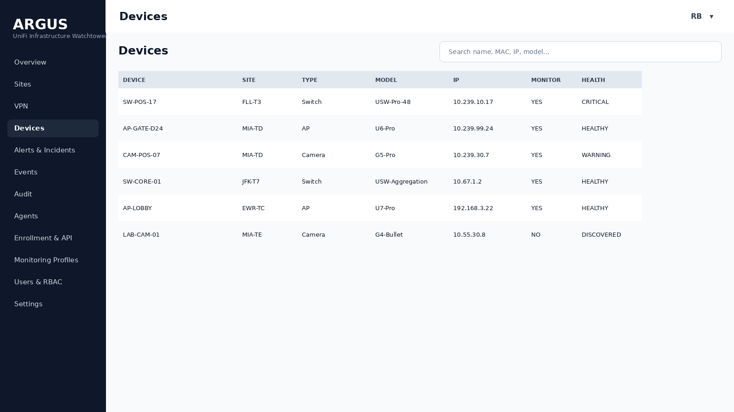
Storyboard 12 - Devices inventory

20.13 Protect summary
Camera/device operational health only; no video ingestion.
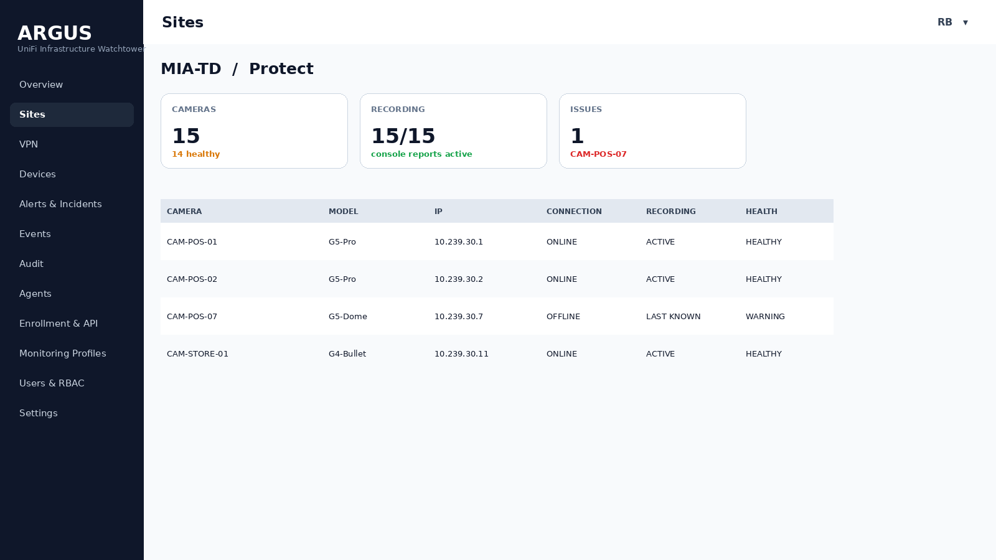
Storyboard 13 - Protect summary

20.14 Incident detail
One incident timeline with evidence, acknowledgement and maintenance actions.
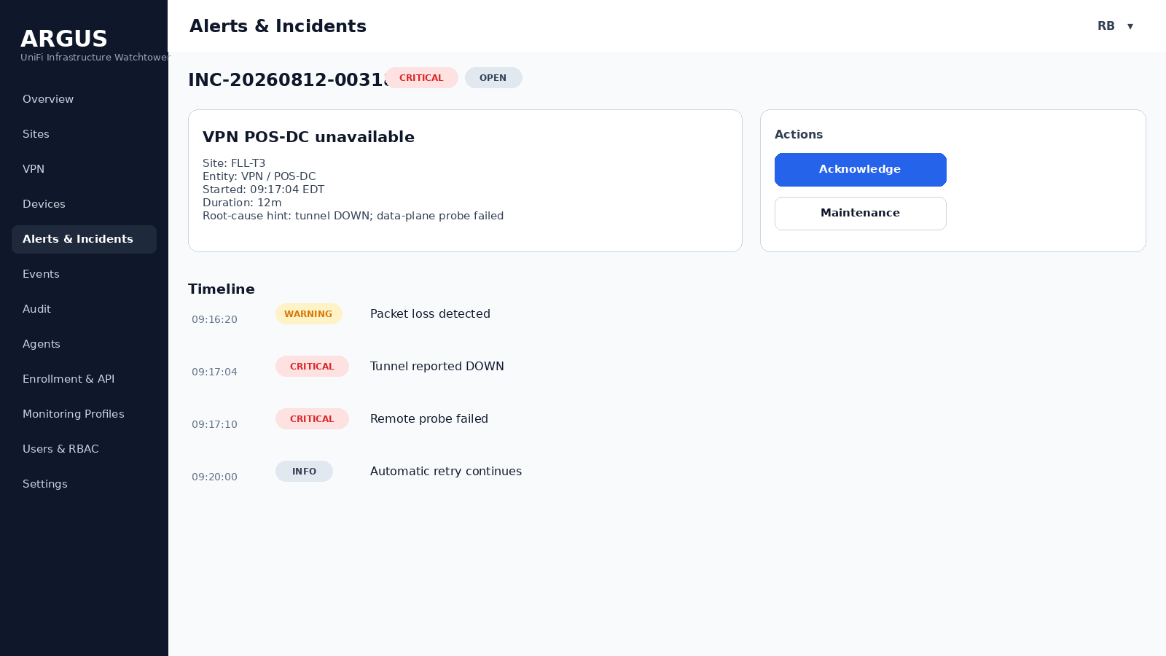
Storyboard 14 - Incident detail

20.15 Events and logs
Fast filters and full-text search for operational records.
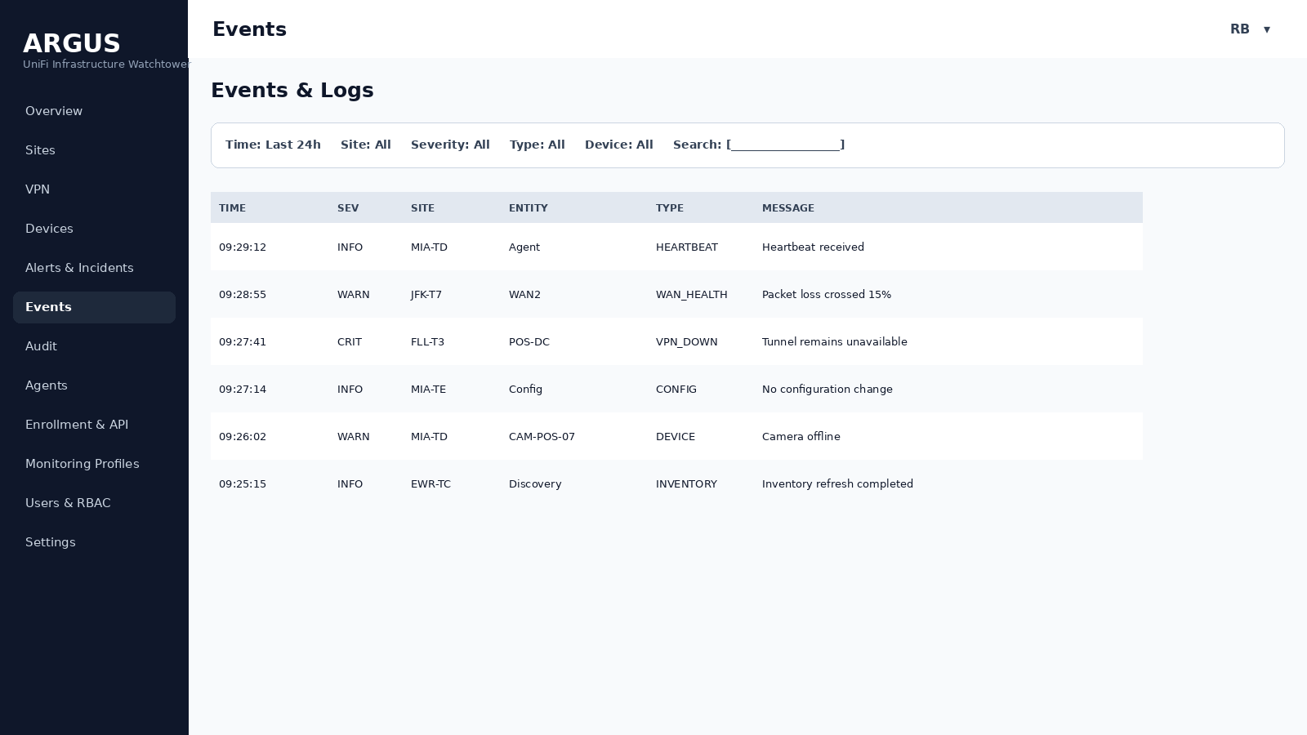
Storyboard 15 - Events and logs

20.16 Audit log
Separate immutable record of administrative actions.
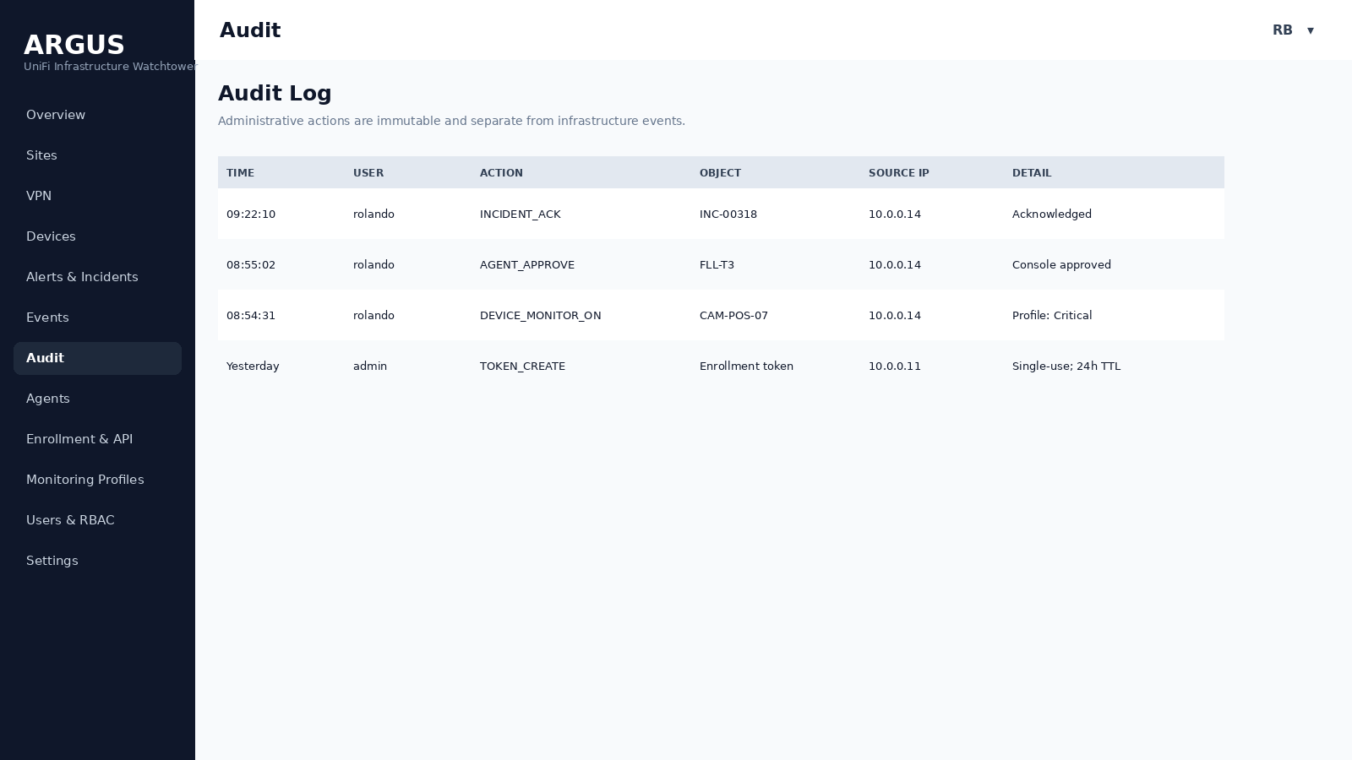
Storyboard 16 - Audit log

20.17 Enrollment and API keys
One-time Agent enrollment separate from integration API keys.
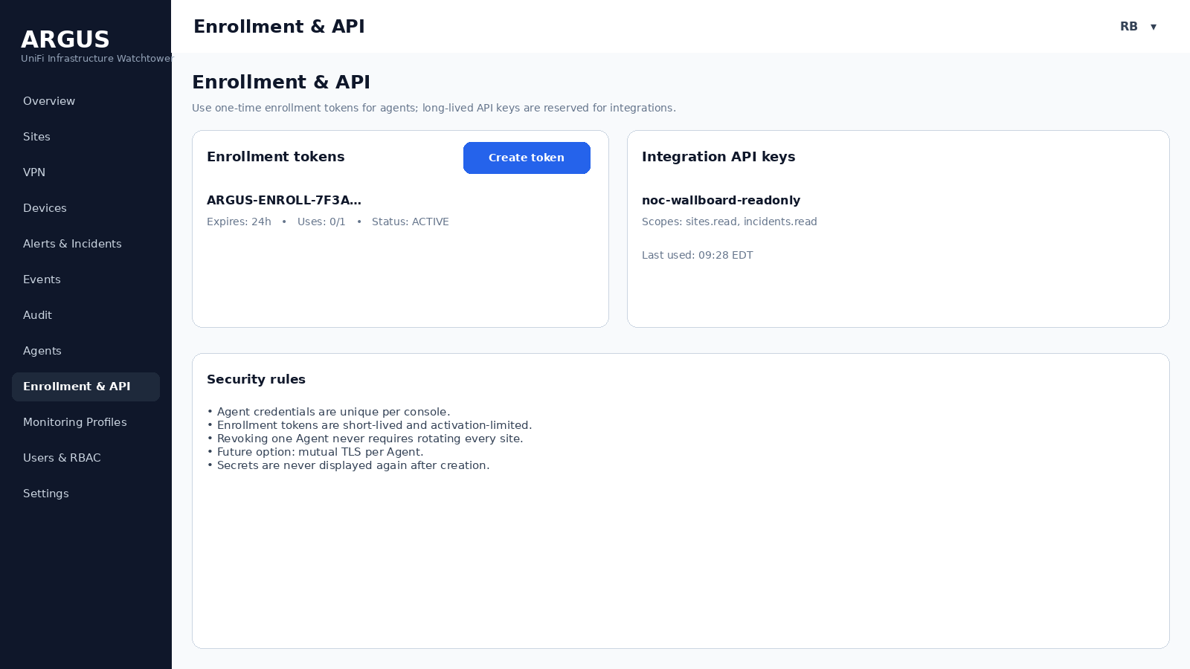
Storyboard 17 - Enrollment and API keys

20.18 Agents and approval
Pending consoles show discovery preview before being admitted to active monitoring.
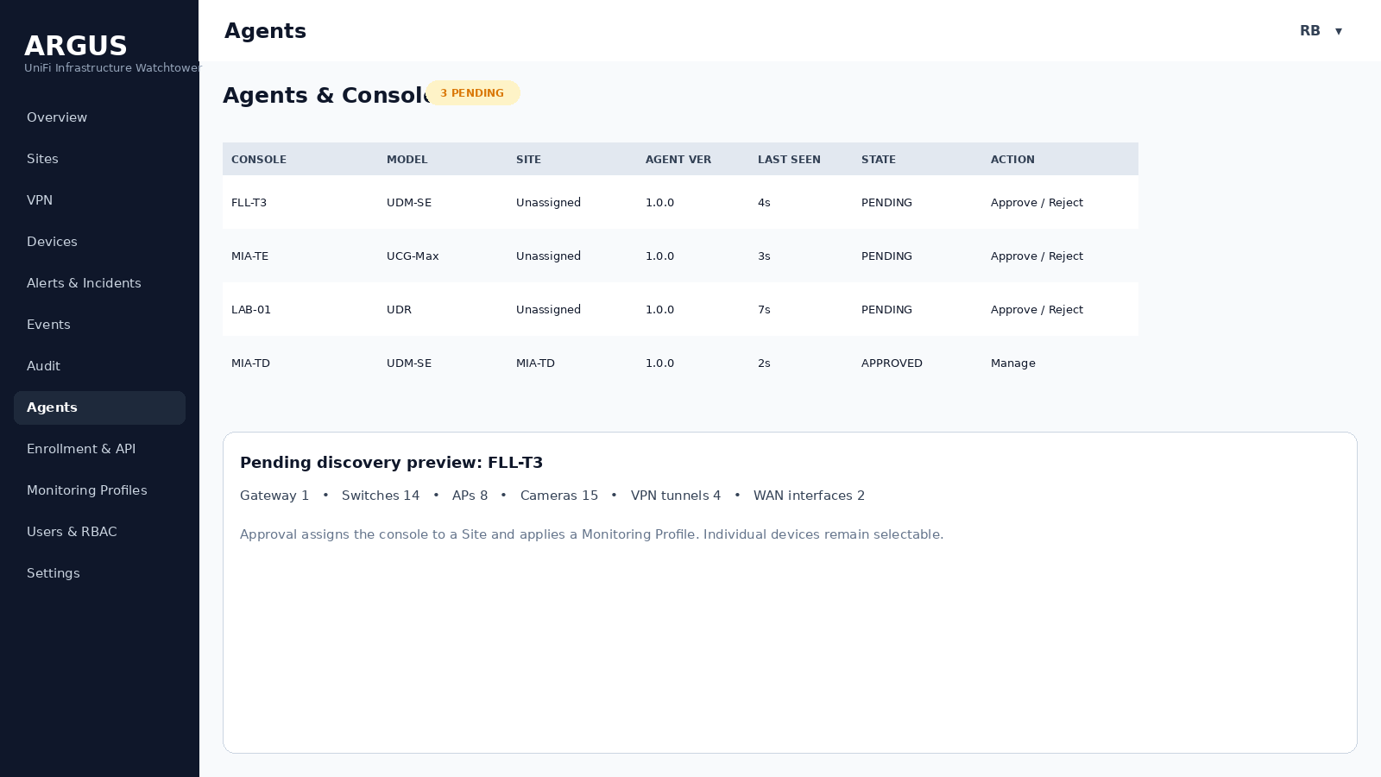
Storyboard 18 - Agents and approval

20.19 Monitoring profiles
Scale controls for 100+ sites; central cadence/threshold inheritance.
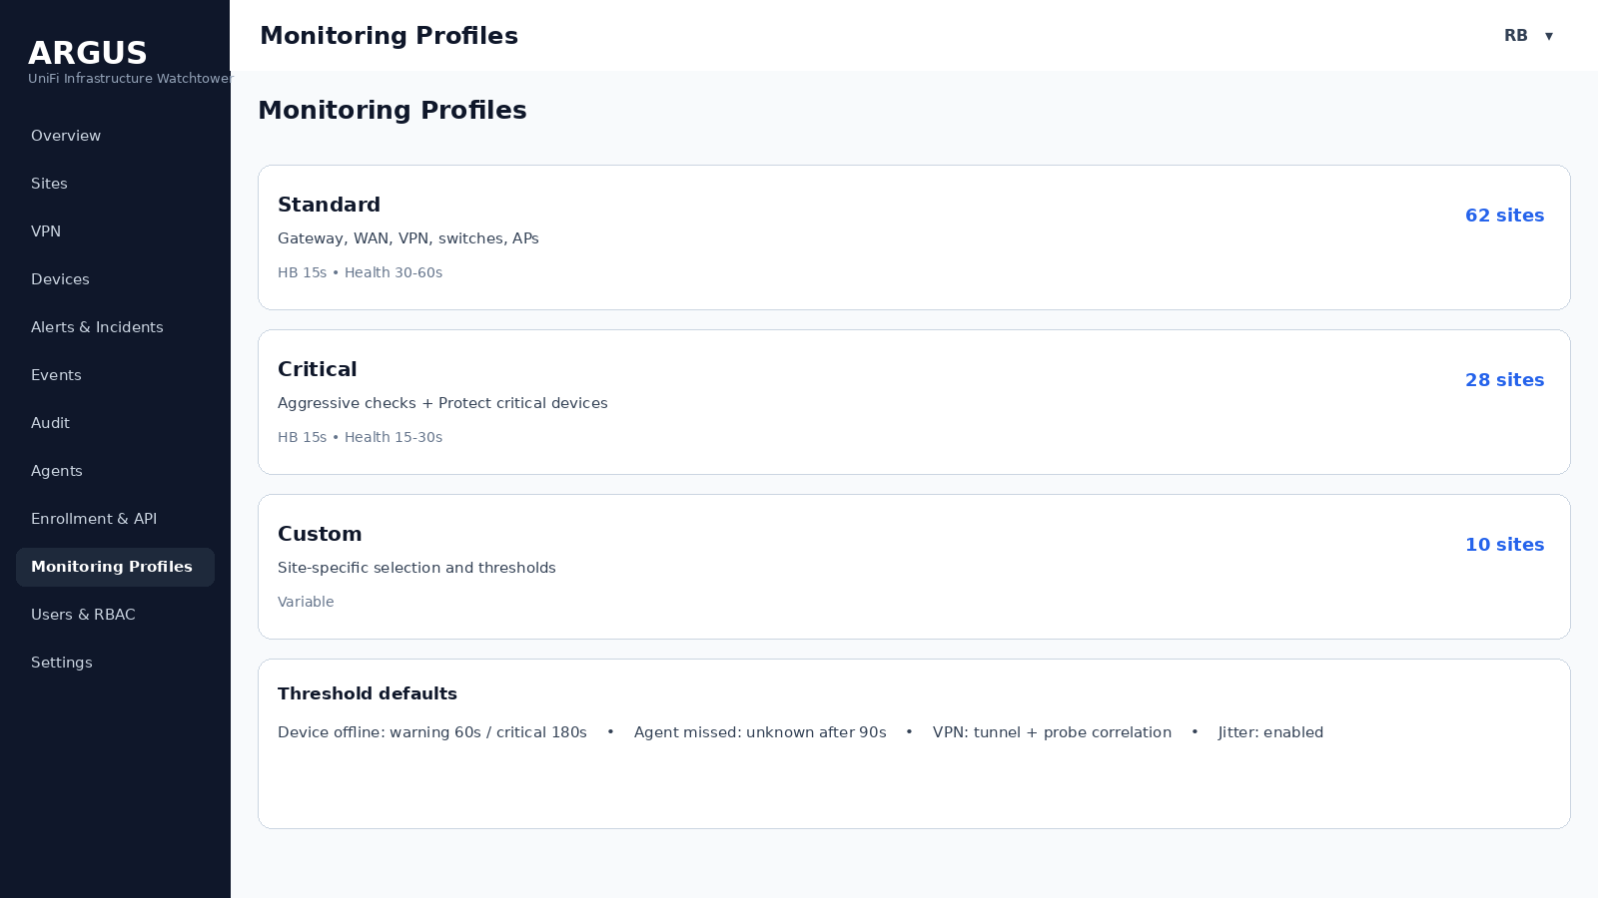
Storyboard 19 - Monitoring profiles

20.20 NOC display settings
Wallboard rotation and non-scroll display constraints are configurable but safe by default.
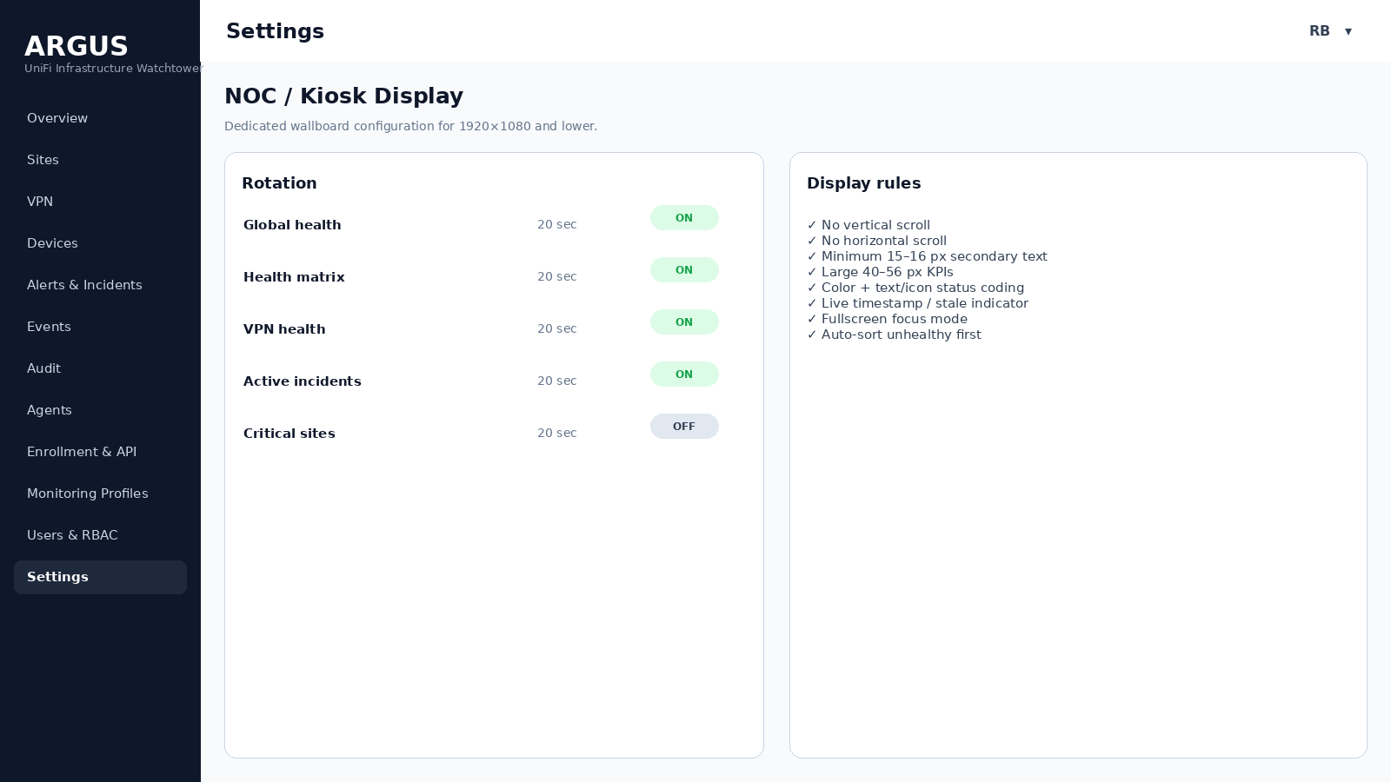
Storyboard 20 - NOC display settings

20.21 Users and RBAC
Least-privilege roles for Super Admin, Administrator, NOC Operator and Viewer.
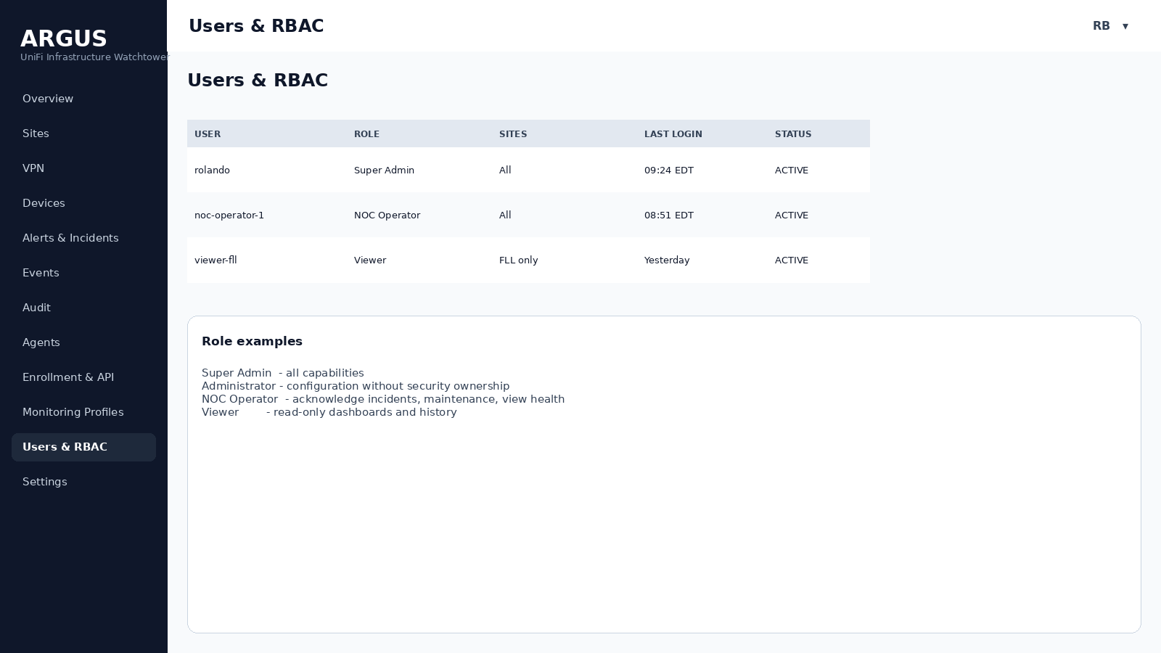
Storyboard 21 - Users and RBAC

20.22 Settings / dark mode
Theme support plus core system/retention configuration.
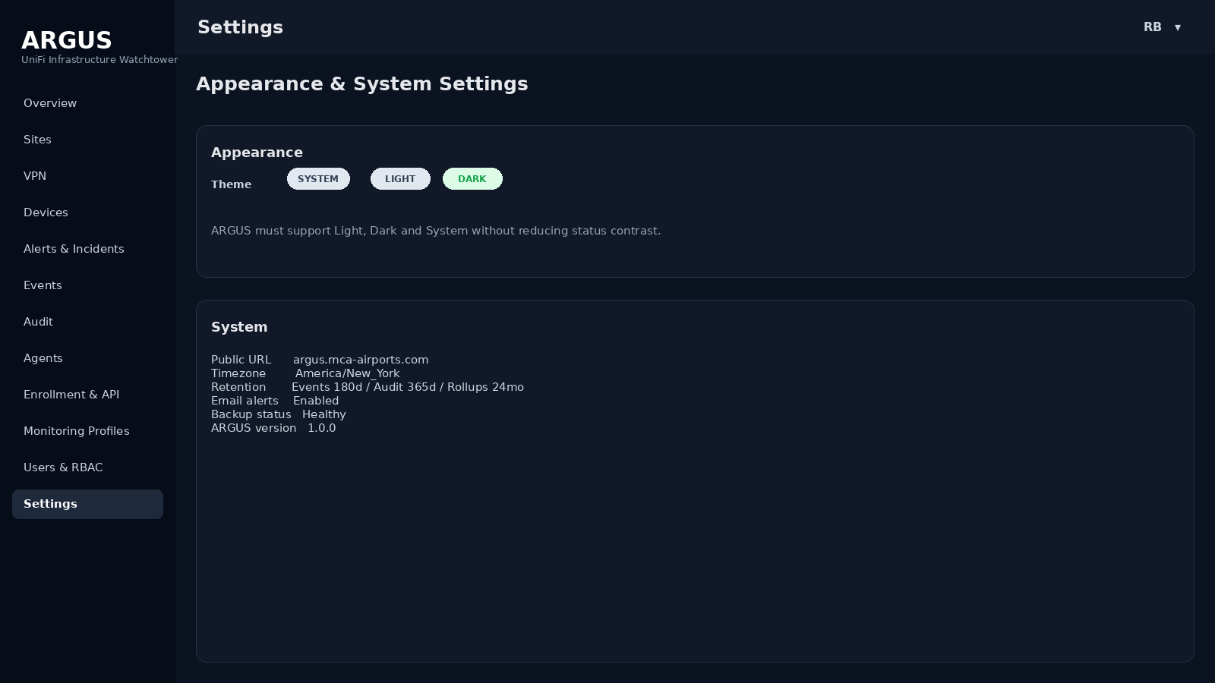
Storyboard 22 - Settings / dark mode

21. RBAC and Administrative Controls
Role | Typical capabilities
Super Admin | All configuration, security, users, tokens, Agents, Sites, incidents and audit.
Administrator | Operational configuration, Sites, devices, profiles, incidents; optionally restricted security ownership.
NOC Operator | View all health, search logs, acknowledge incidents, set approved maintenance windows, add incident notes.
Viewer | Read-only dashboards, Sites, devices, VPN, incidents and history within authorized scope.

22. Monitoring Profiles and Thresholds
Profile | Default intent | Illustrative cadence
Standard | Normal production sites | Heartbeat 15s; critical health 30s; devices 60s; inventory 5m.
Critical | High-value sites / POS-critical infrastructure | Heartbeat 15s; WAN/VPN/core devices 15-30s; Protect critical 30s.
Custom | Exceptions | Per-site overrides while retaining centrally managed defaults.

All recurring work should include jitter so approximately 100 Agents do not synchronize against the server on minute boundaries. Monitoring intervals are configuration values, not hard-coded constants.

23. Notifications and Maintenance
- Email in V1 with severity-aware templates.
- Microsoft Teams/webhook integration prepared for V2.
- Alert suppression during scheduled maintenance while Events continue to be recorded.
- Recovery notifications tied to Incident closure, not every successful sample.
- Per-profile notification routing and quiet-hour policy in future releases.

24. Resilience and Failure Semantics

Figure 24.1 - Failure classification on Agent loss
- Agent maintains bounded local spool and continues collection when ARGUS is unreachable.
- Server ACKs replay sequence; Agent deletes acknowledged buffered records safely.
- Server restarts do not require Agent re-enrollment.
- Database outage should produce API backpressure and preserve Agent retry/spool behavior.
- A frozen NOC page must visually expose stale last-update time.
- If ARGUS itself is unhealthy, internal self-monitoring must show API/DB/worker state to administrators and ideally external monitoring must alert independently.

25. Testing and Acceptance Criteria

25.1 Functional acceptance
- Enroll, reject, approve and revoke a console without affecting other Agents.
- Discover representative gateway/switch/AP/camera inventory.
- Select monitored devices and confirm excluded devices do not alert.
- Generate a WAN, VPN, switch/AP and camera failure and observe correct Event → Alert → Incident behavior.
- Demonstrate tunnel-UP/probe-failed VPN degradation.
- Disconnect Agent from Internet, generate local state changes, restore Internet and verify ordered history replay.
- Change a non-secret network property and verify configuration hash/change event.
- Verify maintenance suppresses notifications but keeps history.
- Verify NOC sorting and focus modes.

25.2 UI acceptance
- 1920×1080 /noc loads with no scrollbars.
- 1600×900 remains usable with no clipping.
- 1366×768 fallback remains operational using responsive density rules.
- No critical information depends on hover.
- Red/amber/green statuses always include text/icon equivalents.
- Raspberry Pi Chromium kiosk remains responsive during rotation for an extended soak test.

25.3 Scale acceptance
- Simulate at least 100 connected Agents with jittered heartbeat/report load.
- Verify current-state upserts and event-change suppression prevent runaway table growth.
- Confirm filtered event search and Site overview response times remain interactive under representative retention volume.

26. Rollout Plan
Phase | Sites | Goal
0 - Lab | 1-2 | Validate local UniFi API collectors, persistence method and enrollment.
1 - Pilot | 5 | Validate operational accuracy, NOC layouts, VPN probes and offline spool.
2 - Controlled production | 20-25 | Validate scale, profiles, alert noise, update process and backup/restore.
3 - Fleet rollout | ~100 | Deploy through MCA-Secure-Downloads-install in staged waves.
4 - Optimization | All | Tune thresholds, retention, dashboards, incident correlation and reporting.

27. Roadmap
- Dependency mapping and root-cause suppression (e.g., switch outage suppresses downstream device storm).
- Site Health Score with weighted criticality.
- Microsoft Teams, webhooks and escalation policies.
- Availability/SLA reporting and historical charts.
- Site Manager ISP metrics correlation.
- Full topology visualization.
- Agent mTLS and automatic certificate rotation.
- Broader SNMP/non-UniFi collectors: UPS, QNAP, Linux, printers, POS health.
- Mobile/PWA operational views.
- Configuration diff details beyond hash-level change detection.

Appendix A - Event Field Baseline
Field | Description
timestamp | Source-observed time in UTC; UI renders configured local timezone.
severity | INFO / DEGRADED / WARNING / CRITICAL.
organization_id | Tenant boundary.
site_id | Operational site.
console_id | Console source.
entity_type | agent / console / wan / vpn / device / protect / config.
entity_id | Stable ARGUS entity ID.
event_type | Machine-readable event name.
message | Human-readable concise explanation.
incident_id | Optional correlated incident.
source_sequence | Agent ordering/replay control when applicable.

Appendix B - Recommended Status Ordering
Default sort order: CRITICAL → WARNING → DEGRADED → UNKNOWN → HEALTHY → DISABLED. Within the same severity, longer-open incidents appear before newer incidents unless an explicit priority override is configured.

Appendix C - Official UniFi API References
The implementation should validate endpoint availability against the locally installed UniFi version during development. Current official documentation referenced for this architecture:
- Getting Started with the Official UniFi API: https://help.ui.com/hc/en-us/articles/30076656117655-Getting-Started-with-the-Official-UniFi-API
- UniFi Network API - Introduction / local application APIs: https://developer.ui.com/network/
- Network API - List Local Sites: https://developer.ui.com/network/v10.4.57/getsiteoverviewpage
- Network API - List Networks: https://developer.ui.com/network/v10.0.162/getnetworksoverviewpage
- Network API - List Site-To-Site VPN Tunnels: https://developer.ui.com/network/v10.3.58/getsitetositevpntunnelpage
- Site Manager API - Getting Started: https://developer.ui.com/site-manager/v1.0.0/gettingstarted
- Site Manager API - Get ISP Metrics: https://developer.ui.com/site-manager/v1.0.0/getispmetrics
- UniFi Local Management: https://help.ui.com/hc/en-us/articles/28457353760919-UniFi-Local-Management
- SNMP Monitoring in UniFi Network: https://help.ui.com/hc/en-us/articles/33502980942615-SNMP-Monitoring-in-UniFi-Network

Appendix D - Diagram Inventory
D01 - System context: D01_system_context.png
D02 - AWS and site deployment topology: D02_deployment_topology.png
D03 - Server component architecture: D03_server_components.png
D04 - Agent component architecture: D04_agent_components.png
D05 - Security trust boundaries: D11_security_boundaries.png
D06 - VPN health evaluation: D10_vpn_health.png
D07 - Health hierarchy: D12_health_hierarchy.png
D08 - Data retention pipeline: D13_retention.png
D09 - Agent update flow: D14_agent_update.png
D10 - UI navigation map: D15_ui_navigation.png
D11 - Outage interpretation decision tree: D16_outage_decision.png
D12 - Incident lifecycle: D09_incident_lifecycle.png
D13 - Core data model: D08_data_model.png
D14 - Enrollment flow: D05_enrollment_sequence.png
D15 - Heartbeat and health flow: D06_health_sequence.png
D16 - Discovery and approval flow: D07_discovery_sequence.png
D17 - Offline buffering and recovery: D17_offline_recovery.png
D18 - Configuration snapshot flow: D18_config_snapshot.png

Appendix E - Storyboard Inventory
S01 - Login: S01_login.png
S02 - Administrative overview: S02_admin_overview.png
S03 - NOC global health: S03_noc_global.png
S04 - NOC health matrix: S04_noc_health_matrix.png
S05 - NOC VPN health: S05_noc_vpn.png
S06 - NOC active incidents: S06_noc_incidents.png
S07 - Sites list: S07_sites_list.png
S08 - Site overview: S08_site_overview.png
S09 - Site network summary: S09_network_summary.png
S10 - Site WAN: S10_site_wan.png
S11 - Site VPN detail: S11_site_vpn.png
S12 - Devices inventory: S12_devices.png
S13 - Protect summary: S13_protect.png
S14 - Incident detail: S14_incident_detail.png
S15 - Events and logs: S15_events.png
S16 - Audit log: S16_audit.png
S17 - Enrollment and API keys: S17_enrollment_keys.png
S18 - Agents and approval: S18_agents_approval.png
S19 - Monitoring profiles: S19_monitor_profiles.png
S20 - NOC display settings: S20_noc_settings.png
S21 - Users and RBAC: S21_rbac.png
S22 - Settings / dark mode: S22_settings_dark.png

