1 | Write a program to print "Welcome to JavaScript" using console.log().
Code | <!DOCTYPE html>  <html lang="en">  <head>  <meta charset="UTF-8">  <meta name="viewport" content="width=device-width, initial-scale=1.0">  <title>QS-1</title>  </head>  <body>  <script>  console.log("Welcome to js");  </script>  </body>  </html>
Output | 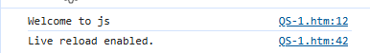
2 | Write a JavaScript program to display student details (Name, Age, and Course) on  a web page using document.write().
Code | <!DOCTYPE html>  <html lang="en">  <head>  <meta charset="UTF-8">  <meta name="viewport" content="width=device-width, initial-scale=1.0">  <title>Document</title>  <style>  </style>  </head>  <form action="#" onsubmit="print(); return false;">  <label for="name">Name :</label>  <input type="text" name="name" id="name">  <br>  <label for="age">Age :</label>  <input type="number" name="age" id="age">  <br>  <label for="course">Course :</label>  <input type="text" name="course" id="course">  <br>  <button type="submit">That's it!!</button>  </form>  <body>  <script>  function print() {  const name = document.getElementById("name").value;  const age = document.getElementById("age").value;  const course = document.getElementById("course").value;  document.writeln(name + "<br>");  document.writeln(age + "<br>")  document.writeln(course + "<br>")  }  document.write("Name : Megji Rehan <br>");  document.write("age : 19");  </script>  </body>  </html>
Output | 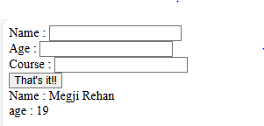  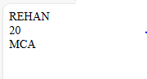
3 | Write a JavaScript code to display the message “Hello ISTAR!”. (Alert Dialog Box)
Code | <!DOCTYPE html>  <html lang="en">  <head>  <meta charset="UTF-8">  <meta name="viewport" content="width=device-width, initial-scale=1.0">  <title>Document</title>  </head>  <body>  <script>  alert("Hello iSTAR!!!")  </script>  </body>  </html>
Output | 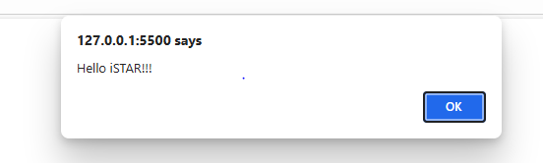
4 | Ask the user for their name using prompt() and display it back with alert().
Code | <!DOCTYPE html>  <html lang="en">  <head>  <meta charset="UTF-8">  <meta name="viewport" content="width=device-width, initial-scale=1.0">  <title>QS-4</title>  </head>  <body>  <script>  const FullName = prompt("Enter your full name Mr/Ms/Mrs!! :");  const Age = prompt("Enter your age :")  const Course = prompt("Enter your course :")  alert(FullName)  alert(Age)  alert(Course)  </script>  </body>  </html>
Output | 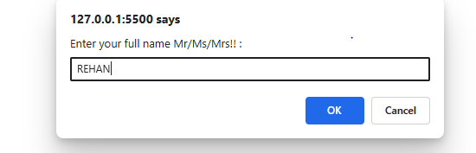  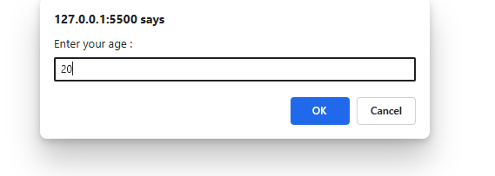  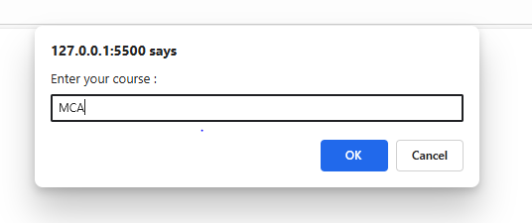  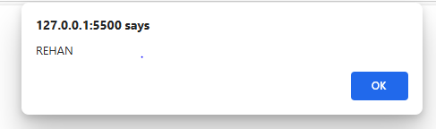  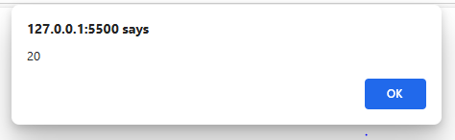  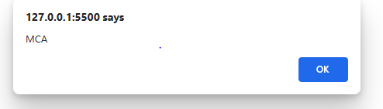
5 | Use let and const to declare variables, and try re-assigning them (observe difference).
Code | <!DOCTYPE html>  <html lang="en">  <head>  <meta charset="UTF-8">  <meta name="viewport" content="width=device-width, initial-scale=1.0">  <title>Document</title>  </head>  <body>  <script>  let name = "Megji Rehan";  name = "Kian";  const age = 19;  // age = 20 //Error  document.write(name + "<br>")  document.writeln(age)  </script>  </body>  </html>
Output | 
6 | Write a program to find typeof all variable of JavaScript .
Code | <!DOCTYPE html>  <html lang="en">  <head>  <meta charset="UTF-8">  <meta name="viewport" content="width=\, initial-scale=1.0">  <title>QS-6</title>  </head>  <body>  <script>  let name = "abc";  let num = 12;  let bool = false;  let num2 = 1.2;  let nill = null;  let d = 6789.00  document.write(name + ":"+typeof(name) + "<br>");  document.write(num + " :" +typeof(num) + "<br>");  document.write(bool + " : " +typeof(bool) + "<br>")  document.write(d + ":"+typeof(d) + "<br>")  document.write(nill + ":"+typeof(nill) + "<br>")  </script>  </body>  </html>
Output | 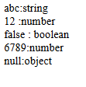
7 | Write a program to add, subtract, division, and multiplication of given numbers.
Code | <!DOCTYPE html>  <html lang="en">  <head>  <meta charset="UTF-8">  <meta name="viewport" content="width=device-width, initial-scale=1.0">  <title>QS-7</title>  </head>  <form action="#" onsubmit="Calc(); return false;">  <h2>Number Game!!!</h2>  <label for="num1"></label>  <input type="number" name="num1" id="num1" placeholder="Enter number-1">  <br><br>  <label for="num2"></label>  <input type="number" name="num2" id="num2" placeholder="Enter number-2">  <br><br>  <button type="submit">Calculate!!</button>  </form>  <body>  <script>  function Calc() {  const number1 = parseInt(document.getElementById("num1").value);  const number2 = parseInt(document.getElementById("num2").value);  let sum = number1 + number2;  document.write("Addition is : " + sum + "<br>")  let sub = number1 - number2;  document.write("Substraction is : " + sub + "<br>")  let product = number1 * number2;  document.write("Product is : " + product + "<br>")  let div = number1 / number2;  document.write("Division is :" + div + "<br>")  }  </script>  </body>  </html>
Output | 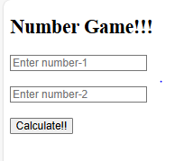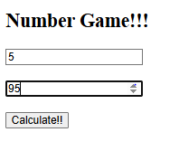  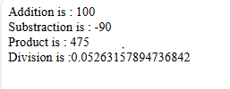
8 | Write a program to convert Fahrenheit to Celsius.
Code | <!DOCTYPE html>  <html lang="en">  <head>  <meta charset="UTF-8">  <meta name="viewport" content="width=device-width, initial-scale=1.0">  <title>QS-8 </title>  </head>  <h2>Fahrenheit to Celsius</h2>  <form action="#" onsubmit="Convert(); return false;">  <label for="temp"></label>  <input type="number" name="temp" id="temp" placeholder="Enter Temprature in fahrenheit">  <button type="submit">Convert</button>  </form>  <body>  <script>  function Convert() {  const temp = parseInt(document.getElementById("temp").value);  const celsius = (temp - 32) * 5 / 9;  document.write(`Temprature in celsius : ${celsius}` + "<br>");  }  </script>  </body>  </html>
Output | 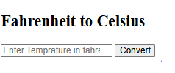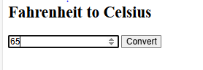  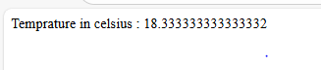
9 | Write a program to convert Celsius to Fahrenheit.
Code | <!DOCTYPE html>  <html lang="en">  <head>  <meta charset="UTF-8">  <meta name="viewport" content="width=device-width, initial-scale=1.0">  <title>QS-9</title>  </head>  <body>  <h2>Celsius to fahrenheit</h2>  <form action="#" onsubmit="Convert(); return false;">  <label for="temp"></label>  <input type="number" name="temp" id="temp" placeholder="Enter temprature in celsius">  <button type="submit">Convert</button>  </form>  </body>  <script>  function Convert() {  const temp = document.getElementById("temp").value;  const fahrenheit = (temp * 9 / 5) + 32;  document.write(`Temprature in fahrenheit : ${fahrenheit}`);  }  </script>  </html>
Output | 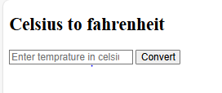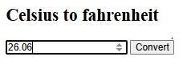  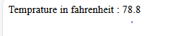
10 | WRITE a program to find answer of ax2 +b*x + c.
Code | <!DOCTYPE html>  <html lang="en">  <head>  <meta charset="UTF-8">  <meta name="viewport" content="width=device-width, initial-scale=1.0">  <title>QS-10</title>  </head>  <body>  <form action="#" onsubmit="quad(); return false;">  <label for="a"></label>  <input type="number" name="a" id="a" placeholder="Enter value for a">  <br><br>  <label for="b"></label>  <input type="number" name="b" id="b" placeholder="Enter value for b">  <br><br>  <label for="c"></label>  <input type="number" name="c" id="c" placeholder="Enter value for c" >  <br><br>  <label for="x"></label>  <input type="number" name="x" id="x" placeholder="Enter value for x">  <br><br>  <button type="submit">Solve</button>  </form>  <script>  function quad() {  const a = parseInt(document.getElementById("a").value);  const b = parseInt(document.getElementById("b").value);  const c = parseInt(document.getElementById("c").value);  const x = parseInt(document.getElementById("x").value);  const Math = a(x * x) + b * x + c;  document.write(Math)  }  </script>  </body>  </html>
Output | 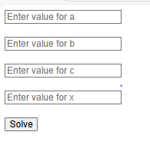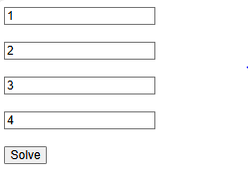  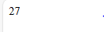
11 | Write a program to find large number among two numbers.
Code | <!DOCTYPE html>  <html lang="en">  <head>  <meta charset="UTF-8">  <meta name="viewport" content="width=device-width, initial-scale=1.0">  <title>QS-11</title>  </head>  <body>  <form action="#" onsubmit="max(); return false;">  <label for="num1"></label>  <input type="number" name="num1" id="num1" placeholder="Enter number-1">  <br><br>  <label for="num2"></label>  <input type="number" name="num2" id="num2" placeholder="Enter number-2">  <br><br>  <button type="submit">Find Max</button>  </form>  <script>  function max() {  const num1 = parseInt(document.getElementById("num1").value)  const num2 = parseInt(document.getElementById("num2").value)  document.write(num1 > num2 ? num1 : num2)  }  </script>  </body>  </html>
Output | 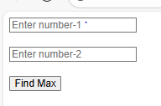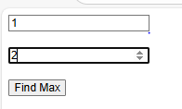  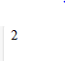
12 | Write a program to find large number among given three numbers.
Code | <!DOCTYPE html>  <html lang="en">  <head>  <meta charset="UTF-8">  <meta name="viewport" content="width=device-width, initial-scale=1.0">  <title>Document</title>  </head>  <body>  <form onsubmit="check(); return false;">  <label>Enter the first number </label><br>  <input type="number" id="num1"><br>  <label>Enter the second the number </label><br>  <input type="number" id="num2"><br>  <label>Enter the third the number </label><br>  <input type="number" id="num3"><br><br>  <input type="submit" id="submit" value="check">  </form>  <script>  function check() {  const num1 = parseInt(document.getElementById("num1").value);  const num2 = parseInt(document.getElementById("num2").value);  const num3 = parseInt(document.getElementById("num3").value);  if (num1 > num2 && num1 > num3) {  alert(num1 + " is greater from " + num2 + "," + num3);  } else if (num2 > num3) {  alert(num2 + " is greater from " + num1 + "," + num3);  } else {  alert(num3 + " is greater from " + num1 + "," + num2);  }  }  </script>  </body>  </html>
Output | 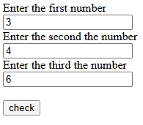  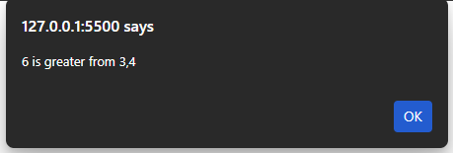
13 | Write a program to check whether the number is positive, negative or zero.
Code | <!DOCTYPE html>  <html lang="en">  <head>  <meta charset="UTF-8">  <meta name="viewport" content="width=device-width, initial-scale=1.0">  <title>Document</title>  </head>  <body>  <script>  const num = prompt("Enter the number");  if (num < 0) {  alert(num + " is negative");  } else if (num == 0) {  alert(num + " is xero");  } else {  alert(num + " is positve");  }  </script>  </body>  </html>
Output | 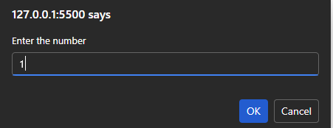  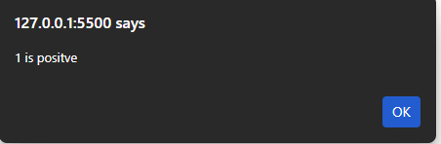
14 | Write a JavaScript code to display the message as "Are you sure you want to  proceed?" and display the message as "Completed successfully." If press OK  button, then display the message as "You have cancelled it." If press Confirm  button. (Confirm dialog box)
Code | <!DOCTYPE html>  <html lang="en">  <head>  <meta charset="UTF-8">  <meta name="viewport" content="width=device-width, initial-scale=1.0">  <title>Document</title>  </head>  <body>  <script>  const a = confirm("Are you sure you want to proceed?");  document.write(a ? "You pressed okay" : "you pressed cancel");  </script>  </body>  </html>
Output | 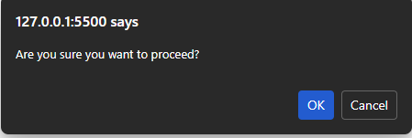  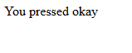
15 | Get one number as “age” from user and check whether he/she is eligible for  voting or not. (Prompt dialog box).
Code | <!DOCTYPE html>  <html lang="en">  <head>  <meta charset="UTF-8">  <meta name="viewport" content="width=device-width, initial-scale=1.0">  <title>Document</title>  </head>  <body>  <script>  const age = prompt("Enter your age: ");  alert(age >= 18 ? "you can vote" : "you can't vote");  </script>  </body>  </html>
Output | 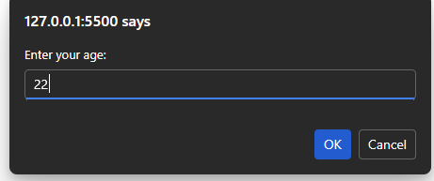  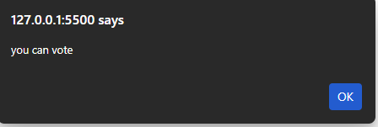
16 | Write a function greet() that prints "Hello, Welcome to JavaScript!".
Code | function greet() {  console.log("hello,welcome to javascript");  }  greet();
Output | 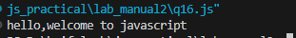
17 | Write a function square(num) that returns the square of a number.
Code | <!DOCTYPE html>  <html lang="en">  <head>  <meta charset="UTF-8">  <meta name="viewport" content="width=device-width, initial-scale=1.0">  <title>Document</title>  </head>  <body>  <script>  let num = prompt("enter number to find square");  square(num);  function square(num) {  document.write("Square of number is " + num * num);  }  </script>  </body>  </html>
Output | 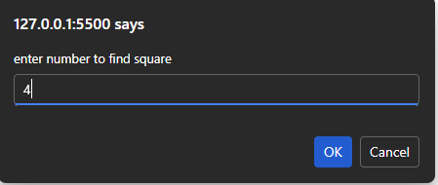  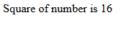
18 | Write a function isEven(num) that checks whether a number is even or odd.
Code | <!DOCTYPE html>  <html lang="en">  <head>  <meta charset="UTF-8">  <meta name="viewport" content="width=device-width, initial-scale=1.0">  <title>Document</title>  </head>  <body>  <script>  let num = prompt("Enter number to check odd or even");  isEven(num);  function isEven(num) {  document.write(num % 2 == 0 ? "Even number" : "odd number");  }  </script>  </body>  </html>
Output | 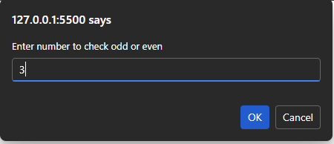  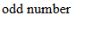
19 | Write a function add(a, b) that takes two numbers and returns their sum.
Code | <!DOCTYPE html>  <html lang="en">  <head>  <meta charset="UTF-8">  <meta name="viewport" content="width=device-width, initial-scale=1.0">  <title>Document</title>  </head>  <body>  <script>  let a = Number(prompt("enter 1 number"));  let b = Number(prompt("enter 2 number"));  add(a, b);  function add(a, b) {  document.write("sum = " + (a + b));  }  </script>  </body>  </html>
Output | 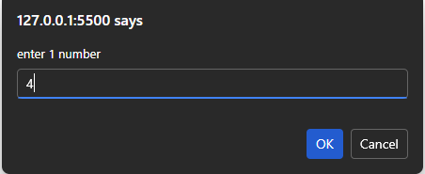  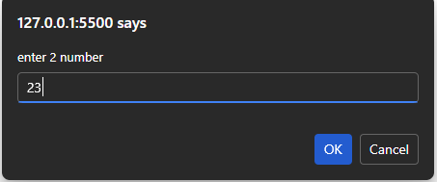  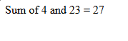
20 | Write a function findMax(a, b) that returns the larger of two numbers.
Code | <!DOCTYPE html>  <html lang="en">  <head>  <meta charset="UTF-8">  <meta name="viewport" content="width=device-width, initial-scale=1.0">  <title>Document</title>  </head>  <body>  <script>  let a = Number(prompt("enter 1 number:"));  let b = Number(prompt("enter 2 number"));  max(a, b);  function max(a, b) {  document.write(a > b ? +a + " is max" : +b + " is max");  }  </script>  </body>  </html>
Output | 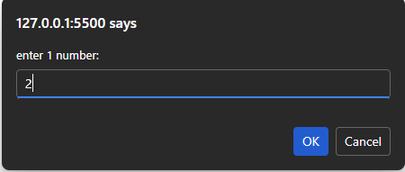  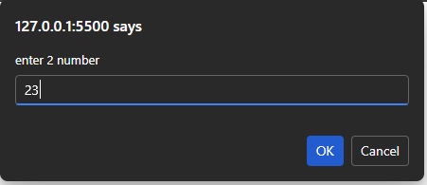  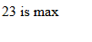
21 | Write a function sumArray(arr) that returns the sum of all elements in an array.
Code | arr = [1, 2, 3, 4, 5];  sumArray(arr);  function sumArray(arr) {  let sum = 0;  for (i of arr) {  sum += i;  }  console.log(sum);  }
Output | 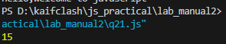
22 | Write a function findLargest(arr) that finds the largest element in an array.
Code | arr = [1, 2, 3, 4, 5, 6, 7, 8];  function findlargest(arr) {  arr.sort((a, b) => b - a);  console.log(arr[0]);  }  findlargest(arr);
Output | 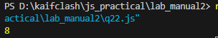
23 | Write a function countEvenNumbers(arr) that counts how many even numbers  are in an array.
Code | arr = [1, 2, 3, 4, 5, 6, 7, 8, 9];  function countevennumbers(arr) {  count=0;  for(i of arr)  {  if(i%2==0)  {  count +=1;  }  }  console.log(count);  }  countevennumbers(arr);
Output | 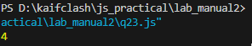
24 | Write a function filterOddNumbers(arr) that returns only odd numbers from an  array.
Code | arr = [1, 2, 3, 4, 5, 6, 7, 8, 9];  function filteroddnumber(arr) {  count = 0;  for (i of arr) {  if (i % 2 != 0) {  count += 1;  }  }  console.log(count);  }  filteroddnumber(arr);
Output | 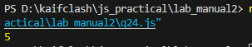
25 | Write a function average(arr) that finds the average of an array of numbers.
Code | arr = [1, 2, 3, 4, 5, 6];  average(arr)  function average(arr) {  sum = 0;  for (i of arr) {  sum += i;  }  len = arr.length;  avg = sum / len;  console.log(avg);  }
Output | 