**ONLINE LEAVE MANAGEMENT SYSTEM**

**A PROJECT REPORT**

**for**

**Project (KCA451)**

**Group No.GA10**

**Session (202324)**

**Submitted by**

**AKASH NEHRA**

**2200290140018**

**AKASH SINGH**

**2200290140019**

**EKANSH ARUN SRIVASTAVA**

**2200290140059**

**Submitted in partial fulfillment of the**

**Requirements for the Degree of**

**MASTER OF COMPUTER APPLICATION**

**Under the Supervision of**

**Ms. Shruti Agarwal**



**Submitted to**

**Department Of Computer Applications**

**KIET Group of Institutions, Ghaziabad**

**Uttar Pradesh201206**

**may 2024**

**CERTIFICATE**

Certified that **Akash Singh 220029014008709, Ekansh Arun Srivastava 220029014032294** and **Akash Nehra** **220029014008550** has/ have carried out the project work having “**Online Leave Management System**” (**ProjectKCA451**) for **Master of Computer Application** from Dr. A.P.J. Abdul Kalam Technical University (AKTU**)** (formerly UPTU), Lucknow under my supervision. The project report embodies original work, and studies are carried out by the student himself/herself and the contents of the project report do not form the basis for the award of any other degree to the candidate or to anybody else from this or any other University/Institution.

**Date:**

**Akash Nehra (2200290140018)**

**Akash Singh (2200290140019)**

**Ekansh Arun Srivastava (2200290140059)**

This is to certify that the above statement made by the candidate is correct to the best of my knowledge.

Date:

**Dr. Arun Tripathi**

**Ms. Shruti Agarwal Head**

**Department of Computer Applications Department of Computer Applications**

**KIET Group of Institutions, Ghaziabad KIET Group of Institutions, Ghaziabad**

**AKASH SINGH**

**AKASH NEHRA**

**EKANSH ARUN SRIVASTAVA**

**ONLINE LEAVE MANAGEMENT SYSTEM**

**ABSTRACT**

The Online Leave Management System revolutionizes the way organizations handle employee leave requests, providing a seamless and efficient process for both employees and administrators. Serving as a centralized platform, it offers intuitive tools for managing various types of leaves, from vacation days to sick leave, enhancing organizational productivity and employee satisfaction.

Key to the system is its user-friendly interface, designed to facilitate easy navigation and usage for all stakeholders. Employees can effortlessly submit leave requests, while administrators can efficiently review and approve them, all within a few clicks. This streamlined approach minimizes confusion and saves time for both parties, promoting a positive user experience.

Central to the system's functionality is its dynamic leave management mechanism, which automates essential processes such as leave balance tracking and approval workflows. By leveraging automation, the platform ensures accuracy and consistency in leave management, reducing the burden on HR personnel and preventing errors.

The Online Leave Management System also boasts a comprehensive dashboard that provides real-time insights into leave usage and trends within the organization. This empowers administrators to make informed decisions regarding staffing and resource allocation, optimizing operational efficiency.

In summary, the Online Leave Management System offers a user-centric design, dynamic leave tracking capabilities, and automated workflows. By prioritizing simplicity and effectiveness, it aims to streamline leave management processes and enhance employee satisfaction. Whether it's scheduling vacations or managing sick leave, the platform provides a convenient solution for organizations to effectively manage employee leave and foster a productive work environment.

**ACKNOWLEDGEMENTS**

Success in life is never attained singlehandedly. My deepest gratitude goes to my project supervisor, **Ms. Shruti Agarwal** for his/ her guidance, help, and encouragement throughout my project work. Their enlightening ideas, comments, and suggestions.

Words are not enough to express my gratitude to Dr. Arun Kumar Tripathi, Professor and Head, Department of Computer Applications, for his insightful comments and administrative help on various occasions.

Fortunately, I have many understanding friends, who have helped me a lot on many critical conditions.

Finally, my sincere thanks go to my family members and all those who have directly and indirectly provided me with moral support and other kind of help. Without their support, completion of this work would not have been possible in time. They keep my life filled with enjoyment and happiness.

**Akash Nehra**

**Akash Singh**

**Ekansh Arun Srivastava**

**TABLE OF CONTENTS**

|  |  |  |  |
| --- | --- | --- | --- |
|  | Certificate | | i |
|  | Abstract | | ii |
|  | Acknowledgments | | iii |
|  | Table of Contents | | iv |
|  | List of Figures | | v |
| 1 | Introduction | | 1 |
|  | 1.1 | Overview | 1 |
|  | 1.2 | Project Objectives | 2 |
|  | 1.3 | Project Requirements | 3 |
| 2 | Feasibility Study | | 4 |
|  | 2.1 | Technical Feasibility | 4 |
|  | 2.2 | Economical Feasibility | 6 |
|  | 2.3 | Operational Feasibility | 8 |
| 3 | System Analysis and Design | | 6 |
|  | 3.1 | System Analysis | 10 |
|  | 3.2 | System Design | 13 |
| 4 | Data Flow Diagram | | 17 |
|  | 4.1 | Block Diagram | 17 |
|  | 4.2 | Data Flow Diagram | 18 |
| 5 | System Implementations and Figures | | 23 |
|  | 5.1 | Admin Registration Page | 25 |
|  | 5.2 | Employee Registration Page | 15 |
| 6 | Data Base | | 47 |
|  | 6.1 | Database Schema | 47 |
|  | 6.2 | Relationships | 49 |
| 7 |  | Conclusion | 50 |
|  |  | Bibliography | 51 |

**CHAPTER 1**

**INTRODUCTION**

* 1. **OVERVIEW**

In an era characterized by technological advancements and the increasing digitization of organizational processes, traditional methods of managing employee leaves are undergoing significant transformation. The emergence of online platforms has ushered in a new era of efficiency and accessibility in leave management, reshaping the way organizations handle employee time-off requests. One such innovative solution is the Online Leave Management System.

The Online Leave Management System represents a paradigm shift in how organizations administer and track employee leaves, transcending geographical barriers and temporal constraints. It provides a virtual platform where employees and administrators can seamlessly manage leave requests, harnessing the power of connectivity and convenience. This report delves into the conception, development, and deployment of our Online Leave Management System, examining its diverse functionalities, intuitive design, and the profound impact it aims to achieve in streamlining leave management processes.

As we delve into the intricacies of this project, it's crucial to acknowledge the transformative potential inherent in modernizing leave management practices with advanced technological solutions. This report unveils the various facets of our Online Leave Management System, highlighting its user-friendly interface, robust security protocols, and the seamless integration of features designed to enhance the overall employee experience. From leave application to approval workflows, leave balance tracking to insightful reporting, our system endeavors to revolutionize leave management, creating a more efficient, transparent, and employee-centric process for organizations of all sizes.

* 1. **PROJECT OBJECTIVES**
* **Development of an Employee Centric Platform:**

Design and implement an intuitive and employee-friendly interface for leave management, ensuring ease of use and accessibility across various devices.

* **Efficient Employee Onboarding and Authentication:**

Create a streamlined employee onboarding process with secure authentication mechanisms to facilitate seamless registration and login experiences while safeguarding sensitive employee information.

* **Comprehensive Leave Request Management:**

Enable employees to submit leave requests with detailed information, including leave type, dates, and reasons, to facilitate efficient processing and tracking by administrators.

* **Flexible Leave Approval Workflows:**

Implement a flexible leave approval system that accommodates various organizational hierarchies and policies, allowing for customizable approval routes and delegation options.

* **Transparent Leave Balances and Policies:**

Provide employees with real-time visibility into their leave balances, accrued leave, and company leave policies, fostering transparency and empowering employees to make informed decisions about their time off.

* **Responsive Design Across Devices:**

Ensure a responsive design that adapts seamlessly to different screen sizes, providing a consistent and user-friendly experience on desktops, tablets, and smartphones for both employees and administrators.

* **Comprehensive Reporting and Analytics:**

Develop robust reporting and analytics capabilities to track leave trends, monitor employee attendance patterns, and generate insights to support strategic workforce planning and decision-making.

**1.3 PROJECT REQUIREMENTS**

**1.3.1 Hardware:**

* Processor: Minimum 2.0GHz requires.
* Ram: 2 GB.
* Hard Disk: 100 GB.
* Input device: Standard Keyboard and Mouse.
* Output device: VGA and High, Resolution Monitor.

**1.3.2 Software:**

* Operating System: Windows 7
* Language: PHP, JAVASCRIPT
* Database: phpMyAdmin.
* Tool: Visual Studio, XAMPP.

**CHAPTER 2**

**FEASIBILITY STUDY**

A feasibility study is an essential phase in project planning, offering a thorough analysis to ascertain the viability of a proposed project. In this context, we will examine the technical, economic, and operational feasibility of implementing an Online Leave Management System.

**2.1 Technical Feasibility:**

**1. System Architecture and Design**

**Scalability:** Modern cloud computing platforms like AWS, Google Cloud, and Microsoft Azure offer scalable infrastructure that can handle varying loads, ensuring that the leave management system can manage high volumes of simultaneous user requests.

**Modular Design:** The system can be designed with a modular architecture, where different components such as user management, leave application processing, approval workflows, and reporting are developed as separate modules. This facilitates easy maintenance and future enhancements.

**2. Leave Application and Tracking**

**Realtime Leave Processing:** Advanced databases like PostgreSQL, MySQL, and NoSQL databases like MongoDB support real-time leave application processing and data handling, ensuring that leave requests are recorded and updated instantaneously.

**Leave Policies and Rules:** The system can enforce leave policies and rules dynamically, which can be configured based on the organization's requirements (e.g., annual leave, sick leave, maternity leave).

**3. User Authentication and Security**

Secure Authentication: Implementing secure user authentication using OAuth2.0, multifactor authentication (MFA), and encrypted passwords ensures that user data is protected.

**Data Encryption:** Secure Sockets Layer (SSL) and Transport Layer Security (TLS) protocols can be used to encrypt data transmitted between the client and the server, protecting sensitive information such as personal details and leave balances.

**4. Approval Workflows and Notifications**

**Customizable Approval Workflows:** The system can support customizable approval workflows to accommodate different organizational structures, ensuring that leave requests are routed to the appropriate managers for approval.

**Realtime Notifications:** WebSocket technology enables real-time updates and notifications, allowing employees and managers to receive instant alerts on leave request status changes.

**5. Integration with HRIS and ERP Systems**

**Seamless Integration:** The leave management system can be designed to integrate seamlessly with existing HRIS and ERP systems, ensuring interoperability and data consistency.

**API Integration:** RESTful APIs can be used to facilitate communication between the leave management system and other third-party applications, enabling functionalities such as employee data synchronization and payroll processing.

**6. Reporting and Analytics**

**Comprehensive Reporting:** Advanced reporting tools can be integrated to generate detailed reports on leave balances, leave history, approval timelines, and employee leave trends.

**Analytics and Insights:** Machine learning algorithms can be applied to analyze leave patterns, identify potential issues such as high absenteeism, and provide actionable insights for improving leave policies.

**7. User Interface and Experience**

**Responsive Design:** A responsive web design ensures that the leave management system is accessible on various devices, including desktops, tablets, and smartphones.

**User-friendly Interface:** The system can be designed with a user-friendly interface, offering intuitive navigation, clear instructions, and easy access to important features, enhancing the overall user experience.

**8. Automated Notifications and Reminders**

**Email and SMS Notifications:** The system can send automated email and SMS notifications to employees and managers regarding leave request submissions, approvals, rejections, and upcoming leave dates.

**Reminder Alerts:** Reminder alerts can be configured to notify employees of important deadlines, such as the end of a leave year or the expiration of accrued leave.

By leveraging modern technologies and adhering to best practices in system design, an Online Leave Management System can be efficiently implemented to streamline leave processes, enhance productivity, and improve employee satisfaction.

**2.2 Economic Feasibility:**

The economic feasibility of an Online Leave Management System involves assessing the costs and benefits associated with its implementation and operation to determine if the investment is financially worthwhile. This evaluation includes analyzing direct and indirect costs, as well as tangible and intangible benefits.

**1. Initial Costs**

**Software Development or Purchase:**

**Custom Development:** Costs for developing a bespoke system include hiring developers or contracting a software development firm, which can range significantly based on complexity and geographic location.

**Commercial Off-The-Shelf (COTS) Solutions:** Purchasing an existing software solution involves licensing fees, which vary depending on the vendor and the number of users.

**Hardware and Infrastructure:**

**On-Premises:** Costs for servers, storage, and network infrastructure. These might also include costs for physical space and power consumption.

**Cloud-Based Solutions:** Subscription fees for cloud services, which are typically based on the number of users and the level of service required.

**Licensing Fees:** Costs for necessary software licenses, including operating systems, databases, and any third-party tools required for integration or additional functionality.

**Implementation Costs:** Expenses for installing, configuring, and customizing the system to fit the organization's specific needs. This may include consultancy fees for expert guidance.

**2. Recurring Costs**

**Maintenance and Support:** Ongoing costs for maintaining the system, applying updates, and providing technical support. This could involve the salaries of internal IT staff or service fees from an external provider.

**Subscription Fees:** For cloud-based solutions, recurring subscription fees based on user count and service level agreements (SLAs).

**Training:** Continuous training for new employees and refresher courses for existing employees to ensure they can effectively use the system.

**3. Tangible Benefits**

**Operational Efficiency:**

Reduced Administrative Costs: Automating leave management reduces the time HR personnel spend on manual processes, resulting in significant cost savings.

**Error Reduction:** Minimizing manual data entry errors reduces costs associated with correcting these errors.

**Improved Productivity:**

**Streamlined Processes:** Automated workflows for leave requests and approvals speed up the process, allowing employees and managers to focus on more strategic tasks.

**Enhanced Decision-Making:** Realtime data and reporting capabilities enable better management of leave balances and forecasting of staffing needs.

**4. Intangible Benefits**

**Employee Satisfaction:**

**Ease of Use:** A user-friendly system enhances the employee experience, leading to higher satisfaction and morale.

**Transparency:** Clear leave policies and real-time tracking increase transparency, fostering trust within the organization.

**Compliance and Risk Management:**

Regulatory Compliance: Ensures compliance with labor laws and company policies, reducing the risk of legal issues and potential fines.

**Audit Trails:** Maintains comprehensive records for audits, enhancing accountability and transparency.

**5. Return on Investment (ROI) Analysis**

**Cost Savings:** Calculate the reduction in administrative costs, error correction, and operational inefficiencies.

**Productivity Gains:** Estimate the value of increased productivity and improved decision-making capabilities.

**Intangible Value:** While harder to quantify, improved employee satisfaction and compliance contribute to long-term organizational health and reduced turnover costs.

**Payback Period:** Determine the time it takes for the benefits to outweigh the initial and recurring costs.

**6. Break-Even Analysis**

**Initial Investment vs. Savings:** Compare the total initial and recurring costs against the anticipated annual savings and productivity gains to find the breakeven point.

**Long-Term Financial Impact:** Project the long-term financial impact over several years to evaluate sustained benefits and cost-effectiveness.

**2.3 Operational Feasibility:**

Operational feasibility assesses how well the proposed Online Leave Management System will function within the organization. It evaluates whether the system can be implemented effectively within the current operational structure and whether it will meet the organization's needs and expectations. This includes analyzing factors such as system integration, user acceptance, support and maintenance, and overall operational impact.

**1. System Integration**

**Compatibility with Existing Systems:** The new system should seamlessly integrate with existing HRIS (Human Resource Information System) and ERP (Enterprise Resource Planning) systems. This ensures data consistency and smooth workflows across different platforms.

**APIs and Middleware:** Utilizing APIs and middleware solutions can facilitate seamless data exchange between the new leave management system and existing software.

**Data Migration:** The process of migrating existing leave records and employee data to the new system should be well-planned to avoid data loss and ensure accuracy.

**Data Cleansing:** Prior to migration, data should be cleansed to remove duplicates and outdated information.

**Testing:** Rigorous testing of the data migration process to ensure data integrity and accuracy.

**2. User Acceptance and Training**

**Ease of Use:** The system should have a user-friendly interface to encourage quick adoption by employees and managers.

**Intuitive Design:** A clean, intuitive design that simplifies the leave request and approval process.

Training Programs: Comprehensive training programs should be provided to ensure that all users are comfortable using the new system.

**Workshops and Tutorials:** Interactive workshops and step-by-step tutorials can help users familiarize themselves with the system.

**User Manuals and Helpdesk:** Providing detailed user manuals and a responsive helpdesk for ongoing support.

**Feedback Mechanism:** Establish a feedback mechanism to collect user input and continuously improve the system based on user experiences.

**3. Support and Maintenance**

**Technical Support**: A robust support system should be in place to address any technical issues that arise during and after implementation.

**Helpdesk and Ticketing System:** An efficient helpdesk and ticketing system to manage and resolve user issues promptly.

**System Maintenance:** Regular maintenance schedules to ensure the system remains up-to-date and functions optimally.

**Software Updates:** Regular software updates to fix bugs, enhance security, and introduce new features.

**Performance Monitoring:** Continuous monitoring of system performance to detect and resolve any issues proactively.

**4. Operational Impact**

**Process Automation:** The system should automate key processes such as leave request submission, approval workflows, and leave balance tracking.

**Workflow Automation:** Automating approval workflows to reduce manual intervention and speed up the process.

**Improved Accuracy and Efficiency:** Reducing manual data entry and errors to improve overall efficiency and accuracy.

**Error Reduction:** Automated calculations of leave balances and entitlements to minimize errors.

**Resource Management:** Better resource planning and management through accurate tracking of employee availability.

**Reporting and Analytics:** Advanced reporting tools to provide insights into leave patterns and help in workforce planning.

**5. Scalability and Flexibility**

**Scalability:** The system should be scalable to accommodate future growth in the number of employees and organizational changes.

**Cloud-Based Solutions:** Leveraging cloud-based solutions for easy scalability and flexibility.

**Customization:** The ability to customize the system to meet specific organizational needs and policies.

**Configurable Leave Policies:** Customizable leave types and policies to match the organization’s requirements.

**6. Compliance and Security**

**Regulatory Compliance:** Ensuring the system complies with local labor laws and regulations regarding leave management.

**Audit Trails:** Maintaining detailed audit trails of leave requests and approvals for compliance and transparency.

**Data Security:** Implementing robust security measures to protect sensitive employee data.

**Encryption and Access Controls:** Data encryption, secure access controls, and regular security audits to safeguard information.

**CHAPTER 3**

**SYSTEM ANALYSIS AND DESIGN**

**3.1 System Analysis:**

System analysis involves a comprehensive examination of the requirements, components, and functionalities necessary to develop an effective Online Leave Management System. This includes understanding current problems, defining system objectives, gathering detailed requirements, and designing a robust system architecture.

**1. Understanding Current Problems**

**Manual Processes:** Organizations often use manual processes for managing leave, which are time-consuming, prone to errors, and inefficient.

**Inefficiencies:** Manual tracking of leave balances, approvals, and recordkeeping leads to significant administrative overhead and delays.

**Lack of Transparency:** Employees and managers may not have real-time visibility into leave balances and the status of leave requests, leading to confusion and potential conflicts.

**Inconsistent Leave Policies:** Variations in how leave policies are applied can cause inconsistencies, affecting employee satisfaction and compliance with company policies.

**2. Defining System Objectives**

**Automation:** Streamline and automate the entire leave management process from application to approval and recordkeeping.

**Efficiency:** Enhance efficiency by reducing administrative tasks and minimizing errors associated with manual processes.

**Transparency:** Provide real-time visibility into leave balances and request statuses for both employees and managers.

**Compliance:** Ensure consistent application of leave policies and compliance with organizational and regulatory requirements.

**3. Gathering Detailed Requirements**

**Functional Requirements:**

**User Management:** Allow administrators to manage user roles, permissions, and profiles.

**Leave Application:** Enable employees to apply for various types of leave (e.g., annual leave, sick leave, maternity leave) through a user-friendly interface.

**Approval Workflow:** Implement configurable approval workflows to route leave requests to the appropriate managers for approval.

**Leave Tracking:** Track leave balances, accruals, and usage in real-time.

**Notifications:** Provide automated notifications for leave request submissions, approvals, rejections, and upcoming leaves.

**Reporting:** Generate detailed reports on leave balances, leave history, and employee leave trends.

**Integration:** Integrate with existing HRIS and ERP systems for data consistency and interoperability.

**Non-Functional Requirements:**

**Usability:** Ensure the system is user-friendly and intuitive for all users.

**Performance:** Ensure the system can handle high volumes of leave requests and data processing efficiently.

**Scalability:** Design the system to scale with the organization’s growth in terms of user numbers and leave management complexity.

**Security:** Implement robust security measures to protect sensitive employee data.

**Availability:** Ensure high availability and reliability of the system to minimize downtime.

**4. Designing System Architecture**

**Architecture Overview:**

**Modular Design:** Develop the system with a modular architecture, with separate modules for user management, leave application, approval workflows, leave tracking, and reporting.

**Cloud-Based vs. On-Premises:** Decide between a cloud-based solution for scalability and reduced infrastructure costs or an on-premises solution for more control over data and customization.

**Database Design:**

**Entity-Relationship Diagram (ERD):** Design an ERD to define the relationships between entities such as employees, leave types, leave requests, and approvals.

**Normalization:** Ensure database normalization to eliminate redundancy and improve data integrity.

**Integration Points:**

**APIs:** Develop RESTful APIs for integration with existing HRIS and ERP systems.

**Middleware:** Use middleware to facilitate seamless data exchange and synchronization between different systems.

**User Interface Design**

**Responsive Design:** Ensure the user interface is responsive and accessible from various devices, including desktops, tablets, and smartphones.

**User Experience (UX):** Focus on intuitive navigation, clear instructions, and easy access to important features.

**Security Measures**

**Authentication and Authorization:** Implement secure authentication (e.g., OAuth2.0, MFA) and role-based access control.

**Data Encryption:** Use SSL/TLS for data transmission and encrypt sensitive data in the database.

**Audit Trails:** Maintain audit trails for all leave requests and approvals to ensure accountability and compliance.

**5. Implementation Plan**

**Phased Rollout:** Implement the system in phases, starting with a pilot program to gather feedback and make necessary adjustments before full deployment.

**Training:** Provide comprehensive training sessions for employees and managers to ensure smooth adoption.

**Support:** Establish a support system to address any issues that arise during and after implementation.

**6. Evaluation and Improvement**

**Monitoring and Evaluation:** Continuously monitor system performance and user feedback to identify areas for improvement.

**Regular Updates:** Provide regular updates and enhancements based on user feedback and changing organizational needs.

By conducting a thorough system analysis, the organization can develop a robust, efficient, and user-friendly Online Leave Management System that meets its specific needs and enhances overall productivity and employee satisfaction.

**3.2 System Design:**

System design is a crucial phase in the development of an Online Leave Management System. It involves creating detailed specifications for the system's architecture, components, modules, interfaces, and data management. The design ensures that the system meets all functional and nonfunctional requirements identified during the system analysis phase.

**1. System Architecture**

**1.1 Modular Architecture:**

User Management Module: Manages user roles, permissions, and profiles.

Leave Application Module: Handles leave requests and related functionalities.

Approval Workflow Module: Manages the routing and approval of leave requests.

Leave Tracking Module: Tracks leave balances, accruals, and usage.

Notification Module: Sends automated notifications for various events.

Reporting Module: Generates detailed reports on leave activities.

Integration Module: Interfaces with existing HRIS and ERP systems.

**1.2 Deployment Architecture:**

Cloud Based Solution: Utilize cloud services for scalability, flexibility, and reduced infrastructure costs.

On-Premises Solution: Deploy on internal servers for more control over data and customization.

**2. Database Design**

**2.1 Entity Relationship Diagram (ERD):**

**Entities:**

**Employee:** Stores employee details (e.g., Employee ID, Name, Department).

**Leave Type:** Defines different types of leave (e.g., Leave Type ID, Description, Max Days).

**Leave Request:** Manages leave requests (e.g., Request ID, Employee ID, Leave Type ID, StartDate, End Date, Status).

**Approval:** Tracks the approval process (e.g., Approval ID, Request ID, Approver ID, Approval Date, Status).

**2.2 Normalization:**

Ensure database normalization to eliminate redundancy and improve data integrity.

**3. Integration Design**

**3.1** **APIs:**

RESTful APIs: Facilitate communication and data exchange between the leave management system and external HRIS/ERP systems.

Endpoints: Define endpoints for various operations such as creating leave requests, retrieving leave balances, and updating approval statuses.

**3.2 Middleware:**

Use middleware for seamless integration and data synchronization between different systems.

**4. User Interface Design**

**4.1 Responsive Design:**

Accessibility: Ensure the interface is accessible from various devices, including desktops, tablets, and smartphones.

UI Framework: Utilize frameworks like Bootstrap or React for responsive design.

**4.2 User Experience (UX):**

Intuitive Navigation: Simplify navigation to improve user experience.

Clear Instructions: Provide clear instructions and tooltips to guide users.

Easy Access: Ensure easy access to important features and information.

**5. Security Measures**

**5.1 Authentication and Authorization:**

OAuth2.0 and MFA: Implement secure authentication mechanisms.

Role-Based Access Control: Define roles and permissions to restrict access based on user roles.

**5.2 Data Encryption:**

SSL/TLS: Encrypt data transmission using SSL/TLS.

Database Encryption: Encrypt sensitive data stored in the database.

**5.3 Audit Trails:**

Maintain audit trails for all leave requests and approvals to ensure accountability and compliance.

**6. Notification System**

**6.1 Real-Time Notifications:**

WebSocket: Implement WebSocket for real-time notifications.

Email and SMS Notifications: Configure email and SMS notifications for leave request submissions, approvals, rejections, and reminders.

**7. Reporting and Analytics**

**7.1 Reporting Tools:**

Predefined Reports: Create predefined reports on leave balances, leave history, and employee leave trends.

Custom Reports: Allow administrators to generate custom reports based on specific criteria.

**7.2 Analytics:**

Data Analysis: Use data analysis tools to identify leave patterns and trends.

Predictive Analytics: Implement predictive analytics to forecast leave demands and potential staffing issues.

**8. Implementation Plan**

**8.1 Phased Rollout:**

Pilot Program: Start with a pilot program to gather feedback and make necessary adjustments.

Full Deployment: Gradually deploy the system across the organization after successful pilot testing.

**8.2 Training:**

Training Sessions: Conduct comprehensive training sessions for employees and managers.

User Manuals: Provide detailed user manuals and online help resources.

**8.3 Support:**

Helpdesk: Establish a helpdesk to address user issues and provide technical support.

Ongoing Maintenance: Plan for regular maintenance and updates to ensure system reliability and performance.

**9. Evaluation and Improvement**

**9.1 Monitoring and Evaluation:**

Continuously monitor system performance and user feedback.

**CHAPTER 4**

**BLOCK DIAGRAM**

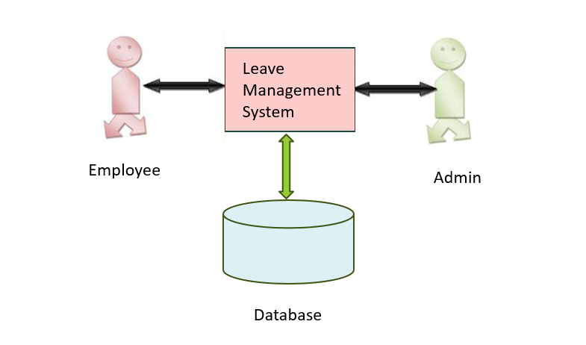

**Fig1: Online Leave Management System Block Diagram**

* + **Employee and Administrator:** components represent the users interacting with the system.
  + **Online Leave Management Platform:** is the central hub facilitating communication between employees and administrators.
  + **User Database:** stores employee information such as registration details, contact information, leave balances, etc.
  + **Leave Request Database:** stores information about leave, requests submitted by employees, including leave type, dates, reasons, etc.
  + **Process Box:** (not explicitly labeled) represents the various processes and functionalities within the leave management system, including leave request submission, approval workflows, leave balance tracking, etc.

**CHAPTER 5**

**DATA FLOW DIAGRAM**

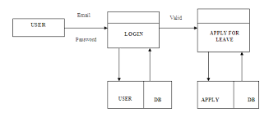

**Fig2: Data Flow Diagram**

The context-level Data Flow Diagram (DFD) for the online leave management system features a central process denoting the system itself, with external entities represented by "Employee" and "Administrator." Employees interact with the system to submit leave requests, while administrators oversee the approval and management of these requests. This high-level overview outlines the primary interactions between the system and its external entities, omitting internal processes and data flows for simplicity.

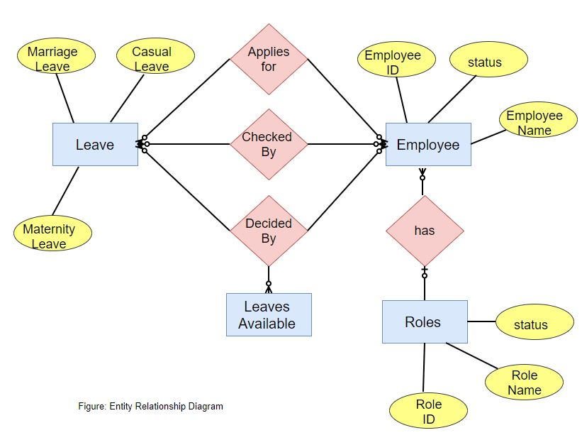

Entity-Relationship Diagram (ERD) for Online Leave Management System

Entities

1. Employee

Attributes:

Employee ID

Employee Name

Status

Relationships:

Applies for Leave

Checked By

Decided By

Has Roles

2. Leave

Attributes:

Leave Type (e.g., Marriage Leave, Casual Leave, Maternity Leave)

Relationships:

Applies for by Employee

Checked By Employee

Decided By Employee

Leaves Available

3. Roles

Attributes:

Role ID

Role Name

Status

Relationships:

Has by Employee

4. Leaves Available

Relationships:

Linked with Leave

Relationships

1. Applies for (Leave)

Represents the action of an employee applying for a leave.

Relationship between Employee and Leave entities.

2. Checked By

Represents the checking or verification process of a leave request by an employee (likely a supervisor or HR personnel).

Relationship between Employee and Leave entities.

3. Decided By

Represents the decision-making process regarding the approval or rejection of a leave request by an employee (likely a supervisor or HR personnel).

Relationship between Employee and Leave entities.

4. Leaves Available

Represents the leaves available for employees.

Relationship between Leave and Leaves Available entities.

5. Has (Roles)

Represents the roles associated with an employee.

Relationship between Employee and Roles entities.

Detailed Explanation

1. Employee

This entity stores information about the employees.

Each employee has a unique Employee ID, a name, and a status.

Employees can apply for various types of leave and have specific roles in the system.

2. Leave

This entity stores information about different types of leaves available in the organization.

Leave types include Marriage Leave, Casual Leave, and Maternity Leave.

Employees can apply for these leaves, which are then checked and decided upon by other employees (supervisors or HR).

3. Roles

This entity defines various roles within the organization.

Each role has a unique Role ID, a name, and a status.

Roles help in defining the responsibilities and permissions of employees within the leave management system.

4. Leaves Available

This entity tracks the availability of leaves for employees.

It helps in determining how many leaves of each type are available for an employee to apply for.

5. Applies for (Leave)

This relationship captures the action of an employee applying for a leave.

It links the Employee and Leave entities, showing which employee applied for which type of leave.

6. Checked By

This relationship captures the verification process of a leave application.

It links the Employee and Leave entities, showing which employee checked the leave application.

7. Decided By

This relationship captures the decision-making process regarding a leave application.

It links the Employee and Leave entities, showing which employee made the decision about the leave application.

8. Has (Roles)

This relationship captures the roles associated with an employee.

It links the Employee and Roles entities, showing which roles an employee has within the system.

By understanding these entities and their relationships, we can design a comprehensive and efficient Online Leave Management System that meets the needs of the organization and its employees.

CHAPTER 6

SYSTEM IMPLEMENTATION AND FIGURES

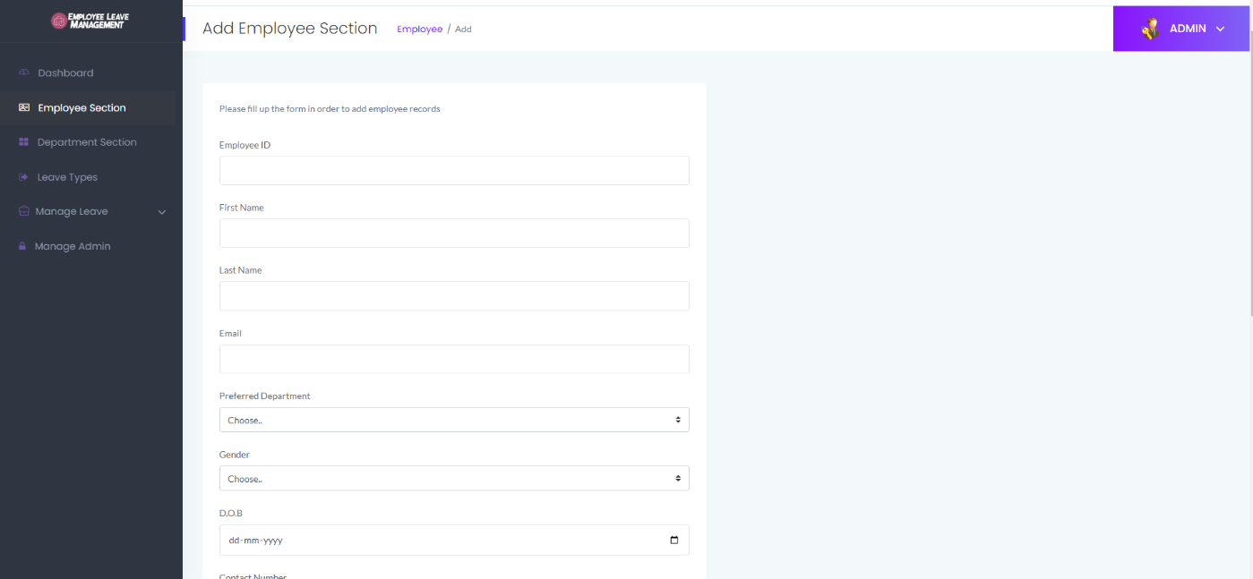

**Fig3: Add New Admin**

In the development of our online leave management system, meticulous attention has been given to crafting an efficient and user-friendly admin registration form. This form serves as the gateway for new administrators to access the system, and it includes the following pivotal fields:

* **Full Name:** This field captures the complete name of the administrator, ensuring precise identification within the system. It employs a text input type, allowing for the entry of alphanumeric characters.
* **Email ID:** Administrators are prompted to input their email addresses in this field, facilitating effective communication and correspondence related to leave management activities. The input type utilized here is "email," incorporating built-in validation to ensure adherence to standard email format conventions.
* **Username:** An essential component of system identification, administrators select a unique username in this field. Alphanumeric characters are accepted, with validation measures in place to ensure uniqueness and compliance with any specified format requirements.
* **Setting Passwords:** This section enables administrators to establish secure access credentials for the system.
* **Password:** Administrators input their chosen passwords here, with stringent validation implemented to enforce password strength requirements. The input type utilized is "password," concealing entered characters for security purposes.
* **Confirmation Password:** To mitigate input errors and ensure accuracy, administrators are prompted to reenter their chosen password for verification. This field utilizes the same input type as the password field, maintaining consistency in user experience.

In our online leave management system, the admin registration form serves as a pivotal gateway for system access and management. It encapsulates essential information for user authentication and control. By capturing details such as full name, email ID, and username, the form ensures accurate identification and communication channels. Moreover, the inclusion of password settings, comprising password creation and confirmation, fortifies security measures, safeguarding sensitive data and system integrity. This robust registration process not only streamlines administrative onboarding but also upholds the confidentiality and reliability of our leave management system.

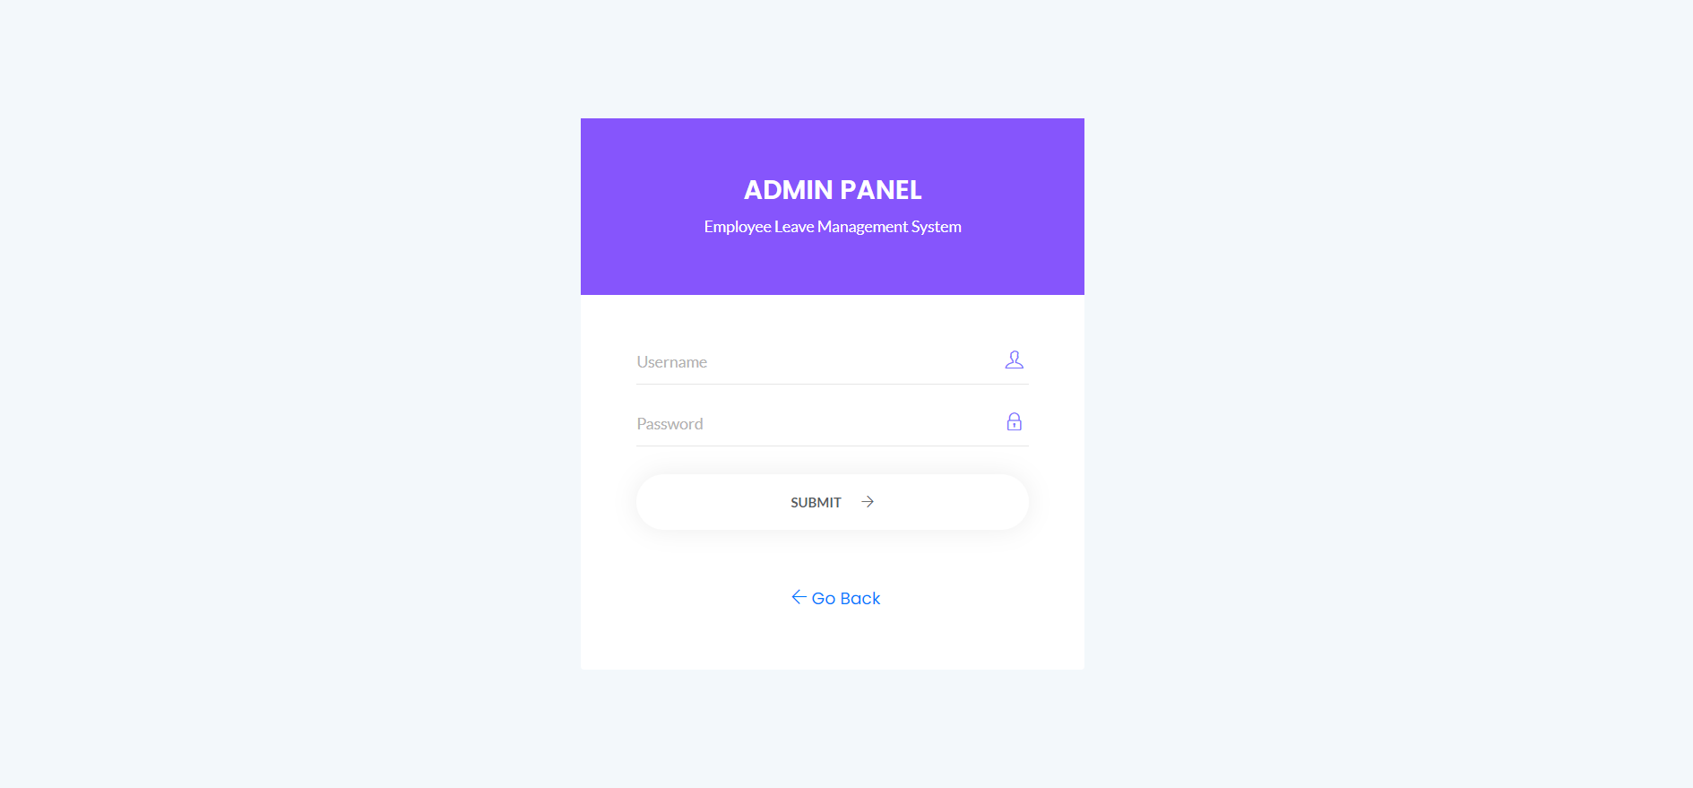

**Fig4: Admin Login Page**

In crafting the admin login page for our system, simplicity and functionality are paramount. The page comprises the following essential elements:

* **Username:** Administrators input their unique usernames in this field, facilitating personalized access to the system.
* **Password:** Secure access is ensured through the password field, where administrators input their confidential passwords. The characters entered are masked for enhanced security.
* **SUBMIT:** This button initiates the authentication process, validating the entered username and password combination against stored credentials in the system.
* **Go Back:** Should administrators need to revisit previous actions or pages, the "Go Back" option provides a convenient mechanism to navigate backward within the system.

By integrating these elements into our admin login page, we prioritize user experience and security, ensuring seamless access for authorized personnel while maintaining robust authentication protocols.

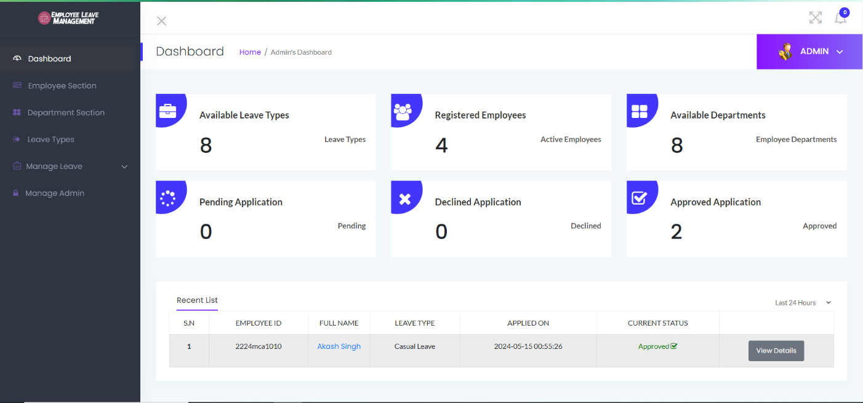

**Fig5: Admin Dashboard**

In the development of our admin dashboard, every aspect has been meticulously crafted to provide administrators with a comprehensive and user-friendly interface for managing the leave system efficiently. Here's a detailed overview of the layout:

## **Navigation Bars**

* **Employee Section:** This section is dedicated to managing employee-related tasks. Administrators can access employee profiles, review leave requests submitted by employees, and update employee information as needed. It serves as a centralized hub for overseeing personnel matters within the organization.
* **Department Section:** Here, administrators can perform various department-related actions. They have the ability to add new departments, modify existing ones, or remove departments when necessary. Additionally, administrators can assign employees to specific departments and analyze departmental performance through insightful analytics.
* **Leave Types:** This section empowers administrators to define and manage different types of leave available to employees. From vacation to sick leave to maternity/paternity leave, administrators can customize leave types according to organizational policies and regulations, ensuring clarity and consistency in leave management.
* **Manage Leave:** A pivotal component of the dashboard, this section streamlines the entire leave management process. Administrators can review leave requests submitted by employees, approve or reject them based on established criteria, monitor leave balances, and generate comprehensive reports to gain insights into leave utilization patterns.
* **Manage Admin:** In this section, administrators have the tools to manage administrative aspects of the system. This includes user management, where administrators can add or remove users, assign roles and permissions, control access to system features, and configure system settings to align with organizational requirements.

**Notification Box**

* **Available Leave Types:** Administrators are provided with a convenient overview of all defined leave types within the system. This ensures easy reference and management adjustments whenever necessary.
* **Registered Employees:** This section presents administrators with a detailed list of registered employees, including their names, positions, and contact information. It serves as a quick access point for administrators to view and manage employee profiles as needed.
* **Available Departments:** Administrators can view all available departments within the organization, facilitating efficient management of departmental resources and assignments.
* **Pending Application:** Administrators are alerted to leave applications that are pending approval. This ensures timely review and action to maintain operational continuity.
* **Declined Application:** Instances where leave applications have been declined are highlighted in this section. Administrators can review the reasons for declination and provide feedback to employees as necessary.
* **Approved Application:** Approved leave applications are showcased here, enabling administrators to track leave utilization and maintain accurate records for organizational purposes.

By integrating these elements into our admin dashboard, we aim to empower administrators with the necessary tools and insights to effectively manage the leave system, foster organizational efficiency, and enhance overall productivity.

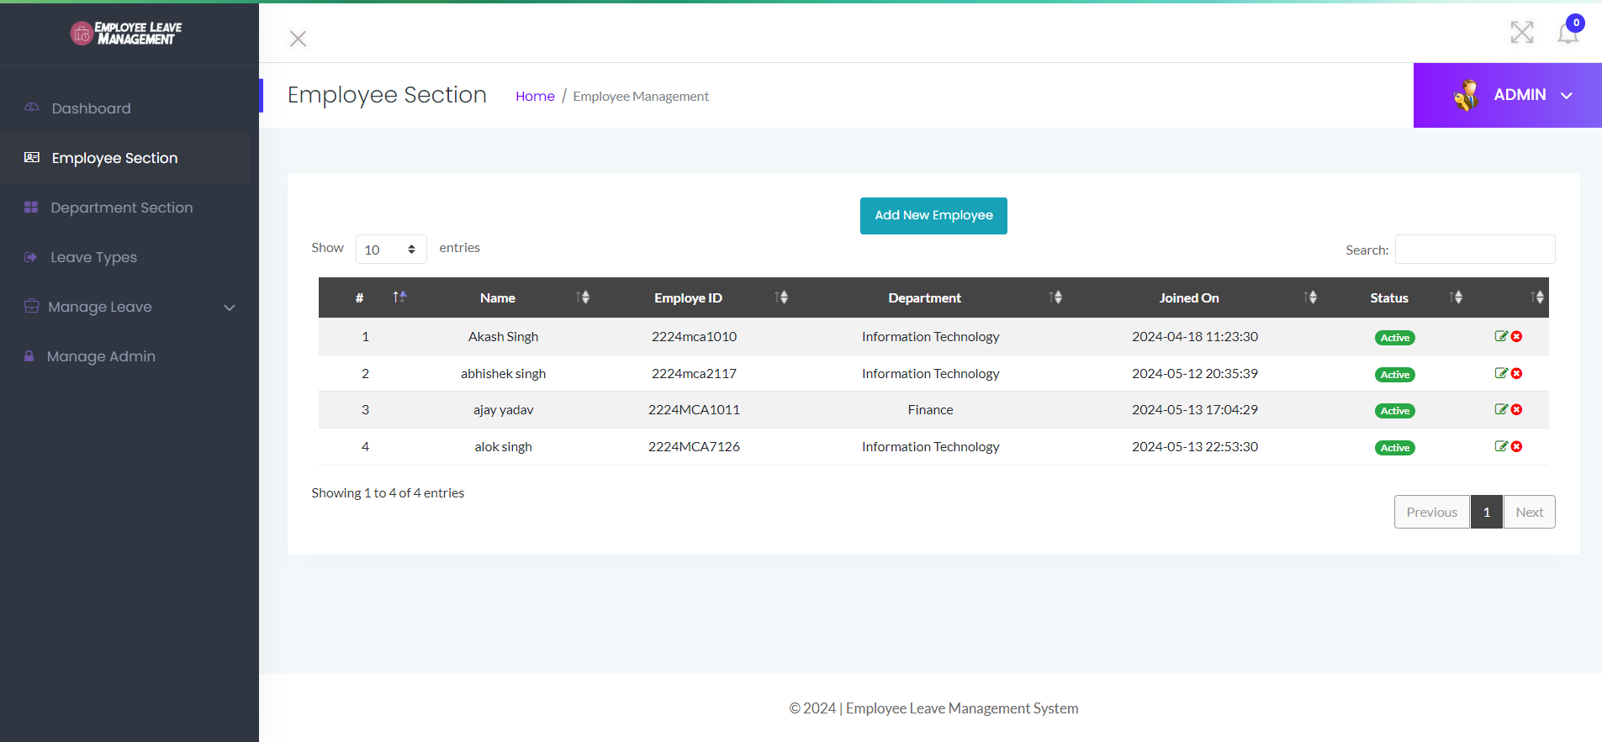

**Fig6: Employee Section**

Got it. Here's a template for the "Employee Section" with a list of active employees:

| **#** | **Name** | **Employee ID** | **Department** | **Joined On** | **Status** |
| --- | --- | --- | --- | --- | --- |
| 1 | Akash Singh | 2224mca1010 | Information Technology | 20240418 11:23:30 | Active |
| 2 | Abhishek Singh | 2224mca2117 | Information Technology | 20240512 20:35:39 | Active |
| 3 | Ajay Yadav | 2224MCA1011 | Finance | 20240513 17:04:29 | Active |
| 4 | Alok Singh | 2224MCA7126 | Information Technology | 20240513 22:53:30 | Active |

**List of Active Employees**

* **Access Employee Section:** Log in to the admin panel or employee management system.
* **Navigate to Active Employees:** Within the employee section, there could be a tab or filter option to view only active employees.
* **View Employee List:** Once in the active employees, section, the administrator can view a table or list displaying details such as Name, Employee ID, Department, Joined On, and Status for all active employees.
* **Optional Actions:** Depending on the system's capabilities, the administrator might have options to edit employee details, deactivate employees, or perform other actions related to employee management.

By following these steps, administrators can efficiently add new employees to the system and also access a clear list of all currently active employees for reference or management purposes.

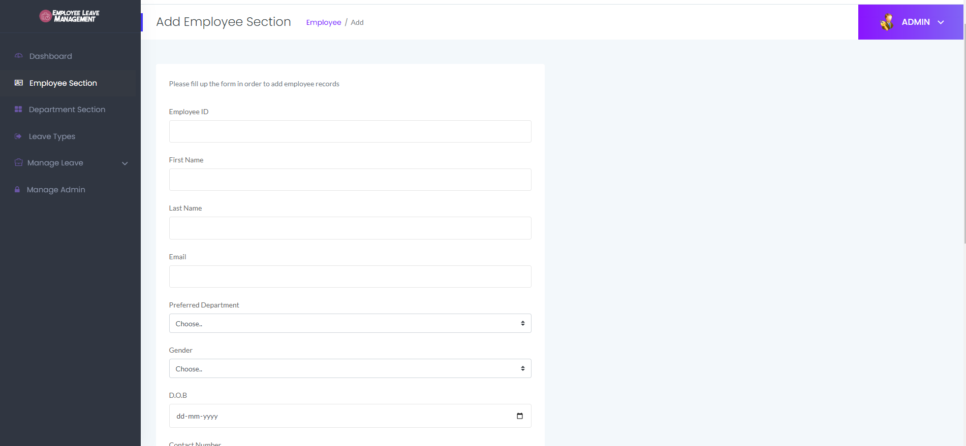

**Fig7: Add Employee Section**

**Add New Employee Section**

The "Add New Employee" section of the project aims to provide a user-friendly interface for administrators to add new employees to the organization's database. This section facilitates the collection of essential employee details and ensures seamless integration into the organization's workforce.

* **Employee ID:** Enter a unique identifier for the employee within the organization.
* **First Name:** Provide the employee's first name.
* **Last Name:** Enter the employee's last name or surname.
* **Email:** Input the employee's email address for communication purposes.
* **Preferred Department:** Select the department to which the employee will be assigned or prefers to work.
* **Gender:** Choose the employee's gender from the dropdown menu.
* **D.O.B (Date of Birth):** Enter the employee's date of birth in the specified format (dd-mm-yyyy).
* **Contact Number:** Provide the employee's phone number for communication or verification purposes.
* **Country:** Select the country where the employee resides or works from the dropdown menu.
* **Address:** Enter the complete address, including street address and city.
* **City:** Specify the city where the employee resides or is based.
* **Password:** Set a password for the employee's login credentials, ensuring compliance with security requirements.
* **Confirmation Password:** Confirm the password by entering it again to ensure accuracy.

After filling out all the fields, click the "Submit" button to add the new employee's records to the organization's database. The information collected will be stored securely and can be accessed for various organizational purposes such as payroll management, attendance tracking, and communication.

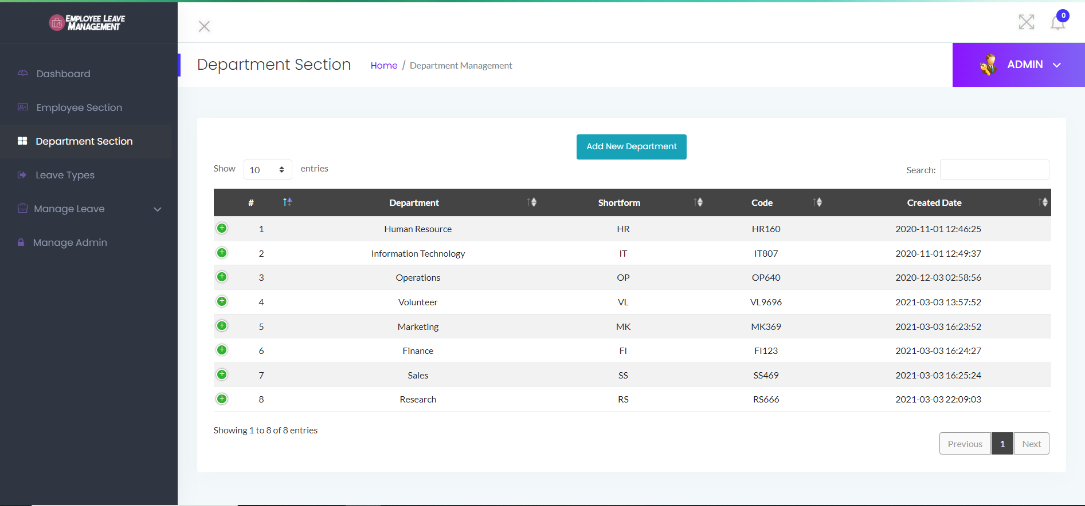

**Fig8: Department Section**

**Department Sections**

This section outlines the various departments within the organization along with their corresponding details.

| **#** | **Department** | **Shortform** | **Code** | **Created Date** |
| --- | --- | --- | --- | --- |
| 1 | Human Resource | HR | HR160 | 20240401 12:46:25 |
| 2 | Information Technology | IT | IT807 | 20240401 12:49:37 |
| 3 | Operations | OP | OP640 | 20240403 02:58:56 |
| 4 | Volunteer | VL | VL9696 | 20240403 13:57:52 |
| 5 | Marketing | MK | MK369 | 20240403 16:23:52 |
| 6 | Finance | FI | FI123 | 20240403 16:24:27 |
| 7 | Sales | SS | SS469 | 20240403 16:25:24 |
| 8 | Research | RS | RS666 | 20240403 22:09:03 |

This table provides an overview of the existing departments within the organization. Each department is identified by its name, short form, unique code, and the date it was created.

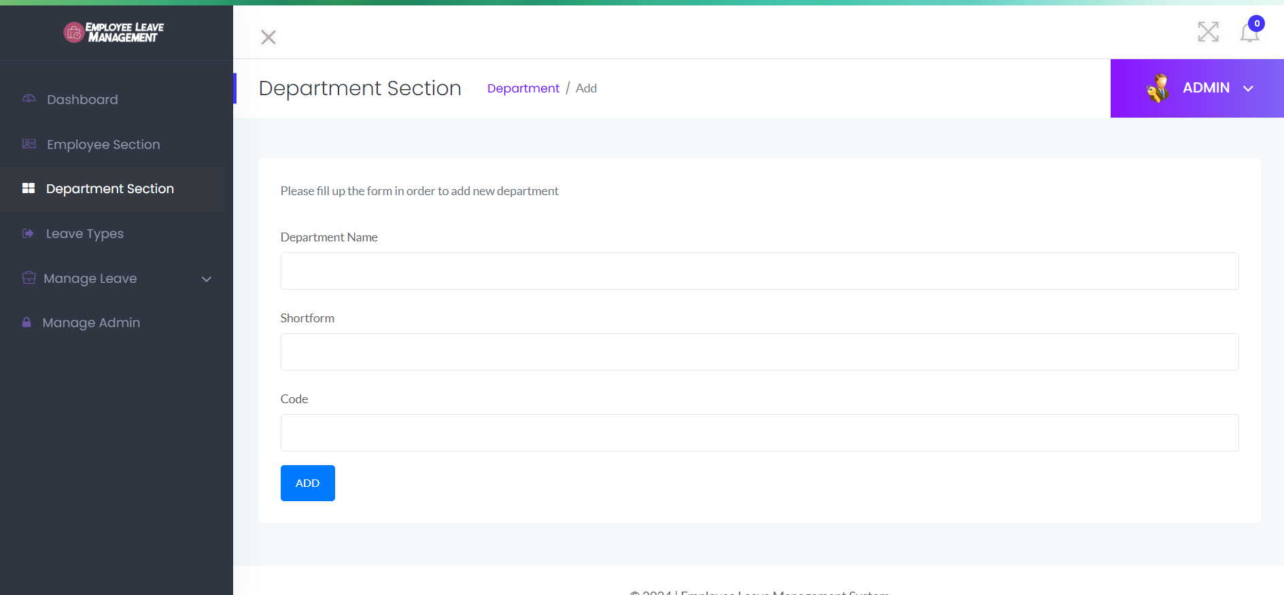

**Fig9: Add New Department**

**Add New Department**

The "Add New Department" section allows administrators to create and add new departments to the organization's structure. Below is the form to fill up for adding a new department.

**Department Name:** Enter the name of the new department.

**Shortform:** Provide a shortform or abbreviation for the department name.

**Code:** Enter a unique code or identifier for the department.

After completing the form, submit the details to add the new department to the organization's department list.

You can include this section in your project report to illustrate how administrators can add new departments to the organization. Adjust the content as needed to fit your project report's format and requirements. Let me know if you need further assistance!

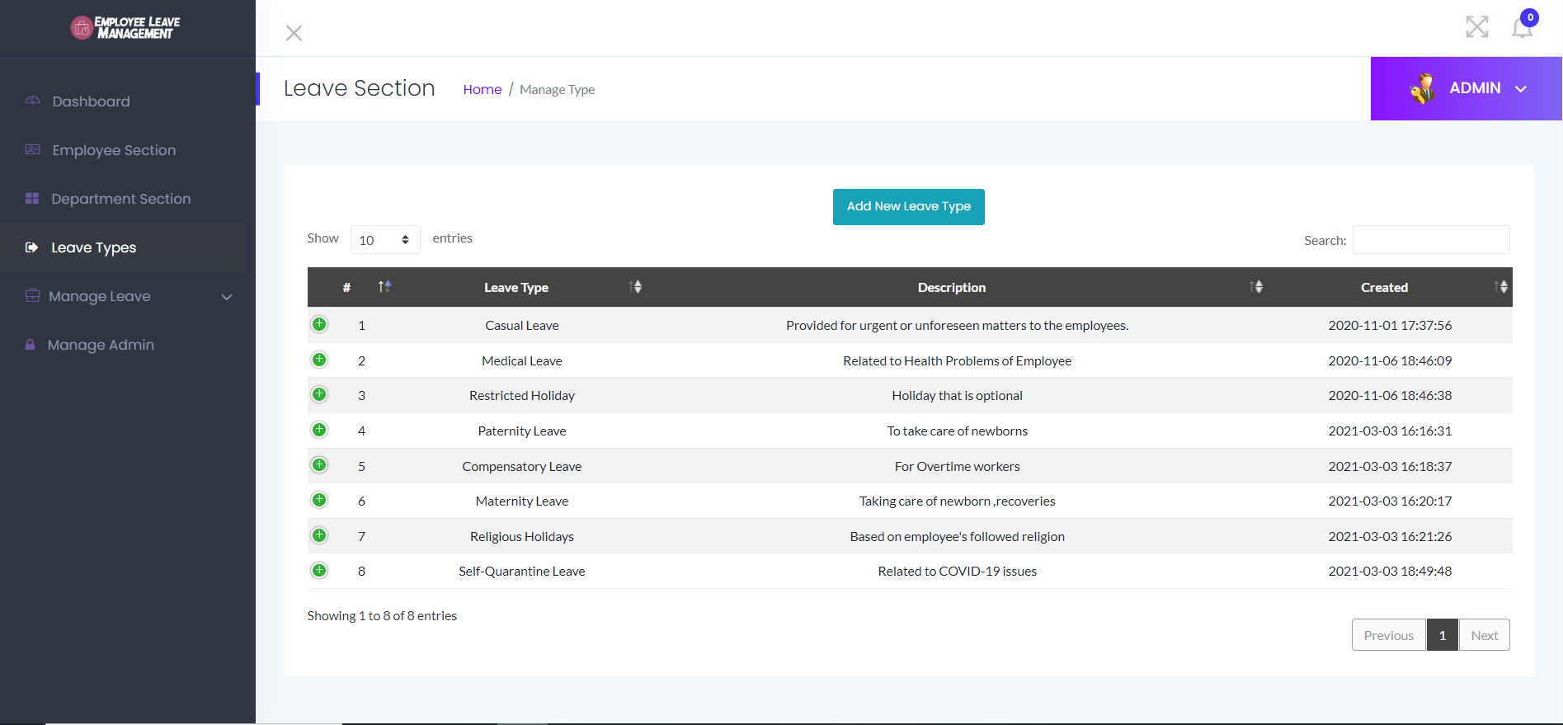

**Fig10: Leave Section**

**Leave Types Overview**

| **#** | **Leave Type** | **Description** | **Created Date** |
| --- | --- | --- | --- |
| 1 | Casual Leave | Provided for urgent or unforeseen matters to the employees. | 20240501 17:37:56 |
| 2 | Medical Leave | Related to Health Problems of Employee | 20240501 18:46:09 |
| 3 | Restricted Holiday | Holiday that is optional | 20240501 18:46:38 |
| 4 | Paternity Leave | To take care of newborns | 20240501 16:16:31 |
| 5 | Compensatory Leave | For Overtime workers | 20240501 16:18:37 |
| 6 | Maternity Leave | Taking care of newborn, recoveries | 20240501 16:20:17 |
| 7 | Religious Holidays | Based on employee's followed religion | 20240501 16:21:26 |
| 8 | SelfQuarantine Leave | Related to COVID19 issues | 20240501 18:49:48 |

This table provides an overview of the different types of leave offered to employees within the organization. Each leave type is accompanied by a description, detailing the circumstances under which it can be availed.

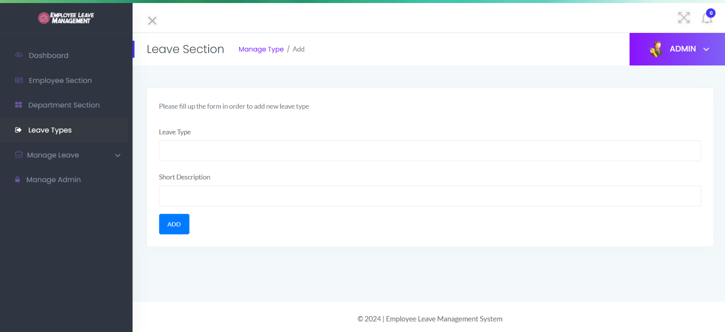

**Fig11: Add New Leave**

**Add New Leave Type**

The "Add New Leave Type" section allows administrators to introduce and define new types of leave within the organization's leave management system. Below is the form to fill up for adding a new leave type.

Please fill up the following form to add a new leave type:

**Leave Type:** Enter the name or title of the new leave type.

**Short Description:** Provide a brief description or summary of the new leave type.

After completing the form, submit the details to add the new leave type to the organization's leave management system.

**Manage Leave**

The "Manage Leave" section serves as a pivotal component of the organization's leave management system, empowering administrators to efficiently handle employee leave requests. This section provides a comprehensive interface for administrators to filter, review, and manage leave requests based on their status and maintain a detailed leave history for reference.

Within the "Manage Leave" section, administrators have access to four distinct filter options:

* **Pending:** This filter displays leave requests that are currently pending approval from the administrator. Pending leave requests represent employee requests awaiting review and decision.
* **Approved:** The "Approved" filter showcases leave requests that have been successfully approved by the administrator. Approved leave requests indicate authorization for employees to take time off as per their request.
* **Declined:** The "Declined" filter presents leave requests that have been declined or rejected by the administrator. Declined leave requests signify instances where the administrator has deemed the request unsuitable for approval.
* **Leave History:** The "Leave History" filter provides a comprehensive overview of all leave requests processed within the organization. This includes approved, declined, and pending leave requests, enabling administrators to track leave patterns and trends over time.

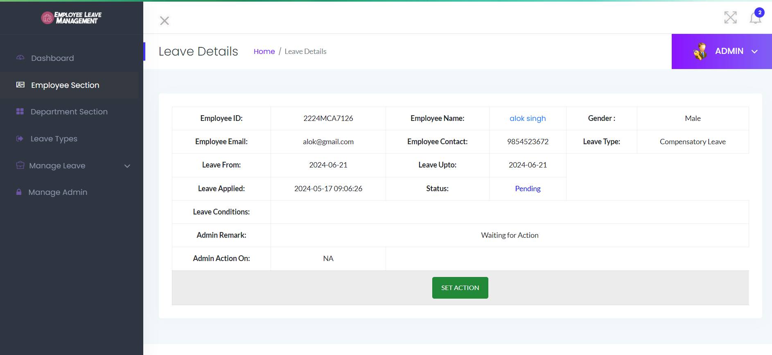

**Fig12: Pending Leave**

**Leave Details**

The "Leave Details" section provides comprehensive information about individual leave requests submitted by employees. This section allows administrators to review specific details of each leave request before taking any action, such as approval or declination.

**Below is an example of a detailed leave request:**

Employee Information:

Employee ID: 2224mca2117

Employee Name: Alok Singh

Gender: Male

Employee Email: alok@gmail.com

Employee Contact: 8149658795

Leave Request Details:

Leave Type: Medical Leave

Leave From: 20240628

Leave Upto: 20240627

Leave Applied On: 20240517 09:07:21

**Administrators can manage the leave request using the following functionalities:**

* **Action Button:** Each leave request in the "Pending" section has an action button. When clicked, it opens a detailed view of the leave request.
* **Review Leave Details:** Administrators review all the information provided in the detailed view.

**Dropdown Options:**

* Approved: Allows the administrator to approve the leave request.
* Decline: Allows the administrator to decline the leave request.
* **Description Field:** A text field where the administrator can enter remarks or reasons for their decision.
* **Apply Button:** After reviewing the details, selecting an option, and entering any remarks, the administrator clicks the "Apply" button to update the status of the leave request. The system records the admin's action and remarks.

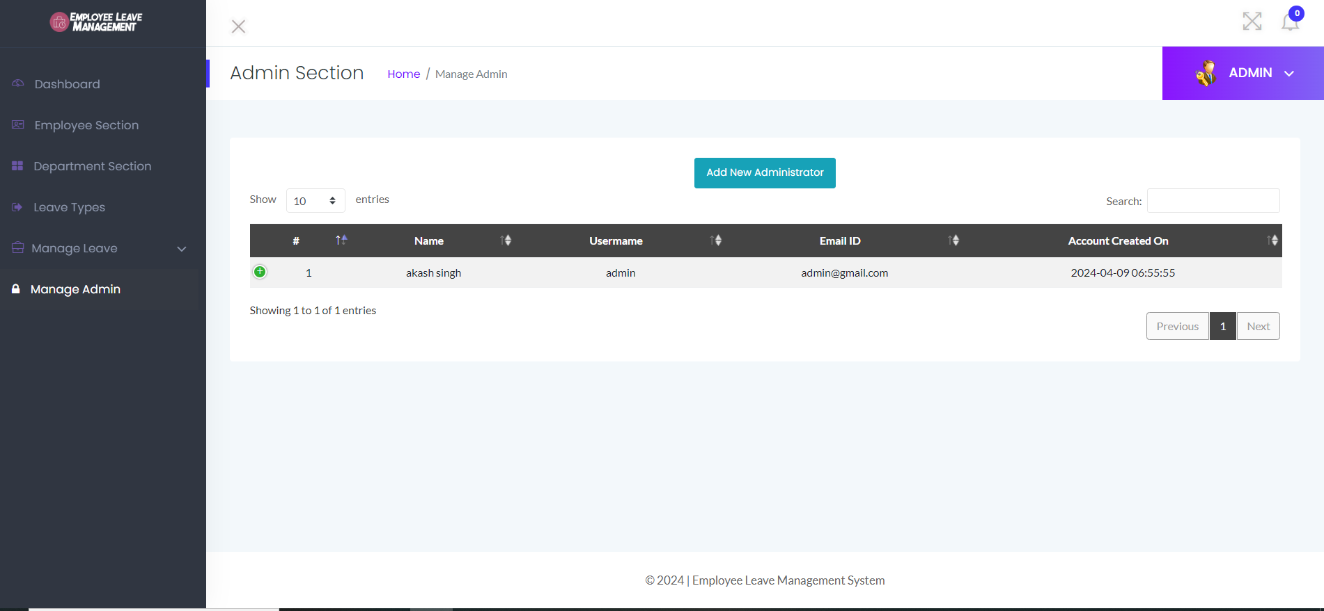

**Fig13: Manage Admin**

**Manage Admin**

The "Manage Admin" section is a critical component of the online leave management system, designed to facilitate the addition and removal of administrative users. This functionality ensures that the system's management can be tailored to the organization's changing needs and maintains the integrity and security of administrative operations.

**Adding a New Admin**

To add a new admin, the system provides a userfriendly form where existing administrators can input the necessary details of the new admin. This process involves the following steps:

**1. Navigate to Manage Admin:** The existing administrator accesses the "Manage Admin" section.

**2. Fill Out Admin Details Form:** A form is presented that requires the following information:

* Admin ID: Unique identifier for the new admin.
* First Name: First name of the new admin.
* Last Name: Last name of the new admin.
* Email: Official email address of the new admin.
* Department: Department to which the new admin belongs.
* Gender: Gender of the new admin (optional).
* D.O.B: Date of birth of the new admin.
* Contact Number: Phone number for contact purposes.
* Country: Country of residence.
* Address: Residential address.
* City: City of residence.
* Password: Set a secure password for the new admin's login.
* Confirmation Password: Confirm the password for accuracy.

**3. Submit Form:** The administrator completes the form and submits it. The system verifies the details and creates a new admin account.

**Deleting an Existing Admin**

To delete an existing admin, the system provides an intuitive interface where the current list of administrators is displayed. The process involves the following steps:

1. Navigate to Manage Admin: The existing administrator accesses the "Manage Admin" section.
2. View Admin List: A list of current administrators is displayed, showing their Admin IDs, names, and departments.
3. Select Admin to Delete: The administrator selects the admin to be removed from the system.
4. Confirm Deletion: The system prompts for confirmation to prevent accidental deletion. Upon confirmation, the selected admin's account is deleted from the system.

**Conclusion**

The "Manage Admin" section is essential for maintaining an uptodate and secure administrative structure within the online leave management system. By allowing the addition and removal of admins, the system adapts to organizational changes and ensures that only authorized personnel have administrative access. This functionality not only enhances security but also ensures that the management of leave processes remains efficient and responsive to the needs of the organization.

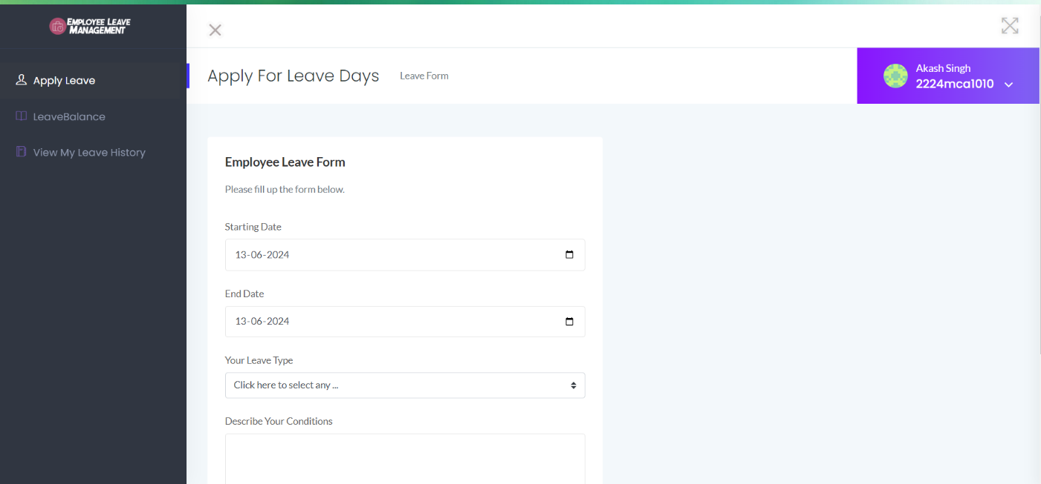

**Fig14: Apply for Leave**

**Employee Dashboard**

The "Employee Dashboard" serves as the central hub for employees within the online leave management system. It provides intuitive access to essential functionalities such as applying for leave, checking leave balances, and viewing leave history. The dashboard is designed to enhance user experience by offering a streamlined and user-friendly interface.

The Employee Dashboard includes three primary menu options:

1. Apply Leave

2. Leave Balance

3. View My Leave History

**Apply Leave**

**Functionality:**

The "Apply Leave" section allows employees to submit new leave requests. This functionality is designed to be straightforward and efficient, enabling employees to specify their leave details quickly.

**Workflow:**

1. Navigate to Apply Leave: The employee clicks on the "Apply Leave" menu option.
2. Fill Out Leave Form: The system presents a form where the employee enters:
3. Leave Type: Select from options like Casual Leave, Medical Leave, etc.
4. Leave From: Start date of the leave.
5. Leave Upto: End date of the leave.
6. Reason: Brief description of the reason for leave.
7. Submit Request: The employee submits the leave application. The system records the request and forwards it to the appropriate administrator for approval.

**Leave Balance**

**Functionality:**

The "Leave Balance" section provides employees with real-time information about their available leave balances. This transparency ensures employees can plan their leave effectively.

**Workflow:**

1. Navigate to Leave Balance: The employee clicks on the "Leave Balance" menu option.
2. View Balances: The system displays the current leave balances for various leave types (e.g., Casual Leave, Medical Leave, etc.). The information is updated in real-time and reflects any recent leave applications or approvals.

**View My Leave History**

**Functionality:**

The "View My Leave History" section allows employees to track their past leave requests and their statuses. This feature provides a comprehensive history of all leave transactions, enhancing transparency and recordkeeping.

**Workflow:**

1. Navigate to View My Leave History: The employee clicks on the "View My Leave History" menu option.

2. Review History: The system displays a detailed list of all past leave requests, including:

Leave Type: Type of leave taken.

Leave Dates: Start and end dates of the leave.

Status: Approval status (Approved, Declined, Pending).

Admin Remarks: Any comments or reasons provided by the administrator.

Application Date: Date when the leave was applied.

**Detailed Workflow Example**

**Apply Leave:**

1. Navigate to Dashboard: The employee logs into the system and accesses the Employee Dashboard.
2. Select Apply Leave: Clicks on the "Apply Leave" menu option.
3. Fill Out Form: Enters leave type, leave dates, and reason.
4. Submit Request: Clicks "Submit" to send the leave request for approval.

**Checking Leave Balance:**

1. Navigate to Dashboard: The employee logs into the system and accesses the Employee Dashboard.
2. Select Leave Balance: Clicks on the "Leave Balance" menu option.
3. View Balances: Reviews the displayed leave balances for various leave types.

**Viewing Leave History:**

1. **Navigate to Dashboard:** The employee logs into the system and accesses the Employee Dashboard.
2. **My Leave History:** Clicks on the "View My Leave History" menu option.
3. **Review History:** Examines the list of past leave requests, their statuses, and any admin remarks.

**Conclusion**

The Employee Dashboard is a crucial feature of the online leave management system, providing employees with easy access to key functionalities. By allowing employees to apply for leave, check their leave balances, and review their leave history, the dashboard enhances user experience and promotes efficient leave management within the organization. This integration ensures that the leave management process is transparent, user-friendly, and accessible to all employees.

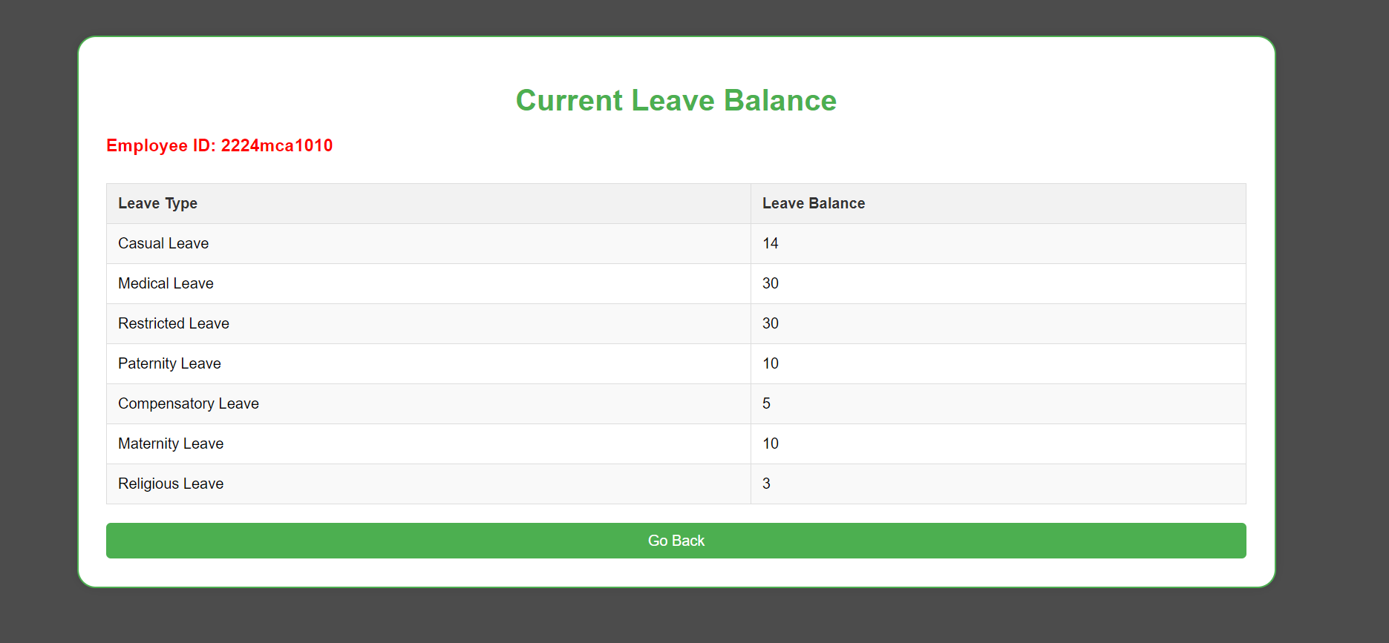

**Fig15: Current Leave Balance**

The "Current Leave Balance" section provides employees with a real-time summary of their available leave balances. This feature ensures that employees are well-in-formed about their remaining leave entitlements, allowing them to plan their leaves efficiently and avoid any discrepancies.

Below is an example of a leave balance summary for an employee with ID

**Leave Balance Details:**

| **Leave Type** | **Leave Balance** |
| --- | --- |
| Casual Leave | 14 |
| Medical Leave | 30 |
| Restricted Leave | 30 |
| Paternity Leave | 10 |
| Compensatory Leave | 5 |
| Maternity Leave | 10 |
| Religious Leave | 3 |

The online leave management system supports various types of leaves, catering to different needs and circumstances of employees. Each leave type serves a specific purpose and has its own set of rules and balances. Below is a detailed description of the leave types available in the system:

**Types of Leave**

* **Casual Leave:**

Casual Leave is essential for addressing unexpected personal matters. This type of leave offers flexibility and ensures that employees can attend to urgent personal affairs without affecting their professional commitments. It is usually granted on a short-term basis and requires minimal notice.

* **Medical Leave:**

Medical Leave is crucial for maintaining the health and wellbeing of employees. It covers a broad range of medical conditions and treatments, ensuring that employees can take the necessary time off to recover without the stress of work obligations. Documentation such as medical certificates might be required to avail of this leave.

* **Restricted Leave:**

Restricted Leave offers flexibility for employees to take time off on days that are not officially recognized as public holidays. This type of leave respects the diverse cultural and personal preferences of employees, allowing them to observe important dates that may not be universally acknowledged.

* **Paternity Leave:**

Paternity Leave supports male employees in their role as new fathers. It acknowledges the importance of the early bonding period with the newborn and helps in sharing the responsibilities of childcare with the partner. This leave can be taken around the time of the child's birth.

* **Compensatory Leave:**

Compensatory Leave rewards employees for their extra efforts and overtime work. It ensures that employees are fairly compensated for their additional contributions, helping to maintain a healthy work-life balance and prevent burnout.

* **Maternity Leave:**

Maternity Leave is a vital benefit for female employees, providing them with the necessary time off to give birth, recover, and care for their newborns. This leave is critical for the health of both the mother and the child and supports the employee during a significant life event.

* **Religious Leave:**

Religious Leave respects the diverse religious practices of employees. It allows them to observe and celebrate important religious events and rituals, promoting inclusivity and respect for different cultural and religious backgrounds within the workplace.

* **Self-Quarantine Leave:**

Self-Quarantine Leave is an essential provision in the context of the COVID19 pandemic. It ensures that employees who need to isolate due to exposure or infection can do so without worrying about work-related repercussions, thereby promoting a safer and healthier work environment.

**Conclusion**

Understanding the different types of leave available within the online leave management system is crucial for both employees and administrators. Each leave type is designed to address specific needs and circumstances, ensuring that employees can balance their professional and personal lives effectively. By providing a comprehensive leave policy, the organization promotes a supportive and flexible work environment.

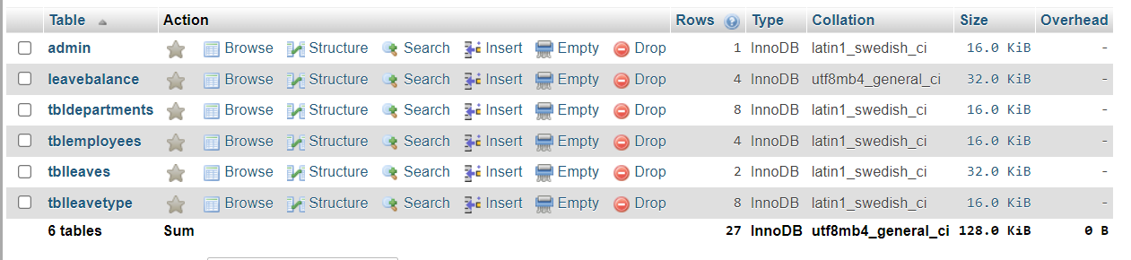**Fig16: Database Schema**

Database Schema

**1. Admin Table:**

Purpose: Stores information about the administrators who manage the leave system.

| **Field** | **Type** | **Description** |
| --- | --- | --- |
| Admin id | INT | Primary key, unique identifier for each admin. |
| First name | VARCHAR (50) | First name of the admin. |
| Last name | VARCHAR (50) | Last name of the admin. |
| email | VARCHAR (100) | Email address of the admin. |
| department | VARCHAR (50) | Department the admin belongs to. |
| gender | VARCHAR (10) | Gender of the admin. |
| Dob | DATE | Date of birth of the admin. |
| Contact number | VARCHAR (15) | Contact number of the admin. |
| country | VARCHAR (50) | Country of residence. |
| address | VARCHAR (255) | Residential address. |
| city | VARCHAR (50) | City of residence. |
| password | VARCHAR (255) | Hashed password for login. |

**2. Leave Balance Table:**

Purpose: Stores the leave balances for each employee.

| **Field** | **Type** | **Description** |
| --- | --- | --- |
| Employee id | VARCHAR (20) | Foreign key, references **employee** table. |
| Leave type id | INT | Foreign key, references **leave Type** table. |
| Leave balance | INT | Number of days remaining for the leave type. |

**3. Department Table:**

Purpose: Stores information about various departments within the organization.

| **Field** | **Type** | **Description** |
| --- | --- | --- |
| Department id | INT | Primary key, unique identifier for each department. |
| Department name | VARCHAR (100) | Name of the department. |
| Shortform | VARCHAR (10) | Shortform for the department name. |
| Code | VARCHAR (10) | Unique code for the department. |
| Created date | DATETIME | Timestamp when the department was created. |

**4. Employee Table:**

Purpose: Stores information about the employees in the organization.

| **Field** | **Type** | **Description** |
| --- | --- | --- |
| Employee id | VARCHAR (20) | Primary key, unique identifier for each employee. |
| First name | VARCHAR (50) | First name of the employee. |
| Last name | VARCHAR (50) | Last name of the employee. |
| email | VARCHAR (100) | Email address of the employee. |
| department | VARCHAR (50) | Department the employee belongs to. |
| gender | VARCHAR (10) | Gender of the employee. |
| Dob | DATE | Date of birth of the employee. |
| Contact number | VARCHAR (15) | Contact number of the employee. |
| Country | VARCHAR (50) | Country of residence. |
| Address | VARCHAR (255) | Residential address. |
| City | VARCHAR (50) | City of residence. |
| password | VARCHAR (255) | Hashed password for login. |
| Joined on | DATETIME | Timestamp when the employee joined. |
| status | VARCHAR (10) | Employment status (e.g., Active, Inactive). |

**5. Leaves Table:**

Purpose: Stores information about the leave applications submitted by employees.

| **Field** | **Type** | **Description** |
| --- | --- | --- |
| Leave type id | INT | Primary key, unique identifier for each leave type. |
| Leave type | VARCHAR (50) | Name of the leave type. |
| Short description | TEXT | Short description of the leave type. |
| Created date | DATETIME | Timestamp when the leave type was created. |

**6. Leave Type Table:**

Purpose: Stores information about the different types of leaves available.

| **id** | **Leave Type** | **Description** | **Creation Date** |
| --- | --- | --- | --- |
| 1 | Casual Leave | Provided for urgent or unforeseen matters to the employees. | 20240501 17:37:56 |
| 2 | Medical Leave | Related to Health Problems of Employee. | 20240501 18:46:09 |
| 3 | Restricted Holiday | Holiday that is optional. | 20240501 18:46:38 |
| 5 | Paternity Leave | To take care of newborns. | 20240501 16:16:31 |
| 7 | Compensatory Leave | For Overtime workers. | 20240501 16:18:37 |
| 8 | Maternity Leave | Taking care of newborn, recoveries. | 20240501 16:20:17 |
| 9 | Religious Holidays | Based on employee's followed religion. | 20240501 16:21:26 |
| 12 | Self-Quarantine Leave | Related to COVID19 issues. | 20240501 18:49:48 |

**Relationships**

* **Admin Table:** Holds admin details, and there is no direct relationship to other tables but is critical for management operations.
* **Leave Balance Table:** Links to `employee` and `leave Type` tables to track how many days of each leave type each employee has left.
* **Department Table:** Contains department details referenced in the `employee` and `admin` tables.
* **Employee Table:** Central to the schema, with references from `leave balance` and `leaves` tables, and links to the `department` table.
* **Leaves Table:** Central to tracking leave applications, with references to `employee` and `leave Type` tables.
* **Leave Type Table:** Defines types of leave, referenced by both the `leave balance` and `leaves` tables.

CHAPTER 14

CONCLUSION

The development of the online leave management system marks a significant stride towards modernizing traditional leave management processes. Through meticulous design and implementation, the system offers a seamless platform for employees and administrators to engage in efficient leave management interactions from the comfort of their workplaces or homes.

The system's robust features, including user authentication, leave application, approval mechanisms, and detailed leave tracking, ensure transparency and fairness throughout the leave management process. Moreover, its intuitive user interface enhances the user experience, making it accessible to a wide range of participants, from new hires to seasoned employees and administrators.

Looking ahead, continual refinement and adaptation will be essential to meet evolving user needs and technological advancements. Integrating machine learning algorithms for predictive leave analytics, enhancing mobile compatibility for on the-go leave management, and implementing blockchain technology for immutable leave records are just a few potential avenues for further enhancement.

Ultimately, the online leave management system represents not only a technological innovation but also a catalyst for transforming the way leave is managed, fostering efficiency, accessibility, and trust in the organizational environment. As it continues to evolve, it holds the promise of revolutionizing leave management practices and redefining the concept of workplace efficiency.

**BILIOGRAPHY**

**1.** GitHub. "GitHub Version Control and Collaboration Platform." https://github.com/.

1. W3Schools. "W3Schools Web Development Tutorials." https://www.w3schools.com/.

**3.** Wikipedia. "Wikipedia The Free Encyclopedia." https://www.wikipedia.org/.

**4.** Stack Overflow. "Stack Overflow Question and Answer Community for Programmers." https://stackoverflow.com/.