Assignment No | 4
Title
Objective | learning and understanding
Roll No | MCA2649

UseCase-1 :- To Impelimenting Static Array & Print
class ArrayUtilites
{
public static void main(String args[])
{
int array[] ={5,7,9,2,3};
for(int i=0;i<array.length;i++)
{
System.out.println(array[i]);
}
System.out.println("Welcome to Arrays Utilies");
}
}
OUTPUT:-
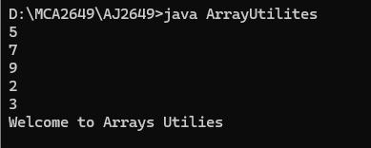

UseCase-2 :- To Take The User Input & Print
import java.util.*;
class ArrayUtilites
{
public static void main(String args[])
{
Scanner sc = new Scanner(System.in);
int array[] = new int[5];
System.out.println("Enter the array elements");
for(int i=0;i<array.length;i++)
{
array[i]=sc.nextInt();
}

//Print Array
for(int i=0;i<array.length;i++)
{
System.out.println("Array elements are :"+array[i]);
}
System.out.println("Welcome to Arrays Utilies");
}
}
OUTPUT:-
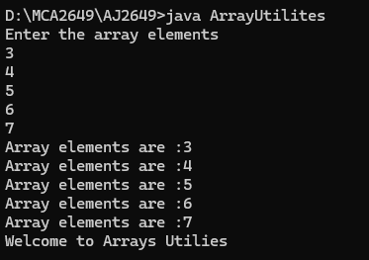

UseCase-3 :-Array With Parameters & Functions
import java.util.*;
class ArrayUtilites
{
void useInput(int[] rawarray)
{
Scanner sc = new Scanner(System.in);
System.out.println("Enter the array elements");
for(int i=0;i<rawarray.length;i++)
{
rawarray[i]=sc.nextInt();
}
}

void display(int[] rawarray)
{
for(int i=0;i<rawarray.length;i++)
{
System.out.println("Array elements are :"+rawarray[i]);
}
}
public static void main(String args[])
{
int rawArray[] = new int[5];
ArrayUtilites obj = new ArrayUtilites();
obj.useInput(rawArray);
obj.display(rawArray);

}
}
OUTPUT:-
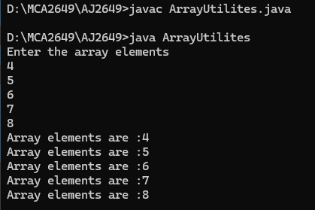

UseCase-4 :- Getter & Setter
import java.util.*;
class ArrayUtilites
{
Scanner sc = new Scanner(System.in);
int array[];
void setArray(int[] array)
{
this.array=array;
}

void useInput()
{
System.out.println("Enter the array elements");
for(int i=0;i<array.length;i++)
{
array[i]=sc.nextInt();
}
}

void display()
{
for(int i=0;i<array.length;i++)
{
System.out.println("Array elements are :"+array[i]);
}
}
public static void main(String args[])
{
int rawArray[] = new int[5];
ArrayUtilites obj = new ArrayUtilites();
obj.setArray(rawArray);
obj.useInput();
obj.display();

}
}
OUTPUT:-
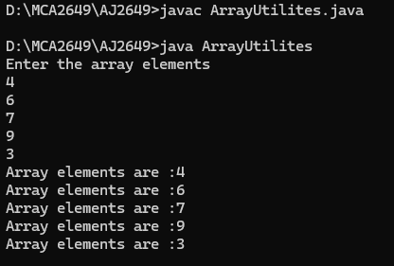

UseCase-5 :- Minimum Element in the array
import java.util.*;
class ArrayUtilites
{
Scanner sc = new Scanner(System.in);
int array[];
void setArray(int[] array)
{
this.array=array;
}

void useInput()
{
System.out.println("Enter the array elements");
for(int i=0;i<array.length;i++)
{
array[i]=sc.nextInt();
}
}

void display()
{
for(int i=0;i<array.length;i++)
{
System.out.println("Array elements are :"+array[i]);
}
}
int minimumValue()
{
int min = array[0];
for(int i=0;i<array.length;i++)
{
if(min>array[i]);
{
min = array[i];
}
return min;
}

public static void main(String args[])
{
int rawArray[] = new int[5];
ArrayUtilites obj = new ArrayUtilites();
obj.setArray(rawArray);
obj.useInput();
obj.display();
System.out.println("minimum array is :" + obj.minimumValue());

}
}

Output:-
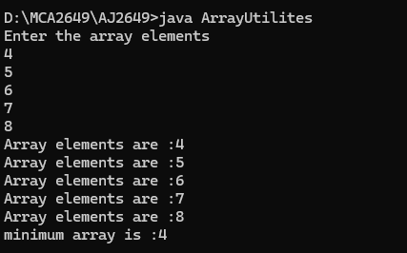

UseCase-6 :-Maximum Element in the array
import java.util.*;
class ArrayUtilites
{
Scanner sc = new Scanner(System.in);
int array[];
void setArray(int[] array)
{
this.array=array;
}

void useInput()
{
System.out.println("Enter the array elements");
for(int i=0;i<array.length;i++)
{
array[i]=sc.nextInt();
}
}

void display()
{
for(int i=0;i<array.length;i++)
{
System.out.println("Array elements are :"+array[i]);
}
}
int minimumValue()
{
int min = array[0];
for(int i=0;i<array.length;i++)
{
if(min>array[i])
{
min = array[i];
}
}
return min;
}

int maximumValue()
{
int max = array[0];
for(int i=0;i<array.length;i++)
{
if(max<array[i])
{
max = array[i];
}
}
return max;
}

public static void main(String args[])
{
int rawArray[] = new int[5];
ArrayUtilites obj = new ArrayUtilites();
obj.setArray(rawArray);
obj.useInput();
obj.display();
System.out.println("minimum array is :" + obj.minimumValue());
System.out.println("maxmum array is :" + obj.maximumValue());

}
}
OUTPUT:-
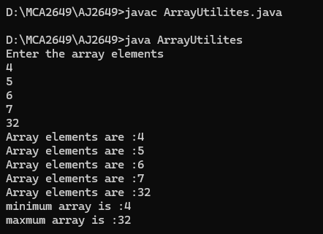

UseCase-1
OUTPUT:-

UseCase-1
OUTPUT:-

