Assignment No | 3
Title | Static & Non Static problems
Objective | - Employee Salary using Non Static Keyword  - Non Static program(Counter)  - Static Program(Counter)  - Student Program(Static)  - Employee Salary using Static keyword
Roll No | MCA2649

1) Employee Salary using Non Static Keyword
Source Code:-
Without Static
import java.util.*;
class Employee
{
//Instance Variable
String name;
int id;
float salary;
float income;

//Constructor
Employee(String name,int id,float salary)
{
this.name = name;
this.id = id;
this.salary = salary;
}

//Method 1 Logic
void calcSalary()
{
income = this.salary*12;
}

//Method 2 Print
public void print()
{
System.out.println("Ename :" + name);
System.out.println("id :" + id);
System.out.println("Salary :" + salary);
System.out.println("Annual Salary :" + income);
}
}
class EmployeeDemo
{
public static void main(String args[])
{
System.out.println("I am employee, calculate my annual salary");
Employee e1 = new Employee("Satish",101,50000);
Employee e2 = new Employee("Abhishek",102,40000);
e1.calcSalary();
e1.print();
e2.calcSalary();
e2.print();
}
}

Output:-

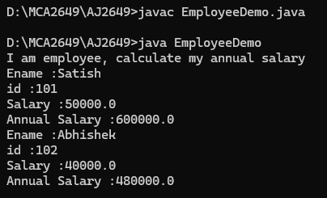

2)Non Static program(Counter)
Source Code:-

class Counter
{
// instance variable
int count=0;
Counter()
{
count++;
System.out.println(count);
}
public static void main(String args[])
{
System.out.println("Counter Task...");
Counter c1 = new Counter();
Counter c2 = new Counter();
Counter c3 = new Counter();
}
}

Output:-

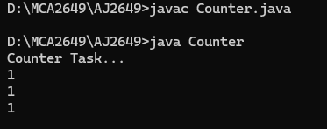

3) Static Program(Counter)
Source Code:-

class Counter
{
// instance variable
static int count=0;
Counter()
{
count++;
System.out.println(count);
}
public static void main(String args[])
{
System.out.println("Counter Task...");
Counter c1 = new Counter();
Counter c2 = new Counter();
Counter c3 = new Counter();
}
}
Output:-

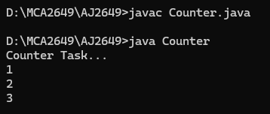

4) Student Program(Static)
Source Code:-

class Student
{
//Instance Variable
int rno;
String name;
static String college = "MET";

//Constructor
Student(int rno,String name)
{
this.rno = rno;
this.name = name;
}

//Method 1 Print
public void print()
{
System.out.println("rno :" + rno);
System.out.println("Sname :" + name);
System.out.println("College:" + college);
}
}
class StudentDemo
{
public static void main(String args[])
{
Student s1 = new Student(101,"Satish");
Student s2 = new Student(102,"Khushi");
s1.print();
s2.print();
Student.college = "Thakur";
s1.print();
s2.print();
}
}
Output:-

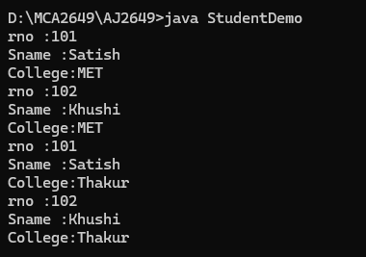

5) Employee Salary using Static keyword
Source Code:-

class Employee
{
// Instance variables
String name;
int id;
float salary;
float income;

static int nextId = 1;

// Constructor
Employee(String name, float salary)
{
this.name = name;
this.id = nextId++;
this.salary = salary;
}

// Calculate annual salary
void calcSalary()
{
income = salary * 12;
}

// Print employee details
public void print()
{
System.out.println("Ename : " + name);
System.out.println("id : " + id);
System.out.println("Salary : " + salary);
System.out.println("Annual Salary : " + income);
}
}

class EmployeeDemoo
{
public static void main(String args[])
{
System.out.println("I am employee, calculate my annual salary");

Employee e1 = new Employee("Satish", 50000);
Employee e2 = new Employee("Abhishek", 40000);

e1.calcSalary();
e1.print();

e2.calcSalary();
e2.print();
}
}

Output:-

