Assignment No | 1
Title | Learning and Understanding :- Factorial of a number & Hello World
Objective | 1A).Hello World program without creating an object  2A). Factorial program without creating an object  3B). Hello World program with creating an object  4B). Factorial program with creating an object
Roll No | MCA2649

Source Code:-

1A).Hello World program without creating an object
class Helloworld
{
public static void main(String []args)
{
String a = "Welcome";
String result = helloWorld(a);
System.out.println(result);
}
public static String helloWorld(String s)
{
return s;
}
}

Output:-
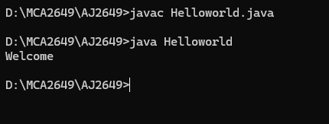

2A). Factorial program without creating an object

import java.util.*;
class FactorialApp
{
public static void main(String [] args)
{

//Scanner Class
Scanner sc = new Scanner(System.in);
System.out.println("Enter the number :");
int number = sc.nextInt();

//local variable
int fact = 1;

//logic
while(number>=1)
{
fact = fact*number;
number = number-1;
}

//print
System.out.println("Factorial Number :" + fact);
}
}

Output:-

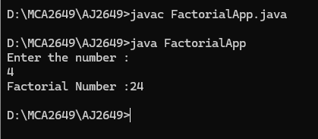

3B). Hello World program with creating an object

class HelloApp
{
public static void main(String args[])
{
HelloApp obj = new HelloApp();
obj.helloAppMethod();

}
public void helloAppMethod()
{
System.out.println("Hello World");
}
}

Output:-

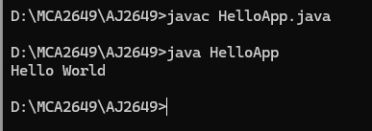

4B). Factorial program with creating an object

class FactorialImpl
{
//Instance Declaration
int number;
int fact = 1;

//Getter/Setter
public void set(int number)
{
this.number = number;
}
int get()
{
return number;
}
//factorial logic
int factorialMethod()
{
while(number>=1)
{
fact = fact*number;
number = number-1;
}
return fact;
}

//print
void print()
{
System.out.println("The Number :" + number);
}
}

class FactorialMain
{
public static void main(String args[])
{
FactorialImpl obj = new FactorialImpl();
obj.set(5);
obj.get();
obj.print();

int res = obj.factorialMethod();
System.out.println("Factorial of Number :" + res);
}
}

Output:-
