Assignment No | 1
Title | Partitioning
Objective | Range , List And Hash
Roll No | MCA2649

1.Range

Source Code:-
CREATE TABLE sales_range
(salesman_id NUMBER(5),
salesman_name VARCHAR2(30),
sales_amount NUMBER(10),
sales_date DATE)
PARTITION BY RANGE(sales_date)
(
PARTITION sales_jan2026 VALUES LESS
THAN(TO_DATE('01/02/2026','DD/MM/YYYY')),
PARTITION sales_feb2026 VALUES LESS
THAN(TO_DATE('01/03/2026','DD/MM/YYYY')),
PARTITION sales_march2026 VALUES LESS
THAN(TO_DATE('01/04/2026','DD/MM/YYYY')),
PARTITION sales_april2026 VALUES LESS
THAN(TO_DATE('01/05/2026','DD/MM/YYYY'))
);

Output:-
Selecting the data from the Range partition

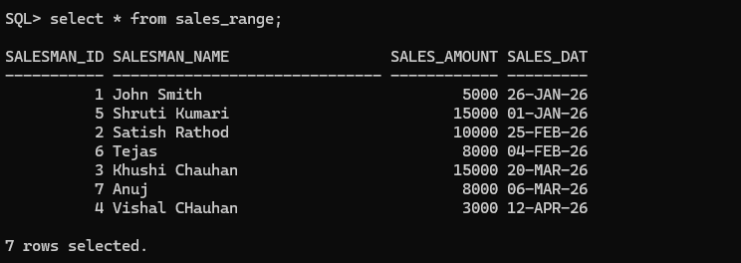

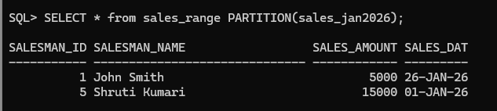

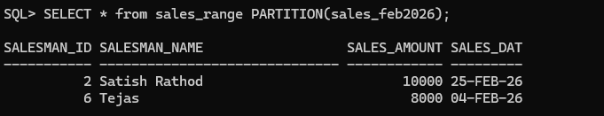

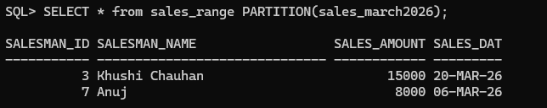
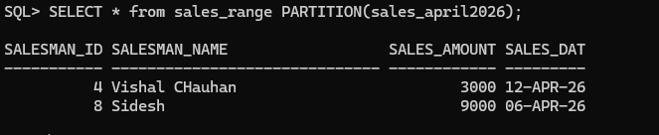

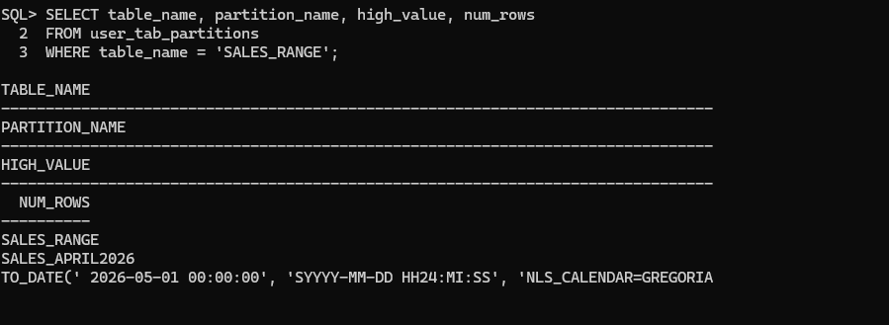

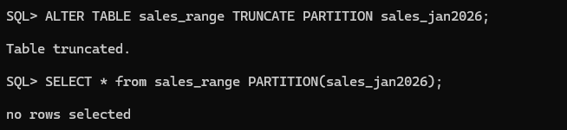

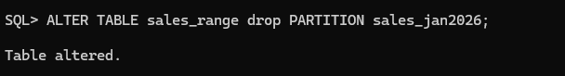

2.List
Source Code:-
CREATE TABLE Student (
student_id NUMBER(5),
student_name VARCHAR2(20),
student_dob DATE)
PARTITION BY LIST (student_name) (
PARTITION stu_divA VALUES ('a','b','c','d','e','f','g','h','i','j','k'),
PARTITION stu_divB VALUES ('n','o','p','q','r','s','t','u','v','w','x','y','z'));

Output:-

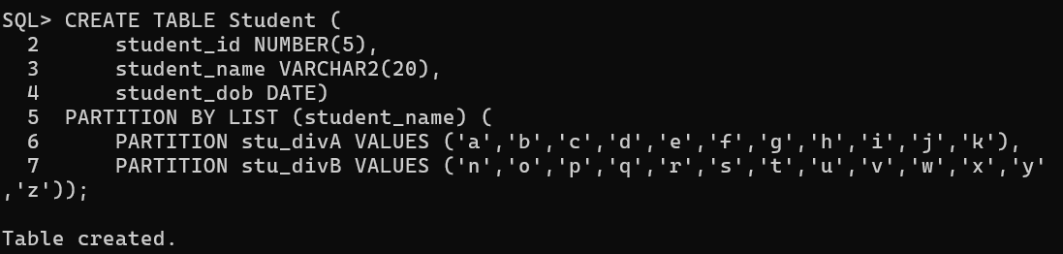

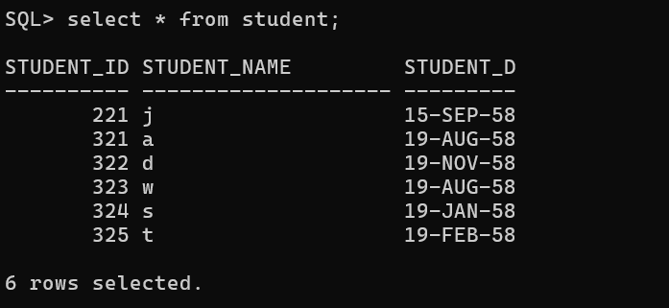
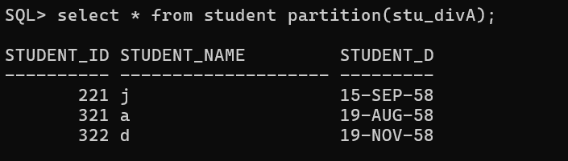

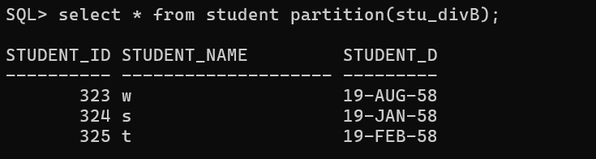

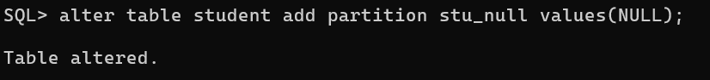

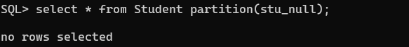
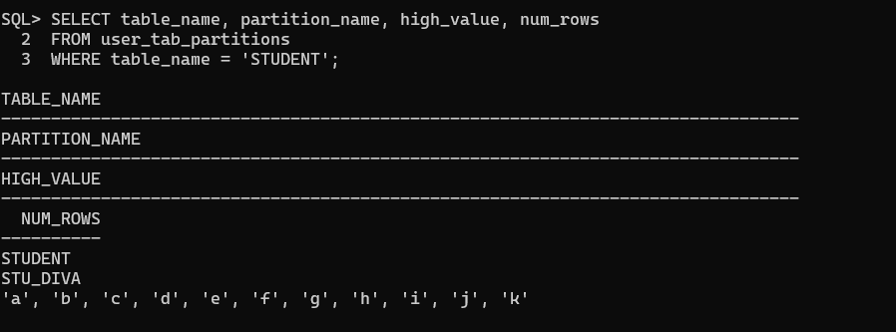

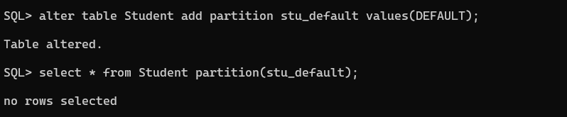

3.Hash
Source Code:-
Create table sales
2 (
3 dept_no NUMBER,
4 part_no VARCHAR2(20),
5 country VARCHAR(20),
6 date1 DATE,
7 amount NUMBER
8 )
9 PARTITION BY HASH(part_no)
10 (
11 PARTITION p1,
12 PARTITION p2,
13 PARTITION p3
14 );

Output:-

