Assignment No | 6
Title | Event Handling
Objective | A. Events associated with Functions to sort an array and search for particular element using parameters  B Events to display Customer Information using parameter  C Events to calculate salary using arrow functions
Roll No | MCA2649

Source Code A:
var e=require('events');
var evmt = new e.EventEmitter();

var st = ['a','v','e','d'];

evmt.on('sortarray',() =>
{
console.log(st);
st.sort();
console.log(st);
});

evmt.on('searcharray',(ch) =>
{
var flag = false;

for(var i=0; i<st.length; i++)
{
if(st[i] == ch)
{
flag = true;
break;
}
}

if(flag)
console.log(`${ch} is found`);
else
console.log(`${ch} is not found`);
});

evmt.emit('sortarray');
evmt.emit('searcharray','w');

Output:
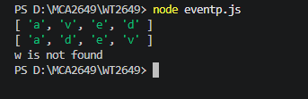

Source Code B:
var e = require('events');
var event = new e.EventEmitter();

var customerinfo = (custid, custname, mobileno, product, amt) => {
console.log(`Customer Id : ${custid}`);
console.log(`Customer Name : ${custname}`);
console.log(`Mobile No : ${mobileno}`);
console.log(`Product : ${product}`);
console.log(`Amount paid : ${amt}`);
}

event.on('customer Details', customerinfo);
event.emit('customer Details', 1, 'Amit', 99911222, 'Washing Machine', 55000);

Output:
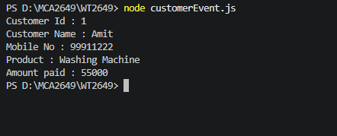

Source Code C:-
var e = require('events');
var event = new e.EventEmitter();

var calculatesalary = (basic) => {
var da = basic * 0.8;
var hra = basic * 0.5;
var ptax = 300;
var it = basic * 0.35;
var pf = basic * 0.12;

var gross = basic + hra + da + ptax + it + pf;
var deductions = ptax + it + pf;
var salary = gross - deductions;

console.log(`Basic Salary : ${basic}`);
console.log(`House Rent Allowance : ${hra}`);
console.log(`Dearness Allowance : ${da}`);
console.log(`Gross Salary : ${gross}`);
console.log(`Professional Tax : ${ptax}`);
console.log(`Income Tax : ${it}`);
console.log(`Provident Fund : ${pf}`);
console.log(`Net Salary : ${salary}`);
};

event.on('salaryprint', calculatesalary);
event.emit('salaryprint', 50000);

Output:
