Assignment No | 7
Title | JSP Scripting Elements
Objective | 1)Current Data & Time  2)Greeting Based On Hour  3) Multiplication Table the value is input from user
Roll No | MCA2649

1)Current Data & Time
Source Code:-
<html>
<body>
Current Data & Time
<%= new java.util.Date() %>
</body>
</html>

Output:-
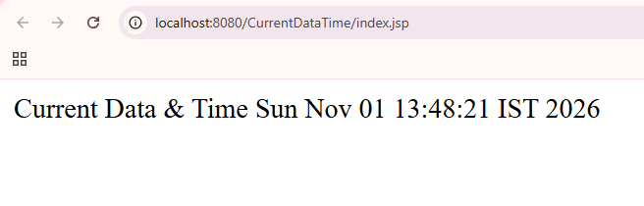

2)Greeting Based On Hour
Source Code:-

<%!
int hour;
%>

<HTML>
<BODY>
<%
//get current hour
hour = java.time.LocalTime.now().getHour();
if(hour <12)
{
out.println("Good Morning!!");
}
else if(hour >= 12 && hour < 16)
{
out.println("Good Afernoon!!");
}
else
{
out.println("Good Evening!!");
}

%>
</BODY>
</HTML>

Output:-

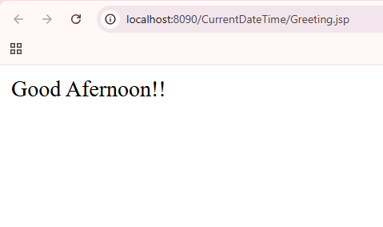

3) Multiplication Table the value is input from user
Source Code:-
i)index.html
<!DOCTYPE html>
<html>
<head>
<meta charset="ISO-8859-1">
<title>Insert title here</title>
</head>
<body>
<form action="MultTable.jsp" method="GET">
Enter a number: <input type="text" name="num">
<br>
<input type="submit" name="sub" value="Submit">
</form>
</body>
</html>
Output:-
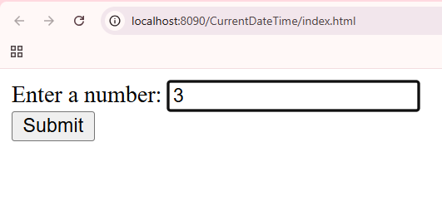

ii)MuilTable.jsp
<HTML>
<BODY>
<%! int num; %>
<%
//fetch the value of num from index.html
num=Integer.parseInt(request.getParameter("num"));
out.println("Multiplication Table of:" + num +"<BR>");
for(int i=1;i<=10;i++)
{
out.println(num+"*"+i+"="+(num*i)+"<BR>");
}
%>
</BODY>
</HTML>
Output:-


