
Neural and Evolutionary Computation

Miguel Ángel Cabanillas Silva
Activity 1: Prediction with Supervised Learning
Models
Master’s degree in computer security engineering and Artificial Intelligence
Table of Contents
Task 1: Feature Extraction with SIFT 3
Code: 3
Results: 4
Figure 1: Keypoint Identification 4
Task 2: Local Feature Matching with SIFT 5
Code: 5
Results: 7
Figure 2: Local Feature Matching Keypoints 7
Task 3: Local Binary Pattern Feature Extraction 8
Code: 8
Task 4: Image Alignment Using Feature Matching 10
Code: 10
Results: 11
Figure 3: Image Alignment Transformation 11
Task 5: Texture Classification Using LBP Features 12
Code: 12
Results: 14
Figure 4: Confusion Matrix 14
Figure 5: Prediction Examples 15

Code Repository
The GitHub repository where the different parts of the activity are located is as follows: Github Repository

Part 1: Selecting and analysing the dataset

Dataset
The dataset used for the task is the Ames Housing dataset for house price prediction problems, which meets the requirements of the activity.

The dataset can be consulted at the following link: Ames Dataset

Pre-processing techniques
- Treatment of missing values
  - Numeric variables: missing values are replaced with the median of each column.
  - Categorical variables: missing values are replaced with the category ‘Missing’.

- Treatment of outliers: the interquartile range is applied to all columns, calculating the upper and lower limits and replacing values that are not within that range with the upper or lower limit, depending on which one is exceeded

- Coding of categorical variables: categorical variables are transformed using the One Hot Encoding technique, converting all variables to numerical values

- Data elimination: columns such as PID, which represent identifiers for each row and do not contribute to the data analysis, are eliminated. The variable to be predicted is also eliminated.

The normalisation and transformation of the data can be seen in the commit log that was made at the beginning of this first part, but as the project has evolved, it has been decided to move this step to part 2, where normalisation, feature scaling, log transformations, etc. are carried out.

Part 3: Obtaining and comparing predictions using the three models (BP, BP-F,

MLR-F)
The following dataset was used for this task, and an auxiliary script was created to convert all images to greyscale: Image Dataset

Results:
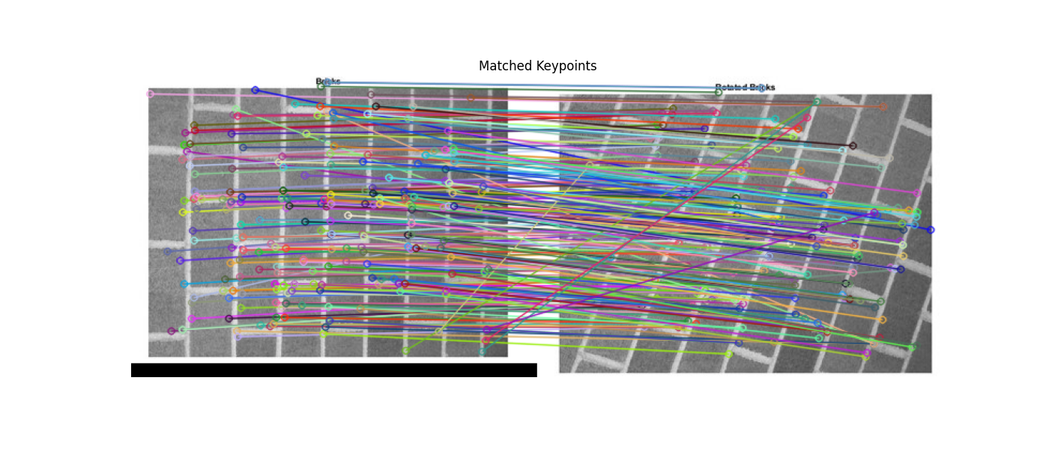

Figure 2: Local Feature Matching Keypoints

Task 3: Local Binary Pattern Feature Extraction
The following dataset was used for this task, and an auxiliary script was created to convert all images to greyscale: Image Dataset

Code:
import cv2
import numpy as np
import os
import pandas as pd
from skimage.feature import local_binary_pattern

LBP_POINTS = 8
LBP_RADIUS = 1
LBP_METHOD = 'uniform'

def compute_lbp_histogram(image):
lbp = local_binary_pattern(image, LBP_POINTS, LBP_RADIUS, method=LBP_METHOD)
hist_size = int(lbp.max() + 1)
hist, _ = np.histogram(lbp.ravel(), bins=hist_size, range=(0, hist_size))
hist = hist.astype("float")
hist /= (hist.sum() + 1e-7)
return hist

input_root = "data"
data_rows = []

for subdir, dirs, files in os.walk(input_root):
label = os.path.basename(subdir)
if label == os.path.basename(input_root):
continue

for filename in files:
if filename.lower().endswith((".png", ".jpg", ".jpeg", ".bmp")):
img_path = os.path.join(subdir, filename)
img = cv2.imread(img_path, cv2.IMREAD_GRAYSCALE)
if img is None:
print(f"Warning: Could not load {img_path}")
continue

lbp_hist = compute_lbp_histogram(img)
row = list(lbp_hist) + [label, filename]
data_rows.append(row)

if data_rows:
num_bins = len(data_rows[0]) - 2
columns = [f"f{i}" for i in range(num_bins)] + ["label", "filename"]
df = pd.DataFrame(data_rows, columns=columns)
df.to_csv("LBP_dataset.csv", index=False)
np.save("LBP_dataset.npy", np.array(data_rows, dtype=object))
print("\nDataset saved as LBP_dataset.csv and LBP_dataset.npy")
else:
print("No images found.")

Task 4: Image Alignment Using Feature Matching

Code:
import cv2
import numpy as np
import matplotlib.pyplot as plt

img1 = cv2.imread("images/Picture1.jpg", cv2.IMREAD_GRAYSCALE)
img2 = cv2.imread("images/Picture2.jpg", cv2.IMREAD_GRAYSCALE)

sift = cv2.SIFT_create()

kp1, des1 = sift.detectAndCompute(img1, None)
kp2, des2 = sift.detectAndCompute(img2, None)

bf = cv2.BFMatcher()
matches = bf.knnMatch(des1, des2, k=2)

good_matches = []
for m, n in matches:
if m.distance < 0.75 * n.distance:
good_matches.append(m)

pts1 = np.float32([kp1[m.queryIdx].pt for m in good_matches])
pts2 = np.float32([kp2[m.trainIdx].pt for m in good_matches])

M, mask = cv2.findHomography(pts2, pts1, cv2.RANSAC, 5.0)

height, width = img1.shape
aligned_img2 = cv2.warpPerspective(img2, M, (width, height))

plt.figure(figsize=(15,7))

plt.subplot(1,3,1)
plt.title("Original Image 1")
plt.imshow(img1, cmap='gray')
plt.axis('off')

plt.subplot(1,3,2)
plt.title("Original Image 2")
plt.imshow(img2, cmap='gray')
plt.axis('off')

plt.subplot(1,3,3)
plt.title("Aligned Image 2")
plt.imshow(aligned_img2, cmap='gray')
plt.axis('off')

plt.show()

Results:
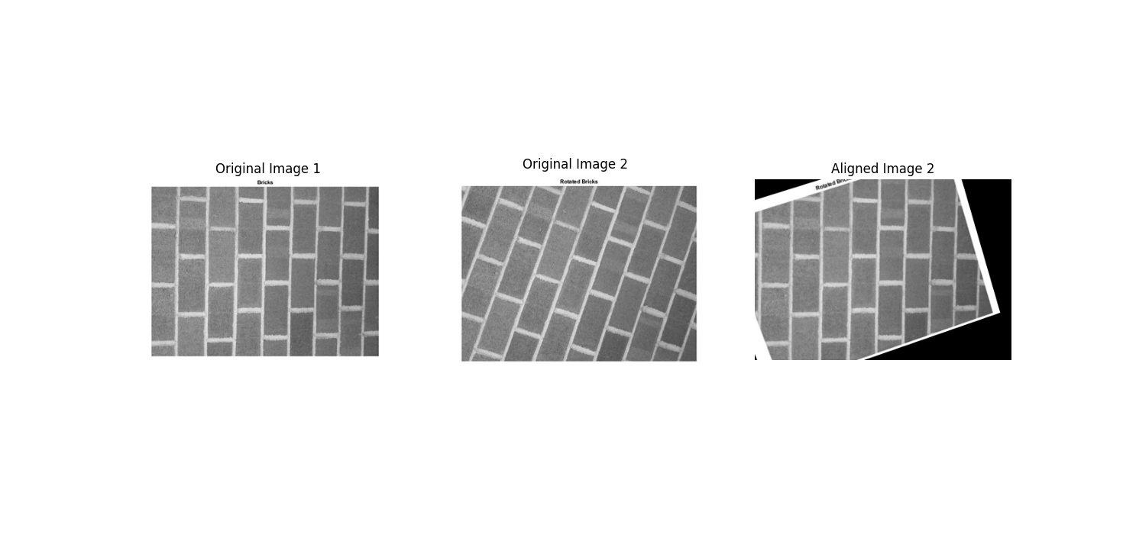

Figure 3: Image Alignment Transformation

Task 5: Texture Classification Using LBP Features

Code:
import numpy as np
import pandas as pd
from sklearn.model_selection import train_test_split, cross_val_score
from sklearn.preprocessing import StandardScaler
from sklearn.neighbors import KNeighborsClassifier
from sklearn.metrics import accuracy_score, confusion_matrix, ConfusionMatrixDisplay, classification_report
import matplotlib.pyplot as plt
import cv2
import os

df = pd.read_csv("LBP_dataset.csv")
X = df.drop(["label", "filename"], axis=1).values
y = df["label"].values
filenames = df["filename"].values

scaler = StandardScaler()
X_scaled = scaler.fit_transform(X)

clf = KNeighborsClassifier(n_neighbors=3)

cv_scores = cross_val_score(clf, X_scaled, y, cv=5)
print(f"Cross-Validation Accuracy: {cv_scores.mean()*100:.2f}% ± {cv_scores.std()*100:.2f}%\n")

X_train, X_test, y_train, y_test, filenames_train, filenames_test = train_test_split(
X_scaled, y, filenames, test_size=0.2, random_state=42
)

clf.fit(X_train, y_train)
y_pred = clf.predict(X_test)

accuracy = accuracy_score(y_test, y_pred)
print(f"Test Set Accuracy: {accuracy*100:.2f}%\n")
print("Classification Report:\n")
print(classification_report(y_test, y_pred))

cm = confusion_matrix(y_test, y_pred, labels=np.unique(y))
disp = ConfusionMatrixDisplay(confusion_matrix=cm, display_labels=np.unique(y))
disp.plot(cmap=plt.cm.Blues)
plt.title("Confusion Matrix")
plt.show()

images_folder = "data"
correct_idx = np.where(y_test == y_pred)[0]
incorrect_idx = np.where(y_test != y_pred)[0]

plt.figure(figsize=(12,6))
for i, idx in enumerate(correct_idx[:3]):
img_path = os.path.join(images_folder, y_test[idx], filenames_test[idx])
img = cv2.imread(img_path, cv2.IMREAD_GRAYSCALE)
if img is not None:
plt.subplot(2,3,i+1)
plt.imshow(img, cmap="gray")
plt.title(f"Correct: {y_pred[idx]}")
plt.axis("off")

for i, idx in enumerate(incorrect_idx[:3]):
img_path = os.path.join(images_folder, y_test[idx], filenames_test[idx])
img = cv2.imread(img_path, cv2.IMREAD_GRAYSCALE)
if img is not None:
plt.subplot(2,3,i+4)
plt.imshow(img, cmap="gray")
plt.title(f"Pred: {y_pred[idx]} / True: {y_test[idx]}")
plt.axis("off")

plt.tight_layout()
plt.show()

Results:
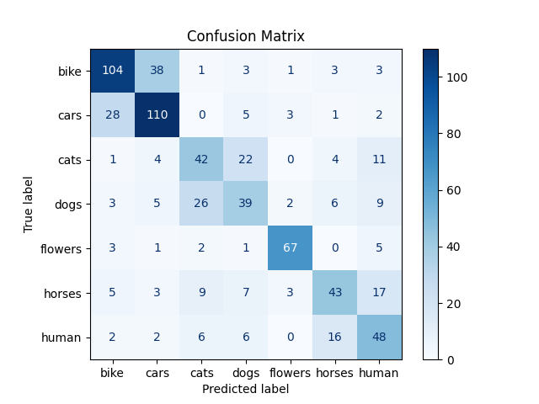

Figure 4: Confusion Matrix

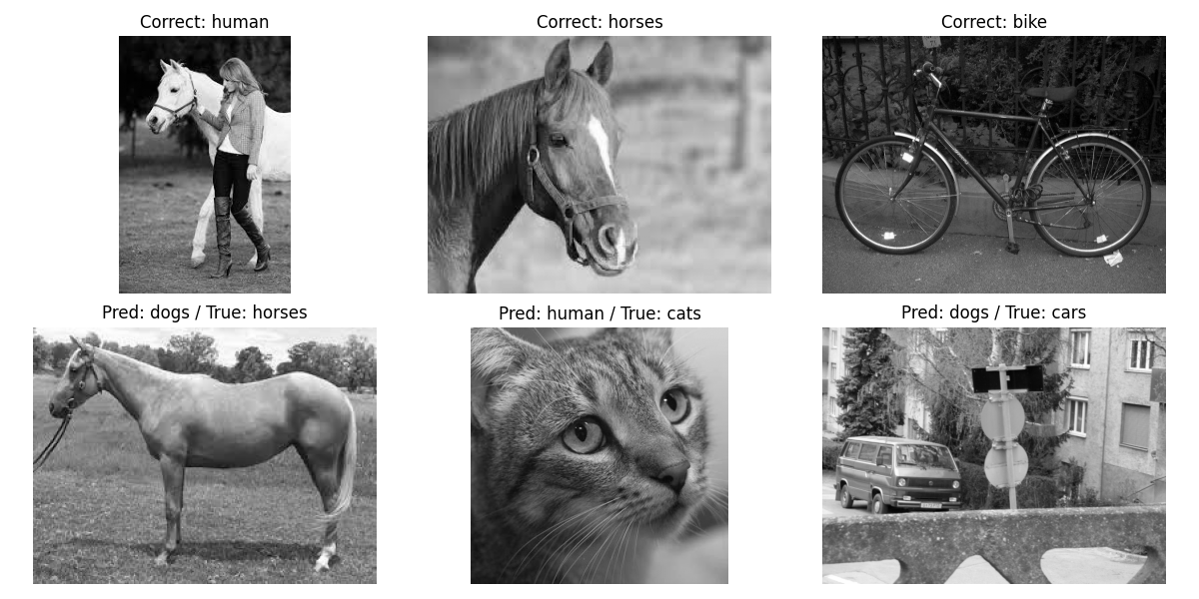

Figure 5: Prediction Examples

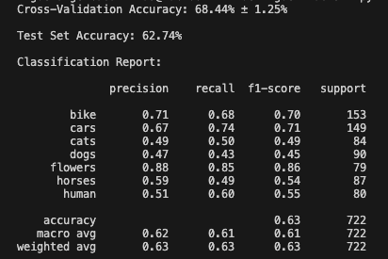

Figure 6: Performance Metrics of Classification

