
COMP132: Advanced Programming
Programming Project Report
Kulatro Game
Muhammed Cagan Goktas, 90082
Spring 2026

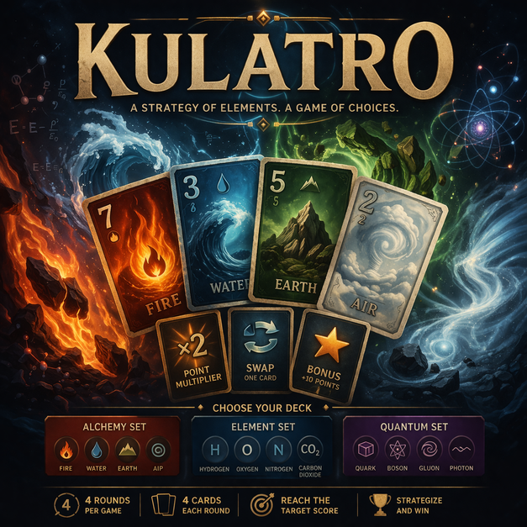

Part 1
1. Game Initialization from GUI
When the game is launched, the user is presented with a login/registration screen. If an account already exists with the entered username and password, the user can log in successfully. Otherwise, an error message is displayed indicating that the account does not exist (Figure 1.1); however, the player can easily create a new account using the "Register" button (Figure 1.2). Once registered, the player can log in by re-entering their credentials, which then directs them to the leaderboard screen showing the latest games of all registered users (Figure 1.3). Clicking the "Back to Menu" button takes the user to the main menu panel (Figure 1.4).
In the main menu, the player is greeted with a panel containing buttons to start a new game, view the leaderboard, adjust settings, or exit the application. Clicking "Leaderboard" redirects the user to the leaderboard panel once again. Clicking "Settings" opens the settings panel, where the user can enable or disable the background music (which plays continuously throughout the application) and button-click sound effects which are disabled by default (Figure 1.5). When the "Exit" button is clicked, the application triggers System.exit(0) and closes.
If the user clicks "Start Game", they are given the choice between "New Game" and "Load Game" (Figure 1.6). Selecting "Load Game" allows them to resume a previously saved session (Figure 1.7). On the other hand, selecting "New Game" opens a setup panel where the player can enter an in-game username (which can either match or differ from their profile name), select a deck type (Alchemy, Element, or Quantum), choose one of the four special cards corresponding to that specific deck, and select a difficulty level (Easy, Medium, or Hard) (Figure 1.8). Choosing a different difficulty level dynamically updates the target scores. Additionally, every panel features a "Back" button, allowing the user to safely return to the previous screen.
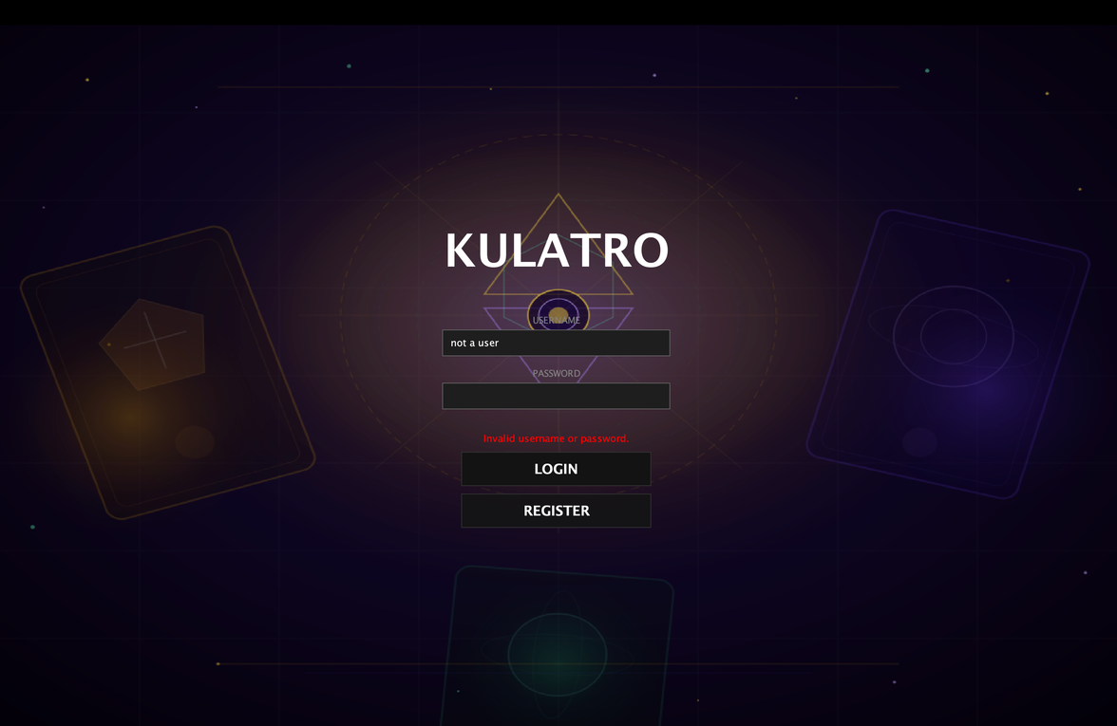  Figure 1.1. Error message displayed during a login attempt with an unregistered account. | 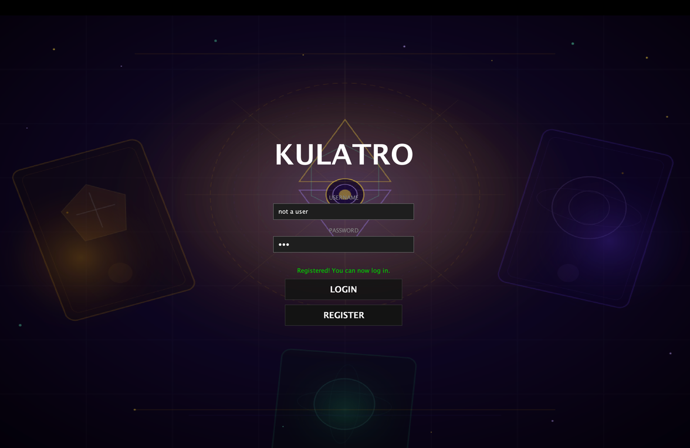  Figure 1.2. New account registration and confirmation message.
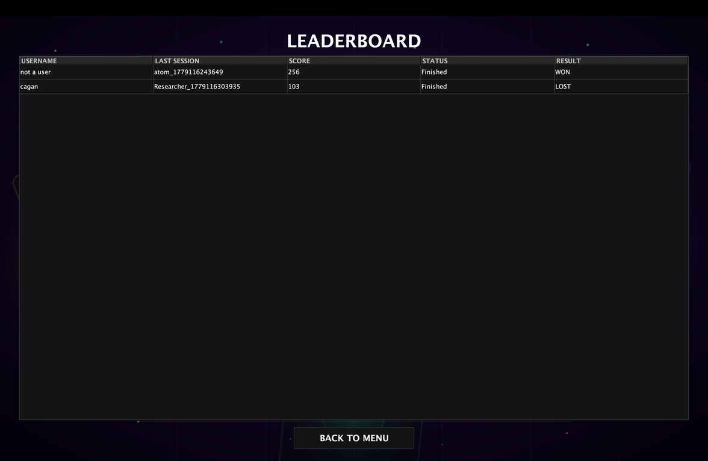  Figure 1.3. Leaderboard screen displaying all registered users and their latest game sessions. | 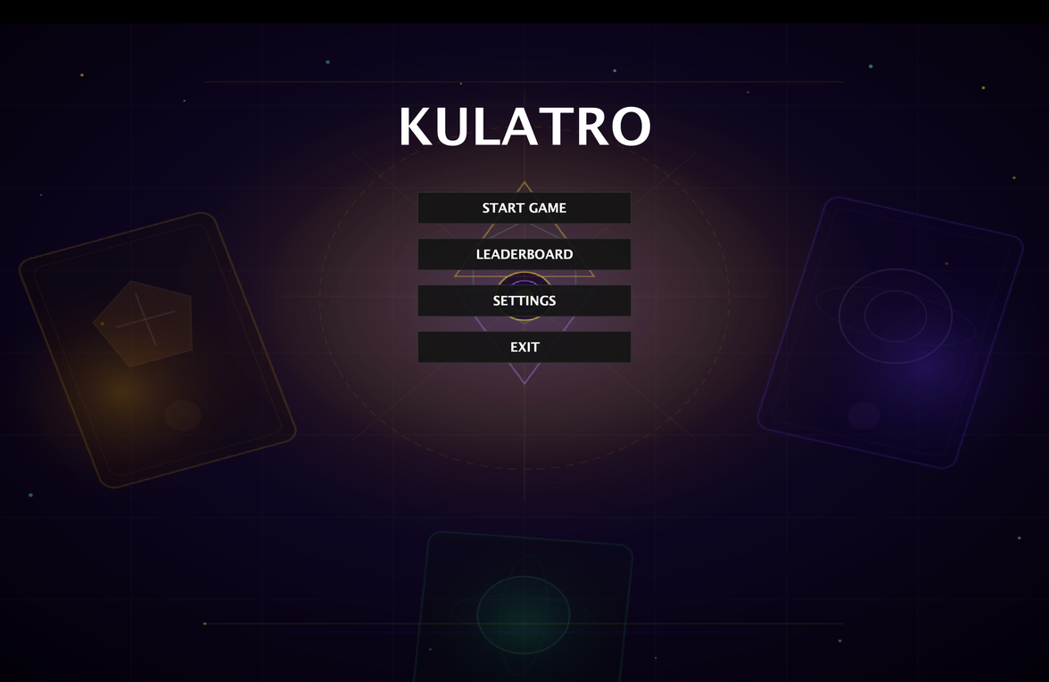  Figure 1.4. The Main Menu panel with navigation buttons.
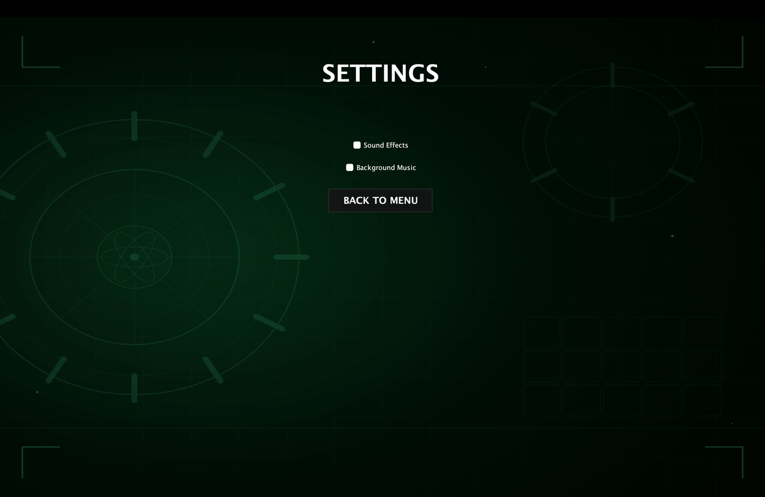  Figure 1.5. Settings panel with audio configuration options for background music and sound effects. | 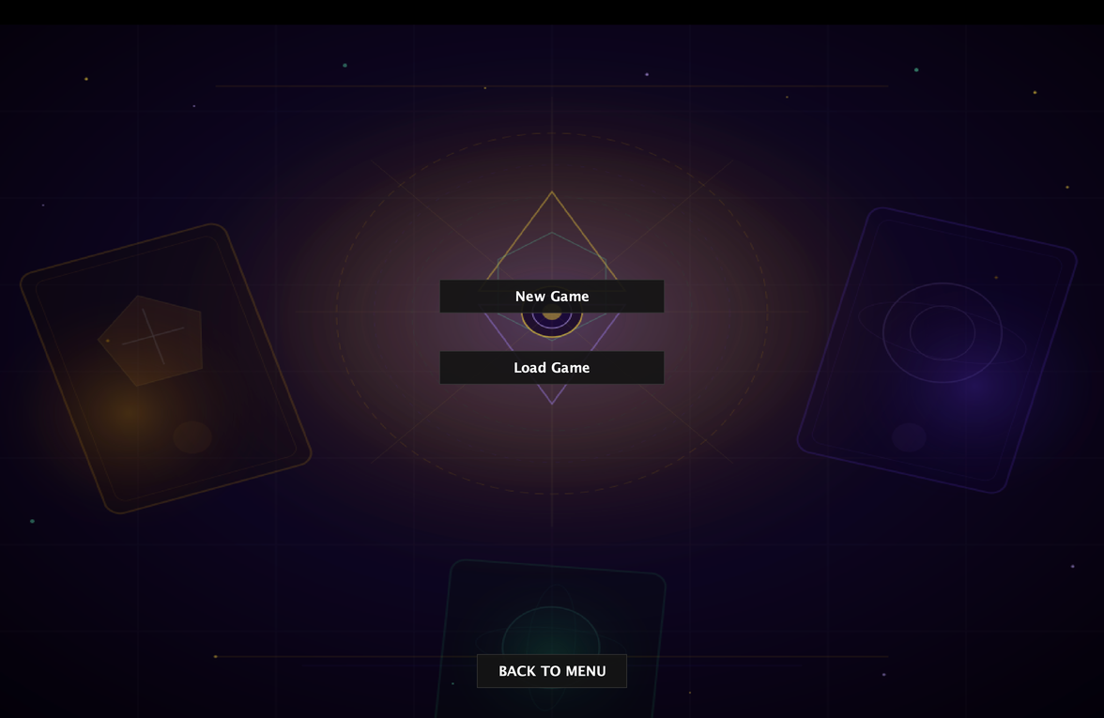  Figure 1.6. Game initialization panel with options to start a new game or load a saved session.
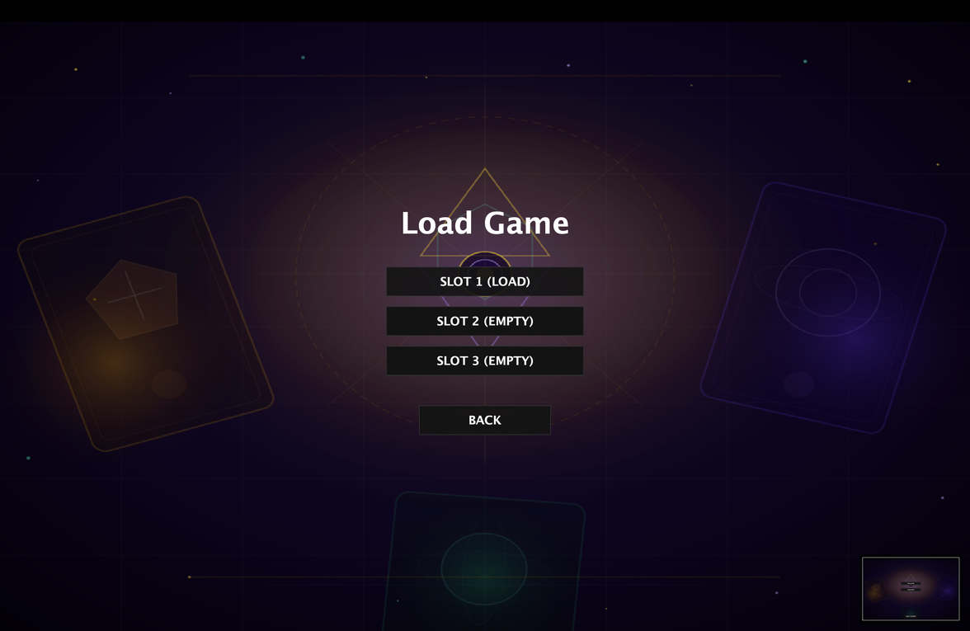  Figure 1.7. Load game panel displaying the three most recently saved game sessions. | 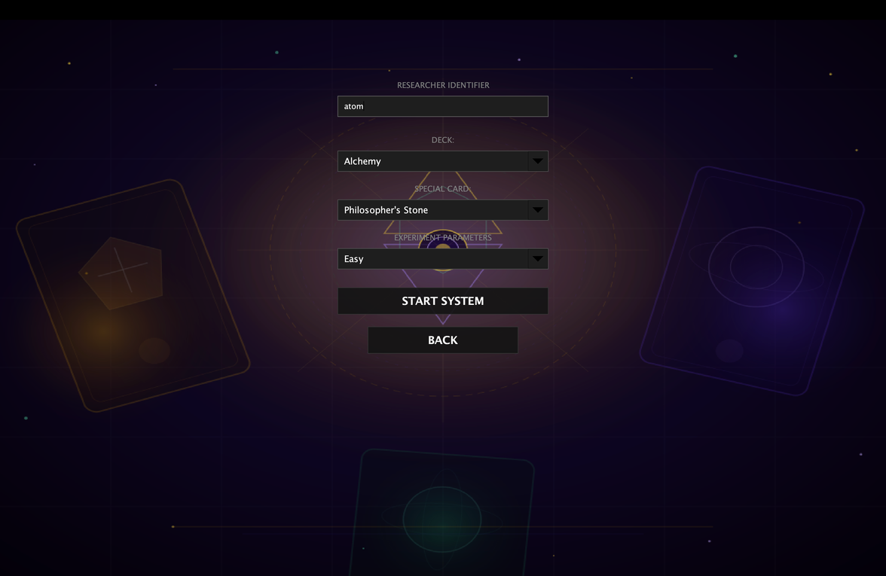  Figure 1.8. New game setup panel featuring nickname entry, deck selection, special card activation, and difficulty configuration.

2. Differences Between Deck Types
When a specific deck is selected, the card types dynamically change to align with that theme. For instance, choosing the Alchemy set introduces Fire, Water, Earth, and Air cards. The Element set features Hydrogen, Oxygen, Nitrogen, and Carbon Dioxide , while the Quantum set includes Quark, Boson, Gluon, and Photon cards.
Furthermore, each deck incorporates four distinct special cards designed to enhance strategic depth. The Alchemy set utilizes the Philosopher’s Stone, Transmutation, Elemental Fusion, and Catalyst cards. The Element set offers Periodic Boost, Noble Gas, Isotope Decay, and Electron Bond, whereas the Quantum set features Quantum Entanglement, Superposition, Gluon Bind, and Photon Burst.
To complement these thematic differences, all cards feature unique custom visuals generated via a Python script, with code optimization and debugging assisted by Claude [1]. Because each deck type provides a completely unique set of special abilities, gameplay strategies must adapt accordingly. Utilizing these special card effects effectively is essential for players to maximize their scores and achieve high-tier rankings.

3. Gameplay Demonstration
a. Card Interaction
In order to toggle or untoggle cards, the left mouse button is used. Selected cards are highlighted with a distinct yellow border to provide immediate visual feedback (Figure 3.1). Toggled cards can be easily untoggled by clicking on them again, which effectively prevents accidental or mistaken selections during gameplay. An in-game console was also implemented to enhance the user interface aesthetics and provide real-time status tracking and error feedback; this console dynamically displays the toggle/untoggle state of the cards as well (Figure 3.2).
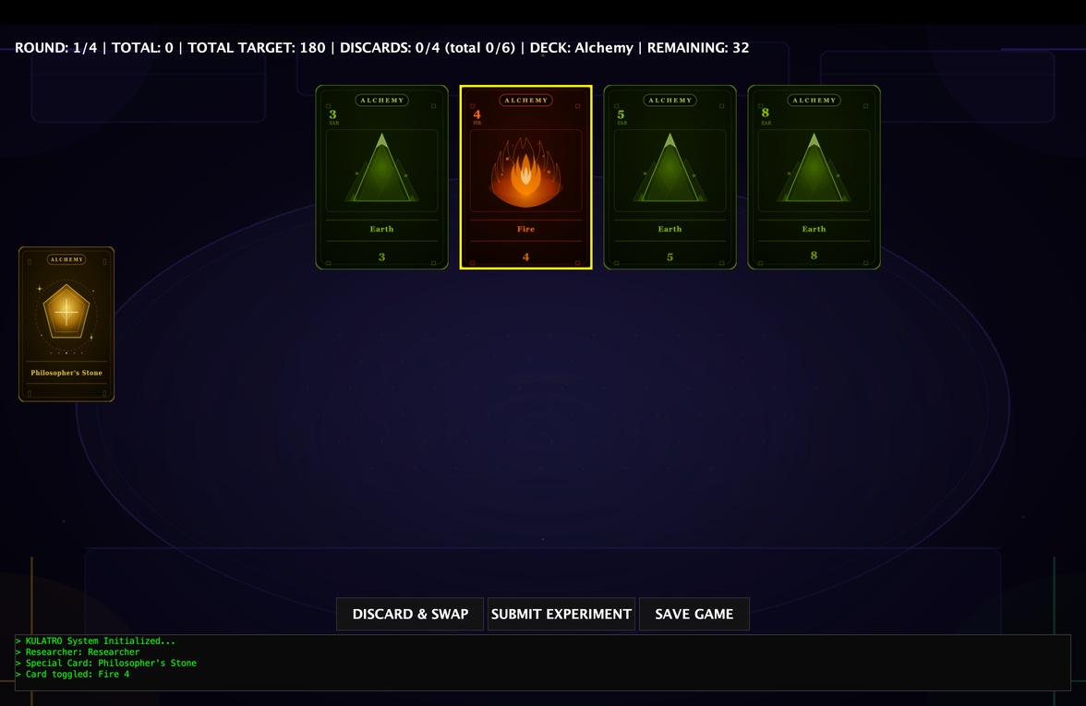  Figure 3.1. Selected card highlighted with a yellow border. | 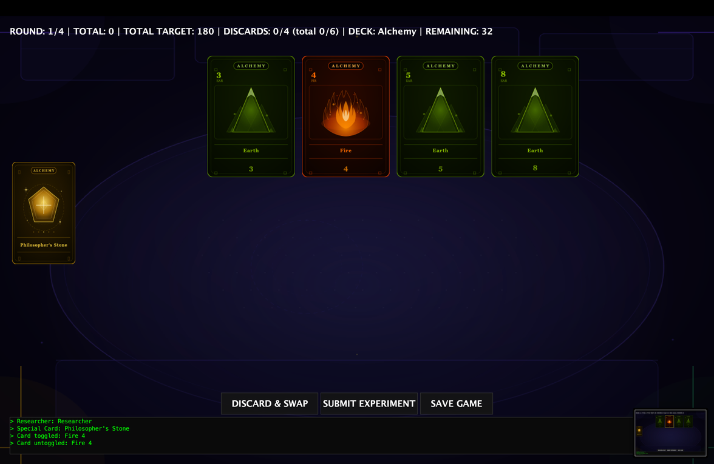  Figure 3.2. In-game console displaying the dynamic toggle and untoggle states of selected cards.
b. Discard Mechanism
By clicking the "Discard & Swap" button, players can discard their currently selected cards (Figure 3.3-3.4). The application then automatically replenishes the hand by drawing an equivalent number of new cards from the deck.
The mechanism dynamically tracks choices based on the player's selection: the exact number of selected cards will be discarded, subject to strict boundaries (a maximum of 4 cards per round and a maximum of 6 cards for the entire game). If a user attempts to discard a number of cards that exceeds either of these limits, the action is blocked, and an error message is immediately displayed in the in-game console to provide direct feedback (Figure 3.5-3.6).
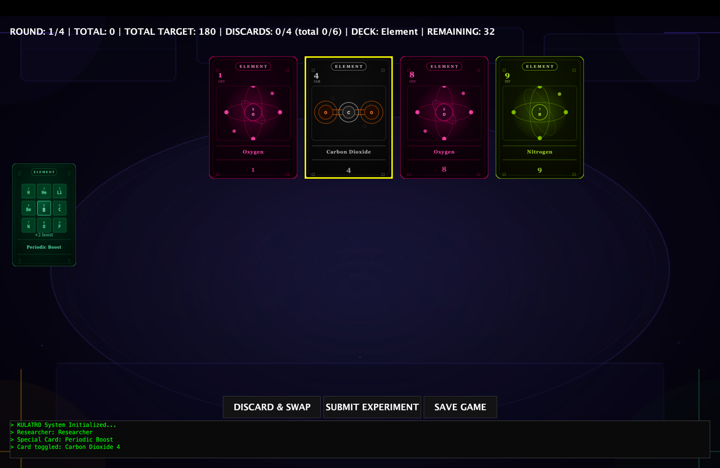  Figure 3.3. Player hand state prior to card removal (Discard status: 0). | 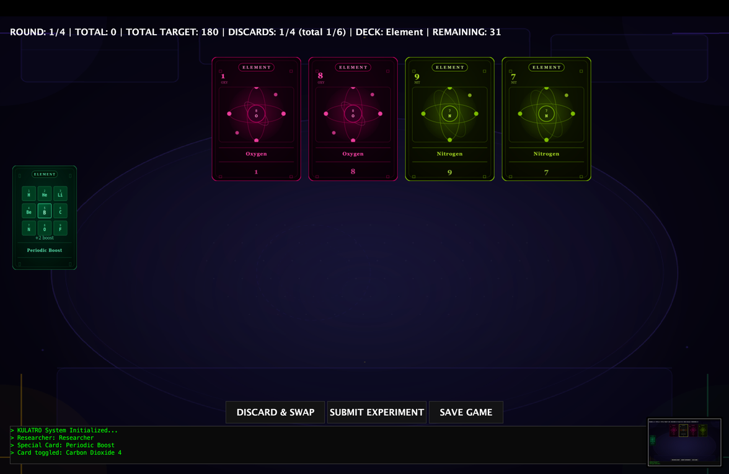  Figure 3.4. Player hand state after removing a single card (Discard status: 1).
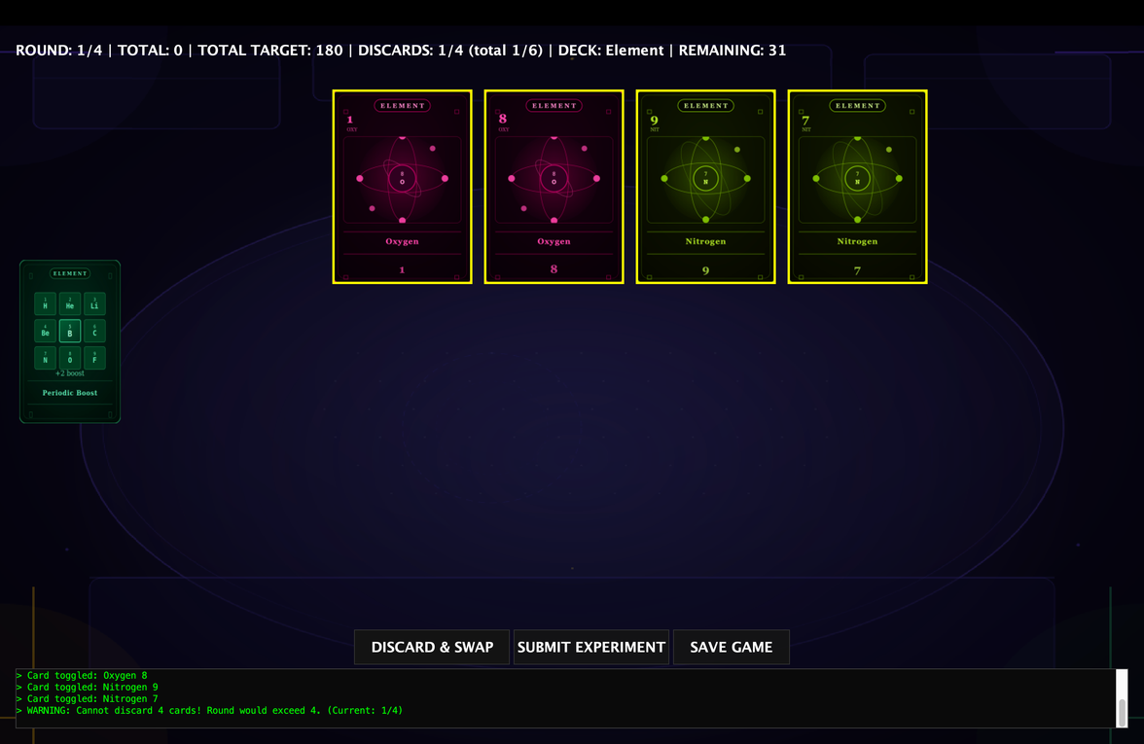  Figure 3.5. Attempting to exceed the discard limit. |   Figure 3.6. Technical block and console feedback when attempting to exceed the discard limit.

c. Special Cards
Available special cards are displayed on the left side of the screen, allowing users to interact with them via a left mouse click. Upon activation, a JOptionPane confirmation dialog appears to verify the user's intent (Figure 3.7). If the player selects "No" or closes the dialog, the card remains unused.
Conversely, confirming with "Yes" triggers the special card's effect (Figure 3.8). If the card is designated for a one-time use, it is immediately removed from the user interface and rendered unavailable for the remainder of the session (Figure 3.9). For multi-use cards, the ability becomes available again in the subsequent round; attempting to reactivate the card within the same round prompts an error message in the in-game console stating that the card has already been deployed, and the action is blocked (Figure 3.10).
To reinforce the thematic distinction between the decks, a color-coded visual hierarchy is implemented: special cards within the Alchemy set utilize a gold-colored style, the Element set features a green-colored style, and the Quantum set adopts a purple-colored style. The structural mechanics and abilities of these special cards are defined as follows:
Alchemy Set Special Cards:
- Philosopher's Stone: Doubles the score of the current hand (one-time use)
- Transmutation: Swap one card in hand with a random card from deck (doesn't count toward discard limit)
- Elemental Fusion: If you have at least 2 cards of the same type, treat them as 4 of that type for scoring this round
- Catalyst: Increase the multiplier of any "pair" scoring by +1 (×2 becomes ×3)
Element Set Special Cards:
- Periodic Boost: Add +2 to the numeric value of all cards in current hand
- Noble Gas: Lock one card in place - it cannot be discarded but its value counts twice for scoring
- Isotope Decay: Discard your entire hand and draw 4 new cards without using discard limit (one-time)
- Electron Bond: Create a pair between two different card types - they count as a matching pair for scoring
Quantum Set Special Cards:
- Quantum Entanglement: Triple the score of one card from the current hand.
- Superposition: Play two scoring patterns simultaneously - take the better result
- Gluon Bind: Merge two cards into one with combined numeric value (max 9), draw one card in its place. (note: if different types are merged, the new card takes the type of the first selected card)
- Photon Burst: Reveal the next 3 cards in deck, you may swap one with a card in hand
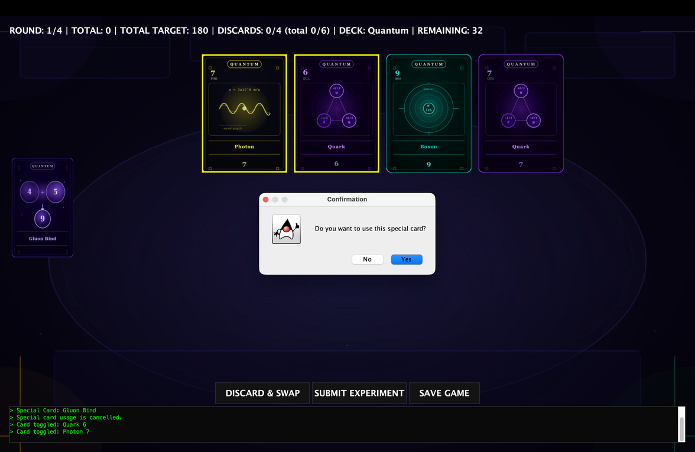  Figure 3.7. Confirmation dialog prompt requiring user verification before activating a special card. | 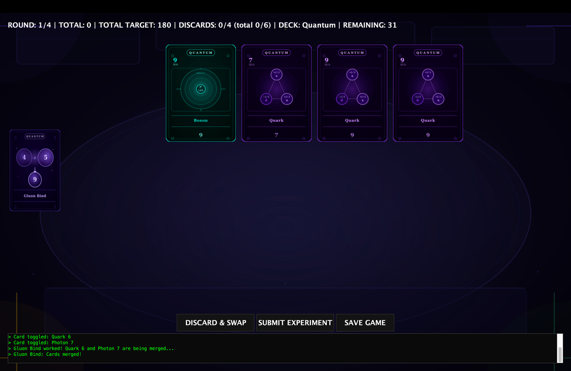  Figure 3.8: Interface state following confirmation and activation of the special card.
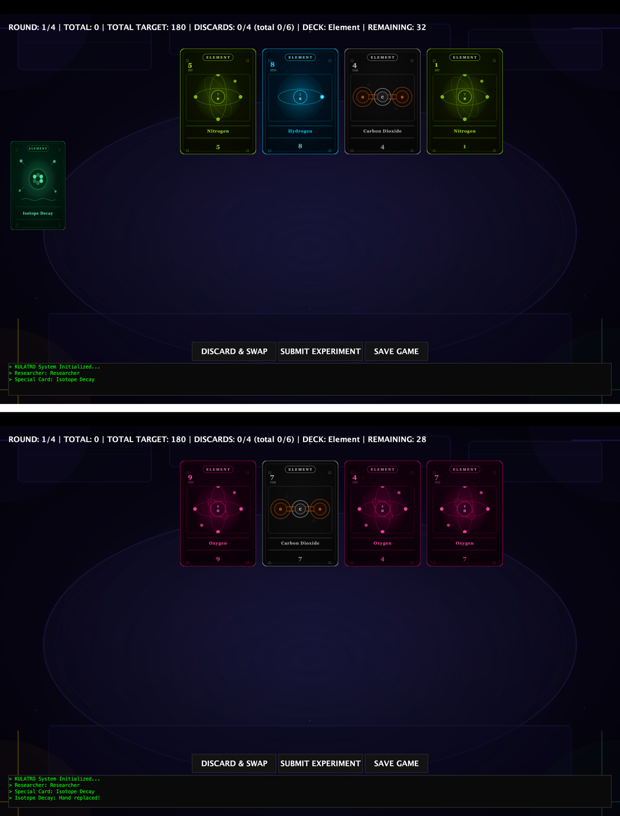  Figure 3.9: Interface transition showing the active state before and the subsequent removal of a one-time use card after activation. | 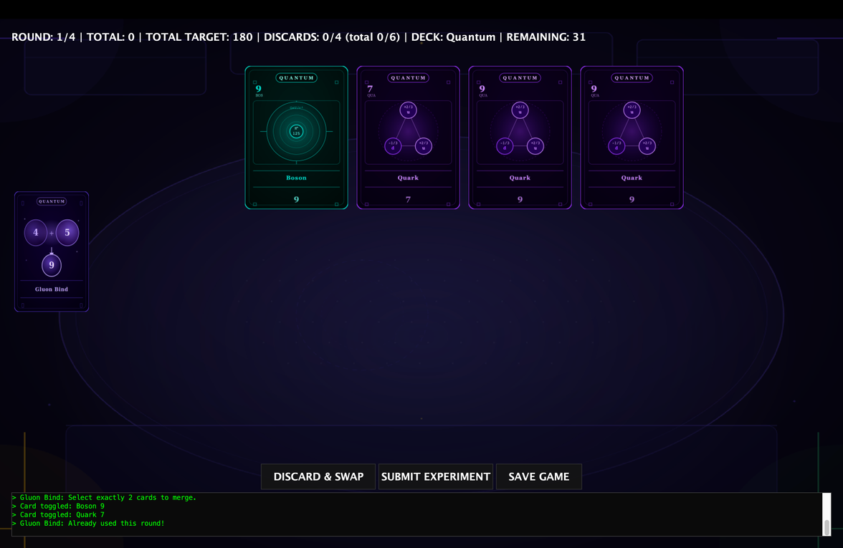  Figure 3.10: System block and in-game console warning when attempting to reactivate a multi-use card within the same round.

4. Scoring System Demonstration
If the four submitted cards are all of the same type (Four of a Kind), the score is calculated by summing the individual numeric values of all four cards and then multiplying the total by 10 (Figure 4.1-4.2).
If the four submitted cards are all of different types (One of Each Type), the score is determined by calculating the sum of the numeric values of all four cards and then multiplying that total by 5 (Figure 4.3-4.4).
If the submitted cards contain exactly two cards of the same type (Pair), the calculation depends on the total number of cards played:
- For a single pair (One Pair): The numeric values of the two matching cards are summed and multiplied by 2. If additional cards are submitted alongside the pair, their numeric values are simply added to this total without receiving the multiplier (Figure 4.5-4.6).
For two pairs (Two Pairs): If a four-card hand forms two distinct pairs, the score for each pair is calculated individually by summing its card values and multiplying by 2. The final score for the hand is then determined by adding the results of these two pairs together (Figure 4.7-4.8).
For any other combination that does not meet these criteria, the final score is simply the baseline sum of the numeric values of all submitted cards, without any multipliers applied (Figure 4.9-4.10).
In-game examples:
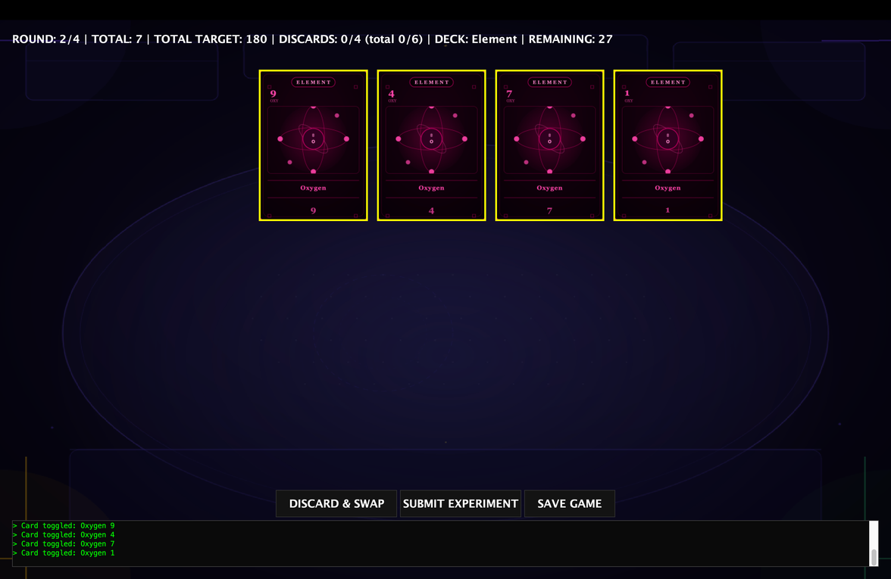  Figure 4.1: Hand configuration and initial state prior to calculating a Four of a Kind score (Score: 7, Expected extra score for the next round: (9+4+7+1)x10 = 210). | 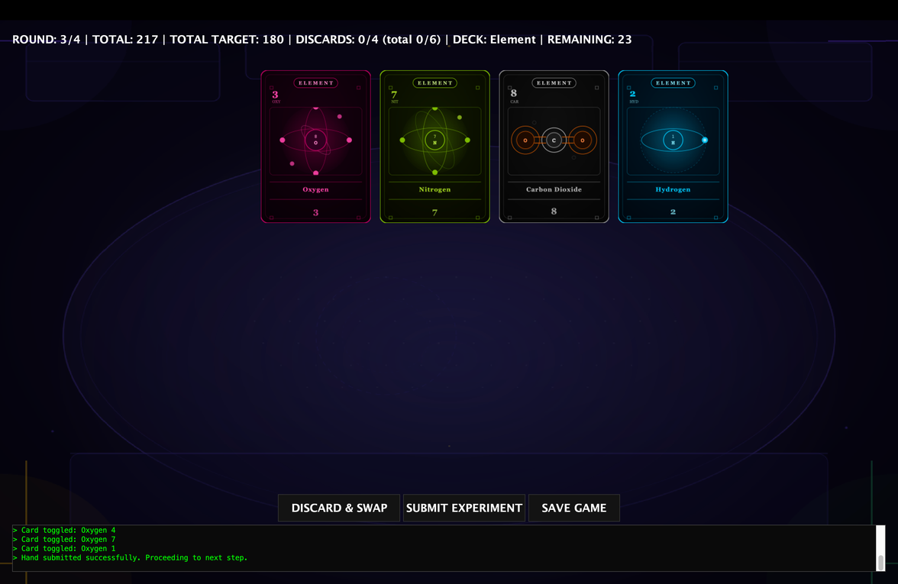  Figure 4.2: Updated score calculation and visual feedback after applying the Four of a Kind multiplier (Score 7 + 210 = 217).
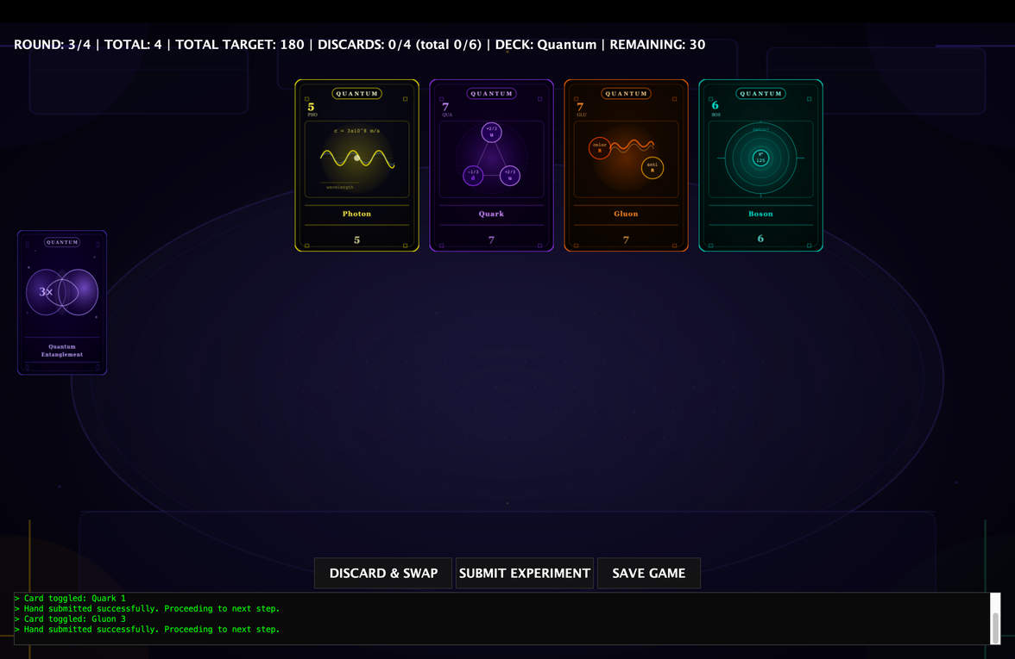  Figure 4.3: Hand configuration and initial state prior to calculating a One of Each Type score (Score: 4, Expected extra score for the next round: (5+7+7+6)x5 = 125). | 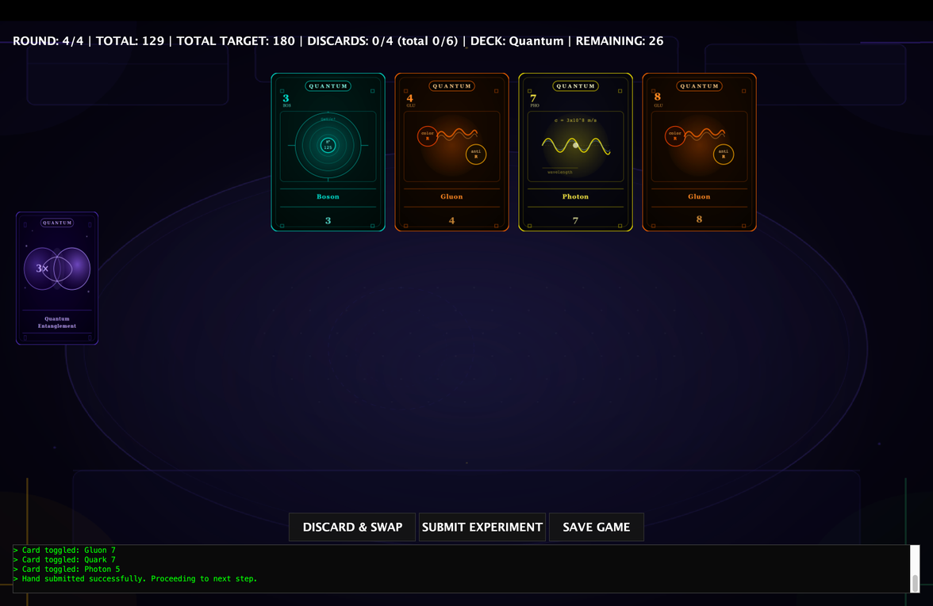  Figure 4.4: Updated score calculation and visual feedback after applying the One of Each Type multiplier (Score 4 + 125 = 129).
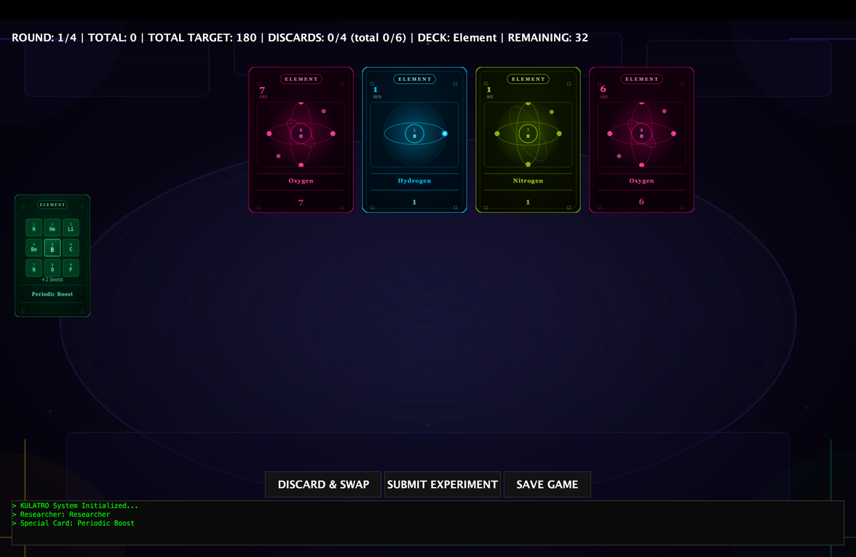  Figure 4.5: Hand configuration and initial state prior to calculating a One Pair score (Score: 0, Expected extra score for the next round: (7+6)x2 +1+1 = 28). | 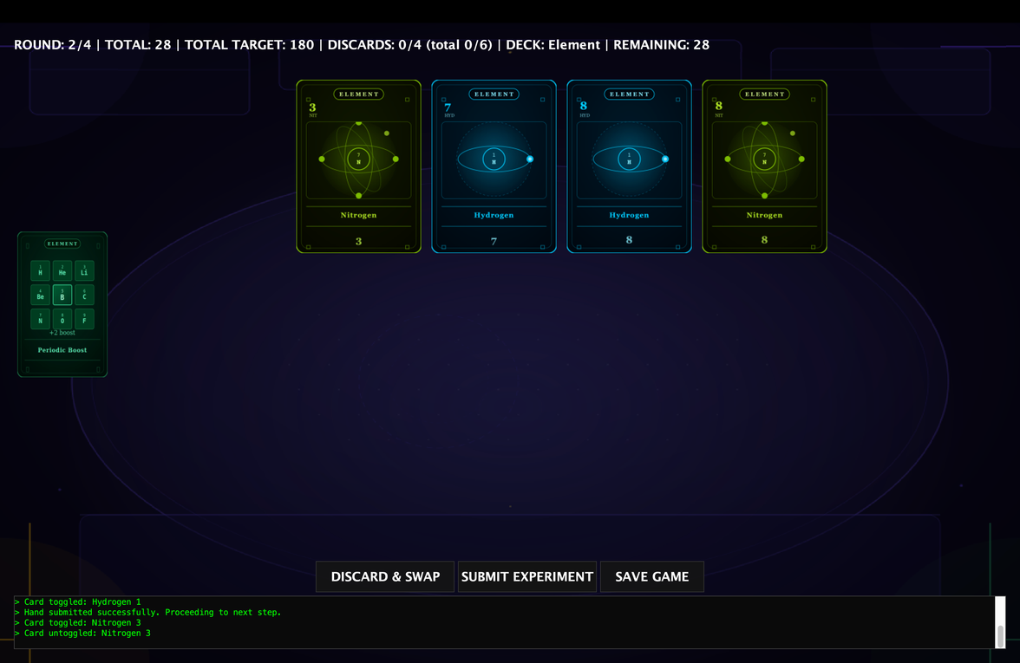  Figure 4.6: Updated score calculation and visual feedback after applying the One Pair multiplier (Score 28).
  Figure 4.7: Hand configuration and initial state prior to calculating a Two Pair score (Score: 28, Expected extra score for the next round: (3+8)x2 + (7+8)x2 = 52). | 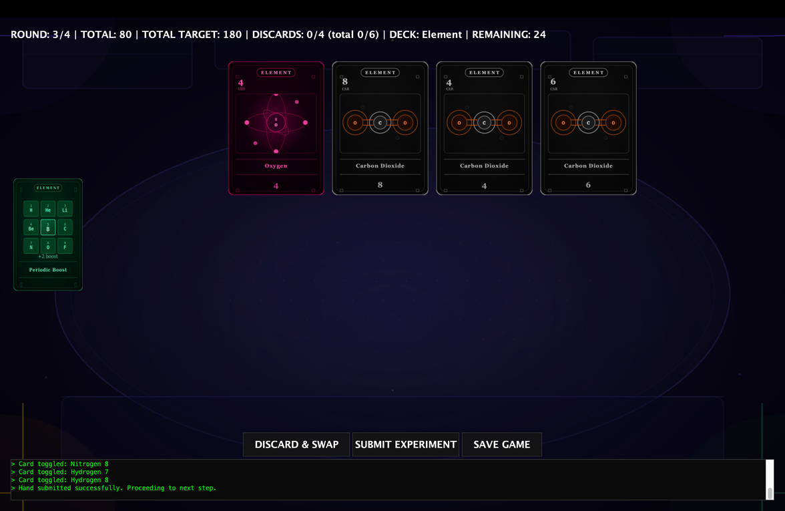  Figure 4.8: Updated score calculation and visual feedback after applying the Two Pair multiplier (Score 28 + 52 = 80).
  Figure 4.9: Hand configuration and initial state prior to calculating a No Match score (Score: 80, Expected extra score for the next round: 4+8+4+6 = 22). | 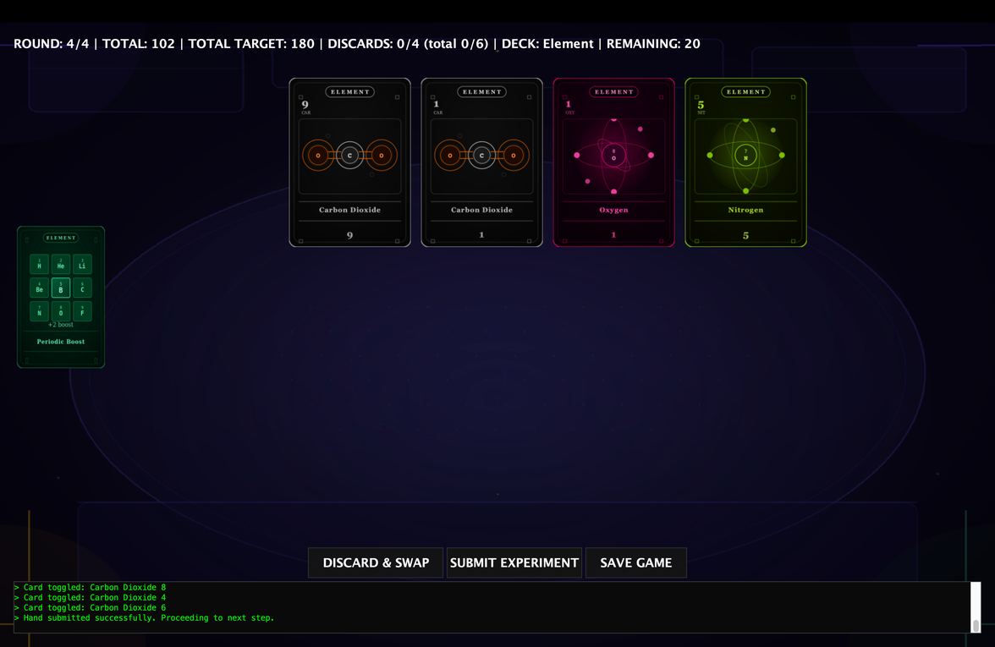  Figure 4.10: Updated score calculation and visual feedback after applying the No Match multiplier (Score 80 + 22 = 102).
If a deployed special card is score-related, its specific ability will directly modify the calculation of the active hand's payout. For instance, the Philosopher’s Stone functions as a x2 multiplier card; when activated by the player, it dynamically applies a doubling factor, multiplying the total calculated score of the currently submitted hand by two (Figure 4.11-4.12).
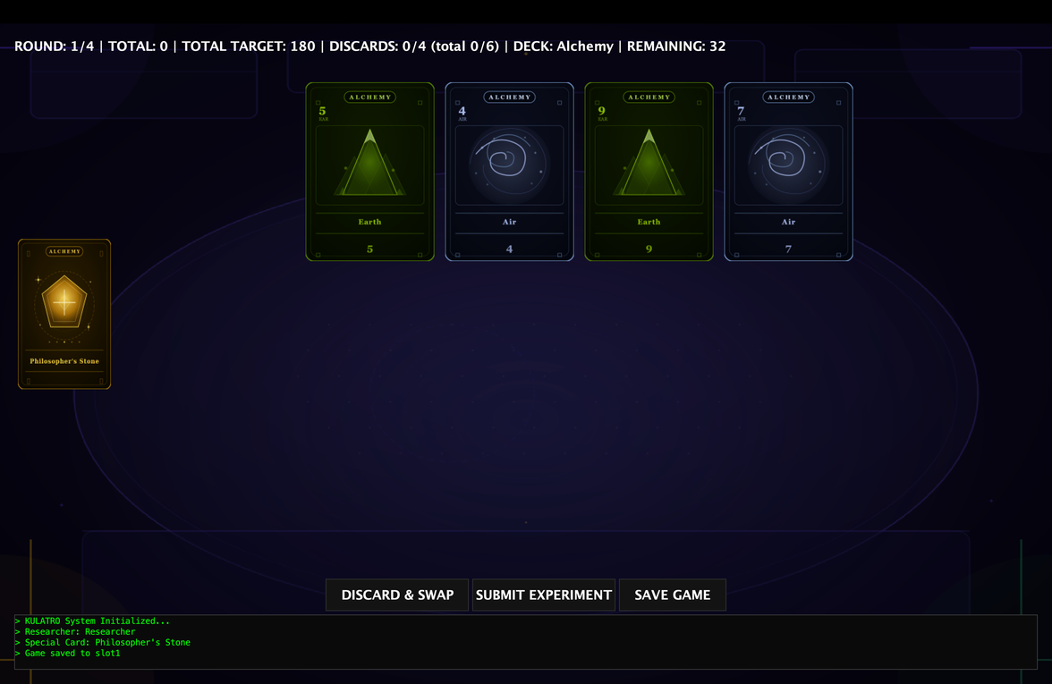  Figure 4.11: Hand configuration and initial state prior to calculating a Two Pair score with the Philosopher’s Stone activated (Current Score: 0, Expected extra score for the next round: ((5+9)x2 + (4+7)x2) x 2 = 100). | 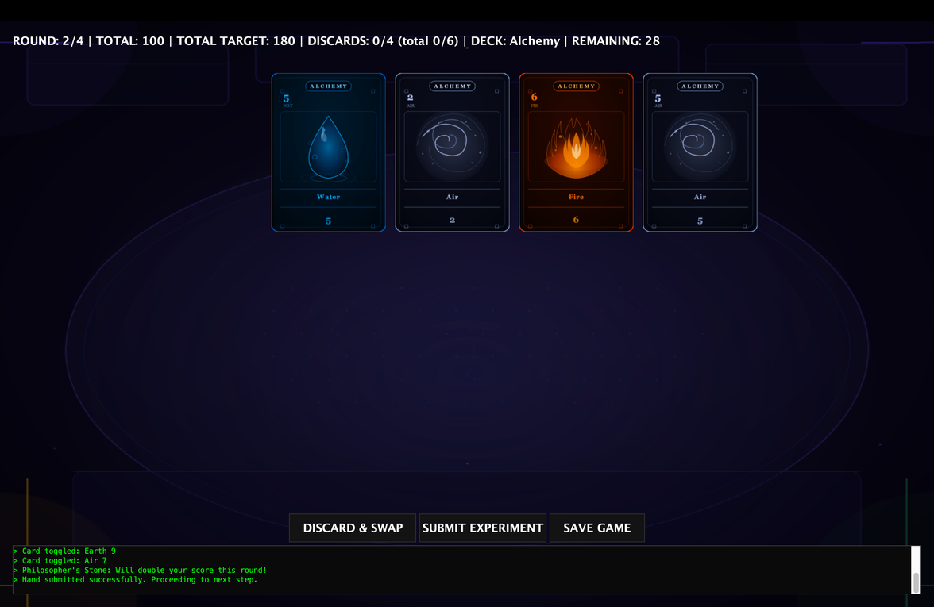  Figure 4.12: Updated score calculation and visual feedback after applying the Philosopher’s Stone card (Score: 100).

5. Round Progression & Game Completion
When the "Submit Hand" button is clicked, the current round terminates, and new cards are immediately drawn from the deck to initiate the subsequent round. Concurrently, the gameplay statistics displayed in the upper panel of the GUI are updated in real-time: the player's cumulative score is refreshed, the round counter increments by one, and the remaining card count in the deck decreases by the exact number of cards submitted and discarded. All of these dynamic metrics are explicitly reflected in the top information bar.
Although the target score varies for each individual round, the core mechanic of the game revolves around comparing the player's average performance against the average target requirements. Consequently, displaying the cumulative target score is sufficient for the gameplay flow, and winning is strictly determined by whether the player's total score exceeds the overall target score. To maintain a clean and intuitive user interface, the upper table exclusively displays the Total Target Points and the Total User Points.
At the end of the game, if the player's total accumulated score surpasses the total target score, a victory is achieved regardless of individual round outcomes. Although this structural design may appear non-traditional, the game logic was implemented in this exact manner to strictly adhere to the provided project specifications and instructions.
Once all rounds are completed, an end-game screen is prompted. This final dashboard comprehensively displays the player's total score, the cumulative target score, the player's average score per round, the target average, the total number of rounds won, a detailed breakdown of the score achieved versus the target set for each individual round, and the final overall win/loss outcome of the match (Figure 5.1).
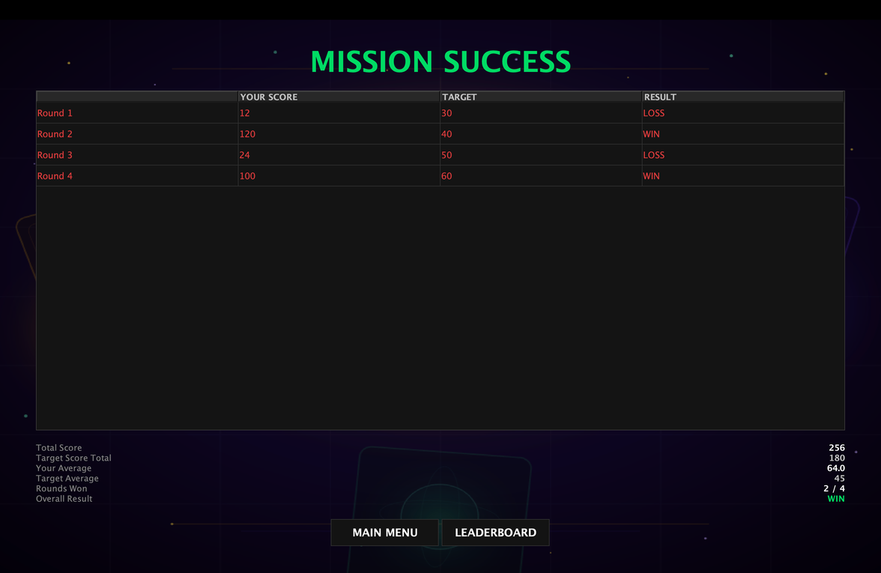
Figure 5.1: Final End-Game dashboard presenting the overall match statistics, including cumulative scores, individual round performances against baseline targets, and the definitive win/loss outcome.
6. Game State Changes During Play
Throughout the entire course of the game, a dedicated upper status panel remains visible at the top of the GUI, providing the player with real-time, continuous feedback on the state of the match.
When a round is played and a hand is submitted, the system automatically replaces the player's submitted cards by drawing new ones from the shuffled deck. Concurrently, the upper panel dynamically reflects these structural changes: the cumulative total score updates based on the points calculated from the submitted round, and the remaining deck size counter decreases to precisely reflect the newly drawn cards.
Furthermore, the upper panel serves as an essential strategic dashboard for managing moves; if a player discards any cards, the interface immediately updates both the current round's discard count and the total maximum allowable discards for the entire match. This allows the user to easily monitor exactly how many discard rights they have left at any given moment. In addition to tracking these resource limits, the panel hosts a progressive round counter and explicitly displays the currently active deck type, ensuring all vital match parameters are transparently accessible during the entire gameplay session (Figure 6.1-6.2).
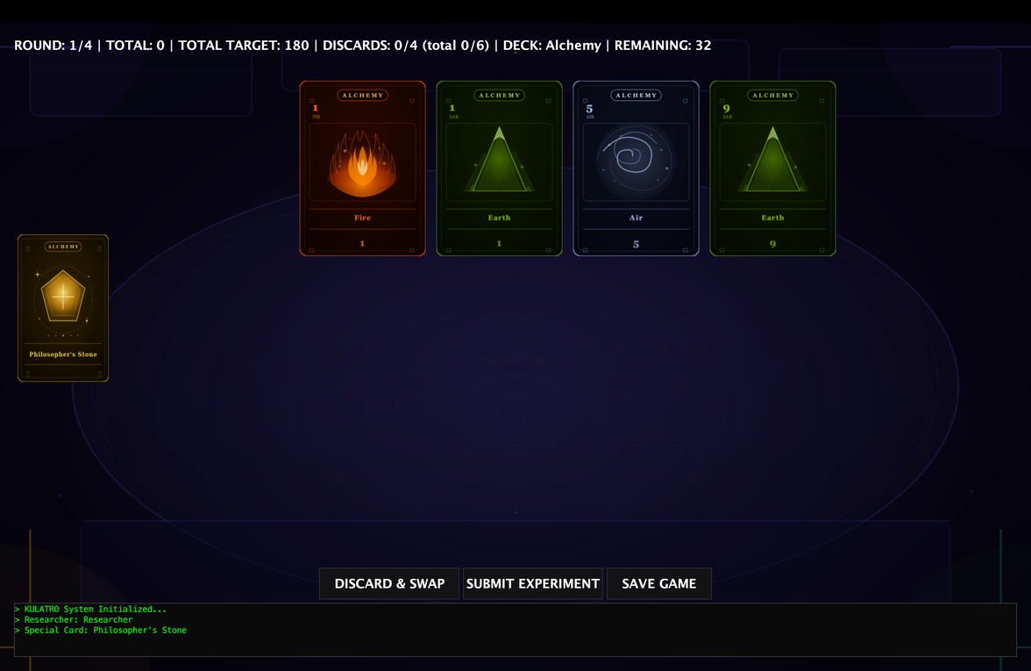  Figure 6.1: Active gameplay state prior to hand submission, showcasing the initial upper panel metrics, current round number, and available discard limits. | 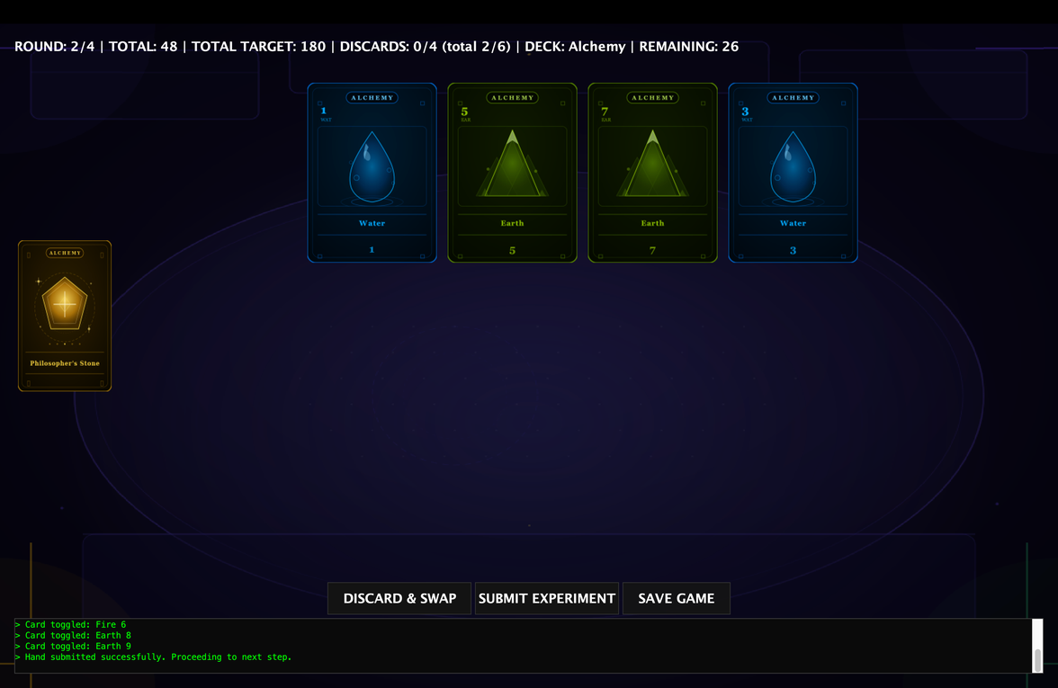  Figure 6.2: Updated upper panel interface immediately after performing a discard action and clicking the "Submit Experiment" button, demonstrating the real-time increment of the round counter, reduction in remaining deck size, updated cumulative score, and the change in the discard counters.

7. Save & Load Functionality
a. Saving the Game
To evaluate the robustness of the serialization and data persistence mechanisms, a controlled test scenario was conducted. A new game session was initialized, during which three cards were discarded and gameplay proceeded across two complete rounds. During one of these rounds, Philosopher’s Stone (a single-use special card) was deployed to verify that state consumption is accurately tracked (Figure 7.1-7.2).
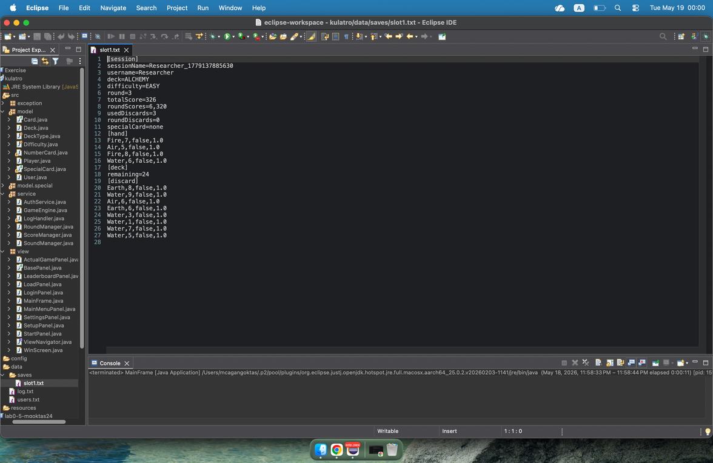  Figure 7.1: Structure and contents of the generated slot1.txt save file, demonstrating the serialized storage of the current round, player hand configuration, remaining deck state, and cumulative score. | 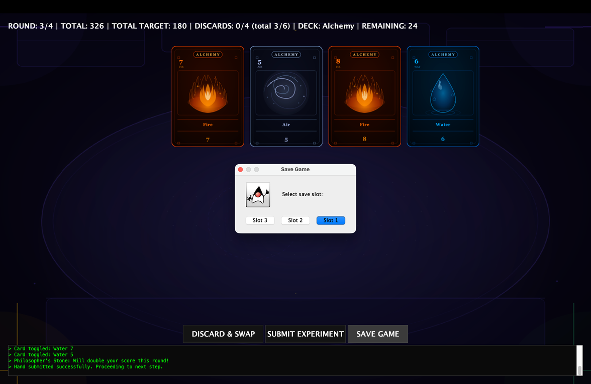  Figure 7.2: Deployed game state prior to saving, illustrating active round progress, consumed discard rights, used special cards, and current score metrics.
b. Loading the Game
Upon saving and subsequently reloading this session, the application successfully re-established the exact architectural state of the match. The upper status panel dynamically refreshed to display the precise historical data, confirming that critical parameters—including the current round counter, the consumption state of special cards, the exact player hand configuration, the structural state of the remaining deck, and the cumulative score—were flawlessly preserved and restored (Figure 7.3).
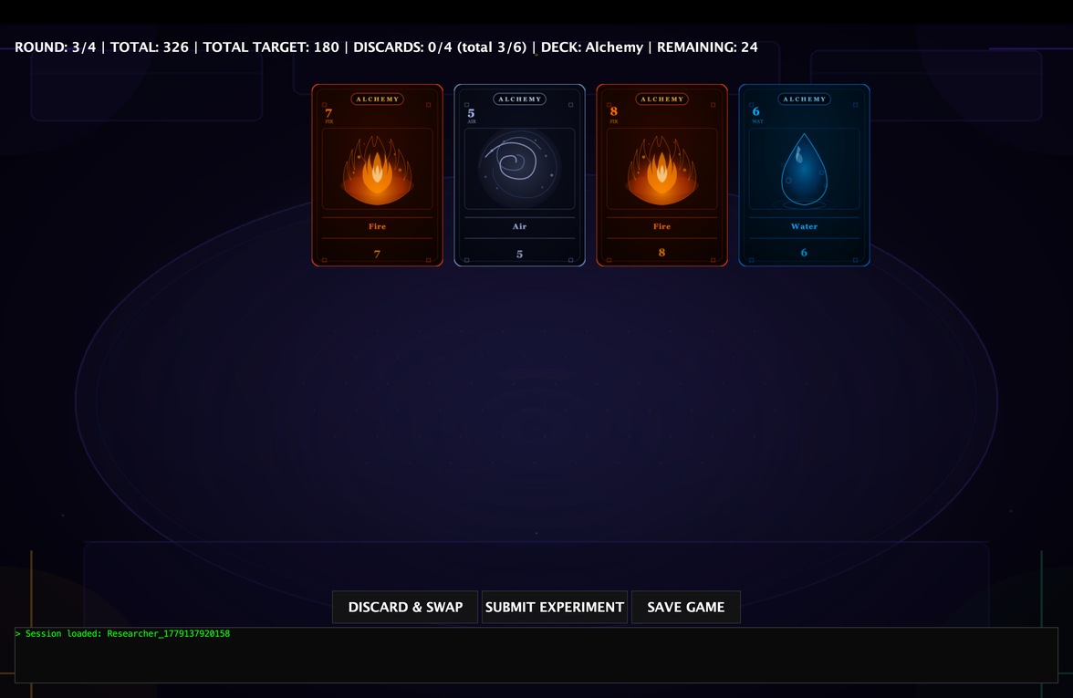
Figure 7.3: Successfully reloaded game session demonstrating identical upper panel statistics, card configurations, and seamless continuity from the exact saved state.

8. Logging System
To ensure complete transparency and traceability of the gameplay flow, the application features a real-time logging system that records every event sequentially into a log.txt file. Each log entry is structured with a standardized timestamp prefix followed by the active user's credentials and a detailed description of the triggered action (Figure 8.1).
As demonstrated in the provided log file data, the system successfully tracks the entire lifecycle of a game session across various states:
- Game Initialization: Upon launching a session, the system registers the exact configuration parameters, including the selected deck type and difficulty level (e.g., Deck: ALCHEMY Difficulty: EASY). Immediately after, the dealer logic logs the exact contents of the initial dealt hand, listing the element types and their corresponding numerical values.
- In-Game Actions: Every critical player decision is closely monitored. When a user chooses to optimize their hand, the system logs the exact number of cards discarded. Upon submitting a hand, the log records the card combination used, immediately followed by an automated score computation entry that breaks down the individual Round score alongside the newly updated cumulative Total score. Transition entries explicitly mark the progression into subsequent rounds.
- Persistence & State Restoration: The logging framework seamlessly integrates with the Save/Load architecture. When a player restores a previously saved game, the system notes the re-initialization of the session parameters and confirms the exact source file from which the match parameters were reconstructed (e.g., Session loaded from slot 1), ensuring that all historical data and continuity are fully validated in the background.
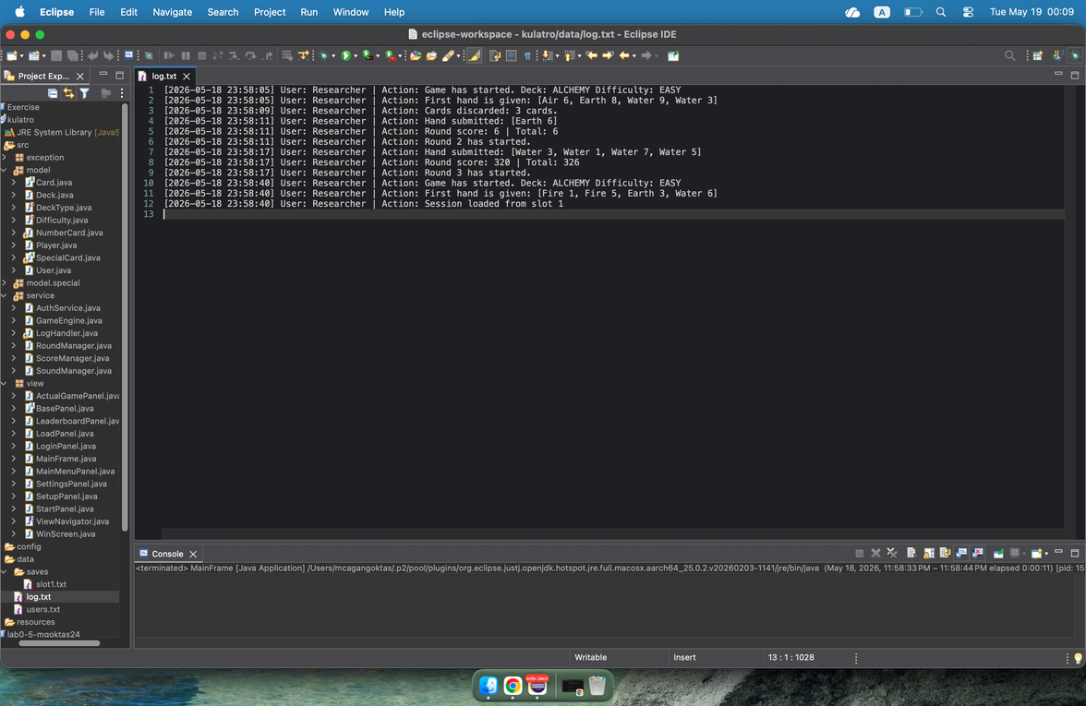
Figure 8.1: Contents of the generated log.txt file, illustrating chronologically timestamped entries for game initialization, hand distribution, discard operations, scoring updates, and session restoration from a save slot.

9. Error Handling Demonstration
To ensure application stability and maintain a seamless user experience, the system implements a robust, hierarchical exception-handling framework alongside proactive GUI-driven redirection mechanisms. The core of this system relies on a custom exception architecture under the package exception, derived from a single base class to gracefully intercept runtime anomalies, prevent crashes, and feed clear messages back to the graphical interface.
The application’s error-handling capabilities are classified into three major operational vectors:
a. Management of Missing or Incorrect Files
System configuration files and state persistence data are strictly validated before processing. Data-related irregularities are managed by GameDataException, a specialized subclass of the core CardGameException.
- Mechanism: When a critical asset or save slot file is corrupted or cannot be found (triggering a native FileNotFoundException), the system encapsulates the root cause and throws a GameDataException carrying a descriptive message ("GameData exception | Cause: ...").
- GUI Feedback & Redirection: Instead of crashing, the GUI safely catches this exception. For instance, if a player attempts to load a session from an uninitialized or empty save slot, the application immediately triggers an automated redirection mechanism that seamlessly routes the user back to the New Game creation panel, prompting them to start a fresh match instead.
b. Validation of Invalid User Actions
Players are constrained by strict gameplay rules, and any illegal inputs or actions during a round are programmatically blocked using custom exceptions:
- InvalidHandException: Thrown immediately if a player attempts to submit a combination that violates the game rules, such as a hand configuration consisting of more than four cards or fewer than one card. The exception formats a strict feedback message ("Invalid Hand: ..."), allowing the UI to warn the player before processing any logic.
- DeckEmptyException: Triggered when the deck state is exhausted and a draw action is requested while both the main deck and the discard pile are empty. It stops the execution with a definitive message: "Deck and discard pile are empty! Cannot draw a new card."
c. GUI Feedback Messages
All of the aforementioned custom exceptions—managed under the broad CardGameException hierarchy—are coupled with the Java Swing UI thread. When an exception is thrown, the catch block intercepts the message and updates the view layer, providing real-time modal alerts or localized warning labels. This ensures that technical errors are translated into digestible feedback, preventing corrupted states while keeping the player fully informed of the game's boundaries.
- In-Game Console Feedbacks: In addition to standard modal dialogs and formal exceptions, the application incorporates a real-time, in-game notification console to guide user actions and enforce strict gameplay rules dynamically. For instance, single-use special cards are restricted to a single activation per round. If a player attempts an invalid action—such as deploying the same special card twice within the same round—the system intercepts the illegal command before modifying the game state. Instead of raising a fatal error, it prints a clear, instructive warning message directly onto the in-game console, smoothly informing the player of the restriction without interrupting the continuous flow of the game.

10. Visual and Functional Differences Across Games
To demonstrate the versatility and dynamic design of the application, multiple game sessions were initialized using different configurations. The system adapts extensively based on the user's initial selections, altering the aesthetic presentation, tactical choices, mathematical constraints, and the overall progression rhythm of the match.
a. Deck Visuals
Each deck type features a completely distinct and customized visual identity implemented across all user interface elements.
- When switching between decks such as Alchemy Set, Element Set, or Quantum Set, the graphical assets for both standard number cards and special cards change entirely. The card backgrounds, element icons, and color palettes are dynamically loaded to match the specific theme of the chosen deck, ensuring a highly customized thematic experience for each game.
b. Special Card Behavior
The functional diversity of the game is heavily driven by the unique mechanics tied to each deck’s special cards.
- Rather than using a generic utility function, special cards possess distinct operational logic that alters scoring or hand states. For example, deploying the Philosopher’s Stone in the Alchemy deck introduces a high-stakes risk/reward mechanic by doubling the final payout of a hand (x2 multiplier). In contrast, special cards in other decks focus on utility or resource manipulation—such as swapping out unfavorable cards or adding flat bonus points—forcing the player to adapt their strategy entirely depending on the active deck type.
c. Difficulty Impact
The difficulty setting alters the mathematical threshold required to achieve a victory condition, directly impacting player strategy.
- Selecting Easy, Normal, or Hard modes does not alter the core rules or card values, but it dynamically adjusts the generation of individual round target scores and the cumulative target total. On higher difficulty thresholds, the margin for error is significantly narrower. A player cannot rely on low-scoring hands and must efficiently manage their discard rights and strategically deploy their single-use special cards to survive the steeper scoring requirements.
d. Gameplay Flow
The convergence of deck visuals, distinct special card mechanics, and difficulty thresholds shapes the overall gameplay flow, dictating the pace and tactical rhythm of each match.
- The gameplay flow transitions based on the selected setup. A match played on Easy difficulty with the Alchemy Set offers a fast-paced, high-scoring flow where players can comfortably trigger massive multipliers to clear targets early. Conversely, a match played on Hard difficulty with the Element Set induces a calculated, tense, and highly defensive flow, where players must meticulously evaluate every single card drop, track remaining deck counts, and optimize minor point additions just to stay ahead of the escalating target line.
The visual and structural modifications across different configurations can be cross-examined in Figure 10.1, Figure 10.2, and Figure 10.3. As observed, selecting the Alchemy Set on Easy difficulty provides a specific aesthetic and lower scoring thresholds, whereas transitioning to the Element Set on Normal difficulty dynamically replaces the asset package with elemental card variations and scales up the target metrics, successfully altering both the visual identity and tactical difficulty of the match.
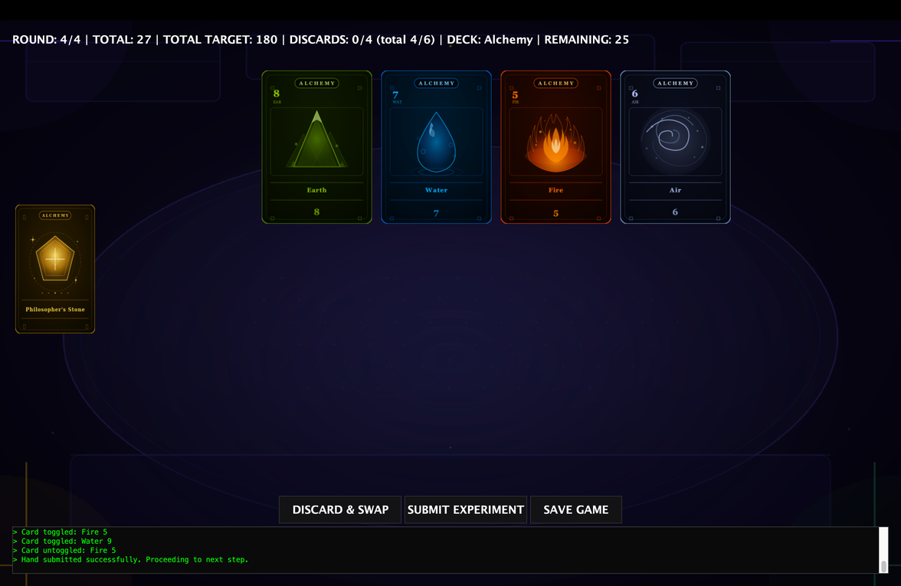  Figure 10.1: GUI layout of a game session initialized with the Alchemy Set on Easy difficulty, highlighting its specific card visuals and lower baseline target scores. | 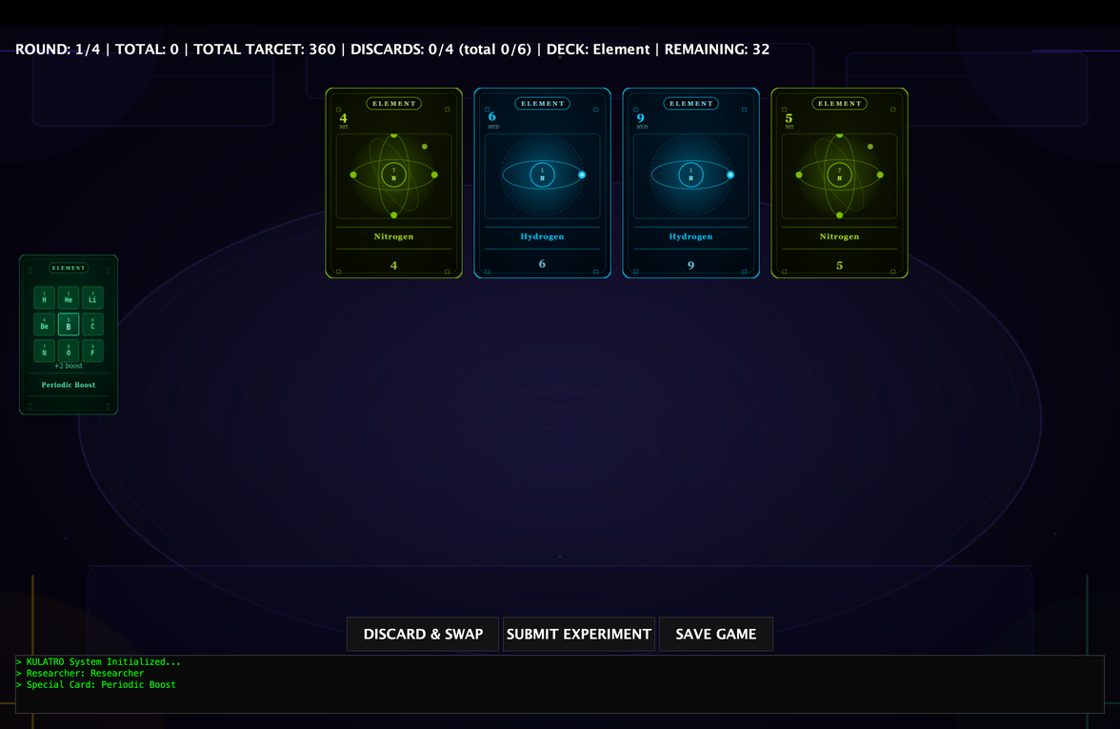  Figure 10.2: GUI layout of a game session initialized with the Element Set on Medium difficulty, showcasing the distinct thematic card designs (e.g., Fire, Water, Earth, Air) and moderately increased target scores that dictate a more balanced gameplay flow. | 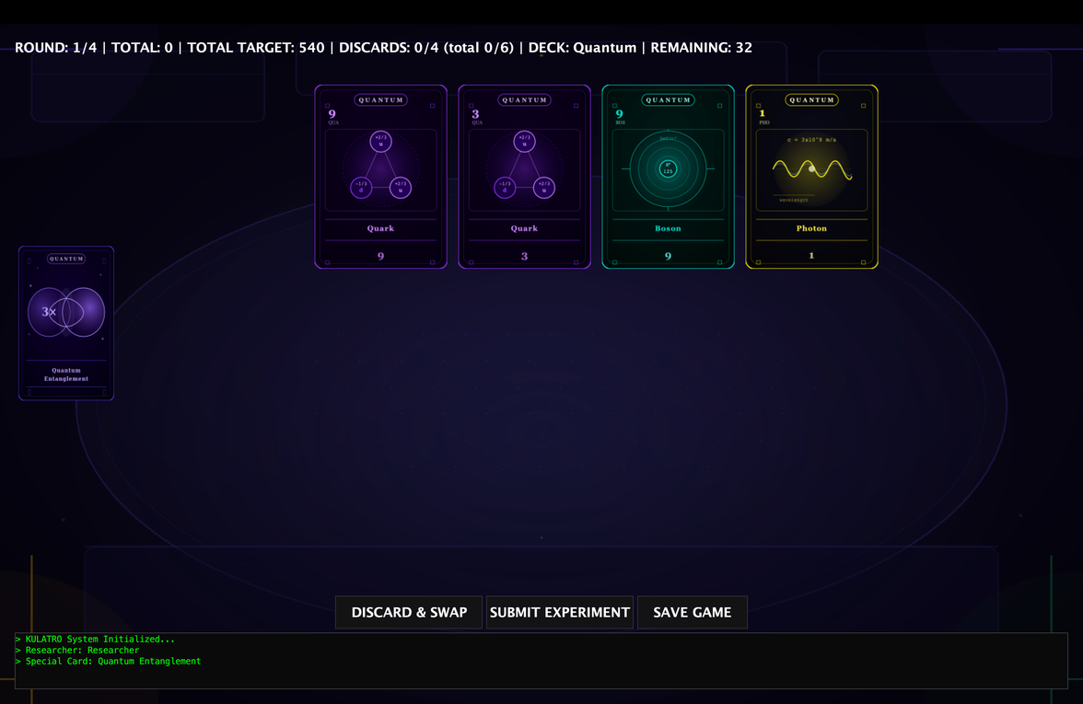  Figure 10.3: GUI layout of a separate game session initialized with the Quantum Set on Hard difficulty, demonstrating the distinct thematic card designs and significantly elevated target thresholds that alter the gameplay flow.

Part 2
Project Design Description:
The architectural design of the application heavily relies on Object-Oriented Programming (OOP) principles to ensure scalability, modularity, and strict segregation of concerns. The codebase is organized into dedicated packages containing specialized hierarchies, abstract structures, and interfaces.
a. Core Domain Model and Type Hierarchies (package model)
The gameplay entities are structured around an abstract foundation to facilitate polymorphic behavior across different card categories:
- Card (Abstract, implements Serializable): Serves as the root of the card hierarchy. Making this class abstract prevents the instantiation of generic cards, enforcing that every card must possess a specific classification while supporting Java's native Serialization mechanism for state persistence.
  - NumberCard (extends Card): Represents standard elemental gameplay cards containing explicit numerical values and elemental associations.
  - SpecialCard (Abstract, extends Card): Establishes an abstract subtype for non-numerical, utility-driven cards. This layout allows the game engine to manage both regular and ability cards uniformly under a single Card collection.
- Deck and Setup Enums: Type safety and immutable game configurations are guaranteed through the use of enums:
  - DeckType (Enum): Defines the active layout choices available to the player (ALCHEMY, ELEMENT, QUANTUM).
  - Difficulty (Enum): Controls the operational difficulty thresholds (EASY, NORMAL, HARD), directly influencing scoring benchmarks.
- State Holders: The state of entities is managed by Player, User, and Deck classes, all implementing Serializable to ensure their dynamic runtime states can be easily preserved in save slots.
b. Special Card Polymorphism Framework (package model.special)
To flawlessly handle distinct card behaviors without introducing cluttered conditional statements into the core engine, a highly polymorphic design is used. Twelve unique specialized classes extend the abstract SpecialCard class, each overriding a core execution contract to implement their custom thematic abilities:
- Alchemy Deck Specials: Catalyst, Transmutation, PhilosophersStone, ElementalFusion.
- Element Deck Specials: IsotopeDecay, PeriodicBoost, NobleGas, ElectronBond.
- Quantum Deck Specials: GluonBind, PhotonBurst, QuantumEntanglement, Superposition.
c. Custom Exception Hierarchy (package exception)
To prevent unexpected application crashes and handle illegal gameplay operations gracefully, a custom unchecked/checked exception tree was engineered:
- CardGameException (extends Exception): The absolute superclass of all domain-specific anomalies in the application.
  - InvalidHandException: Thrown when hand validation rules are violated (e.g., submitting an illegal hand size containing fewer than 1 or more than 4 cards).
  - DeckEmptyException: Triggered when card draw demands cannot be fulfilled due to an exhausted main deck and discard pile.
  - GameDataException: Enforces strict compliance on data streams. It wraps native I/O exceptions when external config files or target components fail to load.
d. Decoupled Service Layer (package service)
The operational logic is managed through dedicated manager modules, detaching core algorithmic calculations from the UI components:
- GameEngine, RoundManager, ScoreManager: These modules implement Serializable to maintain complete operational synchronization upon a session reload.
- AuthService, LogHandler, SoundManager: Operate as utility services handling background credentials validation, chronologically tracking user actions, and playing localized ambient effects, respectively.
GUI Components and View Navigation
The graphical user interface is constructed using Java Swing components, built upon a decoupled panel layout pattern that abstracts navigation logic away from individual visual states.
a. View Navigation Architecture
- ViewNavigator (Interface): Defines the behavioral contract for panel switching operations across the client window. It prevents hardcoded, cross-panel couplings by forcing panels to request navigation via a central controller.
- MainFrame (extends JFrame, implements ViewNavigator): Acts as the supreme window container of the application. It hosts the root layout structure and implements the navigation contract, orchestrating seamless transitions between separate view panels.
b. Panel Component Hierarchy and Workflow
To ensure consistency in look and structural behavior, a custom base design pattern is applied where all UI views extend a common foundation:
- BasePanel (extends JPanel): The abstract foundation for all visual screens. It encapsulates shared style guidelines, layout utilities, and a reference to the centralized ViewNavigator.
The concrete UI implementations extend BasePanel and strictly adhere to the following execution and navigation flow upon application launch:
- LoginPanel: The very first screen presented when the application is launched. It handles user authentication by processing credential inputs and verifying them through the background AuthService. Access to the rest of the application is restricted until a successful login occurs.
- LeaderboardPanel: Immediately after a successful login, the system routes the user to this panel. It fetches and displays the recorded high scores and player rankings. The user can review the standings and must click the "Back to Menu" button to proceed further.
- MainMenuPanel: Accessed directly from the leaderboard's back button, this panel serves as the central hub for the user. From here, the player can navigate to different sections of the application:
  - If "Settings" is selected: Redirects to the SettingsPanel to adjust local profiles and audio levels via the SoundManager.
  - If "Leaderboard" is selected: Allows the user to return to the LeaderboardPanel to check rankings again.
  - If "Start Game" is selected: Advances the workflow to the StartPanel.
- StartPanel: Acts as the strategic choice screen for the match session, offering two distinct paths:
  - If "Load Game" is selected: Routes the workflow to the LoadPanel, allowing the user to select an existing save slot (slot1.txt, slot2.txt, etc.) to correctly restore a past game state.
  - If "New Game" is selected: Routes the workflow to the SetupPanel.
- SetupPanel: Allows users to customize and define their upcoming session parameters before initialization, such as selecting the deck type (DeckType) and difficulty limit (Difficulty). Once the configuration is finalized and the match is officially launched from here, the system initializes the core engine and opens the gameplay panel.
- ActualGamePanel: The core active interface where the match is played. It organizes standard Swing components dynamically.
- WinScreen: Prompts the final detailed statistics report overlay upon the completion of all gaming rounds, showing the final win/loss outcomes and comprehensive match breakdown.
File and Directory Structuring
The application enforces a strict filesystem division separating source logical code, tracking assets, configuration boundaries, and binary data records:
- src/: Houses the operational packages detailed above (exception, model, model.special, service, view).
- config/: Contains special_cards.txt, a text file from which all special card names, types, and descriptions are read.
- data/: Manages text logs and identity registries:
  - users.txt: Serves as the primary user database, holding credentials used by the AuthService.
  - log.txt: Stream destination for the LogHandler, gathering continuous chronological information.
  - saves/: Subfolder housing slot1.txt, slot2.txt, and slot3.txt, which hold the saved games.
- resources/: Dedicated asset directory containing images/ (theme textures for the varying deck visuals) and sounds/ (sound clip data processed by the SoundManager).
Technical Implementation and Key Code Logic
Core Scoring Logic and Rule Evaluation (ScoreManager.java)
The application evaluates game round inputs dynamically using mathematical combinations based on card types and groups. The following code snippet presents the core hand scoring algorithm, which handles group calculations, multiplier bonuses, and downstream special card adjustments:
public int calculateHandScore(List<Card> submittedCards, SpecialCard specialCard) throws InvalidHandException {
validateHand(submittedCards);
Map<String, List<Card>> grouped = new HashMap<>();
for (Card c : submittedCards) {
grouped.computeIfAbsent(c.getType(), _ -> new ArrayList<>()).add(c);
}
int totalScore = 0;
int maxGroupSize = 0;
for (List<Card> g : grouped.values()) {
if (g.size() > maxGroupSize) maxGroupSize = g.size();
}
if (submittedCards.size() == 4 && maxGroupSize == 4) {
totalScore = calculateBaseSum(submittedCards) * 10;
}
else if (submittedCards.size() == 4 && grouped.size() == 4) {
totalScore = calculateBaseSum(submittedCards) * 5;
}
else {
for (Map.Entry<String, List<Card>> entry : grouped.entrySet()) {
List<Card> group = entry.getValue();
int groupSum = calculateBaseSum(group);
if (group.size() == 2) {
totalScore += (groupSum * 2);
} else {
totalScore += groupSum;
}
}
}
if (specialCard != null && specialCard.isUsed()) {
totalScore = specialCard.applyScoreEffect(totalScore, submittedCards);
}
return totalScore;
}
Listing 1: Algorithmic implementation of the polymorphic scoring system tracking card groups, combinations, and structural special card effects.
The calculateHandScore method serves as the analytical hub of the game rules engine. It initially leverages defensive programming by invoking validateHand, ensuring that invalid states prompt an InvalidHandException before any calculations run. The algorithm structurally segregates cards into map collections via data grouping to detect advanced high-scoring combinations (e.g., 4-of-a-kind or one pair variations) which scale the cumulative score using definitive multipliers. Finally, the design highlights open-ended extensibility by utilizing runtime polymorphism: if a SpecialCard object is detected as active, its custom overridden algorithmic logic (applyScoreEffect) is injected into the pipeline, modifying the final integer return values dynamically without altering the core scoring template.
Custom State Persistence and File I/O Logic (Service Layer / Storage Utility)
To implement a transparent and human-readable state preservation system, the application utilizes structured plain-text parsing rather than generic binary streams. The following code snippet presents the serialization architecture that deconstructs the live runtime objects of the GameEngine and exports them into categorized metadata blocks within a text file:
public static void saveGameSession(String sessionName, Object engineObj) throws GameDataException {
if (!(engineObj instanceof GameEngine))
throw new GameDataException("Invalid engine object", null);
GameEngine engine = (GameEngine) engineObj;
File file = new File(SAVE_DIR + sessionName + ".txt");
try (PrintWriter pw = new PrintWriter(new FileWriter(file))) {
Player player = engine.getPlayer();
ScoreManager sm = engine.getScoreManager();
RoundManager rm = engine.getRoundManager();
Deck deck = engine.getDeck();
pw.println("[session]");
pw.println("sessionName=" + engine.getSessionName());
pw.println("username=" + player.getUsername());
pw.println("deck=" + engine.getDeck().getStyle().name());
pw.println("difficulty=" + rm.getDifficulty().name());
pw.println("round=" + rm.getCurrentRound());
pw.println("totalScore=" + sm.getTotalScore());
List<Integer> scores = sm.getRoundScores();
StringBuilder sb = new StringBuilder();
for (int i = 0; i < scores.size(); i++) {
if (i > 0) sb.append(",");
sb.append(scores.get(i));
}
pw.println("roundScores=" + sb);
pw.println("usedDiscards=" + player.getUsedDiscards());
pw.println("roundDiscards=" + player.getRoundDiscards());
SpecialCard sc = engine.getSpecialCard();
pw.println("specialCard=" + (sc != null ? sc.getName() : "none"));
pw.println("[hand]");
for (Card c : player.getHand()) {
if (c instanceof NumberCard) {
NumberCard nc = (NumberCard) c;
pw.println(nc.getType() + "," + nc.getValue() + "," + nc.isLocked() + "," + nc.getScoreMultiplier());
}
}
pw.println("[deck]");
pw.println("remaining=" + deck.getRemainingCount());
pw.println("[discard]");
for (Card c : deck.getDiscardPile()) {
if (c instanceof NumberCard) {
NumberCard nc = (NumberCard) c;
pw.println(nc.getType() + "," + nc.getValue() + "," + nc.isLocked() + "," + nc.getScoreMultiplier());
}
}
} catch (IOException e) {
throw new GameDataException("Game session could not be saved: " + sessionName, e);
}
}
Listing 2: Implementation of custom text-based serialization protocol mapping architectural component fields into an external flat file.
The saveGameSession routine serves as the primary data-export interface for match preservation. The architecture purposefully circumvents generic Java object serialization in favor of a declarative, header-based plain-text format ([session], [hand], [deck], [discard]). This design choice enhances data transparency and facilitates debugging. Structurally, the method extracts deep states from distinct aggregated domains—such as the ScoreManager, RoundManager, and Player instances—and downcasts polymorphism fields safely (e.g., extracting specific NumberCard primitives like lock states and multipliers). Finally, strong error-handling encapsulates native structural failures into the custom GameDataException, protecting upper GUI boundaries from lower-level stream exceptions while maintaining file integrity.
Multimedia Resources and Singleton Audio Management (SoundManager.java)
To enhance user engagement and provide rich sensory feedback during gameplay events, the system features an audio processing service. The code snippet below presents the private constructor of the SoundManager class, illustrating the initialization of tactical sound effects and ambient loops using the native Java Sound API:
private SoundManager() {
try {
File clickFile = new File("resources/sounds/click.wav");
if (clickFile.exists()) {
AudioInputStream clickIn = AudioSystem.getAudioInputStream(clickFile);
clickClip = AudioSystem.getClip();
clickClip.open(clickIn);
}
File bgmFile = new File("resources/sounds/background_music.wav");
if (!bgmFile.exists()) {
System.out.println("G");
}
if (bgmFile.exists()) {
AudioInputStream bgmIn = AudioSystem.getAudioInputStream(bgmFile);
bgmClip = AudioSystem.getClip();
bgmClip.open(bgmIn);
}
} catch (Exception e) {
e.printStackTrace();
}
}
Listing 3: Sound asset stream binding and resource allocation sequence within the private initialization block.
The SoundManager implements the Singleton Design Pattern via a private constructor to guarantee that only a single, global instance controls the audio state. The structural mechanics of this creational design pattern were researched via industry-standard software architecture guides [2]. This architectural constraint prevents memory leaks and asset-lock conflicts that would occur if multiple views tried to open audio files simultaneously. Centralizing this logic ensures that any panel can trigger sound effects safely without causing overlapping audio streams or resource crashes.
To maintain copyright compliance and implement dedicated thematic styling, all integrated audio assets—specifically the user interface feedback sound (click.wav) and the atmospheric gameplay music (background_music.wav)—were programmatically synthesized using the Suno AI Music Generator platform [3]. This generative workflow allowed the production of unique, loopable acoustic themes tailored explicitly to the game's user interface boundaries without relying on restricted third-party media deposits.
Gameplay UI Assembly and Event Handling (ActualGamePanel.java)
To orchestrate a complex and responsive user interface, the application structurally nests standard Java Swing components and layout managers. The following code snippet presents the layout distribution and tactical listener bindings within the main gameplay screen:
protected void setupUI() {
this.setLayout(new BorderLayout(10, 10));
this.setBorder(BorderFactory.createEmptyBorder(20, 20, 20, 20));

JPanel northPanel = new JPanel(new GridLayout(1, 2));
northPanel.setOpaque(false);
statsLabel = new JLabel();
statsLabel.setForeground(Color.WHITE);
statsLabel.setFont(new Font("Consolas", Font.BOLD, 18));
northPanel.add(statsLabel);
add(northPanel, BorderLayout.NORTH);
cardContainer = new JPanel(new FlowLayout(FlowLayout.CENTER, 15, 30));
cardContainer.setOpaque(false);
add(cardContainer, BorderLayout.CENTER);
specialCardBtn = new JButton();
specialCardBtn.setPreferredSize(new Dimension(130, 210));
specialCardBtn.setBorder(BorderFactory.createEmptyBorder());
specialCardBtn.setContentAreaFilled(false);
specialCardBtn.addActionListener(_ -> {
SoundManager.getInstance().playClickSound();

int response = JOptionPane.showConfirmDialog(
this,
"Do you want to use this special card?",
"Confirmation",
JOptionPane.YES_NO_OPTION,
JOptionPane.QUESTION_MESSAGE
);
if (response != JOptionPane.YES_OPTION) {
logConsole.append("> Special card usage is cancelled.\n");
return;
}

handleSpecialCard();
});
specialCardBtn.addMouseListener(new MouseAdapter() {
@Override
public void mouseClicked(MouseEvent e) {
if (e.getButton() == MouseEvent.BUTTON3) {
SpecialCard card = engine.getSpecialCard();
if (card != null) {
showSpecialCardTooltip(card);
}
}
}
});

JPanel westPanel = new JPanel(new GridBagLayout());
westPanel.setOpaque(false);
westPanel.setPreferredSize(new Dimension(140, 0));
westPanel.add(specialCardBtn);
add(westPanel, BorderLayout.WEST);

JPanel southPanel = new JPanel(new BorderLayout());
southPanel.setOpaque(false);
JPanel btnPanel = new JPanel();
btnPanel.setOpaque(false);

JButton submitBtn = createStyledButton("SUBMIT EXPERIMENT", 200);
submitBtn.addActionListener(_ -> {
SoundManager.getInstance().playClickSound();
try {
handleSubmit();
} catch (InvalidHandException e) {
e.printStackTrace();
}
});

JButton discardBtn = createStyledButton("DISCARD & SWAP", 200);
discardBtn.addActionListener(_ -> {
SoundManager.getInstance().playClickSound();
handleDiscard();
});

JButton saveBtn = createStyledButton("SAVE GAME", 150);
saveBtn.addActionListener(_ -> {
SoundManager.getInstance().playClickSound();
handleSave();
});
btnPanel.add(discardBtn);
btnPanel.add(submitBtn);
btnPanel.add(saveBtn);
southPanel.add(btnPanel, BorderLayout.NORTH);
logConsole = new JTextArea(5, 20);
logConsole.setBackground(new Color(10, 10, 10));
logConsole.setForeground(new Color(0, 255, 0));
logConsole.setFont(new Font("Monospaced", Font.PLAIN, 12));
logConsole.setEditable(false);
JScrollPane logScroll = new JScrollPane(logConsole);
logScroll.setBorder(BorderFactory.createLineBorder(Color.DARK_GRAY));
southPanel.add(logScroll, BorderLayout.SOUTH);
add(southPanel, BorderLayout.SOUTH);
}
Listing 4: UI initialization and structural event binding inside ActualGamePanel.
The setupUI routine constructs the core gameplay screen using nested structural layouts (BorderLayout, FlowLayout, and GridBagLayout) to ensure an organized interface alignment across varying window dimensions. It showcases advanced event handling by attaching customized lambda expressions to buttons and utilizing a MouseAdapter to distinguish mouse inputs. Specifically, a standard left-click triggers modal rule validations via JOptionPane, while a right-click (BUTTON3) inspects the dynamic model layer to trigger contextual ability tooltips learnt from Gemini [4]. Finally, the routine links continuous auditory feedback through the Singleton SoundManager and initializes a terminal-inspired JTextArea box to output localized live event telemetry cleanly.
Dynamic State Synchronization and Grid Redrawing (ActualGamePanel.java)
To ensure the graphical interface accurately mirrors the underlying runtime data domain, the application implements a centralized redraw pipeline. The code snippet below illustrates the implementation of the UI synchronization routine, which dynamically updates panel labels, loads relative image buffers, and modifies border feedback based on individual card flags:
private void refreshUI() {
int round = engine.getRoundManager().getCurrentRound();
int target = engine.getRoundManager().getTotalTargetScore();
int total = engine.getScoreManager().getTotalScore();
String deckType = engine.getDeck().getStyle().getDisplayName();
int remaining = engine.getDeck().getRemainingCount();

statsLabel.setText(String.format("ROUND: %d/4 | TOTAL: %d | TOTAL TARGET: %d | DISCARDS: %d/4 (total %d/6) | DECK: %s | REMAINING: %d",
round, total, target,
engine.getPlayer().getRoundDiscards(),
engine.getPlayer().getUsedDiscards(),
deckType.substring(0, deckType.indexOf(" ")), remaining));
cardContainer.removeAll();

SpecialCard sc = engine.getSpecialCard();
if (sc == null) {
specialCardBtn.setVisible(false);
} else {
ImageIcon icon = getScaledIcon(sc.getImagePath(), 130, 210);
if (icon != null) specialCardBtn.setIcon(icon);
else specialCardBtn.setText(sc.getName());
specialCardBtn.setVisible(true);
}

List<Card> hand = engine.getPlayer().getHand();
for (Card card : hand) {
JButton cardBtn = new JButton();
ImageIcon cardIcon = getScaledIcon(card.getImagePath());
if (cardIcon != null) cardBtn.setIcon(cardIcon);
else cardBtn.setText(card.getName());

cardBtn.setPreferredSize(new Dimension(180, 250));
cardBtn.setContentAreaFilled(false);

if (card.isLocked()) {
cardBtn.setBorder(BorderFactory.createLineBorder(Color.CYAN, 3));
} else if (selectedCards.contains(card)) {
cardBtn.setBorder(BorderFactory.createLineBorder(Color.YELLOW, 3));
} else {
cardBtn.setBorder(BorderFactory.createEmptyBorder());
}

cardBtn.addActionListener(_ -> {
if (selectedCards.contains(card)) {
selectedCards.remove(card);
cardBtn.setBorder(card.isLocked() ?
BorderFactory.createLineBorder(Color.CYAN, 3) :
BorderFactory.createEmptyBorder());
logConsole.append("> Card untoggled: " + card.getName() + "\n");
} else {
selectedCards.add(card);
cardBtn.setBorder(BorderFactory.createLineBorder(Color.YELLOW, 3));
logConsole.append("> Card toggled: " + card.getName() + "\n");
}
});
cardContainer.add(cardBtn);
}
cardContainer.revalidate();
cardContainer.repaint();
}
Listing 5: State-driven UI reconstruction and conditional layout styling algorithm inside the gameplay panel.
The refreshUI method acts as the synchronization link between the model and the view layers. It implements a reactive layout update pattern by programmatically clear-cutting active components via removeAll() and populating them on-the-fly based on the live data properties retrieved from engine.getPlayer().getHand(). The method utilizes conditional presentation logic to handle individual component states, dynamically rendering discrete custom borders—specifically Cyan to signify backend locking constraints and Yellow to signify local selection buffers. Finally, the routine demonstrates critical Java Swing layout life-cycle management by calling revalidate() and repaint(), forcing the container grid window to recalculate internal node bounds and render asset changes immediately without causing graphic artifacts or component freezes.
Decoupled View Navigation Contract (ViewNavigator.java)
To eliminate structural dependencies between individual visual screens and centralize active session states, the architecture introduces a dedicated navigation contract. The following interface defines the operational protocols for frame-routing and cross-panel object sharing:
public interface ViewNavigator {
void navigateTo(String viewName);
void setGameEngine(GameEngine engine);
GameEngine getGameEngine();
BasePanel getActualGamePanel();
}
Listing 6: Interface abstraction contract implementing the centralized Mediator pattern for GUI routing.
The ViewNavigator interface implements a variation of the Mediator Design Pattern to control structural routing inside the GUI layer. By abstracting navigation routines into this contract, concrete panels (such as LoginPanel or SetupPanel) remain completely decoupled from one another; they do not need direct references to peer views to trigger transitions [5]. Instead, panels invoke navigateTo(String viewName), passing a token identifier which the super-container (MainFrame) intercepts to flip the visible viewport card safely using a centralized layout sub-system [6]. Furthermore, the interface dictates a unified blueprint for Shared State Management. Through setGameEngine and getGameEngine, data states initialized in configuration steps are passed to downstream runtime consumers like ActualGamePanel without relying on risky global variables or violating encapsulation boundaries.
Advanced Dynamic Table Rendering and Row Color-Coding (WinScreen.java)
To create a clean and readable endgame summary screen, the implementation prevents the user from editing the scores while making the match results visually distinct. The code snippet below shows how the table behavior is customized by overriding its core rendering functions
JTable table = new JTable(data, cols) {
public boolean isCellEditable(int r, int c) { return false; }
public Component prepareRenderer(TableCellRenderer r, int row, int col) {
Component c = super.prepareRenderer(r, row, col);
String result = (String) getValueAt(row, 3);
c.setForeground(result.equals("WIN") ? new Color(0, 220, 100) : new Color(220, 60, 60));
c.setBackground(new Color(20, 20, 20));
return c;
}
};
Listing 7: Customized JTable rendering subsystem for semantic color-coding based on live row metrics.
During the development of the WinScreen, two main goals were targeted: making the table completely read-only and changing the row text colors dynamically based on game results. Since the standard JTable component does not support these features by default, independent research was conducted on Java Swing’s layout lifecycle, leading to the discovery of the isCellEditable and prepareRenderer methods [7].
By overriding isCellEditable to return false, the table grid is successfully locked so users cannot double-click and change their scores at runtime. Furthermore, by overriding prepareRenderer, the visual rendering process of individual cells is intercepted. The logic checks the data in the fourth column (col = 3) at runtime. If the value is "WIN", the text is painted bright green; otherwise, it is painted red, while keeping a clean dark background (Color(20,20,20)). Implementing this structure allowed the conversion of a generic table into an interactive, color-coded summary panel.

References
[1] Anthropic, "Claude (Large language model)," Anthropic Inc., 2026. [Online]. Available: https://www.anthropic.com. [Accessed: May 2026].
[2] Refactoring.Guru, "Singleton Design Pattern - Creational Design Patterns," Refactoring.Guru. [Online]. Available: https://refactoring.guru/design-patterns/singleton. [Accessed: May 2026].
[3] Suno AI, "Suno AI Music Generator Platform," Suno Inc., 2026. [Online]. Available: https://suno.com. [Accessed: May 2026].
[4] Google, "Gemini (COMP132 Project Assistant)," 2026. [Large language model].
[5] GeeksforGeeks, "Interfaces in Java," GeeksforGeeks, 2025. [Online]. Available: https://www.geeksforgeeks.org/interfaces-in-java/. [Accessed: May 2026].
[6] Oracle Corporation, "How to Use CardLayout," Oracle Java Documentation. [Online]. Available: https://docs.oracle.com/javase/tutorial/uiswing/layout/card.html. [Accessed: May 2026].
[7] Oracle Corporation, "JTable (Java Platform SE 8)," Oracle Java Documentation. [Online]. Available: https://docs.oracle.com/javase/8/docs/api/javax/swing/JTable.html. [Accessed: May 2026].

