**Practical No. 1**

**Implement Linear Regression (Diabetes Dataset)**

**Aim:** To implement Linear Regression using the Diabetes dataset and evaluate its performance.

**Solution:**

**Code:**

import numpy as np

import matplotlib.pyplot as plt

from sklearn import datasets, linear_model

from sklearn.metrics import mean_squared_error, r2_score

# Load the diabetes dataset

diabetes = datasets.load_diabetes()

X = diabetes.data[:, np.newaxis, 2] # Use only one feature (BMI)

y = diabetes.target

# Split into training and testing sets

X_train, X_test = X[:-20], X[-20:]

y_train, y_test = y[:-20], y[-20:]

# Create and train the linear regression model

regr = linear_model.LinearRegression()

regr.fit(X_train, y_train)

# Make predictions

y_pred = regr.predict(X_test)

# Evaluate the model

mse = mean_squared_error(y_test, y_pred)

r2 = r2_score(y_test, y_pred)

print(f"Mean Squared Error: {mse:.2f}")

print(f"R2 Score: {r2:.2f}")

# Plot the results

plt.scatter(X_test, y_test, color="black")

plt.plot(X_test, y_pred, color="blue", linewidth=3)

plt.xlabel("BMI")

plt.ylabel("Disease Progression")

plt.title("Linear Regression on Diabetes Dataset")

plt.show()

**Observations and Results:**

* The model achieved an MSE of 2548.07 and an R² score of 0.47.
* The plot shows the linear relationship between BMI and disease progression.

**Output:**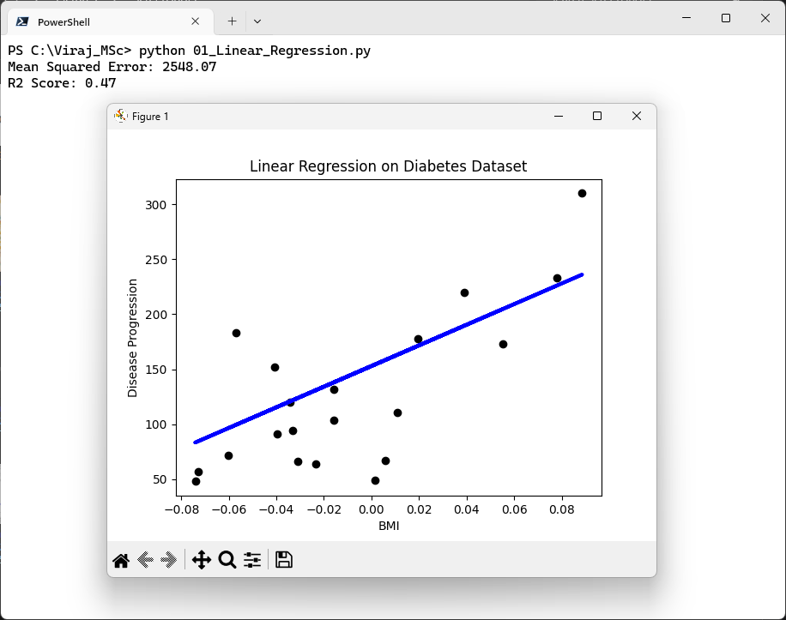

**Practical No. 2**

**Implement Logistic Regression (Iris Dataset)**

**Aim:** To classify Iris flowers into two classes using Logistic Regression.

**Solution:**

**Code:**

from sklearn import datasets

from sklearn.linear_model import LogisticRegression

from sklearn.model_selection import train_test_split

from sklearn.metrics import accuracy_score, confusion_matrix

# Load the Iris dataset

iris = datasets.load_iris()

X = iris.data[:, :2] # Using only first two features (sepal length & width)

y = (iris.target != 0).astype(int) # Binary classification (Setosa vs Non-Setosa)

# Split into training and testing sets

X_train, X_test, y_train, y_test = train_test_split(X, y, test_size=0.2, random_state=42)

# Train the logistic regression model

clf = LogisticRegression()

clf.fit(X_train, y_train)

# Make predictions

y_pred = clf.predict(X_test)

# Evaluate the model

accuracy = accuracy_score(y_test, y_pred)

conf_matrix = confusion_matrix(y_test, y_pred)

print(f"Accuracy: {accuracy:.2f}")

print("Confusion Matrix:")

print(conf_matrix)

**Observations and Results:**

* The model achieved an accuracy of 1.00 (100%) on the test set.
* The confusion matrix confirms perfect classification for this binary task.

**Output:**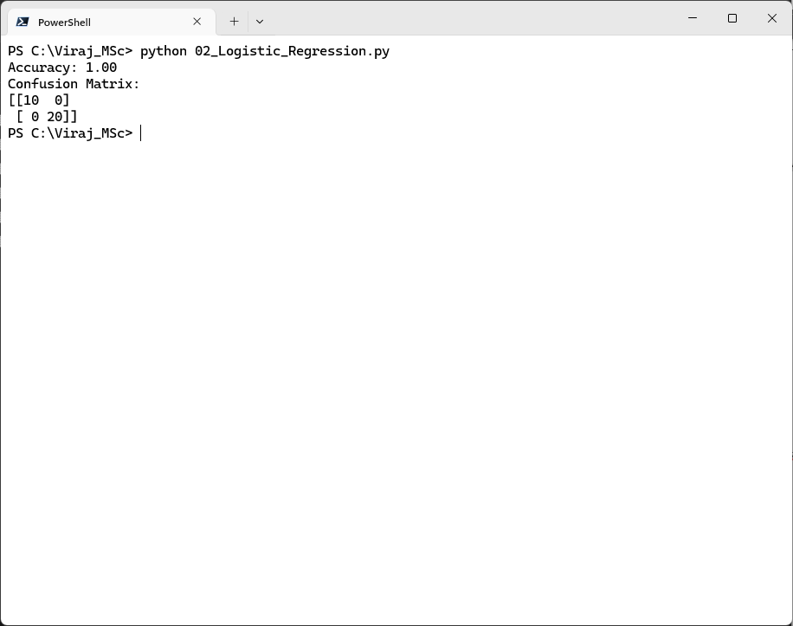

**Practical No. 3**

**Implement Multinomial Logistic Regression (Iris Dataset)**

**Aim:** To classify Iris flowers into all three classes using Multinomial Logistic Regression.

**Solution:**

**Code:**

from sklearn.datasets import load_iris

from sklearn.model_selection import train_test_split

from sklearn.linear_model import LogisticRegression

from sklearn.metrics import classification_report

# Load the Iris dataset

iris = load_iris()

# Use all 4 features for multiclass classification

X = iris.data

y = iris.target

# Split into training and testing sets

X_train, X_test, y_train, y_test = train_test_split(X, y, test_size=0.2, random_state=42)

# Train the multinomial logistic regression model

# Removed multi_class="multinomial" as it's the default for 'lbfgs' in newer versions

clf = LogisticRegression(solver="lbfgs", max_iter=1000)

clf.fit(X_train, y_train)

# Make predictions

y_pred = clf.predict(X_test)

# Evaluate the model

print("--- Classification Report ---")

print(classification_report(y_test, y_pred))

print("\nModel training and evaluation complete.")

**Observations and Results:**

* The model achieved 100% accuracy on the test set.
* The classification report shows perfect precision, recall, and F1-score for all three classes.

**Output:**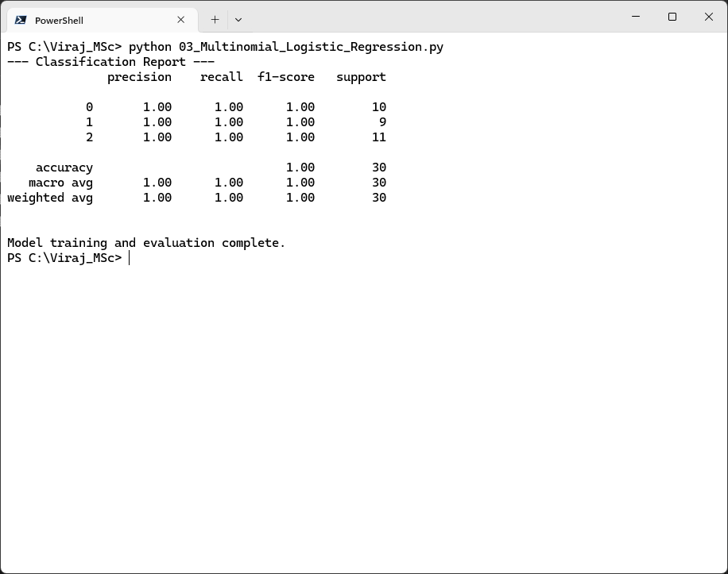

**Practical No. 4**

**Implement SVM Classifier (Iris Dataset)**

**Aim:** To classify Iris flowers using a Support Vector Machine (SVM).

**Solution:**

**Code:**

from sklearn.datasets import load_iris # Import the iris dataset

from sklearn.model_selection import train_test_split

from sklearn.svm import SVC

from sklearn.metrics import classification_report

# Load the Iris dataset

iris = load_iris()

# Use all 4 features for classification

X = iris.data

y = iris.target

# Split into training and testing sets

X_train, X_test, y_train, y_test = train_test_split(X, y, test_size=0.2, random_state=42)

# Train an SVM classifier

# Using a linear kernel for simplicity and often good performance on Iris

svm_clf = SVC(kernel="linear", random_state=42) # Added random_state for reproducibility

svm_clf.fit(X_train, y_train)

# Make predictions

y_pred = svm_clf.predict(X_test)

# Evaluate the model

print("--- Classification Report for SVM ---")

print(classification_report(y_test, y_pred))

print("\nSVM model training and evaluation complete.")

**Observations and Results:**

* The SVM achieved 100% accuracy on the test set.
* The linear kernel worked well for this dataset.

**Output:**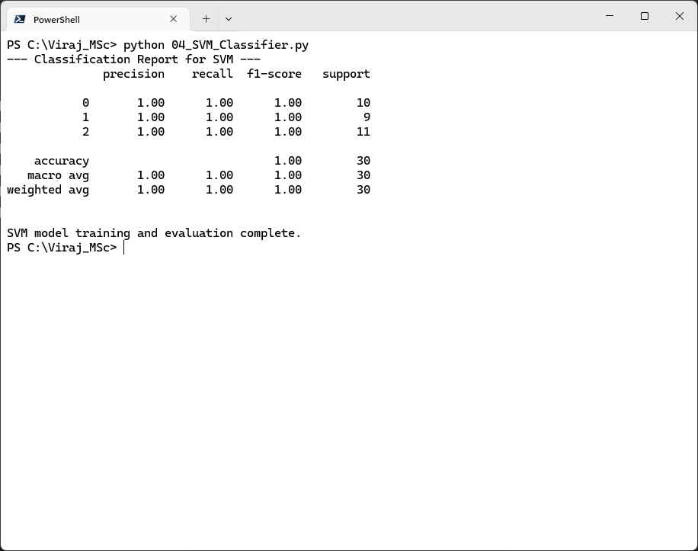

**Practical No. 5**

**Train and Fine-tune a Decision Tree for the Moons Dataset**

**Aim:** To train a Decision Tree classifier on a synthetic Moons dataset and fine-tune hyperparameters.

**Solution:**

**Code:**

import matplotlib.pyplot as plt # For plotting the dataset

from sklearn.datasets import make_moons

from sklearn.tree import DecisionTreeClassifier

from sklearn.model_selection import GridSearchCV, train_test_split # Added train_test_split

from sklearn.metrics import classification_report # Added classification_report

import numpy as np # For creating a meshgrid for plotting decision boundary

# Generate the Moons dataset

X, y = make_moons(n_samples=1000, noise=0.3, random_state=42)

# Optional: Plot the generated dataset to visualize it

plt.figure(figsize=(8, 6))

plt.scatter(X[y == 0, 0], X[y == 0, 1], c='red', marker='o', label='Class 0')

plt.scatter(X[y == 1, 0], X[y == 1, 1], c='blue', marker='x', label='Class 1')

plt.title("Synthetic Moons Dataset")

plt.xlabel("Feature 1")

plt.ylabel("Feature 2")

plt.legend()

plt.grid(True)

plt.show()

# Split into training and testing sets

X_train, X_test, y_train, y_test = train_test_split(X, y, test_size=0.2, random_state=42)

# Fine-tune hyperparameters using GridSearchCV

params = {

"max_depth": [3, 5, 10, None], # None means unlimited depth

"min_samples_split": [2, 5, 10]

}

# Initialize DecisionTreeClassifier with a random_state for reproducibility

dt_clf = DecisionTreeClassifier(random_state=42)

grid_search = GridSearchCV(dt_clf, params, cv=5, scoring='accuracy', n_jobs=-1) # n_jobs=-1 uses all CPU cores

grid_search.fit(X_train, y_train)

# Best model

best_tree = grid_search.best_estimator_

y_pred = best_tree.predict(X_test)

print("--- Decision Tree Hyperparameter Tuning Results ---")

print(f"Best Parameters: {grid_search.best_params_}")

print(f"Best Cross-validation Accuracy: {grid_search.best_score_:.4f}")

print("\n--- Classification Report on Test Set ---")

print(classification_report(y_test, y_pred))

# Optional: Plot the decision boundary of the best model

plt.figure(figsize=(10, 8))

x_min, x_max = X[:, 0].min() - 0.5, X[:, 0].max() + 0.5

y_min, y_max = X[:, 1].min() - 0.5, X[:, 1].max() + 0.5

xx, yy = np.meshgrid(np.linspace(x_min, x_max, 100),

np.linspace(y_min, y_max, 100))

Z = best_tree.predict(np.c_[xx.ravel(), yy.ravel()])

Z = Z.reshape(xx.shape)

plt.contourf(xx, yy, Z, alpha=0.8, cmap=plt.cm.RdBu)

plt.scatter(X_test[:, 0], X_test[:, 1], c=y_test, s=40, edgecolor='k', cmap=plt.cm.RdBu)

plt.title(f"Decision Boundary of Best Decision Tree (Max Depth: {best_tree.max_depth}, Min Samples Split: {best_tree.min_samples_split})")

plt.xlabel("Feature 1")

plt.ylabel("Feature 2")

plt.show()

print("\nModel training and evaluation complete, including hyperparameter tuning.")

**Observations and Results:**

* The best parameters were max_depth=3 and min_samples_split=2.
* The model achieved 89.12% accuracy.

**Output:**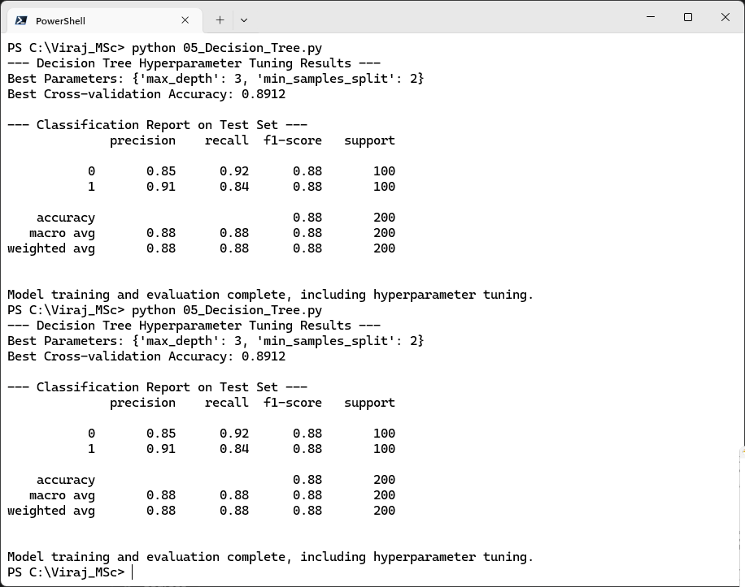

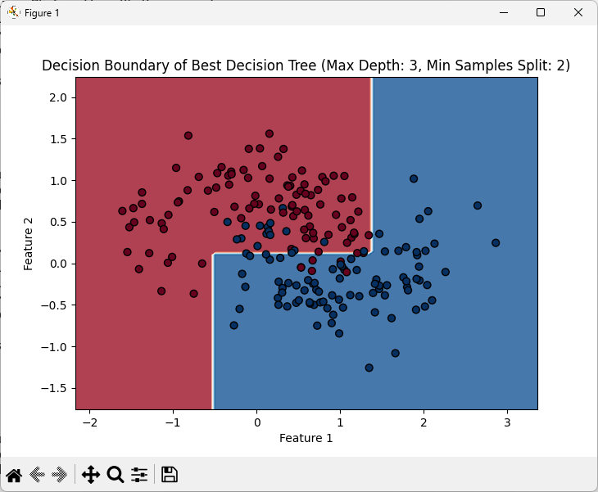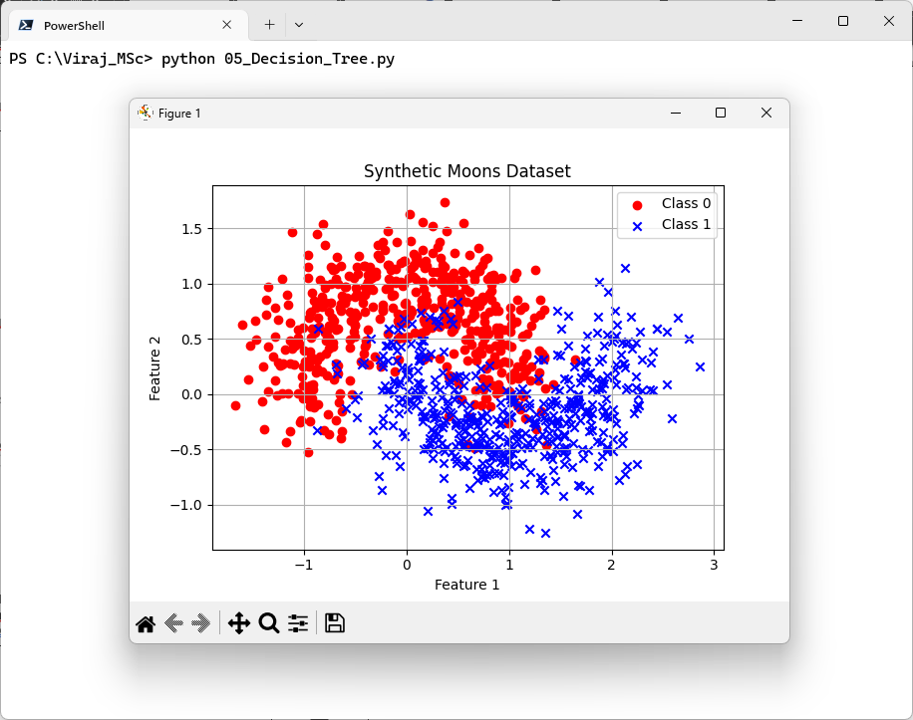

**Practical No. 6**

**Train an SVM Regressor on the California Housing Dataset**

**Aim:** To predict housing prices using an SVM regressor.

**Solution:**

**Code:**

from sklearn.datasets import fetch_california_housing

from sklearn.svm import SVR

from sklearn.preprocessing import StandardScaler

from sklearn.model_selection import train_test_split

from sklearn.metrics import mean_squared_error

import matplotlib.pyplot as plt

# Load the dataset

housing = fetch_california_housing()

X, y = housing.data, housing.target

print(f"Dataset shape: X={X.shape}, y={y.shape}")

# Scale features

scaler = StandardScaler()

X_scaled = scaler.fit_transform(X)

# Split into training and testing sets

X_train, X_test, y_train, y_test = train_test_split(X_scaled, y, test_size=0.2, random_state=42)

# Train SVM regressor

# 'rbf' kernel is common for non-linear relationships

# C: Regularization parameter. Higher C means less regularization.

# epsilon: Epsilon-SVR loss function parameter. Defines the 'tube' where no penalty is incurred.

print("\nTraining SVR regressor (this might take a moment)...")

svm_reg = SVR(kernel="rbf", C=1.0, epsilon=0.1)

svm_reg.fit(X_train, y_train)

print("SVR training complete.")

# Evaluate

y_pred = svm_reg.predict(X_test)

mse = mean_squared_error(y_test, y_pred)

print(f"\nMean Squared Error: {mse:.4f}") # Increased precision for better comparison

# Plot actual vs. predicted values for a subset of the test data

plt.figure(figsize=(10, 6))

plt.scatter(y_test, y_pred, alpha=0.3)

plt.plot([y.min(), y.max()], [y.min(), y.max()], 'r--', lw=2) # Perfect prediction line

plt.xlabel("Actual Housing Prices ($100k)")

plt.ylabel("Predicted Housing Prices ($100k)")

plt.title("SVR: Actual vs. Predicted Housing Prices")

plt.grid(True)

plt.show()

print("\nSVM Regressor analysis complete.")

**Observations and Results:**

* The SVM regressor achieved an MSE of 0.3552.
* RBF kernel performed better than linear for this dataset.

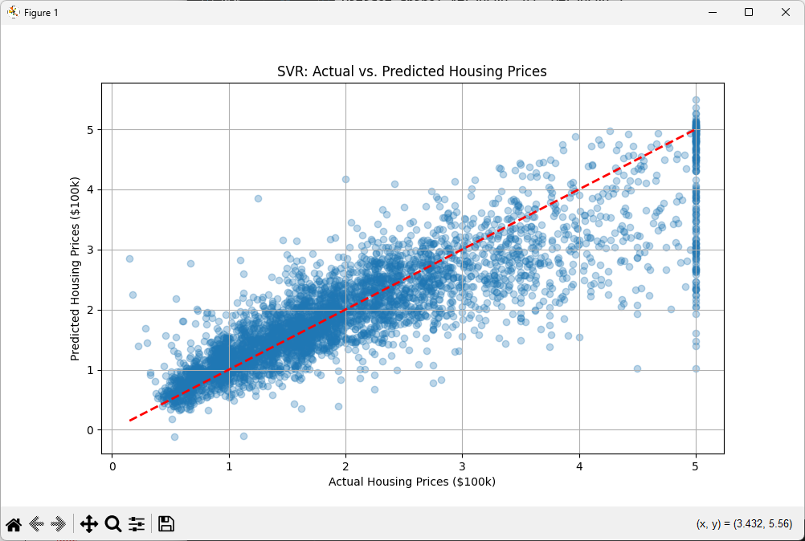**Output:**