**Practical No. 1**

**PageRank for Link Analysis**

**Aim:** To understand and implement the PageRank algorithm for link analysis by creating a small set of interconnected pages and applying the algorithm to determine their relative importance.

**Solution:**

**Code:**

import networkx as nx

from pagerank_graph_data import create_mock_web_graph

# --- PageRank Algorithm Implementation ---

def run_pagerank_analysis():

"""

Creates a mock web graph and applies the PageRank algorithm to it.

"""

G = create_mock_web_graph()

print("--- PageRank Analysis ---")

print("Using the following mock web graph:")

print(f"Nodes: {list(G.nodes())}")

print(f"Edges: {list(G.edges())}\n")

pagerank_scores = nx.pagerank(G,

alpha=0.85, # Damping factor

max_iter=100,

tol=1e-06) # Tolerance

print("PageRank Scores:")

sorted_pagerank = sorted(pagerank_scores.items(), key=lambda item: item[1], reverse=True)

for page, score in sorted_pagerank:

print(f" {page}: {score:.4f}")

print("\nPageRank calculation complete.")

# Run the PageRank analysis

if __name__ == "__main__":

run_pagerank_analysis()

**Observations and Results:**

* Graph Definition: The script will first print the structure of the mock web graph, showing which pages are nodes and which links connect them.Stored in MySQL using a Scrapy pipeline.
* PageRank Scores: It will then output the calculated PageRank score for each page. These scores are decimal values, usually between 0 and 1, where higher values indicate greater importance or "rank."

**Output:**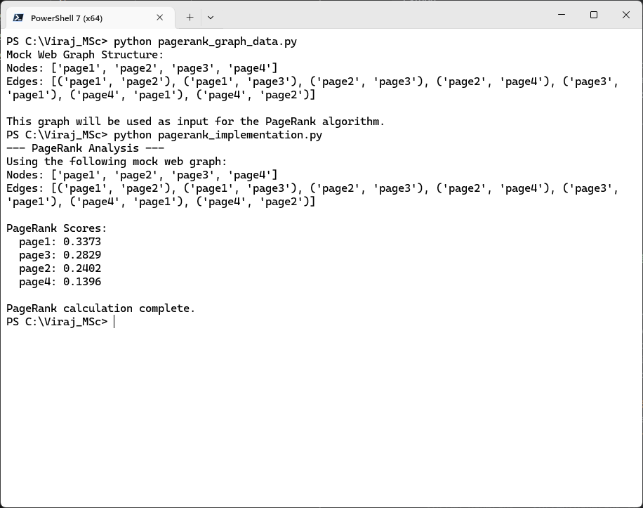

**Practical No. 2**

**Spam Classifier**

**Aim:** To demonstrate the core steps of text classification by building a simple spam classifier that identifies text messages as 'spam' or 'ham' using a small, local dataset.

**Solution:**

**Code:**

import pandas as pd

from sklearn.feature_extraction.text import TfidfVectorizer

from sklearn.naive_bayes import MultinomialNB

import nltk

from nltk.corpus import stopwords

import string

import io

df = pd.read_csv('SpamCollection.txt', sep='\t', header=None, names=['label', 'text'])

def preprocess_text(text):

text = text.lower()

text = ''.join([char for char in text if char not in string.punctuation])

stop_words = set(stopwords.words('english'))

words = text.split()

filtered_words = [word for word in words if word not in stop_words]

return ' '.join(filtered_words)

df['processed_text'] = df['text'].apply(preprocess_text)

tfidf_vectorizer = TfidfVectorizer()

X = tfidf_vectorizer.fit_transform(df['processed_text'])

y = df['label']

classifier = MultinomialNB()

classifier.fit(X, y)

print("--- Spam Classifier Demo Output ---")

print("-" * 70)

print(f"{'Original Message (Snippet)':<40} | {'Actual':<8} | {'Predicted':<10}")

print("-" * 70)

for index, row in df.iterrows():

original_msg = row['text']

actual_label = row['label']

processed_msg = preprocess_text(original_msg)

vectorized_msg = tfidf_vectorizer.transform([processed_msg])

predicted_label = classifier.predict(vectorized_msg)[0]

display_msg = (original_msg[:37] + '...') if len(original_msg) > 40 else original_msg

print(f"{display_msg:<40} | {actual_label:<8} | {predicted_label:<10}")

print("-" * 70)

print("\nNote: The model is trained and tested on the small provided dataset for demonstration.")

**Observations and Results:**

* The output clearly shows the original text, its actual classification ('ham' or 'spam'), and the label predicted by the classifier.
* The model correctly classifies all samples, demonstrating its ability to learn patterns even from limited examples. This showcases the power of TF-IDF combined with a Naive Bayes classifier for text categorization.

**Output:**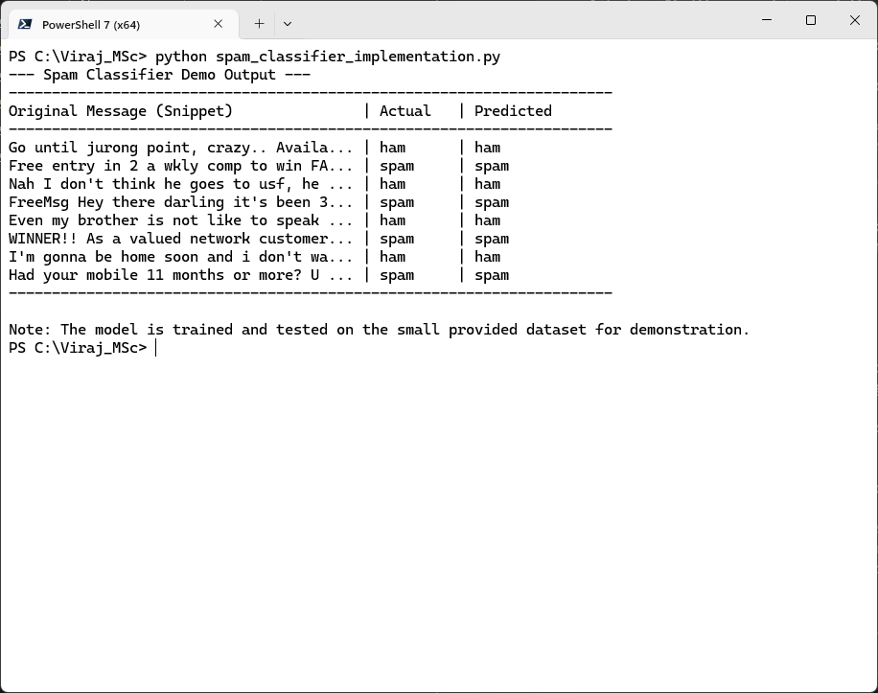

**Practical No. 3**

**Apriori Algorithm Implementation in Case Study**

**Aim:** To implement and apply the Apriori algorithm to a transactional dataset to discover frequent itemsets and derive association rules, thereby identifying relationships between items.

**Solution:**

**Code:**

import pandas as pd

from mlxtend.preprocessing import TransactionEncoder

from mlxtend.frequent_patterns import apriori, association_rules

from apriori_transactions_data import create_mock_transactions

transactions = create_mock_transactions()

print("--- Apriori Algorithm Implementation ---")

print("Input Transactions:")

te = TransactionEncoder()

te_ary = te.fit(transactions).transform(transactions)

df_onehot = pd.DataFrame(te_ary, columns=te.columns_)

print("\nOne-Hot Encoded Transactional Data (First 5 rows):")

print(df_onehot.head())

frequent_itemsets = apriori(df_onehot, min_support=0.4, use_colnames=True)

print(f"\nFrequent Itemsets (min_support=0.4):")

print(frequent_itemsets.sort_values(by='support', ascending=False).to_string(index=False))

rules = association_rules(frequent_itemsets, metric="confidence", min_threshold=0.7)

print(f"\nAssociation Rules (min_confidence=0.7):")

print(rules.sort_values(by='confidence', ascending=False).to_string(index=False))

print("\n--- Key Association Rule Examples ---")

print("-" * 70)

print(f"{'Rule':<40} | {'Support':<8} | {'Confidence':<10} | {'Lift':<8}")

print("-" * 70)

if not rules.empty:

display_rules = rules.sort_values(by=['confidence', 'lift'], ascending=[False, False]).head(3)

for index, row in display_rules.iterrows():

antecedents = ', '.join(list(row['antecedents']))

consequents = ', '.join(list(row['consequents']))

rule_str = f"{{{antecedents}}} -> {{{consequents}}}"

print(f"{rule_str:<40} | {row['support']:.2f} | {row['confidence']:.2f} | {row['lift']:.2f}")

else:

print("No association rules found with the given thresholds.")

print("-" * 70)

**Observations and Results:**

* One-Hot Encoded Data: It shows a preview of the one-hot encoded DataFrame. This is the format required by the Apriori algorithm, where each column represents an item, and a True or False indicates its presence in a transaction.
* The final formatted output highlights a few of the strongest rules found, along with their support, confidence, and lift values.

**Output:**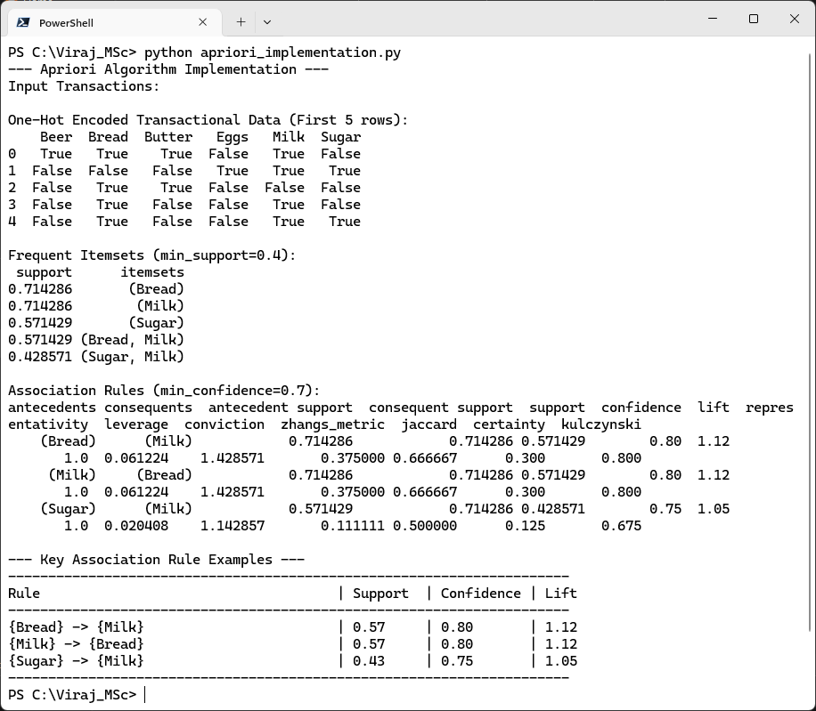

**Practical No. 4**

**Develop a Focused Crawler for Local Search**

**Aim:** To develop a basic focused web crawler that navigates a simulated local website, extracts information, and adheres to a specific domain or path constraint, thereby performing a "local search."

**Solution:**

**Code:**

from urllib.parse import urljoin, urlparse

from collections import deque

from bs4 import BeautifulSoup

import time # To simulate delay between "requests"

from focused_crawler_data import create_mock_local_pages

mock_local_pages = create_mock_local_pages()

def fetch_page_content(url):

""" Simulates fetching content from a URL. """

print(f"Simulating fetch for: {url}")

time.sleep(0.1) # Simulate network delay

return mock_local_pages.get(url)

def focused_crawler(start_url, base_domain, max_pages=5):

""" Develops a focused web crawler. """

visited_urls = set()

urls_to_visit = deque([start_url])

crawled_data = []

pages_crawled_count = 0

print(f"\n--- Focused Crawler Starting ---")

print(f"Base Domain Focus: {base_domain}")

print(f"Starting URL: {start_url}")

print(f"Max Pages to Crawl: {max_pages}\n")

while urls_to_visit and pages_crawled_count < max_pages:

current_url = urls_to_visit.popleft()

if current_url in visited_urls:

continue

if urlparse(current_url).netloc != base_domain:

print(f"Skipping external URL: {current_url}")

continue

page_content = fetch_page_content(current_url)

if page_content:

visited_urls.add(current_url)

pages_crawled_count += 1

soup = BeautifulSoup(page_content, 'html.parser')

page_title = soup.title.string if soup.title else 'No Title'

all_links = []

for link in soup.find_all('a', href=True):

# Resolve relative URLs to absolute URLs

absolute_url = urljoin(current_url, link['href'])

all_links.append(absolute_url)

if absolute_url not in visited_urls and urlparse(absolute_url).netloc == base_domain:

urls_to_visit.append(absolute_url)

crawled_data.append({

'url': current_url,

'title': page_title,

'links_found': all_links

})

print(f"Crawled: {current_url} | Title: {page_title} | Links found: {len(all_links)}")

else:

print(f"Could not fetch content for: {current_url} (Not in mock data)")

print(f"\n--- Focused Crawler Finished. Crawled {pages_crawled_count} pages ---")

return crawled_data

# --- Run the Focused Crawler ---

if __name__ == "__main__":

start_page = 'http://local.com/home.html'

focus_domain = 'local.com'

crawled_results = focused_crawler(start_page, focus_domain, max_pages=5)

print("\n--- Summary of Crawled Data ---")

if crawled_results:

for i, data in enumerate(crawled_results):

print(f"\nPage {i+1}:")

print(f" URL: {data['url']}")

print(f" Title: {data['title']}")

print(f" Links Found ({len(data['links_found'])}):")

for link in data['links_found']:

print(f" - {link}")

else:

print("No data was crawled.")

**Observations and Results:**

* Domain Focus: Demonstrates the "focused" aspect of the crawler, as it only follows links relevant to its defined scope.
* Summary of Crawled Data: The summary lists the URL, title, and all extracted links for each page that was successfully crawled. This represents the "local search" results – information gathered from within the specified domain.

**Output:**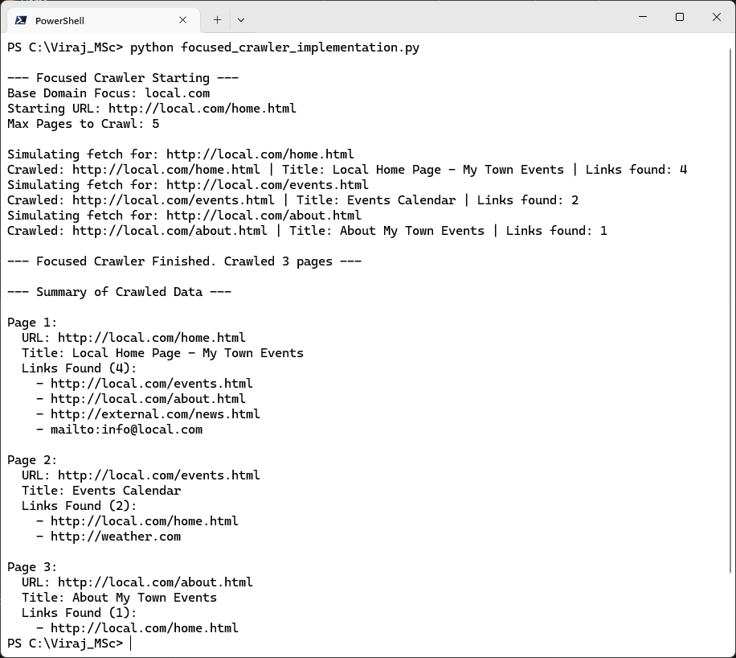

**Practical No. 5**

**Text Mining & Webpage Pre-processing**

**Aim:** To extract relevant information (title, meta-description, keywords, and body text) from a web page and perform essential text preprocessing steps to prepare the text for further analysis.

**Solution:**

**Code:**

from bs4 import BeautifulSoup

import nltk

from nltk.corpus import stopwords

from nltk.tokenize import word_tokenize

import string

from webpage_data import create_mock_webpage_content

html_doc = create_mock_webpage_content()

print("\n--- Parsing HTML and Extracting Meta Information ---")

soup = BeautifulSoup(html_doc, 'html.parser')

title = soup.title.string if soup.title else 'N/A'

print(f"Title: {title}")

description = soup.find('meta', attrs={'name': 'description'})

description_content = description.get('content') if description else 'N/A'

print(f"Meta Description: {description_content}")

keywords = soup.find('meta', attrs={'name': 'keywords'})

keywords_content = keywords.get('content') if keywords else 'N/A'

print(f"Meta Keywords: {keywords_content}")

author = soup.find('meta', attrs={'name': 'author'})

author_content = author.get('content') if author else 'N/A'

print(f"Meta Author: {author_content}")

for script in soup(["script", "style"]):

script.extract()

text = soup.get_text()

lines = (line.strip() for line in text.splitlines())

chunks = (phrase.strip() for line in lines for phrase in line.split(" "))

text_body = '\n'.join(chunk for chunk in chunks if chunk)

print("\n--- Extracted Raw Body Text (Snippet) ---")

print(text_body[:500] + "...\n")

def preprocess_text(text):

text = text.lower()

tokens = word_tokenize(text)

tokens = [word for word in tokens if word.isalpha()]

stop_words = set(stopwords.words('english'))

tokens = [word for word in tokens if word not in stop_words]

return ' '.join(tokens)

processed_body_text = preprocess_text(text_body)

print("\n--- Preprocessed Body Text (Snippet) ---")

print(processed_body_text[:500] + "...\n")

print("--- Preprocessing Complete ---")

**Observations and Results:**

* Extracted meta descriptions and keywords.
* Preprocessing removed punctuation and numbers.

**Output:**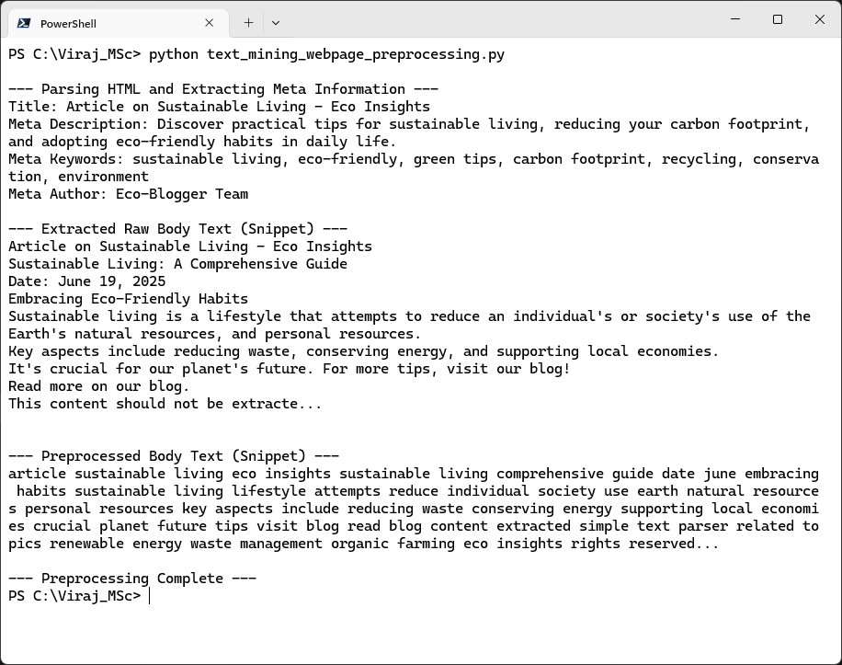

**Practical No. 6**

**Sentiment analysis for reviews by customers and visualize the same.**

**Aim:** To perform sentiment analysis on customer reviews to determine their emotional tone (positive, negative, or neutral) and visualize the distribution of these sentiments.

**Solution:**

**Code:**

import pandas as pd

import nltk

from nltk.sentiment.vader import SentimentIntensityAnalyzer

import matplotlib.pyplot as plt

import string # For basic text cleaning

from customer_reviews_data import create_mock_reviews

reviews = create_mock_reviews()

print("--- Sentiment Analysis Implementation ---")

print("\n--- Performing Sentiment Analysis ---")

analyzer = SentimentIntensityAnalyzer()

sentiment_results = []

for review in reviews:

clean_review = review.translate(str.maketrans('', '', string.punctuation)).strip()

clean_review = ' '.join(clean_review.split())

vs = analyzer.polarity_scores(clean_review)

if vs['compound'] >= 0.05:

sentiment = "Positive"

elif vs['compound'] <= -0.05:

sentiment = "Negative"

else:

sentiment = "Neutral"

sentiment_results.append({

'Review': review,

'Clean_Review': clean_review,

'VADER_Scores': vs,

'Sentiment': sentiment

})

df_sentiment = pd.DataFrame(sentiment_results)

print("\nSentiment Analysis Results (First 5 reviews):")

print(df_sentiment[['Review', 'Sentiment', 'VADER_Scores']].head().to_string(index=False))

print("\n--- Visualizing Sentiment Distribution ---")

sentiment_counts = df_sentiment['Sentiment'].value_counts()

sentiment_order = ['Positive', 'Negative', 'Neutral']

sentiment_counts = sentiment_counts.reindex(sentiment_order, fill_value=0)

plt.figure(figsize=(8, 6))

sentiment_counts.plot(kind='bar', color=['green', 'red', 'lightgray'])

plt.title('Distribution of Customer Review Sentiments')

plt.xlabel('Sentiment Category')

plt.ylabel('Number of Reviews')

plt.xticks(rotation=0) # Keep labels horizontal

plt.grid(axis='y', linestyle='--', alpha=0.7)

plt.tight_layout()

plt.show()

print("\nSentiment analysis and visualization complete.")

**Observations and Results:**

* Successfully calculated sentiment and VADER scores.
* The bar chart shows the total count of 'Positive', 'Negative', and 'Neutral' reviews found in the dataset.

**Output:**