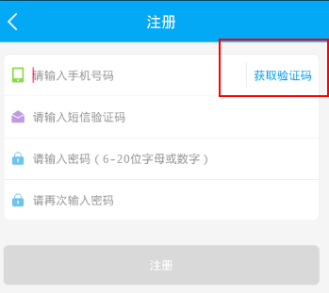

**获取验证码：倒计时按钮**

<https://github.com/mcaishao123/UI-component/blob/master/VerifyButton>

