Logging Tips Use Case

Document Information

|  |  |
| --- | --- |
| **Document Title** | Logging Tips Use Case |
| **Document Owner** | Peter McAllister |
| **Version** | First |
| **Status** | Completed |
| **Date** | December 12th, 2020 |

1. Brief Description

This use case is for entering tips received in a day or during a shift into a database that can store those tips for future reference. The use case ends once all tips have been logged into the MySQL database.

1. Actors

* User
* Browser
* Java Program
* Tomcat Server
* MySQL Database

1. Pre-Conditions

* A tip has been received by the user

1. Basic Flow
2. Launch Java Server
3. Start the tip tracker
4. Enter the Order ID, Total Sale Amount, and Tip Amount
5. Log entry
6. Log all entries into database
7. Close server
8. Alternate/Exception Flows

3a – If inputs do not meet system requirements the User is asked to try again – Restarts step 3

4a – The User can opt to re-enter tip – Returns to step 3

5a – The User can opt to delete all of today’s entries – Use Case ends

1. Post Conditions

* All tips are logged into a MySQL database to be referenced at a later time.

1. Visual Model

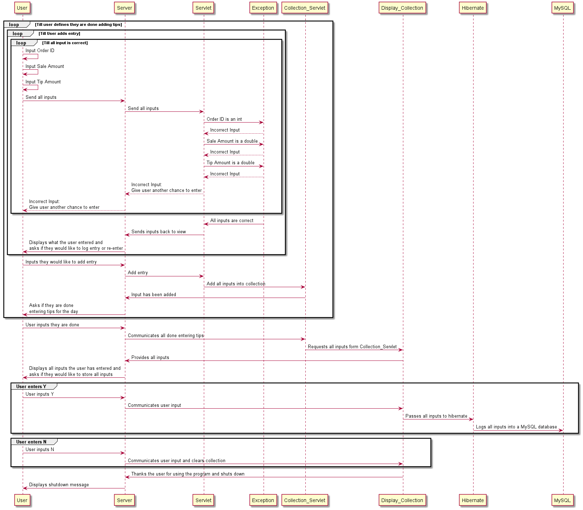

Revision History

|  |  |  |  |  |
| --- | --- | --- | --- | --- |
| V. | Date | Author | Description | Status |
| 1 | 12/12/2020 | Peter McAllister | Original version | Completed |
|  |  |  |  |  |