Biologically Inspired Computation – Coursework 2

Introduction

The aim of this coursework is to highlight how changes in parameter values within Genetic Programming (**GP**) can affect the overall fitness and solutions obtained by the method. Various tests were performed using the Java based evolutionary computation research system – ECJ.

For all tests, three different groups of parameter were explored: the evaluation budget, function set and depth constraint groups. Tests were performed on two of the provided parameter files, *sextic regression* and *santa fe ant*. For both problems, the average fitness and hits were calculated over fifty runs over the same parameter. This number of runs was chosen for testing as it was performed by Machado et al (2015) in their experiments.

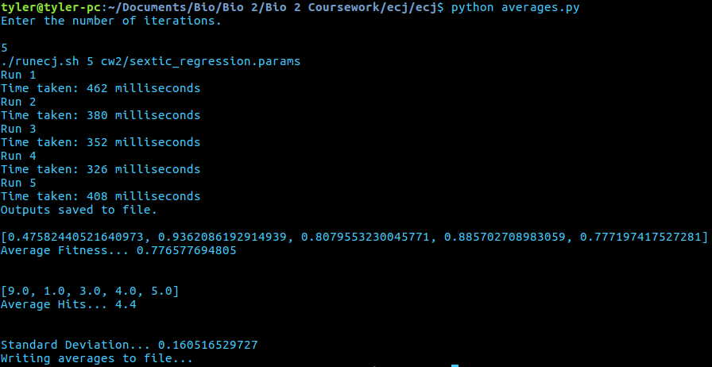To make running the same parameters fifty times a less tedious task I created a Python script (pictured in Figure 1) to run ECJ a defined number of times and calculate the average number of hits, average standardised fitness and the standard deviation of all the obtained results. Additionally, the *runecj.sh* script was edited to calculate the time taken for each run, in milliseconds. My python script and the edited *runecj* script can be found at:<https://github.com/mcallistertyler95/Bio2>

Figure - Script after running 5 iterations

Population Size

The first parameter that was changed was the population. All other parameters were kept at their default values: Generations at 50, maxdepth of mutation and crossover at 17, the size of tournament selection kept at 7 and no changes made to the function set. Population was started at 10 and was gradually risen to 1000, increasing the increment to increase population by after a few iterations. From Figure 2 we can see that as the population was increased the average fitness generally always got lower in the *santa fe ant* problem. As the standardised fitness lowers, we get better results (higher hits). However, for “good” results (fitness below 30) the population had to be greatly increased, reaching 900 individuals. The same test was run on the *sextic regression* problem as shown in Figure 3. Here population had the same effect, steadily decreasing fitness as it was increased, although the fitness reached values much closer to zero by the time 1000 individuals was reached. The book, *“A Field Guide to Genetic Programming”* by Poli, Langdon and McPhee (2008) states that *“the most important control parameter is the population size”*, the results obtained in Figure 2 and 3 reflect this as solely raising the population leads to lower fitness.

Figure - Population Increasing

Generations

The second test was increasing generation size; population was kept at 100 and every other parameter was kept at their default values. Generation size was started at 50 and increased by increments of 50 until reaching 550. This rate of increasing generations was similar to that done by Silva et al (2011), where the initial generation value was 50 and was increased to 500. Figure 4 shows the results of increasing generation size in the *santa fe ant* problem.

As the generation size was increased the fitness took a lot longer to fall. The fitness would only steadily fall every 100 generations meaning the number of generations was not as effective at improving the results of the program than the population size was. The average time to run was around *2414.6 milliseconds* with generations set to 500 while the average was *1420.82 milliseconds* with the population set to 1000. From this we can observe that generations are more computationally expensive than population.

Figure 5 highlights our previous conclusion in that the fitness is overall not largely affected by the increase in generation alone. Even more interestingly the results in *sextic regression* appear to be almost unaffected by the increase in the number of generations. By increasing the number of generations, the number of iterations of newly generated population, mutation, crossover and tournament selection increases but if the number of individuals is low, as it was here then our results will generally not see a large change. By using ideal generation and population values together the fitness will improve overall because the search space for individuals increases as well as the number of iterations for evaluating the best individuals and creating new ones. To come to this conclusion, I ran two experiments using the santa fe ant problem with my script. The first experiment had generations set to 500 and population to 1000, the results are in Figure 6. While the second had generations set to 50 and population to 1000, shown in Figure 7.

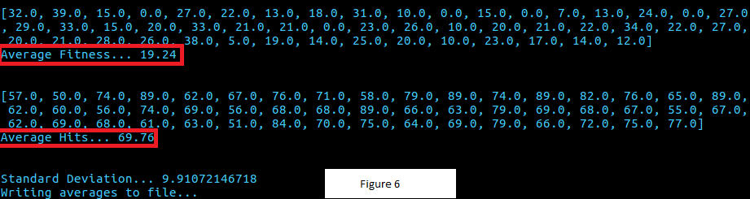

As shown, the average fitness is much lower in Figure 6 than in Figure 7, proving that having a high number of generations and population can be beneficial.

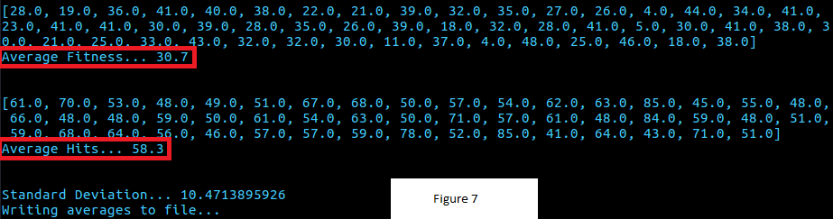

Mutation and Crossover Max Depth

The max depth for mutation and crossover were treated as one parameter so their values were kept the same during each experiment. Generations was set to a constant 500 for each experiment and population to 100, while other parameters were kept to default. Figure 8 shows the effect of mutation on the *santa fe ant* problem and 9 shows its effects on *sextic regression*. The mutation and crossover showed the most effect on decreasing the fitness values when the max depth was set between 1 to 5, once it reached 8 it began to converge for both programs.

The largest jump in fitness decreasing was when the max depth for mutation and crossover was 8. The fitness does not dramatically decrease at any point after this. The reason for this may be that for both programs, a maximum depth of 8 is all that is needed for them to reach optimal solutions, anything more than this is unnecessary for finding the best solutions.

Once the maximum depth reaches 20 the execution time for one run of the program is also far greater than a lower max depth. This may be due to the

Function Set Size

The size of the function set was also experimented on for each problem. In *sextic regression* I first removed *sin, cos exp and log* from the function set. As described by, Alvarez (2000) basic operations such as addition, multiplication subtraction and division are capable of approximating sine, cosine, logarithmic and exponential operations. Therefore, I steadily removed each of these from the function set in *sextic regression*. Figure 10 shows the average fitness as each function is removed. Interestingly the fitness is better when sine is removed than when all functions are present. This may mean that in the *sextic regression* problem sine makes it more difficult to obtain optimal results.

As expected and stated by Alvarez (2000), as we remove mathematical operations from the function set it becomes harder to get to optimal solutions as the genetic program will use the functions it has to approximate the missing ones. Here, sine, cosine, exponential, logarithm and multiplication can all be approximated with the addition and subtraction functions but as division is removed the standardised fitness greatly increases and we obtain extremely bad solutions.

For the *santa fe ant* problem the experiment done was slightly different. Only a few chosen members of the function set were removed each time with each experiment instead of continuously removing one as done in Figure 10. The bar chart in Figure 11 below shows how the fitness is effected when the ant has some of its movement options removed.

When *move* is taken out of the function set we can see that without any way of moving from its initial position the ant cannot eat anything within the path, so our fitness is very high and the number of hits is exactly 0. Similar results can be seen when *left* and *right* are removed.

However, when only one function was removed, in this case *left*, the ant was still capable of producing similar results. This is due to a similar concept in the *sextic regression* experiments. With genetic programming, operations within the function set can still be used to approximate actions that are not within it. In this case, when left is removed the ant can still move left in theory, it just needs to take more actions, just as when *iffoodahead* is removed the ant can still move forward and eat food it will just have to use more actions to do it.

References

Poli, R., Langdon, W. and McPhee, N. (2008). *A Field Guide to Genetic Programming*. 1st ed. p.26.

Machado, Penousal et al. *Genetic Programming*. 1st ed. Copenhagen, Denmark 2015. p.161-163

Silva, Sara et al. *Genetic Programming: 14th European Conference*. 1st ed. Torino, Italy 2011 p.30

Alvarez, L. (2000). *Design Optimization Based On Genetic Programming*. Ph.D. Department of Civil and Environmental Engineering, University of Bradford.