Date: 4/23/2019

To: Frank Castle, Lead Consultant, Janzen Consultant Group

From: Martin Campos, Janzen Consultant Group

RE: The connection between the budget of a US movie and how many Facebook likes it receives

Movies have become a very essential part of the entertainment industry. There are a lot of factors that go into making a movie. According to an article by Eric Buchman, he says the gear used to create movies is constantly being improved and upgraded resulting filmmakers always having to upgrade their technology.[1] With all these different factors this results in different movie budgets. The budgets depend on the equipment used, actors hired and many other costs. Once these movies are released there are many different reviews of the movies and on successful, they are. One of these reviews could be the number of likes the movies receives on Facebook. It is important to see the number of likes a movie gets on Facebook because is one of the most popular social media platforms that include many people not just teenagers.

The target population is movies made in the United States. I hypothesize that the budget of a movie does impact the number of likes it receives on Facebook. This memo will show that there is a relationship between the budget a movie made in the United States and the number of Facebook likes it receives but that it is not very substantive.

 To investigate this question, I used the Internet Movie Database (IMDB) data set. This dataset includes budget, country and other measures. The independent variable is the movie budget. The dependent variable is the number of movie Facebook likes it receives. For this question, I narrowed it down to only movies made in the United States. This is because movies that were made in other country have budgets of different currencies and result in more conversions. Therefore, I did a subset of only movies that were made in the USA.

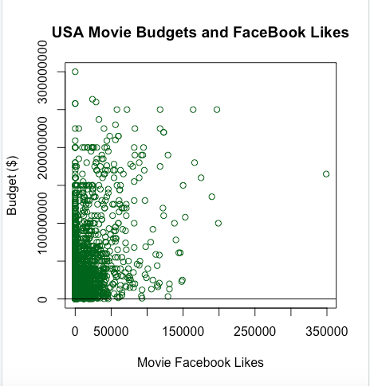The level of alpha I chose was .05. For every additional dollar change in the budget of the movie, corresponds to an average increase of 727.5 Facebook likes. I reject the null hypothesis because the p-value is less than the alpha. The budget of a movie also explained a significant proportion of variance in the number of Facebook likes a movie receives, *R*2 = .1248,

*p* < .001.Percentage of variance in the DV that can be explained by the change in IV.

The findings are not substantively significant because of *R*2 = .1248 which is very small. This study also takes into account the assumptions. I performed the regression diagnostics and through those was able to verify that this study does not violate the assumptions.

These findings can be generalized in that although budget does in fact affect the number of Facebook likes it won’t make a very large difference. This can be applied to filmmakers in that if they want more social media approval a bigger budget could make slight difference.

There are some ways to improve this study like there are many of the movies that having missing values for the number of Facebook likes. This results in missing data. Another aspect that can be improved is the budget. Some of movies have budgets that are in different currencies which will require the user to convert the number into a single form of currency in order to be able to compare.

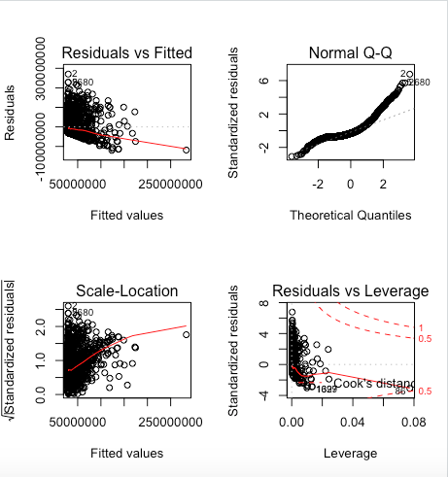

1. Buchman, E.(2014, December 10th) Why are movies more expensive than ever when tech makes them easier to make?. Digital Trends. Retrieved from <https://www.digitaltrends.com/movies/why-hollywood-movies-are-more-expensive-to-make-than-ever/>