Date: 5/14/2019

To: Frank Castle, Lead Consultant, Janzen Consultant Group

From: Martin Campos, Janzen Consultant Group

RE: The connection between the movie budget, the number of Facebook likes of the Director, Primary actor, and another actor in relation to the IMDB score of the movie

Movies have become a very mainstream form of entertainment. They have a large influence on society. According to the article by Siddhi Bahadkar, the author talks about how movies are essential because they can be inspirational and change people’s behaviors. Movies have proven to be one of the best methods of mass communication. Movies allow viewers to escape into the movie and experience from a different point of view.[1] Movies are more than just entertainment, they provide a discussion on topics and open people’s perspective on certain topics and ideas. Therefore it is important to analyze movies and determine the criteria that make up a good movie.

The target population is movies made in the United States. I hypothesize that the budget, the number of Facebook likes of the director, the primary actor and secondary actor all influence the IMDB score of the movie. This memo will show that there is a relationship between the budget, Facebook likes of actor1, actor2, director and the IMDB score.

To investigate this issue I used the Internet Movie Database (IMDB) data set. This dataset has many different measures like budget, the total number of Facebook likes for the cast, duration and many other measures. For this, I had multiple independent variables. These are the budget of the movie, the number of facebook likes on the Facebook page of the Director of the movie, the number of likes on the Facebook page of the primary actor and the number of Facebook likes the facebook page of another actor or secondary actor in the movie. For my dependent variable, I used the IMDB score. I subsetted my data so that only focuses on movies made in the United States. This is to avoid currency differences and avoid currency conversions of other countries. 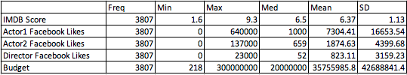

The level alpha I chose was .05. I reject the null hypothesis because all the independent variables are all less than the alpha of .05. Keeping all the other variables constant, for every 1 unit change in the IMDB score, corresponds to an average increase of 902.229 dollars change in the movie budget. For every one unit change in the IMDB score, corresponds is an average increase of 3.846 likes on the Facebook page of Actor 1. For every one unit change in the IMDB score, corresponds to an average increase of 15.332 likes on the Facebook page of Actor 2. For every one unit change in the IMDB score, corresponds to an average increase of 65.048 likes on the Facebook page of Director. The movie budget and the Facebook likes of actor1, actor2, the director also explained a significant proportion of variance in the IMDB score. *R*2 = .5385, *p* < .001. 5.4% of the variance in IMDB score can be explained the change in the Budget and the Facebook likes of actor1, actor2 and, director.

The findings are somewhat substantively significant because the R2 was .5385 which is moderately significant because it is neither too small or too high. This study also takes into account assumptions. I performed the regression diagnostics and through those, I was able to verify that this study does not violate the assumptions.

There are some ways to improve this study. One way to facilitate this study would be to change the scale between the budget and the facebook likes. The budget tends to have really high numbers while the IMDB score has only a range of 1-10. This can be difficult to connect because the budget has a such a high range, therefore, the proportions between the budget as an independent variable and the Facebook like as independent variables in relation to the IMDB score would be difficult to compare. Another way to improve this study would be to expand it to movies form other cou ntries. This would mean that we would have to verify that all the currencies in the dataset are converted to a single common currency in order to be able to use them all. This could then give us information on a global context.

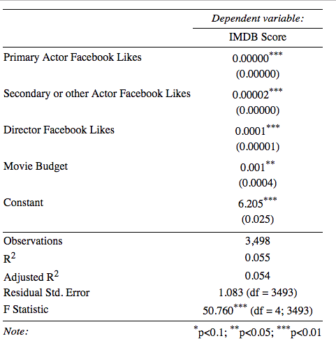

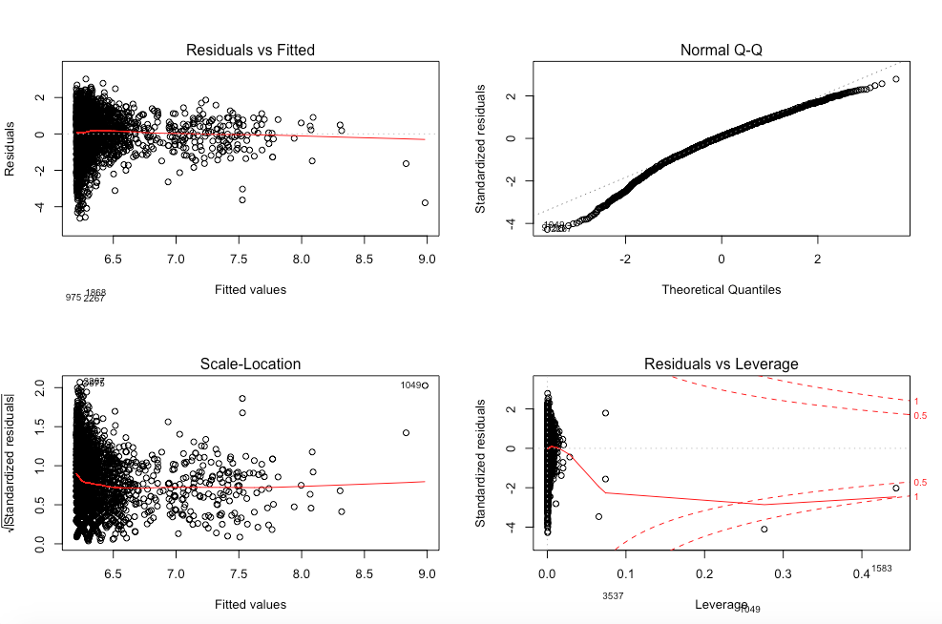

1. Bahadkar, S. (2019, January) Movies, And the Role They Play, Youth Ki Awaaz, Retrieved from <https://www.youthkiawaaz.com/2010/06/movies-and-the-role-they-play/>