U.S. Wildfire Analysis Report

Q1: Have wildfires become more or less frequent over time?

In 1992, the number of incidents are 67,975. The incidents first decreases in 1994, then increases back to 71,472 in 1995. In 1997, the number of incidents are minimum with 61,450. Then the incidents increases to 96,416 in 2000, after that increase, the numbers drop down to 68,261 in 2003. After the drop, the incidents creates a peak with a number of 114,001, then drops to 78,325 in 2009. The numbers increases to 90,552 in 2011, then rolls back to 64,780 in 2013. Finally, the numbers increases back to 74,491 in 2015.

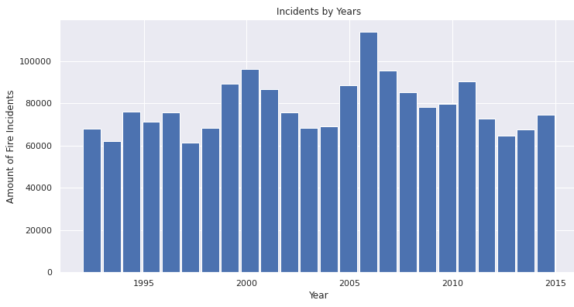
It is hard to determine if the wildfires are becoming more or less frequent from this histogram. To provide a clearer sight, number of incidents are given below in the table with respect to their matched years.

1992 | 1993 | 1994 | 1995 | 1996 | 1997 | 1998 | 1999
67975 | 61989 | 75955 | 71472 | 75574 | 61450 | 68370 | 89363
2000 | 2001 | 2002 | 2003 | 2004 | 2005 | 2006 | 2007
96416 | 86587 | 75656 | 68261 | 69279 | 88604 | 114004 | 95573
2008 | 2009 | 2010 | 2011 | 2012 | 2013 | 2014 | 2015
85378 | 78325 | 79889 | 90552 | 72769 | 64780 | 67753 | 74491
In the graph below, a density estimation is given with the incident frequencies (num. of incidents / 365). The wildfires that are between 1992 and 2000 have more or less similar frequencies, this makes the timeline looking more dense than others in the graph. In 2006, the frequency of incidents rises exceptionally and makes the graph seem more sparse. We can see the minimums are slightly increases. To get a better understanding, we will examine the frequency trend.
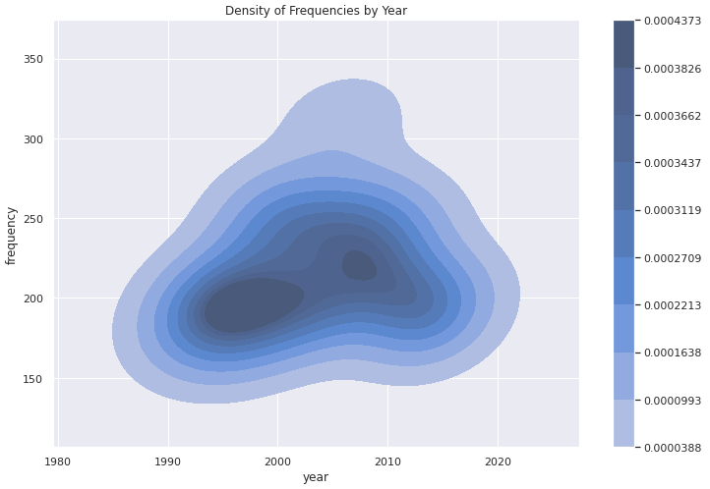

The graph below shows a clearer sight that the frequency of the wildfires, from 1992 to 2015, is in an increasing trend, which proves the frequency of wildfires in U.S. is increasing over time.

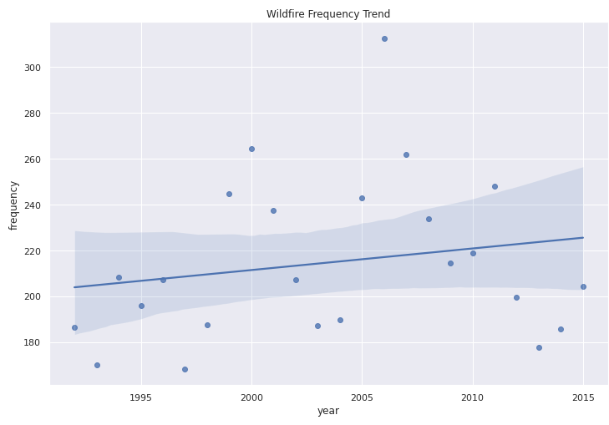

Q2: What counties are the most and least fire-prone?

Q2.1) Fire Size

To understand which counties are the most and least fire-prone, we should also check the fire sizes as well as frequency of reports. First, we will look at the 15 counties with their number of total wildfire sizes by acres.

Elko, NV | Malheur, OR | Owyhee, ID | Yukon-Koyukuk, AK | Idaho, ID
3132882.440 | 1886590.550 | 1834768.900 | 1754427.690 | 1509590.250
Harney, OR | Elmore, ID | Okanogan, WA | Humboldt, NV | Lincoln, NV
1272853.200 | 1159911.300 | 1076506.830 | 992270.260 | 895149.400
Valley, ID | Catron, NM | Chelan, WA | Pershing, NV | Lea, NM
765921.830 | 644717.680 | 627131.590 | 610328.400 | 593666.819

In the graph below, the counties are sorted by the least fire sizes. With respect to the graph we can say Elko, Nevada is the most fire prone by the measure of fire sizes.

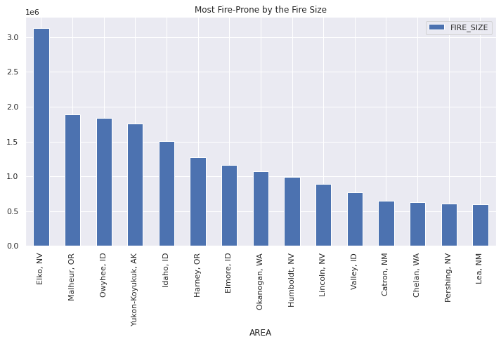

In the graph below, the counties are sorted by the least fire sizes. With respect to the graph we can say Trego, Kansas is the least fire prone by the measure of fire sizes.

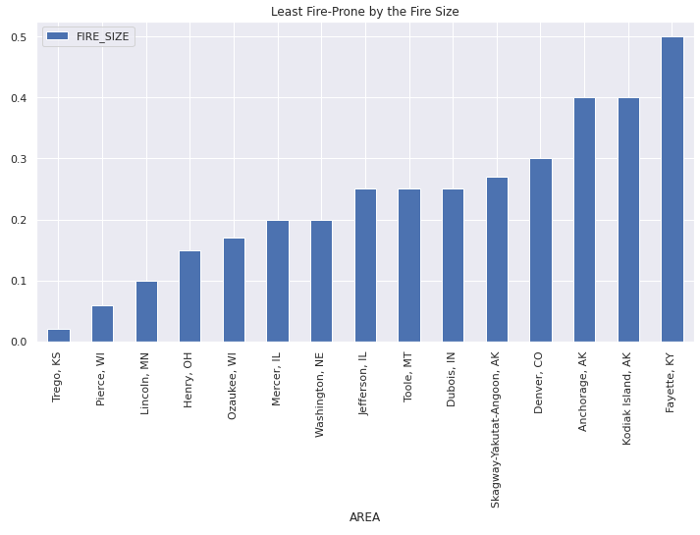
Q2.1) Frequency

To understand which counties are the most and least fire-prone, we now will check the frequency reports. First, we will look at the 15 counties with their number of incident frequencies.

Coconino, AZ | Suffolk, NY | Riverside, CA | Honolulu, HI | Ocean, NJ
7900 | 7595 | 6925 | 6780 | 4941
McCurtain, OK | Idaho, ID | Laurens, GA | St. Louis, MN | Polk, FL
4593 | 4255 | 4246 | 4153 | 4013
Monroe, NY | Williamsburg, SC | Orange, NY | Jackson, OR | Berkeley, SC
3747 | 3732 | 3694 | 3675 | 3610
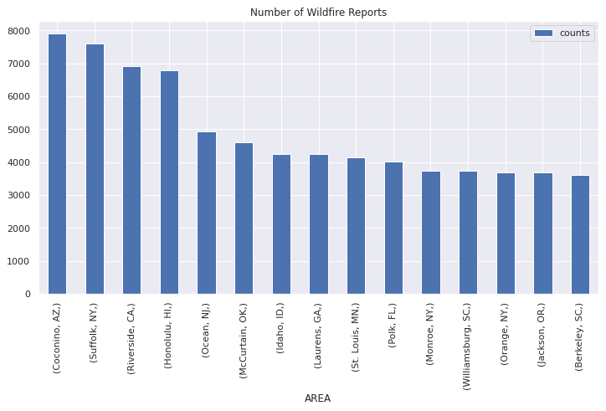

According to the graph given above, Coconino, Arizona is the most fire prone by the number of wildfire reports it have. After Coconino; Suffolk, Riverside and Honolulu are one of the most fire prone counties.

Least fire prone counties with respect to the frequency, they will be listed below if they get lower than 2 reports in a year.

Red Lake, MN | Alfalfa, OK | Craig, OK | Costilla, CO | Madison, OH | Ascension, LA | Concordia, LA | Hamilton, IL | Freeborn, MN | Adams, NE | Henry, OH | Faribault, MN | Hillsdale, MI | Pontotoc, OK | Milwaukee, WI | Daniels, MT | Cuyahoga, OH | Hampton City, VA | Gurabo Municipio, PR | Fayette, KY | Fairfax, VA | Kingfisher, OK | Garden, NE | Jefferson, IL | Washington, NE | Gratiot, MI | Lake, OH | Ozaukee, WI | Lafayette, WI | Owyhee, NV | Cass, IL | Rogers, OK | Kenosha, WI | Buena Vista City, VA | Dubois, IN | Robertson, KY | Canadian, OK | O'Brien, IA | Walworth, WI | Kodiak Island, AK | Douglas, CA | Caddo, OK | Kiowa, OK | Sheridan, MT | Calhoun, IL | Boyd, NE | Pepin, WI | Colonial Heights City, VA | Denver, CO | Platte, MO | Humboldt, IA | Pipestone, MN | Love, OK | Barber, OK | Garvin, OK | Terrebonne, LA | Richland, MT | Ellis, OK | Gibson, IN | Wichita, KS | Lipscomb, OK | Clay, AR | Richmond (city), VA | Lincoln, NE | Lincoln, MN | Berrien, MI | Wells, ND | Todd, SD | Blaine, NE | Toole, MT | Glacier County, MT |

Q3: Given the size, location and date, can you predict the cause of a wildfire?

To predict the cause of a wildfire, the following steps are taken in order: 1) Feature that will be used, 2) Determining which model to train, 3) Training and evaluating the model.

Features:
FIRE_SIZE
STATE
LATITUDE
LONGITUDE
CONT_DOY
CONT_TIME
STAT_CAUSE_DESCR

Models:
DecisionTreeClassifier
ExtraTreeClassifier
BaggingClassifier
RandomForestClassifier
KNeighborsClassifier
GradientBoostingClassifier

Model Performance Comparison
 | Train ACC | Test ACC | Time Cost (sec.)
Decision Tree | 99.9% | 47.5% | 5.37
Extra Tree | 99.9% | 44.1% | 0.59
Bagging | 98.2% | 55.8% | 36.09
Random Forest | 99.9% | 58.9% | 136.33
KNeighbors | 63.1% | 50.1% | 0.85
Gradient Boosting | 52.8% | 52.3% | 7621.54

From the table above, the most promising model is Gradient Boosting with 52.8% of training accuracy and 52.3% of testing accuracy. Decision Tree, Extra Tree, Bagging and Random Forest seems to overfit heavily. The most closer model in terms of performance is Kneighbors. To train a model that predicts the cause of a wildfire, we will choose Gradient Boosting. If the project can’t afford a time cost, we can choose Kneighbors over Gradient Boosting.

Training and Evaluating:

Gradient Boosting Classifier Accuracy and Time Cost
 | Train ACC | Test ACC | Time Cost (sec.)
Gradient Boosting (n_estimators=600) | 57.0% | 56.0% | 7903

From the table, it is obvious that the trained Gradient Model with n_estimators=600 is better than the previous trained models. To evaluate the model further, we will look at the confusion matrix and the classification report.

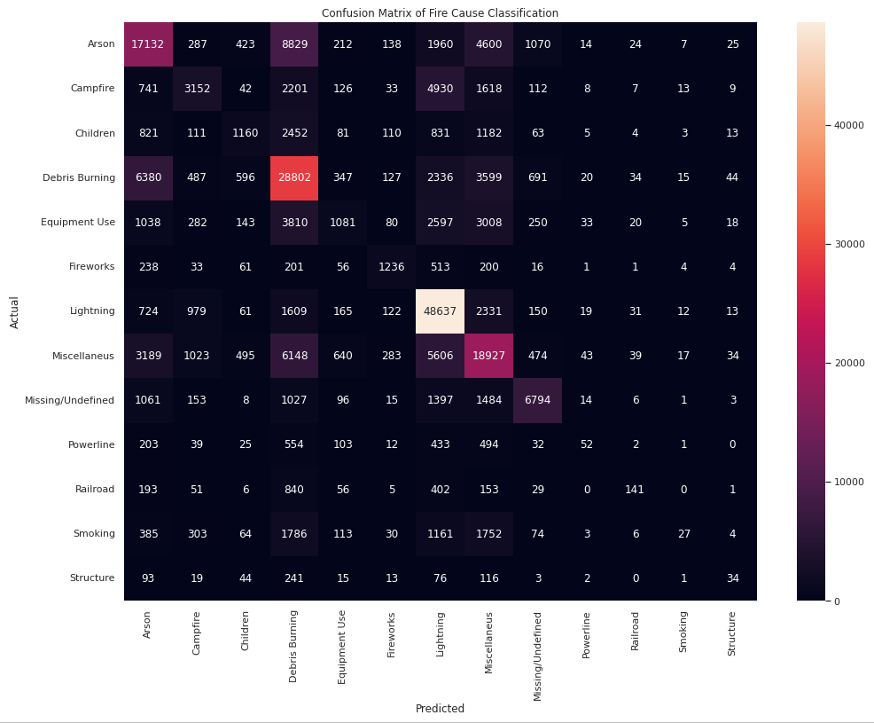

Gradient Boosting Classifier Confusion Matrix Report
 | TP | TN | FP | FN
0 - Arson | 17132 | 177191 | 15066 | 17589
1 - Campfire | 3152 | 210219 | 3767 | 9840
2 - Children | 1160 | 218174 | 1968 | 5676
3 – Debris Burning | 28802 | 153802 | 29698 | 14676
4 -Equipment Use | 1081 | 212603 | 2010 | 11284
5 - Fireworks | 1236 | 223446 | 968 | 1328
6 - Lightning | 48637 | 149883 | 22242 | 6216
7 - Miscellaneus | 18927 | 169523 | 20537 | 17991
8 - Missing/Undefined | 6794 | 211955 | 2964 | 5265
9 - Powerline | 52 | 224866 | 162 | 1898
10 - Railroad | 141 | 224927 | 174 | 1736
11 - Smoking | 27 | 221191 | 79 | 5681
12 – Structure | 34 | 226153 | 168 | 623

From the analysis of confusion matrix, the model seems like successful only at predicting Arson, Lightning, Missing/Undefined classes. Now let’s ook at to a more detailed table which examines sensitivity, specificity, presicion, recall and f1-score.

Gradient Boosting Classifier Classification Report
 | Sensitivity | Specificity | Precision | Recall | F1-Score | Support
0 - Arson | 49.3% | 92.1% | 53% | 49% | 51% | 34721
1 - Campfire | 24.2% | 98.2% | 46% | 24% | 32% | 12992
2 - Children | 16.9% | 99.1% | 37% | 17% | 23% | 6836
3 – Debris Burning | 66.2% | 83.8% | 49% | 66% | 56% | 43478
4 -Equipment Use | 8.7% | 99% | 35% | 9% | 14% | 12365
5 - Fireworks | 48.2% | 99.5% | 56% | 48% | 52% | 2564
6 - Lightning | 88.6% | 87% | 69% | 89% | 77% | 54853
7 - Miscellaneus | 51.2% | 89.1% | 48% | 51% | 50% | 36918
8 - Missing/Undefined | 56.3% | 98.6% | 70% | 56% | 62% | 12059
9 - Powerline | 2.6% | 99.9% | 24% | 3% | 5% | 1950
10 - Railroad | 7.5% | 99.9% | 45% | 8% | 13% | 1877
11 - Smoking | 0.4% | 99.9% | 25% | 0% | 1% | 5708
12 - Structure | 5.1% | 99.9% | 17% | 5% | 8% | 657

The model was pretty unsuccessful on predicting the following wildfire causes: Arson, Campfire, Children, Equipment Use, Fireworks, Miscellaneus, Missing/Undefined, Powerline, Railroad, Smoking and Structure.

The model was successful only on predicting the following wildfire causes: Debris Burning and Lightning.

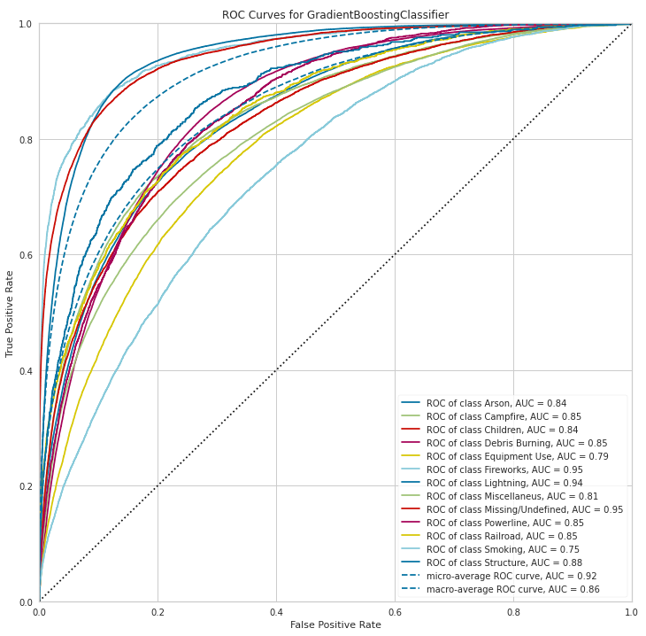
ROC Curve

In conclusion, from looking at the tables and the ROC curve given above we can’t successfully predict the cause of a wildfire.

