Single Nucleotide Polymorphisms Associated with Fasting Blood Glucose Trajectory and Type 2 Diabetes Incidence: A Joint Modelling Approach *(max 48 characters)*

Mickaël Canouil1,2,3 Philippe Froguel1,2,3,4 and Ghislain Rocheleau1,2,3

1University of Lille, UMR 8199 - EGID, F-59000 Lille, France.

2CNRS, UMR 8199, F-59000 Lille, France.

3Institut Pasteur de Lille, F-59000 Lille, France.

4Department of Genomics of Common Disease, Imperial College London, London, United Kingdom.

###### Corresponding authors

Mickaël Canouil, EGID - UMR 8199, Pôle Recherche - 1er étage Aile Ouest, 1 place de Verdun, 59045 Lille CEDEX, France. E-mail: mickael.canouil@cnrs.fr

Ghislain Rocheleau, Maelstrom Research - The Research Institute of the McGill University Health Centre (RI MUHC), 2155 Guy, 4th Floor, Office 458, Montreal, Quebec, H3H 2R9, Canada. E-mail: grocheleau@maelstrom-research.org

# Abstract *(max 250 words)*

In observational cohorts, longitudinal data are collected with repeated measurements at predetermined time points for many biomarkers, along with other covariates measured at baseline. In these cohorts, time until a certain event of interest occurs is commonly reported and very often, a relationship will be observed between a biomarker repeatedly measured over time and that event. Joint models were designed to efficiently estimate statistical parameters by combining a mixed model for the longitudinal biomarker trajectory and a survival model for the event risk, using a set of random effects to account for the link between the two types of data. First, using genotypes assayed with the Metabochip DNA arrays (Illumina) from close to 4,500 subjects recruited in the French cohort D.E.S.I.R. (Données Épidémiologiques sur le Syndrome d’Insulino-Résistance), we assessed the feasibility of implementing the joint modelling approach in a real high-throughput genomic dataset. Second, we checked model consistency based on different simulation scenarios, varying sample size, minor allele frequency, number of repeated measurements and missing data patterns. In our study, the event of interest was onset of type 2 diabetes (T2D), and the longitudinal biomarker repeatedly measured over time was fasting plasma glucose level. To the best of our knowledge, joint models have never been applied into a genetic epidemiology context and could help identify novel loci sharing effects on both glycaemic traits and T2D.

# Key words

joint modelling; genetic association; longitudinal studies

# Introduction

With the increased availability of longitudinal and survival data within prospective cohorts, joint models have emerged to account for both type of data, particularly when dealing with the informative/non-informative dropouts which occur in such cohorts. Joint models have been studied and overviewed in the literature (L. M. Chen, Ibrahim, & Chu, 2011; R. Elashoff, li, & Li, 2016; Anastasios A. Tsiatis & Davidian, 2004; M. S. Wulfsohn & Tsiatis, 1997) and software implementation has been proposed within different software and platforms (Diggle & Kenward, 1994; R. M. Elashoff, Li, & Li, 2008; Proust-Lima, Joly, Dartigues, & Jacqmin-Gadda, 2009; Rizopoulos, 2010; Rizopoulos & Ghosh, 2011; J. Sun, Sun, & Liu, 2007). The main idea behind the joint modelling is: 1) to model efficiently the survival process with a time-varying covariate, accounting for missing data and measurements errors, and 2) to account for informative dropouts in the longitudinal data. To model the two components of a joint model, a linear mixed effects (LME) model and a Cox proportional hazards model (CoxPH), are classically used to, respectively, fit the longitudinal component, and the survival component. Unlike the CoxPH model, in which the time-varying covariate is assumed to be exogenous, i.e not modified by the occurrence of a previous event (Kalbfleisch & Prentice, 2002), the joint modelling framework allows to account for an endogenous time-varying covariate. An example of an endogenous covariate is given by the relationship between fasting glucose and T2D: once T2D is diagnosed, level of fasting glucose is irremediably modified due to medication.

Two approaches can be used for estimation and inference of the model parameters: a "naive" Two-Step (TS) method or a joint likelihood method (JM). The first method consists in estimating the random effects of the trajectory, as provided by a LME model, and including them as a time-varying covariate into a CoxPH model, then using partial likelihood of the CoxPH model for parameter estimation (Therneau & Grambsch, 2000). The second method is based on a joint likelihood of the two components (longitudinal and survival) at the same time. Comparison of these two approaches showed that the latter offers more consistent and efficient estimators than the former (Albert & Shih, 2010a, 2010b). But JM could be challenging to compute, especially achieving convergence at the Expectation-Maximisation (EM) step. Moreover, depending on the number of time points and/or the sample size, the overall computation time can substantially increase.

In this paper, we conducted a comprehensive simulation study to compare two joint model approaches, JM and TS, for joint modelling of the longitudinal and survival components. We also included classical approaches to model the two processes separately, such as LME and CoxPH models, as sometimes used in genome-wide association studies. Our main goal is to show that a joint modelling approach, when compared to separate modelling, might improve statistical power to detect an effect on either, or both, longitudinal and survival processes, while resulting in a bias reduction in parameter estimation. We also compared JM with the TS approach and show that, in the context where highly demanding computation and convergence issues might arise in JM computation, the TS offers a good alternative to JM in a reasonable time span, especially when applied at the genome-scale level. We also investigated and decomposed the computational time required by the R package "JM", on one hand, and by the TS approach combining the R packages "survival" and "nlme", on the other hand.

Finally, we applied these approaches to a real dataset, the prospective D.E.S.I.R. cohort (*Données Épidémiologiques sur le Syndrome d’Insulino-Résistance*), which includes 5,212 individuals with extensive phenotypic measures recorded at 4 different occasions spanning a 9-year follow up (data collected every 3 years). These individuals were genotyped using the Illumina Metabochip DNA array which interrogates nearly 200,000 SNPs. Relying on cross-sectional genome-wide association study designs, the D.E.S.I.R cohort was instrumental in identifying novel loci associated to prevalent type 2 diabetes (T2D) and to blood fasting glucose (FG) level in normoglycemic subjects (Sladek et al., 2007; Rung et al. 2008; Bouatia-Naji et al. 2008). We specifically focused on prediabetes conditions, such as IFG, which is part of the diagnostic definition of T2D (FG > 7.0 mmol/l), and on time-to-onset of T2D, in order to possibly identify loci, novel or published, which simultaneously associate with the risk of developing T2D and with increasing blood FG. Our results were then compared to the genetic variants as reported in the literature (Vaxillaire et al., 2014; Welter et al., 2014), and to the meta-analyses results published by large consortia, such as the DIAGRAM (Morris et al., 2012) or the MAGIC (Dupuis et al., 2010) consortium.

# Methods

## Models Formulation

### Joint Likelihood Model (JM)

Standard formulation of the joint model involves two components: a longitudinal component and a time-to-event component. Let denotes the sample size, and the longitudinal measurements collected for each subject at time points , , , where is the number of measurements of subject . The longitudinal component (measurements) typically consists of a (generalized) linear mixed effect (LME) model, whose within-subject correlation matrix is modelled using random-effect parameter vector .

Under the joint likelihood framework as implemented in "JM" (Rizopoulos, 2010) within the class of "shared parameter models" (R. Elashoff et al., 2016; Rizopoulos, 2012), we define

where is the observed value and is the true (unobserved) value of the longitudinal measurement at time . The quantity is a random error term usually assumed to be normally distributed:

The quantity is typically called the trajectory function and is usually specified as a linear (or quadratic) function of time . We also define , a variable denoting the genotype of subject *i*, and , a set of adjusting covariates:

For ease of representation, the term will be omitted in the following. Random effects (intercept) and (slope) are assumed bivariate Normal , and supposed independently distributed from . The coefficient assesses the genotypic (additive) effect of variable in the trajectory function. To account for possible varying slopes, an interaction term between and time could be added into the trajectory function. The interaction term was not considered in our study.

The time-to-event (survival) component usually consists of a parametric (e.g. exponential or Weibull distribution) or semi-parametric (e.g. Cox proportional hazards) model. Let denotes the event time for subject , and the right censoring time (e.g. end of the follow-up). Let be the event indicator: , if , and , if . Under the Cox proportional hazards model, variable is specified using the following equation:

where is the hazard function at time , and is the unspecified baseline hazard function, which we assume piecewise constant with two knots placed at intermediate time points in the following. The coefficient measures the effect of on the hazard function, while measures the association between the trajectory function and the hazard function. In this formulation, we suppose that the subject-specific parameters included in the trajectory could modify the hazard function, which implies that is the parameter linking the longitudinal and survival components.

### Two-Step Model (TS)

As an alternative to JM, and based on the work of Tsiatis, DeGruttola & Wulfsohn (1995), the two-step model estimates parameters of the joint model by first, estimating parameters of the trajectory function in Equation (3); and second, by substituting this estimated trajectory, say , into Equation (4) before fitting the Cox survival model.

## Simulation Study

Simulation studies were carried out to further examine the sensitivity of the JM estimations under several scenarios. Parameters were set based on values estimated from the strongest SNP associated with T2D, that is, SNP rs17747324 in gene *TCF7L2* (Table 1) (; (Morris et al., 2012) ; FG (; (Dupuis et al., 2010) ).

Longitudinal data were simulated according to Equation (3), while event times were generated according to the exponential distribution for the CoxPH model (Austin, 2012)

where was set to achieve the targeted incidence rate in the simulated dataset.  
Datasets were simulated by varying the number of longitudinal measurements , the number of subjects , the allele frequency , and the incidence rate , thereby leading to 240 different scenarios. Each scenario was simulated 500 times.

The Root-Mean-Square Error (RMSE)

was used to assess precision for estimation of , and , when testing association between and , effect on , and effect on , resp. We compared JM and TS approaches with the linear mixed effect model and the Cox regression model with time-varying covariate. Power and Type 1 error were computed for each model. The computational burden of each approach was also investigated as our goal is to implement all of these at a genome-wide scale.

## Computational times

Based on our simulations, we provide approximate computational times for four sample sizes with parameters as listed in Table 1, when using a UNIX system with Intel® Xeon® CPU E7- 4870 @ 2.40GHz (80 such CPUs available computing in parallel). Table 2 shows computational time for one model, and when extrapolating the total computational time for 100 000 SNPs, which is the approximate number of SNPs on the Metabochip, after we applied data cleaning and quality control over common SNPs (minor allele frequency > 0.05).

## Real Data

SNP genotyping was performed with Metabochip DNA arrays (Voight et al., 2012) using Illumina HiScan technology and GenomeStudio software (Illumina, San Diego, USA) in 5,212 subjects from the French cohort D.E.S.I.R. (Balkau, 1996). These subjects have been followed up for 9 years, and extensive phenotypic data has been recorded at 4 different time occasions during that follow-up. Quality control was performed using PLINK 1.90 beta version (Chang et al., 2015; Purcell & Chang, 2015). SNPs with call rate greater or equal to 95 %, with no departures from Hardy-Weinberg equilibrium at , and with minor allele frequency (MAF) over 5 % were kept for analysis, resulting in 101,305 SNPs. Due to missing phenotypes which did not allow to confirm T2D status, 232 subjects were removed. An additional 554 subjects were excluded due to individual call rate lower than 95%, leaving 4,426 subjects for analysis after these quality control steps (Figure 1).

Principal component analysis was performed in a combined dataset comprised of the 4,426 subjects, and of the subjects from the publicly available 1,000 Genomes project database (The 1,000 Genomes Project Consortium, 2015). SNPS retained for analysis were restricted to those common in both samples. The first two components were sufficient to discriminate ethnic origin. Non-Caucasian subjects (62) were excluded from the analysis. A further 12 prevalent T2D cases at baseline were also removed. The final dataset included 4,352 samples, of which 167 were diagnosed as T2D incident cases.

Using the joint modelling approach implemented in the package JM (Rizopoulos, 2010) within R software version 3.3.3 (R Core Team, 2017), all 101,305 SNPs were tested for joint association with blood fasting glucose and T2D. Based on the joint modelling formulation (see Equations 3 and 4), let denote the observed values of blood fasting glucose (FG), and let represent the genotype of individual *i* at each SNP, along with covariates such as age, sex and BMI. Finally, let be the time at which a subject is diagnosed with T2D. As illustrated in Figure 2, the association between each SNP and the FG longitudinal values is captured through the parameter ; association between each SNP and the time at onset of T2D is captured through the parameter ; the association between the longitudinal values of FG and the onset of T2D is assessed using the parameter . By convention, a subject is diagnosed with T2D if his/her measured value of FG is above 7.0 mmol/L and/or is under lowering glycaemia treatment. In the joint modelling framework, the trajectory of FG is viewed as a dropout process, since all FG values become missing after T2D diagnosis, as a result of diabetic subjects being placed under treatment to lower and regulate the glucose level in their blood. In this case, FG is considered as an endogenous covariate, because the dropout process is not independent from the measured glucose values prior to T2D diagnosis.

# Results

## Comparison of estimation accuracy

We explored the influence of several factors on the estimator accuracy when using a linear mixed effect model (LME) to estimate , and when using a Cox regression model with time-varying covariate (CoxPH) to estimate and , and compared it with the accuracy as obtained under the joint modelling approach (JM) and its Two-Step approximation (TS). For each simulated scenario, we measured the root-mean-square error (RMSE) for all three parameters of interest (, and ). Due to the complexity of the estimating algorithm within JM, convergence could not be obtained ( % of convergence issues in average per scenario) for the whole set of 500 simulations (i.e. algorithm “piecewise-PH-aGH” for a time-dependent relative risk model with a piecewise constant baseline risk function, using the adaptive Gauss-Hermite quadrature rule to approximate integrals within the Expectation-Maximisation (EM) step).

RMSE for parameter (Figure 3) showed performance quite similar between JM and TS, which was expected given the formulation of the joint model within the "Shared Parameter Models" framework, in which (mean of modelled within LME according to Equation (3)) links the longitudinal data to the time of event.

RMSE for parameter (Figure 4) and for parameter (Figure 5) was smaller within the joint modelling framework (either JM or TS) than within the more classical CoxPH model. While RMSE for was uniformly the same in the CoxPH model across all scenarios, under JM or TS it decreased whenever any of the sample size, incidence rate or allele frequency increases.

Differences in RMSE for parameter were less important than for parameter , where TS performed as equally well as CoxPH with time-dependent covariate, probably because partial likelihood inferences were used in both approaches. JM estimations were less biased in almost all scenarios when the sample size was greater than 2,500.

Overall, our simulations revealed that JM is less biased than when separate approaches are used to model the effect of on the longitudinal trajectory and on the time-to-event . While separate approaches performed well for parameters and , the bias for was the greatest observed across all scenarios.

In addition, statistical power and type 1 error were also studied (Table ??), for the default simulation settings (Table 1), and showed similar results between JM and TS approaches. Nevertheless, these last simulations highlighted convergence issues that might occur within the joint likelihood approach (19.4 % of the power simulation study).

## Computational times

Computational times are reported in Table 2. We observed that the time required to complete JM or TS algorithms increases linearly with respect to sample size in our simulations. However, these figures are very optimistic since our simulations did not include any covariate or more complex random parameter.

To investigate further computational time issues, we profiled the execution of the main function "jointmodel" from the R package "JM", which implements the joint likelihood modelling approach as described in this paper. In the "JM" package, the linear mixed effect sub-model is handled by the function "lme" from the "nlme" package. One may argue that using a faster approach, e.g. as implemented in the R package "lme4", the computational time might be decreased. As shown in Figure 6, the main issue is within the "jointmodel" function which took over 95 % of the global computation time. After examination of the call tree diagram, we can see that the more time-consuming task within the "jointmodel" function is the optimisation of the EM algorithm (described in Rizopoulos (2012), Appendix B), despite calculation tricks (i.e. adaptive Gauss-Hermite quadrature for numerical integration).

## Application in real data

Applying R package JM to our D.E.S.I.R. cleaned dataset lead to 265 SNPs (Figure 7) which were globally associated (with p-value < 0.05) with FG and T2D event through their respective parameters and . Amongst these 265 SNPs (163 unique genes), we identified 17 genes (Table 3) which were already reported to be associated with FG and/or T2D risk.

In Figure 8, we specifically focused on parameters and . After Bonferroni correction (nominal p-value ), no genetic variant showed a significant association with both parameters and simultaneously; only SNPs in the following genes (or within a 100kb window) remained significant when testing for : G6PC2/ABCB11, GCK/YKT6, GCKR and MTNR1B, with effect per risk allele of increasing FG from 0.10 mmol/L to 0.047 mmol/L. Zooming in on simultaneous associations with the longitudinal and survival processes revealed well known genes, such as TCF7L2, which was shown in many meta-analyses to be associated with elevated FG and increased risk of T2D (Table 4). MTNR1B was also found to be associated (34 SNPs within 50kb) with () and () for SNP rs10830963, which is the SNP usually reported. While SNP rs17747324 showed consistent results with the DIAGRAM meta-analysis for both and (Table 4), rs10830963 showed a reverse effect on T2D compared to the effect reported in MAGIC for FG (, ).

To better compare JM and TS, we repeated the analysis on the whole dataset using TS. As shown in Figure 9, approximation of p-values can be inaccurate, especially for parameter ; for parameter , approximations were quite close to the p-values provided via the joint likelihood framework. Moreover type 1 error is well contained and statistical power is shown to be closer to the joint model than the cross-sectional model (Figure 10).

# Discussion / Conclusion

With the ever-increasing availability of genomic data generated by genotyping arrays and next generation sequencing, the need to develop and implement efficient models is important to ensure that statistical analysis will be achieved in a reasonable time frame. In this paper, we proposed a comparison of two approaches, namely the joint model (JM) and the two-step model (TS), to infer parameters accounting for a simultaneous SNP effect on longitudinal and survival processes without omitting information about value dropouts or status of the longitudinal variable of interest. In our real data application, FG is the longitudinal trait, whereas T2D diagnostic defines survival time of interest, both being linked together by the fact that an upper threshold on FG actually defines T2D onset (currently, FG > 7 mmol/L). Through simulations over different scenarios, we showed that joint models are less biased than classical separate approaches, could provide more insight regarding the event of interest, and could assess the potential impact of a SNP on incident cases of T2D.

By looking at different statistical measures, such as RMSE for bias in the model estimators, and by estimating computational time using the available R implementation of joint models, our study revealed that the use of an approximate method, such as TS, at a genome-wide scale might represent a good tradeoff between bias and computational time. TS could be used to overcome the computational burden of current joint likelihood methods by exploiting available softwares performing the two steps, LME and CoxPH, and could help filter out SNPs with low or undetectable association during a first preliminary scan. However, depending on the dataset parameters (sample size, incidence rate, number of measures), a joint likelihood method is highly preferred to obtain accurate estimation of parameters and , describing the SNP effect on the trajectory of FG and time-to-onset of T2D. Finally, using parallel and grid computing approaches will reduce the computational time to a more suitable time frame when applied at a genome-wide level (i.e with millions of SNPs).

In our real data application, results observed for MTNR1B in the French cohort D.E.S.I.R., even if they seemed inconsistent with previous studies, may uncover some interesting peculiarities pertaining to T2D incident cases in this population. In the literature, SNPs in MTNR1B were reported for being associated with increased blood FG and elevated T2D risk, but meta-analyses were performed on populations with different genetic backgrounds, and the two traits were never co-analyzed jointly. However, we recognize that MTNR1B associations identified in our study need to be confirmed and replicated in other longitudinal cohorts, as they might represent cohort-specific associations. In addition, a major limitation of our study is the low number of incident T2D cases in the D.E.S.I.R. cohort (only 167 incident T2D cases over 5,200 subjects followed up over 9 years).

# Acknowledgments

This study was supported by grants for funding of scientific research conducted in France and within the European Union: "Centre National de la Recherche Scientifique", "Université de Lille 2", "Institut Pasteur de Lille", "Société Francophone du Diabète", "Lilly", "Contrat de Plan Etat-Région", "Agence Nationale de la Recherche", ANR-10-LABX-46, ANR EQUIPEX Ligan MP, ANR-10-EQPX-07-01, European Research Council GEPIDIAB - 294785.

###### Conflict of interest disclosure

The authors declare that they have no conflict of interest.

# List of tables

TABLE 1. Parameters and numerical values used for sensitivity analysis and simulations (based on results from rs17747324 within gene *TCF7L2*)

|  |  |
| --- | --- |
| Parameters | Values |
| Number of subjects () | 4,351 |
| Number of measures () | 4 |
| Incidence rate () | 0.0384 |
| Minor allele frequency () | 0.244 |
| Random effects () |  |
| SNP effect on () | 0.0229 |
| SNP effect on () | 0.265 |
| Association between and () | 3.17 |
| Error term () |  |

TABLE 2 Approximate computational times (in seconds) using function system.time of R software. System time is computed ten times per sample size (number of subjects). Extrapolation are displayed (in days) for 100,000 tests.

|  |  |  |  |  |
| --- | --- | --- | --- | --- |
|  | Joint Model |  | Two-Step Model |  |
| Sample Size | mean (sd) per test | 100K test | mean (sd) per test | 100K test |
| 500 | 51 s (3.4) | 59 d | 0.71 s (0.07) | 0.82 d |
| 2,500 | 100 s (11) | 120 d | 3.1 s (0.09) | 3.6 d |
| 5,000 | 180 s (25) | 210 d | 6.3 s (0.17) | 7.3 d |
| 10,000 | 340 s (34) | 400 d | 9 s (0.22) | 10 d |

TABLE 3. List of loci found to be associated with both FG and T2D in D.E.S.I.R. dataset using R package JM. All loci reported in this Table were previously shown to be associated with FG and/or T2D in the NHGRI GWAS Catalog (Welter et al., 2014)

|  |  |  |  |  |
| --- | --- | --- | --- | --- |
| SNP (gene) | (p-value) | (p-value) | (p-value) | Power () |
| rs6945660_G (ETV1) | 0.55 () | 0.0352 () | 3.48 () | 69.7% |
| rs1942873_C (MC4R) | 0.41 () | 0.0234 () | 3.14 () | 69.6% |
| rs55899248_G (TCF7L2) | 0.292 () | 0.0253 () | 3.49 () | 55.3% |
| rs17301514_A (ST6GAL1) | -0.657 () | 0.0451 () | 3.65 () | 45.8% |
| rs833425_C (PTPRD) | 0.321 () | 0.0432 () | 3.51 () | 44.2% |
| rs7072870_A (C10orf35) | -0.404 () | 0.0248 () | 3.58 () | 39.6% |
| rs61871514_A (KCNQ1) | 0.425 () | 0.0457 () | 3.18 () | 39.4% |
| rs9883865_A (ADAMTS9) | -0.598 () | 0.0426 () | 3.2 () | 34.9% |
| rs114508985_C (HLA) | -0.294 () | 0.0209 () | 3.22 () | 27.1% |
| rs10814856_T (GLIS3) | -0.265 () | 0.0248 () | 3.2 () | 18.5% |
| rs73025532_C (SLC22A1) | -0.377 () | 0.0317 () | 3.58 () | 17.3% |
| rs11769484_C (JAZF1) | -0.254 () | 0.0221 () | 3.21 () | 16.9% |
| rs6450176_G (ARL15) | -0.291 () | 0.0365 () | 3.54 () | 15.2% |
| rs4712580_C (CDKAL1) | -0.289 () | 0.0313 () | 3.57 () | 14.0% |
| rs10830963_G (MTNR1B) | -0.44 () | 0.0991 () | 3.25 () | 10.2% |
| rs853787_T (ABCB11) | -0.247 () | 0.0831 () | 3.21 () | 3.3% |
| rs560887_C (G6PC2) | -0.315 () | 0.0992 () | 3.21 () | 2.6% |

TABLE 4. Effect sizes on FG and T2D risk estimated using JM. Comparison is shown with effect sizes as reported by consortia meta-analyses in genes MTNR1B and TCF7L2

|  |  |  |  |  |  |
| --- | --- | --- | --- | --- | --- |
| SNP (gene) | (p-value) | (p-value) | (p-value) | (p-value) | (p-value) |
|  | JM (D.E.S.I.R.) | DIAGRAM | JM (D.E.S.I.R.) | MAGIC | JM (D.E.S.I.R.) |
| rs10830963_G (MTNR1B) | -0.44 () | 0.104 () | 0.0991 () | 0.079 () | 3.25 () |
| rs17747324_C (TCF7L2) | 0.265 () | 0.358 () | 0.0229 () | 0.025 () | 3.17 () |

# List of figures

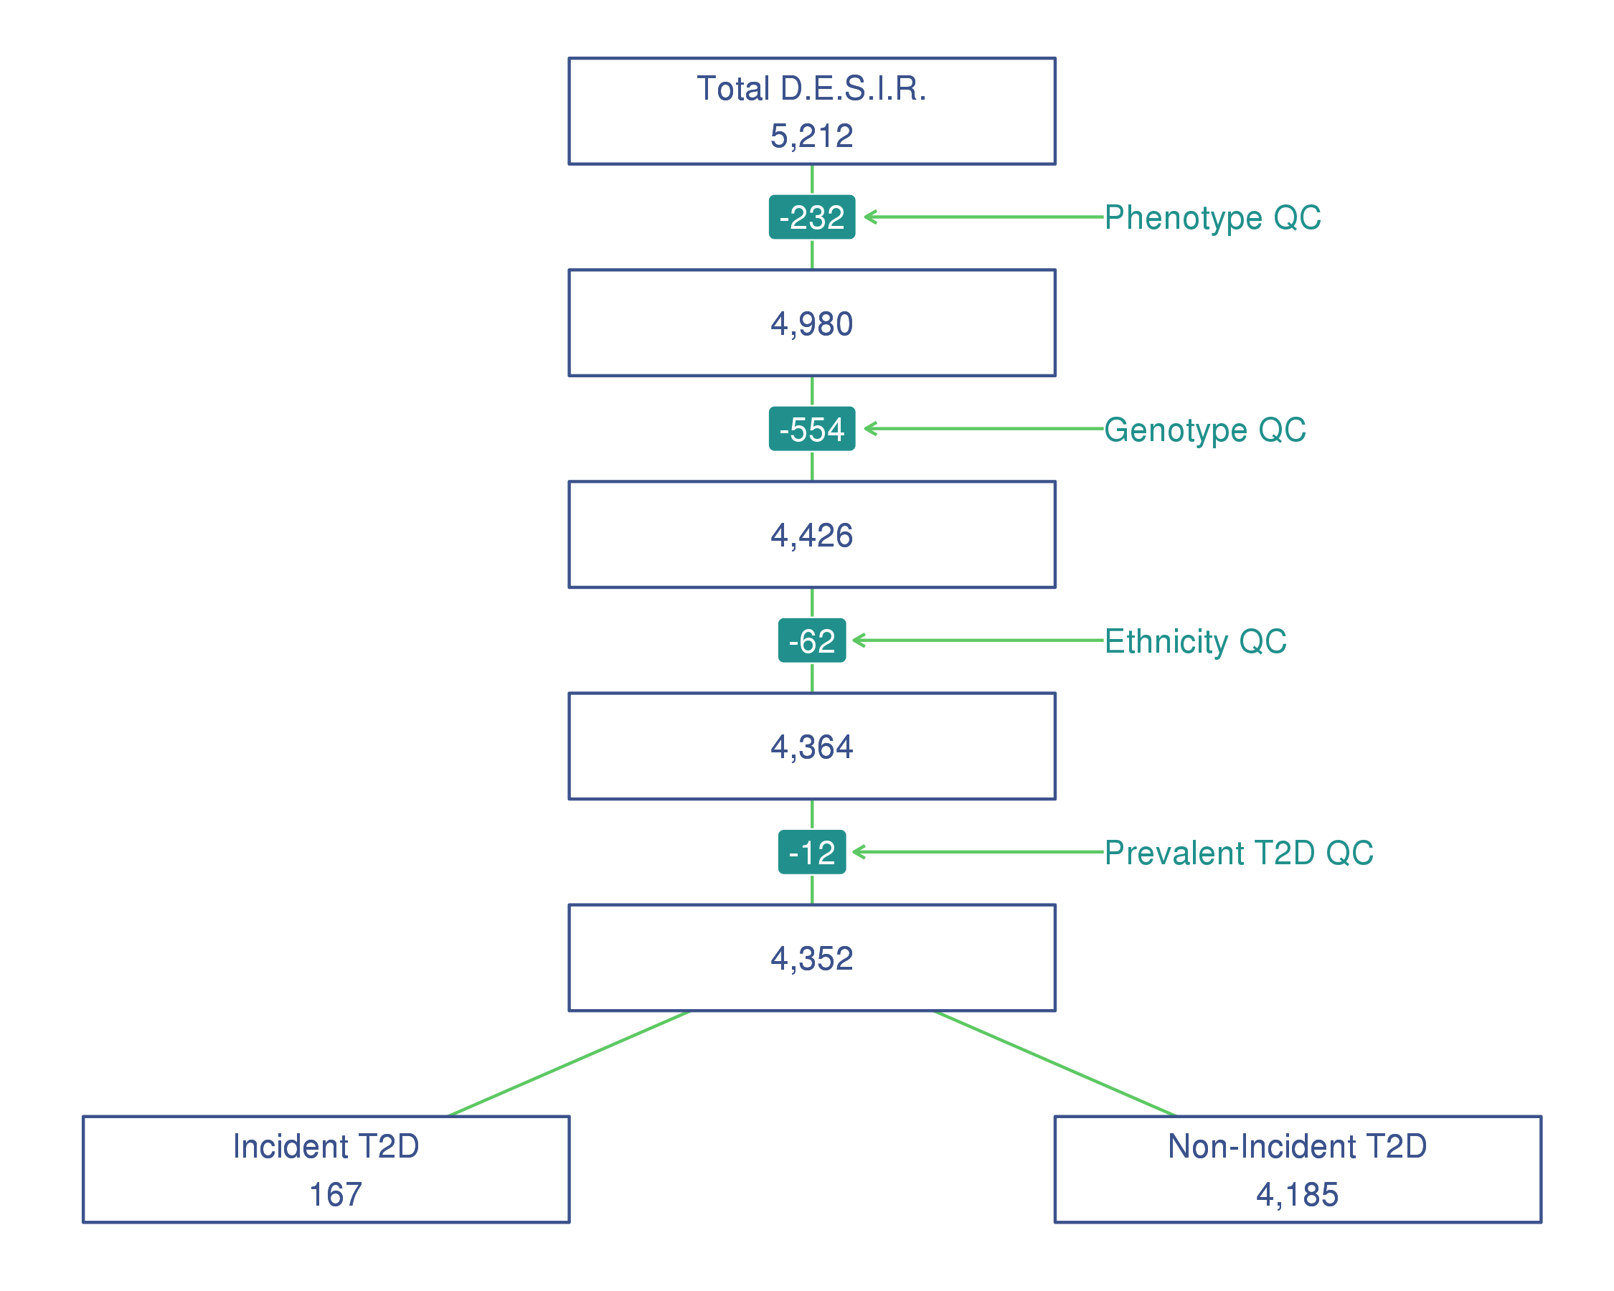

FIGURE 1. Flowchart quality control on subjects from the French cohort D.E.S.I.R.

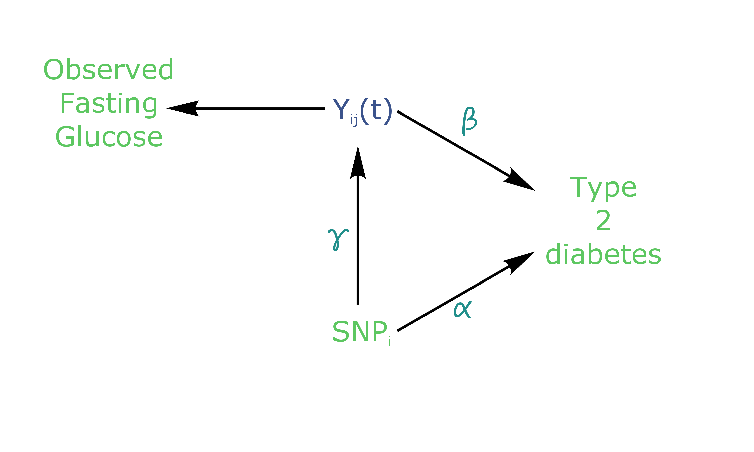

FIGURE 2. Causal diagram for joint modelling applied to fasting glucose and T2D (adapted from Ibrahim et al., 2010)

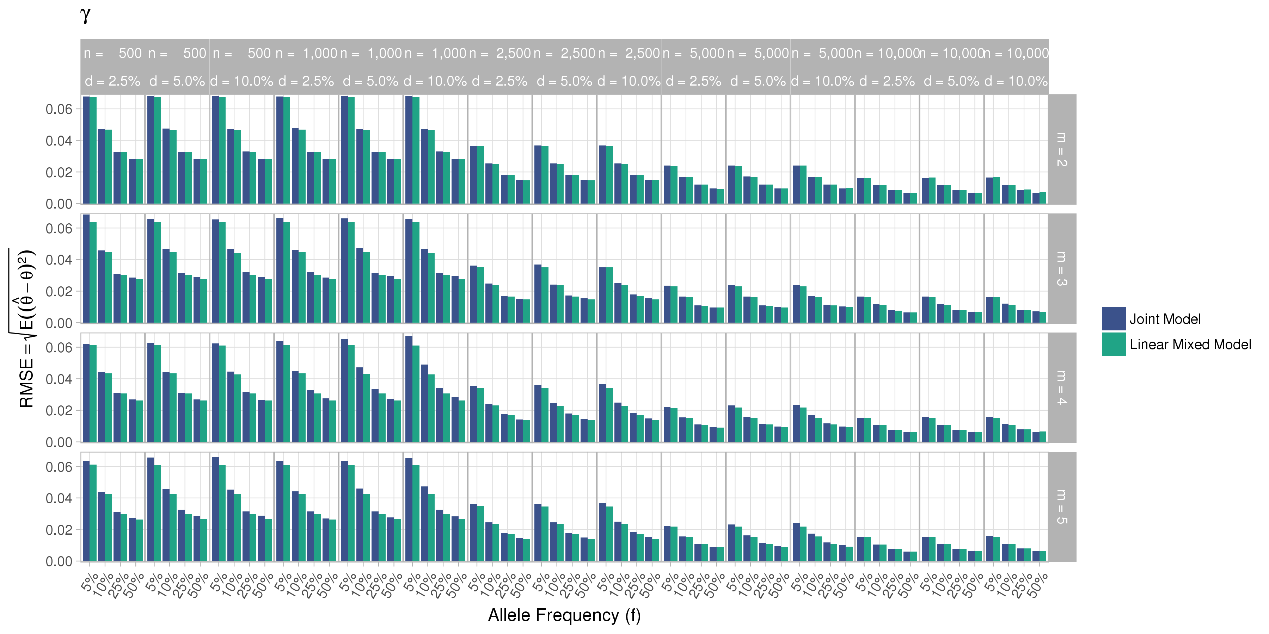

FIGURE 3. Simulation study for accuracy of estimator provided by the joint model (JM package) and by the linear mixed effect model (nlme package)

: number of measures; : number of subjects; : incidence rate

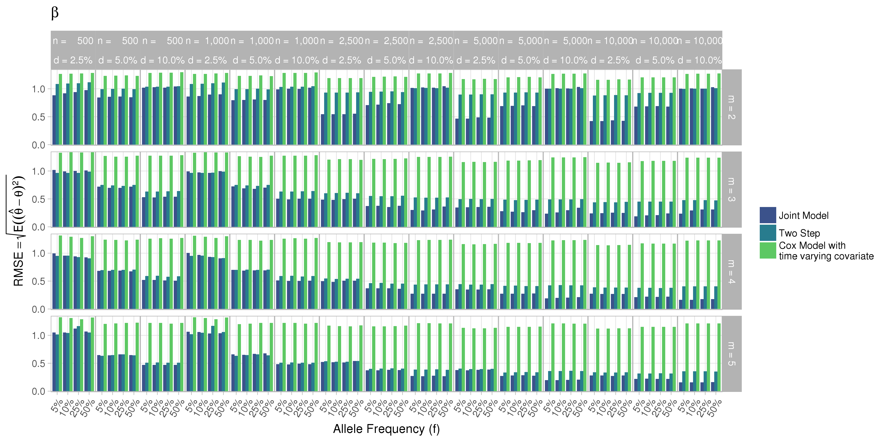

FIGURE 4. Simulation study for accuracy of estimator provided by the joint model (JM package) and by the linear mixed effect model (nlme package)

: number of measures; : number of subjects; : incidence rate

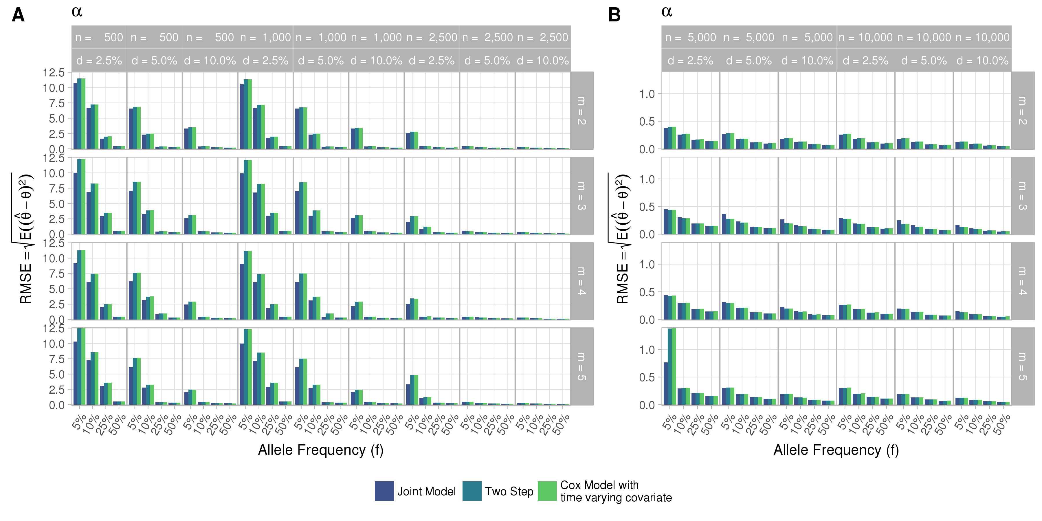

FIGURE 5. Simulation study for accuracy of estimator provided by the joint model (JM package) and by the linear mixed effect model (nlme package)

: number of measures; : number of subjects; : incidence rate

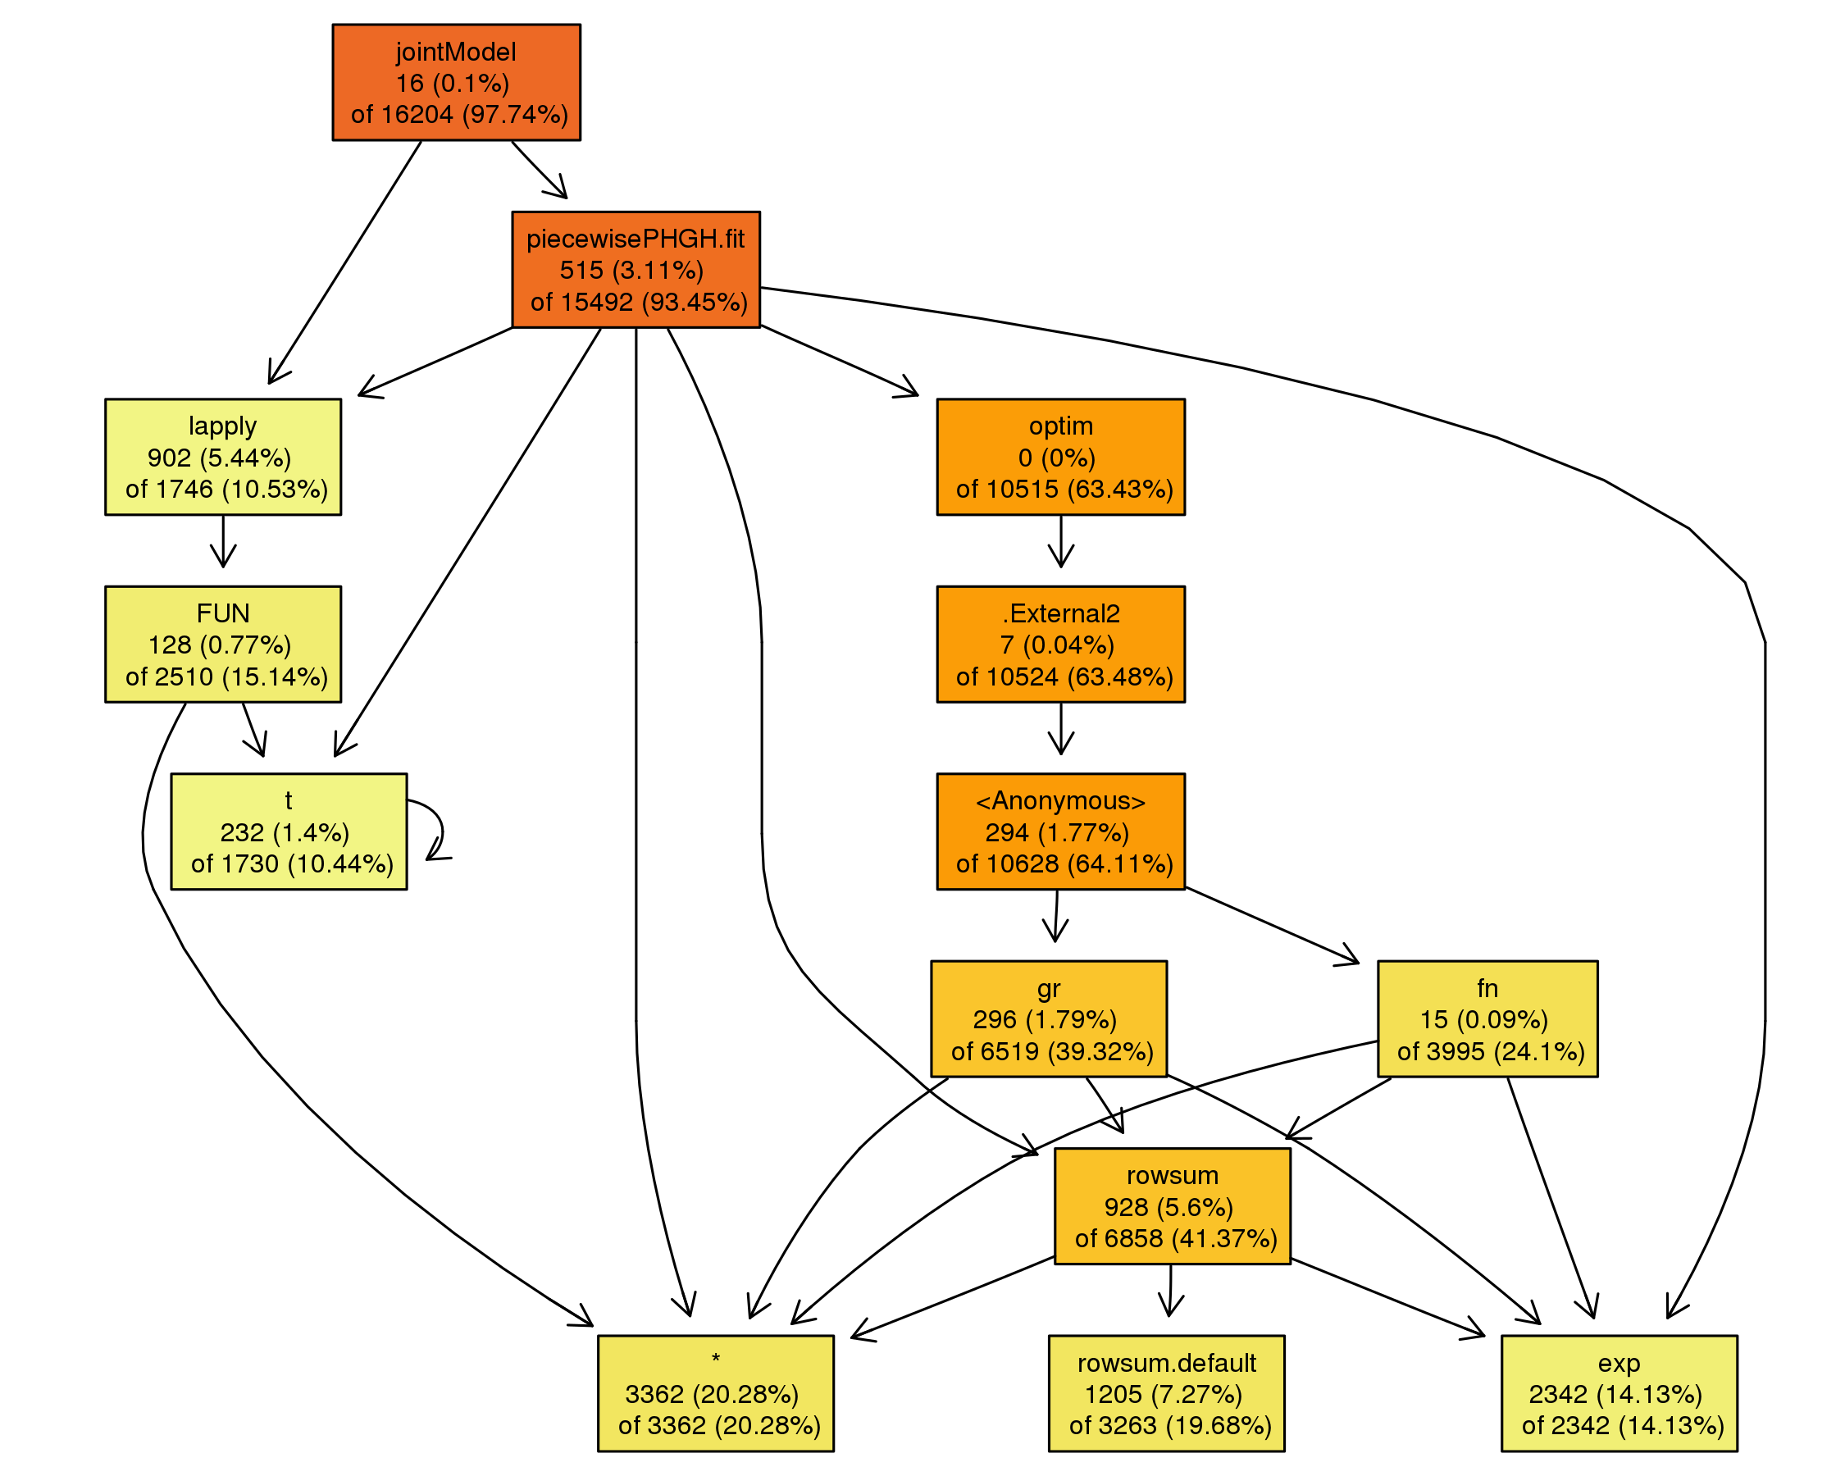

FIGURE 6. Call tree diagram of the main function jointmodel in the R package JM. Call based on a simulated dataset with three longitudinal measures and 5,000 subjects (other parameter values set as in Table 1)

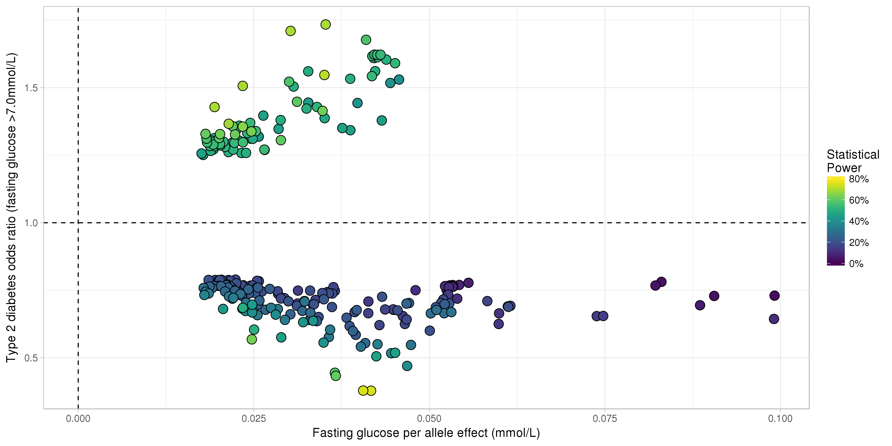

FIGURE 7. Results from statistical analysis using JM (Rizopoulos, 2010). Estimated effects of are displayed on the x-axis, with corresponding estimated odds ratio on the y-axis. Statistical power reported is the theoretical (retrospective) power to detect a joint effect based on estimated model parameters (Chen et al., 2011)

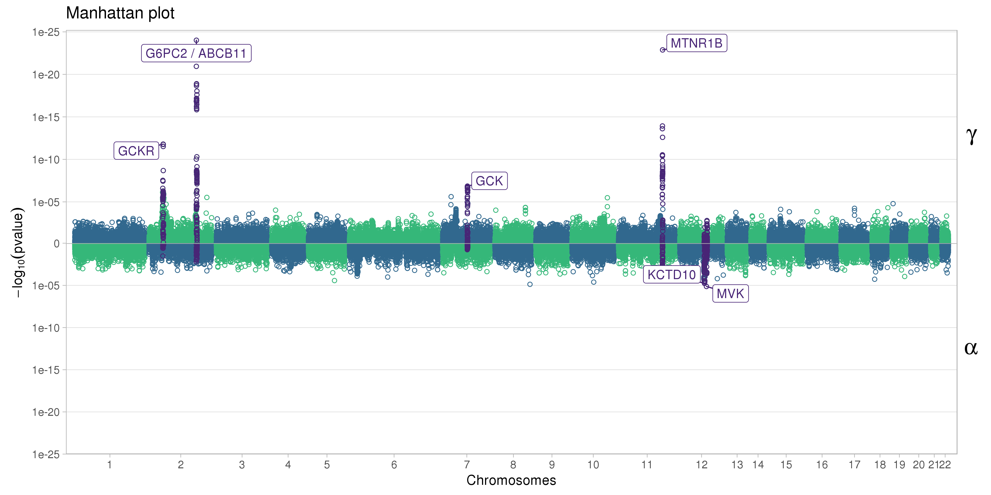

FIGURE 8. Manhattan plot for estimated effects of and using JM. Results are presented for the cleaned set of 101,305 SNPs

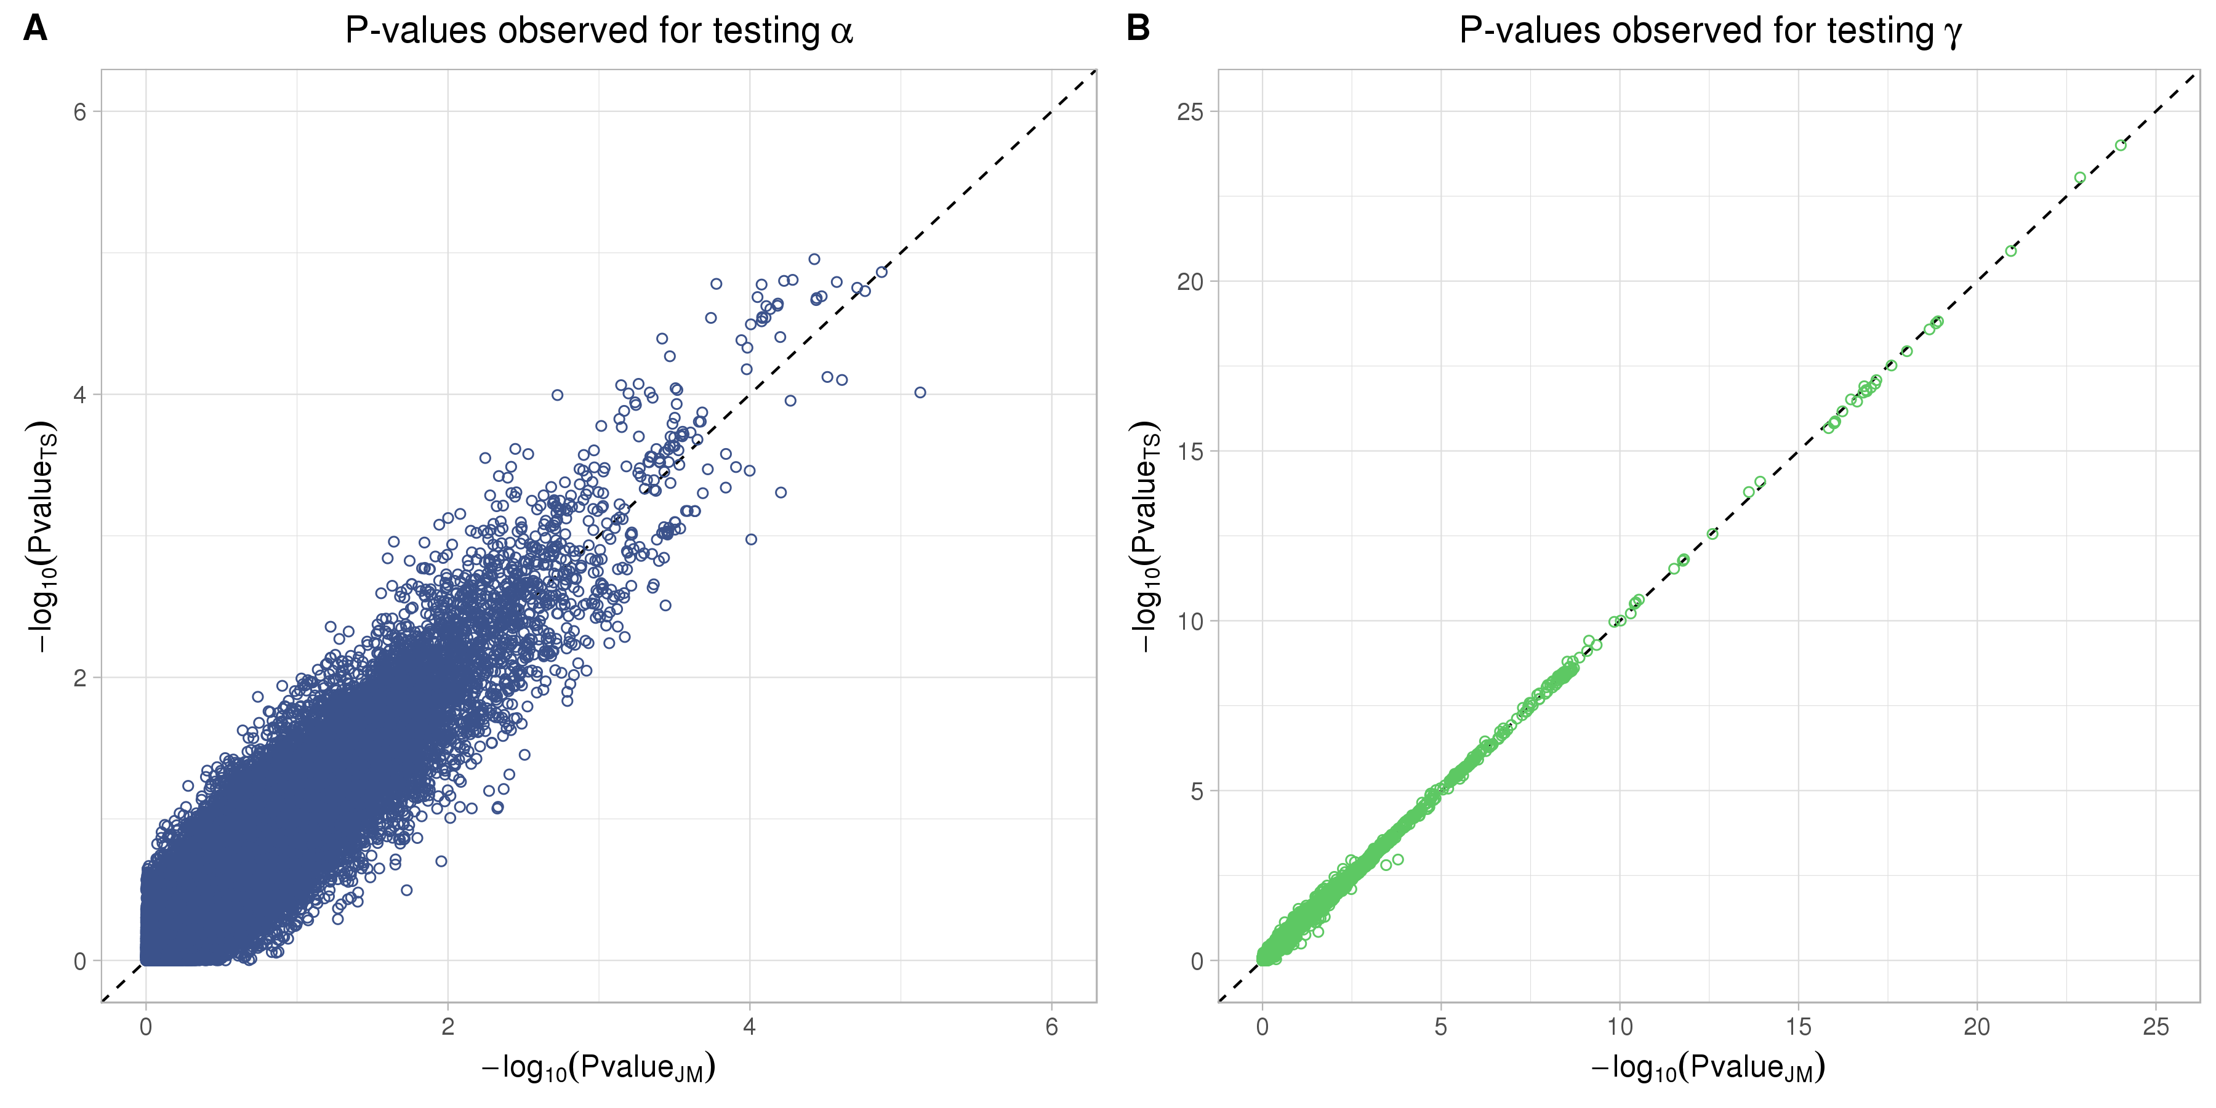

FIGURE 9. Testing for (SNP effect on onset of T2D) and (SNP effect on the trajectory of FG) using Two-Step approach compared to Joint Model approach for 265 SNPs with significant associations for and . On the x-axis, from the Joint Model and on the y-axis the corresponding from the approximate Two-Step approach

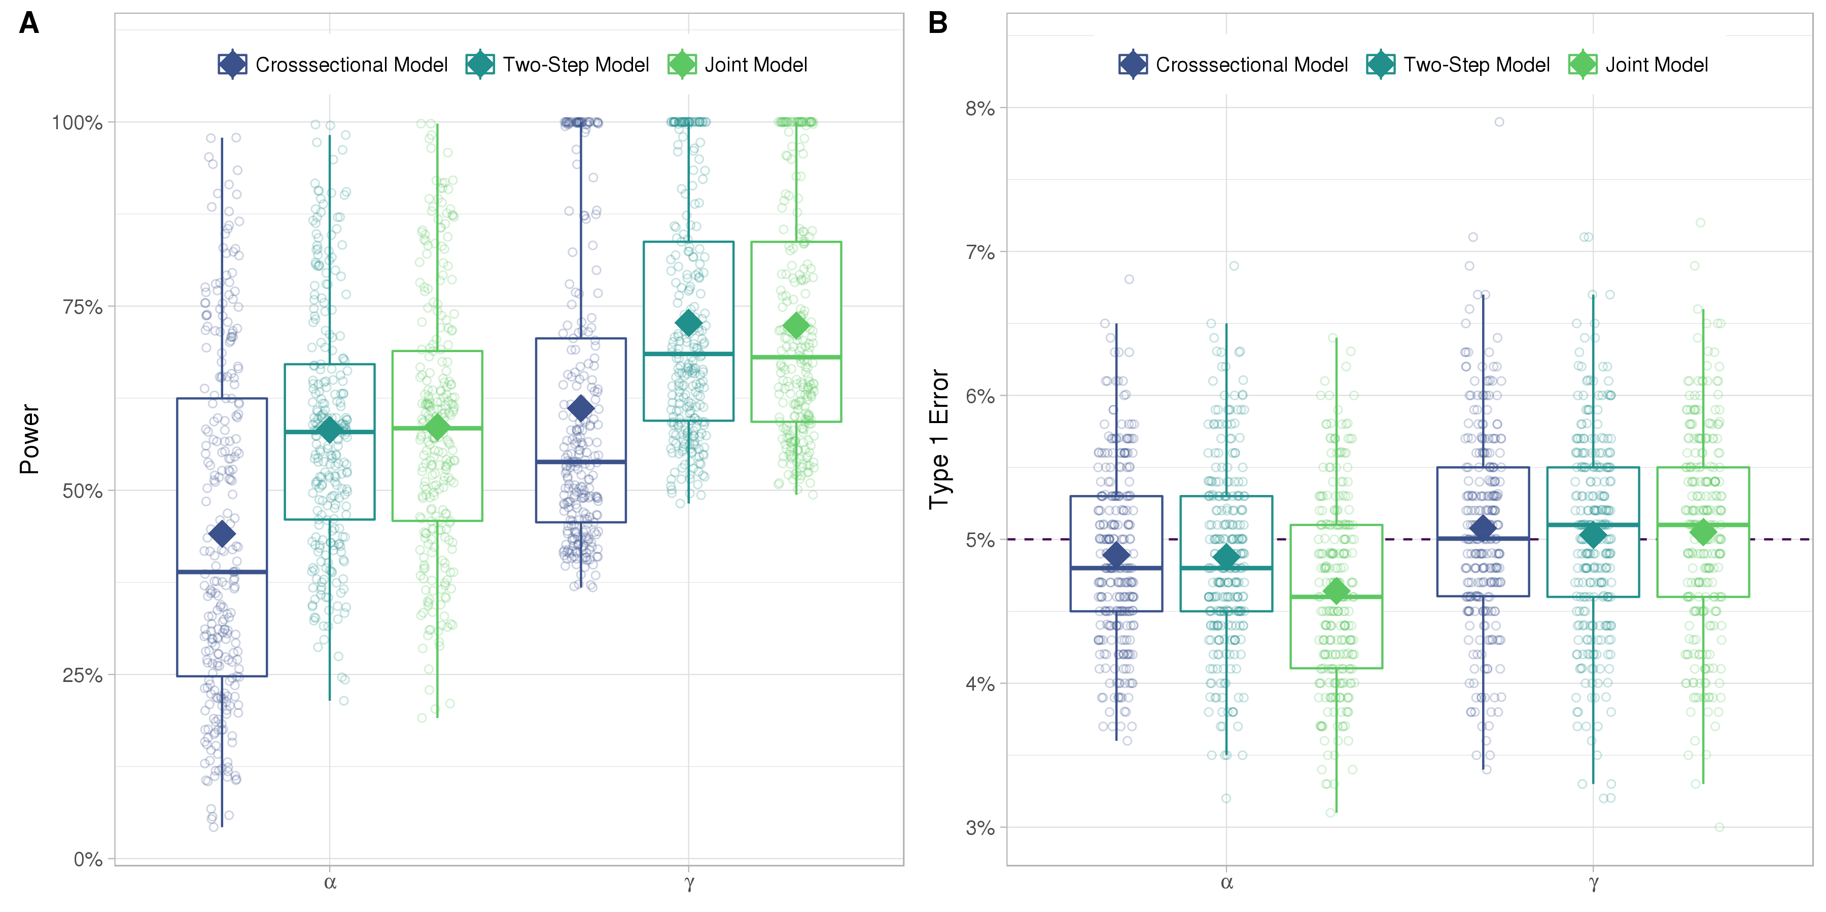

FIGURE 10. Power and Type 1 Error based on the 265 top associations found via a Joint Model approach for 265 SNPs with significant associations for and . Power and Type 1 Error are compared between Joint Model, Two-Step model and Cox or linear model regression, respectively for and

# References

Albert, P. S., & Shih, J. H. (2010a). An approach for jointly modeling multivariate longitudinal measurements and discrete time-to-event data. *The Annals of Applied Statistics*, *4*(3), 1517–1532.

Albert, P. S., & Shih, J. H. (2010b). On Estimating the Relationship between Longitudinal Measurements and Time-to-Event Data Using a Simple Two-Stage Procedure. *Biometrics*, *66*(3), 983–987.

Austin, P. C. (2012). Generating survival times to simulate Cox proportional hazards models with time-varying covariates. *Statistics in Medicine*, *31*(29), 3946–3958.

Balkau, B. (1996). An epidemiologic survey from a network of French Health Examination Centres, (D.E.S.I.R.): Epidemiologic data on the insulin resistance syndrome. *Revue D’épidémiologie Et De Santé Publique*, *44*(4), 373–375.

Chang, C. C., Chow, C. C., Tellier, L. C., Vattikuti, S., Purcell, S. M., & Lee, J. J. (2015). Second-generation PLINK: Rising to the challenge of larger and richer datasets. *GigaScience*, *4*, 7.

Chen, L. M., Ibrahim, J. G., & Chu, H. (2011). Sample size and power determination in joint modeling of longitudinal and survival data. *Statistics in Medicine*, *30*(18), 2295–2309.

Diggle, P., & Kenward, M. G. (1994). Informative Drop-Out in Longitudinal Data Analysis. *Journal of the Royal Statistical Society. Series C (Applied Statistics)*, *43*(1), 49–93.

Dupuis, J., Langenberg, C., Prokopenko, I., Saxena, R., Soranzo, N., Jackson, A. U., … Barroso, I. (2010). New genetic loci implicated in fasting glucose homeostasis and their impact on type 2 diabetes risk. *Nature Genetics*, *42*(2), 105–116.

Elashoff, R. M., Li, G., & Li, N. (2008). A Joint Model for Longitudinal Measurements and Survival Data in the Presence of Multiple Failure Types. *Biometrics*, *64*(3), 762–771.

Elashoff, R., li, G., & Li, N. (2016). *Joint Modeling of Longitudinal and Time-to-Event Data* (1st ed.). Chapman; Hall/CRC.

Ibrahim, J. G., Chu, H., & Chen, L. M. (2010). Basic Concepts and Methods for Joint Models of Longitudinal and Survival Data. *Journal of Clinical Oncology*, *28*(16), 2796.

Kalbfleisch, J. D., & Prentice, R. L. (2002). *The Statistical Analysis of Failure Time Data*. Hoboken, NJ, USA: John Wiley & Sons, Inc.

Morris, A. P., Voight, B. F., Teslovich, T. M., Ferreira, T., Segrè, A. V., Steinthorsdottir, V., … McCarthy, M. I. (2012). Large-scale association analysis provides insights into the genetic architecture and pathophysiology of type 2 diabetes. *Nature Genetics*, *44*(9), 981–990.

Proust-Lima, C., Joly, P., Dartigues, J.-F., & Jacqmin-Gadda, H. (2009). Joint modelling of multivariate longitudinal outcomes and a time-to-event: A nonlinear latent class approach. *Computational Statistics & Data Analysis*, *53*(4), 1142–1154.

Purcell, S., & Chang, C. (2015). PLINK v1.90b3.36.

R Core Team. (2017). *R: A Language and Environment for Statistical Computing*. Vienna, Austria: R Foundation for Statistical Computing.

Rizopoulos, D. (2010). JM: An R package for the joint modelling of longitudinal and time-to-event data. *Journal of Statistical Software*, *35*(9), 1–33.

Rizopoulos, D. (2012). *Joint models for longitudinal and time-to-event data: With applications in R*. CRC Press.

Rizopoulos, D., & Ghosh, P. (2011). A Bayesian semiparametric multivariate joint model for multiple longitudinal outcomes and a time-to-event. *Statistics in Medicine*, *30*(12), 1366–1380.

Sladek, R., Rocheleau, G., Rung, J., Dina, C., Shen, L., Serre, D., … Froguel, P. (2007). A genome-wide association study identifies novel risk loci for type 2 diabetes. *Nature*, *445*(7130), 881–885.

Sun, J., Sun, L., & Liu, D. (2007). Regression Analysis of Longitudinal Data in the Presence of Informative Observation and Censoring Times. *Journal of the American Statistical Association*, *102*(480), 1397–1406.

Therneau, T. M., & Grambsch, P. M. (2000). *Modeling Survival Data: Extending the Cox Model*. (K. Dietz, M. Gail, K. Krickeberg, J. Samet, & A. Tsiatis, Eds.). New York, NY: Springer New York.

Tsiatis, A. A., & Davidian, M. (2004). Joint modeling of longitudinal and time-to-event data: An overview. *Statistica Sinica*, *14*, 809–834.

Tsiatis, A. A., DeGruttola, V., & Wulfsohn, M. S. (1995). Modeling the Relationship of Survival to Longitudinal Data Measured with Error. Applications to Survival and CD4 Counts in Patients with AIDS. *Journal of the American Statistical Association*, *90*(429), 27–37.

Vaxillaire, M., Yengo, L., Lobbens, S., Rocheleau, G., Eury, E., Lantieri, O., … Froguel, P. (2014). Type 2 diabetes-related genetic risk scores associated with variations in fasting plasma glucose and development of impaired glucose homeostasis in the prospective DESIR study. *Diabetologia*, *57*(8), 1601–1610.

Voight, B. F., Kang, H. M., Ding, J., Palmer, C. D., Sidore, C., Chines, P. S., … Boehnke, M. (2012). The Metabochip, a Custom Genotyping Array for Genetic Studies of Metabolic, Cardiovascular, and Anthropometric Traits. *PLoS Genetics*, *8*(8), e1002793.

Welter, D., MacArthur, J., Morales, J., Burdett, T., Hall, P., Junkins, H., … Parkinson, H. (2014). The NHGRI GWAS Catalog, a curated resource of SNP-trait associations. *Nucleic Acids Research*, *42*(D1), D1001–D1006.

Wulfsohn, M. S., & Tsiatis, A. A. (1997). A Joint Model for Survival and Longitudinal Data Measured with Error. *Biometrics*, *53*(1), 330.