Single Nucleotide Polymorphisms Associated with Fasting Plasma Glucose Trajectory and Type 2 Diabetes Incidence: A Joint Modelling Approach

Mickaël Canouil1,2,3, Beverley Balkau4,5,6, Ronan Roussel7,8,9, Philippe Froguel1,2,3,10 and Ghislain Rocheleau1,2,3

1Univ. Lille, UMR 8199 - EGID, F-59000 Lille, France.  
2CNRS, UMR 8199, F-59000 Lille, France.  
3Institut Pasteur de Lille, F-59000 Lille, France.  
4CESP Centre for Research in Epidemiology and Population Health, Villejuif, France.  
5Univ. Paris-Saclay, Univ. Paris Sud, UVSQ, UMRS 1018, F-94807, Villejuif, France.  
6INSERM U1018, CESP, Renal and Cardiovascular Epidemiology, UVSQ-UPS, Villejuif, France.  
7INSERM, U1138 (équipe 2: Pathophysiology and Therapeutics of Vascular and Renal Diseases Related to Diabetes, Centre de Recherches des Cordeliers), Paris, France.  
8Univ. Paris 7 Denis Diderot, Sorbonne Paris Cité, France.  
9AP-HP, DHU FIRE, Department of Endocrinology, Diabetology, Nutrition, and Metabolic Diseases, Bichat Claude Bernard Hospital, Paris, France.  
10Department of Genomics of Common Disease, Imperial College London, London, United Kingdom.

###### Corresponding authors

Mickaël Canouil, EGID - UMR 8199, Pôle Recherche - 1er étage Aile Ouest, 1 place de Verdun, 59045 Lille CEDEX, France. Phone: +33(0)3-74-00-81-29. E-mail: mickael.canouil@cnrs.fr  
Ghislain Rocheleau, Maelstrom Research - The Research Institute of the McGill University Health Centre (RI MUHC), 2155 Guy, 4th Floor, Office 458, Montreal, Quebec, H3H 2R9, Canada. E-mail: grocheleau@maelstrom-research.org

# Abstract

In observational cohorts, longitudinal data are collected with repeated measurements at predetermined time points for many biomarkers, along with other covariates measured at baseline. In these cohorts, time to a certain event of interest occurring is commonly reported and very often, a relationship will be observed between a biomarker repeatedly measured over time and that event. Joint models were designed to efficiently estimate statistical parameters by combining a mixed model for the longitudinal biomarker trajectory and a survival model for the event risk, using a set of random effects to account for the link between the two types of data.  
First, we checked model consistency based on different simulation scenarios, varying sample size, minor allele frequency and number of repeated measurements. Second, using genotypes assayed with the Metabochip DNA arrays (Illumina) from close to 4,500 individuals recruited in the French cohort D.E.S.I.R. (*Data from an Epidemiological Study on the Insulin Resistance syndrome*), we assessed the feasibility of implementing the joint modelling approach in a real high-throughput genomic dataset and showed more precise and less biased estimations through a joint modelling approach (e.g. Joint Model, Two-Step approach). Although, the Joint Model showed better estimations, the Two-Step model showed more suitable computation times and thus could be used for screening purposes at genome-wide scale. To the best of our knowledge, joint models have never been applied in a genetic epidemiology context and could help identify novel loci sharing effects on both glycaemic traits and T2D.

# Key words

Diabetes; fasting plasma glucose; genetic association; joint modelling; longitudinal studies

# Introduction

With the increased availability of longitudinal and survival data in cohorts, joint models have emerged to account for both types of data, particularly when dealing with the informative/non-informative dropouts which occur in such cohorts. Joint models have been studied and overviewed in the literature (Chen, Ibrahim, & Chu, 2011; Elashoff, li, & Li, 2016; Tsiatis & Davidian, 2004; Wulfsohn & Tsiatis, 1997) and implementation has been proposed in different software and platforms (Diggle & Kenward, 1994; Elashoff, Li, & Li, 2008; Proust-Lima, Joly, Dartigues, & Jacqmin-Gadda, 2009; Rizopoulos, 2010; Rizopoulos & Ghosh, 2011; Sun, Sun, & Liu, 2007). The main idea behind the joint modelling is: 1) to model efficiently the survival process with a time-varying covariate, accounting for missing data and measurements errors, and 2) to account for informative dropouts in the longitudinal data. To model the two components of a joint model, a linear mixed effects (LME) model and a Cox proportional hazards model (CoxPH), are classically used to, respectively, fit the longitudinal component, and the survival component. Unlike the CoxPH model, in which the time-varying covariate is assumed to be exogenous, i.e. not modified by the occurrence of an event (Kalbfleisch & Prentice, 2002), the joint modelling framework allows to account for an endogenous time-varying covariate. An example of an endogenous covariate would be the fasting plasma glucose which is irremediably modified due to glucose lowering medication, once T2D is diagnosed.

Two approaches can be used for the estimation and inference of the model parameters: a "naive" two-step (TS) method or a joint likelihood method (JM). In the first method, the random effects of the trajectory are estimated by an LME model, and they are included as a time-varying covariate in a CoxPH model, then parameter estimation uses the partial likelihood of the CoxPH model (Therneau & Grambsch, 2000). The second method is based on a joint likelihood of the two components (longitudinal and survival) at the same time. Comparison of these two approaches showed that the latter offers more consistent and efficient estimators than the former (Albert & Shih, 2010a, 2010b). But JM can be challenging to compute, especially achieving convergence at the Expectation-Maximisation (EM) step. Moreover, depending on the number of time points and/or the sample size, the overall computation time can substantially increase.

In this paper, we conduct a comprehensive simulation study to compare two modelling approaches, JM and TS, for jointly modelling the longitudinal and the survival components. Our main goal is to show whether the JM approach, when compared to TS, might improve statistical power to detect an effect on either, or both, the longitudinal and the survival processes, while resulting in a bias reduction in parameter estimation. We also compared JM with TS and show that in the context where highly demanding computation and convergence issues might arise in JM computation, whether the TS offers a good alternative to JM in a reasonable computation time-span, especially when applied at the genome-scale level. We also investigated and decomposed the computational time required by the R package "JM" (Rizopoulos, 2010, 2016), and by the TS approach combining the R packages: "survival" (Therneau, 2017) and "nlme" (Pinheiro, Bates, & R-core, 2017).

Finally, we applied these approaches to a real dataset, the D.E.S.I.R. cohort (*Data from and Epidemiological Study on the Insulin Resistance syndrome*), that included 5,212 individuals with extensive phenotypic measures recorded at four three-yearly intervals, spanning a nine-year follow up. Individuals were genotyped using the Illumina Metabochip DNA array of nearly 200,000 SNPs) (Voight et al., 2012). Relying on cross-sectional genome-wide association study design, the D.E.S.I.R. cohort was instrumental in identifying novel loci associated with prevalent type 2 diabetes (T2D) and with fasting plasma glucose (FPG) level in normoglycemic individuals (Bouatia-Naji et al., 2008; Rung et al., 2009; Sladek et al., 2007). We specifically focus on prediabetes conditions, such as IFG (Impaired Fasting Glucose), and on time-to-onset of T2D, in order to possibly identify loci, novel or published, which simultaneously associate with the risk of developing T2D and with increasing FPG. Our results were then compared to the genetic variants as reported in the literature (Vaxillaire et al., 2014; Welter et al., 2014), and to the meta-analyses results published by large consortia, such as, DIAGRAM (Morris et al., 2012) and the MAGIC (Dupuis et al., 2010) consortia.

# Methods

## Model Formulations

### Joint Likelihood Model (JM)

The standard formulation of the joint model involves two components: a longitudinal component and a time-to-event component. Let $n$ denote the sample size, and $Y_{ij}$ the longitudinal measurements collected for each individual $i$ at time points $t_{ij}$, $i=1,⋯,n$, $j=1,⋯,m_{i}$, where $m_{i}$ is the number of measurements on individual $i$. The longitudinal component (measurements) typically consists of a (generalised) linear mixed effect (LME) model, whose within-subject correlation matrix is modelled using random-effect parameter vector $b_{i}=\left(\begin{matrix}θ_{0i} \\ θ_{1i}\end{matrix}\right)$.

Under the joint likelihood framework as implemented in "JM" (Rizopoulos, 2010, 2016), within the class of "shared parameter models" (Elashoff et al., 2016; Rizopoulos, 2012), we define

$$Y_{ij}=X_{ij}+ϵ_{ij} (1)$$

where $Y_{ij}$ is the observed value and $X_{ij}$ is the true (unobserved) value of the longitudinal measurement at time $t_{ij}$ for individual $i$. The quantity $ϵ_{ij}$ is a random error term usually assumed to be normally distributed:

$$ϵ_{ij}∼N(0,σ^{2}) (2)$$

The quantity $X_{ij}$ is typically called the trajectory function and is usually specified as a linear or quadratic function of time $t_{ij}$; for simplicity here, we assume linearity over time. We also define $Z_{i}$, a vector denoting the genotype of individual $i$, and $W_{i}$, a set of adjusting covariates:

$$Y_{ij}=X_{ij}+ϵ_{ij}=θ_{0i}+θ_{1i}t_{ij}+γZ_{i}+δW_{i}+ϵ_{ij} (3)$$

For simplification here, the term $δW_{i}$ will be omitted. Random effects $θ_{0i}$ (intercept) and $θ_{1i}$ (slope) are assumed bivariate Normal: $θ∼N_{2}(μ,Σ)$, and independently distributed from $ϵ_{ij}$. The coefficient $γ$ assesses the genotypic (additive) effect of variable $Z_{i}$ in the trajectory function. To account for possible varying slopes, an interaction term between $Z_{i}$ and time $t_{ij}$ could be added into the trajectory function; this term was not considered in this study.

The time-to-event (survival) component usually consists of a parametric (e.g. exponential or Weibull distribution) or semi-parametric (e.g. Cox proportional hazards) model. $T_{i}$ denotes the event time for individual $i$, and $C_{i}$ the right censoring time (end of the follow-up). Let $Δ_{i}$ be the event indicator: $Δ_{i}=0$, if $T_{i}>C_{i}$, and $Δ_{i}=1$, if $T_{i}<=C_{i}$. Under the Cox proportional hazards model, variable $T_{i}$ is specified using the following equation:

$$λ_{i}(t)=λ_{0}(t)exp(βX_{i}(t)+αZ_{i}) (4)$$

where $λ_{i}(t)$ is the hazard function at time $t$ for individual $i$ and $λ_{0}(t)$ is the unspecified baseline hazard function, which we assume piecewise constant with two knots placed at intermediate time points in the follow-up. The coefficient $α$ measures the effect of $Z_{i}$ on the hazard function, while $β$ measures the association between the trajectory function and the hazard function. In this formulation, we suppose that the subject-specific parameters $b_{i}=\left(\begin{matrix}θ_{0i} \\ θ_{1i}\end{matrix}\right)$ included in the trajectory $X_{i}(t)$ could modify the hazard function, which implies that $β$ is the parameter linking the longitudinal and survival components.

### Two-Step Model (TS)

As an alternative to JM, and based on the work of Tsiatis, DeGruttola, & Wulfsohn (1995), the two-step model estimates parameters of the joint model by first, estimating parameters of the trajectory function $X_{i}(t)$ in Equation (3), and second, by substituting this estimated trajectory, say $X_{i}^{*}(t)$, into (4) before fitting the Cox survival model.

## Simulation Study

Simulation studies were carried out to further examine the sensitivity of the JM estimations under several scenarios. Parameters were set based on values estimated from the strongest SNPs associated with T2D (Table I), that is rs17747324 in gene *TCF7L2* (T2D effect alle: C; $OR=1.43$; $p=8.5×{10}^{-55}$ (Morris et al., 2012); FPG effect allele: C; $β=0.025$; $p=6.47×{10}^{-08}$ (Dupuis et al., 2010)).

Longitudinal data were simulated according to Equation (3), while event times were generated from an exponential distribution for the CoxPH model (Austin, 2012)

$$λ_{0}(t)=λ (5)$$

$$H_{i}(T_{i})=\int_{0}^{T_{i}}{λ}exp(βX_{i}(t)+αZ_{i})dt (6)$$

$$T_{i}=\frac{1}{βθ_{1i}}log\left(1-\frac{βθ_{1i}×log(1-u)}{λexp(βθ_{0i}+(βγ+α)Z_{i})}\right) (7)$$

where $λ$ was set to achieve the targeted incidence rate in the simulated dataset.  
Datasets were simulated by varying the number of longitudinal measurements $m∈\{2;3;4;5\}$, the number of individuals studied $n∈\{500;1,000;2,500;5,000;10,000\}$, the allele frequency $f∈\{0.05;0.1;0.25;0.5\}$ and the incidence rate $d∈\{0.025;0.05;0.1\}$, thereby leading to 240 different scenarios. Each scenario was simulated 500 times.

The Root-Mean Square Error (RMSE)

$$RMSE(\overset{^}{θ})=\sqrt{E((\overset{^}{θ}-θ)^{2})} (8)$$

was used to assess precision for the estimation of $β$, $γ$ and $α$, when testing the association between $Y_{ij}$, and $T_{i}$, the $Z_{i}$ effect on $Y_{ij}$ and the $Z_{i}$ effect on $T_{i}$, respectively. We compared JM and TS approaches with a linear mixed effect model and the Cox regression model with a time-varying covariate, fasting plasma glucose. In addition, statistical power and type I error were also studied. The computational burden of each approach was also investigated as our goal is to implement these models at a genome-wide scale.

## Computational times

Based on our simulations, we provide approximate computational times for four sample sizes with parameters as listed in Table I, using a UNIX system with Intel® Xeon® CPU E7- 4870 @ 2.40GHz (80 such CPUs available computing in parallel). Table II shows computational time for one model, and when extrapolating the total computational time for 100,000 SNPs, which is the approximate number of SNPs on the Metabochip, after data cleaning and the quality-control over common SNPs (minor allele frequency > 0.05).

To investigate further computational time issues, we profiled the execution of the main function "*jointmodel*" from the R package "JM", which implements the joint likelihood modelling approach as described in this paper. In the "JM" package, the linear mixed effect sub-model is handled by the function "*lme*" from the "nlme" package. One may argue that using a faster approach, e.g. as implemented in the R package "lme4", the computational time might be decreased.

## Real Data

SNP genotyping was performed with Metabochip DNA arrays (Voight et al., 2012) using Illumina HiScan technology and GenomeStudio software (Illumina, San Diego, USA) in 5,212 individuals from the French cohort D.E.S.I.R. (Balkau, 1996). They have been followed for nine years, and extensive phenotypic data has been recorded at four different three-yearly times during that follow-up. Quality control was performed using PLINK 1.90 beta version (Chang et al., 2015; Purcell & Chang, 2015). SNPs with call rate of at least 95%, with no significant deviation from Hardy-Weinberg equilibrium at $p>1×{10}^{-5}$, and with minor allele frequency (MAF) over 5% were kept for analysis, resulting in 101,305 SNPs. Due to missing phenotypes which did not allow to confirm T2D status, 232 individuals were removed. An additional 554 individuals were excluded due to individual call rate lower than 95%, leaving 4,426 individuals for analysis after these quality control steps (Supplementary Figure S1).

Principal component analysis was performed in a combined dataset with the 4,426 D.E.S.I.R. participants, and individuals from the publicly available 1,000 Genomes database (The 1000 Genomes Project Consortium, 2015). SNPs retained for analysis were restricted to those common to both samples. The first two components were sufficient to discriminate ethnic origin. Non-Caucasians (62) were excluded from the analysis. A further 12 prevalent cases of T2D at baseline were also removed.

The final dataset included 4,352 individuals, of whom 167 were diagnosed as T2D incident cases. Type 2 diabetes was defined using one of the following criteria: use of glucose lowering medication, fasting plasma glucose $[FPG]≥7$ mmol/L, or glycated hemoglobin A1c $[HbA1c]≥6.5\%$ (48 mmol/mol).

Using the joint modelling approach implemented in the package JM (Rizopoulos, 2010, 2016) within the R software version 3.3.3 (R Core Team, 2015), all 101,305 SNPs were tested for joint association with FPG and T2D. Based on the joint modelling formulation, let $Y_{ij}$ denote the observed values of FPG, and let $Z_{i}$ represent the genotype of individual $i$ at each SNP, along with $W_{i}$ covariates such as age, sex and BMI (Figure 1). Finally, let $T_{i}$ is the time at which an individual is diagnosed with T2D.  
In the joint modelling framework, the trajectory of FPG is viewed as a dropout process, since all FPG values become missing after T2D diagnosis, as a result of individuals with diabetes being placed under treatment to lower and regulate the glucose level in their blood. In this case, FPG is considered as an endogenous covariate, because the dropout process is not independent from the measured glucose values prior to T2D diagnosis.

# Results

## Comparison of estimation accuracy

Due to the complexity of the estimating algorithm within JM, convergence could not be obtained ($4.53±5.81$% of convergence issues on average per scenario) for the whole set of 500 simulations (i.e. algorithm “piecewise-PH-aGH” for a time-dependent relative risk model with a piecewise constant baseline risk function, using the adaptive Gauss-Hermite quadrature rule to approximate integrals within the Expectation-Maximisation (EM) step (Rizopoulos, 2010, 2016)).

RMSE for parameter $γ$ (Figure 2) showed similar performance for JM and TS, which was expected given the formulation of the joint model within the "Shared Parameter Models" framework, in which $Y_{i}$ (mean of $Y_{ij}$ modelled within LME according to Equation (3)) links the longitudinal data to the time of event.

RMSE for parameter $β$ (Figure 3) and for parameter $α$ (Figure 4) were smaller within the joint modelling framework (either JM or TS) than in the more classical CoxPH model with time varying fasting plasma glucose. While RMSE for $β$ was the same in the CoxPH model across all scenarios, under JM or TS it decreased with increases in the sample size, incidence rate or allele frequency. Differences in RMSE for parameter $α$ were less than for parameter $β$, and TS and CoxPH with time-dependent covariate, performed equally probably because partial likelihood inferences were used in both approaches. JM estimations were less biased in almost all scenarios when the sample size was greater than 2,500.

Overall, our simulations showed that JM is less biased than when separate approaches are used to model the effect of $Z_{i}$ on the longitudinal $Y_{i}$, and on the time-to-event $T_{i}$. While separate approaches performed well for parameters $γ$ and $α$, the bias for $β$ was the greatest observed across all scenarios.

For the default simulation settings (Table I), the type 1 error and statistical power showed similar results between JM and TS (Table III). Nevertheless, the simulations highlighted convergence issues that might occur within the joint likelihood approach (19.4% of the power simulation study).

## Computational time

Computational times are reported in Table II. The time required to complete JM or TS algorithms increased linearly with sample size in our simulations. However, these times are very optimistic since our simulations did not include any covariate or more complex random parameters.

The main issue is within the "*jointmodel*" function which took over 95 % of the global computation time (Supplementary Figure S2). After examination of the call tree diagram, we can see that the more time-consuming task within the "*jointmodel*" function is the optimisation of the EM algorithm (described in Rizopoulos (2012), Appendix B), despite the use of a calculation trick (i.e. adaptive Gauss-Hermite quadrature for numerical integration).

## Application in real data

Applying the R package JM to our D.E.S.I.R. cleaned dataset, 265 SNPs (Figure 5) were associated (with p-value<0.05) with FPG and T2D events through their respective parameters $γ$ and $α$. Amongst these 265 SNPs (163 unique genes), we identified 17 genes (Supplementary Table I) which had already been reported to be associated with FPG and/or T2D risk. Parameter $β$ was highly significant (below the genome-wide threshold of $5×{10}^{-8}$) for all these SNPs, which was expected considering the fact that $β$ estimates the association between FPG trajectory and T2D risk, therefore one of the criteria used to define T2D.

In Figure 6, we specifically focused on parameters $γ$ and $α$. After Bonferroni correction (nominal p-value $≃5×{10}^{-7}$), no genetic variants showed a highly significant association with both parameters $γ$ and $α$ simultaneously; only SNPs in the following genes (or within a 100 kb window) remained significant when testing for $γ$: *G6PC2*/*ABCB11*, *GCK*/*YKT6*, *GCKR* and *MTNR1B*, with effect per risk allele of increasing FPG from 0.10 mmol/L to 0.047 mmol/L. Zooming in on simultaneous associations with the longitudinal and survival processes revealed well known genes, such as *TCF7L2*, which has been shown in many meta-analyses to be associated with elevated FPG and an increased risk of T2D (Table IV). *MTNR1B* was also found to be associated (34 SNPs within 30kb) with $α=-0.44$ ($p-value=9.37×{10}^{-04}$) and $γ=0.099$ ($p-value=1.33×{10}^{-23}$) for SNP rs10830963, the SNP usually reported.

To better compare JM and TS, we repeated the analysis on the whole dataset using TS. As shown in Figure 7, p-values can differ, especially for parameter $α$; for parameter $γ$, approximations were quite close to the p-values provided via the joint likelihood framework.

# Discussion

With the ever-increasing availability of genomic data generated by genotyping arrays and next generation sequencing, the need to develop and implement efficient models is important to ensure that statistical analysis will be achieved in a reasonable time frame. In this paper, we propose a comparison of two approaches, namely the joint model (JM) and the two-step model (TS), to estimate parameters accounting simultaneously the SNP effect on longitudinal and on survival processes without omitting information about missing values and dropouts for the status of the longitudinal variable of interest. In our real data application, FPG is the longitudinal trait, whereas T2D diagnosis is the survival time of interest, both being linked together by the fact that an upper threshold on FPG actually defines T2D onset (currently, FPG $≥$ 7 mmol/L), along with glucose lowering medication. Through simulations over different scenarios, we showed that joint models are less biased than classical separate approaches, could provide more insight regarding the event of interest, and could better assess the potential impact of a SNP on incident T2D than current methods.

By looking at statistical measures, such as RMSE for accuracy in the model estimators, and by estimating computational time using the available R implementation of joint models, our study showed that the use of an approximate method, such as TS, at a genome-wide scale, might be a good trade-off between accuracy and computational time. TS could be used to overcome the computational burden of current joint likelihood methods by exploiting available software performing the two steps, LME and CoxPH, and could help filter out SNPs with low or undetectable associations during a first preliminary scan. However, depending on the parameters of the data set (sample size, incidence rate, number of measures), a joint likelihood method is highly preferred to obtain accurate estimation of parameters $γ$ and $α$, describing the SNP effect on the trajectory of FPG and time-to-onset of T2D. Although, we computed the theoretical statistical power to detect a genetic joint effect $βγ+α$ based (Chen et al., 2011), we did not test this effect at genome-wide scale due to its computational burden. Joint effect of the SNP can be tested using a likelihood ratio test to compare the full joint model (i.e. with SNP in both submodels) to the joint model without SNP in the survival submodel, as implemented in the package JM (Rizopoulos, 2010, 2016). Finally, using parallel and grid computing approaches will reduce the computational time to a more suitable time frame when applied at a genome-wide level (i.e. with millions of SNPs).

In our real data application, results for rs17747324 showed consistent results, with the DIAGRAM meta-analysis for both $α$ and $γ$ (Table IV), and for rs10830963 showed an opposite effect on T2D compared to the effect reported in MAGIC for FPG ($α=0.104$, $p-value=7.3×{10}^{-07}$). The results observed for *MTNR1B* (rs10830963) in the French cohort D.E.S.I.R., even if they seemed inconsistent with previous studies, may uncover some interesting peculiarities pertaining to T2D incident cases in this population. In the literature, SNPs in *MTNR1B* were reported as being associated with higher FPG and T2D risk, but meta-analyses were performed on populations with different genetic backgrounds, and the two traits were never co-analysed jointly. However, we recognise that *MTNR1B* associations identified in our study need to be confirmed and replicated in other cohorts, as they might be cohort-specific associations. In addition, a major limitation of our study is the low number of incident T2D cases in the D.E.S.I.R. cohort (167 incident T2D cases in 4,352 individuals followed over 9 years).

# Acknowledgments

This study was supported by grants for funding of scientific research conducted in France and within the European Union: "Centre National de la Recherche Scientifique", "Université de Lille 2", "Institut Pasteur de Lille", "Société Francophone du Diabète", "Lilly", "Contrat de Plan Etat-Région", "Agence Nationale de la Recherche", ANR-10-LABX-46, ANR EQUIPEX Ligan MP: ANR-10-EQPX-07-01, European Research Council GEPIDIAB - 294785.

The D.E.S.I.R. study has been funded by INSERM contracts with Caisse nationale de l'assurance maladie des travailleurs salariés (CNAMTS), Lilly, Novartis Pharma, and sanofi-aventis; INSERM (Réseaux en Santé Publique, Interactions entre les déterminants de la santé, Cohortes Santé TGIR 2008); the Association Diabète Risque Vasculaire; the Fédération Française de Cardiologie; La Fondation de France; Association de Langue Française pour l'Etude du Diabète et des Maladies Métaboliques (ALFEDIAM)/Société Francophone de Diabétologie (SFD); l'Office national interprofessionnel des vins (ONIVINS); Ardix Medical; Bayer Diagnostics; Becton Dickinson; Cardionics; Merck Santé; Novo Nordisk; Pierre Fabre; Roche; Topcon.

The D.E.S.I.R. Study Group. INSERM U1018: B. Balkau, P. Ducimetière, E. Eschwège; INSERM U367: F. Alhenc-Gelas; CHU D’Angers: Y Gallois, A. Girault; Centre de Recherche des Cordeliers, INSERM U1138, Bichat Hospital: F. Fumeron, M. Marre, R Roussel; CHU de Rennes: F. Bonnet; CNRS UMR8090, Lille: A. Bonnefond, S. Cauchi, P. Froguel; Centres d’Examens de Santé: Alençon, Angers, Blois, Caen, Chateauroux, Chartres, Cholet, Le Mans, Orléans, Tours; Institute de Recherche Médecine Générale: J. Cogneau; General practitioners of the region; Institute inter-Regional pour la Santé: C. Born, E. Caces, M. Cailleau, O Lantieri, J.G. Moreau, F. Rakotozafy, J. Tichet, S. Vol.

###### Conflict of interest disclosure

The authors declare that they have no conflict of interest.

# Tables

Table I. Parameters and numerical values used for sensitivity analysis and simulations, based on results from rs17747324 within gene *TCF7L2*.

|  |  |
| --- | --- |
| Parameters | Values |
| Number of participants ($n$) | 4,352 |
| Number of measures ($m$) | 4 |
| Diabetes incidence rate ($d$) | 0.0384 |
| Minor allele frequency ($f$) | 0.244 |
| Random effects ($θ$) | $$∼N_{2}\left(\left[\begin{matrix}4.55 \\ 0.0108\end{matrix}\right],\left[\begin{matrix}0.143 & -0.00109 \\ -0.00109 & 6.8×{10}^{-04}\end{matrix}\right]\right)$$ |
| SNP effect on $Y_{ij}$ ($γ$) | 0.0229 |
| SNP effect on $T_{i}$ ($α$) | 0.265 |
| Association between $Y_{ij}$ and $T_{i}$ ($β$) | 3.17 |
| Error term ($ϵ$) | $$∼N(0,{0.305}^{2})$$ |

Table II. Approximate computational times using function *system.time* of R software. System time was computed ten times per sample size (number of individuals). Extrapolation is displayed for 100,000 SNPs

|  |  |  |  |  |
| --- | --- | --- | --- | --- |
|  | Joint Model | | Two-Step Model | |
| Sample Size | mean (sd) per SNP in seconds | 100K SNPs in days | mean (sd) per SNP in seconds | 100K SNPs in days |
| 500 | 51 (3.4) | 59 | 0.71 (0.066) | 0.82 |
| 2,500 | 100 (11) | 120 | 3.1 (0.092) | 3.6 |
| 5,000 | 180 (25) | 210 | 6.3 (0.17) | 7.3 |
| 10,000 | 340 (34) | 400 | 9 (0.22) | 10 |

Table III. RMSE, Type 1 Error and Power from default simulation settings for rs17747324 (*TCF7L2*).

|  |  |  |  |  |  |  |
| --- | --- | --- | --- | --- | --- | --- |
|  |  | Joint Model |  |  | Two-Step Model |  |
| Parameter | RMSE | Type 1 Error | Power | RMSE | Type 1 Error | Power |
| α | 0.137 | 0.036 | 45.4% | 0.139 | 0.051 | 48.5% |
| γ | 0.010 | 0.051 | 61.8% | 0.010 | 0.050 | 58.8% |

Table IV. Effect sizes on FPG and T2D risk estimated using JM (Joint Model) and TS (Two-Step). Comparison is shown with effect sizes as reported by consortia meta-analyses in genes MTNR1B and TCF7L2.

|  |  |  |  |  |  |  |  |  |
| --- | --- | --- | --- | --- | --- | --- | --- | --- |
| SNP (gene) | $α$ (p-value) | | | $γ$ (p-value) | | | $β$ (p-value) | |
| JM (D.E.S.I.R.) | TS (D.E.S.I.R.) | DIAGRAM | JM (D.E.S.I.R.) | TS (D.E.S.I.R.) | MAGIC | JM (D.E.S.I.R.) | TS (D.E.S.I.R.) |
| rs10830963_G (MTNR1B) | -0.440 ($9.4×{10}^{-04}$) | -0.443 ($5.0×{10}^{-04}$) | 0.104 ($7.3×{10}^{-07}$) | 0.0991 ($1.3×{10}^{-23}$) | 0.0992 ($8.9×{10}^{-24}$) | 0.079 ($1.3×{10}^{-68}$) | 3.25 ($3.6×{10}^{-42}$) | 3.52 ($2.7×{10}^{-54}$) |
| rs17747324_C (TCF7L2) | 0.265 ($4.1×{10}^{-02}$) | 0.284 ($2.2×{10}^{-02}$) | 0.358 ($8.5×{10}^{-55}$) | 0.0229 ($3.0×{10}^{-02}$) | 0.0218 ($3.8×{10}^{-02}$) | 0.025 ($6.5×{10}^{-08}$) | 3.17 ($8.9×{10}^{-42}$) | 3.39 ($2.2×{10}^{-52}$) |

# Figures

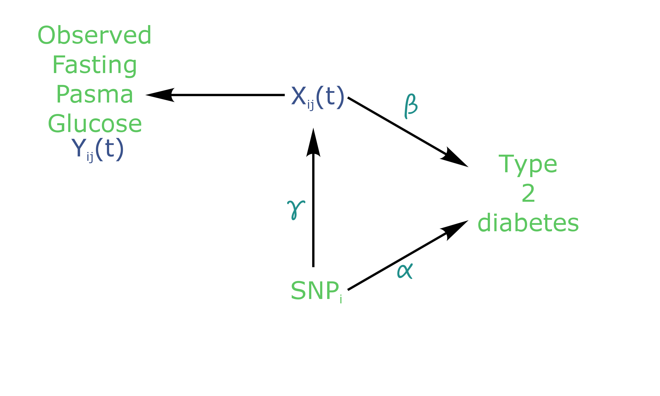

Figure 1. Causal diagram for joint modelling applied to fasting plasma glucose (FPG) and type 2 diabetes (T2D) (adapted from Ibrahim, Chu, & Chen (2010)). SNP: Single Nucleotide Polymorphism.

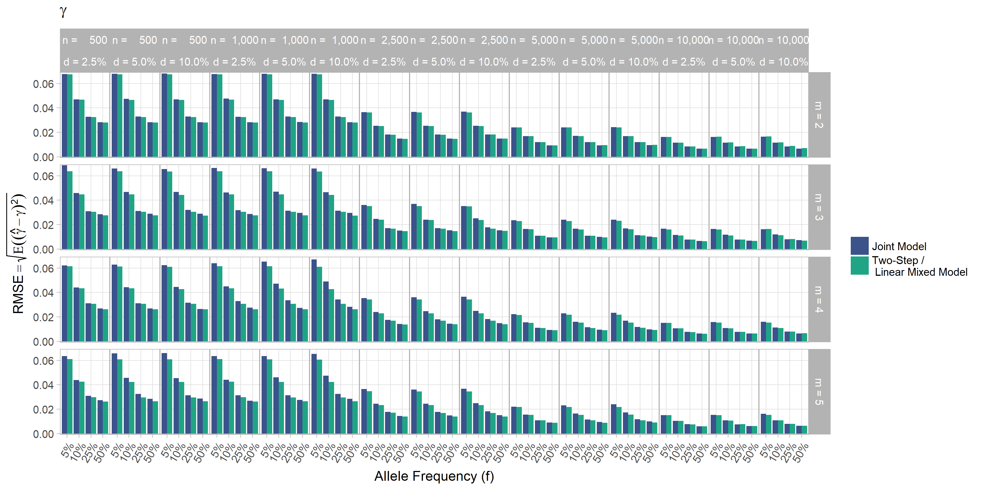

Figure 2. Simulation study for accuracy of estimator $\overset{^}{\text{γ}}$ provided by the joint model (JM package) and by the two-step linear mixed effect model (nlme package). $\text{m}$: number of measures; $\text{n}$: number of individuals; $\text{d}$: diabetes incidence rate.

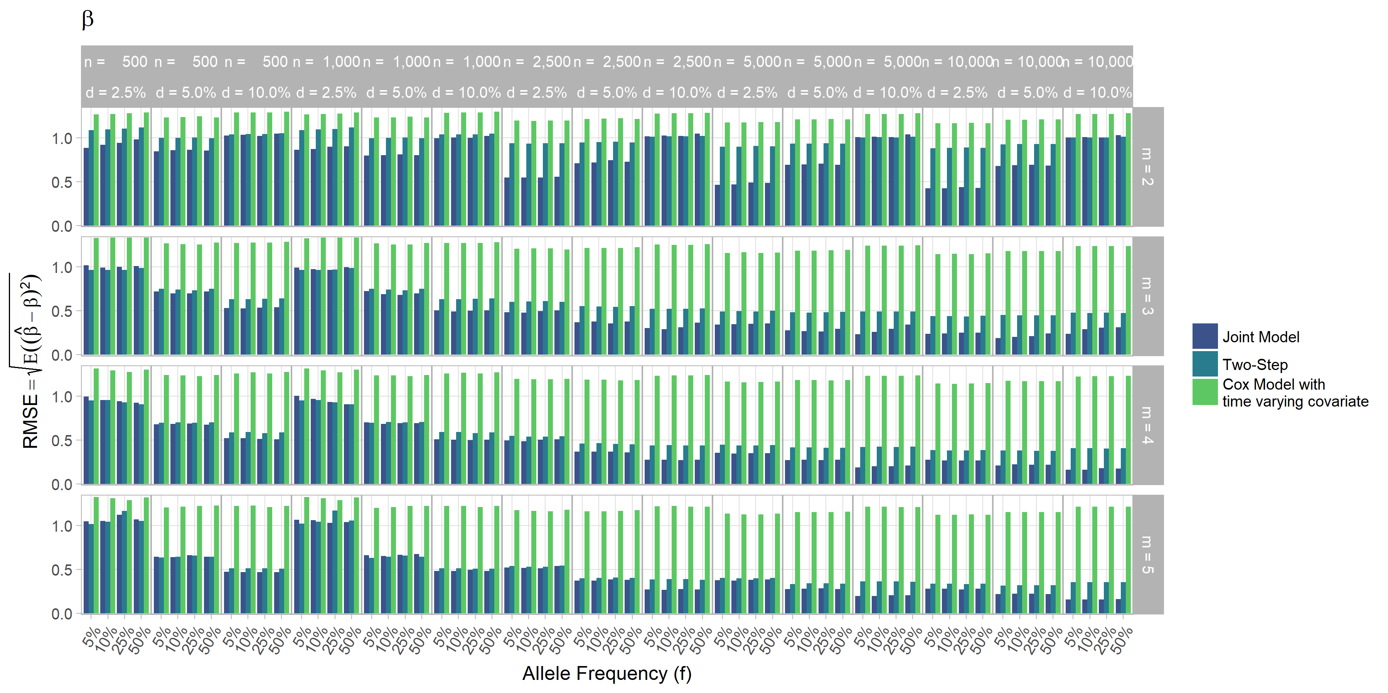

Figure 3. Simulation study for accuracy of estimator $\overset{^}{\text{β}}$ provided by the joint model (JM package), by the two-step linear mixed effect model (nlme package) and by the Cox model with time-varying covariate. $\text{m}$: number of measures; $\text{n}$: number of individuals; $\text{d}$: diabetes incidence rate.

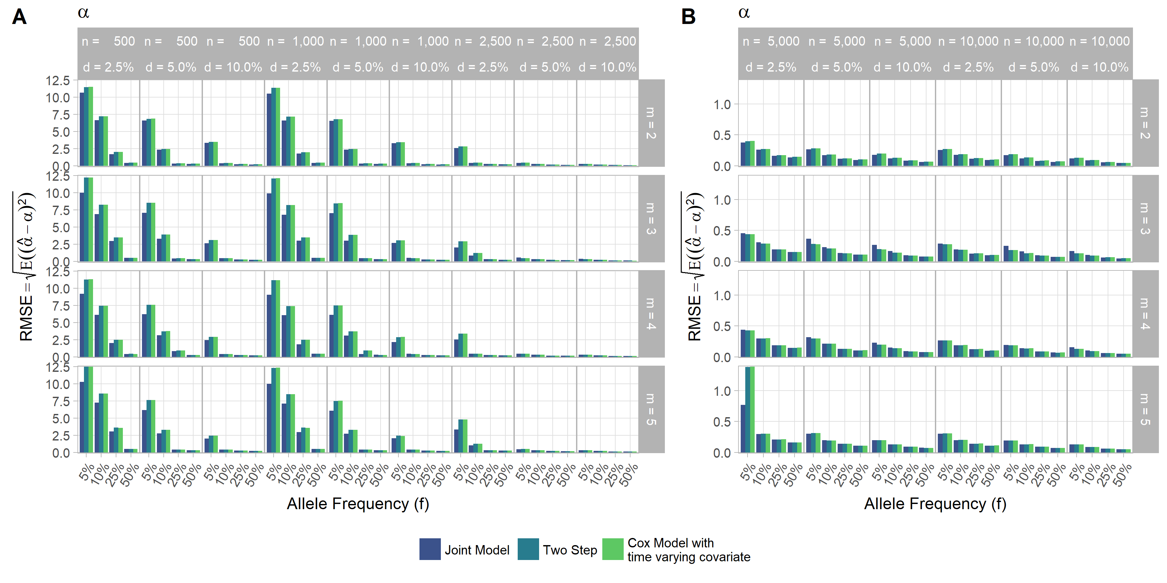

Figure 4. Simulation study for accuracy of estimator $\overset{^}{\text{α}}$ provided by the joint model (JM package), by the two-step linear mixed effect model (nlme package) and by the Cox model with time-varying covariate. $\text{m}$: number of measures; $\text{n}$: number of individuals; $\text{d}$: diabetes incidence rate.

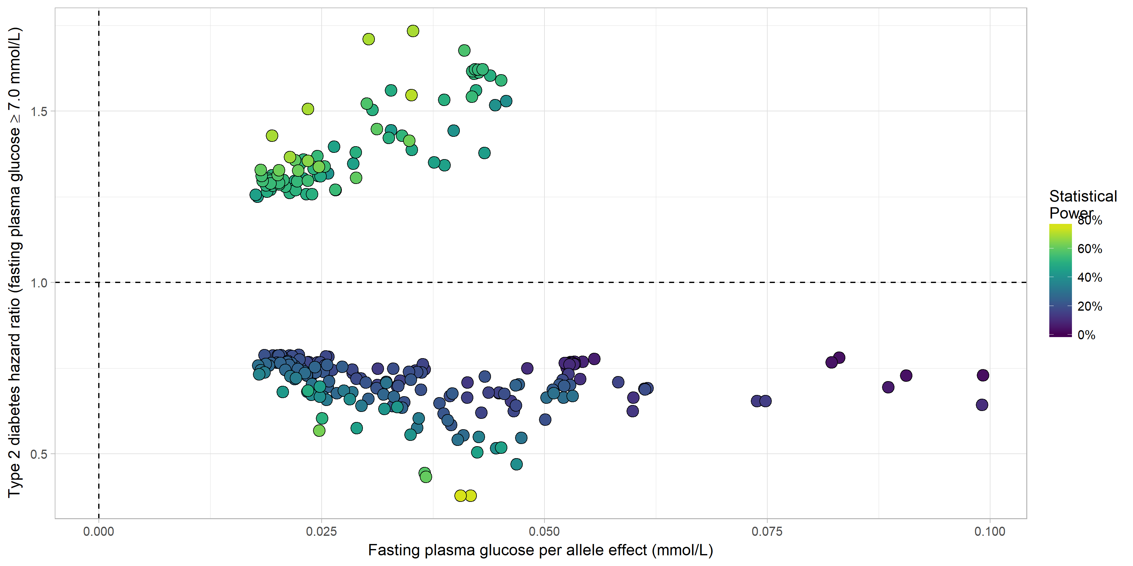

Figure 5. Results from statistical analysis using JM (Rizopoulos, 2010, 2016). Estimated effects of $γ$ are displayed on the x-axis, with corresponding estimated odds ratio $\text{exp(α)}$ on the y-axis. Statistical power reported is the theoretical (retrospective) power to detect a genetic joint effect $\text{βγ+α}$ based on estimated model parameters (Chen et al., 2011).

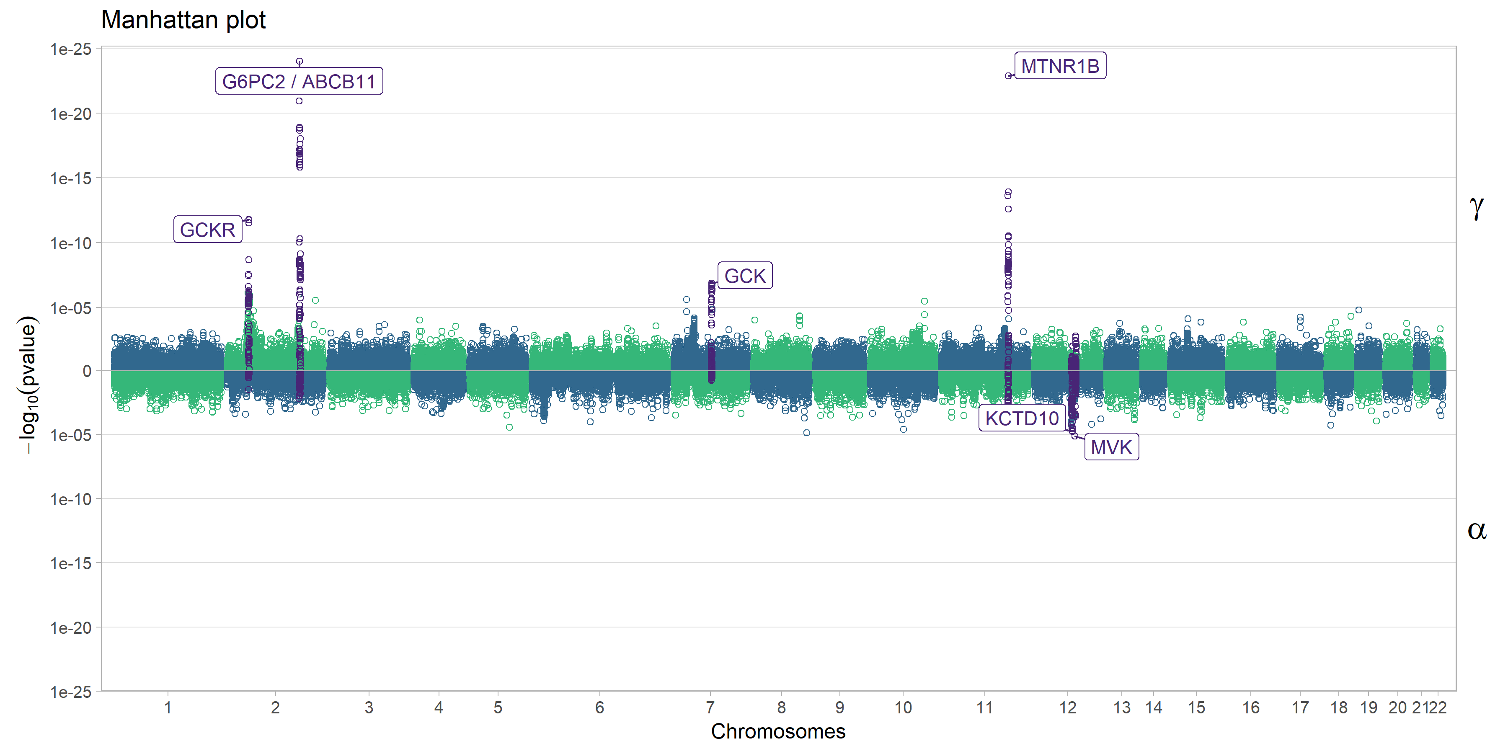

Figure 6. Manhattan plot for estimated effects of $γ$ and $α$ using JM. Results are presented for the cleaned set of 101,305 SNPs.

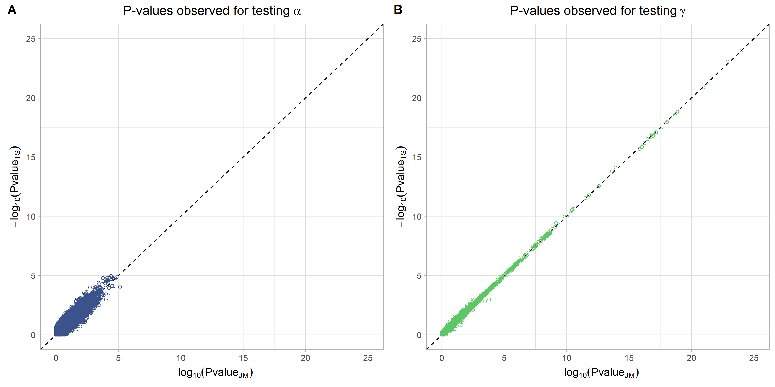

Figure 7. Testing for $α$ (SNP effect on onset of T2D) and $γ$ (SNP effect on the trajectory of FPG) using Two-Step approach compared to Joint Model approach. On the x-axis, $\text{-}{\text{log}}_{\text{10}}\text{(p-value)}$ from the Joint Model and on the y-axis the corresponding $\text{-}{\text{log}}_{\text{10}}\text{(p-value)}$ from the approximate Two-Step approach.

# References

Albert, P. S., & Shih, J. H. (2010a). An approach for jointly modeling multivariate longitudinal measurements and discrete time-to-event data. *The Annals of Applied Statistics*, *4*(3), 1517–1532.

Albert, P. S., & Shih, J. H. (2010b). On Estimating the Relationship between Longitudinal Measurements and Time-to-Event Data Using a Simple Two-Stage Procedure. *Biometrics*, *66*(3), 983–987

Austin, P. C. (2012). Generating survival times to simulate Cox proportional hazards models with time-varying covariates. *Statistics in Medicine*, *31*(29), 3946–3958.

Balkau, B. (1996). An epidemiologic survey from a network of French Health Examination Centres, (D.E.S.I.R.): epidemiologic data on the insulin resistance syndrome. *Revue D’épidémiologie et de Santé Publique*, *44*(4), 373–375.

Bouatia-Naji, N., Rocheleau, G., Van Lommel, L., Lemaire, K., Schuit, F., Cavalcanti-Proença, C., … Froguel, P. (2008). A polymorphism within the G6PC2 gene is associated with fasting plasma glucose levels. *Science (New York, N.Y.)*, *320*(5879), 1085–1088.

Chang, C. C., Chow, C. C., Tellier, L. C., Vattikuti, S., Purcell, S. M., & Lee, J. J. (2015). Second-generation PLINK: Rising to the challenge of larger and richer datasets. *GigaScience*, *4*, 7.

Chen, L. M., Ibrahim, J. G., & Chu, H. (2011). Sample size and power determination in joint modeling of longitudinal and survival data. *Statistics in Medicine*, *30*(18), 2295–2309.

Diggle, P., & Kenward, M. G. (1994). Informative Drop-Out in Longitudinal Data Analysis. *Journal of the Royal Statistical Society. Series C (Applied Statistics)*, *43*(1), 49–93.

Dupuis, J., Langenberg, C., Prokopenko, I., Saxena, R., Soranzo, N., Jackson, A. U., … Barroso, I. (2010). New genetic loci implicated in fasting glucose homeostasis and their impact on type 2 diabetes risk. *Nature Genetics*, *42*(2), 105–116

Elashoff, R. M., Li, G., & Li, N. (2008). A Joint Model for Longitudinal Measurements and Survival Data in the Presence of Multiple Failure Types. *Biometrics*, *64*(3), 762–771.

Elashoff, R., li, G., & Li, N. (2016). *Joint Modeling of Longitudinal and Time-to-Event Data* (1st ed.). Chapman and Hall/CRC.

Ibrahim, J. G., Chu, H., & Chen, L. M. (2010). Basic Concepts and Methods for Joint Models of Longitudinal and Survival Data. *Journal of Clinical Oncology*, *28*(16), 2796.

Kalbfleisch, J. D., & Prentice, R. L. (2002). *The Statistical Analysis of Failure Time Data*. Hoboken, NJ, USA: John Wiley & Sons, Inc.

Morris, A. P., Voight, B. F., Teslovich, T. M., Ferreira, T., Segrè, A. V., Steinthorsdottir, V., … McCarthy, M. I. (2012). Large-scale association analysis provides insights into the genetic architecture and pathophysiology of type 2 diabetes. *Nature Genetics*, *44*(9), 981–990.

Pinheiro, J., Bates, D., & R-core. (2017). *Nlme: Linear and nonlinear mixed effects models*. Retrieved from <https://CRAN.R-project.org/package=nlme>

Proust-Lima, C., Joly, P., Dartigues, J.-F., & Jacqmin-Gadda, H. (2009). Joint modelling of multivariate longitudinal outcomes and a time-to-event: A nonlinear latent class approach. *Computational Statistics & Data Analysis*, *53*(4), 1142–1154.

Purcell, S., & Chang, C. (2015). PLINK v1.90b3.36.

R Core Team. (2015). *R: A Language and Environment for Statistical Computing*. Vienna, Austria: R Foundation for Statistical Computing.

Rizopoulos, D. (2010). JM: An R package for the joint modelling of longitudinal and time-to-event data. *Journal of Statistical Software*, *35*(9), 1–33.

Rizopoulos, D. (2012). *Joint models for longitudinal and time-to-event data: With applications in R*. CRC Press.

Rizopoulos, D. (2016). *JM: Joint modeling of longitudinal and survival data*. Retrieved from <https://CRAN.R-project.org/package=JM>

Rizopoulos, D., & Ghosh, P. (2011). A Bayesian semiparametric multivariate joint model for multiple longitudinal outcomes and a time-to-event. *Statistics in Medicine*, *30*(12), 1366–1380.

Rung, J., Cauchi, S., Albrechtsen, A., Shen, L., Rocheleau, G., Cavalcanti-Proença, C., … Sladek, R. (2009). Genetic variant near IRS1 is associated with type 2 diabetes, insulin resistance and hyperinsulinemia. *Nature Genetics*, *41*(10), 1110–1115.

Sladek, R., Rocheleau, G., Rung, J., Dina, C., Shen, L., Serre, D., … Froguel, P. (2007). A genome-wide association study identifies novel risk loci for type 2 diabetes. *Nature*, *445*(7130), 881–885.

Sun, J., Sun, L., & Liu, D. (2007). Regression Analysis of Longitudinal Data in the Presence of Informative Observation and Censoring Times. *Journal of the American Statistical Association*, *102*(480), 1397–1406.

The 1000 Genomes Project Consortium. (2015). A global reference for human genetic variation. *Nature*, *526*(7571), 68–74.

Therneau, T. M. (2017). *Survival: Survival analysis*. Retrieved from <https://CRAN.R-project.org/package=survival>

Therneau, T. M., & Grambsch, P. M. (2000). *Modeling Survival Data: Extending the Cox Model*. (K. Dietz, M. Gail, K. Krickeberg, J. Samet, & A. Tsiatis, Eds.). New York, NY: Springer New York.

Tsiatis, A. A., & Davidian, M. (2004). Joint modeling of longitudinal and time-to-event data: An overview. *Statistica Sinica*, *14*, 809–834.

Tsiatis, A. A., DeGruttola, V., & Wulfsohn, M. S. (1995). Modeling the Relationship of Survival to Longitudinal Data Measured with Error. Applications to Survival and CD4 Counts in Patients with AIDS. *Journal of the American Statistical Association*, *90*(429), 27–37.

Vaxillaire, M., Yengo, L., Lobbens, S., Rocheleau, G., Eury, E., Lantieri, O., … Froguel, P. (2014). Type 2 diabetes-related genetic risk scores associated with variations in fasting plasma glucose and development of impaired glucose homeostasis in the prospective DESIR study. *Diabetologia*, *57*(8), 1601–1610.

Voight, B. F., Kang, H. M., Ding, J., Palmer, C. D., Sidore, C., Chines, P. S., … Boehnke, M. (2012). The Metabochip, a Custom Genotyping Array for Genetic Studies of Metabolic, Cardiovascular, and Anthropometric Traits. *PLoS Genetics*, *8*(8), e1002793.

Welter, D., MacArthur, J., Morales, J., Burdett, T., Hall, P., Junkins, H., … Parkinson, H. (2014). The NHGRI GWAS Catalog, a curated resource of SNP-trait associations. *Nucleic Acids Research*, *42*(D1), D1001–D1006.

Wulfsohn, M. S., & Tsiatis, A. A. (1997). A Joint Model for Survival and Longitudinal Data Measured with Error. *Biometrics*, *53*(1), 330.

# Supplementary

Supplementary Table I. List of loci found to be associated within the joint modelling framework with both FPG and T2D, previously shown as associated with FPG and/or T2D in the NHGRI GWAS Catalogue (Welter et al., 2014).

|  |  |  |  |  |  |
| --- | --- | --- | --- | --- | --- |
| SNP (gene) | $α$ (p-value) | $γ$ (p-value) | $β$ (p-value) | Power ($βγ+α$) | Risk Allele Frequency |
| rs6945660_G (ETV1) | 0.550 ($3.7×{10}^{-02}$) | 0.035 ($2.5×{10}^{-02}$) | 3.480 ($9.6×{10}^{-45}$) | 69.7% | 0.91 |
| rs1942873_C (MC4R) | 0.410 ($1.3×{10}^{-02}$) | 0.023 ($3.7×{10}^{-02}$) | 3.140 ($1.9×{10}^{-41}$) | 69.6% | 0.81 |
| rs55899248_G (TCF7L2) | 0.292 ($2.7×{10}^{-02}$) | 0.025 ($1.7×{10}^{-02}$) | 3.490 ($1.7×{10}^{-44}$) | 55.3% | 0.24 |
| rs17301514_A (ST6GAL1) | -0.657 ($4.4×{10}^{-03}$) | 0.045 ($3.4×{10}^{-03}$) | 3.650 ($2.9×{10}^{-45}$) | 45.8% | 0.09 |
| rs833425_C (PTPRD) | 0.321 ($5.0×{10}^{-02}$) | 0.043 ($4.2×{10}^{-03}$) | 3.510 ($1.3×{10}^{-43}$) | 44.2% | 0.1 |
| rs7072870_A (C10orf35) | -0.404 ($7.5×{10}^{-03}$) | 0.025 ($2.2×{10}^{-02}$) | 3.580 ($1.7×{10}^{-45}$) | 39.6% | 0.22 |
| rs61871514_A (KCNQ1) | 0.425 ($4.7×{10}^{-02}$) | 0.046 ($2.0×{10}^{-02}$) | 3.180 ($8.5×{10}^{-42}$) | 39.4% | 0.06 |
| rs9883865_A (ADAMTS9) | -0.598 ($7.5×{10}^{-04}$) | 0.043 ($1.2×{10}^{-02}$) | 3.200 ($5.9×{10}^{-42}$) | 34.9% | 0.92 |
| rs853787_T (ABCB11) | -0.247 ($4.3×{10}^{-02}$) | 0.083 ($9.3×{10}^{-19}$) | 3.210 ($1.7×{10}^{-42}$) | 3.3% | 0.65 |
| rs114508985_C (HLA) | -0.294 ($2.1×{10}^{-02}$) | 0.021 ($3.0×{10}^{-02}$) | 3.220 ($8.2×{10}^{-43}$) | 27.1% | 0.31 |
| rs560887_C (G6PC2) | -0.315 ($1.2×{10}^{-02}$) | 0.099 ($9.6×{10}^{-25}$) | 3.210 ($1.3×{10}^{-42}$) | 2.6% | 0.7 |
| rs10814856_T (GLIS3) | -0.265 ($4.0×{10}^{-02}$) | 0.025 ($1.5×{10}^{-02}$) | 3.200 ($1.5×{10}^{-42}$) | 18.5% | 0.73 |
| rs73025532_C (SLC22A1) | -0.377 ($4.8×{10}^{-02}$) | 0.032 ($3.6×{10}^{-02}$) | 3.580 ($1.3×{10}^{-45}$) | 17.3% | 0.9 |
| rs11769484_C (JAZF1) | -0.254 ($4.8×{10}^{-02}$) | 0.022 ($3.6×{10}^{-02}$) | 3.210 ($2.1×{10}^{-42}$) | 16.9% | 0.77 |
| rs6450176_G (ARL15) | -0.291 ($1.8×{10}^{-02}$) | 0.036 ($3.0×{10}^{-04}$) | 3.540 ($2.2×{10}^{-45}$) | 15.2% | 0.73 |
| rs4712580_C (CDKAL1) | -0.289 ($4.2×{10}^{-02}$) | 0.031 ($7.4×{10}^{-03}$) | 3.570 ($1.2×{10}^{-45}$) | 14.0% | 0.82 |
| rs10830963_G (MTNR1B) | -0.440 ($9.4×{10}^{-04}$) | 0.099 ($1.3×{10}^{-23}$) | 3.250 ($3.6×{10}^{-42}$) | 10.2% | 0.29 |

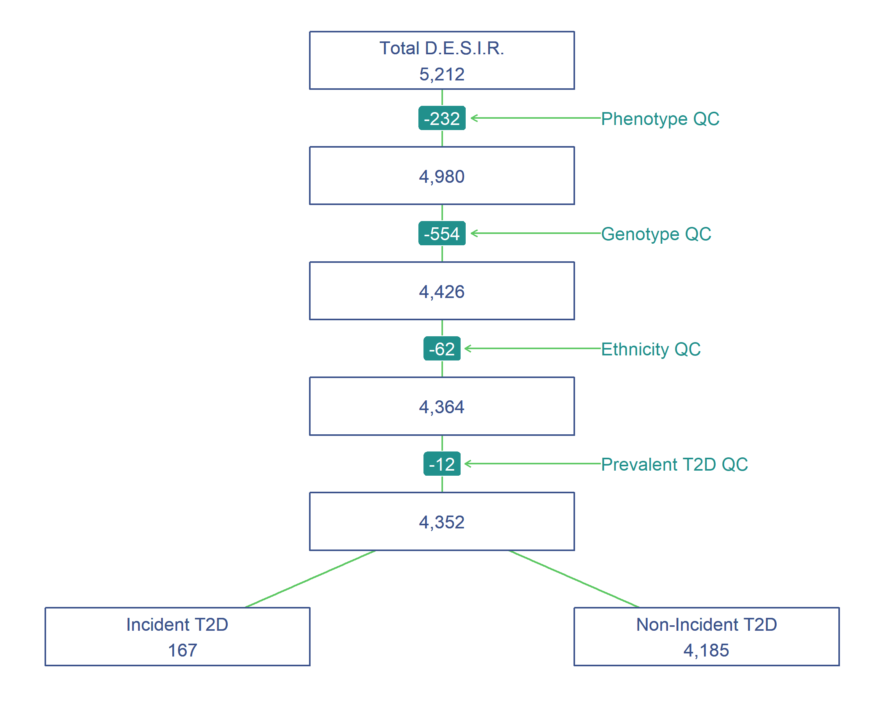

Supplementary Figure 1. Study flowchart of people from the French cohort D.E.S.I.R.

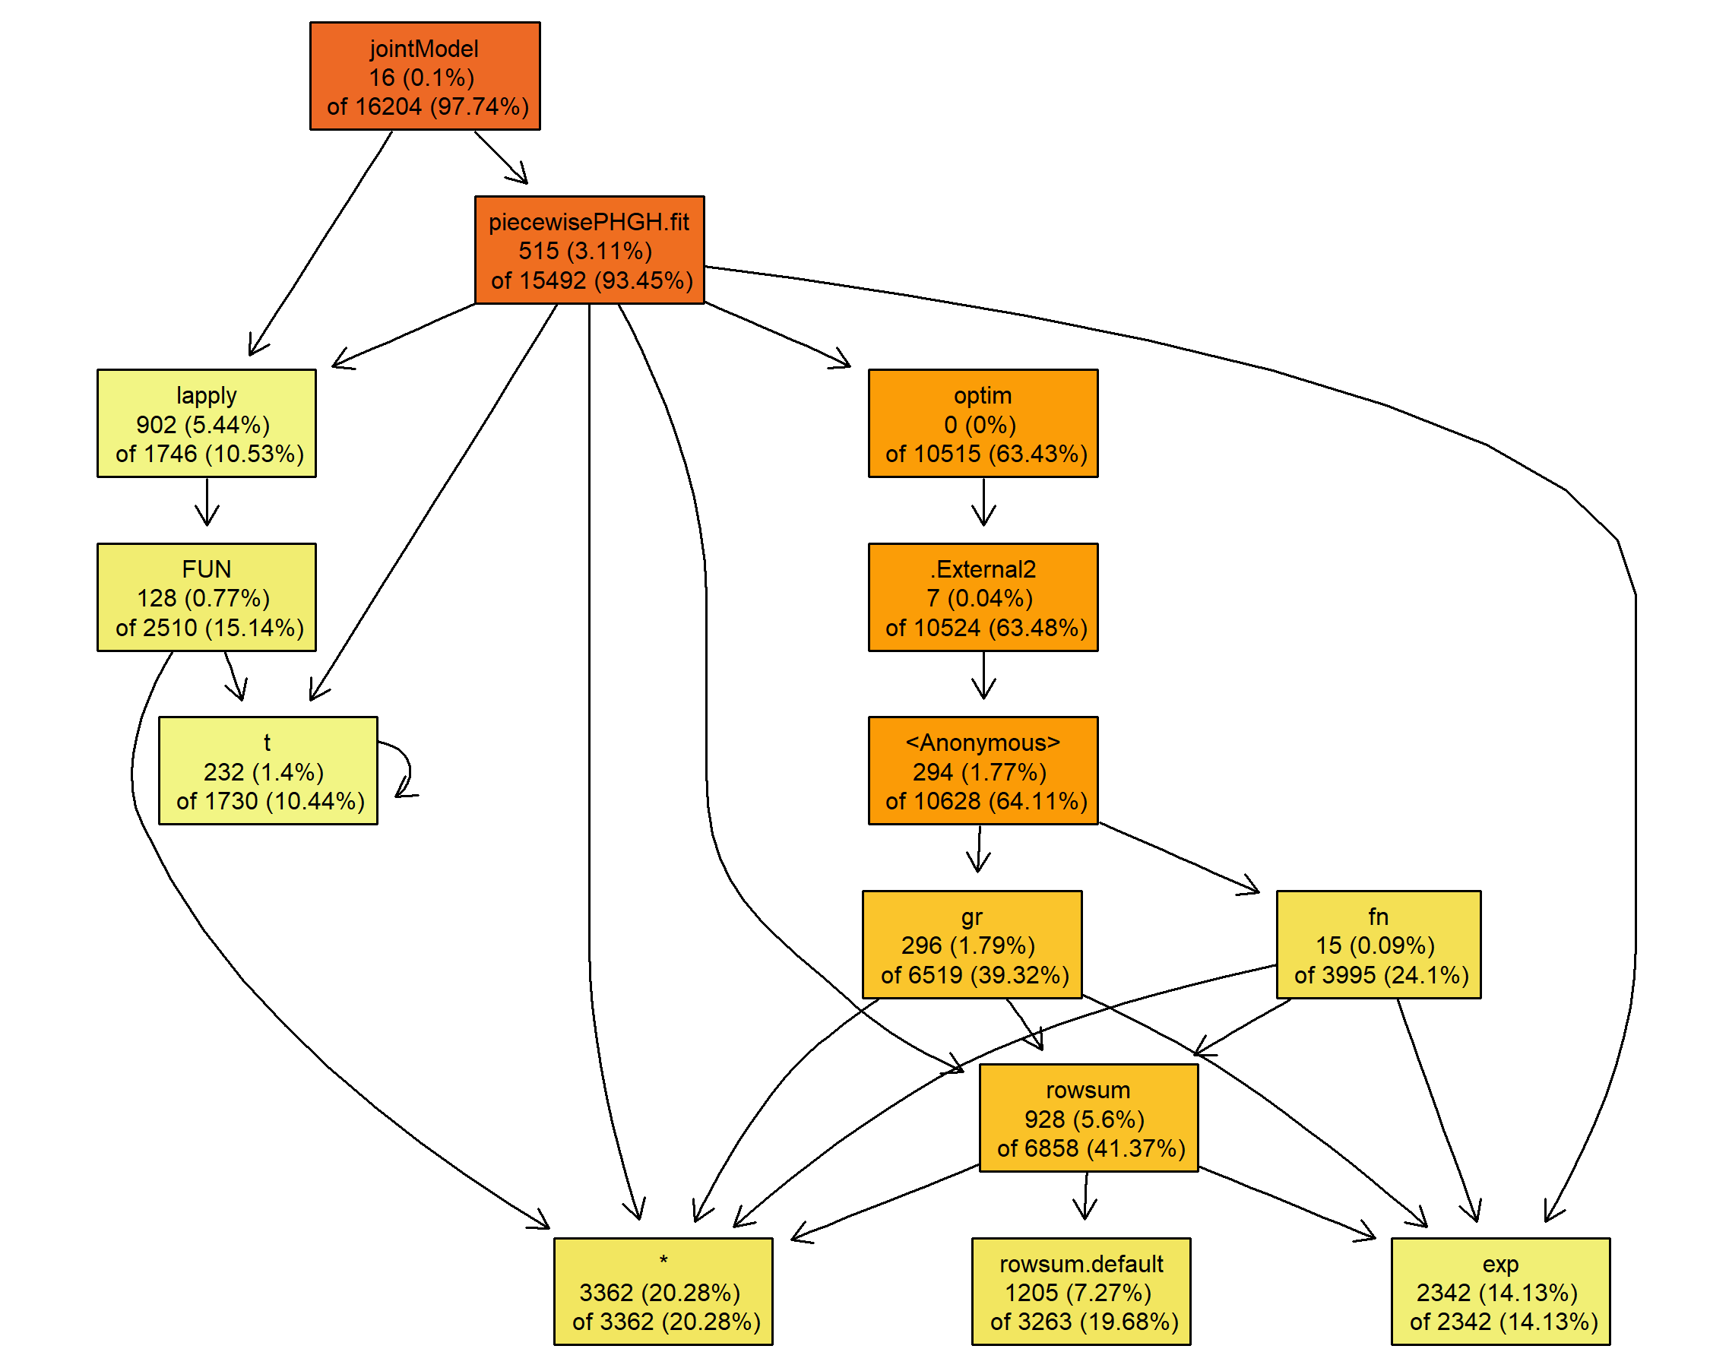

Supplementary Figure 2. Call tree diagram of the main function *jointmodel* in the R package JM. Call based on a simulated dataset with three longitudinal measures and 5,000 individuals (other parameter values set as in Table I).