Supplementary Document 1: Image Analysis Protocol

1. Import image into ImgaeJ (FIJI)
2. Split the channels of the image
3. On **cellular stained channel** image: *Image > Stacks > Z- Project > Projection type: Max Intensity*
4. On **bead channel** image (grayscale of beads): *Image > Stacks > Z-Project > Projection type: Sum Slices*

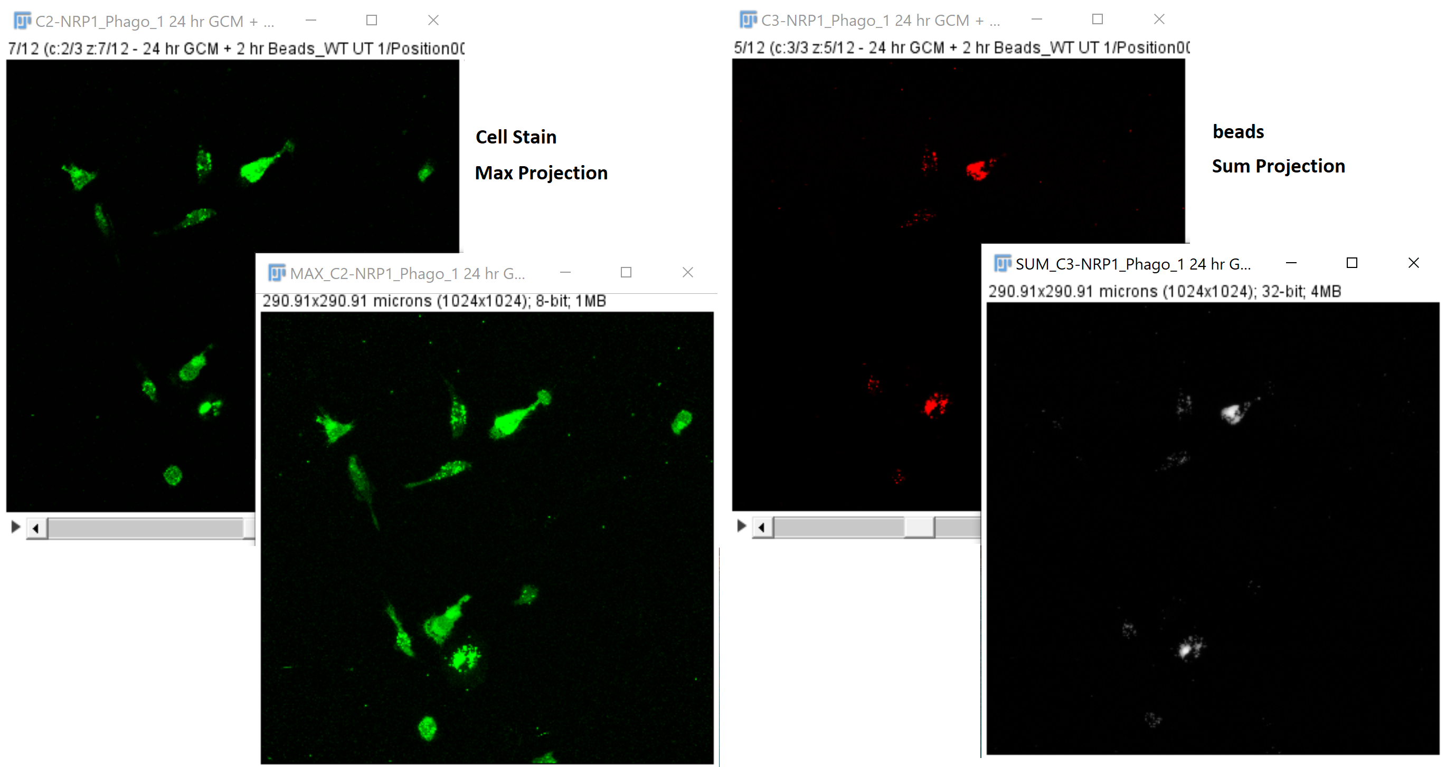

1. Open ROI manager: *Analyze -> tools -> ROI manager*
2. Trace cells of interest (cells that are completely in frame and do not overlap with other cells) using free hand selection tool. Add each cell to ROI manager by clicking ‘add’ or by pressing “T”

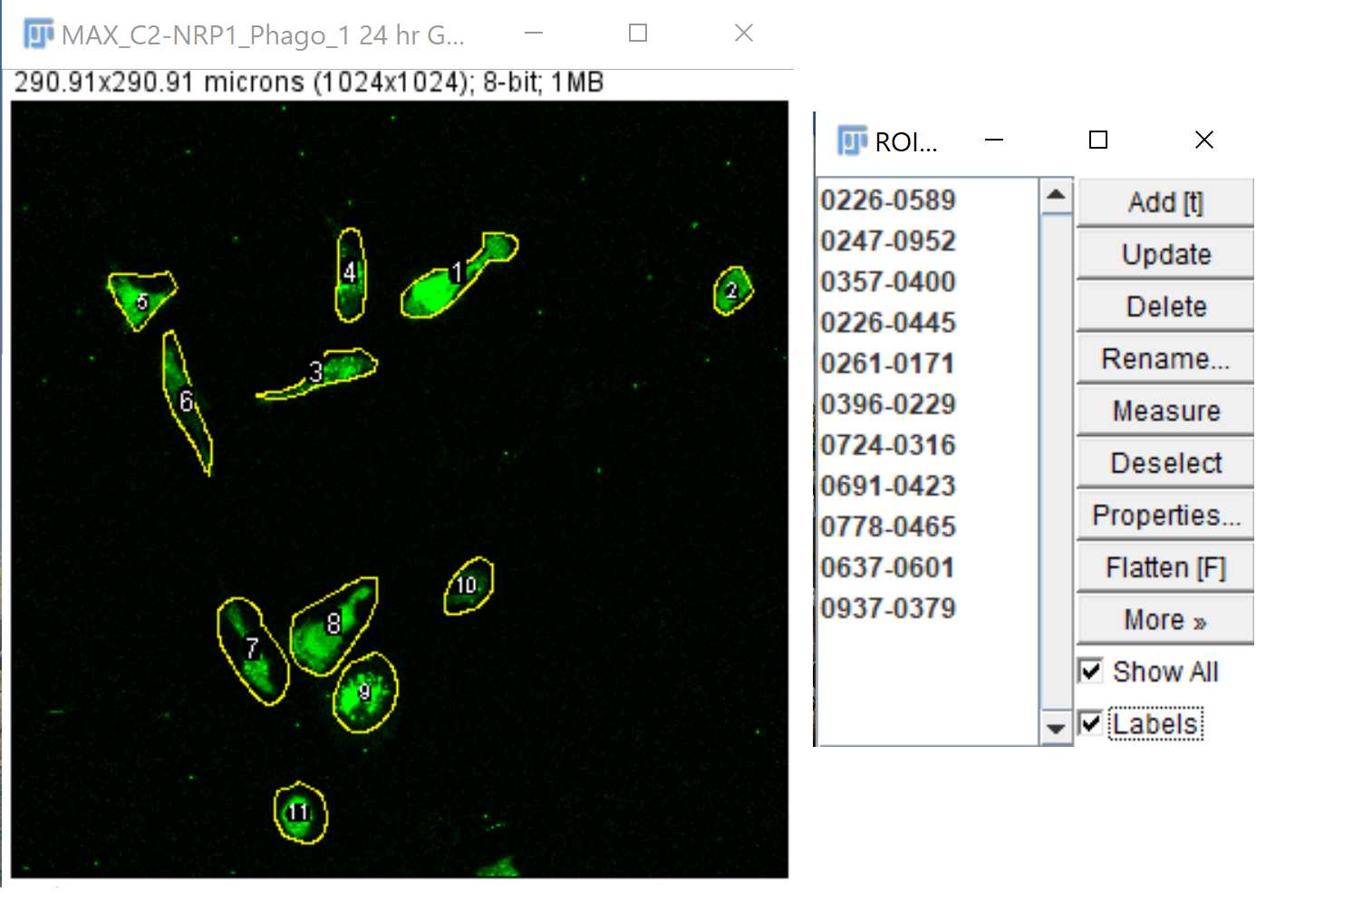

1. In **sum projected beads image**, click on an ROI. This should select the same cell in the grayscale sum projection.

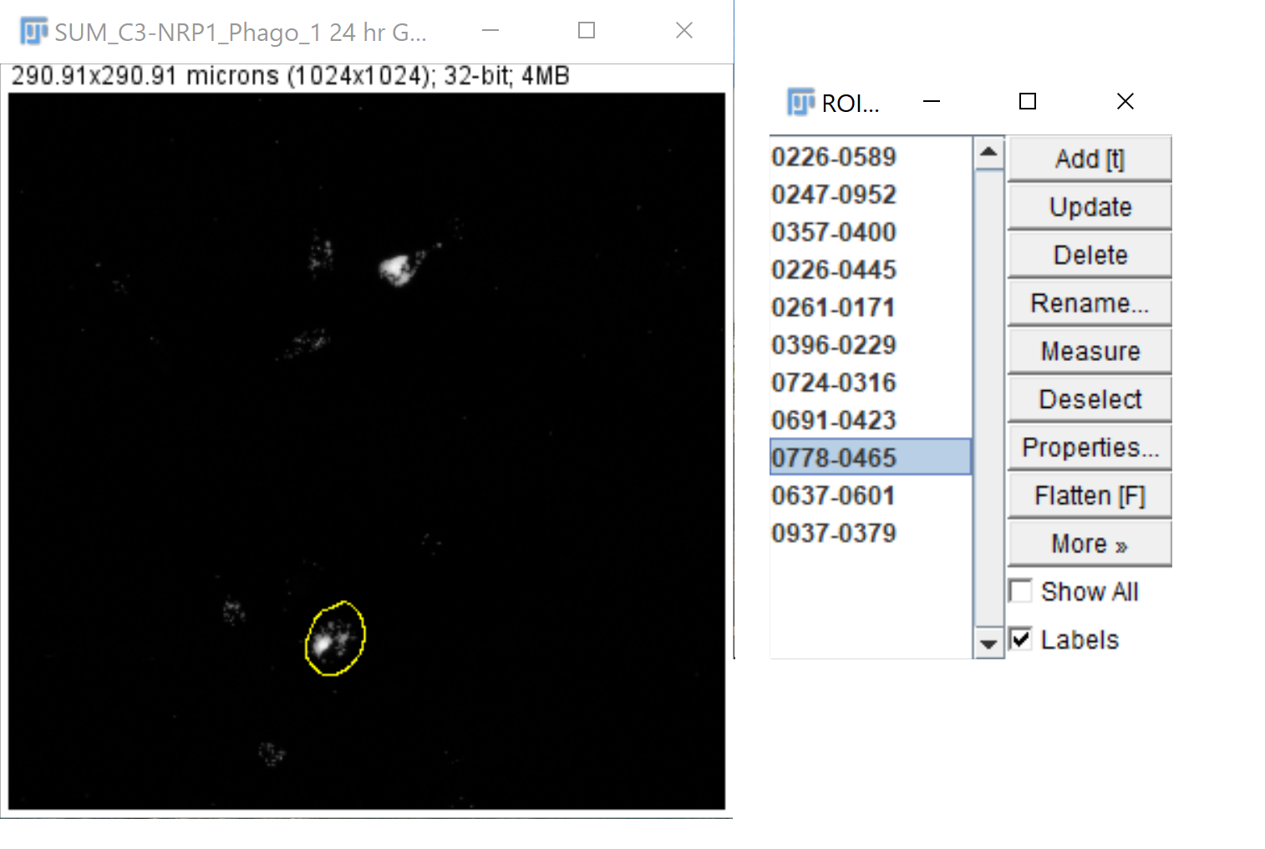

1. To collect fluorescent signal value: *Analyze -> set measurements -> check area, mean gray value, and integrated density.*
2. To collect data: Analyze -> measure or press Ctrl+M

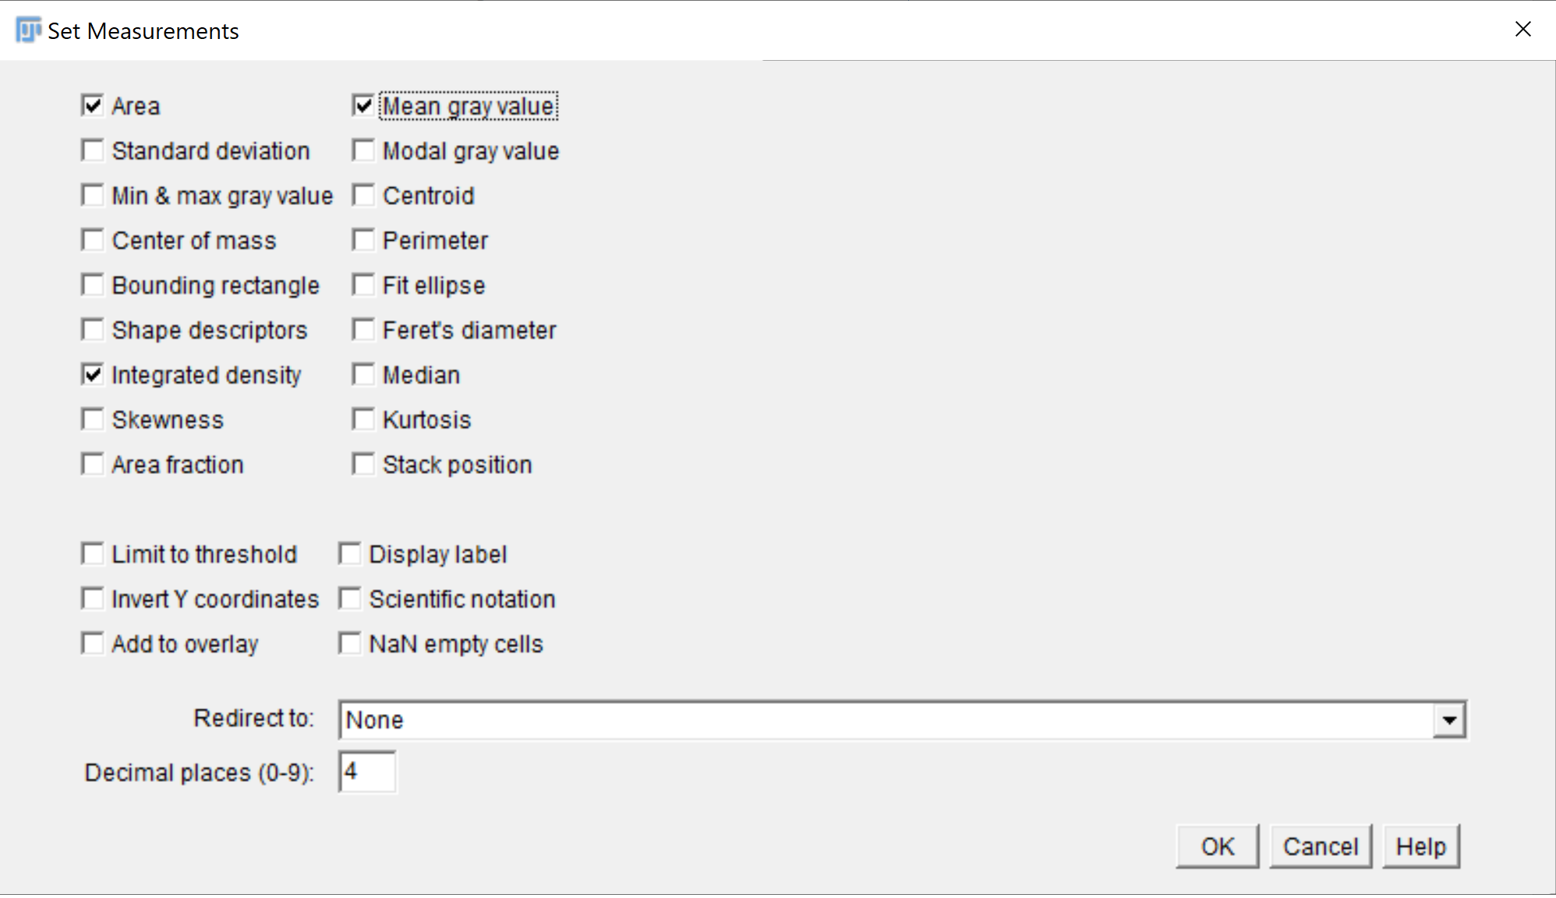

1. Copy and paste results into Excel spreadsheet. We use the RawIntDen value, as it does not normalize to mean fluorescence of the selected cell. Thus, it captures the *sum* of the pixels generated across the z stack.