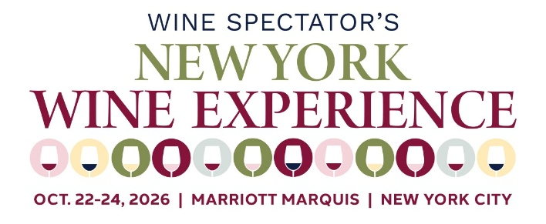
TERMS AND CONDITIONS
Winery Sponsor agrees to participate with the Wine Spectator Scholarship Foundation during Wine Spectator's NY Wine Experience Grand Tastings on October 22 and 23, 2026 according to the following conditions:
PRODUCT
Winery sponsor agrees to provide product for this event, in accordance with applicable laws and regulations. Winery sponsor also agrees to claim and/or remove all unused bottle after the event. Wine Spectator Scholarship Foundation and M. Shanken Communications, Inc. are not responsible for any leftover product.
INSURANCE REQUIREMENTS
Prior to the commencement of the event, Winery Sponsor shall submit a Certificate(s) of Insurance from an insurance carrier, rated "A-" or better for both nights of the Grand Tastings. Wine Spectator Scholarship Foundation / M. Shanken Communications, its subsidiaries and affiliates as additional insured. Said policies must remain in full force and effect throughout the event. Certificates should note the event name, venue and dates that the exhibitor is onsite, including load-in and load-out periods.

Certificate Holder
Wine Spectator Scholarship Foundation / M. Shanken Communications, Inc. - 825 8th Ave., Floor 33, New York, NY 10019-7640, Attn: Susannah Nolan

Requirements: Minimum Limits:
Comprehensive General Liability (per occurrence), Each Occurrence $1,000,000, Damage to Rented Premises (ea occurrence) $1,000,000, Med Exp $5,000, Personal & Adv Injury $1,000,000, General Aggregate $2,000,000, Products/Completed Op Agg $2,000,000
- Automobile Liability $1,000,000,
- Umbrella Liability (per occurrence/agg) $5,000,000
- Workers Compensation, as required by law and Employers liability insurance with a minimum limit of $500,000.

INDEMNIFICATION
The Winery Sponsor indemnifies Wine Spectator Scholarship Foundation/M. Shanken Communications, Inc. against all claims, damages or liability whatsoever arising out of or in any way caused by or connected to this agreement.

Wine Spectator Scholarship Foundation/M. Shanken Communications Inc. indemnifies Winery Sponsor against all claims, damages or liability whatsoever arising out of or in any way caused by or connected to this agreement.

BREACH OF PAYMENT
The Wine Spectator Scholarship Foundation / M. Shanken Communications, Inc. reserves the right to cancel the contract upon default of payment or breach of any provision herein where such breach is incapable of remedy. The Festival Sponsor agrees to indemnify, save, and hold harmless the Wine Spectator Scholarship Foundation / M. Shanken Communications, Inc. against all losses and expenses incurred in the collection of any delinquent balance including reasonable attorneys’ fees.
Please confirm that you have reviewed the terms and conditions for NY Wine Experience Grand Tastings 2026.
Yes, I acknowledge that I have reviewed and agree to the terms and conditions outlined.

______________________________ Wine Spectator Scholarship Foundation\s1\\s2\
Licensee Licensor
___________________\d1\\d2\
DATE
Participation fee: $70,000 for the following wineries:
Jermann
Louis M. Martini
Massican
Pahlmeyer
Rombauer

