THE ULTIMATE TRAVEL GUIDE TO NAPA VALLEY | CALISTOGA
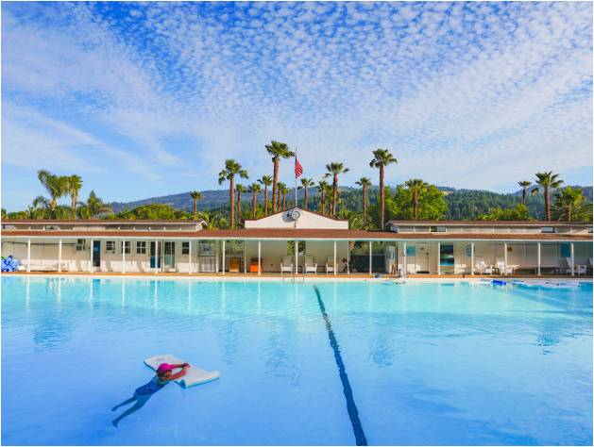Indian Springs Resort
CALISTOGA A Wine Country Retreat By Mitch Frank
Tucked away at the northern end of Napa Valley, the town
of Calistoga has long held its own, unique vibe. For those looking for a more relaxed version of wine coun try, Calistoga is a haven.
One reason for that vibe is location: 30 miles north of down town Napa, where the valley narrows and turns west. The tall evergreen woods of Robert Louis Stevenson State Park and the looming Mount St. Helena make it feel more like a wooded re treat than wide open farming country.
That retreat aspect is the second distinction—wellness tour ism predates wine tourism in Calistoga. The Wappo natives valued the geothermal springs and mud baths here and built sweat lodges atop them. Sam Brannan, who made his fortune selling equipment to miners during the height of the California Gold Rush, visited the hot springs in 1859 and bought up the northern portion of Rancho Carne Humana, establishing the town and building a resort that still stands today (albeit mod
ernized), Indian Springs. He named his town by combining 2 WINE SPECTATOR • JUNE 15 & 30, 2026
California with Saratoga Springs, a popular resort in New York state.
To help his tourism destination grow, Brannan founded the Napa Valley Railroad, connecting Calistoga to ferry terminals in Vallejo on the bay, making it easy for San Francisco residents to travel upvalley for vacation. The Napa Valley Wine Train travels over portions of the track today. Not all the locals ap
preciated Brannan’s changes to their sleepy area—he was shot by residents, though he recovered, proving that wariness of overdevelopment is not a new Napa phenomenon.
Calistoga today still offers that rustic, relaxed feel paired with sophisticated escape. You can stroll the old downtown stretch of Lincoln Road, which feels like an 1800s California town, de spite the coffee shops and art galleries. You can head out to the wineries, which feel a little less formal than those farther down the valley. And you can visit the spas or hiking trails to unwind from a long day of tasting.
WS063026_napaCalistoga_draft.indd 2 3/26/26 10:22 AM
WHERE TO TASTE
Calistoga’s location brings with it several differ ences from the conditions in the heart of Napa
THE ULTIMATE TRAVEL GUIDE TO NAPA VALLEY | CALISTOGA
Aubert
333 Silverado Trail
Valley. Because its farther from the bay, tem peratures can get pretty high on summer days. But evening winds drawn in from the Pacific through the
Hourglass
4208 Silverado Trail | hourglasswines.com
Chalk Hill Gap cool the vines dramatically in the eve ning. There’s also a higher percentage of volcanic soil here. The wineries vary too, from secluded spots to the perched, modernist lookout of Sterling Vineyards to the faux Tuscan castle of Castello di Amorosa.
aubertwines.com
Note: Currently tastings are limited as they reno vate the hospitality space, but soon they will have expanded capacity.
Bennett Lane 3340 CA-128
bennettlane.com
CADE Estate
More than five years after the Glass Fire tore through, destroying several buildings, Hourglass forges on, with consulting wine maker Tony Biagi producing outstanding Bordeaux-style blends from two estate vineyards. Founded by couple Jeff Smith and Carolyn Duryea, the winery at their Blueline estate blends into the eastern hills of the Valley, with a round, Hobbiton-style door opening into the hillside and into the winery. Guests can pass through the winery and down into the aging tunnels deep under ground to find a peaceful tasting room and a flight of multiple wines.
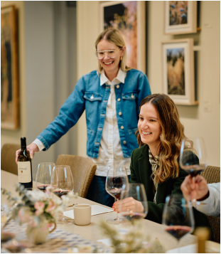
Larkmead Vineyards
1100 Larkmead Lane | larkmead.com
Larkmead’s Howard Backen-designed
tasting salon looks fairly new, but there
are plenty of hints that this is a winery
with real history. The property was
founded in 1895 by Lillie Colt, a San
Francisco woman whose wealthy par
ents gave her a Napa farm to get her out
of the corrupting city. She responded by
converting the land into a winery, which
survived through Prohibition by produc
ing sacramental wine and then was pur
chased by the Solari family in 1948. Lo
cated at one of the narrowest, hottest
points of the valley, Larkmead is sur
rounded by its vineyards, primarily Cab
ernet with some Sauvignon Blanc and a
bit of Tocai Friulano. A visit includes a
tour of the vineyards followed by a
seated tasting paired with cheese and
charcuterie in the comfortable tasting
room, or the pergola when the weather
is nice. And in this part of the valley, it
usually is.
Larkmead
260 Howell Mountain Road S.
cadewinery.com
Castello di
Amorosa
4045 St. Helena High way
castellodiamorosa.com
Frank Family 1091 Larkmead Lane frankfamilyvineyards. com
Girard
1077 Dunaweal Lane girardwinery.com
Lola Wines
916 Foothill Blvd.
lolawines.com
Outpost Wines 2075 Summit Lake Drive
outpostwines.com
Rivers-Marie 900 Foothill Blvd. riversmarie.com
Spire Collection 299 Bennett Lane spirecollection.com
Sterling
Vineyards
1111 Dunaweal Lane sterlingvineyards.com
Lola Wines
916 Foothill Blvd. | lolawines.com
Driving into the heart of town, you might be forgiven for think ing the Lola House is a residence—it looks like a quaint brick bungalow. But inside is a welcoming tasting experience. Wine maker and owner Seth Cripe, who trained at Caymus and Belle Glos, makes Russian River Valley Pinot Noir plus a fascinating selection of wines from less-typical California grapes, includ ing Vermentino, Charbono and Counoise. A tasting here is just $35 for five wines, and it can be paired with snacks, including bottarga. This is one of the better bargains in the valley. Sit down in one of several eclectic rooms or on the shaded patio space and enjoy a funkier side of Napa.
Schramsberg
1400 Schramsberg Road | schramsberg.com
Napa locals thought Jack and Jamie Davies were fools when they fled Los Angeles in 19764[UH??] and bought the old Sch ram place in the foothills of Spring Mountain, with its crum bling buildings and abandoned tunnels. Instead, the Davieses helped kickstart Napa Valley’s modern era, part of a migration of young, enthusiastic winemakers into the region. The couple cleared out the tunnels to age their sparkling wine in and be gan producing bubbly that rivals Champagne. Schramsberg is still owned by the family today. Guests can enjoy a tour of the tunnels and learn more about sparkling winemaking, then taste six wines from both Schramsberg and Davies Vineyard, their nearby still-wine project.
Tamber Bey 1251 Tubbs Lane
tamberbey.com
Tank Garage 1020 Foothill Blvd. tankgaragewinery.com
Trois Noix
865 Silverado Trail N. troisnoixwine.com
Vine Cliff
7400 Silverado Trail vinecliff1871.com
JUNE 15 & 30, 2026 • WINE SPECTATOR 3
WS063026_napaCalistoga_draft.indd 3 3/26/26 10:22 AM
THE ULTIMATE TRAVEL GUIDE TO NAPA VALLEY | CALISTOGA
WHERE
TO EAT
C^{alistoga’s restaurant}
scene reflects the
town’s mix of refined
and comfortable. You can opt for fine dining options at the resorts in town, including a two-star Michelin experience at Auro at the Four Seasons. But there are also comfy local dining rooms that will feed you well and help you relax after a day of winery visits or hiking the trails of the nearby state park. And nearly every place in town has a good wine program.
Calistoga Inn & Brewery
1250 Lincoln Ave. | calistogainn.com
Located where Lincoln Road crosses the Napa River, the Calistoga Inn’s restaurant epitomizes the upscale California comfort the town is characterized by. Choose between a cozy dining room or, when the weather is nice (which, c’mon, it’s Napa Valley) sit on the spacious patio alongside the river. For a break from wine, try one of the excellent beers from the inn’s micro-brewery, Napa Valley Brewing Company. Of course, the wine selection (and cocktail choices) are good too. The menu takes in Napa versions of comfort food—skirt steak, Sonoma duck leg confit with seasonal mushrooms, a wood-fire grilled pork chop garnished with pomegranate and ginger Cabernet sauce.
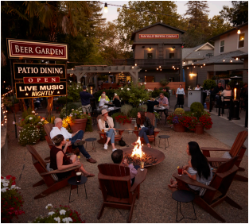
Auro
400 Silverado Trail N.
auronapavalley.com
Bricco Osteria
1350 Lincoln Ave.
briccoosteria.com
Buster’s
Original
Southern BBQ
1207 Foothill Blvd.
busterssouthernbbq.
com
Evangeline
1226 Washington St.
evangelinenapa.com
Calistoga Inn & Brewery
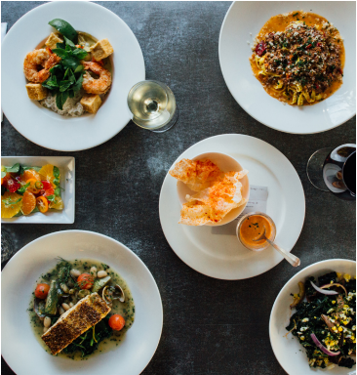Lovina 4 WINE SPECTATOR • JUNE 15 & 30, 2026
Lovina
1107 Cedar St. | lovinacalistoga. com
Lovina feels like it’s been around forever, in part due to the 120-year-old house it occupies but also the boisterous atmo sphere inside thanks to the crowd of locals who dine here. It’s also welcoming to all, with numerous vegan and gluten-free options on the Cal-Ital menu. Consider the “impossible sau sage” lasagna, or dive into the ri sotto with braised Wagyu bone less short rib. Plus, respect to a restaurant whose desserts in clude “Sundae Funday” and “A Hot Mess,” which is a hot brownie topped with house made marshmallow cream and pistachio gelato. The Napa- and Sonoma-focused wine list in cludes a selection of older wines, like Freemark Abbey Cabernet Sauvignon Rutherford Sycamore Vineyard 2009.
Fleetwood
Calistoga Motor Lodge & Spa
1880 Lincoln Ave.
fleetwoodcalistoga.com
House of Better Dr. Wilkinson’s Back yard Resort)
1507 Lincoln Ave.
drwilkinson.com/
house-of-better
Solbar
Solage, Auberge Re sorts Collection
755 Silverado Trail N. auberge.com/solage/ dine/solbar
The Living
Room at TRUSS Four Seasons Resort Napa Valley
400 Silverado Trail N. trussrestaurantandbar. com; fourseasons.com/ napavalley
WS063026_napaCalistoga_draft.indd 4 3/26/26 10:22 AM
THE ULTIMATE TRAVEL GUIDE TO NAPA VALLEY | CALISTOGA
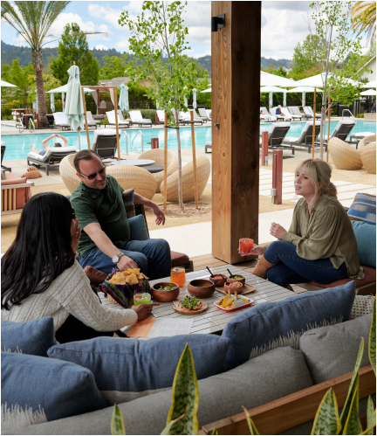
Picobar (at Solage, Auberge
Resorts Collection)
755 Silverado Trail N. | auberge.com/solage/
dine
The Solage resort houses two restaurants,
both helmed by executive chef Gustavo
Rios: the more formal Solbar and the casual
Picobar. The former is great, but Picobar is
a unique experience for its poolside loca
tion, focus on upscale Mexican cuisine and
impressive selection of agave spirits. The
fresh tortilla chips and salsas alone are rea
son to visit and relax by the pool. The wine
list is outstanding too, both by bottle and
glass. Diners can also book, in advance, an
eight-course “Head Tilt Tasting,” as in, tilt
your head to bite that taco, diving into a
delicious culinary exploration of Mexico.
Sam’s Social Club (at Indian
Springs Resort)
1712 Lincoln Ave. | samssocialclub.com
Tucked away on the side of Indian Springs
Resort, Sam’s Social Club is welcoming to
resort guests and non-guests alike. The bar
area is a good spot for meeting up, with
plenty of tables, an appealing cocktail
menu, and a wines by-the-glass list that
takes in both California and international
wines. The menu is upscale America, with
starters like smoked trout dip with house
made potato chips and a crostini covered in
fresh ricotta and house-made pepper jelly.
For entrées, the bone-in pork schnitzel is
large enough to play pickleball with, but it’s
better to eat, covered with Napa cabbage and fennel.
Picobar
Breakfast/Coffee/Sandwiches/Snacks
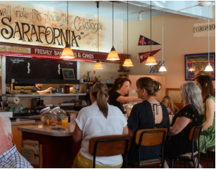
Café Sarafornia
1413 Lincoln Ave. | cafesarafornia.com
If you’re looking for a hearty breakfast
before you head out for wine tasting,
Sarafornia is the place to start. Named
for a supposed slip of the tongue by
town founder Sam Brannan (he meant to
say his town would be the Saratoga of
California and instead said Calistoga of
Sarafornia), this diner has been open
since 1976, serving breakfast and lunch.
The breakfast plates are big and com
forting, with more than a dozen egg
dishes, including “The Best Huevos Ran
cheros in Napa Valley.”
Cafe Sarafornia
Calistoga
Roastery
1426 Lincoln Ave. (707) 942-5757
Palisades
Eatery
1414 Lincoln Ave. (707) 942-9300
Sam’s General Store
109 Wappo Ave.
(707) 942-4200
JUNE 15 & 30, 2026 • WINE SPECTATOR 5
WS063026_napaCalistoga_draft.indd 5 3/26/26 10:22 AM
THE ULTIMATE TRAVEL GUIDE TO NAPA VALLEY | CALISTOGA
WHERE TO STAY AND SOAK
Lodging in Calistoga offers a choice of small and luxurious
or big and luxurious, with intimate hotels like the Francis House Inn and Okaeri, both with fewer than 10 guest rooms, and large resorts like Solage and Indian Springs, each boasting Olympic sized-pools and dozens of rooms. One common
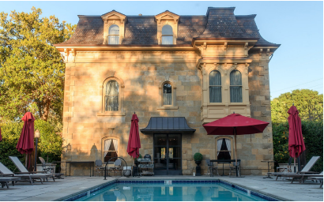Francis House Inn
thread at all of these homes-away-from-home is a focus on well ness, allowing you to recharge after a day of wine touring. There’s an incredible concentration of spas here; take full advantage while staying at one of the resorts or, if you’re staying at a smaller ho tel, buy a day pass and get away from it all for an afternoon.
The Francis House Inn
1403 Myrtle St. | thefrancishouse.com
Tucked away on a side street two blocks from
Lincoln Road, this is an intimate luxury hotel, with
just eight rooms but plenty of deluxe amenities,
from a sauna and salt room to a heated pool and
clay tennis court. It’s also on the National Register
of Historic Places. Built in 1886 as a family home
for prominent local merchant James H. Francis,
the old house with French Second Empire archi
tecture was converted to the Calistoga Hospital in
1919, then abandoned in 1964. In 2014, interior
designer Dina Dwyer and her developer/contrac
tor husband, Richard Dwyer, began a four-year
restoration before opening the inn.
Four Seasons Resort &
Residences Napa Valley 400 Silverado Trail fourseasons.com/ napavalley
Indian Springs Resort & Spa 1712 Lincoln Ave.
indianspringscalistoga. com
Okaeri
1415 Foothill Blvd. okaericalistoga.com
Solage
755 Silverado Trail N. | aubergeresorts.com/solage Of Auberge Resorts’ three Napa Valley properties, So lage is the most relaxed and approachable, popular with both guests and locals who come enjoy the pool and spa with day passes. Guests can stay in one of TK bun galows reached on winding shady paths, making this feel like a resort community. The bungalows are luxuri ous, with glass doors that open wide into private yards.
Solage offers a full menu of wellness options in a 20,000-square-foot spa. Need a massage? There are more than a dozen options to choose from, each at vari ous durations. Then there’s the “signature mudslide,” which provides a lengthy soak in the mineral-enriched mud common to the area, followed by relaxation in a geothermally heated mineral bath. Guests can end their spa day in a private poolside cabana with wine service
Dr. Wilkinson’s Backyard Resort & Mineral Springs
1507 Lincoln Ave. | drwilkinson.com
Driving by, this looks like a 1950s motel, and it sort of is. Dr. Jon Wilkinson and his wife, Edy, founded this road side resort in 1952 with the aim of promoting wellness in Calistoga’s mineral springs. Today, it’s a luxury hotel, run by Marriott. From the outside, the rooms and cot tages still look like a ’50s motor lodge, but interiors have been updated and modernized. At the spa, a lengthy list of amenities includes three mineral pools of varying temperatures, mud treatments and a Mexican American restaurant with a focus on health food.
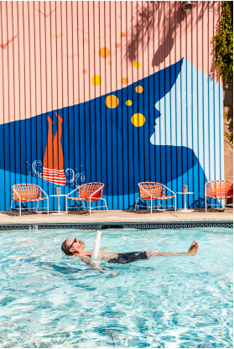Dr Wilkinson’s
6 WINE SPECTATOR • JUNE 15 & 30, 2026
WS063026_napaCalistoga_draft.indd 6 3/26/26 10:22 AM
THE ULTIMATE TRAVEL GUIDE TO NAPA VALLEY | CALISTOGA
CALISTOGA
CHOOSE YOUR
ADVENTURE
Two excursions from
Mitch Frank
If you’re staying all the way up in Calistoga, you’re probably
Napa smart. There are plenty of incredible wineries mak ing outstanding to classic bottlings in this part of the valley, but here are three journeys that are a little more outside the box.
1: A Walkable Tasting Tour Wine country is beautiful, but there are a lot of vine yards between the wineries, which can mean a lot
of driving. Here’s an antidote to that: a tasting at
three great Calistoga wineries, all within walking distance of one another.
To begin, head to where Lincoln Road, the main street of Cal istoga, meets Highway 29 (in Calistoga it’s called Foothill Bou levard). From there, it’s two and a half blocks south to Rivers Marie. Winemaker—Thomas Rivers Brown is a California
superstar who got his start with Zinfandel and Petite Sirah at Turley, then began making some of the world’s highest-rated Cabernets. This is his personal winery, and the tasting room is a glass-enclosed, light-filled space where you can sample his single-vineyard bottlings of Chardonnay and Pinot Noir from the Sonoma Coast, as well as some Cabernet Sauvignon.
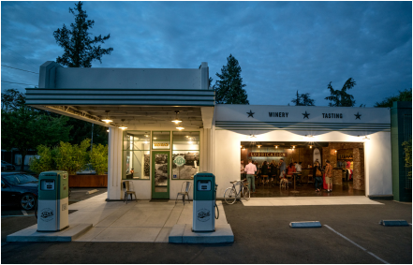
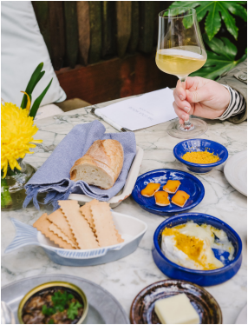Lola
Head back up Foothill and in just a block you’ll arrive at your next destination: Lola Wines. The brick bungalow looks like a residence, but within discover the wines of owner Seth Cripe, who trained at Caymus and Belle Glos. Cripe makes Russian River Valley Pinot Noir plus a fascinating selection of wines from less-typical California grapes, including Vermentino, Charbono and Counoise. A tasting here is just $35 for five wines, and you can pair it with various snacks while sitting in one of several eclectic rooms or on the shaded patio space.
If Lola looks like someone’s house, your next stop looks like a gas station. Tank Garage Winery
is built in a restored 1930s gas sta
tion—sadly, the pumps out front
don’t dispense wine. But inside
you’ll find an eclectic range of vari
ous blends, all fairly affordable.
And tastings run about $40 per
person.
If you like any of the wines you
taste, buy a bottle for your next
stop, lunch at Buster’s BBQ, a
block to the north and just across
the street. Charles “Buster” Davis
was born and raised in Shreveport,
Louisiana, before moving to Cali
fornia and eventually Calistoga. He
cooks brisket, ribs and other meaty
goodness here, the perfect pairing
for a juicy Napa red wine. They
have a limited wine list, but allow
7 WINE SPECTATOR • JUNE 15 & 30, 2026
Tank Garage
BOYB with a corkage fee.
WS063026_napaCalistoga_draft.indd 7 3/26/26 10:22 AM
2: Mountain Getaway
Some of the most promising wineries in Napa Valley aren’t
in the valley at all—they’re up the mountain. One of those mountain appellations is Howell Mountain, which pro duces some of the more interesting wines in the region thanks to its blend of soils.
For this journey, you’ll need to drive a bit—12 miles to start. Head south out of town on Highway 29. Just before you reach St. Helena, turn left onto Deer Park Road. After crossing the val ley and Silverado Trail, you’ll start heading up the mountain. Shortly after Deer Park changes to Howell Mountain Road and you pass Linda Falls on the right, you’ll reach the entrance to CADE Estate, on the left.
This is one of the wineries of the
PlumpJack Group, co-owned by Gor
don Getty, California Governor Gavin
Newsom and John Conover, who is also
the general manager. Past a fire pit,
there’s a tasting room with gorgeous
views of redwoods and the valley far
below. CADE makes a lovely Sauvignon
Blanc and delicious Cabernet that is a
Tip: Most wineries require reservations to
visit and taste (local regulations require
them to). So make your appointments in
advance. But if you end up with some free
time during less busy seasons, some win
eries will gladly make that appointment
for you at the front door.
THE ULTIMATE TRAVEL GUIDE TO NAPA VALLEY | CALISTOGA 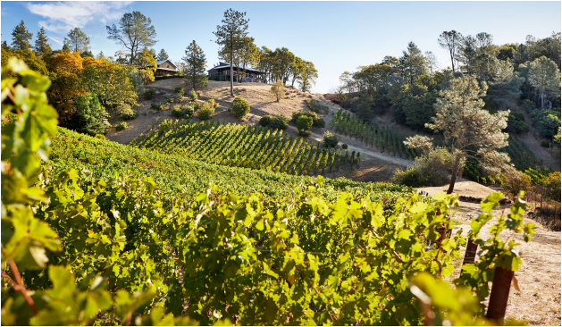Outpost
good intro to Howell Mountain fruit.
Head back onto Howell Mountain Road and head farther up hill. Have faith in your GPS, because it’s another 5 miles uphill to Outpost Wines, perched on a ridge of the mountain, with Napa Valley on one side and Pope Valley on the other. AXA Mil
lésimes, which owns Bordeaux’s Château Pichon Baron and Por tugal’s Quinta do Noval, purchased Outpost from Frank Dotzler in 2018. Dotzler is still managing the place and Thomas Rivers Brown makes the wines, which include Cabernet but also an in triguing Grenache and Zinfandel that can be hard to find outside the tasting room. That room feels like an old California barn, but with gorgeous views of Napa Valley below.
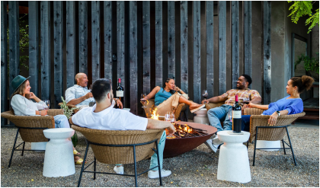CADE Estate JUNE 15 & 30, 2026 • WINE SPECTATOR 8
WS063026_napaCalistoga_draft.indd 8 3/26/26 10:22 AM

