THE ULTIMATE TRAVEL GUIDE TO NAPA VALLEY | DOWNTOWN NAPA
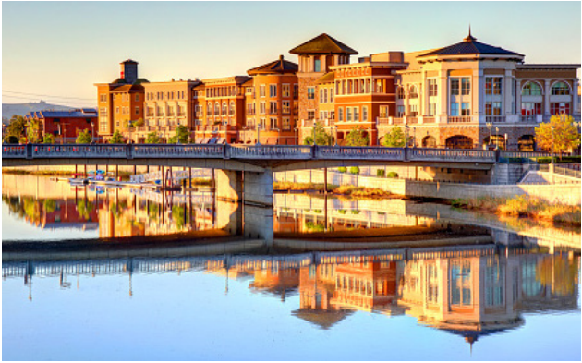Napa River DOWNTOWN NAPA Gateway to the Valley By MaryAnn Worobiec
Once upon a time, there were two Napas. Napa the val ley, known as a chic playground for well-heeled wine
lovers, and Napa the town, a sleepy, workaday com munity. That dichotomy has disappeared. Downtown Napa has become a destination in its own right while also serving as the main hub for exploring the valley that runs for 30 miles in length to its north.
There’s plenty to see, eat, drink and do in downtown Napa, led by a strong concentration of tasting rooms, now numbering more than 40. These urban spaces typically do not require res ervations (unlike most upvalley tasting rooms) and offer a more casual and accessible experience.
Restaurants, hotels and music venues abound, and the town’s walkable streets are lively, lined with shops, galleries, spas and more. Downtown has a thriving coffee, cocktail and craft beer culture, too, infusing the energy of those passions to the mix.
The evolution began in the early 2000s when vintner Robert Mondavi opened Copia: The American Center for Wine, Food & the Arts along an oxbow-shaped curve of the Napa River. To day, a branch of the Culinary Institute of America occupies the space, offering classes, seminars and a restaurant. Oxbow Pub lic Market, opened in 2008, features artisanal food vendors, specialty shops, restaurants and a wine bar under one roof. The three-day music festival BottleRock draws a diverse audience
2 WINE SPECTATOR • JUNE 15 & 30, 2026
whose interests are reflected in the many new businesses pop ping up.
First Street Napa is a centerpiece for the downtown area. A three-block, 325,000-square-foot mixed-use development, it features dozens of shops and restaurants, anchored by the Ar cher Hotel. On weekends, the hotel’s rooftop restaurant and bar buzz with energy. Phase two is under construction and will add a 160-room hotel and 78-unit condominium building, both with rooftop access. The expansion will create a pedestrian friendly corridor extending to Main Street and bring even more shopping opportunities.
The city has also integrated the Napa Wine Train into its cul tural identity. The 2-mile stretch of semi-industrial backyards that the train passes through has been transformed into the Rail Arts District, where murals and art installations wrap around switch boxes and line a paved walking path.
Food City, near downtown, has emerged as a hot spot, home to a specialty market, the popular Naysayer Coffee, a fried chicken joint, a taqueria, even a cat café. Good Pantry, a zero waste grocery store, has also opened there.
This fresh-faced Napa doesn’t live in the valley’s shadow. It complements the region, blending wine, food, art, culture and community into an experience that feels distinctly, confidently Napan.
WS063026_napaDT_draft.indd 2 3/26/26 10:19 AM
WHERE TO TASTE W^{ith more than 40 tasting spots}
to choose from, there is no
shortage of wines to explore in
downtown Napa. Hours and days open can vary, typically ramping up as the weekend approaches. Many accept walk-ins, but for the best experience we recommend secur
ing an appointment. Tasting rooms are part of the hospitality industry, and tipping for excellent service (as you would in a restau rant) is always appreciated.
Cadet Wine & Beer Bar
930 Franklin St. | cadetbar.com
The vibe here is trendy and cool, a dark spot with loud music that speaks to a younger crowd. There’s an impressive selection of international wines and cocktails. Small bites include grilled cheese and a
THE ULTIMATE TRAVEL GUIDE TO NAPA VALLEY | DOWNTOWN NAPA
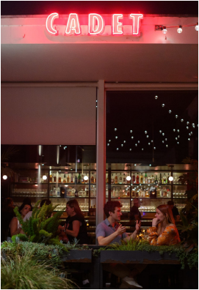
Back Room
Wines
1546 First St.
backroomwines.com
Bounty Hunter
Wine Bar &
Smokin’ BBQ
975 First St.
bountyhunterwinebar.
com
Compline Wine
Shop/Compline
Restaurant
1300 First St., Suite 319
and Suite 312
complinewine.com
Kerr Cellars
1463 First St.
kerrcellars.com
Maison Fayard
1408 Second St.
maisonfayard.com
No Love Lost
Wine Co.
chocolate panini with marshmallow whip. Gentleman Farmer Bungalow
Cadet
Hestan Napa
960 Clinton St. nolovelost.wine
Outer Space
1564 First St. | gentlemanfarmerwines.com Owners Joey Wolosz and Jeff Durham’s Gentleman Farmer Bungalow is a welcome addition to the downtown Napa scene, offering an intimate experi ence. A renovated Craftsman home built in the 1920s has been reimagined into a cozy, homey spot where guests feel welcome to enjoy a glass, a bot tle, or take on a unique experience in which the owners prepare family recipes and share stories.
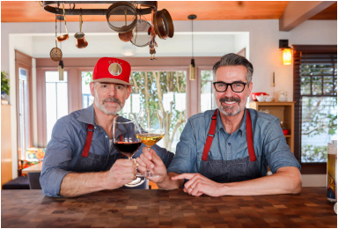
1300 First St., Suite 291 | hestan.com/hestan-napa
Stanley Cheng is both a vintner and a kitchen innovator, founder of Meyer Corporation, one of the largest cookware companies in the world. So it makes sense that when he and his wife, Helen, opened their downtown Napa spot (they have a tasting room in Yountville as well), the couple com bined their loves into a new concept: part restaurant, part cookware bou tique. Guests can enjoy the talents of chef Mark Dommen, formerly of One Market Restaurant, while admiring the showroom of products and appli ances and enjoying the lineup of wines.
Mayacamas
Downtown
1256 First St. | mayacamas.
com
If you can’t make the jour
ney to visit the remote
Mayacamas estate on
Mount Veeder, you can
head to their chic down
town tasting room to sam
ple current releases or li
brary vintages by the
bottle or glass in a more
accessible setting.
Gentleman Farmer
Wines
974 Franklin St.
outerspace.wine/
Robert Craig Winery
1553 Second St.
robertcraigwine.com
Roots Run Deep Tasting Salon 1607 First St.
rootsrundeep.com
Vintner’s
Collective
1245 Main St.
vintnerscollective.com
JUNE 15 & 30, 2026 • WINE SPECTATOR 3
WS063026_napaDT_draft.indd 3 3/26/26 10:19 AM
THE ULTIMATE TRAVEL GUIDE TO NAPA VALLEY | DOWNTOWN NAPA
WHERE TO EAT
Dining in downtown is diverse, from white tablecloth es tablishments to more casuals spots. Many restaurants
offer seasonal specials that highlight locally grown and raised ingredients. You can easily find vegetarian, vegan and glu ten-free options. Wait staff are reliably ready with a wine rec ommendation. Restaurants also regularly welcome winemakers
and wine collectors, but check ahead to confirm their corkage policies. Also check open hours: They can vary throughout the week and year; for example, many places are closed for lunch Tuesdays and Wednesdays.
RESTAURANTS
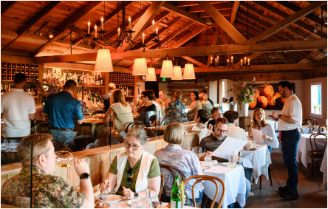
Angèle Restaurant & Bar
540 Main St. | angelerestaurant.com
Since it opened in 2002, Angéle has set
the bar for food and wine in downtown
Napa, with French countryside food
meeting warm service in both a comfy
interior and a big outdoor space (when
the weather permits). Classic onion
soup, tuna or beef tartare, escargot,
beef bourguignon and croque monsieur
are typically on the menu, as are hand
made pastas, seasonal salads and the
must-order flowerpot full of French fries.
The wine list is thoughtful and mixes
French sensibilities with local wines.
Angèle
Celadon
Napa Valley Restaurant
500 Main St., Suite G celadonnapa.com
Celadon has quietly and consistently been a go-to place for excellent food since 1996. The setting is in a relaxing garden courtyard and adjacent dining room, the menu a mix of California, Mediterranean and Asian influences. The dinner- and brunch-only menu features wine-friendly items like pork belly lettuce cups, Moroccan braised lamb shanks and the signature wild mushroom risotto.
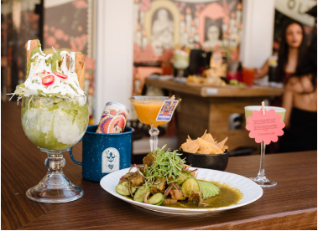
Con Amor
815 Main St.
iloveconamor.com
Con Amor is a fun new place
showcasing top-notch Mexi
can dishes, including chile
relleno, gorditas, mole
chicken wings and birria, a
Sunday special. The black
matte walls, chandeliers and
Dia de los Muertos vibe pro
vide a charming setting. This
is an excellent spot for in
ventive mezcal and tequila
based cocktails, like the La
Teresota, with tequila, alma
finca, lime and salt foam.
Con Amor
Azzuro Pizzeria E Enoteca
1260 Main St.
azzurropizzeria.com
Charlie Palmer Steak
1260 First St.
charliepalmersteak.com
Cole’s Chop House
1122 Main St.
coleschophouse.com
Compline
Restaurant
1300 First St., Suite 312 complinerestaurant. com
Crocante
Artisan Pizza 976 Pearl St.
croccantepizza.com
JUNE 15 & 30, 2026 • WINE SPECTATOR 4
WS063026_napaDT_draft.indd 4 3/26/26 10:20 AM
THE ULTIMATE TRAVEL GUIDE TO NAPA VALLEY | DOWNTOWN NAPA
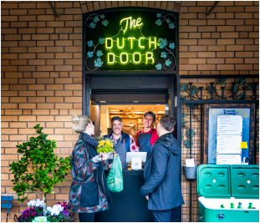
KenzoNapa
1339 Pearl St.
kenzonapa.com
Kitchen Door
Napa
Restaurant
1300 First St., Suite 272
kitchendoornapa.com
Los Agaves
Napa
660 Main St.
losagavesnapa.com
Morimoto Napa
and Morimoto
Asia
610 Main St. and 790
The Dutch Door
1245 First St.
thedutchdoornapa.com
Look for the Dutch door–a horizontally split door–on Randolph Street, around the corner from the First Street address. You’ll probably see plenty of people waiting to pick up their to-go only food. Fried chicken is the signature dish here, which can be served with either Cajun, Korean or Spanish spices, as either ten ders or in a sandwich. Vegetarian op tions are plentiful, with a made-from scratch plant burger created from quinoa, roasted mushrooms and pep pers, kale, black beans and chickpeas. There are also plant-based bowl options and a beef hot dog with caramelized
Main St.
morimotonapa.com
Normandie
Napa
670 Main St.
normandienapa.com
Osha Thai
Restaurant & Bar
1142 Main St.
oshathai.com/napa
Oenotri
1425 First St.
oenotri.com
Red Rock Cafe & Back Door BBQ
1010 Lincoln Ave.
backdoorbbq..com
Slanted Door Napa
1650 Soscol Ave.
slanteddoor.com/napa
Stateline Road Smokehouse 872 Vallejo St.
stateline-road.com
The Waterfront Seafood Grill 720 Main St.
waterfrontseafoodgrill.. com
Zuzu
829 Main St.
zuzunapa.com
Dutch Door onions and crushed potato chips.
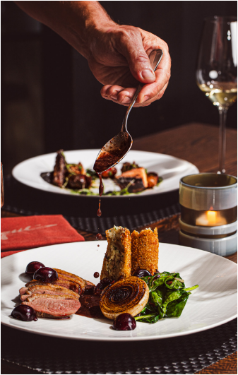
La Toque (GA)
1314 McKinstry St.
latoque.com
Located inside the Westin Verasa, chef
Ken Frank’s space has helped define
wine country cuisine, focusing on sea
sonal and inventive food, including a
vegetarian tasting menu in addition to a
traditional omnivore tasting menu. But
Frank is perhaps at his best when work
ing with luxury ingredients; this year is
the 44th edition of his “All Black Truffle
Menu” with truffles slipped into every
course. A Wine Spectator Grand Award
winner since 2014, the wine list is one of
the best in the area. This is truly a fine
dining experience, but with plenty of
warmth to the service.
Scala Osteria & Bar
1141 First St.
scalaosteria.com
From the moment it opened, this off
shoot of the popular Bistro Don
Giovanni has been swarmed with locals
and tourists alike, drawn to the south
ern Italian coastal fare with Mediterra
nean details, including pan-seared bran
zino, petrale sole piccata and poached
octopus salad. There are also wood
fired pizzas, handmade pastas and a
thin and crispy pork chop Milanese. The
wine and cocktail list cater to the fresh
fare on the menu.
La Toque
5 WINE SPECTATOR • JUNE 15 & 30, 2026
WS063026_napaDT_draft.indd 5 3/26/26 10:20 AM
THE ULTIMATE TRAVEL GUIDE TO NAPA VALLEY | DOWNTOWN NAPA
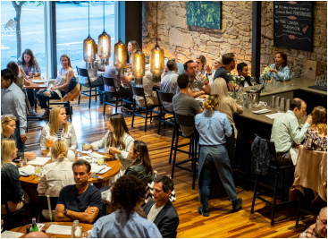
Torc Napa
1140 Main St.
torcnapa.com
Torc is one of those rare restaurants that can make delicious
food in many directions, from a sweet potato pakora to black
truffle grilled cheese to English pea risotto. The food is im
mensely pairable with wine, and the staff can handily help
you navigate a wine pairing, even with creative dishes like
duck breast with blood orange, radish and Oaxacan bitter
chocolate sauce. The service is friendly, the space is open and
airy, with exposed stone walls and wood floors and a peek
into the kitchen in the back.
Torc
Breakfast/Coffee/Sandwiches/Snacks
Ohm Coffee
There are plenty of places to fuel up
before a full day of exploration in Napa; whether that means quality coffee, breakfast, provisions or grab-and go (and some offering all of the above). Here are some local favorites.
Contimo Provisions
950 Randolph St. | contimonapa..com
Fresh-baked biscuits, homemade pimento cheese, luxurious sandwiches and gourmet pantry items are all on offer at this bright and cheerful spot.
Genova Delicatessen
550 Trancas St. | genovadelinapa.com
Sandwiches here are generous, many with an Ital ian spin, and there is both a hot and cold selection of deli salads. Imported Italian goods are also sold, as are homemade ravioli and sauces, soups and meatballs. Before anyone reminds you, take the cannoli.
Grace’s Table
1400 Second St. | gracestable.net
Grace’s Table is open all day serving international bistro food, but the iron skillet cornbread served with lavender honey butter, the shrimp and grits,
the chilaquiles and cinnamon rolls make it ideal for breakfast or brunch.
Le Paris Artisan and Cafe
828 Brown St. | lepariscafe.com
Not only does the pastry selection include cropuffs, sticky buns and crème brûlée brioche, there are also wonderful savory options, like a fresh-baked croissant with smoked salmon, scram bled eggs and crème fraîche. If the purple ube or decadent tres leches offerings catch your eye, you should absolutely try them.
Moulin Bakery
1321 First St. | moulinbakerycoffee.com It might be hidden in an alley behind First Street, but once you find Moulin it will no doubt be full of patrons spilling onto the few outdoor tables. Ex pertly made coffees and French-style pastries are here, including the most crunchy, delicate viennoi series imaginable.
Naysayer Coffee
1813 Old Sonoma Road | naysayercoffee.com Located in Food City, Naysayer has some of the best coffee in town, with some of the friendliest service. Seasonal beverages are inspired, like an horchata latte or spiced chamomile latte, and small bites are precise and fresh. A second loca tion recently opened up north of downtown.
1412 Second St. | ohmcoffee.com
The “ohm” here refers to the musical term for the measure of electrical resistance in an amplifier, and founder Derek Bromley names his roasts after guitar amplifiers. Bromley is not only a rock gui tarist, he also worked in the wine industry and ap plies both of these approaches to his coffee, fea turing single-origin roasts in a rock ‘n’ roll setting. A second location near the Rail Arts District is the coffee roastery and lab, where classes in cupping, latte art and brewing methods are taught.
Winston’s Cafe and Bakery 1517 Third St. | winstonsnapa.com
This bright and airy café is known for generous plates of breakfast and lunch and an eye-popping assortment of baked goods, donuts and pastries. It can be busy, but orders move quickly.
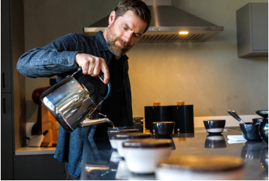Ohm Coffee JUNE 15 & 30, 2026 • WINE SPECTATOR 6
WS063026_napaDT_draft.indd 6 3/26/26 10:20 AM
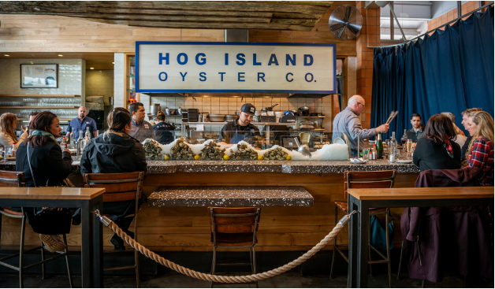
THE ULTIMATE TRAVEL GUIDE TO NAPA VALLEY | DOWNTOWN NAPA STANDALONE EYEBROW
Hog Island
The Oxbow Market
As far as culinary destinations go,
this public market is a wonderful gathering place for foodies and wine lovers, with multiple vendors in one location. There are shops for ingredients and specialty items, as well as some very tasty restaurants.
Ritual Coffee Roaster has been an an chor since the market opened in 2007, one of the best places for a cup of coffee or tea in the area. Hog Island Oyster Company is also a mainstay, with fresh and grilled oysters, po’ boy sandwiches and more.
Don’t be dismayed by the line outside Gott’s Roadside—it moves quickly and the food comes out promptly, including thick shakes, gourmet burgers, fish tacos, sweet potato fries and inventive salads. Loveski brings pastrami sandwiches, potato latkes, matzoh ball soup and bagels to Napa from chefs Christopher and Martina Kostow. Live Fire Pizza specializes in wood-fired pies and small bites.
For international flavors, El Porteno features empanadas both sweet and sa vory, while Moro showcases Moroccan flavored mains on flatbreads, salads or
7 WINE SPECTATOR • JUNE 15 & 30, 2026
couscous, tasty and fresh. Sumo Dog takes hot dogs and puts a Japanese twist on them, with ingredients like wasabi relish, tonkatsu sauce and furikake. Rotation is the newest addition, with a rotation of chef residencies, including Martin Yan and Tristan Epps.
Bar Lucia is a wine bar with small bites, adjacent to the decadent Kara’s Cup cakes. For the sweet tooth, there’s also lo cal chocolatier Annette’s Chocolates. Fieldwork taproom has 20 beers on tap and Detroit-style pizza. The Walt tasting room is located across the street.
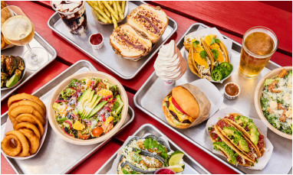Gott’s
Hudson Greens & Goods blends a juice bar with fresh produce and curated pan try goods. Fatted Calf Charcuterie has some of the best high-end butcher and charcuterie items, as well as terrific sand wiches such as a savory porchetta and house-smoked ham with black truffle but ter. Whole Spice will inspire your next cooking adventure, as well as give you a place to test your smell memories. And Model Bakery has Oprah’s favorite Eng lish muffins, fresh-baked breads and plenty of sandwiches, wraps, cookies and pastries.
WS063026_napaDT_draft.indd 7 3/26/26 10:20 AM
THE ULTIMATE TRAVEL GUIDE TO NAPA VALLEY | DOWNTOWN NAPA
WHERE TO STAY
Day trips from population centers such as Sacramento
and San Francisco are popular, but a for a deeper dive into wine country pleasures, most visitors plan a longer stay. The city (pop. 76,000) provides myriad accommodations,
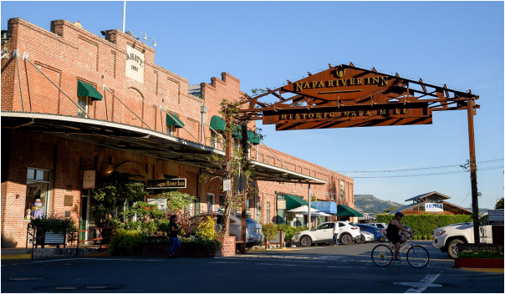
Napa River Inn
500 Main St. | napariverinn.com
Located at the historic Napa mill and
right on the Napa River, this hotel, which
dates to the 1880s, is perfectly situated
within walking distance of most of the
best restaurants and tasting rooms
downtown, making it an ideal location
as a vacation home base.
Westin Verasa
1314 McKinstry St.
marriott.com/en-us/hotels/sfonw-the
westin-verasa-napa/overview/ [FIX]
Westin was the first luxury hotel in
downtown Napa, opening in 2008. Its
convenient location in the Oxbow
District[CK] is walking distance from the
Oxbow Market and Napa Wine Train,
and it’s a short walk across the Napa
River to access the rest of downtown.
Chef Ken Frank oversees the restaurants
here, including Wine Spectator Grand
Award-winning La Toque and the more
casual—yet still elevated—Bank Café and
Bar in the lobby.
including roughly 2,800 hotel rooms (not including projects in development), ranging from expansive resorts to more intimate experiences.
Napa River Inn
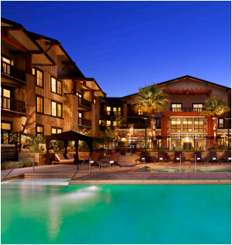
Andaz Napa, by
Hyatt
1450 First St.
hyatt.com/andaz/en
US/apcrn-andaz-napa
[FIX]
Archer Hotel
Napa
1230 First St.
archerhotel.com/napa
Hotel Napa
Valley
1556 Polk St.
hotelnapavalley.com
Westin Verasa
JUNE 15 & 30, 2026 • WINE SPECTATOR 8
WS063026_napaDT_draft.indd 8 3/26/26 10:20 AM
THE ULTIMATE TRAVEL GUIDE TO NAPA VALLEY | DOWNTOWN NAPA
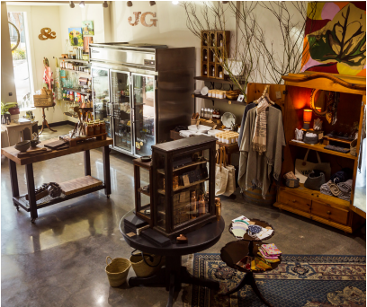
DOWNTOWN NAPA Culture & Cocktails D^{owntown Napa has plenty of}
shopping and non-wine related
activities to add to the mix. Busi
ness hours can vary by venue and season,
so be sure to check the most recent infor
mation before heading out.
The Arbaretum
1149 First St. | napadistillery.comthe-arbaretum
This local distillery makes quality brandy, gin,
whiskey and bottled cocktails such as mint julep,
brown derby and the sidecar. This art deco-in
spired spot fills up with people tasting inventive
cocktails and snacking on small bites like deviled
eggs and muffaletta pizza.
Bougie Napa Luxury Candles
1300 First St., Suite 332. | bougienapa.com
There are dozens of lovely hand-poured candles to
purchase at Bougie, but consider one of the can
dle-making classes to sharpen your senses. During
the class, the math and chemistry behind a perfect
burn are discussed, and you can design a signa
ture scent.
Jeffries
Chispa Bar
1500 First St., Suite 140. | chispabar.com Tastebuds come alive at this hybrid tequila and agave-centric cocktail bar meets swank restau rant. Bites include crudo, tacos, caviar, a spicy oc topus dish with sautéed peanuts, pasilla peppers and pickled garlic, and plenty of sandwiches and salads. Cocktails include clever concoctions like the Oaxacan old fashioned, with reposado mezcal, toasted agave, mole and orange bitters, or Peat & Repeat, a mix of Laphroaig Scotch, mezcal, agave, lemon, lime and yuzu.
Marquee Pinball 9 WINE SPECTATOR • JUNE 15 & 30, 2026
CIA at Copia
500 First St.. | ciaatcopia.com
The calendar at the CIA at Copia is full of wine and food-events, single-day classes, family friendly movies and cooking boot camps that fo cus on different parts of the world. From learning to make pasta at home, scavenger hunts and BBQ training, there’s plenty to add to your itinerary. An on-site restaurant called The Grove offers an avo cado toast brunch experience most weekends.
Crafted Napa Valley
1300 Third St., Suite 301. | craftednapavalley.com Shop for locally made bath and body products, jewelry, seasonings, candles and snacks in this charming gallery.
Folklore
1226 Third St.. | folklore-napa.com
A combination record store, wine and cocktail bar, restaurant and radio station, Folklore is located in a semi-industrial, funky and chill spot with plenty of personality.
Jeffries General Store
1416 Second St.. | Instagram only
This delightful store is teeming with amazing and eclectic gifts, including stationary, pottery, spa products, tea towels, snacks and art. But it’s also a useful store for forgotten travel necessities (espe cially without a grocery store or drugstore located downtown).
Marquee Pinball Lounge
1311 First St.. | marqueepinball.com
If you’re someone that needs to level up, this pin ball and classic video game spot is flipping awe some, a welcome new spot in downtown Napa. Marquee currently serves beer, with wine and ci der offerings coming soon.
WS063026_napaDT_draft.indd 9 3/26/26 10:20 AM
Mommenpop Tasting Room
920 Franklin St.. | mommenpop.compages/
tasting-room
This cheerful, aperitif tasting room showcases
the citrus-based Mommenpop drinks created by
winemaker Samantha Sheehan. The blood or
ange is made from an organically grown Bar
bera rosé with blood oranges and botanicals.
There is also Seville orange, ruby grapefruit, and
a lime-pop made from a base of Chardonnay
with Makrut and Bearss limes, long pepper,
toasted fig leaves, orris root and vanilla bean.
Rail Arts District
Start at 816 Vallejo St.. | radnapa.org
Consider this stretch a sort of contemporary
open-air gallery, with public art installations
along a paved walking and biking trail. Eleven
murals, wrapped switch boxes and 21 clay sculp
tures have turned a semi-industrial area into a
colorful patch.
Rancho Gordo
1350 Main St.. | ranchogordo.com
Steve Sando changed the way we talk about
beans when in 2001 he founded Rancho Gordo,
a company focused on cultivating and selling
rare, indigenous heirloom bean varieties. The
beans have since become the ultimate designer
ingredient, and the Rancho Gordo Bean Club
has a waiting list thousands long. This new loca
tion for a retail shop is an expanded, bright and
colorful place to shop for beans, spices and
cookbooks for the legume lovers in your life.
Tonewood & Courage
1300 First St., Suite 212. | tonewoodandcourage.
com
Musicians will find themselves at home in this
part music store, part gathering place. High-end
guitar and bass brands are sold, as well as hand
built instruments by local artisans. In the eve
nings, it becomes an intimate music venue for
musicians in a variety of genres.
Wilfred’s Lounge
967 First St.. | wilfredslounge.com
A tiki bar in Napa that pulls no punches with the
Polynesian stylings or flavors, Wilfred’s is a
place to get your fix of kalua pork, chicken katsu
or spam fries (panko-crusted fried spam served
with a mango habanero sauce), along with mai
tais and other colorful and tasty cocktails.
Rancho Gordo
THE ULTIMATE TRAVEL GUIDE TO NAPA VALLEY | DOWNTOWN NAPA Rail Arts District Tonewood & Courage
JUNE 15 & 30, 2026 • WINE SPECTATOR 10
WS063026_napaDT_draft.indd 10 3/26/26 10:20 AM
THE ULTIMATE TRAVEL GUIDE TO NAPA VALLEY | DOWNTOWN NAPA
DOWNTOWN NAPA Beyond City Limits
One of the most appealing aspects of using downtown
Napa as a travel base is its proximity to the wine regions that surround the town. Just a few miles east is Coombsville. Head a few miles in the opposite direction and
you’ll arrive either[UNCLEAR] in the windswept Carneros re gion of Napa Valley or in the rustic hills of Mt. Veeder. Coombsville is mostly a residential area, but there are vine
yards tucked into valleys and rolling hills leading east up to Mt. George. Carneros, which straddles Napa and Sonoma counties, is known for its cool climate and proximity to the San Pablo Bay, with plenty of vineyards to drive through. Mt. Veeder is marked by rugged, windy[WINDING?] roads; vineyards here are hard to see from the road through the trees clinging to the eastern face of the Mayacamas mountain range.
Etude WHERE TO TASTE
Artesa
Vineyards & Winery
(Carneros)
1345 Henry Road
artesawinery.com
Bouchaine
Vineyards
(Carneros)
1075 Buchli Station Road
bouchaine.com
Cuvaison
Winery /
Brandlin Estate (Carneros)
1221 Duhig Road
cuvaison.com
Domaine
Carneros
(Carneros)
1240 Duhig Road
domainecarneros.com
Frias Family Vineyards
(North Napa) 1886 El Centro Ave. friasfamilyvineyard.com
HdV Wines
(North Napa) 588 Trancas St.
www.hdvwines.com
Hess Persson Estates (Mt. Veeder)
4411 Redwood Road hessperssonestates. com
Hyde Vineyards (Carneros)
1044 Los Carneros Ave. hydevineyards.com
Kenzo Estate (Coombsville) 3200 Monticello Road
Etude Winery (Carneros)
1250 Cuttings Wharf Road | etudewines.com
Etude’s tasting room, in a stone building and former distillery, provides an inviting, relaxed backdrop to focus on Etude’s wines, especially the single-vineyard expressions of Pinot Noir and Cabernet Sau vignon. There are multiple ways to enjoy a tasting, including a seated experience or simply wandering around the grounds.
Favia Wines (Coombsville)
2031 Coombsville Road | faviawines.com
The ultimate intimate experience, a visit here is a visit to the home
stead of vintners Annie Favia and Andy Erickson. Private tastings take
place in a cabin that doubles as the winery’s tasting lab and include an
overview of the historic former Antonio Carbone Wine Cellar and Ital
ian Garden, which dates to the 1870s. Historic artifacts and documents
are on display, but are overshadowed by the spectacular wines.
Hudson Ranch (Carneros)
5398 Sonoma Highway | hudsonranch.com
Hudson is a magical spot, with landscaping of unusual succulents and
a flower, fruit and vegetable garden with life-size[UNCLEAR] gourds
that offer a touch of Willy Wonka. The meticulous vineyards are sur
rounded by rugged oaks, with stunning views and plenty of wildlife–
Farella Vineyard (Coombsville) 2222 N. 3rd Ave.
farella.com
kenzoestate.com
Mayacamas Estate (Mt. Veeder)
1155 Lokoya Road mayacamas.com
the ranch covers 2,000 acres. In addition to enjoying the impressive estate-grown wines, ask about picnics and hikes around the property.
11 WINE SPECTATOR • JUNE 15 & 30, 2026
Hudson Ranch
WS063026_napaDT_draft.indd 11 3/26/26 10:20 AM
THE ULTIMATE TRAVEL GUIDE TO NAPA VALLEY | DOWNTOWN NAPA
WHERE TO EAT
Bistro Don Giovanni (North Napa)
4110 Howard Lane | bistrodongiovanni.com
An institution in Napa, Bistro Don Giovanni has been
serving exceptional rustic Italian cuisine to vintners and
tourists since 1993. A large, covered patio and garden
setting make it one of the most romantic spots around,
especially on a summer night. But the food is top-notch year-round, including handmade pastas, fried anchovy–
stuffed olives, wood-fired pizzas, veal parmigiana and
Mamma Concetta’s meatballs, served on soft polenta.
Carabao (South Napa)
145 C Gasser Drive | carabaonapa.com
Carabao is the hot new eatery in town, serving high-end and inventive Filipino cuisine in an intimate, friendly
space. Chef Jade Cunningham takes the high-end tech
niques she learned at stints at The French Laundry and
Meadowood and applies them to Filipino dishes like pork lumpia and Kare Kare stew with oxtail croquette, tripe
and a coconut peanut sauce. There is also plenty of cre
ativity on the menu, from the deviled egg adobo and
crispy pork sisig tacos served with a sunny side up quail egg. The wine list is compact but put together with
plenty of thought to pairing with the cuisine, featuring
plenty of German Rieslings and other aromatic white
wines from around the world.
Farm Restaurant &
Bar (Carneros)
Inside Carneros Resort
4048 Sonoma Highway
carnerosresort.com
Foodshed (North
Napa)
3385 Old California Way
Carabao
foodshedpizza.com
WHERE TO STAY
Carneros Resort
Bear (Carneros) 200 Stanly Crossroad auberge.com/stanly-ranch/ dine/bear
Boon Fly Cafe
4048 Sonoma Highway boonflycafe.com
(Carneros)
4048 Sonoma Highway carnerosresort.com
Casa Mani
Resort Napa Valley (North Napa)
1075 California Blvd. hilton.com/en/hotels/ napvpqq-casa-mani resort-napa-valley
Napa Valley
Marriott Hotel & Spa (North
Napa)
3425 Solano Ave.
marriott.com
The Meritage Resort & Spa (South Napa) 875 Bordeaux Way
meritageresort.com
Milliken Creek Inn(North
Napa)
1815 Silverado Trail millikencreekinn.com
Napa Winery Inn (North
Napa)
1998 Trower Ave. napawineryinn.com
Senza Hotel (North Napa) 4066 Howard Lane senzahotel.com
Silverado
Country Club (North Napa) 1600 Atlas Peak Road silveradoresort.com
Stanly Ranch, Auberge
Collection
(Carneros)
200 Stanly Crossroad auberge.com/
stanly-ranch
Casa Mani
JUNE 15 & 30, 2026 • WINE SPECTATOR 12
WS063026_napaDT_draft.indd 12 3/26/26 10:20 AM
THE ULTIMATE TRAVEL GUIDE TO NAPA VALLEY | DOWNTOWN NAPA
A CARNEROS ADVENTURE
from MaryAnn Worobiec
THE WIND IN YOUR HAIR TOUR
S^{everal places around Napa feel}
completely distinct from the rest
of the valley. Carneros stands out
with its own microclimate, aromas, am
bience and energy.
Driving through Carneros typically
means traveling east to west, rather
than following Napa Valley’s usual
north-to-south route. Rolling hills de
fine the landscape more than valley
floors or rugged mountains. Curving
roads invite leisurely drives, and on
clear days you can glimpse San Pablo
Bay to the south. Because the region
sits so close to the bay, ocean winds
sweep through Carneros, especially
during the summer. Towering eucalyp
tus trees serve as windbreaks and re
lease a camphorlike fragrance into the
air.
Start a day exploring the Napa side
of Carneros (the region also stretches west into Sonoma) with donuts—spe
Domaine Carneros
cifically, the famous ones at Boon Fly Café. Located at Carneros Resort and Spa, the bright red, barn-style restaurant welcomes guests through a separate entrance off Sonoma Highway. You might order the chicken and waffles, Dungeness crab Benedict
Bouchaine
or corned beef hash, but save room for the donuts—they make the perfect sweet finish to breakfast.
Next, drive less than 10 minutes to Bouchaine Winery. On a clear day the property offers sweeping bay views. The wines are precise and aromatic, and the winery hosts dynamic
educational programs. On Friday mornings, the Fal conry in the Garden experience truly stands out. A master falconer introduces guests to raptors—perhaps a hawk, owl or falcon—and explains how these birds partner with vineyard teams, how they hunt and how they see. You can even pose for a photo with the birds, all while enjoying a glass of wine.
Just five minutes away, Domaine Carneros rises from a hilltop like a fairy-tale château. Climbing the romantic, grand staircase offers countless photo op portunities. Domaine Carneros has built its reputation on exceptional sparkling wines and a wide range of tasting experiences. Two stand out in particular. The Art of Sabrage teaches guests to open a bottle of spar
kling wine with a sword, a tradition that dates to Na poleon’s era. Equally memorable is the Ultimate Caviar Experience, where sparkling wines pair with an as sortment of Tsar Nicoulai Caviar served alongside gourmet potato chips, toast points, and crème fraîche.
JUNE 15 & 30, 2026 • WINE SPECTATOR 13
WS063026_napaDT_draft.indd 13 3/26/26 10:20 AM

