THE ULTIMATE TRAVEL GUIDE TO NAPA VALLEY | LANDMARKS
NAPA LANDMARKS
SIGNS OF THE (GOOD) TIMES
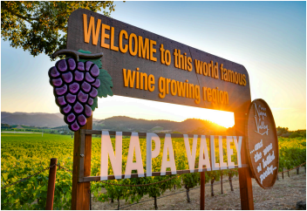
leaders of Napa’s then-nascent modern wine industry,
including Robert Mondavi, Fernande de Latour, Elmer
Salmina, Charles Forni, John Daniel Jr., Louis M. Mar
tini and Louis Stralla. NVV’s mission was to implement
initiatives to support the growth of Napa Valley.
Among its first acts was to commission local artist
Roland Hauck to design the signs. In their original
form, the signs listed the names of nine wineries on
the barrel head portion: Beringer, Louis M. Martini,
Inglenook, Freemark Abbey, Beaulieu Vineyard, Napa
Cooperative Vineyard, Vin-Mont Wines, The Christian
Brothers and C. Mondavi & Sons. In 1966 the barrel
head portion was changed to its current iteration, with
a quotation from author Robert Louis Stevenson: “…
And the wine is bottled poetry … .”
The quote is taken from Stevenson’s 1883 memoir,
The Silverado Squatters, in which the author travels to
“Welcome to this world famous winegrowing re gion” reads the sign sitting off Highway 29. The
sign is on redwood panels resembling barrel
staves, with large block letters spelling “NAPA VALLEY” under neath. A grape cluster adorns the left side of the sign, a barrel head the right. Located in Oakville at the southern end of the val ley, the marker has become as famous as the region it touts, and
today is one of the valley’s most popular tourist attractions. Many people who visit the spot are likely unaware that there is twin signage located at the northern end of the valley, with an arguably better vantage point. The signs were erected in 1949 by Napa Valley Vintners (NVV), an association formed in 1944 by
CRUSHIN’ IT
Napa Valley on a honeymoon with his wife, Fanny. When unable to afford a hotel, they ended up squat ting at a mini camp named Silverado near Mount St. Helena for two months. Stevenson’s experiences with vintners lead to his penning a lengthy passage explaining the wines of California, with that quote becoming one of his most famous. The author’s works can be found at his namesake museum in St. Helena. Both the Oakville and Calistoga signs have vineyards and mountains as backdrops, providing lovely photo opportunities. Be sure to stop at the signs safely; it’s best to avoid crossing High way 29, so visit the southern sign on your way down valley, the northern sign while traveling up valley. The signs are also non functional, meant for taking pictures with subjects in front of
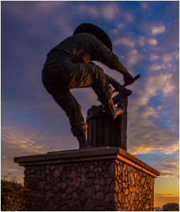
Along with the “Welcome” sign, “The Grape Crusher” sculpture is
one of Napa Valley’s best-known landmarks. Erected in May 1988 at
the southern gateway to Napa Valley, the statue of a vineyard worker
pressing grapes is a symbol of the agriculture that is intertwined with the
community.
The eye-catching statue, perched on a hill just east of the Napa River Bridge,
is visible from Highway 29. The farm worker is depicted in a wide brim hat,
sleeves and pant legs rolled up, barefoot, and operating a grape press by hand.
Visibly strained, he’s tightly gripping the screw handle with one foot an
chored on the basket for leverage.
Santa Fe-based sculptor Gino Miles designed and cast the bronze statue
using the cire-perdue (lost wax) method. A wax model inside a one-time-use
mold is replaced by molten metal. Miles cast 137 individual bronze pieces
that way, then welded them together to create the 15-foot-tall sculpture,
which weighs over 6,000 pounds.
The figure actually started as the logo for the Napa Valley Corporate Park,
built in 1983 by developer Peter Bedford. The statue is accessible at the Vista
Point Park, just behind the Meritage Resort.
—Chris Cardoso
JUNE 15 & 30, 2026 • WINE SPECTATOR 2
WS063026_napaLandmarks_draft.indd 2 3/26/26 10:17 AM
(not on top of ) them. And please do not enter the vineyards
that sit behind them.
—Chris Cardoso

