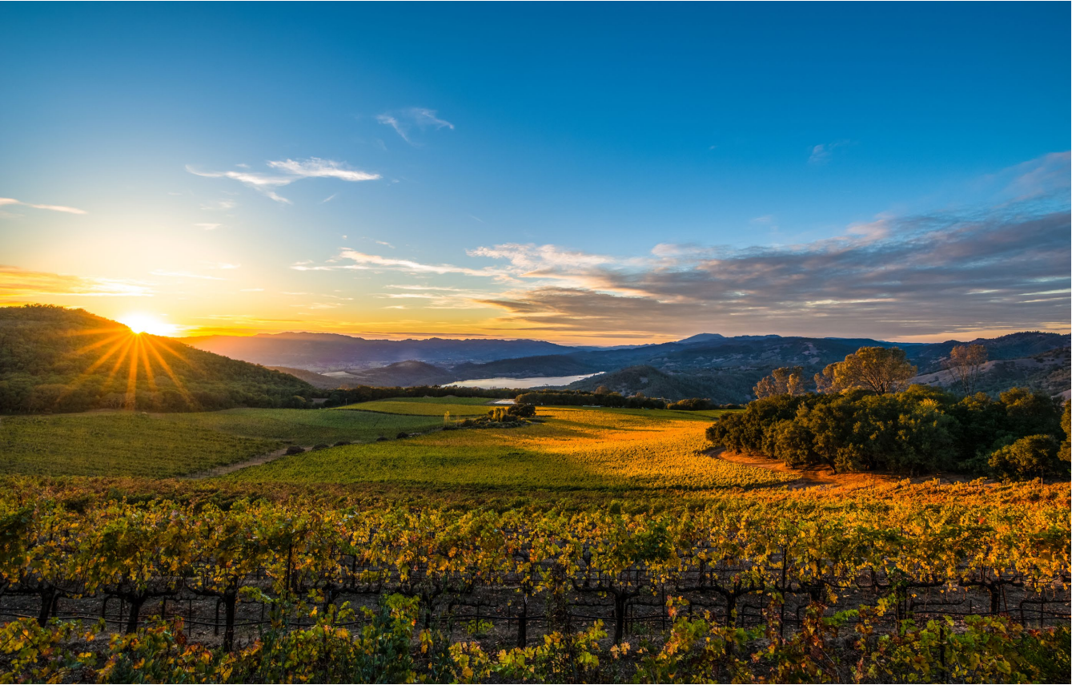
The
ULTIMATE GUIDE to
NAPA _{V}alley
2 WINE SPECTATOR • JUNE 15 & 30, 2026
OUR EDITORS’ PICKS FOR WHERE TO TASTE, EAT, STAY AND MORE ACROSS AMERICA’S PREMIER WINE REGION. PLUS, FUN-FILLED SIDE TRIPS NEAR EACH TOWN, UP VALLEY OR DOWN
This is just a general scenic
from Napa Valley, no vineyard
ID. CaptionWhite here. The
quick brown fox jumped over
the lazy dog. This text is for
layout purpose only.
JUNE 15 & 30, 2026 • WINE SPECTATOR 3
D^{espite the recent reports of}
downtowns in the wine indus-
try, the outlook in Napa Valley
remains an optimistic one, and
the towns and businesses there
continue to give visitors all
they could ask for and more in
a wine country destination.
There’s little doubt these are challenging times for wine, with sales and consumption down, growers pulling up vines and some wineries shrinking production or even closing their doors. Nevertheless, wine lovers are still flocking to Napa, America’s most famous wine region.
Prohibition. While some wineries survived by selling grapes or sacramental wine, many did not. And shuttered wineries were not much of a tourism draw. In the years after Prohibition, as the industry started to dust itself off, there were more plum and pear trees than vines.
But when Napa wine found a new wave of energy in the 1960s, thanks to innovative winemakers and an American public that was realizing the virtues of a good bottle of wine, tourism was a natural secondary effect.
Not that everyone was excited about more visitors—this was still a farming community. One of the reasons the county es- tablished the Agricultural Preserve to conserve farmland in 1967 was a failed effort to build a large
“Napa finished 2025 up 3% in hotel oc- cupancy from the previous year,” points out Linsey Gallagher, president of tour- ism trade group Visit Napa Valley. In fact, hotel occupancy rates are nearly back to 2019 levels, before the global pandemic devastated travel. “Yes, international travel is down; yes, wine is facing head- winds and consumers are facing eco- nomic uncertainty. The fact that hotel guest numbers are up shows the strength of the Napa Valley brand, but also that we’re delivering on the experience.” For starters, there is the natural beauty
of the place. This narrow stretch of land, running up from San Pablo Bay, between the Mayacamas and Vaca moun- tains and ending at Mount St. Helena, is gorgeous most days. It’s ideal for both farming and tourism, with bright sun- shine, a Mediterranean climate and a var- ied mix of soils.
Numerous native tribes called this val- ley home before the Mexicans began to
CONTENTS
HEADER TK
36 NAPA
42 OXBOW MARKET 36 OUTSIDE NAPA
42 TACOS
36 YOUNTVILLE, STAG’S LEAP, & OAK KNOLL
42 LANDMARKS
42 OAKVILLE
36 JUDGMENT OF PARIS 42 RUTHERFORD
42 PRITCHARD HILL 36 ST. HELENA
42 CALENDAR
36 CALISTOGA
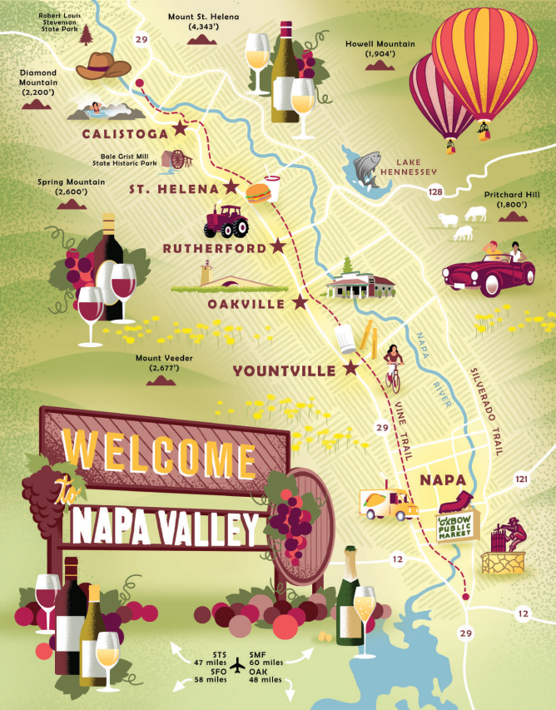
hotel in the valley.
”There used to be a saying around here,” says grapegrower Andy Beckstof fer, who arrived in the valley in 1969. “Don’t let the setting sun hit a tourist.” In other words, day trippers are OK, but no one’s allowed to stay the night.
There’s still a bit of that tension today whenever traffic builds up on Highway 29 or the Silverado Trail. But thanks to the Ag Preserve, hotels are confined to incorporated areas, outside farmland. Be-
tween the wine scene and the natural beauty, it was inevitable that luxury ho- tels like Auberge de Soleil would go up wherever they could find space. And that fine dining, the essential companion to fine wine, would follow. Restaurants like the French Laundry made a trip to Napa Valley a complete experience in the joys of life.
Another big change has been the in- credible growth of the tourism industry in the City of Napa, at the valley’s south- ern end. It used to be a place people drove
explore it in 1823. Settlers immigrating from America came about a decade later. George Yount, a North Carolinian who had worked for Mexican general Mariano Vallejo in Sonoma, settled down on the Rancho Caymus in 1836, near where the town of Yountville now sits, and began cultivating grapevines. More followed him, especially after California became part of the United States.
Tourism was a natural outgrowth of the Bay Area’s growing prosperity when the Gold Rush hit—Napa Valley was a nearby retreat for new money from San Francisco. Samuel Brannan, who had made his fortune selling equipment to miners, estab-
lished the town of Calistoga at the valley’s northern end in 1862 and built a resort, hoping to profit from visitors to the local hot springs. He also helped finance the Napa Valley Railroad, which brought even more people through the valley, including to the new commercial wineries that were springing up—Charles Krug, Beringer, Inglenook. By the 1890s, there were more than 140 wineries in the valley.
Then came decades of obstacles—phylloxera, followed by
past on their way to the wineries. But in 2011, the Army Corps of Engineers began a flood control project on the Napa River in downtown. Afterward, land that used to flood regularly was dry, and restaurants and tasting rooms began springing up. Guests could tour the wineries up valley during the day, then return downtown before the setting sun hit them.
One recent economic trend has been a K-shaped economy. While there is plenty of economic uncertainty in the world, folks in higher income brackets are doing well, and they make up a large percentage of Napa visitors.
But there’s another trend, especially among younger con- sumers: the experience-based economy. While luxury goods have been struggling, luxury experiences have flourished. In our post-pandemic, emerging AI world, people are increasingly valuing real life experience.
Gallagher often tells wineries to focus on offering that. The days of simply welcoming guests to a bar with five wines to sample and some basic education are over.
“We have 400 wineries that are open to the public,” she says.
4 WINE SPECTATOR • JUNE 15 & 30, 2026 JUNE 15 & 30, 2026 • WINE SPECTATOR 5

