THE ULTIMATE TRAVEL GUIDE TO NAPA VALLEY | OAKVILLE 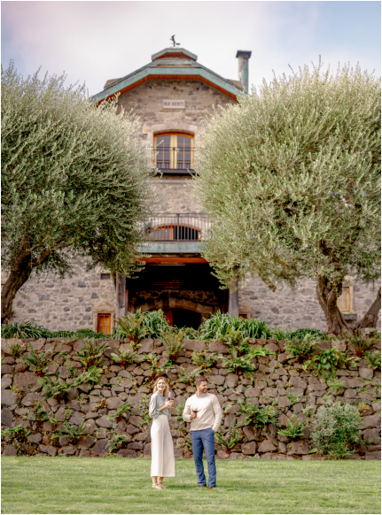OAKVILLE
Far Niente
Located between Yountville and Rutherford as you head north, Oakville can appear to visitors as lit tle more than a blip, with the famed Oakville Grocery serving as its spiri tual center. Yet Oakville boasts the highest concentration of benchmark estates in Napa Valley—Harlan Es tate, Robert Mondavi, Opus One, Sil ver Oak, Far Niente and Heitz Cellar to name a few. It is also home to two of California’s most renowned vine yards, To Kalon and Martha’s.
The Oakville Grocery dates to 1881 and is one the longest continuously operating grocery stores in Califor nia. It remains both a must-stop for tourists and a convenient pit stop along Highway 29 for the locals. Visi tors can refuel with excellent coffee, pastries and high-quality picnic pro visions, including hearty sandwiches and a curated selection of gourmet pantry goods. On sunny days, guests enjoy wood-fired pizzas on the patio. The shop also offers an excellent se lection of gifts for food lovers.
Grapegrowing in Oakville began with H.W. Crabb, an Ohio native who came to California in search of gold. Crabb purchased 240 acres in what is now Oakville in 1868. He built a railroad depot and initially planted table and raisin grapes. In 1872, Crabb established a vineyard and winery he named To Kalon, Greek for “highest beauty.” At the time, it was one of the largest vineyards in the region, producing about 5,500 cases of wine annually.
Since Crabb’s death, vintners have debated the vineyard’s legacy. Sub
The Spirit of Cabernet By MaryAnn Worobiec
The Oakville AVA is sacred ground for Cabernet Sauvi gnon. Its vineyards are considered the filet mignon of
the valley because of how the grape performs in the terroir. Oakville Cabernets are beloved for their richness and density of fruit, savory and earth elements combined with their reputation as being among the most ageworthy in Napa Valley.
2 WINE SPECTATOR • JUNE 15 & 30, 2026
sequent owners divided and sold the land. In 1966, vintner Rob ert Mondavi built his winery on part of the To Kalon property, helping to launch Napa’s modern wine era. Along the way, Mon davi was granted trademarks in 1988 and 1994, now owned by Constellation Brands following their purchase of the Mondavi winery in 2004. Other vintners argue that they have the right to use the name because they farm portions of the original es tate; grower Andy Beckstoffer was able to secure naming rights for his portion. The dispute continues and has grown bitter at
times, a testament to To Kalon’s enduring significance. Driving through Oakville offers one of the best ways to un derstand the “valley.” The AVA covers ground from the foot hills of the Vaca mountain range’s volcanic soils on its eastern flank to the Mayacamas’ alluvial soils on its western edge, with each side offering distinct characteristics in their wines.
WS063026_napaOakville_draft.indd 2 3/26/26 10:15 AM
THE ULTIMATE TRAVEL GUIDE TO NAPA VALLEY | OAKVILLE
WHERE TO TASTE
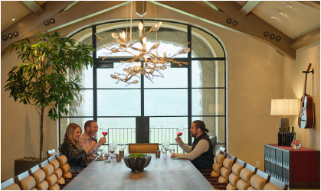
Cardinale Winery
7600 St. Helena Highway | cardinale.com
It’s a short drive off of Highway 29 up to
the beautiful stone building where Car
dinale hosts its tastings, but it feels like
a world away from the traffic and bustle
of the valley floor. Panoramic views are
highlighted by a recent upgrade, with
more outdoor options, comfortable
seating and stylish designs. Tasting ex
periences of Christopher Carpenter’s
Bordeaux-style wines include culinary
options and library vintages.
Cardinale
Far Niente Winery /
Bella Union Winery
1350 Acacia Drive | far niente.com
Gil and Beth Nickel opened Far Niente in 1979, and the 19th-century stone winery and surrounding fairy tale-esque gardens are definitely worth a visit to experience the environs, fine wines and a chance to try their late-harvest Dolce.
We also recommend taking a short drive north to check out the latest tasting room in the winery’s portfolio, Bella Union (which is technically in Rutherford), founded in 2012 as a way to celebrate re gional blend expressions of Napa wine. The former Provenance tasting room was recently remodeled for Bella Union, and embraces the La Belle Époque era with more modern designs, many tasting op portunities and stunning views.
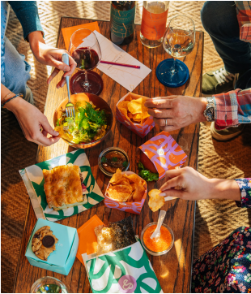
Nickel & Nickel
8164 St. Helena Highway | farniente.com/
wineries/nickel-and-nickel
A distinctive white estate fence outlines
this picturesque estate, which includes
an 1884 Victorian farmhouse, barn-style
winery and horse stables. The wines are
also distinctive; winemaker Joe Harden
dives into single-vineyard expressions of
Napa Cabernet Sauvignon through a va
riety of methods that make an excellent
case for terroir.
Rudd Estate /
Crossroads House
500 Oakville Cross Road | ruddwines.com
Rudd Estate is among the most scenic
wineries in Napa, with a wonderful gar
den and scraggly oak trees creating a
serene setting. It’s also among one of
the few second-generation, family
owned properties you can visit. While
visiting Rudd to taste their wines is an
excellent idea, the Crossroads House is
also on the property, where their second
label of the same name is served with
various offerings from caviar to picnic
B Cellars
Winery
703 Oakville Cross Road
bcellars.com
Groth
Vineyards & Winery
750 Oakville Cross Road
grothwines.com
Miner Family Winery
7850 Silverado Trail minerwines.com
Opus One
1144 Oakville Cross Road
opusonewinery.com
PlumpJack Estate Winery 620 Oakville Cross Road
plumpjackwinery.com
Promontory Wine
1601 Oakville Grade promontory.wine
Rudd
lunches curated by nearby Under-Study.
JUNE 15 & 30, 2026 • WINE SPECTATOR 3
WS063026_napaOakville_draft.indd 3 3/26/26 10:15 AM
THE ULTIMATE TRAVEL GUIDE TO NAPA VALLEY | OAKVILLE
Brix
7377 St. Helena Highway | brix.com
WHERE TO EAT
Brix represents farm-to-table cuisine, but in this case the res taurant is located amid the farm. Part of an exquisite 16-acre estate, there are raised beds of vegetables and herbs, a fruit and citrus orchard and a vineyard where the Kelleher family– owners of Brix and their own namesake winery–grow grapes. Seasonal offerings might include pappardelle with bone mar row, black pepper and Parmigiano-Reggiano, or their fried
chicken, which is served with a cheddar biscuit, mashed pota toes and gravy. Further comfort food items, like “Arnold Palm er’s Meatloaf” are perfectly prepared, as is a Dungeness crab tagliatelle with crispy prosciutto and sea urchin butter.
Mustards Grill
7399 St. Helena Highway | mustardsgrill.com
“Sorry, everything is delicious,” you’ll see on the signage for Mustard’s Grill, a dreamy restaurant that is always buzzing with excitement and dishing up hearty American fare as imag ined by chef-owner Cindy Pawlcyn. Since 1983, Pawlcyn has helped define wine country cuisine–seasonal, fresh, comfort ing and approachable, and of course, a terrific match for wine. The delicate onion rings are a must-order, as is the Mongolian pork chop with sweet-n-sour red cabbage and house-made mustard. The kitchen does lighter fare with plenty of precision, including the daily tostada and Hunan grilled chicken salad.
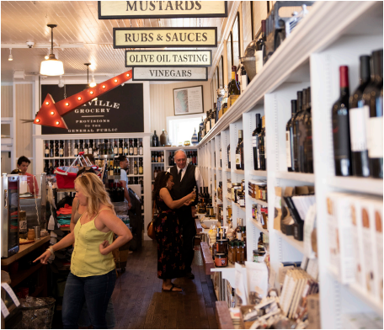Oakville Grocery 4 WINE SPECTATOR • JUNE 15 & 30, 2026
Mustards
shooting
Mustards
Breakfast/
Coffee/
Sandwiches/
Snacks
Oakville Grocery
7856 St. Helena Highway | oakville
grocery.com
Do stop by the iconic Oakville Gro
cery, if only to stretch your legs and
wander among the crowded shelves
packed with gourmet pantry ingredi
ents and snacks that make excellent
gifts. Coffee, pastries, cookies and
picnic provisions are all here, as well
as gourmet salads and large, share
able sandwiches, like the “Wagon
Wheel” sandwich with Fra’mani rose
mary ham, Cowgirl Creamery Wagon
Wheel Cheese and Dijonnaise.
Wood-fired pizzas, served on the pa
tio, are also top notch.
WS063026_napaOakville_draft.indd 4 3/26/26 10:15 AM
Mondavi
THE ULTIMATE TRAVEL GUIDE TO NAPA VALLEY | OAKVILLE Mondavi
AN OAKVILLE ADVENTURE from MaryAnn Worobiec THE EVERYTHING OLD IS NEW AGAIN TOUR
Two of the most anticipated re-openings this year are the
Robert Mondavi Winery and Beaulieu Vineyard. Both are scheduled to open soon; RMW in May and BV by July, and they are offering reservations as of press time. When historic wineries reinvent themselves they reflect broader shifts across Napa Valley. As a new generation of own ers and wine lovers shapes the region’s future, Napa continues to ask: How do you honor a storied past while embracing what comes next?
At RMW, the renovation preserves the iconic 1966 Cliff May design, including the signature arch and tower that echo Cali fornia’s Spanish missions. The team has added new structures on either side, including a hospitality wing wrapped in glass walls that bring guests visually closer to the vineyards. Design ers lined the ceiling with oak staves salvaged from old fermen tation vats—wine stains and all—adding texture and authenticity to the modern space.
Five minutes down the road, BV has also chosen restoration over replacement. The team reinforced the original stone walls instead of rebuilding them and repurposed redwood from old tanks to clad the ceilings, even preserving boards marked with handwritten notes. During construction, the winery recycled 98% of its materials. The redesigned space blends contemporary
elements and natural light with the historic stone facade, creat ing a seamless indoor-outdoor flow. Historical artifacts are on display Throughout the property, including founder Georges de
Latour’s refurbished Cadillac near the entrance. Expect heavier traffic as wine lovers line up to experience the results of these years-long renovations. As with any highly an ticipated restaurant debut, allow a little time for staff to settle into the new spaces and refine service. Even so, both re-openings promise to reward the wait.
BV
CADE Estate
BV
JUNE 15 & 30, 2026 • WINE SPECTATOR 5
WS063026_napaOakville_draft.indd 5 3/26/26 10:15 AM

