THE ULTIMATE TRAVEL GUIDE TO NAPA VALLEY | PRITCHARD HILL
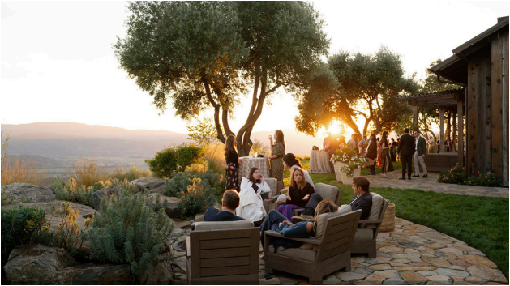
STANDALONE EYEBROW
caption
PRITCHARD HILL A Visit Above the Fog Line
In the late 1960s, Pritchard Hill was an isolated and essen tially forgotten area. Today, while it retains a sense of isola tion, it has become home to a cluster of prominent Cabernet Sauvignon producers who hew long-lived wines out of the site’s distinctive iron-red and yellow-tinged volcanic soils. Driving up the long, winding road to the top, which hits 1,800 feet of eleva
The Howard Backen Estate
275 Long Ranch Road | backenestate.com
Perhaps no single architect defines the Napa Valley wine country lifestyle more than Howard Backen. Backen’s signature farmhouse-chic aesthetic championed functionality and natural harmony while favoring discreet affluence over ostenta
tion. A prolific architect, he designed upwards of 300 private homes, 40 restau rants and more than 60 wineries through his Backen & Backen Architecture firm. Most of his work is in Napa Valley, including the home he considered his fin est: the Pritchard Hill Estate. Designed initially for the Nelson-Johnson family, who went on to create the Ovid wine estate next door, the property features 10,000 square feet of living space across a main house, guest houses and cot tages. The sweeping panoramic view of the valley below is so stunning it might make you forget the pool, yoga room, fireplaces and open chef’s kitchens that embellish the estate.
Ovid was eventually purchased by the Duncan family of Silver Oak in 2017 while the house went to a different owner. Then a group of partners, including chef Thomas Keller, purchased the house with the idea of creating an ultra-pre mium vacation property available to rent. With an in-house concierge, you can have your full itinerary prepared for you, from wine tastings at other Pritchard Hill estates, to meals on-premise with chefs from Thomas Keller Restaurant Group and more.
Now called the Howard Backen Estate, this piece of Napa Valley history of fers a spectacular vantage point—isolated, quiet and comforting—that provides for arguably the ultimate Napa Valley getaway.
2 WINE SPECTATOR • JUNE 15 & 30, 2026
tion, you’ll pass numerous vineyards as well as a handful of eye popping homes and showpiece wineries. Make sure to take no tice of how the flora changes from the valley floor. It’s as unique an area as Napa Valley has to offer, and a visit is a must for any serious wine enthusiast.
—James Molesworth
WHERE TO TASTE ON PRITCHARD HILL David Arthur Vineyards
210 Long Ranch Road | davidarthur.com
Don Long purchased 1,000 acres on Pritchard Hill in the 1950s and was among the first to plant vines in the 1970s. Today, his son David and grand daughter Laura are carrying on the family tradition. Winemaker Nile Zach erle fashions muscular, mineral-accented wines that help define Pritchard Hill’s terroir.
Chappellet Winery
1581 Sage Canyon Road | chappellet.com
Don and Molly Chappellet founded their winery in 1967; early vintages were made by the legendary Philip Togni. Togni was followed by Joe Cafaro, Tony Soter and Cathy Corison. Since the 1990s, Phillip Corallo-Titus has handled winemaking, while second- and third-generation Chappellets, led by Don and Molly’s son Cyril, pilot this historic family estate.
Continuum Estate
1677 Sage Canyon Road | continuumestate.com
Tim Mondavi (Robert’s son) and his sister, Marcia Mondavi Borger, founded Continuum Estate in 2005. Today, Tim’s children Dante, Carlo, Chiara and Carissa all pitch in. They’re christening a brand new barrel and hospitality area with plans to offer a rotating cast of guest chefs, sunrise vineyard hikes and more.
WS063026_napaPritchard_draft.indd 2 3/26/26 10:14 AM

