THE ULTIMATE TRAVEL GUIDE TO NAPA VALLEY | RUTHERFORD
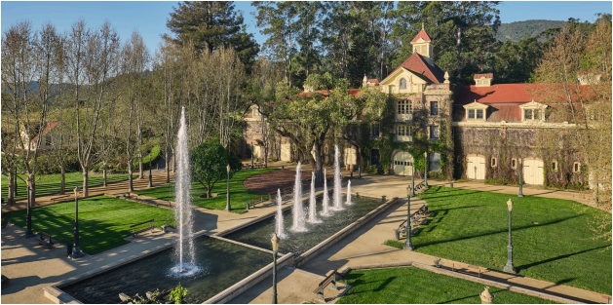Inglenook
RUTHERFORD Storied Vineyards By MaryAnn Worobiec
When it comes to grapevines, Rutherford is one of
Napa Valley’s big names. But as far as towns go, Rutherford is a blink-and-you’ll-miss-it spot along Highway 29 about halfway up the valley. As you drive past a former railroad station you might catch the smoky aromas of expertly grilled food at Rutherford Grill without realizing
you’ve just passed through the heart of a town with a popula tion of only about 100. On Rutherford Cross Road, there’s a small post office, the Rancho Caymus Inn and La Luna Market & Taqueria, a go-to for locally favored Mexican food. But this sleepy appearance belies that Rutherford boasts a rich wine history shaped by some of the region’s most important trailblazers.
The indigenous Mishewal-Wappo people first inhabited the land that now includes present-day Yountville, Oakville and Rutherford. In 1836, authorities granted nearly 12,000 acres on the valley floor to George C. Yount as part of the Rancho Cay
mus land grant. In 1864, Yount gave his daughter Elizabeth 1,040 acres in the center of the modern-day AVA as a wedding gift when she married Thomas Rutherford. The Rutherfords planted vineyards and produced wine, while giving the town its name.
The Rutherfords’ parcel changed hands several times before Finnish fur trader and sea captain Gustave Niebaum acquired it in 1879. He founded Inglenook and built its semi-Gothic châ teau in 1887; the building still stands. After Prohibition ended, his grand-nephew John Daniel Jr. crafted a series of extraor dinary wines until he sold the estate in the 1960s. In 1975, film maker Francis Ford Coppola purchased the estate; he worked
2 WINE SPECTATOR • JUNE 15 & 30, 2026
reunite the original property and transform it into a popular tourist destination.
French chemist Georges de Latour had arrived in California in 1883 and built his fortune in the cream of tartar business, an important baking ingredient that is a natural byproduct of wine making. In 1900, he moved to Napa Valley and founded Beau lieu Vineyard on land adjacent to Inglenook. He also became the first to import phylloxera-resistant rootstock. In 1938, de Latour hired winemaker André Tchelistcheff at BV and under his direction, the Georges de Latour Private Reserve Cabernet became one of the most famous wines in the world.
Rutherford sits at the widest point of Napa Valley, where fewer mountain shadows allow more sunlight to reach the vine yards. The benchlands divide into two distinct areas. On the eastern edge, complex soils and varied microclimates fold into the Vaca Mountains. Volcanic soils dominate much of this ter rain and remain moderately deep, but the mountains delay sun rise and slow the warming of the vines.
The western benchland receives morning sun and gains pro tection from afternoon heat when the sun dips behind the May acamas Mountains. This side of the valley features more allu vial soils and experiences cooler, windier conditions that create
a drying effect.
Tchelistcheff coined the term “Rutherford Dust,” in refer ence to dusty, powdery alluvial soils on the west side, and the distinct subtle grain and minerality they imbue in the AVA’s Cabernets. There are few simple pleasures as fine as sipping a Rutherford Cabernet while some Rutherford Dust clings to your shoes after a day in the vineyards.
WS063026_napaRutherford_draft.indd 2 3/26/26 10:13 AM
Cathiard Family
Estate
1978 Zinfandel Lane | cathiardvine
yard.com
The late Daniel Cathiard built an im
pressive career in wine, purchasing
Bordeaux’s Smith-Haut-Lafitte in
1990, then buying (and renaming)
the former Flora Springs estate at
the base of the Mayacamas moun
tain range in 2020. Management
was just transitioning to the family’s
next generation when Cathiard died
earlier this year. A visit makes it
clear how deeply the family is dedi
cated to this property, with meticu
lously maintained grounds and inti
mate visit experiences that might
include a tour of the vineyards in an
electric Range Rover, including the
wine cave and on-site cooperage.
Inglenook/Niebaum; Pennino
WHERE TO TASTE
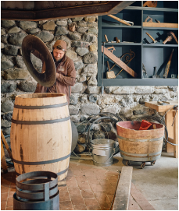
Beaulieu
Vineyard
1960 St. Helena
Highway
bvwines.com
Cakebread
8300 St. Helena
Highway
cakebread.com
Caymus
Vineyards
8700 Conn Creek Road
caymus.com
Dakota Shy
Wine
771 Sage Canyon Road
dakotashywine.com
Foley
Cathiard
Johnson
Winery
Honig
Vineyard and Winery
850 Rutherford Road honigwine.com
Mumm Napa 8445 Silverado Trail mummnapa.com
Round Pond Cellars
875 Rutherford Road roundpond.com
Rutherford Hill Winery 200 Rutherford Hill Road
rutherfordhill.com
Sequoia
Grove Winery 8338 St Helena
1991 St. Helena Highway | inglenook.com; niebaumpennino.com
Even if you didn’t know Francis Ford Coppola owned Inglenook, you’d still pick up on how cinematic and grand the estate is, a mix of history, beauty, movie memorabilia and elegant wines. There are plenty of visitor experiences available, from simply enjoying a glass to more informative tours and li brary tastings. The recently opened Pennino House on the property is another chance to taste wines in a relaxed atmosphere, like stepping into a family home with a cozy living room plus plenty of out door seating. Here they also serve a curated selection of Italian-inspired non-alcoholic beverages.
Quintessa
1601 Silverado Trail | quintessa.com
Quintessa lies an easy turn off of the Silverado Trail, but a visit here takes you off the beaten path, into the heart of Rutherford and a uniquely serene setting. The entire property is nearly 300 acres, and the best way to soak it all in is through the “Quintessential Experience,” where a tasting takes place in a private glass pavilion overlooking Dragon Lake.
8350 St. Helena
Highway
foleyjohnsonwines.com
Frog’s Leap Winery
8815 Conn Creek Road frogsleap.com
Grgich Hills 1829 St. Helena High way S.
grgich.com
Highway
sequoiagrove.com
St. Supéry Estate
Vineyards & Winery
8440 St. Helena Highway
stsupery.com
Sullivan
Rutherford Estate
1090 Galleron Road sullivanwine.com
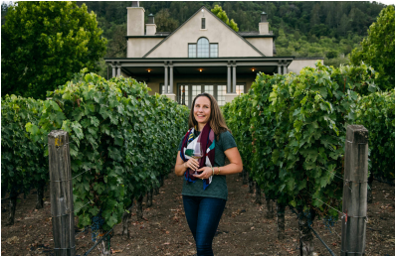Staglin
Staglin Family Vineyard
1570 Bella Oaks Lane | staglinfamily.com
There’s much to learn from a visit to Staglin, begin ning with the viticultural history of the property, which dates to 1864. Significant figures such as An dré Tchelistcheff and Beaulieu founder Georges de Latour have ties here, drawn to this place that clearly defines what makes the Rutherford Bench an amaz ing place to grow grapes.
For more than 40 years, the Staglin family has been the caretaker, including piecing together parts of the property that had been separated from the original, such as the Steckter home, which is now their base for hospitality. The winery remains family run, with second-generation vintner Shannon Staglin at the helm.
JUNE 15 & 30, 2026 • WINE SPECTATOR 3
WS063026_napaRutherford_draft.indd 3 3/26/26 10:13 AM
Rancho Caymus Inn
1140 Rutherford Road | ranchocaymusinn.com
WHERE TO EAT
shoot
Rutherford
Grill
WHERE TO STAY
Rutherford Grill 1180 Rutherford Road | ruth erfordgrill.com
It would be easy to simply think of Rutherford Grill as the best place to pair ex pertly crafted barbeque with rich Napa Cabernets. But there’s so much more to en joy, including deviled eggs, a generous iceberg wedge salad, oak-grilled salmon and iron skillet cornbread bites. The staff is friendly and the patio seating is popular when weather permits.
La Luna
Market &
Taqueria
1153 Rutherford Road
lalunamarket.com
The
Restaurant at Auberge du
Soleil
180 Rutherford Hill
Road
auberge.com/auberge du-soleil/dine
Recently renovated, this inn has plenty of personal ity. It was originally designed and built by the Mor ton Salt heiress Mary Tilden Morton, who leaned into Spanish-hacienda architecture with 19th-century barn wood beans and wrought iron details. Today, it’s the Goldilocks of Napa Valley hotels; it has quiet vibes in the tiny town of Rutherford, but also is con veniently located halfway up the valley and close to much of the vineyard action. Rooms are air-condi tioned and feature fireplaces and private balconies or patios.
Auberge du Soleil
180 Rutherford Hill Road
auberge.com/auberge-du-soleil
4 WINE SPECTATOR • JUNE 15 & 30, 2026
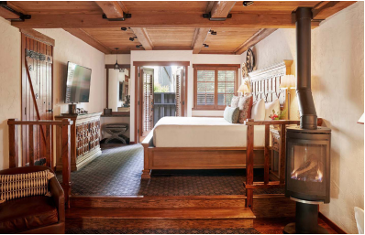Rancho Caymus Inn
WS063026_napaRutherford_draft.indd 4 3/26/26 10:13 AM
THE ULTIMATE TRAVEL GUIDE TO NAPA VALLEY | RUTHERFORD
A RUTHERFORD ADVENTURE
from MaryAnn Worobiec
THE SAUVIGNON BLANC DISCOVERY TOUR
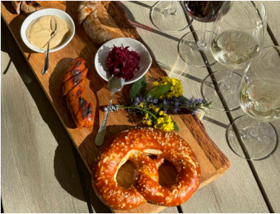
Napa may be Cabernet country, but many
of its red wine specialists also craft ex
ceptional Sauvignon Blancs (not to
mention that Sauvignon Blanc is one of Caber
net Sauvignon’s parents, along with Cabernet
Franc). White wine lovers have plenty to cele
brate with these refreshing, expressive wines.
Several standout producers lie close to one
another, making it easy to explore. Start at Groth
in Oakville and choose a tasting that features the
estate Sauvignon Blanc. The experience high
lights how Napa has transformed Sauvignon
Blanc from an afterthought into a deliberate, dy
namic category. In the 1990s, the Groth family—
now in its second generation in wine—recog
nized that certain clay-heavy vineyard blocks planted to Cabernet suited white varieties bet ter. They began replanting, helping to usher in a new era for the grape. The estate Sauvignon Blanc, first released with the 2019 vintage, ex
shoot St
Supery
emplifies that vision.
St Supery
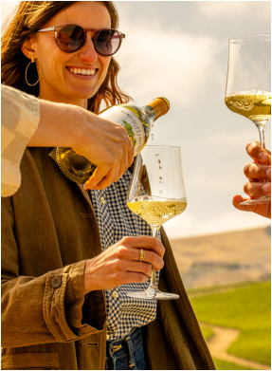Grgich Hills
Just 3 miles away, Rutherford’s St. Supéry welcomes guests with one of the valley’s most approachable tasting experiences. The winery farms its Sauvignon Blanc at Dollarhide Ranch in Pope Valley, east of Napa, and has championed distinctive ex
pressions of the grape since the 1980s. Today, it remains a cat egory leader. Several tasting flights spotlight Sauvignon Blanc, including the “White Wine Discovery,” which demonstrates how fermentation vessels from stainless steel to French oak bar rels and concrete fermentors shape the wine’s texture and style.
In season, try St. Supéry’s Mustard Season Tasting Flight. The winery pairs red and white wines with artisan pretzels, Jour neyman sausages and house-made savory mustards. You can also opt for a white wine and caviar pairing to explore how Sau vignon Blanc and Sémillon complement the delicacy.
When hunger strikes, head down Highway 29 to Mustards Grill. The ever-popular seafood tostada changes daily but typi cally arrives on a large, crisp tortilla layered with black beans, cabbage-jicama slaw and avocado, and then finished with chi potle aioli and cotija cheese. It pairs beautifully with a glass of crisp white wine.
Finish your Sauvignon Blanc tour at Grgich Hills Estate. This historic family-run winery continues to earn attention for its role in the Judgment of Paris anniversary, but its Sauvignon Blancs deserve equal acclaim. The wines show aromatic inten
sity, floral lift and distinctive character, with select bottlings available only at the winery. Choose a tasting flight that includes them, or order a glass—or bottle—and enjoy it in the garden.
JUNE 15 & 30, 2026 • WINE SPECTATOR 5
WS063026_napaRutherford_draft.indd 5 3/26/26 10:13 AM

