NAPA TACOS El Taco Feliz
NAPA VALLEY TACO TOUR 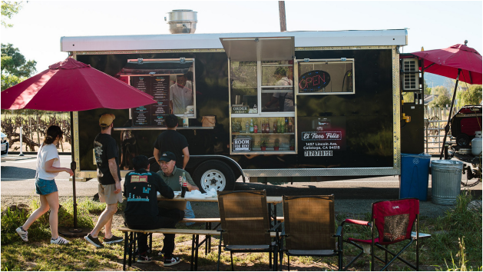
Napa Valley and Mexico have a long-entwined history
that has blended their cultures together along the way. Street tacos, once serving mainly as an easy meal for workers, have become a go-to food option beloved by all. To day, taquerias are located all over the valley, whether brick and-mortar restaurants or food trucks. Most specialize in clas sic “street tacos,” plates of smothered tortillas that are typically prepared quickly, packed with flavor in an array of combina tions and able to be eaten handily.
A proper street taco needs just five ingredients: tortilla, meat, sauce, cilantro and onion. The magic happens in high quality ingredients.
It all starts with the tortilla. Dough made of masa harina de maíz and water is pressed flatly and cooked to form the base of a taco dish. The best tortillas are handmade to order and warmed on a grill. Then the meat gets added.
Any taco spot worth its salt offers pollo asado (grilled chicken). Carne (steak) is also a staple protein, often coming in multiple options such as asada (grilled slices), suadero (braised), cabeza (beef cheeks) or lengua (beef tongue). Pork rounds out the big three, with al pastor (seasoned and topped with a pineapple slice), carnitas (braised) and chorizo (seasoned sausage), per haps the most popular. More adventurous palates can go for chicharrón (pork rind), tripa (intestine) or buche (pork stom ach). The proteins may be simply grilled or seasoned with a mix of guajillo, ancho and chipotle chiles, achiote, cumin, gar lic, onion and oregano.
2 WINE SPECTATOR • JUNE 15 & 30, 2026
Azteca Market & Taqueria
789 Main St., St. Helena
2995 Jefferson St., Napa
aztecanapavalley.com
This Mexican grocery store in St. Helena is home to one of the val ley’s most popular taco counters (there’s a second location in
Napa). The hedonistic street-style taco lineup includes basics such as pollo asado, carnitas and chorizo, along with traditional buche, len gua and suadero.
El Rodeo
1850 Soscol Ave., Napa
(707) 415-9800
This truck specializes in fresh sea food offerings like shrimp or fish tacos alongside with aguachile and seafood cocktail[UNCLEAR]. Try the tripa for an authentic and adventurous street taco bite. The taco gobernadora, with shrimp, cheese and grilled onions, is a heartier choice.
El Sabor Serano 1017 Coombsville Road, Suite B, Napa
elsaborserano.com
El Sabor Serano is located on the east side of Napa heading to Coombsville, next to the Fairview Market and not far from the Napa Valley Exposition. It’s best to sit down at this restaurant for your meal. The suadero stands out for its juicy and tender beef. You’re going to want as much salsa verde as possible as it is made with fire roasted tomatillos that add a smoky depth to the sauce.
El Taco Feliz
Lake Street, Calistoga
This taco truck is just past the in tersection of Silverado Trail and Lake Street. The lines are long for a reason—it’s among the best spots in the valley and the service is always friendly. Their carnes are tender, juicy and packed with fla vor. The cabeza stands out for its generosity of seasonings and melt-in-your-mouth braised beef.
Sauces add flavors that bring spice and acidity to the taco, usually as salsa roja, verde or aguacate. Roja is spicy and smoky, made with tomatillos and chiles. Verde is mild and tangy, made
lections can also be found. Be mindful of levels of spiciness and your tolerance to them—the radish or cucumber slices typically served on the side are there to help if you take one of those too
WS063026_napaTaco_draft.indd 2 3/26/26 10:08 AM
with tomatillo, cilantro and lime juice. Aguacate is a creamy version of salsa verde with avocado. Some places specialize in habanero for ultimate spice, or macha for an oily crispness. The street taco’s final garnish is cilantro for freshness and chopped raw onion for a bitter crunch.
There are also seafood tacos which typically come with pico de gallo, cabbage and chipotle aioli. Vegan and vegetarian se
hot bites. Some taquerias include carrots or grilled onions on the side for a sweet counterpoint.
When pairing wine with tacos, look for something with fresh ness and bright acidity, which cuts through the richness of the proteins and seasonings. A lower alcohol wine allows the taco’s flavors to shine and keeps spice in the background. Sparkling wines are also a great option. Rich white wines can stand up
THE ULTIMATE TRAVEL GUIDE TO NAPA VALLEY | TACOS
La Condesa
Grape Yard shopping center. The
Taqueria
1745 Soscol Ave., Napa
lacondesataquerianapa.com Open early, La Condesa offers breakfast tacos and licuados (smoothies) along with traditional street tacos. The chorizo stands out for its seasoning and spices and is served on a toasted tortilla that holds together nicely. There may not be a better way to start the day than at this taqueria.
La Luna Market & Taqueria
1153 Rutherford Road, Rutherford lalunamarket.com
Right in front of the Rancho Cay mus Inn, this market and taqueria provides one-stop shopping for a taco picnic. The pastor and pollo adobado tacos shine here, with excellent seasonings and juicy meat. Conveniently, picnic tables surround the exterior of the market.
La Taquiza Fish Tacos
2007 Redwood Road, Napa lataquizafishtacos.com
In the Redwood Plaza, this brick and-mortar taqueria is known for its fresh seafood options. Shrimp, fish and octopus come in various
formats such as ceviche or sea food cocktail. The fish taco can be battered and fried or seasoned and grilled, then topped with pico de gallo, cabbage and chipotle crema. The octopus is a stand out—grilled fresh, tender and meaty.
Mother’s Tacos
3150 A Jefferson St., Napa
madebymothers.com
Napa’s newest taco joint is a fast casual restaurant located in the
tortillas are made in-house and provide the perfect platform for the traditional carne asada, suadero or pollo asado. The mush room taco outperforms for its melt-in-your-mouth sweetness. Mother’s offers four sauces at the table; be sure to try the oil-based macha sauce for great acidity and crunch.
Ray Ray’s Tacos
1304 Main St., St. Helena
rayrays.com
Ray Ray’s offers convenience with its tacos to go. Choose from vari ous kits designed so you can build your own tacos. A tray of 16 street tacos tray makes things even eas ier—all you have to do is pick the meat. The spiced carrot taco here should not be missed, either. There is also plenty of seating for dining in.
Tacos El Muchacho Alegre
751 Jackson St., Napa
tacoselmuchachoalegre.com This truck is just off Soscol where there are plenty of parking spaces and picnic tables. The spiced shrimp taco here is filled to capac ity, with fresh slaw, pico de gallo and creamy aoli. Traditional meats, like the al pastor, are also sea soned perfectly.
Tacos Garcia (Truck) 6792 Washington St., Yountville (707) 980-4896
Yountville’s only taco truck is on the corner of Washington Street and Champagne Drive, one block from picnic tables, bocce and vol
leyball courts. The tortillas are lightly toasted on the grill, making them a firm base for the fillings (which are ample). Tacos Garcia
specializes in the tender lengua. Be sure to top any taco with the to-die-for red tomatillo sauce.
Tacos Los
Compadres
Claremont Way, Napa
(707) 339-2305
Open until midnight, Tacos Los
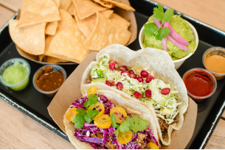Ray Ray’s 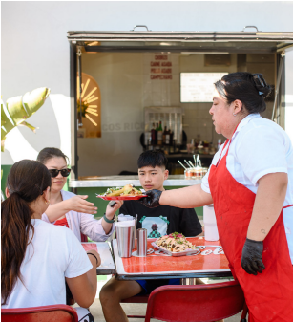Mother’s Tacos
truck allows you to conveniently top your tacos with as much cilan tro, onions and sauce as you’d like.
Tacos Michoacan 1800 Pueblo Ave., Napa
(707) 812-9963
One of the longest-running taque rias in Napa (since the 1990s) this
Recommended Wines
HYDE Pinot Noir Napa Valley Larry Hyde 2022
KINSMAN Eades Chenin Blanc Diamond Mountain District Aberro 2024 LOS CUERNOS Chardonnay California NV
NEWFOUND Grenache Napa Valley Yount Mill Vineyard 2022 NOMADICA California Bubbly White NV
SCHRAMSBERG Brut Rosé Napa Valley Querencia 2021 SPHAERICS Chardonnay Napa Valley Carneros Overline 2023 UNTI Vermentino Dry Creek Valley 2024
Compadres is a great spot for late-night munchies. The al pastor is one of the best in the valley. A trompo is used to spin the layered meat around a flame, crisping it until ready to be sliced, after which it is topped with slices of grilled pineapple that rotate on the trompo, above the carne. A salad bar on the outside of the
outfit sports a brick-and-mortar along with two trucks. With house-made tortillas, traditional meats and three sauces, Micho acan offers the archetypal Mexi can street food. Their carnitas are spot on, with an intensity of salti ness and fattiness. Don’t overlook their carrot side either, as it adds just the right sweetness to finish.
JUNE 15 & 30, 2026 • WINE SPECTATOR 3
WS063026_napaTaco_draft.indd 3 3/26/26 10:08 AMto the complexity of the taco, while lightly tannic red wines com
pliment the seasonings without accentuating spice. If you love a
big red wine though, go ahead and have it with your tacos. Don’t
forget about canned wines, an easily transportable option if you’re
having a picnic.
—Chris Cardoso

