CAT BREEDS

Capangi Mihaela

Contents

I. Chapter 1 – Small breeds 1

A. Abyssinian Cat breed 1

B. American Curl Cat breed 1

C. Russian Blue Cat breed 2

D. Singapura Cat breed 3

E. Other small cats 4

II. Chapter 2 – Medium breeds 5

A. Birman Cat breed 5

B. Bombay Cat breed 5

C. Burmese Cat breed 6

D. Other medium cats 7

III. Chapter 2 – Large breeds 9

A. LaPerm Cat breed 9

B. Manx Cat breed 9

C. Ocicat Cat breed 10

D. Other large cats 11

IV. Bibliography 13

List of figure

CatFigure I:1 1

CatFigure I:2 American Curl Cat 2

CatFigure I:3 Russian Blue Cat 3

CatFigure I:4 Singapura Cat 3

CatFigure II:1 Birman Cat 5

CatFigure II:2 Bombay Cat 6

CatFigure II:3 Burmese Cat 6

CatFigure III:1 LaPerm Cat 9

CatFigure III:2 Manx Cat 10

CatFigure III:3 Ocicat Cat 11

List of table

CatTable I‑1 Small cats 4

CatTable II‑1 Medium cats 7

CatTable III‑1 Large cats 11

# Chapter 1 – Small breeds

## Abyssinian Cat breed

Size: Small to medium, with males weighing 7 to 10 pounds and females weighing 6 to 8 pounds

Coat: Medium

Color: Ruddy, red, blue, fawn

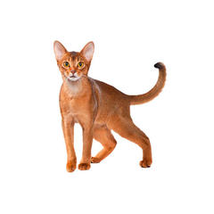

CatFigure I:1

Regal and highly intelligent, the Abyssinian is best described in one word: busy. Not a lap cat, this insatiably curious breed is always on the move, except when eating or sleeping.

A fascinating, gorgeous breed, the Abyssinian is a natural athlete, with a muscular body and no fear of heights (Barbery, 2017). The Aby is an affectionate, loyal, people-oriented companion that is well-suited for families with children older than 6.

## American Curl Cat breed

Size: Small to medium, with males weighing 7 to 10 pounds and females weighing 5 to 8 pounds

Coat: Short (shorthair) and semi-long (longhair)

Color: White, black, blue, red, cream, chocolate, lilac, silver, golden, various patterns and shadings

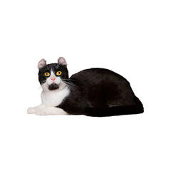

CatFigure I:2 American Curl Cat

The American Curl has distinctive curled ears that form a graceful arc, giving an alert, perky expression. This breed is known as the “Peter Pan” of cats due to retaining its kittenlike personality throughout life. The Curl has two coat varieties, shorthair and longhair.

With her outstanding temperament, the Curl is a people-oriented breed that makes an affectionate soul mate and easily adjusts to other pets and children (Cat, 2018).

## Russian Blue Cat breed

Size: Small to medium, with males weighing 7 to 11 pounds and females weighing 5 to 8 pounds

Coat: Short, dense, fine, plush

Color: Blue with silver tips

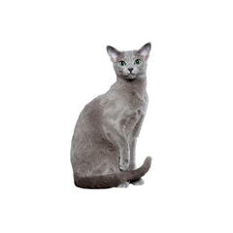

CatFigure I:3 Russian Blue Cat

The Russian Blue is easily distinguished with her emerald green eyes and silver-tipped blue coat. Though naturally shy, this feline is affectionate toward her family and gets along well with older children. Highly intelligent, the Russian Blue has been reported to open doors.

This clean, quiet-mannered cat thrives in a consistent, routine environment. The Russian Blue is a healthy breed that does well when left alone for long periods (Hoshino, 2016).

## Singapura Cat breed

Size: Small, with males weighing 6 to 8 pounds and females weighing 5 to 6 pounds

Coat: Short, fine, silky

Color: Sepia

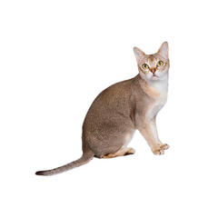

CatFigure I:4 Singapura Cat

The smallest domestic cat breed, the Singapura is an extroverted, playful feline sometimes called a “pesky people cat.” This breed thrives on attention and interactive play. Called Pura for short, these cats are intelligent and keenly observant (Hoshino, 2016).

Friendly and social, they enjoy cats and cat friendly dogs, but dislike loud noises so are not ideal for busy households with boisterous children.

## Other small cats

CatTable I‑1 Small cats

|  |  |  |  |  |
| --- | --- | --- | --- | --- |
| Breed | Country | Origin | Coat | Pattern |
| [Abyssinian](https://en.wikipedia.org/wiki/Abyssinian_cat) | Ethiopia | Natural | Short | Ticked |
| [Aegean](https://en.wikipedia.org/wiki/Aegean_cat) | Greece | Natural | Semi-long | Bi- or tricolored |
| [American Curl](https://en.wikipedia.org/wiki/American_Curl) | United States | Mutation | Short | All |
| [American Wirehair](https://en.wikipedia.org/wiki/American_Wirehair) | United States | Mutation | Rex | All but colorpoint |
| [Australian Mist](https://en.wikipedia.org/wiki/Australian_Mist) | Australia | Crossbreed: [Abyssinian](https://en.wikipedia.org/wiki/Abyssinian_cat" \o "Abyssinian cat) and [Burmes](https://en.wikipedia.org/wiki/Burmese_cat)e | Short | Spotted or [tabby](https://en.wikipedia.org/wiki/Tabby_Cat" \o "Tabby Cat) |

# Chapter 2 – Medium breeds

## Birman Cat breed

Size: Medium to large, with males weighing 9 to 15 pounds and females weighing 6 to 10 pounds

Coat: Medium to long

Color: Seal point, blue point, chocolate point, lilac point

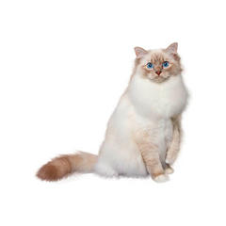

CatFigure II:1 Birman Cat

With her marvelous, social personality, the Birman doesn’t like being the only animal in the house. She is active and playful but quiet if you are busy (Hunter, 2017).

This healthy, long-lived breed has an outstanding semi-long silky coat that does not mat and a luxurious, long bottle-brush tail. Brilliant blue, almost-round eyes are prominent features of her sweet expression.

## Bombay Cat breed

Size: Medium, males weighing 8 to 11 pounds and females weighing 6 to 9 pounds

Coat: Short

Color: Black

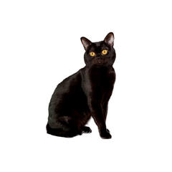

CatFigure II:2 Bombay Cat

A people-oriented breed, the Bombay enthusiastically greets visitors. This easygoing feline is sweet, affectionate and curious. The Bombay enjoys playing fetch, going for leash walks and inventing entertainment (Smith, 2018).

This breed is known for its beautiful gold to copper eyes and short, flat, gleaming coat that accentuates a solid, muscular body. A devoted companion, the Bombay gets along well with children and other pets.

## Burmese Cat breed

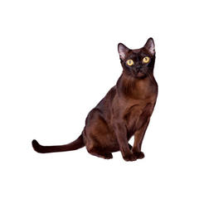

CatFigure II:3 Burmese Cat

Size: Medium, with males weighing from 8 to 12 pounds and females weighing from 6 to 10 pounds.

Coat: Short.

Color: Sable, champagne, blue, platinum.

An extremely people-oriented breed, the Burmese is frisky and mischievous well into adulthood. Craving close contact, she loves to cuddle in warm laps. With an almost doglike personality, the Burmese can be taught to retrieve (Barbery, 2017).

This breed is good with children and tolerates cat friendly dogs. Having a short, satinlike coat and compact body, this cat has large, expressive eyes that are one of the breed’s endearing traits.

## Other medium cats

CatTable II‑1 Medium cats

|  |  |  |  |  |
| --- | --- | --- | --- | --- |
| Breed | Country | Origin | Coat | Pattern |
| [Bengal](https://en.wikipedia.org/wiki/Bengal_cat) | Developed in the United States (foundation stock from Asia) | Hybrid: [Abyssinian](https://en.wikipedia.org/wiki/Abyssinian_cat) and [Egyptian Mau](https://en.wikipedia.org/wiki/Egyptian_Mau) × [leopard cat](https://en.wikipedia.org/wiki/Leopard_cat) | Short | Spotted, marbled, or rosetted |
| [Birman](https://en.wikipedia.org/wiki/Birman) | Developed in France (foundation stock from Burma, etc.) | Crossbreed: original Birman with [Persian](https://en.wikipedia.org/wiki/Persian_cat)and [Siamese](https://en.wikipedia.org/wiki/Siamese_cat) | Semi-long | Colorpoint |
| [Bombay](https://en.wikipedia.org/wiki/Bombay_cat) | Developed in the United States (some foundation stock from Burma and Thailand) | Crossbreed: [American Shorthair](https://en.wikipedia.org/wiki/American_Shorthair) and [Burmese](https://en.wikipedia.org/wiki/Burmese_cat) | Short | Solid |

# Chapter 2 – Large breeds

## LaPerm Cat breed

Size: Medium, with males weighing from 7 to 10 pounds and females weighing from 5 to 8 pounds.

Coat: Short or long, soft, wavy.

Color: White, black, blue, red, cream, chocolate, cinnamon, fawn and lavender, plus various patterns and shadings.

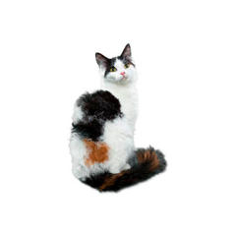

CatFigure III:1 LaPerm Cat

Distinguished by her curly, rippled coat and people-oriented personality, the LaPerm is calm and friendly, yet at other times energetic and inquisitive. This feline thrives on attention and likes to be close to her human companions (Cat, 2018).

Though curious, this breed is content to be a lap cat and close to whatever is going on. The LaPerm blossoms with a loving family.

## Manx Cat breed

Size: Medium to large, with males weighing from 9 to 13 pounds and females weighing from 7 to 11 pounds.

Coat: Longhair — medium, dense, soft, silky; shorthair — short, dense, glossy.

Color:White, black, blue, red, cream and silver, plus various patterns and shadings.

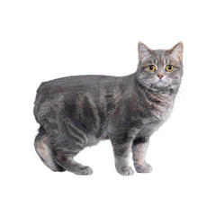

CatFigure III:2 Manx Cat

The short, round Manx is known as the sprint car of the cat world due to her quick acceleration and turns. This feline has powerful back legs that enable her to jump high. One usually finds a Manx in the tallest perch of a room (Hoshino, 2016).

This breed likes to retrieve and bury toys, much like a dog, and is fascinated by water. Sweet and affectionate, the Manx is a good family pet. The breed has two coat varieties, longhair and shorthair.

## Ocicat Cat breed

Size: Medium to large, with males weighing 10 to 15 pounds and females weighing 7 to 12 pounds.

Coat: Short, smooth, satiny.

Color: Tawny, chocolate, cinnamon, blue, lavender, fawn, ebony silver, chocolate silver, cinnamon silver, blue silver, lavender silver, fawn silver.

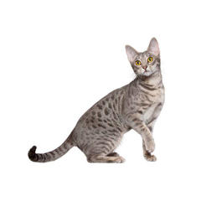

CatFigure III:3 Ocicat Cat

The Ocicat is the only spotted domestic breed selectively bred to emulate cats of the wild. This muscular, athletic breed can be trained to play fetch and walk on a leash.

A people-devoted feline, the Ocicat loves companionship and doesn’t like being left alone too long. This cat does well with other cats and cat friendly dogs. A healthy breed, the Ocicat may live to be 15 to 18 years old (Smith, 2018).

## Other large cats

CatTable III‑1 Large cats

|  |  |  |  |  |
| --- | --- | --- | --- | --- |
| Breed | Country | Origin | Coat | Pattern |
| [Bengal](https://en.wikipedia.org/wiki/Bengal_cat) | Developed in the United States | Hybrid: [Abyssinian](https://en.wikipedia.org/wiki/Abyssinian_cat) and [Egyptian Mau](https://en.wikipedia.org/wiki/Egyptian_Mau) | Short | Spotted, marbled, or rosetted |
| [Birman](https://en.wikipedia.org/wiki/Birman) | Developed in France | Crossbreed: original Birman with [Persian](https://en.wikipedia.org/wiki/Persian_cat) and [Siamese](https://en.wikipedia.org/wiki/Siamese_cat) | Semi-long | Colorpoint |
| [Bengal](https://en.wikipedia.org/wiki/Bengal_cat) | Developed in the United States | Hybrid: [Abyssinian](https://en.wikipedia.org/wiki/Abyssinian_cat) and [Egyptian Mau](https://en.wikipedia.org/wiki/Egyptian_Mau) [leopard cat](https://en.wikipedia.org/wiki/Leopard_cat) | Short | Spotted, marbled, or rosetted |

# Bibliography

Barbery, M. (2017). *The Elegance of the Cat.* Paris: Musette Editors.

Cat, T. (2018, 10 12). *Purina Cat Breeds*. Retrieved from https://www.purina.com: https://www.purina.com/cats/cat-breeds

Hoshino, T. (2016). *We, the Children of Cats.* Tokyo: Adventure Works Press.

Hunter, E. (2017). *Warrior cats.* London: Pegasus publishers.

Smith, J. (2018). *My book about cats.* New York: New York Times.