BASAVESHWAR ENGINEERING College (AUTONOMOUS) BAGALKOt



DEPARTMENT OF ELECTRONICS AND COMMUNICATION

REPORT

Number guessing game using python

Subject: Higher Programming Paradigm

Subject code : 21UEC308C

DIV: B

Presented By :

|  |  |  |
| --- | --- | --- |
| Name | USN | Roll no. |
| Prasankumar Patil | 2BA21EC061 | 25 |
| Pratham Asuti | 2BA21EC063 | 27 |

Faculty I/C: Dr. M.C.Aralimarad

**Number guessing game**

**Introduction:**

The number guessing game is a popular game among programmers. In the number guessing game, the program selects a random number between two numbers, and the user guesses the correct number. To create a guessing game, we need to write a program to select a random number between 1 and 10. To give hints to the user, we can use [conditional statements](https://en.wikipedia.org/wiki/Conditional_(computer_programming)) to tell the user if the guessed number is smaller, greater than or equal to the randomly selected number.

**Block Diagram :**

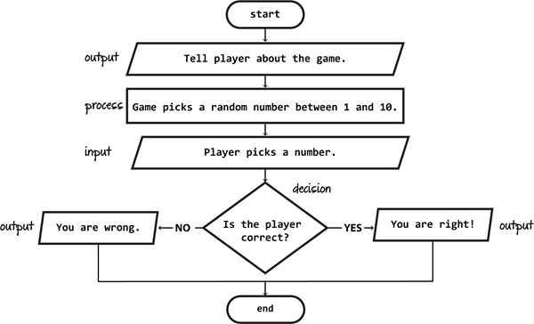

**Library Function:**

**random()** function generates random floating numbers in the range[0.1, 1.0). (See the opening and closing brackets, it means including 0 but excluding 1). It takes no parameters and returns values uniformly distributed between 0 and 1.

**randint()** is an inbuilt function of the *random module*in Python3. The random module gives access to various useful functions and one of them being able to generate random numbers, which is *randint()*.

**Source Code :**

import random  
import math  
# Taking Inputs  
lower = int(input("Enter Lower bound:- "))  
  
# Taking Inputs  
upper = int(input("Enter Upper bound:- "))  
  
# generating random number between  
# the lower and upper  
x = random.randint(lower, upper)  
print("\n\tYou've only ",  
 round(math.log(upper - lower + 1, 2)),  
 " chances to guess the integer!\n")  
  
# Initializing the number of guesses.  
count = 0

# for calculation of minimum number of  
# guesses depends upon range  
while count < math.log(upper - lower + 1, 2):  
 count += 1  
 # taking guessing number as input  
 guess = int(input("Guess a number:- "))  
 # Condition testing  
 if x == guess:  
 print("Congratulations you did it in ",  
 count, " try")  
 # Once guessed, loop will break  
 break  
 elif x > guess:  
 print("You guessed too small!")  
 elif x < guess:  
 print("You Guessed too high!")  
# If Guessing is more than required guesses,  
# shows this output.  
if count >= math.log(upper - lower + 1, 2):  
 print("\nThe number is %d" % x)  
 print("\tBetter Luck Next time!")

**Output:**

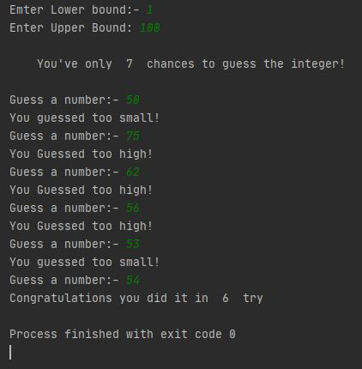

**Conclusion:**

So this is how you can write a program to create a guessing game using Python. It is a popular game among programmers. In this game, the program selects a random number between two numbers, and the user guesses the correct number.