Flight Controls
F1 |  | 1 | Forward (front) view |  | V | External views ²
F2 |  | 2 | Aft (rear) view |  | Z | Cycle IFF Scanner zoom ³
F3 |  | 3 | Port (left) view | ⇫ | Z | Reset IFF Scanner zoom
F4 |  | 4 | Starboard (right) view |  | \ | Select next Space Compass target ⁴  †
↑ |  | ↓ | Pitch down (dive) / up (climb) |  | | | Select previous Space Compass target ⁴
← |  | → | Roll clockwise / anticlockwise | ⇫ | L | Contact Station Traffic Control ⁵
, |  | . | Yaw (turn) left / right |  | C | Activate Docking Computer  †
 |  | Ctrl | Fine control of pitch, roll and yaw | ⇫ | C | Activate Fast Docking Computer ⁶  †
W |  | S | Speed increase / decrease |  | S | Turn off the music while auto-docking  †
 |  | I | Witchspace Fuel Injectors | ⇫ | D | Dump one cargo canister ⁷  †
 |  | J | Engage Jump (torus) drive | ⇫ | R | Rotate through the manifest ⁷  †
 |  | H | Hyperspace jump |  | ` | Show the communication log
 |  | G | Galactic Hyperspace jump ¹ | Esc | Esc | Launch Escape Pod
 |  | ; | Cycle current MFD ⁸ |  | : | Select next MFD ⁸
Ctrl |  | ; | Cycle current MFD in reverse ⁸ | Ctrl | : | Select previous MFD ⁸

Combat Controls
 |  | A | Fire laser | + |  | - | Cycle to next / previous target
 |  | T | Missile target seek |  |  | R | Activate ID recognition
 |  | M | Fire missile (if locked) |  |  | E | Activate ECM system
 |  | U | Unlock missile target |  |  | _ | Toggle weapon lockdown
 |  | Y | Cycle through available missiles † | ⇫ |  | T | Target nearest incoming missile

Commodities Market Controls |  |  |  |  |  |  |  |  |  | Planetary Data
F8 |  |  | 8 |  | Commodities Market |  |  |  |  |  | F7 |  | 7 | Data on Planet
F8 |  | F8 |  |  |  | 8 | 8 | Commodity Details |  |  | Home |  |  | Select current system
Enter |  |  |  |  | Buy / sell maximum amount |  |  |  |  |  | End |  |  | Select current destination system
↑ |  |  |  | ↓ | Move cursor up / down the list |  |  |  |  |  | ← |  | → | Select previous / next system on course
← |  |  |  | → | Sell / buy one unit of commodity
/ |  |  |  | ? | Change commodity list sort / filter
Note: holding shift while buying or selling will also
buy or sell the maximum amount.
Ship, Systems & Status Controls
F1 |  |  | 1 | Launch the ship |  | F2 |  | 2 |  |  | Game Menu
F3 |  |  | 3 | Ship Outfitting ‡ | F3 | F3 |  | 3 |  | 3 | Ships For Sale ‡
F5 |  |  | 5 | Commander’s Profile | F5 | F5 |  | 5 |  | 5 | Ship’s Manifest
↑ |  |  | ↓ | Move cursor up / down the list |  | ⇫ | N |  | Prime next special equipment
Enter |  |  |  | Select the highlighted entry | Ctrl | ⇫ | N |  | Prime previous special equipment
Tab |  |  | 0 | Fast-activate special equipment | N |  | B |  | Activate special equipment ⁹

Navigation Controls
F6 | F6 |  | 6 | 6 | Galactic Chart | Arrows | Move cursor around the charts
 | F6 |  | 6 |  | Short Range Chart | Pg Up | Zoom chart in
I | Toggle name/system information view |  |  |  |  | Pg Dn | Zoom chart out
? | Cycle highlight mode |  |  |  |  | Home | Return cursor to current system
^ | Advanced navigation – cycle route mode
Note: typing a planet’s name while in the Galactic Chart will automatically move the cursor to the world matching the text. When more than one planet matches the text, use shift-arrow keys to move the cursor to the next highlighted world. Use Alt + left / right arrow keys to select the system for which information will be displayed in the F7 system data screen.

Ship-Station Interfaces Controls
F4 |  | 4 | List available interfaces ‡ | ↑ |  | ↓ | Move cursor up / down the list
Enter |  |  | Activate selected interface | ← |  | → | Move between pages on list

Other Controls – All Systems
 |  | P |  |  | Pause the game |  |  |  | O | Turn the HUD off / on while paused
⇫ |  | F |  |  | Toggle the game frame rate display |  |  |  | * | Take a screenshot
⇫ |  | M |  |  | Toggle mouse flight control in full  screen mode (roll on x-axis) |  | Ctrl | ⇫ | M | Toggle mouse flight control in full  screen mode (yaw on x-axis)
Caps Lock |  |  |  |  |  | Toggle free-look camera in ext. view
 |  |  | F12 |  |  | Toggle window / full screen mode |  | ⇫ | Esc |  | Quit the game

Notes
X | X | Tap this key twice
F2 | Function key
⇫ | Shift key
Ctrl | Ctrl key
X | Key only available when equipment installed |  | X | Key only available with mod pack equipment
‡ | Only GCW (Galactic Cooperative of Worlds) Stations support all of these functions. Other anchorages may only carry a limited range.
1 | Galactic Hyperdrives are one time use only. To jump again another drive must be bought.
2 | The key cycles through the available external views of your craft. Ships featured in OXPs may not have external views available.
3 | The key cycles through the five magnification setting of the IFF Scanner.
4 | See the Space Compass section on the next page for more information.
5 | The key requests a docking window from station launch control. Use the same key to cancel or renew a request.
6 | Usually allowed at GCW Stations only
7 | Unless cargo is selected by the commander, dumping cargo will dump one unit from the first commodity listed in your manifest.
8 | MFDs are multi-function displays which can be configured to show information from various equipped items. Different HUDs will have different numbers of MFDs available. See page 6 for more information on MFD’s.
9 | Function of N and B keys varies with equipment. Not all equipment will define functions for both keys. See specific mod documentation for more information.
This reference sheet makes several references to mod packs. The 1000+ Oolite eXpansion Packs (OXP’s) can add extra missions, equipment, ships or change the game mechanics. These mods are not part of the default installation of the game and will not be covered by this sheet. For more information on them and how to install them, visit the Oolite Wiki or consult the in-game Expansions Pack Manager (see page 5 for more information).
Attention non-US/UK keyboard users
Some keys may vary from the ones listed here. All keys are alterable via the keyboard configuration screen, accessed from the F2 Game options menu, which is available when docked or paused.

1 | Speed
This is a percentage gauge showing how fast the ship is travelling relative to its maximum speed.

2 | Roll and Pitch
The diamonds show how much the ship is anti/clockwise rolling and climbing/diving relative to its maximum turn rate.
Some ships and HUDs may also feature a Yaw indicator.
It functions exactly the same way as the Roll and Pitch units.

3 | Energy Banks
The multiple meters of the Energy Banks show how much energy you have available for ship systems. Recharging your shields, firing your lasers or ECM and direct hits to the ship’s hull will drain the banks. If completely drained, the collapse of the energy banks destroys the ship. The number and size of energy banks installed is dependent on the model of ship being flown.

4 | Shields
The front (FWD) and rear (AFT) shields, where the bar length equals the shield strength. As the shields weaken, the risk of weapons fire penetrating the shield increases. Any penetration will result in energy drain, along with the risk of equipment damage and the destruction of cargo.

5 | Fuel
A gauge displaying how much witchspace fuel is available. If a destination has been selected for a hyperspace jump, a marker line will show how much you need to activate the drive.

6 | Cabin Temperature
This gauge shows the ship’s life support temperature. Exposure to excessive amounts of heat will overload the life support resulting in the crew’s death.

7 | Laser Temperature
Displays the heat level of the active laser. Continuous fire raises the laser temperature. An overheated laser will shut down, requiring a cool-down period before it will fire again.

8 | Altitude
Shows the proximity of a nearby planet or sun. Exposure to excessive atmospheric and gravitational pressures of such bodies will destroy the ship.

9 | Missiles
These icons show what types of, and how many, missiles or other pylon-mounted devices you are carrying, and which one is active (yellow border). When a weapon has been locked on to the target, its icon turns red.
 | Empty pylon
 | Active standard missile
 | ECM hardened missile target locked
 | Quirium cascade mine target locked
Should you see a green square replacing the missile information, this means that you have used ID Recognition without a missile being active.
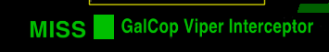
Installing additional equipment will allow you to keep a target lock with one missile while target seeking with another.
Mods may add additional pylon-based equipment for purchase. See the mod documentation for more information.

10 | Fuel Scoop
The Fuel Scoop icon will be added to the HUD when one is fitted to the ship. When the fuel scoop is active, the icon strobes. If the tail of the icon becomes red, then your cargo bay is full and any new object scooped will be destroyed.

11 | Station Aegis
The Station Aegis is the area of space around a GCW station where its Vipers will provide protection to your ship should you come under attack.

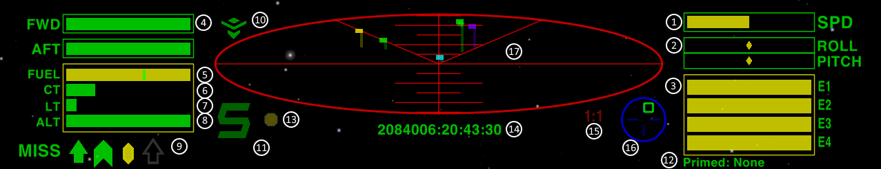  12 | Primed Equipment
Displays currently primed OXP equipment, which can be activated with the “b” and “n” keys. See page 6 “MFDs and Primable Equipment” for more information.
13 | Threat Indicator
This is an indicator showing the current level of risk to your ship. When green, there are no other ships within scanner range. Yellow indicates that there are objects within scanner range. When the indicator turns red, other ships have targeted you.

14 | Date and Time
The current date and time, set to Galactic Cooperative of Worlds Mean Time.

15 | Scanner Zoom
The zoom ratio displays the current magnification setting of the IFF scanner.

16 | Space Compass
The Space Compass shows the direction of the target relative to the direction of the ship. The default target of the space compass is the planet. When inside the GCW Station Aegis, the compass will target the station.
Fore |  | Target position relative to the ship | Aft
 |  | Planet
 |  | Sun †
 |  | GCW Stations †
 |  | Navigation beacon †
 |  | Witchspace beacon †
 |  | Active target †
Additional compass targets may become available with the installation of mods. Refer to the individual mod documentation for more information.
† In order for stations to become manually selectable the Advanced Space Compass equipment is required to be installed.

17 | IFF Scanner
The IFF Scanner Grid shows the relative positions of all objects within scanner range of the ship. The V lines show which direction you are currently viewing. The rule lines show the scale the scanner is working in.
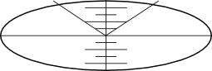 |  | 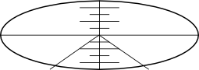
Forward (front) View |  | Aft (rear) View
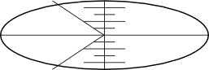 |  | 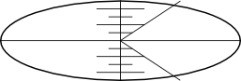
Port (left) View |  | Starboard (right) View
Each object is represented by a colour-coded flag and pole. The length and position of the flag pole represents the object’s direction and distance from your ship. The flag’s position on the pole indicates whether the object is above or below your ship.
 | Non-powered objects ¹
 | Civilian craft
 | Hostile craft
 | Police/Government craft
 | Police/Government craft on intercept
 | Thargoid craft
 | Missile ²
 | Mine about to detonate ²
 | Space stations and other anchorages
 | Navigation and witchpoint beacons
 | Witchspace cloud
The twin colour flags are the colours that those IFF flags cycle through.
1 | Non-powered objects include asteroids, cargo pods, escape pods, and abandoned craft.
2 | Certain OXPs will add extra types of munitions to Oolite. The game will use the missile or mine IFF flag to show them.
Note: The layout shown here is for the Faulcon deLacy Cobra Mk III which you are issued with at the start of the game. Other vessels may have alternative instrument configurations.

Equipment Guide
Item | TL | Cost ₢
Advanced Navigational Array (ANA) | 7 | 2250
Advanced Space Compass (ASC) | 8 | 650
Beam Laser | 5 | 1000
Docking Computers (DC) | 10 | 1500
ECM Hardened Missile | 10 | 350
ECM System (ECM) | 3 | 600
Escape Pod (EP) | 7 | 1000
External Heat Shielding (HS) | 5 | 1500
Extra Energy Unit (EU) | 9 | 1500
Fuel | All | Varies
Fuel Scoop (FS) | 6 | 525
Galactic Hyperdrive (GH) | 11 | 5000
Integrated Targeting System (ITS) | 12 | 1500
Large Cargo Bay (LCB) | 2 | 400
Maintenance Overhaul | 7 | Varies
Military Laser | 11 | 6000
Military Shield Enhancement (MSE) | 14 | 47550
Mining Laser | 11 | 800
Missile | 2 | 30
Multi-Targeting System (MTS) | 6 | 325
Passenger Berth | 6 | 825
Pulse Laser | 4 | 400
Quirium Cascade Mine | 7 | 2500
Remove Passenger Berth | 2 | 100
Scanner Targeting Enhancement (STE) | 12 | 450
Shield Boosters (SB) | 11 | 14750
Target System Memory Expansion (TSME) | 9 | 1250
Unmount and sell all pylon-mounted weapons | 2 | 20
Witchdrive Fuel Injectors (FI) | 11 | 600
Wormhole Scanner (WS) | 10 | 2395
Equipment damage can only be repaired in systems of that Tech Level or one lower. The listed prices apply only to GCW station shipyards. Prices may vary in other anchorages. Additional equipment can be obtained by installing mods. See the individual mod documentation for more information on their cost, availability and use.

Commodities Guide
Commodities | Price ₢ |  |  | per
Commodities | Min | Avg | Max | per
Food | 2.0 | 4.8 | 7.9 | t
Textiles | 5.2 | 7.0 | 9.0 | t
Radioactives | 17.3 | 22.8 | 28.8 | t
Slaves † | 2.4 | 14.7 | 27.9 | t
Liquor/Wines | 20.7 | 28.6 | 37.4 | t
Luxuries | 78.4 | 90.8 | 101.9 | t
Narcotics † | 0.5 | 50.9 | 101.4 | t
Computers | 61.3 | 83.0 | 102.2 | t
Machinery | 46.5 | 56.4 | 65.5 | t
Alloys | 31.6 | 38.8 | 45.6 | t
Firearms † | 49.8 | 70.3 | 88.5 | t
Furs | 45.4 | 69.7 | 95.2 | t
Minerals | 10.0 | 11.9 | 13.9 | t
Gold | 35.3 | 38.7 | 42.2 | kg
Platinum | 62.6 | 71.6 | 81.0 | kg
Gem-stones | 15.3 | 19.5 | 23.8 | g
Alien Items | 21.3 | 44.8 | 65.7 | t
† Trafficking in these commodities is illegal in all GCW member systems.

Note: These prices are indicative only. GalCop regulations expressly forbids the broadcasting of actual prices beyond the current system. Prices may also vary widely at non-GCW stations.

Combat Rank
Rank | Kills
Harmless | 0
Mostly Harmless | 8
Poor | 16
Average | 32
Above Average | 64
Competent | 128
Dangerous | 512
Deadly | 2560
Elite | 6400

Government Guide
Risk | Icon | Type
Negligible |  | Corporate State
▲  Low  ▼ |  | Democracy
▲  Low  ▼ |  | Confederacy
▲  Medium  ▼ |  | Communist
▲  Medium  ▼ |  | Dictatorship
▲  High  ▼ |  | Multi-Government
▲  High  ▼ |  | Feudal
Extreme |  | Anarchy

Economy Guide
Produces | Icon | Type
Advanced technology |  | Rich Industrial
▲  Basic technology and  Advance Materials  ▼ |  | Average Industrial
▲  Basic technology and  Advance Materials  ▼ |  | Poor Industrial
▲  Mixture of both  ▼ |  | Mainly Industrial
▲  Mixture of both  ▼ |  | Mainly Agricultural
▲  Advanced organics and Refined Materials  ▼ |  | Rich Agricultural
▲  Advanced organics and Refined Materials  ▼ |  | Average Agricultural
Basic organics and  Raw Materials |  | Poor Agricultural
On the F6 chart screen, press the “?” key to cycle the highlighted information between:
- Sun color
- Economy type
- Government type
- Tech level
Legal Status
Status | The commander can expect
Clean  ▼ | Free travel and access to GCW Stations. Full protection by GalCop Vipers.
Offender  ▼ | Free travel and access to GCW Stations. Limited protection by GalCop Vipers, but could also be targeted at law enforcer's discretion. Small bounty on the commander.
Fugitive | Limited travel and access to GCW Stations. Actively targeted by GalCop Vipers. Large bounty on the commander.
All commanders start as Clean, with any criminal acts reducing their legal standing. Performing services for the GCW will repair their reputation.

GCW Orbital Laws
Services
Defence Of GCW Space
Providing assistance to the Galactic Navy by the destruction of Thargoid Invasion Fleet craft.
Space Lane Hazard Clearance
Destruction of navigation hazards from the space lanes, i.e. asteroids and wreckage.
Termination Of Criminals
Providing assistance to GalCop by the destruction of Offender and Fugitive rated craft.
Crimes
Murder
The destruction of any law-abiding vessel with the resulting loss of life.
Piracy
Attacking any law-abiding craft to force them to discharge cargo.
Property Destruction
Attacking a Galactic Cooperative of Worlds Station, Rock Hermitage or other anchorages.
Trafficking
Leaving a GCW station with any of the following commodities on-board: Slaves, Narcotics or Firearms.

Game Settings
Autosave – on / off
Automatically saves your game as ‘autosave’ before you leave a GCW Station.
Docking Clearance Protocol – on / off
Enables docking clearance requests for GCW stations (and some OXP stations)
Music – off / on
Turns the in-game music on and off.
Sound Volume – sliding scale
Volume slider controls both in-game music and sound effects.
Spoken Messages – off / on
Makes the computer read all messages. (if “on”, Voice and Gender options are available)
Full Screen Mode width x height
Rotate through screen resolutions choices for full screen mode.
Play in Window / Full Screen
Toggle between playing the game in the full screen or a window.
HDR Max Brightness (nits) - value
HDR Mode only. Max brightness monitor is able to produce.
HDR Paper White Brightness (nits) – sliding scale
HDR mode only. Controls how bright a paper white surface should be.
Wireframe Graphics – on / off
Play Oolite with visuals reminiscent of the original Elite. This visual style does not alter the game speed.
Graphics Detail – minimum / normal / shaders / extra
Changes the levels of in-game graphics detail. Higher settings may be unavailable on old hardware, and use more processing power
Gamma – sliding scale
Adjust gamma setting for Oolite to suit your display hardware.
Field Of View – sliding scale, in degrees
Adjust field of view of your viewscreen, value range 30-80.
Colorblind Mode – None / Protanopia / Deuteranopia / Tritanopia
Available when “Graphics Detail” set to “Shaders” or “Extra detail”. Adjusts the colors of the game to help colorblind players see things more clearly.
Joystick Configuration
Assign most game actions to your joystick.
Keyboard Configuration
Reassign any game actions to keys on your keyboard.
Joystick Flight Controls
Propulsion
Roll
Direction axis for roll anti/clockwise.
Pitch
Direction axis for dive/climb.
Yaw
Direction axis for turn left/right.
Increase / Decrease thrust
Buttons or direction axis to fly faster or slower.
Fuel injection
Button to activate the Witchspace Fuel Injectors.
Torus drive
Button to activate the Torus drive hyperspeed system.
Witchspace jump
Button to initiate a witchspace jump.
Galactive jump
Button to initiate a galactic jump.
Roll/pitch precision toggle
Button to toggle the degree of thrust relative to angle of the joystick.
Navigation
Next / Previous compass target
Buttons to select the next/previous space compass target.
Zoom scanner
Button to zoom out the scanner.
Unzoom scanner
Button to reset the scanner zoom factor.
Forward / aft / port / starboard view
Buttons or axes to change the view screen direction.
Cycle external views
Button to cycle the available external views.
Ident system
Button to activate the ID Recognition System.
Request docking clearance
Button to request docking clearance from a station.
Docking computer
Button to activate/deactivate the docking computer.
Fast docking
Button to activate the fast docking computer.
Toggle docking music on/off
Button to turn on/off the docking music.
Offensive
Weapons toggle
Button to toggle weapons online/offline.
Fire laser
Button to fire the energy weapon.
Fire missile/bomb
Button to fire currently active pylon-mounted weapon or equipment.
Arm missile/bomb
Button to activate / target seek currently highlighted pylon-mounted weapon or equipment.
Disarm missile/bomb
Button to deactivate highlighted pylon-mounted weapon or equipment.
Target incoming missile
Button to automatically target the incoming missile nearest to the player ship.
Select next missile/bomb
Button to rotate through the available range of pylon-mounted weapons or equipments.
Next / Previous target
Buttons to cycle to next/previous target.
Defensive
ECM
Button to activate the Electronic Counter-Measure Systems.
Dump cargo
Button to dump one cargo canister
Rotate cargo
Button to rotate through the manifest
Escape pod
Button to activate the Escape Pod, if installed. Requires fast double press.
Special equipment
Select next / previous MFD
Buttons to select the next/previous MFD.
Cycle next / previous MFD
Buttons to cycle to the next/previous MFD display.
Prime next / previous equipment
Buttons to cycle through selectable equipment.
Activate equipment
Button to activate primed selectable equipment.
Set equipment mode
Button to change the mode of the primed equipment.
Fast-activate first equipment item
Button to fast-activate the first equipment item.
Fast-activate second equipment item
Button to fast-activate the second equipment item.
Miscellaneous
Take Snapshot
Button to capture a screen shot
Pause
Button to pause the game.
Toggle HUD
Button to toggle the HUD on/off.
Comms log
Button to view the comms log.
Mouse Flight Controls
Fly by mouse control is only available when the game is in Full Screen mode.
Move Mouse Up and Down
Ship dives and climbs.
Move Mouse Left and Right
Roll anticlockwise and clockwise.
Left Mouse Button
Fire primary weapon.
Right Mouse Button
Zero flight roll and pitch.
Mouse Wheel Up
Increase speed
Mouse Wheel Down
Decrease speed
With Caps Lock active and Left Mouse Button down: on external views
Move Mouse Up and Down
External Camera rotates Up / Down
Move Mouse Left and Right
External Camera rotates Left / Right
With Caps Lock active on external views
Mouse Wheel Up
Zoom View In
Mouse Wheel Down
Zoom View Out

Career Choices
Bounty Hunting
Collect bounties for pirate/fugitive craft destroyed. Bounties are also paid if you capture/rescue the escape pods of the criminals/victims.
No additional equipment required. Recommend minimum of: Beam Laser, ECM, Fuel Scoop and Shield Booster be fitted before attempting this profession.
Carrier Service
With a big enough ship you can get paid for moving someone else’s bulk goods from A to B. Contracts are available through the Interfaces screen.
Requires a ship with larger cargo bays. Recommend an Advanced Navigation Array be fitted.
Mining
Blast asteroids, scoop up the fragments and sell the minerals on the commodities market.
Requires a Fuel Scoop and Mining Laser. Recommend a Cargo Bay Expansion be fitted.
Passenger or Courier Service
With a passenger berth fitted, you take a traveller from point A to point B for profit. Small packages may also be carried without requiring extra equipment. Contracts are available through the Interfaces screen.
May require a Passenger Berth. Recommend an Advanced Navigation Array be fitted.
Piracy
Attack other ships and steal their cargo, which will make you a fugitive very quickly. You will then have GalCop, bounty hunters and opportunist commanders after you.
Requires a Fuel Scoop and upgraded combat systems. Recommend fitting an Escape Pod.
Trading
Buy low-priced commodities on one world and sell at a higher price on another.
No additional equipment required. Recommend a Cargo Bay Expansion be fitted.
Trafficking In Illegal Goods
Illegal goods can be traded for massive profit. Doing so will eventually make you a fugitive and limit the systems you can trade in.
No additional equipment required. Recommend a Cargo Bay Expansion and upgraded combat systems be fitted.
Additional careers can be added by installing mods.
Refer to the Oolite Wiki for more details.
Expansion Pack Manager
The Expansion Pack Manager is accessed from the main game menu, and provides easy access to hundreds of Oolite mods that have been created by community members over a number of years. However, please note that these mods are not endorsed or vetted by the Oolite development team. They are provided “as-is”, with no warranty or guarantee whatsoever. Care should be taken to read all the documentation for each mod to fully understand the changes it will make to the game and your playing experience.
Guide to colors
The color of the various expansions in the list is used to indicate the following:
Yellow |  |  | Ready to download and install
White |  |  | Installed and at the current version
Cyan |  |  | Installed; updated mod available for download.
Orange |  |  | Ready to download, but Oolite will also download extra mods to make it work.
Brown |  |  | Conflicts with an already installed mod.
Gray |  |  | Incompatible with this version of Oolite.
Red |  |  | Manually installed: cannot also be installed automatically (eg. a tweaked mod in the AddOns folder)
Blue |  |  | Installed but no longer available for download.
Special key controls
The following keys perform special functions within the Expansion Pack Manager
F |  | Filter sets. Allows custom filter to be applied to list.
I |  | Display information about the mod.  Additionally, copies the URL to the clipboard so it can be pasted into a browser.
X |  | Extracts mod content to the AddOns folder.  Folder will initially have an extension of “.off”.  Change this to “.oxp” to enable it.
Frequently Asked Questions
Q: Where is my log file?
A: While Oolite Runs, various diagnostic information is written to a file called Latest.log. Where that file is located depends on your operating system:
Windows: In Oolite’s folder (typically in C:\Oolite), there is a folder called oolite.app, which contains a folder called Logs. A shortcut to this folder is created at Oolite's Start Menu entries during installation.

Linux and other Unix-like systems: ~/.Oolite/Logs (that is, in the hidden folder .Oolite in your home folder). If you’re using Nautilus or Konqueror—if you’ve never heard of them, you probably are—select Show Hidden Files from the View menu.
Q: Why do none of the mods I have installed appear to work in the game?
A: Check you do not have Oolite in “Strict Play” mode. Also, make sure any mods you have added manually to the AddOns folder have an extension of “.oxp”.
Q: I made a tweak to one of the expansions I added, but the tweak hasn’t been applied in game?
A: After making a change to an expansion pack, make sure to hold down the right shift key when starting the game, and hold it until you see the spinning Cobra. This will force Oolite to rebuild its game cache, thus applying your change to the game files.
Q: I am getting destroyed by pirates everywhere I go!
A: Make sure to avoid dangerous systems if you aren’t prepared for them. Pirates will generally demand some cargo from you, so always keep some cheap cargo on hand which you can eject when asked.
Watch out for parcel or passenger contracts that have a higher than normal payout as they might attract unwanted attention. They might also require you to travel through dangerous systems.
For more detailed information on combat tactics and dealing with pirates, visit this page on the wiki: https://wiki.alioth.net/index.php/Oolite_Tactics
Frequently Asked Questions
Q: I keep crashing when trying to dock!
A: Make sure to use the navigation beacon in front of the docking port to help with lining up your ship. Keep the docking port centred in your front view, and the navigation beacon centred in your rear view. Match the rotation of the station and accelerate slowly towards the dock. When you enter the dock, keep moving forwards towards the back wall of the dock until the docking animation appears.
For more detailed discussions on docking methods, please visit the wiki, and in particular, this page: https://wiki.alioth.net/index.php/How_to_Dock
Q: It takes a *long* time to travel to the station after arriving in a new system!
A: Yes it does. However, if there are no powered ships in scanner range, you can make use of the torus drive, which can be activated by pressing the “J” key. The system will speed up the flight time considerably, but will auto-disengage whenever another ship comes inside scanner range. Which will occur frequently because most ships are travelling along the direct route from the witchpoint beacon to the planet and main station. But that doesn’t mean you have to. Flying at right angles a short distance away from the main route will put you out of the way of most ships and allow your torus drive to operate for longer periods without interruption.

MFDs

MFDs, or Multi-function displays, are a part of the HUD that can show additional information to the player. Mods are the primary way MFDs are used, and each mod will use them in different ways - you will need to check the documentation for each mod to learn about what information will be displayed.

Each HUD can define multiple MFD positions or slots, and the content of each MFD can be cycled through the available options. For the default HUD, there are 2 MFD slots defined: slot 1 being located in the top left of the screen, and slot 2 in the top right of the screen.

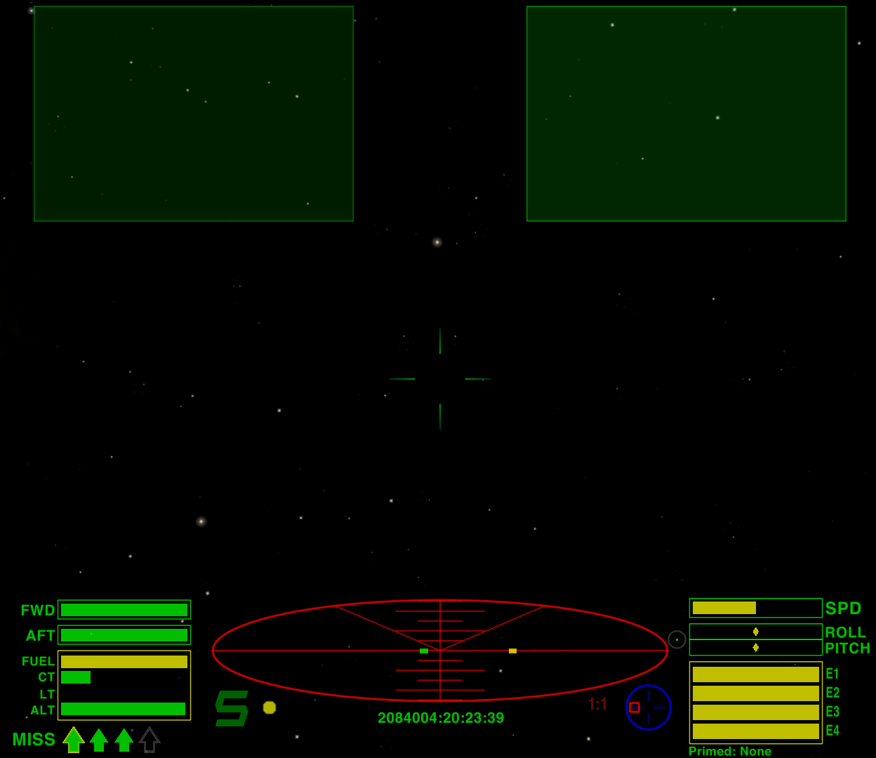
Each MFD slot can be made active in turn, but only one MFD slot can be active at any one time.

To activate an MFD slot, use the ":" key. Press the key multiple times to move through all the MFD positions. As each position is activated, a console message will appear on your HUD indicating which MFD slot has just become active.

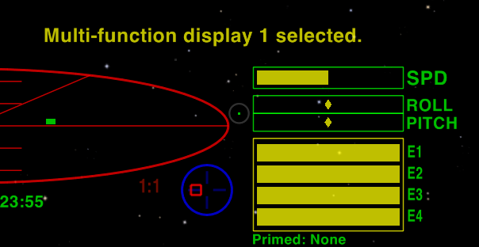
To move in reverse order through the MFD slots, use the Ctrl + ":" key combination.

To cycle through the available content for an MFD slot, use the ";" key. The initial display of any MFD slot is blank. As you cycle through the available content options, eventually you will return to the blank item. The available content will be defined by what mods are installed and what equipment items have been purchased by the player.

To cycle in reverse order through the available content for an MFD slot, use the Ctrl + ";" key combination.

Primable equipment

Some mods will give the player custom equipment that can be activated and used in flight. If the activation of the equipment is not automatic (that is, based on some condition or situation) then it is likely a piece of primable equipment has been installed on the player's ship so it can be manually activated.

On the default HUD, the currently primed equipment is displayed on the bottom right of the screen, below the energy banks. If there are no primable equipment items installed, nothing will be displayed in this position. If there are some available, the text "Primed: None" will initially be shown.


To "prime" a piece of equipment, use the Shift + "N" key combination. If there are several pieces of equipment installed, you may have to press the combination multiple times until the desired equipment is primed. As each piece of equipment is primed, a console message will appear on your HUD indicating what equipment has been primed, and the currently primed equipment will be displayed at the bottom of the screen.

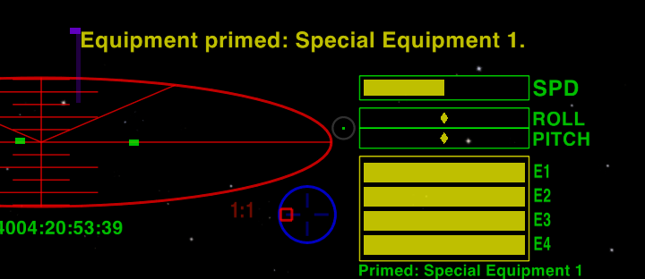
To move in reverse order through the primable equipment, use the Ctrl + Shift + "N" key combination.

Once primed, there are two functions keys available to a piece of equipment. The "mode" function is called by pressing the "b" key, and the "activate" function is called by pressing the "n" key. As these functions can be used in a variety of different ways, it is important to read the documentation for each equipment item to learn how the functions are utilised.
Fast activation

Along with the standard priming and activation methods described above, 2 keys have been allocated to directly execute the activation function of a particular piece of primable equipment. The first is the "0" key, the second is the "Tab" key. In essence, once configured, these keys allow the player to bypass the need to prime an equipment item individually in order to activate it.

To set up what equipment is assigned to each key, you will need to be docked at a station and then go to the F4 "Available Interfaces" screen, and select the "Manage primable equipment" option.

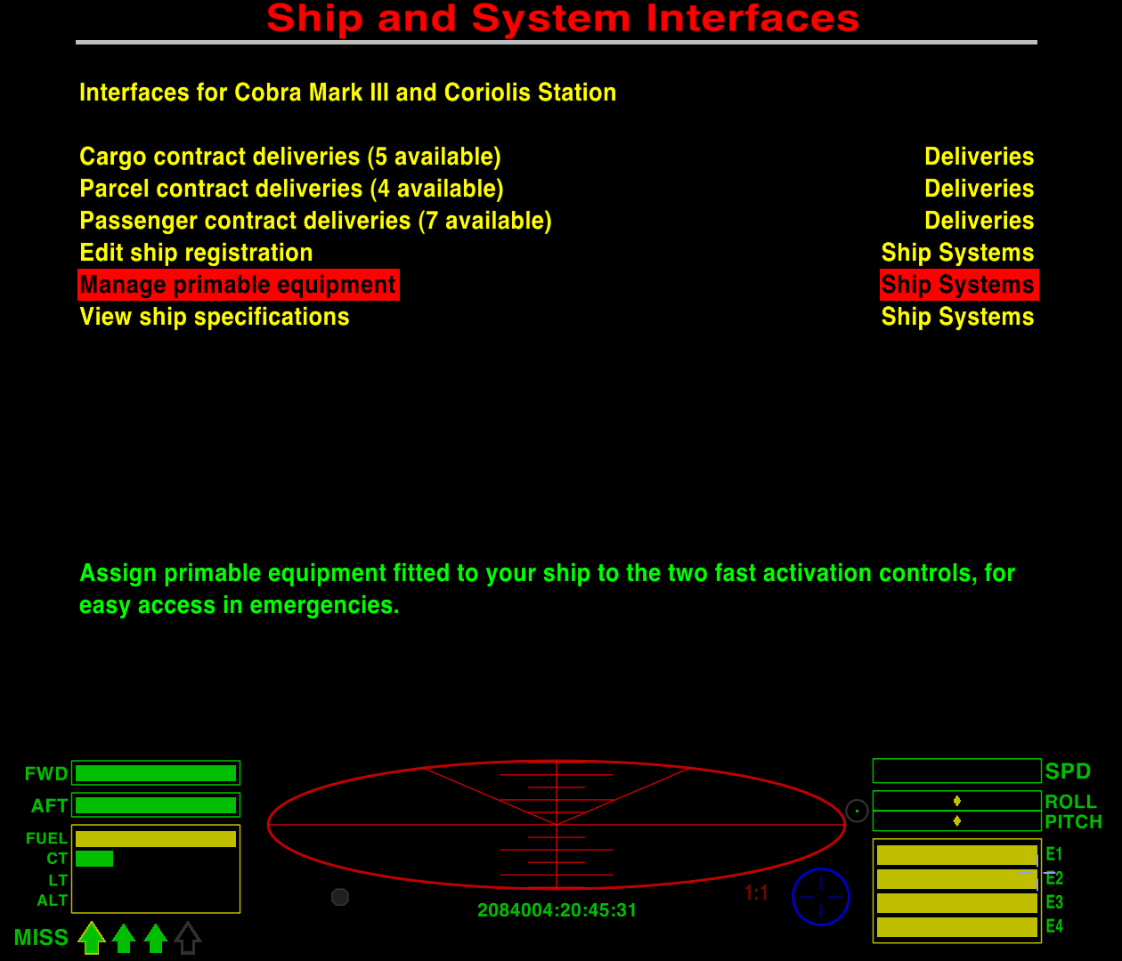
When selected, you will be asked what equipment should be allocated to the "0" key.

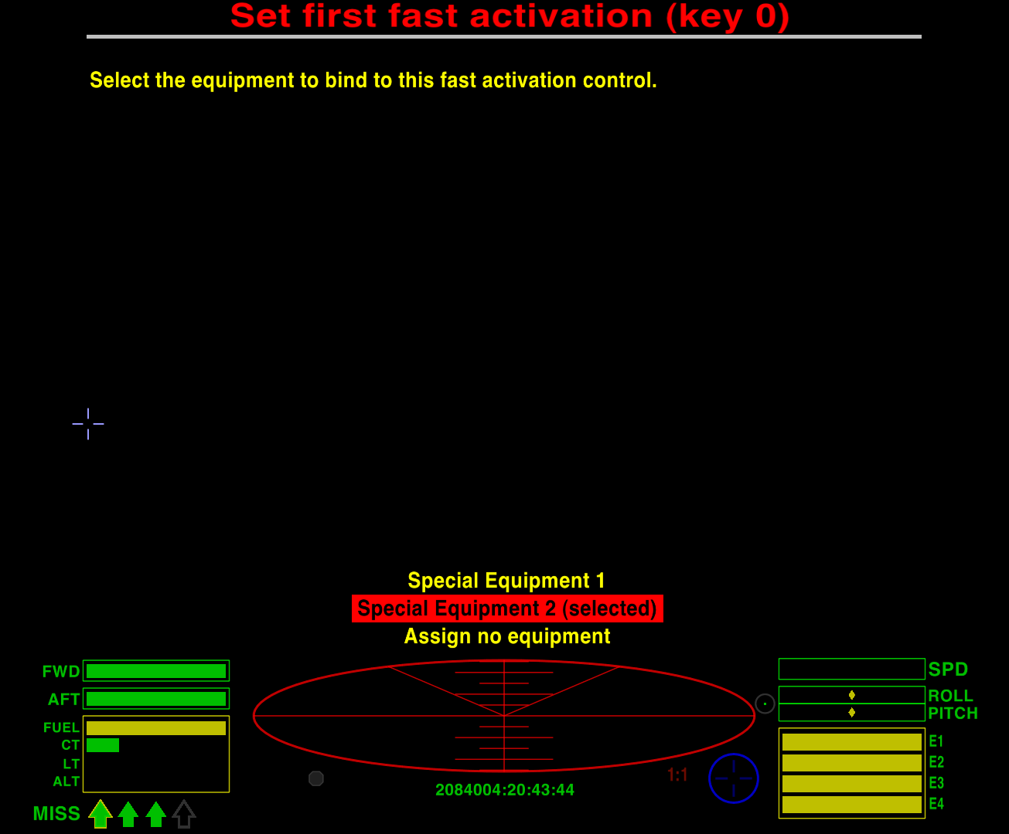

This will be followed by what equipment should be allocated to the "Tab" key.

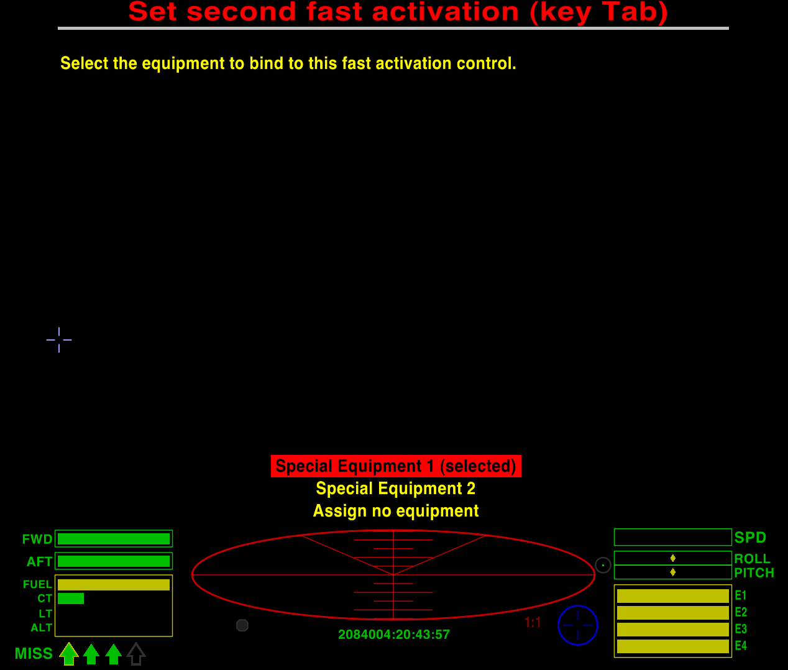
After both equipment items have been selected, the new arrangement will be displayed as confirmation.

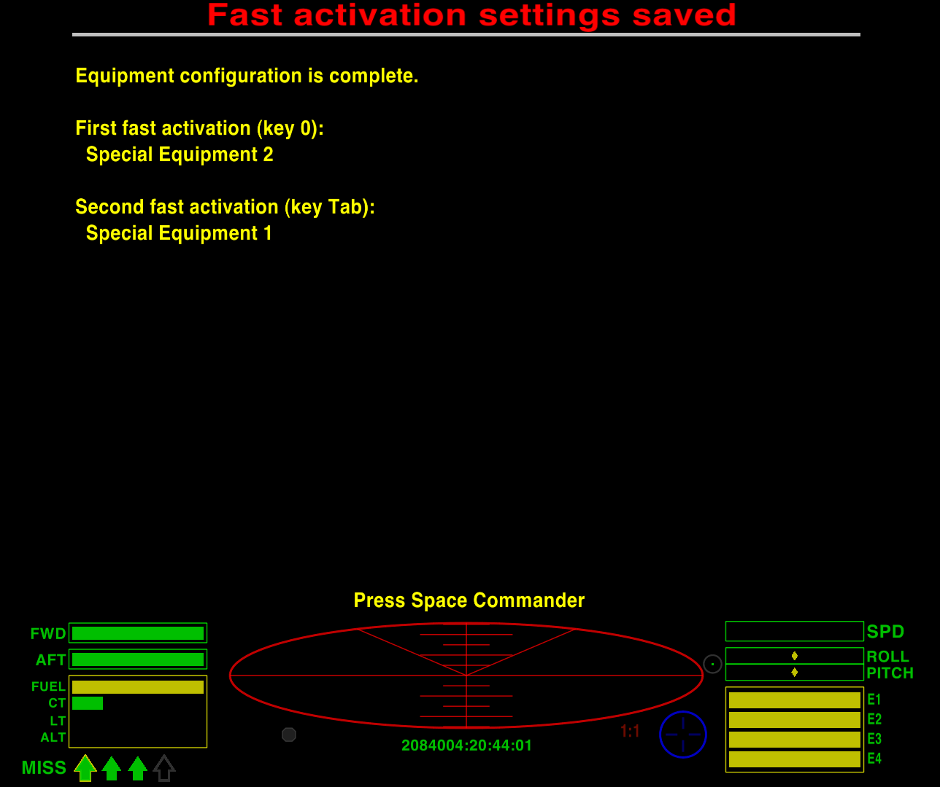
Custom keys for mod equipment

To avoid the need to prime individual equipment items to make use of its functions, after you have purchased a new piece of primable equipment, you can go to the Keyboard configuration screen in the Game options menu, and allocate individual keys to the “mode” and “activate” functions of the equipment.
Adder |  |  | 30w x 8h x 45l m
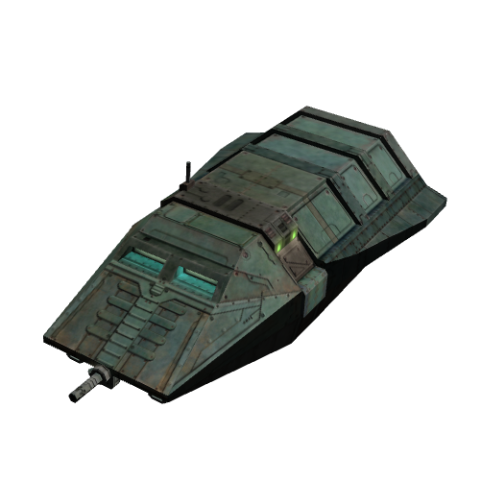 | Speed/Thrust (lm) | 0.24/0.030 | Banks & Charge | C20
 | Roll & Pitch | NJ | Weapon Mounts | F M1
 | Cargo Space (t) | 2 | Hyperspace | yes
 | Sold at Tech Level | 5 | Base Price (cr) | 65000
 | Base Equipment | Pulse Laser, 1 Missile, HS
An agile compact ship favoured by couriers, customisers and professional racers.
Anaconda |  |  | 75w x 60h x 170l m
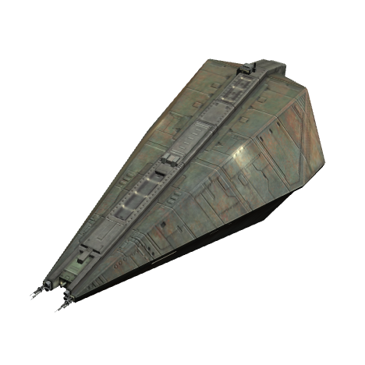 | Speed/Thrust (lm) | 0.14/0.014 | Banks & Charge | P30
 | Roll & Pitch | DB | Weapon Mounts | All M7
 | Cargo Space (t) | 750 | Hyperspace | yes
 | Sold at Tech Level | 9 | Base Price (cr) | 650000
 | Base Equipment | Pulse Laser, 3 Missiles
The biggest mass produced freighter available, built like an asteroid and steers like one.
Asp Mk II |  |  | 65w x 20h x 70l m
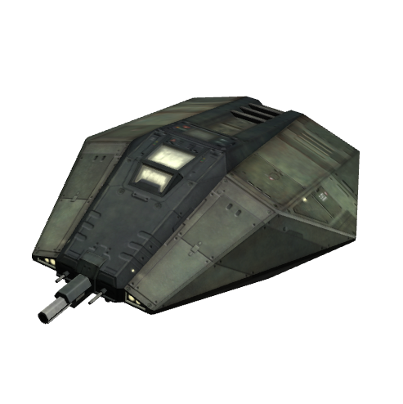 | Speed/Thrust (lm) | 0.40/0.050 | Banks & Charge | P30
 | Roll & Pitch | JE | Weapon Mounts | FA M1
 | Cargo Space (t) | N/A | Hyperspace | yes
 | Sold at Tech Level | 11 | Base Price (cr) | 375000
 | Base Equipment | Pulse Laser, 1 Missile
The civilian version of the Galactic Navy’s premier long range scouting / commando craft.
Boa |  |  | 65w x 60h x 115l m
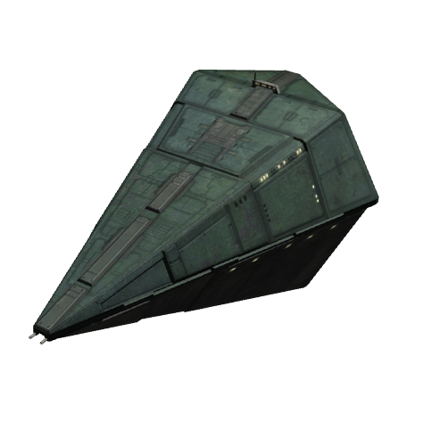 | Speed/Thrust (lm) | 0.24/0.036 | Banks & Charge | P30
 | Roll & Pitch | NE | Weapon Mounts | All M4
 | Cargo Space (t) | 125 | Hyperspace | yes
 | Sold at Tech Level | 7 | Base Price (cr) | 450000
 | Base Equipment | Pulse Laser, 3 Missiles
The replacement for the ageing Python, with better performance and capacity.
Boa Cruiser / Mk II |  |  | 65w x 60h x 115l m
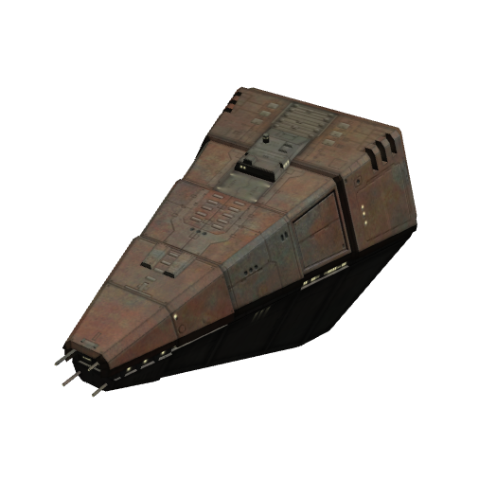 | Speed/Thrust (lm) | 0.31/0.040 | Banks & Charge | P32
 | Roll & Pitch | LE | Weapon Mounts | All M5
 | Cargo Space (t) | 175 | Hyperspace | yes
 | Sold at Tech Level | 8 | Base Price (cr) | 495000
 | Base Equipment | Beam Laser, 5 Missiles
The long haul version of the Boa, trading some agility for more capacity and speed.
Cobra Mk I |  |  | 70w x 15h x 55l m
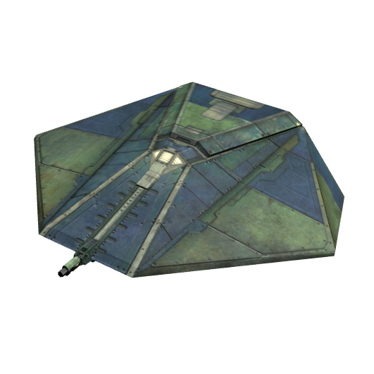 | Speed/Thrust (lm) | 0.26/0.025 | Banks & Charge | E25
 | Roll & Pitch | JF | Weapon Mounts | FA M1
 | Cargo Space (t) | 10 | Hyperspace | yes
 | Sold at Tech Level | 5 | Base Price (cr) | 100000
 | Base Equipment | Pulse Laser, 1 Missile
The first truly effective solo fighter/trader ship, but now superseded by the Mk III.
Cobra Mk III |  |  | 130w x 30h x 65l m
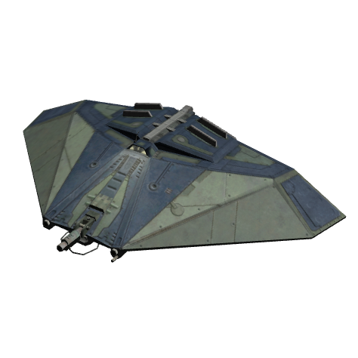 | Speed/Thrust (lm) | 0.35/0.032 | Banks & Charge | H40
 | Roll & Pitch | JE | Weapon Mounts | All M4
 | Cargo Space (t) | 20 (+15) | Hyperspace | yes
 | Sold at Tech Level | 7 | Base Price (cr) | 150000
 | Base Equipment | Pulse Laser, 3 Missiles
The most successful medium size ship ever built and an excellent fighter/trader.
Constrictor † |  |  | 54w x 10h x 60l m
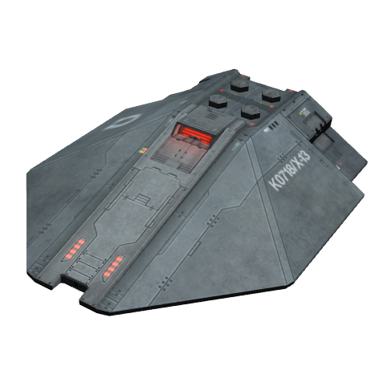 | Speed/Thrust (lm) | Unknown | Banks & Charge | ?
 | Roll & Pitch | Unknown | Weapon Mounts | ?
 | Cargo Space (t) | Unknown | Hyperspace | yes
 | Sold at Tech Level | N/A | Base Price (cr) | N/A
 | Base Equipment | Unknown
Currently under test by the Galactic Navy, the rumours say it’s extremely deadly.
Escape Pod |  |  | 7w x 6h x 6l m
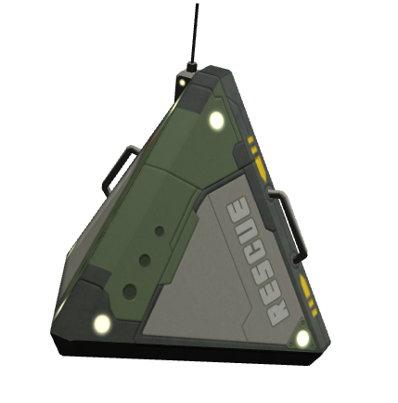 | Speed/Thrust (lm) | 0.05/0.005 | Banks & Charge | P30
 | Roll & Pitch | AA | Weapon Mounts | N/A
 | Cargo Space (t) | N/A | Hyperspace | no
 | Sold at Tech Level | 7 | Base Price (cr) | 1000
 | Base Equipment | N/A
Only technically a ship, the Escape Pod is the primary lifeboat system of GCW ships.
Fer-de-Lance |  |  | 45w x 20h x 85l m
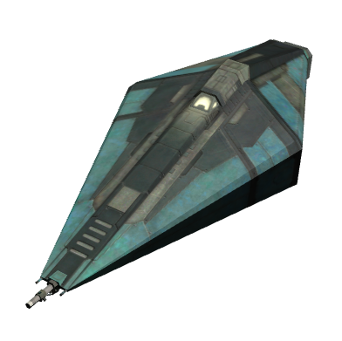 | Speed/Thrust (lm) | 0.30/0.036 | Banks & Charge | H45
 | Roll & Pitch | RE | Weapon Mounts | All M2
 | Cargo Space (t) | 12 | Hyperspace | yes
 | Sold at Tech Level | 9 | Base Price (cr) | 485000
 | Base Equipment | Beam Laser, 2 Missiles, 2 Passenger Berths, MTS, STE, ECM, ASC, FI, FS, DC, SB, EP
An agile and deadly assault class ship favoured by bounty hunters and the well-to-do.
Gecko † |  |  | 65w x 12h x 40l m
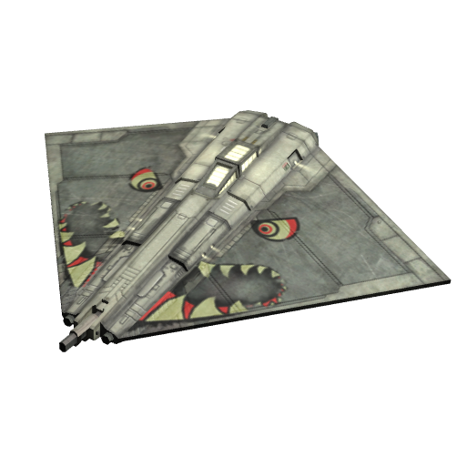 | Speed/Thrust (lm) | 0.30/0.045 | Banks & Charge | H40
 | Roll & Pitch | OG | Weapon Mounts | F M1
 | Cargo Space (t) | 3 | Hyperspace | no
 | Sold at Tech Level | N/A | Base Price (cr) | N/A
 | Base Equipment | Beam Laser, 1 Missile
Produced in unlicensed shipyards, this fighter is a favourite of pirates and assassins.
Krait † |  |  | 90w x 20h x 80l m
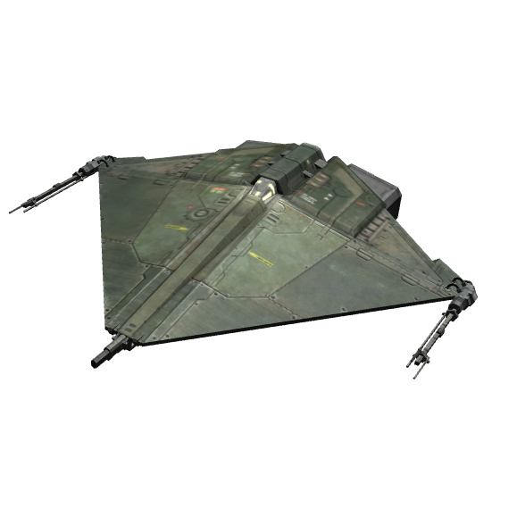 | Speed/Thrust (lm) | 0.30/0.035 | Banks & Charge | H25
 | Roll & Pitch | MG | Weapon Mounts | F M0
 | Cargo Space (t) | 2 | Hyperspace | no
 | Sold at Tech Level | N/A | Base Price (cr) | N/A
 | Base Equipment | Beam Laser
A discontinued fighter design finding a new life in the professional racing circuit.
Mamba † |  |  | 65w x 12h x 55l m
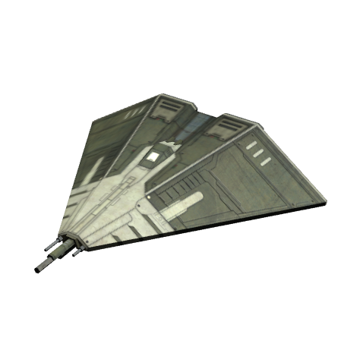 | Speed/Thrust (lm) | 0.32/0.032 | Banks & Charge | H30
 | Roll & Pitch | JG | Weapon Mounts | F M0
 | Cargo Space (t) | 4 | Hyperspace | no
 | Sold at Tech Level | N/A | Base Price (cr) | N/A
 | Base Equipment | Beam Laser
Originally used in professional racing, this fighter is used by pirates and escorts alike.
Moray Star Boat |  |  | 60w x 25h x 65l m
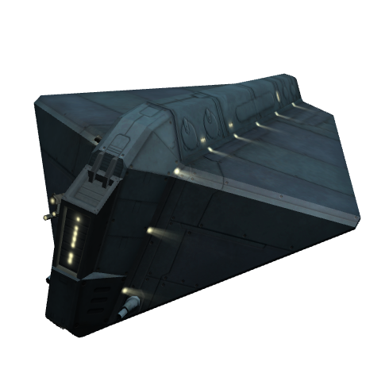 | Speed/Thrust (lm) | 0.30/0.032 | Banks & Charge | H30
 | Roll & Pitch | JG | Weapon Mounts | All M2
 | Cargo Space (t) | 7 | Hyperspace | yes
 | Sold at Tech Level | 6 | Base Price (cr) | 125000
 | Base Equipment | Pulse Laser, 2 Missiles, HS
A multi-role ship, often seen as a medical or tourist craft. It’s popular with pirates too.
Moray Medical Boat |  |  | 60w x 25h x 65l m
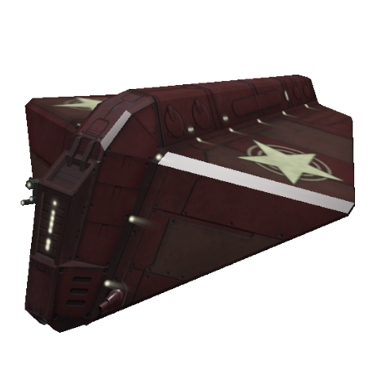 | Speed/Thrust (lm) | 0.30/0.032 | Banks & Charge | H30
 | Roll & Pitch | JG | Weapon Mounts | F M2
 | Cargo Space (t) | 7 (+15) | Hyperspace | yes
 | Sold at Tech Level | 6 | Base Price (cr) | 145000
 | Base Equipment | HS
Largely used for medical applications, standard model comes with no offensive capbilities.
Orbital Shuttle † |  |  | 20w x 20h x 35l m
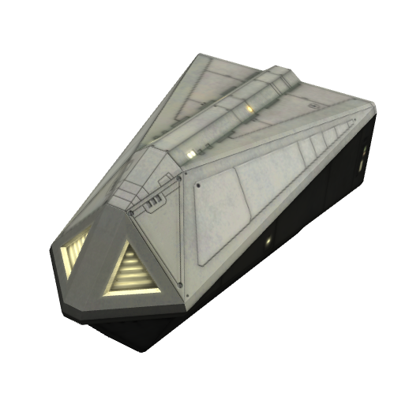 | Speed/Thrust (lm) | 0.08/0.016 | Banks & Charge | D10
 | Roll & Pitch | JD | Weapon Mounts | N/A
 | Cargo Space (t) | 30 | Hyperspace | no
 | Sold at Tech Level | N/A | Base Price (cr) | N/A
 | Base Equipment | None
Often unmanned, this ship is the GCW’s primary in-system heavy cargo hauler.
Python |  |  | 80w x 40h x 130l m
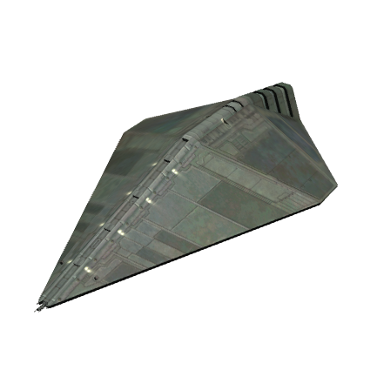 | Speed/Thrust (lm) | 0.20/0.020 | Banks & Charge | N25
 | Roll & Pitch | JD | Weapon Mounts | All M2
 | Cargo Space (t) | 100 (+15) | Hyperspace | yes
 | Sold at Tech Level | 5 | Base Price (cr) | 200000
 | Base Equipment | Pulse Laser, 1 Missile
An ageing design that’s still popular with commanders needing a simple robust freighter.
Sidewinder Scout Ship † |  |  | 65w x 15h x 35l m
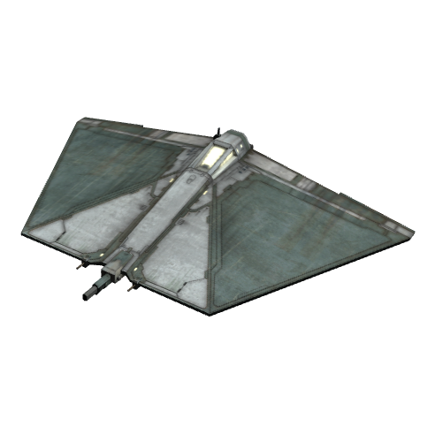 | Speed/Thrust (lm) | 0.37/0.037 | Banks & Charge | H25
 | Roll & Pitch | NH | Weapon Mounts | F M0
 | Cargo Space (t) | N/A | Hyperspace | no
 | Sold at Tech Level | N/A | Base Price (cr) | N/A
 | Base Equipment | Pulse Laser
A tough compact fighter popular with racers, freighter escorts and pirates alike.
Thargoid Warship † |  |  | 180w x 40h x 180l m
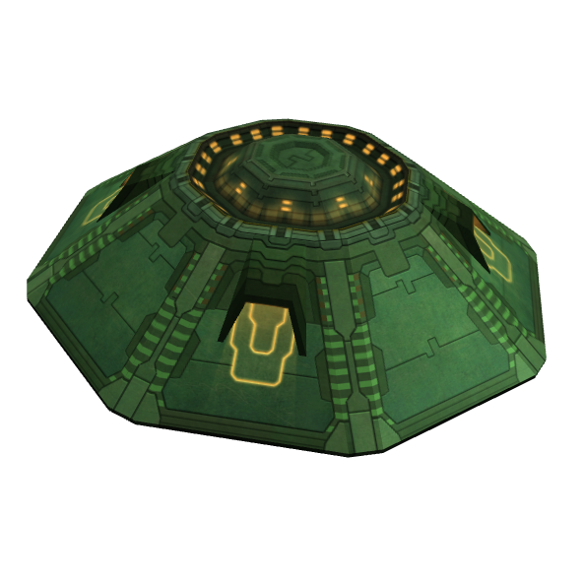 | Speed/Thrust (lm) | 0.50/0.050 | Banks & Charge | S40
 | Roll & Pitch | JE | Weapon Mounts | All M5
 | Cargo Space (t) | N/A | Hyperspace | yes
 | Sold at Tech Level | N/A | Base Price (cr) | N/A
 | Base Equipment | Thargoid Laser, ECM, 5 Robotic fighters
The primary vessel of the Thargoid Invasion Fleet. Deadly and fights without fear.
Thargoid Robotic Fighter † |  |  | 38w x 9h x 36l m
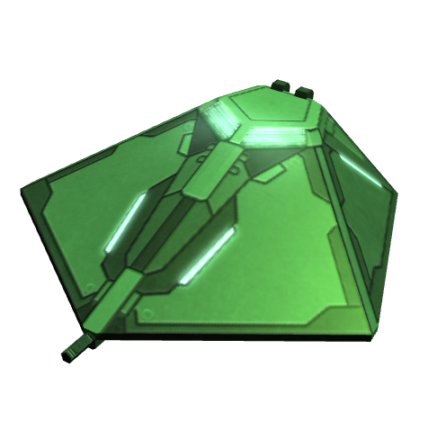 | Speed/Thrust (lm) | 0.45/0.040 | Banks & Charge | E30
 | Roll & Pitch | JE | Weapon Mounts | F M0
 | Cargo Space (t) | N/A | Hyperspace | no
 | Sold at Tech Level | N/A | Base Price (cr) | N/A
 | Base Equipment | Pulse Laser
Small remote-controlled fighters designed to swarm their victims.
Transporter † |  |  | 30w x 10h x 35l m
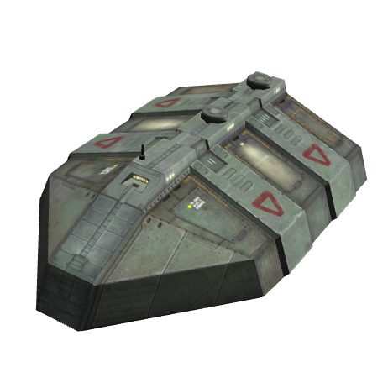 | Speed/Thrust (lm) | 0.10/0.020 | Banks & Charge | E30
 | Roll & Pitch | JE | Weapon Mounts | All M0
 | Cargo Space (t) | 12 | Hyperspace | no
 | Sold at Tech Level | N/A | Base Price (cr) | N/A
 | Base Equipment | None
Predating the GCW, this ship serves as shuttle, cargo hauler and industrial platform.
Viper † |  |  | 50w x 16h x 55l m
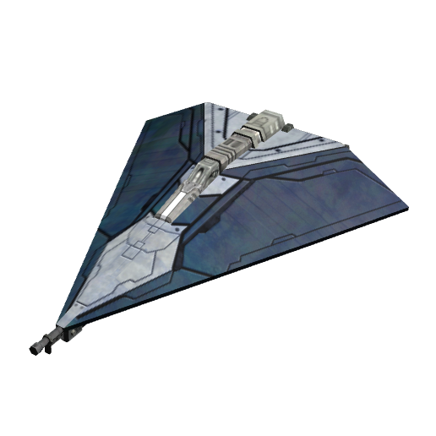 | Speed/Thrust (lm) | 0.32/0.032 | Banks & Charge | F40
 | Roll & Pitch | NI | Weapon Mounts | F M1
 | Cargo Space (t) | N/A | Hyperspace | no
 | Sold at Tech Level | N/A | Base Price (cr) | N/A
 | Base Equipment | Beam Laser, ECM, 1 Missile, EP
GalCop’s mainstay patrol vessel, capable of dealing with the most deadly threat.
Viper Interceptor † |  |  | 50w x 16h x 55l m
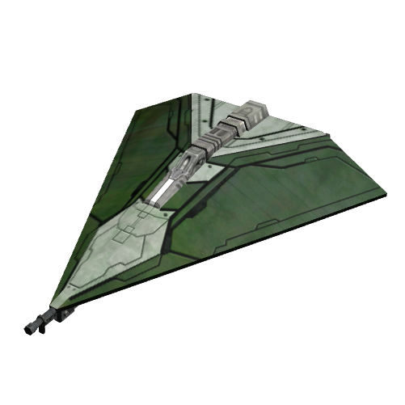 | Speed/Thrust (lm) | 0.52/0.050 | Banks & Charge | I60
 | Roll & Pitch | UJ | Weapon Mounts | F M3
 | Cargo Space (t) | N/A | Hyperspace | yes
 | Sold at Tech Level | N/A | Base Price (cr) | N/A
 | Base Equipment | Military Laser, ECM, 3 Missiles, EP
GalCop’s best pilots fly these ships to fight threats of an interstellar scale.
Worm † |  |  |  |  | 35w x 12h x 35l m
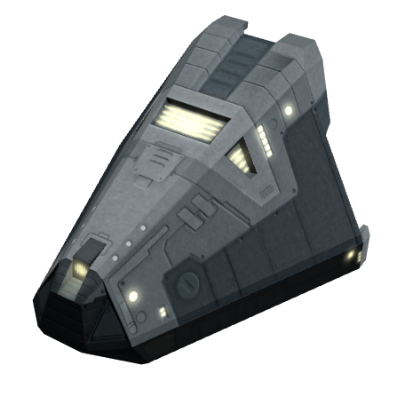 |  | Speed/Thrust (lm) |  | 0.11/0.012 | Banks & Charge |  | C20
 |  | Roll & Pitch |  | JE | Weapon Mounts |  | F M0
 |  | Cargo Space (t) |  | 2 | Hyperspace |  | no
 |  | Sold at Tech Level |  | N/A | Base Price (cr) |  | N/A
 |  | Base Equipment |  | None
A simple support craft, often seen as a ship’s launch, lifeboat or miner.
Stations and Other Anchorages
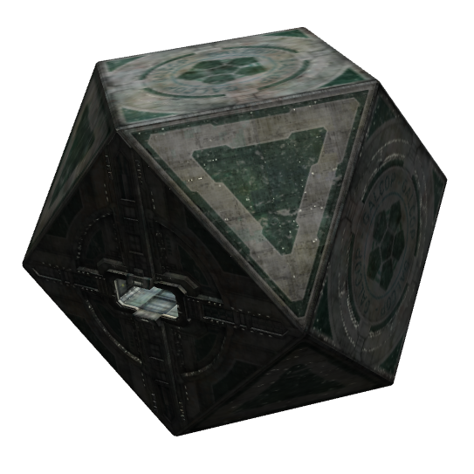 | 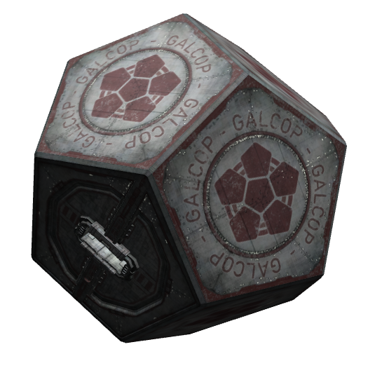 |  | 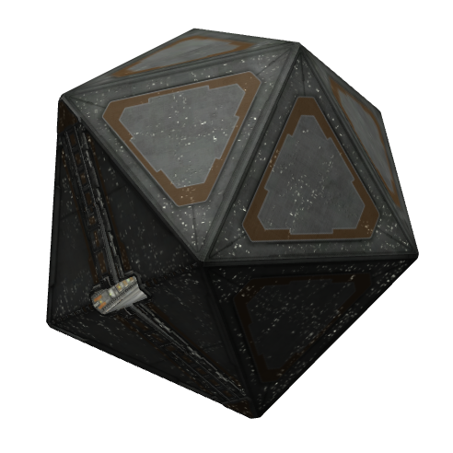 |  |  | 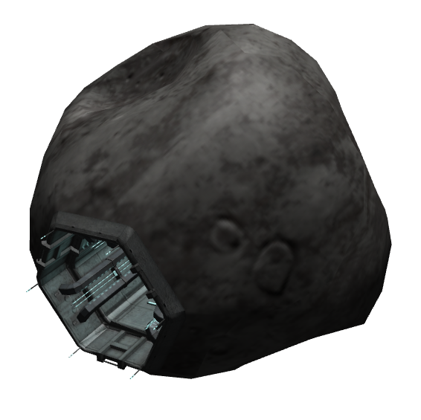
Coriolis Station | Dodecahedron Station |  | Icosahedron Station |  |  | Rock Hermit

Notes
† | Ships which are unavailable for purchase at the GCW station shipyards for the following reasons:
 | • | GCW shipyards specialise in currently manufactured models fitted with hyperspace drives.
 | • | GCW shipyards will not deal in craft from unlicensed manufacturers.
 | • | It is illegal for civilians to own Local Government, Galactic Navy and GalCop ships. It is also illegal for civilians to be in possession of craft constructed outside of the Galactic Cooperative of Worlds.
• | Speed is measured against Light Mach, which is the maximum velocity a ship can reach before suffering relativistic effects.
• | The ships’ banks and charge rate are graded on the KeZecky scale. The higher letter (A being the lowest) and number value, the larger and faster charging the energy bank is.
• | A vessel’s agility is measured using the Holdstock method. The higher value of each letter (A being the lowest) the better the performance.
• | Ships have laser mounts in the Forward, Aft, or All view screen directions. The number of pylons is shown by the M value.
• | Cargo space is measured in GCW standardised 1 TC cargo canisters.
• | The base price is calculated for craft with the base equipment fitted. Ships available for sale may be fitted with extra equipment, with a corresponding increase in price.
• | Images shown here are not to scale and measurements are listed in metres.
Other Objects
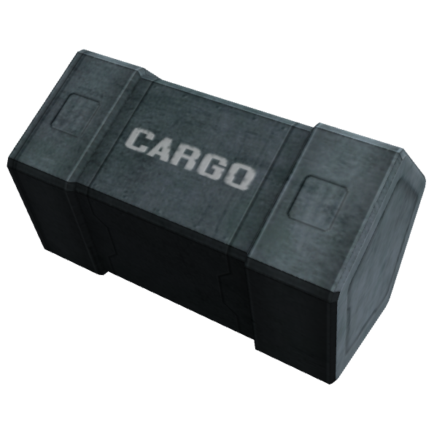 |  |  | 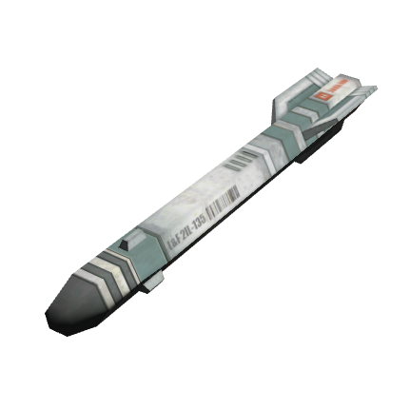 | 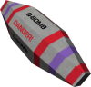
Cargo Canister |  |  | Missile | Quirium Cascade Mine
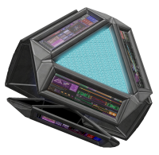 |  |  | 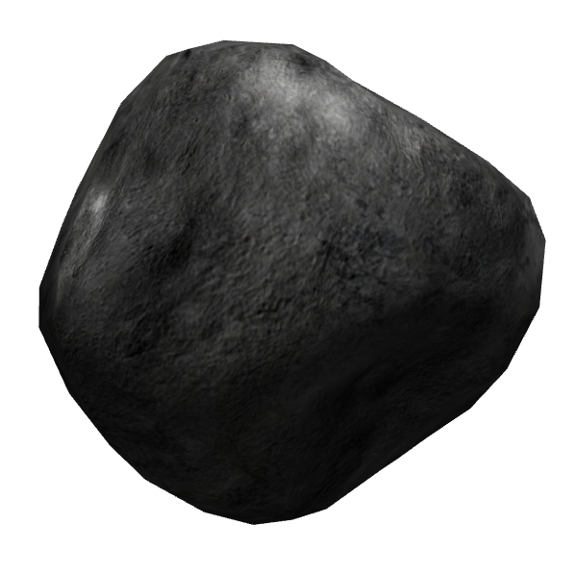 | 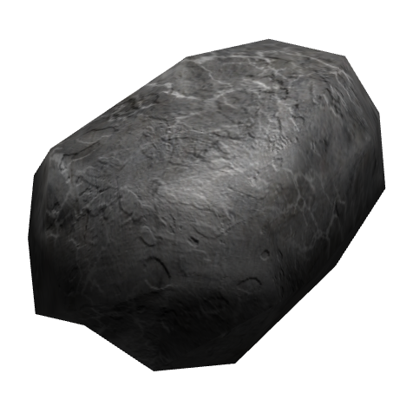
Beacon |  |  | Asteroid | Boulder
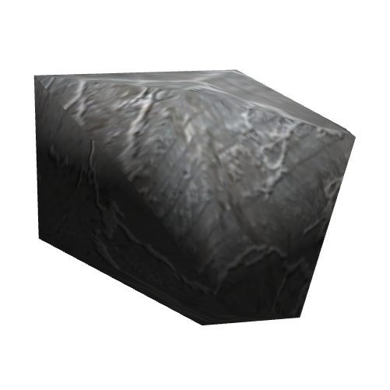 |  |  | 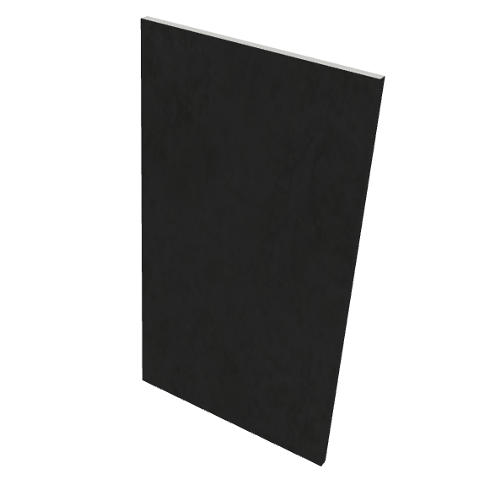 | 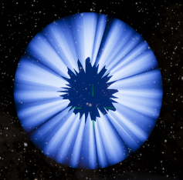
Splinter |  |  | Metal Fragment | Witchcloud
Oolite Reference Sheet by KZ9999, updated and expanded by phkb.
Inspired by the OoliteRS by Darkbee / another_commander / Commander McLane
Checking by: Disembodied, _ds_, Kaks, Commander McLane, Ahruman, Micha, another_commander, Cholmondely and others.
Released under the Creative Commons – BY – NC – SA 3.0
This document was created using OpenOffice 3.0, Inkscape, Paint.net and IrfanView.
Typefaces are the Deja Vu family.

Solar System – Galaxy |  | Commander Status |  | Manifest
GCW MT |  | Ship |  | Commodity | Quantity | Buy Price |  | Sell Price
Present System | Destination System | Credits | Cargo Capacity
Government | Government | Legal Status: | Combat Rating:
Economy | Economy | Outstanding Contracts
Tech Level | Tech Level
Notes
Solar System – Galaxy |  | Commander Status |  | Manifest
GCW MT |  | Ship |  | Commodity | Quantity | Buy Price |  | Sell Price
Present System | Destination System | Credits | Cargo Capacity
Government | Government | Legal Status | Combat Rating
Economy | Economy | Outstanding Contracts
Tech Level | Tech Level
Notes

