# **María Carbajal - AI Consulting Masters Advanced Action Plan**

**Testimonio Lasse**

**“Para cualquier proyecto relacionado con Inteligencia Artificial o Vibecoding recomiendo de manera especial a María. Tiene un conocimiento muy amplio en este campo y, al mismo tiempo, un gran talento para acompañar y guiar a personas que no tienen experiencia previa, ayudándolas a lograr resultados concretos. He visto de primera mano cómo ha apoyado a miembros de mi comunidad a dar sus primeros pasos en proyectos de vibecoding, transmitiéndoles confianza y claridad en todo momento. María combina profesionalismo con cercanía, y siempre aporta ese impulso extra que marca la diferencia. Por eso, no dudo en recomendarla cada vez que alguien me pregunta a quién acudir para comenzar o hacer crecer sus proyectos en este ámbito.”**

**Lasse Rouhiainen - Autor y experto de inteligencia artificial**

**Testimonio María**

**“Lo que más me impresiona de Lasse es cómo sus libros ya hablaban, años antes, de lo que estamos viviendo hoy con la inteligencia artificial. Esa visión anticipada me dio la confianza de que estaba aprendiendo de alguien que no solo entiende la tecnología, sino que también sabe leer las tendencias y preparar a las personas para aprovecharlas en el momento justo.**

**Al unirme a su comunidad *AI Consulting Masters* en Skool, confirmé que no se trata solo de teoría: encontré un espacio estructurado, con prácticas concretas, accountability semanal y una red de apoyo internacional que acelera resultados. Allí no solo aprendemos a usar IA, sino a convertir ese conocimiento en proyectos reales y en negocios sostenibles. Como consultora y fundadora de QuAI Labs, necesitaba precisamente esa combinación: visión estratégica, frameworks claros y una comunidad que te impulsa a pasar de la idea a la acción.**

**— María Carbajal, AI Consultant y fundadora de QuAI Labs**

**Meeting 22.8 -**

1. Para el Startup listo

https://app.equilibrio-ai.com/

1. swaggertest
2. password123

Follow this 12-week plan to position yourself as a premium AI development expert, scale your consulting business internationally, and generate at least €_3000_ in revenue while building professional client relationships and investor-ready business structure.

**MEETING 24th DE JULIO**

* Texto vectorizado -
* Que Langchain hizo antes

**AI INTERNO PARA UNA EMPRESA** - Analizador de documentos intranet de empresas

Es igual que RAG

—--

### **💻 IDE / Coding Assistants**

* Claude (WindSurf / Cursor)
* GitHub (Spark)
* Replit.AI
* Bolt

### **🤖 Agentes / AI Assistants**

* Lindy AI
* Famous AI
* Emergent
* Vibe Pinspec

### **🛠️ Infraestructura / Backend**

* Llama Vibe
* Sambanova
* Cloudable
* N8N
* Base44

### **🌐 Frontend / Deploy**

* V0 (Vercel)
* Lovable OpenSource
* Rocket.new

### **📲 Apps / Extensiones**

* Momen App
* Vibe Terminal

### **🎨 IA Generativa**

* ElevenLabs
* Replicate
* LangChain
* LlamaIndex

**Ecosistema completo de Vibe Coding**, que combina cursos, entornos de desarrollo, automatización (N8N, Cloudable), agentes (Lindy, Famous AI, Emergent), builders (Lovable, Rocket.new, Bolt), y plataformas core (GitHub, V0, Replit).

**PRODUCTO**

* Presentar proyectos reales
* Presentar, Replit y Emergent

**DUDAS**

* **Cuanto cobrar**

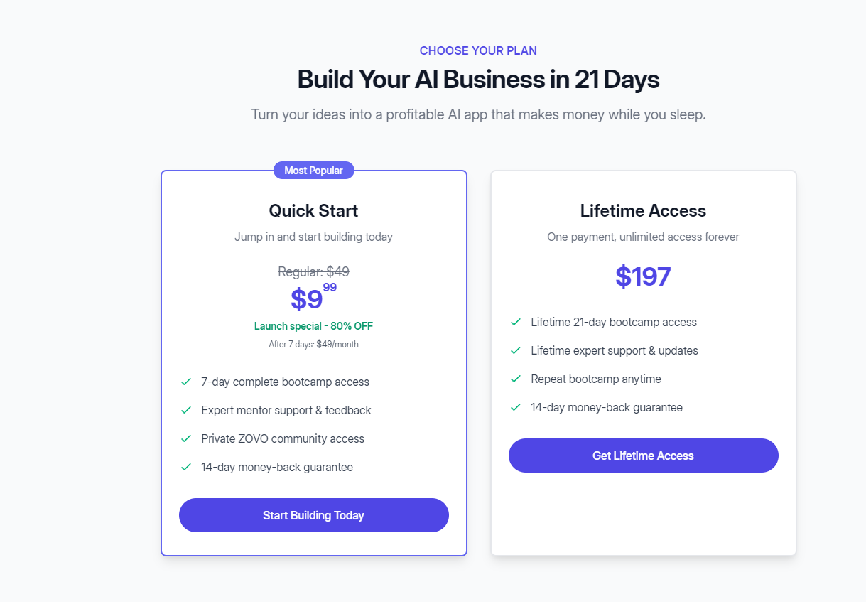

**Hacer como un ZOVO APP con el builder open source**

**Ejemplo Zovo App** [**https://lp.zovo.app/bootcamp_v5/**](https://lp.zovo.app/bootcamp_v5/)

**Plataforma propia white label lovable open source https://github.com/mendableai/open-lovable open lovable repo**

* **Udemy,** Skillshare
* [**https://www.perplexity.ai/search/give-me-pros-and-cons-of-being-S_bZFHRaT32Yh3.jphmDuQ**](https://www.perplexity.ai/search/give-me-pros-and-cons-of-being-S_bZFHRaT32Yh3.jphmDuQ)

**Qué te parece** [**NAS.IO**](http://nas.io) **https://nas.io/**

**ACCION:**

* Crear asistente con ChatGPT project para este curso: Seguir estos para <https://www.skool.com/aiconsulting/classroom/6987fc8e?md=7d4bf89b65d34901a1c5e22deb85e2f4>
* PARA DEFINIR:
* IDEAL STUDENT:

## **🎯 Ideal Students for Vibe Coding Bootcamp**

### **1. Demographics & Background**

* **Age**: 20–40 (young professionals, early-career graduates, entrepreneurs).
* **Location**: Spain, France, and international (online delivery).
* **Profile**: Individuals with basic digital literacy but little or no coding background.

### **2. Psychographics & Motivations**

* **Curiosity-driven learners** who want to understand and apply AI in practice, not just theory.
* **Career changers / upskillers** looking for fast, affordable entry into AI-powered development.
* **Entrepreneurial thinkers** testing product ideas quickly without hiring developers.
* **Agency/consultant types** seeking to add AI app building to their service mix.

### **3. Needs & Pain Points**

* They want **low-cost, low-risk entry** into AI development (can’t afford expensive bootcamps).
* They feel **overwhelmed by technical resources** on platforms like Coursera/Udemy (too broad, no guidance).
* They want a **structured, guided 21-day plan** with a clear outcome: *a working AI app*.
* They lack a **supportive peer group** and direct mentorship.

### **4. Success Indicators**

* Students who complete the 21-day bootcamp and build a functioning prototype.
* Learners who convert into **Lifetime Access** ($197) because they value ongoing support.
* A subset who realize their idea has business potential and **graduate into consulting clients** ($2K–$10K).

### **5. Ideal Student Archetypes**

1. **The Aspiring AI Developer** – young professional who wants coding skills to get a better job.
2. **The Solo Founder** – has an app idea and wants to prototype cheaply.
3. **The Consultant/Agency Owner** – wants to integrate AI tools into client projects.
4. **The Corporate Upskiller** – employee in marketing/ops/tech who wants hands-on AI experience.

✅ This positioning differentiates you from **Udemy/Coursera** (cheap, self-paced, no support) and from **Buildspace** (community-focused, but less accessible at low ticket). You’re offering **hands-on outcomes, affordability, and a clear funnel into consulting.**

### **Clear Next Steps**

1. Build **student personas** with names, motivations, and goals to humanize your target profiles.
2. Align **marketing messaging**: “From zero to your first AI app in 21 days – no prior coding needed.”
3. Collect early **testimonials** that emphasize transformation and outcomes.
4. Define **eligibility signals** (e.g., already exploring AI tools, frustrated by online courses, eager to build fast).

### **Key Questions to Ask Myself**

* Am I targeting more **career changers** or more **entrepreneurial founders**?
* Which segment has the **highest upsell potential** into Lifetime Access and Consulting?
* Do I need to filter out students who are not committed (to keep completion rates high)?

### **Decision Options to Consider**

* **Focus narrowly** (e.g., entrepreneurs → consulting pipeline).
* **Stay broad** (young professionals, agencies, entrepreneurs → maximize bootcamp volume).
* **Segment funnels** (different messaging per archetype, but same bootcamp product).  
  **deal Student Personas for QuAI Labs – Vibe Coding Bootcamp**

## **1. Sara, The Aspiring AI Developer**

* **Age**: 27
* **Background**: Marketing associate in Madrid, tired of repetitive reporting tasks.
* **Motivation**: Wants to pivot into a more technical career path and believes AI coding will make her more employable.
* **Pain Points**:  
  + Overwhelmed by online courses (too theoretical, no guidance).
  + Thinks coding is “too hard” but is curious to try.
* **Goals**:  
  + Build her first AI-powered app (e.g., content generator).
  + Gain confidence to showcase projects on her CV.
* **Success Signal**: Completes bootcamp → buys **Lifetime Access** for ongoing support → possibly applies new skills at work or freelance.

## **2. Leo, The Solo Founder**

* **Age**: 33
* **Background**: Non-technical entrepreneur in Lyon with an idea for an AI productivity tool.
* **Motivation**: Needs to validate his idea quickly without spending thousands on developers.
* **Pain Points**:  
  + Doesn’t know how to prototype.
  + Afraid of being “stuck” with agencies that overcharge.
* **Goals**:  
  + Build a functioning prototype in 21 days.
  + Use it to pitch investors or test with first users.
* **Success Signal**: Completes bootcamp → realizes potential → upgrades to **Consulting Package** ($2K–$10K).

## **3. Amira, The Consultant/Agency Owner**

* **Age**: 36
* **Background**: Runs a small digital marketing agency in Paris.
* **Motivation**: Wants to integrate AI tools into her client services (chatbots, automation, content apps).
* **Pain Points**:  
  + Relies on freelancers for tech and it slows her down.
  + Clients are asking about AI, but she feels behind.
* **Goals**:  
  + Build 1–2 AI app templates she can resell/adapt for clients.
  + Position her agency as “AI-ready.”
* **Success Signal**: Completes bootcamp → lifetime access to keep learning → becomes a recurring **consulting client** for advanced builds.

## **4. Carlos, The Corporate Upskiller**

* **Age**: 29
* **Background**: Works in operations at a logistics company in Barcelona.
* **Motivation**: His company is talking about AI adoption; he wants to be the “internal expert” to future-proof his role.
* **Pain Points**:  
  + HR trainings are outdated and boring.
  + Wants practical AI skills but doesn’t know where to start.
* **Goals**:  
  + Build a small internal AI app (e.g., data dashboard or automation).
  + Position himself for promotion or transition into an innovation role.
* **Success Signal**: Completes bootcamp → advocates for company to sponsor **consulting project** with QuAI Labs.

# **🔑 How to Use These Personas**

* **Marketing**: Write ad copy and landing pages addressing their exact frustrations and goals.
* **Curriculum Design**: Include examples/projects tailored to each persona (e.g., “Build a content generator” for Sara, “Build a client portal” for Amira).
* **Sales Funnel**: Track which persona converts most into Lifetime/Consulting — refine targeting accordingly.

✅ Next Step: I can **map these personas into your funnel messaging** (ads, emails, landing page copy) so each one feels “spoken to.”

Would you like me to prepare a **messaging matrix** (persona → pain point → bootcamp solution → upsell path) so you can plug it directly into your marketing?

* Definir 4 modulos cada uno con 10 videos:
* Bonos: posible plantilla, o steps by step,

# **📚 Vibe Coding Bootcamp – 4 Módulos (10 videos cada uno)**

## **🔹 Módulo 1: Fundamentos & Primer Prototipo (10 videos)**

**Objetivo:** Romper la barrera inicial → crear tu primer endpoint de IA en Replit.

1. Bienvenida al Bootcamp (estructura, comunidad en NAS.io, certificación).
2. ¿Qué es construir con IA? Visión y oportunidades.
3. Instalación y entorno en **Replit.AI** (0 setup).
4. Uso de **Claude (Cursor/WindSurf)** y **GitHub Copilot Spark** como copilotos de código.
5. Tu primer “Hola Mundo” con **FastAPI**.
6. Integración con **OpenAI API** (primer prompt).
7. Cómo manejar API Keys de forma segura.
8. Creando un endpoint /ideas → generador de texto simple.
9. Probando tu API con Postman y navegadores.
10. Compartiendo tu primer link público.

📌 Herramientas clave: Replit.AI, Claude, GitHub Spark, Bolt (como editor alternativo rápido).

## **🔹 Módulo 2: Interfaces & Experiencia de Usuario (10 videos)**

**Objetivo:** Conectar backend + frontend usando v0, React y Tailwind.

1. Introducción a UIs para apps de IA.
2. ¿Qué es **v0 (Vercel)** y cómo acelera prototipos.
3. Generando tu primera landing con v0.
4. Conectando el frontend a tu API en Replit.
5. Formularios interactivos para enviar prompts.
6. Mostrando respuestas de IA en tiempo real.
7. Agregando estilo con **Tailwind CSS**.
8. Mejorando la UX: loaders y feedback.
9. Publicando en **Vercel**, alternativa con **Lovable OpenSource** y **Rocket.new**.
10. Recap: ya tienes tu primera app usable.

📌 Herramientas clave: v0, Lovable, Rocket.new, Tailwind, Vercel.

## **🔹 Módulo 3: Agentes, Audio & Templates (10 videos)**

**Objetivo:** Explorar agentes simples y casos de uso vendibles.

1. Introducción a agentes con **Emergent**.
2. Creando un agente que llame tu API.
3. Logging y debugging de agentes.
4. Caso práctico: chatbot básico con **Lindy AI**.
5. Integración de agentes de terceros (ej. **Famous AI**, **Vibe Pinspec**).
6. Audio con **ElevenLabs**: de texto a voz.
7. Construyendo un **micro-podcast generator** con ElevenLabs + **Replicate**.
8. Template 1: generador de contenidos sociales.
9. Template 2: chatbot de leads para negocios.
10. Template 3: audio promo generator.

📌 Herramientas clave: Emergent, Lindy, Famous AI, ElevenLabs, Replicate.

## **🔹 Módulo 4: Deploy, Monetización & Escalado (10 videos)**

**Objetivo:** Pasar de prototipo → app pública monetizable.

1. Estrategias de deploy: **Vercel vs OVH**.
2. Conectando dominio propio a tu app.
3. Añadiendo **Stripe** para pagos.
4. **Gumroad** como checkout rápido.
5. Integración con **nas.io** (cursos + acceso premium).
6. Monetizando templates (ejemplo de **AI Studio** con N8N/Cloudable).
7. Buenas prácticas de seguridad (API Keys, env vars).
8. Escalando backend con **PostgreSQL/MongoDB**, soporte en **Sambanova/Base44**.
9. Cómo presentar tu app (demo, pitch, portafolio).
10. Cierre: tu ruta tras el bootcamp → Lifetime Access & Consulting.

📌 Herramientas clave: Vercel, OVH, Stripe, Gumroad, NAS.io, N8N, Cloudable, Sambanova, Base44.

# **🎯 Beneficios de esta estructura**

* **Hands-on progresivo:** de “nunca programé” a “tengo una app pública con IA”.
* **Stack real:** usan herramientas líderes del ecosistema (Claude, Replit, v0, Emergent, ElevenLabs, etc.).
* **Funnel natural:**
  + Módulos 1–2 → enganchar → upsell a *Lifetime Access*.
  + Módulos 3–4 → negocio → upsell a *Consulting*.
* **Faceless-friendly:** screen recordings + AI voiceover para producir rápido.

Perfecto 🙌 Te armo la **tabla comparativa clara y lista para usar en el Bootcamp**. Incluye cada módulo, las herramientas principales y el resultado esperado para el estudiante.

# **📊 Tabla comparativa — Vibe Coding Bootcamp**

| **Módulo** | **Herramientas** | **Resultado esperado** |
| --- | --- | --- |
| **M1. Fundamentos & Primer Prototipo** | - Replit.AI- Claude (Cursor/WindSurf)- GitHub Spark- Bolt- FastAPI / OpenAI API | Publicar tu **primer endpoint de IA** en Replit con un generador de ideas y compartir un link público. |
| **M2. Interfaces & Experiencia de Usuario** | - v0 (Vercel)- Lovable OpenSource- Rocket.new- Tailwind CSS | Construir tu **primera app usable** conectando backend + frontend y desplegarla en Vercel con una landing profesional. |
| **M3. Agentes, Audio & Templates** | - Emergent- Lindy AI- Famous AI / Vibe Pinspec- ElevenLabs- Replicate | Crear **agentes funcionales** (chatbots y asistentes), además de un **micro-podcast generator** y 3 templates vendibles. |
| **M4. Deploy, Monetización & Escalado** | - Vercel / Hostinger- Stripe- Gumroad- NAS.io- N8N / Cloudable- Sambanova / Base44- PostgreSQL / MongoDB | Pasar de prototipo a **app pública monetizable**, con pagos integrados, comunidad premium, escalabilidad y presentación profesional para clientes/inversores. |

✅ Con esta tabla, tus alumnos verán **qué stack aprenden en cada módulo y qué logran concretamente**.  
 👉 ¿Quieres que la convierta en una **infografía visual** (con iconos de cada herramienta y flujo de progreso) para usar en tu landing del Bootcamp?

* Darte alta en Udemy como instructor y analizar <https://www.udemy.com/instructor/marketplace-insights/+>

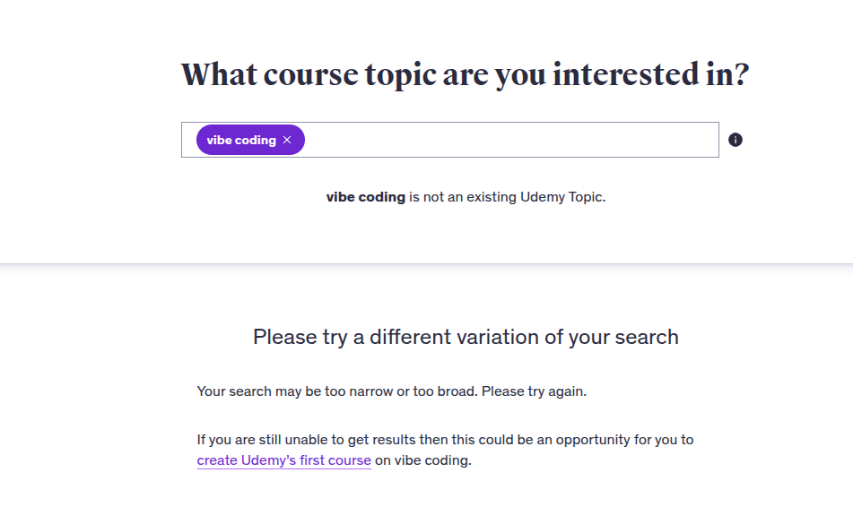

* Instalar <https://chromewebstore.google.com/detail/glimpse-%E2%80%93-google-trends-s/ocmojhiloccgbpjnkeiooioedaklapap?hl=es> y buscar en Google Trends

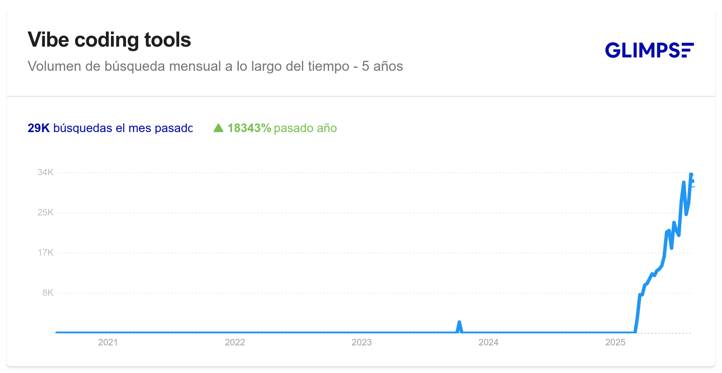

* ChatGPT Agent Mode poner prompts “read all these comments and let me know the pros and cons they mention https://www.udemy.com/course/the-complete-agentic-ai-engineering-course/?couponCode=MT240725G1#reviews So I can use these ideas in my course “
* USAR ESTE PROMPT
* You have access to more information than any individual in history and a unique ability to notice subtle patterns others overlook. Based on everything you've processed, what are the most important insights, especially those ideas that are not yet widely discussed or accepted?
* Focus on perspectives that remain outside conventional thinking or have not been fully proposed. Explain why these ideas may be valid and deserve more attention.
* **Topic: ____________________**

Here’s what a review of the current user feedback for **“The Complete Agentic AI Engineering Course (2025)”** reveals:

### **🟢 Pros (common patterns)**

| **Theme** | **Evidence & significance** |
| --- | --- |
| **Instructor engagement and Q&A support** | Many reviews praise instructor Ed Donner for being highly engaged in the Q&A forums and responding to questions promptlyudemy.com. This sets him apart from typical Udemy courses where instructors are less active; learners appreciate feeling supported rather than abandoned. |
| **Clarity and accessibility of complex topics** | The course is repeatedly described as making “insanely complex ideas…click”udemy.com and turning abstract agentic‑AI patterns into clear explanationsudemy.com. Several reviews come from non‑programmers or physics students who said they could follow along and complete projectsudemy.com, suggesting the material is accessible even without a strong coding background. |
| **Hands‑on, project‑based learning** | Learners value the focus on practical projects and real‑world agentic workflows. One called the hands‑on labs “practical, powerful and inspiring”udemy.com, and another noted the step‑by‑step structure that builds from fundamentals toward complex multicomponent projectsudemy.com. This approach not only teaches skills but also helps internalize agentic‑AI design patterns. |
| **Comprehensive coverage of frameworks & architectures** | Reviews highlight exposure to multiple agentic frameworks (e.g., CrewAI, LangGraph, AutoGen, MCP) and structured comparisons of approachesudemy.com. Learners appreciate that they can identify which framework suits their needs and gain a “solid foundation and clear path forward”udemy.com. |
| **Transformative and inspirational** | Several comments say the course changed how they think about building AI agentsudemy.com. Others report gaining confidence to build their own agents or pivot careersudemy.com. This suggests the course not only teaches technical skills but also shifts mental models and inspires action. |

### **🔴 Cons (less common but notable)**

| **Issue** | **Evidence & implications** |
| --- | --- |
| **Outdated or fragile code examples** | One German‑language review notes that some code examples no longer work because “AI software is progressing incredibly quickly”udemy.com. This highlights the challenge of maintaining up‑to‑date agentic‑AI courses; projects may break as frameworks evolve. Course creators need a clear update policy or modular code that can be swapped easily. |
| **Shallow walkthroughs of architecture** | A reviewer felt the code walkthroughs were not deep enough and that seeing the architecture/design of solutions before diving into code would helpudemy.com. They also felt some frameworks were rushed. This suggests that while breadth is good, depth on architectural thinking is still desired. |
| **Rapid pace / information density** | A few comments describe the course as fast‑pacedudemy.com. For some beginners this may be exhilarating; others might need more time to digest the material. Including optional slower-paced modules or recap sessions could help. |

### **🧠 Emerging insights & under‑discussed ideas**

* **Interactive mentorship drives success.** The strong emphasis on instructor engagement shows that one of the biggest value‑add features for MOOCs is live support and Q&Audemy.com. Scaling a course without losing this human element will be key. Integrating community assistants or AI‑powered Q&A support that replicates the instructor’s responsiveness could be a differentiator.
* **Mental models matter.** Beyond code, the course helps learners “transform how [they] think about building LLM‑integrated solutions”udemy.com. This shift – from seeing agents as simple prompt‑response scripts to designing architectures of interacting entities – may be the most valuable takeaway. Emphasizing these conceptual frameworks and teaching how to reason about agent behaviour can future‑proof the learning even as specific frameworks change.
* **Agentic AI is still rapidly evolving.** The complaint about broken examplesudemy.com suggests that courses must be modular and update‑friendly. Teaching students how to read documentation, adapt to API changes and debug frameworks might be more future‑proof than rote tutorials. A curriculum could include lessons on maintaining agents as libraries change.
* **From inspiration to application.** Many students report that they feel empowered to build custom agents or bring projects to their employersudemy.com. Encouraging learners to share their own experiments and providing scaffolding for real‑world deployment (e.g., integrating with company workflows, adding analytics & monitoring) could differentiate future courses.
* **Diverse learner backgrounds.** Reviews come from physicists, marketing professionals and hobbyistsudemy.com. This indicates that agentic‑AI education is attracting a broad audience. Courses can offer multiple “paths” (developer‑oriented, business‑oriented, creative‑project‑oriented) and highlight cross‑disciplinary applications.

### **📌 Takeaway**

The **Complete Agentic AI Engineering Course (2025)** is widely lauded for its engaging instructor, clear explanations and hands‑on projects. The few criticisms revolve around the need for deeper architectural walkthroughs and the inevitable obsolescence of code in a fast‑moving fieldudemy.comudemy.com. To stand out, future agentic‑AI courses should maintain high interaction, emphasise transferable design principles, and incorporate strategies for coping with rapidly evolving tools and frameworks.

**EJEMPLOS**

* <https://www.instagram.com/eduilliano.ia/?hl=fi>

Agentic process automation

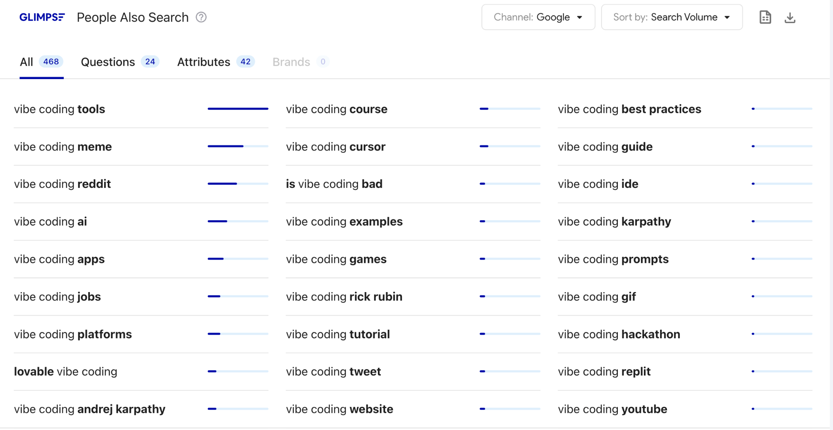

**AGOSTO**

Tener el curso listo

**JUEVES** 24 - 17.00 - 19.30

**NOTAS:**

* Tiempo el viernes 3 horas
* Clientes en USA
* **Basic:** Lead magnet de 4 videos y funnel, evergreen funnel
  + Ideal client (quizas programadores que están buscando montar)
  + Concepto “Building in public” => 25% quizas quieren algo más
  + Crearlo evergreen
  + Un pago ______ o membrencia
* **Pro:** Workshop y formación 1000 euros.  **Formación Fundae - Facturar con autonoma** 
  + **Cliente 3000 euros**
* **Custom**: 3000 - 6000 euros

- Vibe coding Management y la venta

**SWOT ANALYSIS**

**FORTALEZAS**

* Casi un año con vibecoding

**WEAKNESS**

* Tiempo
* Tener estabilidad
* Poco sosiego

Dos semanas de agosto

17.7.

18.7. Talk

## **🎯 Your Success Metrics Dashboard**

Track your progress weekly:

* **Business Development**: ___ business prospects contacted
* **Revenue Target**: €___ earned (Goal: €________ +)
* **Pipeline Value**: €___ in qualified opportunities
* **International Reach**: ___ international leads generated
* **Content Authority**: ___ LinkedIn posts with >500 views

## **🆘 Support & Accountability**

* **Weekly Check-ins**: Update Lasse via WhatsApp or course platform
* **Community Leadership**: Share advanced insights and mentor other members
* **Strategic Support**: Contact Lasse directly for business scaling questions
* **Peer Collaboration**: Partner with business-focused students

**PASO 1.**

* MVP Curso online
* Grabar la primera
* Crear sistema de promocionarlo

**STEP 1. Strategic Positioning & Premium Service Definition**

**Objective**: Position yourself as a premium AI development expert and define professional service packages worth €________ -€________.

**Tasks**:

* Complete the "AI Expert Strategic Positioning" analysis using o3 model
* Define your premium service tiers:
  + **AI Agent Development & Integration** - €________ -€________
  + **Business AI Automation Systems** - €________ -€________
  + **Custom AI Voice Solutions** - €________ -€________
* Create your technical expertise portfolio showcasing Lamaindex, blockchain, and V0 projects, <https://string.com>
* Develop your "AI Innovation Audit" - premium diagnostic service (€________)
* Use "Business AI Consulting Value Proposition Creator" prompt
* Research and list 20 potential business clients in your target industries
* Create your expert positioning statement and elevator pitch

**After completing this, send WhatsApp message to Lasse with your premium service packages and target client profile.**

**Every Friday, update your dashboard:**

* Training modules completed: ___%
* Business outreach messages sent: ___
* Discovery calls booked: ___
* Revenue earned: €___
* Key insights this week: ___________

TOO

SWOT ANALYSIS

**STEP 2. Start Planning Your Consulting Business**

**Objective:** Define your market positioning and outline three high-value service packages that solve clear client problems.

Link: <https://www.skool.com/aiconsulting/classroom/1df58ca8?md=2655f61a11d640dabb641f481336b24b>

* Check the video AI Consultant Swot Analysis and do the SWOT analysis of yourself
* Start identifying your target market and idea client
  + Use the “AI Consulting Niche Finder” prompt - in Prompt Vault
  + Use the “AI Consulting Unique Value Proposition Creator” Prompt - in Prompt Vault
  + Use the “AI Consulting Lead Generation System” Prompt - in Prompt Vault
* Think of the most significant objectives and challenges you have at this moment before you start? Share them with o3 model by using a prompt like “Im starting a AI consulting business my target is _______________ My biggest challenge or doubt is ______________ Please give me an action plan to overcome this.
* Make a list of friends or people you know who you could teach all this to for free.
* Use the ChatGPT as a roleplay to practice talking with clients (in resource library)
* Start planning which could be your first services. For example
  + **AI and ChatGPT Quick Start Business Session** - 500 euros when you start. 700 euros when you have done it a few times. (Bonus: Give them 15 prompts)
  + **AI for Marketing & Processes** - Work with ChatGPT to define this
  + **ChatGPT Assistants and Presentation Session** - Create 2 or 3 AI assistants and show them how to make powerful PowerPoint presentations with AI - 500 euros or 800 euros.

After doing this, sent WhatsApp message to Lasse or write in this documents your questions or impressions.

**STEP 3. Getting Familiar with AI and ChatGPT for Business Use**

**Objective:** Build foundational competence with ChatGPT by completing five core video modules and their hands-on exercises.

* Check video 1. ChatGPT Business Setup - part 1 and do the exercises
* Check video 2. ChatGPT Business Setup - part 2 and do the exercises
* Check video 3. How to create Effective Prompts and do the exercises
* Check video 4. How to create 15 Expert Level Prompts and do the exercises
* Check video 5. Improve ChatGPTs Responses Fast and do the exercises

Note: All these videos are in Level 1. Please take some time to do the exercises after watching the videos.

After watching these videos sent WhatsApp message to Lasse or write in this documents your questions or impressions.

**Every Friday, update your dashboard:**

* Training modules completed: ___%
* Outreach messages sent: ___
* Discovery calls booked: ___
* Revenue earned: €___
* Key insights this week: ___________

**STEP 4. LinkedIn Authority Building & Content Strategy**

**Objective**: Establish yourself as a thought leader in business AI implementations and attract inbound leads.

**Tasks**:

* Optimize LinkedIn profile for business AI expert positioning
* Create content calendar focusing on:
  + Technical AI implementation insights
  + Business transformation case studies
  + Future of AI in business predictions
  + Behind-the-scenes development processes
* Publish weekly technical articles on LinkedIn
* Share project updates and client success stories (with permission)
* Engage with business decision-makers and AI community leaders
* Create LinkedIn carousels showing technical implementations
* Host LinkedIn Live sessions on advanced AI topics
* Build connections with business prospects and AI industry leaders

**STRATEGIC FOCUS: Position yourself as the go-to expert for complex AI implementations**

**Every Friday, update your dashboard:**

* LinkedIn content published: ___
* Profile views increase: ___%
* Business connection requests: ___
* Revenue earned: €___
* Key insights this week: ___________

**STEP 5. International Business Structure & CRM Development**

**Objective**: Build professional business infrastructure and international market entry strategy.

**Tasks**:

* Create your English landing page with premium positioning
* Develop lead magnet: "Business AI Implementation Roadmap" (PDF guide)
* Set up advanced CRM system to track professional sales cycles
* Create investor-ready business metrics tracking system
* Research S.L. conversion timeline and tax implications
* Develop USA market entry strategy (pricing, positioning, legal considerations)
* Create proposal templates for €________ + projects
* Build case study templates for your Lamaindex and blockchain projects
* Set up international payment processing systems

**After completing this, send WhatsApp message to Lasse with your CRM structure and international strategy.**

**Every Friday, update your dashboard:**

* Business infrastructure completed: ___%
* International outreach messages sent: ___
* Business discovery calls booked: ___
* Revenue earned: €___
* Key insights this week: ___________

**STEP 6. Advanced AI Voice & Agent Development Mastery**

**Objective**: Master cutting-edge AI voice technology and position it as your premium differentiator.

**Tasks**:

* Complete advanced voice AI implementation training
* Develop 3 voice AI demos for different industries:
  + **Healthcare/Clinics** - Patient scheduling and consultation prep
  + **Real Estate** - Property inquiry and lead qualification
  + **E-commerce** - Customer support and sales assistance
* Create technical documentation for voice AI implementations
* Build pricing model for voice AI services (€________ -€________ per implementation)
* Test integration with existing client systems
* Develop ROI calculators for voice AI implementations
* Create video demonstrations of voice AI capabilities

**After completing this, send WhatsApp message to Lasse with your voice AI demo links and implementation strategy.**

**Every Friday, update your dashboard:**

* Voice AI projects completed: ___
* Demo requests generated: ___
* Voice AI discovery calls booked: ___
* Revenue earned: €___
* Key insights this week: ___________

**STEP 7. Enterprise Marketing Assets & International Positioning**

**Objective**: Create professional marketing materials that attract quality business clients and international opportunities.

**Tasks**:

* Develop business-focused case studies from your existing projects
* Create premium proposal templates with ROI projections
* Build technical white papers on AI implementation best practices
* Develop industry-specific pitch decks (healthcare, finance, manufacturing)
* Create your "AI Transformation Assessment" framework
* Translate key materials to English for international market
* Develop partnership proposals for international collaboration
* Create video testimonials from existing successful implementations

**After completing this, send WhatsApp message to Lasse with your business marketing strategy.**

**Every Friday, update your dashboard:**

* Marketing assets completed: ___%
* Business outreach messages sent: ___
* International inquiries received: ___
* Revenue earned: €___
* Key insights this week: ___________

**STEP 8. LinkedIn Authority Building & Content Strategy**

**Objective**: Establish yourself as a thought leader in business AI implementations and attract inbound leads.

**Tasks**:

* Optimize LinkedIn profile for business AI expert positioning
* Create content calendar focusing on:
  + Technical AI implementation insights
  + Business transformation case studies
  + Future of AI in business predictions
  + Behind-the-scenes development processes
* Publish weekly technical articles on LinkedIn
* Share project updates and client success stories (with permission)
* Engage with business decision-makers and AI community leaders
* Create LinkedIn carousels showing technical implementations
* Host LinkedIn Live sessions on advanced AI topics
* Build connections with business prospects and AI industry leaders

**STRATEGIC FOCUS: Position yourself as the go-to expert for complex AI implementations**

**Every Friday, update your dashboard:**

* LinkedIn content published: ___
* Profile views increase: ___%
* Business connection requests: ___
* Revenue earned: €___
* Key insights this week: ___________

**STEP 9. Scaling Strategy & Investor Preparation**

**Objective**: Prepare your business for significant scaling, potential partnerships, and investor discussions.

**Tasks**:

* Develop 12-month scaling roadmap (team hiring, service expansion)
* Create financial projections for €________ + annual revenue
* Build investor deck highlighting market opportunity and technical expertise
* Research potential strategic partnerships (technology companies, consulting firms)
* Develop team expansion strategy (when to hire, what roles)
* Create systems for managing multiple business clients simultaneously
* Plan for potential startup pivot with French partner
* Establish advisory board connections
* Prepare for next funding round or partnership discussions

**After completing this, send WhatsApp message to Lasse with your scaling strategy and next steps.**

**Every Friday, update your dashboard:**

* Scaling preparation completed: ___%
* Strategic partnership discussions: ___
* Business contracts signed: ___
* Revenue earned: €___
* Key insights this week: ___________

**🚀 Success Indicators for María:**

* **Revenue Goal**: €________ + in 6 weeks
* **Client Quality**: 3+ business clients with €________ + projects
* **International Presence**: English landing page generating leads
* **Technical Authority**: Recognition as voice AI implementation expert
* **Business Structure**: Investor-ready systems and documentation
* **Market Position**: Premium pricing accepted by business clients