A tool to simulate digital aging; aka “shoot a file”.
Manfred Thaller, University at Cologne
1. Disclaimer
This tool has been developed to simulate some types of damage, which may occur during the life of digital holdings by irregularities within a technical environment. This tool has primarily been written for general educational purposes, to develop sensitivity for the different behavior of file formats in critical situations. It does not claim, that the differences in the behavior of file formats which you can discover by it cannot be controlled by technical means, e.g., checksums. Nor does it claim to simulate the effects to be studied based on a sophisticated simulation of the behavior of specific types of hardware, it uses a rough approximation of the most general common characteristics of storage devices.
Still, the effects you can discover are for real.

2. Installation
This document should be accompanied by a file called ShotGun.zip, which expands to an executable program which should work on all versions of Win32 – Windows XP, Vista and all forerunners since the middle of the nineties. A linux version and the source code are available on request from Manfred.Thaller@uni-koeln.de.
(1) Copy ShotGun.zip into a directory of your choice.
(2) Expand it with your favorite de-compression tool.
(3) Open the uncompressed directory in the Windows explorer. After deleting the ShotGun.zip file you should see – depending on the settings of your explorer – something similar to
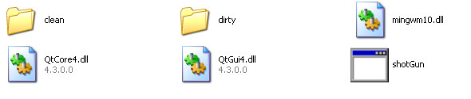
or
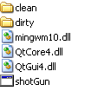
(4) Doubleclick the Icon 

You should see the following dialogue:

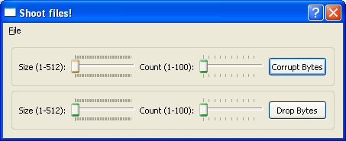

Installation is complete.

3. Experimenting with files
3.1 Background
The tool you just installed lets you simulate two types of damages, which files take in repositories which is suffering from hardware irregularities.
“Bit rot” stands for files where the degradation of storage media leads to tiny changes in the data stored, usually individual bits shifting from zero to one or the other way around. This type of damage occurs typically as a result of aging media. Most typically it either affects individual bytes, or sequences of bytes the length of which may vary with media types, will most frequently be 512, however.
“Byte loss” stands for files, where faulty copying operations have lead to the loss of individual bytes, so a file is a few bytes shorter. This is usually the result of faulty equipment and / or faulty transmission lines. Most typically such a problem will only affect very short sequences of bytes, usually individual bytes only, as larger loss of data gets discovered quickly.

3.2 Running a first experiment
(1) Start the tool as described in item (4) in section 2 – installation – above.
(2) Open its “file” menu. It will display a dialogue similar to
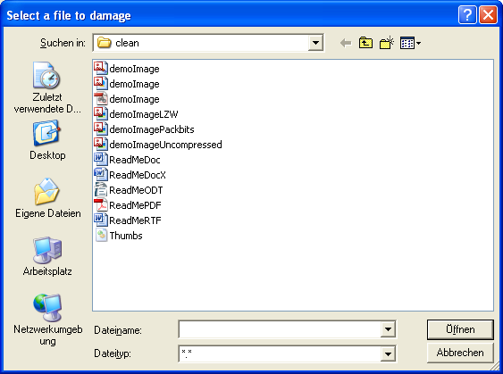
The files with variations on the name “demoImage” are versions of the screen dump of the tool stored in different formats; the files with variations on “ReadMe” are versions of the text you are reading, also stored in different formats.

Select the file you want to experiment with.
Next press the button “Corrupt Bytes” in the dialogue displayed by the tool. The performed action will be acknowledged by the message:
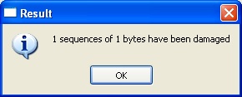
This means that exactly one byte has been set to binary zero, simulating bit rot. The byte concerned has been selected by a random process, so the result is not predictable!
(3) Now look into the directory “dirty”, which is contained in the directory where you installed the tool. You will see a copy of the file, which you have selected in step 1 above. This is the corrupted version of the selected file, resulting from your last experiment of that file. Open the file with an appropriate tools and see whether it still can be displayed / how much damage it has taken from this one byte being changed.
Again: The damage inflicted is the result of a random process! It may very well be that on two successive tests a file seems to be completely undamaged in the first try and gets totally unreadable in the second, though in both cases only a single bit may have changed.
(4) Perform the same on the other versions of the same file stored in different formats and study the differences in their behavior.
(5) Move the slide ruler labeled “Size (1-512):” to the left of the “Corrupt Bytes” button and try again. The acknowledging message will show, that the length of the corrupted byte sequences has increased. Study the effect as before.
(6) Move the slide ruler labeled “Count (1-100):” to the left of the “Corrupt Bytes” button and try again. The acknowledging message will show, that the number of corrupted byte sequences has increased. Study the effect as before.
(7) Now repeat steps 2 – 7 with the button labeled “Drop Bytes”. It will simulate byte loss in exactly the same way.

3.3 Running your own experiments
Please note, that the files attached to the tool have just been selected to give you a feeling for the process and make absolutely sure, that nobody can think up some subtle reason why your exercises could infringe upon any conceivable copyright. Otherwise the files provided are not necessarily good examples for the consequences of damages to files – it will be much more useful if you run some experiments with samples of the files your institution actually wants to preserve. (File size will normally not be a problem; nevertheless handling a one gigabyte file does take longer than handling one of the small samples provided.)
To make sure that you do not inspect any residuals from earlier experiments, you should always:
(1) Completely delete the content of the “dirty” subdirectory in the directory where you did install the tool.
(2) Copy the files you want to test into the “clean” subdirectory in the directory where you did install the tool.
(3) Than run tests as described in the previous section.

4. Finally …
We wish you interesting experiments!
If you have results on “exotic” file formats or results which you consider particularly interesting, it would be nice to hear about them. If such a report would be accompanied by (copyright free) copies of the files with which they have been gained, participants of future teaching events on digital preservation would be very grateful!

