Universidad de Buenos Aires
Facultad de Ciencias Económicas
Escuela de Negocios y Administración Pública

Maestría en Economía Aplicada

Trabajo Final de Maestría

Aprendizaje Automático Doble para Diferencias en Diferencias: Fundamentos y Aplicación

Autor: Martín Gabriel Cargnel

Director: María Noelia romero

[Abril 2026]

Abstract

Machine Learning (ML) models have traditionally been associated with prediction tasks due to their flexibility, while social scientists have typically relied on simpler, often linear, regressions for assessing causality. However, a novel framework named Double Machine Learning (DML) has emerged, providing a way to leverage the predictive performance of these complex methods for robust causal estimation. This thesis examines the fundamentals and applications of double machine learning for two distinct popular Difference-in-Differences (DiD) settings.
Keywords: Double Machine Learning, Causal Inference, Difference-in-Differences

Table of Contents
1. Introduction 5
2. Difference in Differences 7
2.1. The DiD Estimator 7
2.1.1. Estimation 8
2.1.2. Assumptions 8
2.2. Extension: Staggered DiD 10
2.2.1. Estimation 11
2.2.2. Limitations and Recent Advances 11
2.2.3. Extensions to Covariates 11
3. Double Machine Learning 13
3.1. Double Machine Learning Framework 13
3.2. The General Framework 13
3.2.1. Estimation Goal and Model Setup 13
3.2.2. The Confounding Problem 14
3.2.3. Theoretical Solution Through Orthogonalization 15
3.3. Practical Implementation with Machine Learning 16
3.3.1. Cross-Fitting: Addressing Overfitting Bias 17
3.3.2. Neyman Orthogonality: Addressing Estimation Bias 18
3.4. DML for Difference-in-Differences 18
3.4.1. Two-Period Difference-in-Differences 19
3.4.2. Staggered Treatment Adoption 20
3.4.3. Doubly Robust Estimation of Cohort Effects 21
3.4.4. Event Study Aggregation 21
4. Simulations 23
4.1. Data Generating Process 23
4.1.1. Covariates 24
4.1.2. Treatment Assignment 25
4.1.3. Fixed Effects 26
4.1.4. Potential Outcomes 26
4.1.4. Observed Outcomes 27
4.2. Simulation Setup 27
4.3. Results 30
4.3.1. Constant Treatment Effect Scenarios (1, 2, 3) 31
4.3.2. Two-Period Scenarios (4, 5, 6) 33
4.3.4. Six-Period Non-Staggered Scenarios (7, 8, 9) 34
4.3.5. Staggered Scenarios (10, 11, 12) 36
5. Applications 38
5.1. Difference-in-Differences with Treatment in One Period 38
5.1.1. Replication of Gonzáles 39
5.1.2. Double Machine Learning 39
5.1.3. Comparing results 41
5.2. Staggered difference in differences 42
5.2.1. Two-Way-Fixed-Effects 43
5.2.2. Double Machine Learning 43
5.2.3. Comparing results 44
6. Conclusion 48
References 49
Appendix 52

1. Introduction
As discussed in Shmueli (2010), when working in applied statistics there is a clear distinction between predicting and explaining. Prediction is usually associated with achieving the best performance on a selected goodness-of-fit metric, while explaining is focused on understanding the effects or relationships between variables. This distinction makes it clear why flexible, and often considered black-box, Machine Learning (ML) algorithms are widely used when the goal is to achieve the best prediction performance. However, when the goal is to interpret results or to draw causal relationships, other, usually simpler approaches like linear regressions are preferred. This distinction is not new, as it was highlighted by Breiman (2001b), who clearly differentiated between statistics and machine learning when the latter field started to gain popularity.
The focus on prediction and not explanation generated criticism among economists and other social scientists who needed tools for understanding and studying causal relationships, which is not possible with black-box models. However, the new models were appealing, so in recent years, many authors have explored how to bridge this gap. Early work, such as Varian (2014), highlighted how ML techniques, especially tree-based models, could complement traditional econometric methods in settings with non-linearities and complex interactions. Similarly, Mullainathan and Spiess (2017) explored the practical applications of machine learning in econometrics, particularly emphasizing prediction, but also cautioning against drawing causal conclusions about the effects of independent variables without careful consideration.
Although the prevailing view cautioned against using machine learning for explaining, these algorithms gained popularity among researchers over the years. As shown in Desai (2023), which reviews how ML algorithms are being integrated into economic analysis, this popularity has grown significantly. An attempt to bridge the gap between black-box, prediction-focused machine learning methods and simpler, more interpretable methods was the emergence of interpretable machine learning. There are now several techniques that aim to combine the predictive power of complex, black box machine learning models with methods to interpret them. A comprehensive overview of these techniques can be found in Molnar (2025). However, it is important to note that many of these methods focus on describing the behavior of the model itself, rather than uncovering the underlying data generating process (DGP) as is common in classical statistics.
While interpretable ML addresses the transparency problem, it does not directly solve the fundamental challenge economists face: estimating causal effects with formal statistical guarantees. What is needed is a framework that uses machine learning not to explain its own predictions, but rather to flexibly control for confounding variables while maintaining the ability to perform valid statistical inference on causal parameters. This work focuses its attention on a particularly influential framework that achieves exactly this: Double Machine Learning (DML) (Chernozhukov et al., 2018).
The DML framework provides a general, robust method that formally combines the predictive power of machine learning with the theoretical rigor of causal inference to estimate a specific parameter of interest. Notably, the framework is not restricted to a single econometric setting. It can be adapted to multiple familiar contexts for economists, including Instrumental Variables (IV) estimation, treatment effect models, and, central to this thesis, Difference-in-Differences (DiD) designs.
This document aims to contribute to the growing literature on how to apply these methods in practice, focusing specifically on the application of DML within the DiD framework. By providing both conceptual foundations and practical guidance, this thesis seeks to equip practitioners with the understanding and tools needed to leverage this powerful technique in their own research.
The rest of this document is structured as follows: First, the classic Difference-in-Differences framework and its econometric tools are introduced. Second, the Double Machine Learning (DML) framework is presented along with its specific application for DiD setups. Then, two real-world applications of this algorithm are provided to demonstrate its practical utility, and finally, a conclusion is presented.

2. Difference in Differences
Difference in Differences (DiD) is a widely used econometric technique for estimating causal effects when randomized experiments are not feasible. It is particularly useful in policy analysis, economics, and social sciences to evaluate the impact of a treatment or intervention over time. Essentially, the DiD approach compares the changes in outcomes over time between a group that is exposed to a treatment (the treatment group) and a group that is not (the control group). The key idea is to control for unobserved factors that are constant over time and for common trends affecting both groups. An excellent introduction to the method can be found in Cunningham (2021).
This chapter begins with the classical Difference in Differences design, lay out identification and estimation in the two-period case, move to extensions for staggered adoption, and clarify the role of covariates.

2.1. The DiD Estimator
This section first defines the canonical two group, two period estimator and link it to the Average Treatment Effect on the Treated.
Suppose two groups are observed over two periods: before and after a treatment is implemented. The DiD estimator is calculated as:
$$\begin{aligned}{\hat{δ}}^{t,c}=\left(Y_{post}^{t}-Y_{pre}^{t}\right)-\left(Y_{post}^{c}-Y_{pre}^{c}\right)\#\left(2.1\right)\end{aligned}$$
where $Y_{post}^{t}$ is the average outcome for the treatment group after the intervention, $Y_{pre}^{t}$ the average outcome for the treatment group before the intervention, $Y_{post}^{c}$ the average outcome for the control group after the intervention, and $Y_{pre}^{c}$ the average outcome for the control group before the intervention. This double differencing removes biases from permanent differences between the groups and from trends that affect both groups equally and can be seen as the average treatment effect on the treated, defined as
$$\begin{aligned}ATT=E[Y^{(1)}-{ Y}^{(0)} | D=1]\#\left(2.2\right)\end{aligned}$$

where $Y^{\left(1\right)}$ would be the potential outcome if treated, $Y^{\left(0\right)}$ the potential outcome if not treated, and $D∈0,1$ the treatment indicator, with $D=1$ if treated and $D=0$ if not. So, it’s the expected treatment effect for the units that received the treatment.
In summary, comparing changes across groups recovers the effect on treated units under appropriate assumptions.

2.1.1. Estimation
An equivalent regression formulation clarifies the interpretation of the interaction coefficient as the Difference in Differences estimand.
DiD models are often estimated using regression analysis, typically with a specification like:
$$\begin{aligned}Y_{it}=α+β{\text{Post}}_{t}+γ{\text{Treat}}_{i}+δ\left({\text{Post}}_{t}×{\text{Treat}}_{i}\right)+ϵ_{it}\#\left(2.3\right)\end{aligned}$$
where $Y_{it}$ is the outcome for unit $i$ at time $t$, ${\text{Post}}_{t}$ an indicator variable that equals 1 if time $t$ is after the treatment, and 0 otherwise, ${\text{Treat}}_{i}$ an indicator variable that equals 1 if unit $i$ is in the treatment group, and 0 otherwise, $δ$ is the DiD estimator (treatment effect), and $ϵ_{it}$ the error term.
Under the same conditions, this regression delivers the same estimand as the difference in differences formula.

2.1.2. Assumptions
Next, the identifying requirement is stated and illustrated through an algebraic decomposition and parallel trends plots.
The main identifying assumption of DiD is the parallel trends assumption: in the absence of treatment, the average change in the outcome would have been the same for both groups. If this assumption holds, the DiD estimator provides an unbiased estimate of the treatment effect.
A nice way to see this is by working with the DiD estimator, expanding it to
$$\begin{aligned}{\hat{δ}}^{t,c}=\left(E\left[Y^{t} | post\right]-E\left[Y^{t} | pre\right]\right)-\left(E\left[Y^{c} | post\right]-E\left[Y^{c} | pre\right]\right)\#\left(2.4\right)\end{aligned}$$
after some algebra, the following expression is obtained:
$$\begin{aligned}\begin{aligned}{\hat{δ}}^{t,c}&=(E[Y^{t,1}|post]-E[Y^{t,0}|post]) \#\#\#\#\#\#\#\#\#\#\#\#\# \\ &+(E[Y^{t,0}|post]-E[Y^{t,0}|pre])-(E[Y^{c,0}|post]-E[Y^{c,0}|pre]) \#\end{aligned}\#\left(2.5\right)\end{aligned}$$
In this decomposition, the first term corresponds to the ATT estimator. Please note that the superscripts denote whether the group corresponds to the treated ($t$) or control ($c$), and whether it was treated (1) or not (0).
But the second and third terms cancel out if the parallel trends assumption holds, basically because if the group that received the treatment and the group that didn’t receive the treatment would both behave the same in the absence of treatment, then both would be equal before and after the treatment. So, the terms would cancel out, and only the ATT would remain.
When pretreatment trends are parallel, the remaining terms cancel, and the estimator recovers the Average Treatment Effect on the Treated.
A popular way to validate this assumption is to use a parallel trend plot. This visualization allows for the evaluation of how the dependent variable evolves for the control and treatment groups before and after the treatment. An example with simulated data can be found in Figure (1), where both control and treatment units behave similarly before the treatment (denoted by a vertical red dotted line) but differ after it.
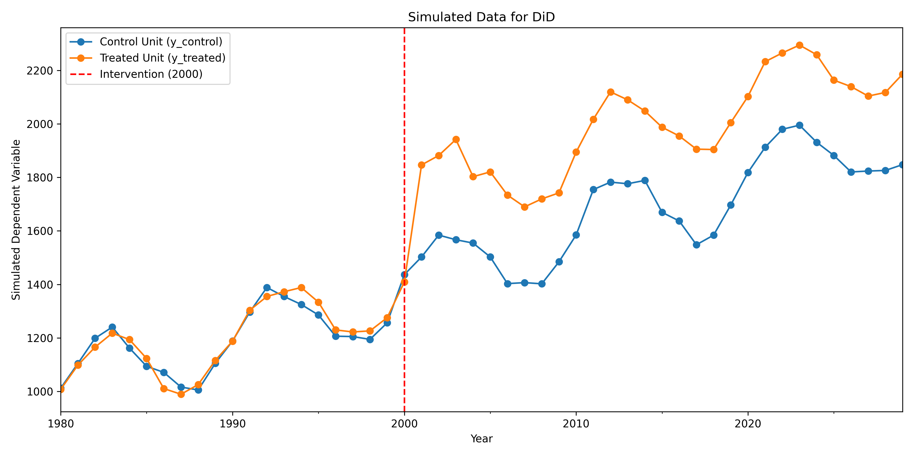
Figure 1: Parallel trends example: control and treatment groups follow similar trends before treatment.
On the other hand, Figure (2) is an example of a plot where the assumption does not hold, because the trends for the two groups are not parallel before the treatment, meaning that the groups are not comparable.
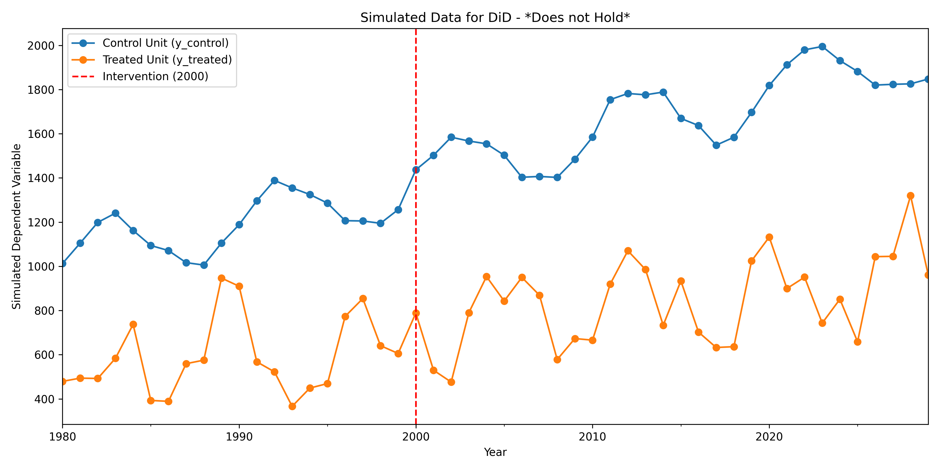
Figure 2: Violation of parallel trends: groups show different pre-treatment trends.

2.2. Extension: Staggered DiD
Staggered adoption complicates identification and motivates alternative estimators. This section begins with the standard two-way fixed effects specification and then summarizes recent advances that address its limitations.
In many empirical applications, treatments are not implemented at the same time for all treated units. Instead, different units receive the treatment at different points in time; a situation known as staggered adoption. The standard two-period DiD framework does not account for this complexity, so extensions are needed.

2.2.1. Estimation
The two-way fixed effects regression is commonly used for staggered adoption panels. A common approach is to use a two-way fixed effects (TWFE) regression:
$$\begin{aligned}Y_{it}=α_{i}+λ_{t}+δD_{it}+ϵ_{it}\#\left(2.6\right)\end{aligned}$$
where $Y_{it}$ is the outcome for unit $i$ at time $t$, $α_{i}$ are unit fixed effects, $λ_{t}$ are time fixed effects, $D_{it}$ is an indicator for whether unit $i$ is treated at time $t$, and $δ$ is the average treatment effect.

2.2.2. Limitations and Recent Advances
Recent research, mainly pioneered by the decomposition demonstrated in Goodman-Bacon (2021), has shown that the TWFE estimator can be seen as a weighted average of all potential 2x2 DiD estimates, where weights are based on both group sizes and variance in treatment. However, this decomposition revealed that TWFE can produce biased estimates when treatment effects are heterogeneous across groups or over time in a staggered design. This is because the estimator may compare already treated units to newly treated units, contaminating the control group. Also, it assumes that groups in the middle of the panel should be weighted more than those at the end.
To address these issues, alternative estimators have been developed by different authors. However, in this thesis, the focus will be on the proposal from Callaway and Santa’Anna (2021), who propose a reliable way to estimate staggered DiD. In sum, while TWFE is convenient, it can be problematic under staggered designs with heterogeneous effects.

2.2.3. Extensions to Covariates
Finally, this section motivates conditioning on covariates and clarifies when and how to include them in a Difference in Differences design. The standard parallel trends assumption can be restrictive. In many settings, it may be more plausible to assume conditional parallel trends: the trends between the treated and control groups would be parallel, conditional on a set of covariates $X$.
Including covariates can thus strengthen the validity of the DiD design. In a traditional regression framework, this is done by simply adding the covariates $X_{it}$ to the estimation equation:
$$\begin{aligned}Y_{it}=α+β{\text{Post}}_{t}+γ{\text{Treat}}_{i}+δ\left({\text{Post}}_{t}×{\text{Treat}}_{i}\right)+θ^{'}X_{it}+ϵ_{it}\#\left(2.7\right)\end{aligned}$$
this model is often estimated as a fixed effects model (similar to the TWFE specification) to control for time invariant unobservables:
$$\begin{aligned}Y_{it}=α_{i}+λ_{t}+δD_{it}+θ^{'}X_{it}+ϵ_{it}\#\left(2.8\right)\end{aligned}$$
A limitation of this approach is that it assumes the covariates $X_{it}$ have a linear and additive effect on the outcome $Y_{it}$. If the true relationship is nonlinear or involves complex interactions, this model is misspecified, and the estimate of $δ$ can be biased.
This limitation provides a key motivation for using machine learning. The Double Machine Learning (DML) framework, as discussed in the next chapter, is designed to overcome this exact problem. It allows for controlling for a rich set of covariates $X_{it}$ in a flexible, nonparametric way, thereby avoiding the biases associated with model misspecification.
However, regardless of the chosen method, the practitioner must be careful when including covariates as this might introduce bias. It is usually recommended to include only time invariant covariates or those that are measured before the treatment takes place. The main risk is that inappropriate covariates might be affected by the treatment, so they would not be a valid control anymore and can be considered colliders, which would introduce bias in the estimation. Taken together, conditioning on covariates can strengthen identification when done carefully, and the next chapter introduces Double Machine Learning to bring flexibility while preserving valid inference.

3. Double Machine Learning

3.1. Double Machine Learning Framework
This chapter presents the Double Machine Learning framework introduced by Chernozhukov et al. (2018), which provides a rigorous method for combining machine learning flexibility with formal causal inference. The chapter begins by establishing the core framework in a general partially linear model setting, demonstrating how the method addresses key challenges in estimating causal effects when controlling for high-dimensional covariates. It then shows how this framework can be adapted to Difference-in-Differences settings, first in the canonical two-period case and subsequently in the more complex staggered adoption scenario.
The chapter is organized as follows. First, the general DML framework is introduced, starting with the estimation goal and the fundamental confounding problem. The theoretical solution based on orthogonalization is then presented, explaining how machine learning is used in practice to implement this solution. Second, the two critical techniques that ensure valid statistical inference despite using flexible machine learning methods are discussed: cross-fitting and Neyman orthogonality. Finally, this framework is adapted to Difference-in-Differences designs, showing how the core principles apply in both simple and staggered treatment timing contexts.

3.2. The General Framework

3.2.1. Estimation Goal and Model Setup
The fundamental objective in causal inference is to estimate the causal effect of a treatment $D$ on an outcome $Y$ while properly accounting for a potentially high-dimensional set of covariates $X$. The focus is on estimating a constant treatment effect parameter $θ$, which represents the Average Treatment Effect (ATE).
$\begin{aligned}ATE=E\left[Y_{i}\left(1\right)-Y_{i}\left(0\right)\right]\#\left(3.1\right)\end{aligned}$here, $Y_{i}\left(1\right)$ represents the potential outcome for unit $i$ under treatment, while $Y_{i}\left(0\right)$ represents the potential outcome without treatment. The fundamental challenge is that only one of these potential outcomes is observed for each unit, making direct estimation of the ATE impossible without additional structure.
To provide this structure, a Partially Linear Model specification is adopted, which forms the basis for the DML approach:
$\begin{aligned}\begin{aligned}Y_{i}&=θD_{i}+g(X_{i})+ϵ_{i} \text{(Outcome Model)} \\ D_{i}&=m(X_{i})+u_{i} \text{(Treatment Model)}\end{aligned}\#\left(3.2\right)\end{aligned}$where $Y_{i}$ is the observed outcome, $D_{i}$ is the observed treatment status (e.g., 1 if treated, 0 if not), $X_{i}$ is a vector of covariates, $θ$ is the causal parameter of interest (the ATE, assuming a constant effect), $g\left(X_{i}\right)$ and $m\left(X_{i}\right)$ are unknown, potentially complex functions, known as “nuisance functions”, that represent how the covariates $X$ affect the outcome and the treatment, respectively, and $ϵ_{i}$ and $u_{i}$ are error terms, which are assumed to be exogenous (i.e., $E\left[ϵ_{i} | X_{i},D_{i}\right]=0$ and $E\left[u_{i} | X_{i}\right]=0$).

3.2.2. The Confounding Problem
A naive approach of regressing $Y$ directly on $D$ would yield biased estimates of $θ$. The source of this bias is confounding: the covariates $X$ simultaneously influence both the treatment assignment through $m\left(X\right)$ and the outcome through $g\left(X\right)$. This creates a backdoor path from $D$ to $Y$ that runs through $X$, violating the conditions necessary for causal identification.
The structure of this confounding problem can be visualized through a Directed Acyclic Graph (Figure 1):
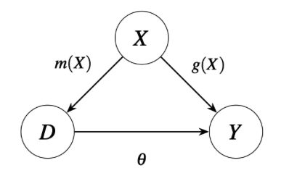
Figure 3: Directed Acyclic Graph showing the confounding structure. Covariates X affect both treatment D (through m(X)) and outcome Y (through g(X)), while the causal effect of interest is θ (from D to Y).
Obtaining an unbiased estimate of $θ$ requires properly controlling for the confounding influence of $X$. The challenge lies in doing so when the functional forms $g\left(X\right)$ and $m\left(X\right)$ are unknown and potentially complex, making traditional parametric approaches inadequate.

3.2.3. Theoretical Solution Through Orthogonalization
The DML framework addresses the confounding problem by building on the Frisch-Waugh-Lovell theorem from econometrics.
This theorem demonstrates that estimating a parameter in a multivariate regression can be accomplished by first residualizing all variables with respect to the controls. Applying this principle to our partially linear model yields an estimating equation for $θ$ that is free from dependence on the nuisance functions $g\left(X\right)$ and $m\left(X\right)$.
Start with the outcome model: $Y_{i}=θD_{i}+g\left(X_{i}\right)+ϵ_{i}$ and take the conditional expectation of $Y_{i}$ given $X_{i}$:
$$\begin{aligned}E\left[Y_{i} | X_{i}\right]=E\left[θD_{i} + +g\left(X_{i}\right) + ϵ_{i} | X_{i}\right]\#\left(3.3\right)\end{aligned}$$
assuming $E\left[ϵ_{i} | X_{i}\right]=0$ and since $g\left(X_{i}\right)$ is a function of $X_{i}$, $E\left[g\left(X_{i}\right) | X_{i}\right]=g\left(X_{i}\right)$:
$$\begin{aligned}E\left[Y_{i} | X_{i}\right]=θE\left[D_{i} | X_{i}\right]+g\left(X_{i}\right)\#\left(3.4\right)\end{aligned}$$
this gives us an expression for the confounder $g\left(X_{i}\right)$:
$$\begin{aligned}g\left(X_{i}\right)=E\left[Y_{i} | X_{i}\right]-θE\left[D_{i} | X_{i}\right]\#\left(3.5\right)\end{aligned}$$
now, substitute this expression for $g\left(X_{i}\right)$ back into the original outcome model:
$$\begin{aligned}Y_{i}=θD_{i}+\left(E\left[Y_{i} | X_{i}\right]-θE\left[D_{i} | X_{i}\right]\right)+ϵ_{i}\#\left(3.6\right)\end{aligned}$$
finally, rearrange the terms to isolate $Y$ and $D$ from their conditional expectations:
$$\begin{aligned}Y_{i}-E\left[Y_{i} | X_{i}\right]=θ\left(D_{i}-E\left[D_{i} | X_{i}\right]\right)+ϵ_{i}\#\left(3.7\right)\end{aligned}$$
let’s define our residuals: ${\tilde{Y}}_{i}=Y_{i}-E\left[Y_{i} | X_{i}\right]$ (The “residualized” outcome) and ${\tilde{D}}_{i}=D_{i}-E\left[D_{i} | X_{i}\right]$ (The “residualized” treatment). Then our equation becomes:
$$\begin{aligned}{\tilde{Y}}_{i}=θ{\tilde{D}}_{i}+ϵ_{i}\#\left(3.8\right)\end{aligned}$$
This transformation represents the central theoretical insight of the framework. The complex partially linear model reduces to a simple linear regression in residualized variables. If the true residuals ${\tilde{Y}}_{i}$ and ${\tilde{D}}_{i}$ were available, unbiased estimation of $θ$ would follow directly from regressing $\tilde{Y}$ on $\tilde{D}$. The remaining challenge is that the conditional expectations required to compute these residuals are unknown in practice, motivating the use of machine learning for their estimation.

3.3. Practical Implementation with Machine Learning
The true conditional expectation functions $E\left[Y | X\right]$ and $E\left[D | X\right]$ are unknown in practice and may exhibit complex, nonlinear relationships with the covariates. The key innovation of Double Machine Learning is to estimate these nuisance functions using flexible machine learning algorithms designed for predictive accuracy.
Specifically, $\hat{l}\left(X_{i}\right)$ is estimated as a machine learning approximation of $E\left[Y_{i} | X_{i}\right]$, typically framed as a regression task since outcomes are often continuous. Similarly, $\hat{m}\left(X_{i}\right)$ is estimated as an approximation of $E\left[D_{i} | X_{i}\right]$, which represents the propensity score $P(D_{i}=1|X_{i})$ and is typically framed as a classification task when treatment is binary.
The term “double” in Double Machine Learning refers to this dual use of machine learning: once for modeling the outcome and once for modeling the treatment assignment. The framework is agnostic to the specific machine learning algorithm employed, allowing researchers to use Random Forests, Gradient Boosting, Neural Networks, or any other suitable method depending on the data structure and performance considerations.
The estimated residuals are then computed:
$$\begin{aligned}{\hat{Y}}_{i}=Y_{i}-\hat{l}\left(X_{i}\right) \text{and} {\hat{D}}_{i}=D_{i}-\hat{m}\left(X_{i}\right)\#\left(3.9\right)\end{aligned}$$
and finally, $θ$ is estimated using the simple linear regression:
$$\begin{aligned}{\hat{Y}}_{i}=θ{\hat{D}}_{i}+{\hat{ϵ}}_{i}\#\left(3.10\right)\end{aligned}$$
While this procedure is conceptually straightforward, using machine learning for nuisance function estimation introduces statistical complications that must be addressed to ensure valid inference. The following two subsections explain how the DML framework overcomes these challenges through cross-fitting and Neyman orthogonality.

3.3.1. Cross-Fitting: Addressing Overfitting Bias
Using the same observations to both train the machine learning models and estimate the final parameter $θ$ would introduce overfitting bias. The generated residuals would exhibit spurious correlation because the models were optimized using the very same observations for which residuals are being computed.
Cross-fitting solves this problem through sample splitting. The procedure ensures that residuals for any observation are computed using models trained exclusively on different observations, thereby eliminating the overfitting link.
The procedure is most easily understood through a two-fold split, though K-fold cross-fitting generalizes naturally. First, randomly partition the dataset into two equal subsets. Second, train models ${\hat{l}}_{1}$ and ${\hat{m}}_{1}$ using only the first fold, then use these models to generate residuals for observations in the second fold. Third, train new models ${\hat{l}}_{2}$ and ${\hat{m}}_{2}$ using only the second fold, then generate residuals for observations in the first fold. Fourth, combine all residuals into a single dataset. Finally, estimate $θ$ via ordinary least squares regression of ${\hat{Y}}_{i}$ on ${\hat{D}}_{i}$ using this complete set of residuals. This ensures that no observation contributes to both the training of its prediction model and the final parameter estimation, eliminating overfitting bias.

3.3.2. Neyman Orthogonality: Addressing Estimation Bias
Machine learning models optimize prediction accuracy rather than unbiased estimation of the true functions $l\left(X\right)$ and $m\left(X\right)$. Regularization and other aspects of these algorithms inevitably introduce estimation bias in $\hat{l}$ and $\hat{m}$. A critical requirement is that this bias in the nuisance function estimates must not propagate into the final estimate of $θ$.
Protection against this bias contamination comes from the structure of the estimating equation itself. The equation ${\tilde{Y}}_{i}=θ{\tilde{D}}_{i}+ϵ_{i}$, derived through the Frisch-Waugh-Lovell approach, possesses a property called Neyman orthogonality. This means the estimate of $θ$ is first-order insensitive to estimation errors in the nuisance functions. Because both the outcome and treatment have been residualized with respect to their conditional expectations, errors in estimating $l\left(X\right)$ and $m\left(X\right)$ effectively offset one another, leaving the estimate of $θ$ asymptotically unbiased.
Neyman orthogonality is the theoretical foundation that enables the DML framework to combine flexible machine learning prediction with rigorous causal inference. It allows researchers to employ powerful but imperfect machine learning models for the nuisance functions while still obtaining statistically valid estimates of the causal parameter $θ$ with proper asymptotic properties including consistency and asymptotic normality.
Having established the general framework and the techniques that ensure valid inference, the discussion now turns to adapting this approach for Difference-in-Differences settings.

3.4. DML for Difference-in-Differences
The DML framework extends naturally to Difference-in-Differences settings, where the goal is to estimate the Average Treatment Effect on the Treated in panel data with treatment and control groups observed over time. The core principles of orthogonalization, cross-fitting, and Neyman orthogonality remain central, but the specific implementation adapts to the DiD context where identification relies on parallel trends assumptions rather than selection on observables alone.
This section presents two applications of DML to DiD designs. The discussion begins with the canonical two-period case where all treated units receive treatment at the same time. The framework is then extended to handle staggered treatment adoption, where different units may begin treatment at different time periods, addressing the complications this introduces for estimation and aggregation.

3.4.1. Two-Period Difference-in-Differences
For the canonical DiD setting with a single treatment period, Chang (2020) developed a doubly robust estimation approach built on a Neyman-orthogonal score function. The framework requires panel data with pre-treatment and post-treatment periods and permits flexible control for covariates through machine learning.
Consider panel data where $Y_{i0}$ denotes the pre-treatment outcome, $Y_{i1}$ denotes the post-treatment outcome, $D_{i}$ indicates treatment status, and $X_{i}$ represents a vector of covariates. The Neyman-orthogonal score function for unit $i$ takes the form:
$$\begin{aligned}ψ_{i}=\frac{D_{i}-E[D=1|X]}{E[D](1-(E[D=1|X]))}[(Y_{i1}-Y_{i0})-E[Y_{i1}-Y_{i0}|D=0,X]]\#\left(3.11\right)\end{aligned}$$
The Average Treatment Effect on the Treated is then estimated as the sample average of these individual scores:
$$\begin{aligned}\hat{ψ}=\frac{1}{n}\sum_{i=1}^{n}{ψ_{i}}\#\left(3.12\right)\end{aligned}$$
The score function comprises two multiplicative components. The first is the residualized outcome change: $(Y_{i1}-Y_{i0}-E[Y_{i1}-Y_{i0}|D=0,X]$. This represents the observed outcome change for unit $i$ minus the predicted outcome change based on the control group’s evolution among units with similar covariates. The conditional expectation $E[Y_{i1}-Y_{i0}|D=0,X]$ is a nuisance function estimated via machine learning, capturing the counterfactual trend under parallel trends assumptions adjusted for covariates.
The second component is the propensity score weight: $(D_{i}-E[D=1|X])/(E[D]*(1-E[D=1|X]))$. This reweights observations to account for treatment assignment patterns, using the propensity score $E[D=1|X]$ and the marginal treatment probability $E\left[D\right]$. This weighting ensures the score function achieves Neyman orthogonality and provides the doubly robust property: consistency obtains if either the outcome model or the propensity score model is correctly specified.
As in the general DML framework, the nuisance functions must be estimated using cross-fitting to avoid overfitting bias. Specifically, $E[D=1|X]$, $E\left[D\right]$, and $E[Y_{i1}-Y_{i0}|D=0,X]$ are estimated on separate folds, and scores are computed using predictions from models trained on different observations.

3.4.2. Staggered Treatment Adoption
Many empirical applications feature staggered treatment adoption, where different units begin treatment at different time periods. As discussed in the previous chapter, this introduces complications for traditional two-way fixed effects estimators. The DML framework can be extended to handle this setting through the approach developed by Callaway and Santa’Anna (2021).
The key innovation is to estimate cohort-specific treatment effects $ATT_{g,t}$, where $g$ denotes the cohort defined by the period of initial treatment and $t$ denotes the post-treatment period for which the effect is estimated. For each cohort $g$, treated units are compared against a control group consisting of never-treated and not-yet-treated units. This yields multiple cohort-time specific estimates that must subsequently be aggregated to produce an overall average treatment effect.
Formally, the aggregate ATT is computed as a weighted average:
ATT=g,t​wg,tATTg,t#3.13
where the weights wg,t=Ng,tg',t'​Ng',t' reflect the relative size of each cohort-time cell, ensuring that larger groups receive appropriate weight in the aggregate estimate.

3.4.3. Doubly Robust Estimation of Cohort Effects
Each cohort-specific effect $ATT\left(g,t\right)$ is estimated using a doubly robust approach that combines outcome regression and inverse propensity score weighting:
ATT(g,t)&=1ngi:Gg=1​(Yit-E[Yt-Yg-1|D=0,X])&-1ngi:C=1​E[D=1|X]1-E[D=1|X](Yit-E[Yt-Yg-1|D=0,X])#3.14
$G_{i}=g$ identifies units in cohort $g$ (those first treated at time $g$), $C=1$ identifies control units (never-treated or not-yet-treated at time $t$), and $n_{g}$ denotes the cohort size. The notation can be simplified by defining ${\hat{μ}}_{0}(X_{i},t)=E[Y_{t}-Y_{g-1}|D=0,X]$ and ${\hat{p}}_{g}(X_{i})=E[D=1,X]$.
The nuisance function ${\hat{μ}}_{0}\left(X_{i},t\right)$ represents the machine learning estimate of the expected outcome at time $t$ for a unit with covariates $X_{i}$ had it remained in the control state, estimated using observed control group outcomes. The nuisance function ${\hat{p}}_{g}\left(X_{i}\right)$ represents the probability that a unit with covariates $X_{i}$ belongs to treatment cohort $g$ rather than the control group.
The estimator has two components. The first averages the difference between observed outcomes and predicted counterfactual outcomes across treated cohort $g$ units. The second applies inverse propensity score weighting to the control group, with weights $\frac{{\hat{p}}_{g}\left(X_{i}\right)}{1-{\hat{p}}_{g}\left(X_{i}\right)}$ that rebalance the control group to match the covariate distribution of the treated cohort.
Double robustness ensures consistent estimation if either the outcome model ${\hat{μ}}_{0}\left(X,t\right)$ correctly predicts untreated outcomes or the propensity score model ${\hat{p}}_{g}\left(X\right)$ correctly predicts cohort membership. As with all DML applications, these nuisance functions must be estimated using cross-fitting to maintain valid inference properties.

3.4.4. Event Study Aggregation
While the weighted average aggregation described above produces a single summary measure of the treatment effect, researchers often want to understand how effects evolve over time relative to treatment adoption. Event study aggregation addresses this by organizing cohort-time effects according to relative time $e=t-g$, where $e$ represents the number of periods before ($e<0$) or after ($e≥0$) initial treatment.
For each event time $e$, the event study estimator aggregates across all cohorts that contribute an observation at that relative time:
ATTe=g​wge⋅ATTg,g+e#3.15
where wge=Ngg'​Ng' weights each cohort by its relative size among cohorts observed at event time $e$. This produces a sequence of estimates $ATT\left(e\right)$ for $e∈e_{min},…,-1,0,1,…,e_{max}$.
The event study representation serves two important purposes. First, estimates for $e<0$ (pre-treatment periods) provide a diagnostic check of the parallel trends assumption. If the identifying assumption holds, one expects $ATT\left(e\right)≈0$ for all $e<0$, since treatment has not yet occurred. Significant pre-treatment effects suggest potential violations of parallel trends. Second, estimates for $e≥0$ reveal the dynamic path of treatment effects, showing whether impacts are immediate or gradual, persistent or transitory.
This event study structure is particularly valuable for policy evaluation, as it allows researchers to assess both the validity of the identification strategy and the temporal pattern of causal effects within a unified framework.
This completes our presentation of the DML framework and its application to Difference-in-Differences settings. The following chapter demonstrates these methods using real empirical applications.

4. Simulations
This chapter presents a Monte Carlo simulation exercise designed to illustrate when DML estimators offer meaningful advantages over classical approaches in Difference-in-Differences settings, and when a simpler Two-Way Fixed Effects (TWFE) specification is preferred. The simulation procedure builds on the framework introduced by Hatamyar et al. (2023), which itself extended the staggered DiD design of Callaway and Sant’Anna (2021). The present work adapts and extends the Hatamyar et al. (2023) DGP in several directions: it introduces multiple tiers of confounding complexity (beyond the original linear specification), adds nonlinear outcome models that create conditional parallel trends, varies the propensity score strength parameter across scenarios, and includes noise covariates to test estimator robustness.
The chapter is organized as follows. First, the data generating process (DGP) is described, covering the construction of covariates, treatment assignment, potential outcomes, and observed outcomes. Second, the simulation scenarios are defined, varying the complexity of confounding and outcome models across three tiers. Third, the estimation procedures and Monte Carlo design are outlined.

4.1. Data Generating Process
The simulation framework generates panel data for $n$ units observed over $T$ periods. Each unit $i$ is assigned to a treatment cohort $G_{i}∈0,1,…,T$, where $G_{i}=0$ indicates a never-treated unit and $G_{i}=g>0$ indicates that unit $i$ first receives treatment at period $g$.
The core of the DGP is defined by two potential outcome equations. The untreated potential outcome for unit $i$ at period $t$ is:
$$\begin{aligned}Y_{it}\left(0\right)=θ_{t}+α_{i}+h\left(X_{i}\right)⋅\frac{t+1}{T}+ε_{it}\#\left(4.1\right)\end{aligned}$$
and the treated potential outcome is:
$$\begin{aligned}Y_{it}\left(1\right)=θ_{t}+α_{i}+X_{i}^{*}⋅β_{t}^{X}+\left(1\left(G_{i}≤t\right)⋅δ_{e}+1\right)⋅τ_{i}+ε_{it}\#\left(4.2\right)\end{aligned}$$
where $θ_{t}=t$ is a shared time trend, $α_{i}$ is a unit-specific fixed effect, $ε_{it}∼N\left(0,1\right)$ is an idiosyncratic error, $h\left(X_{i}\right)$ is a function of covariates whose complexity varies across scenarios, $X_{i}^{*}$ is a covariate index entering $Y\left(1\right)$, $β_{t}^{X}$ is a time-varying coefficient on covariates in the treated outcome, $δ_{e}$ is a dynamic treatment effect component that depends on event time $e=t-G_{i}+1$, and $τ_{i}$ is a unit-specific treatment effect modifier. The observed outcome switches between these two equations based on treatment status:
$$\begin{aligned}Y_{it}=1\left(G_{i}≤t\right)⋅Y_{it}\left(1\right)+\left(1-1\left(G_{i}≤t\right)\right)⋅Y_{it}\left(0\right)\#\left(4.3\right)\end{aligned}$$
In Hatamyar et al. (2023), the untreated outcome did not depend on covariates (equivalent to $h\left(X_{i}\right)=0$), confounding was limited to a single linear specification, and the propensity score strength was fixed. The present design extends each of these dimensions, as described in the subsections that follow.

4.1.1. Covariates
Five types of covariates are generated for each unit. Two continuous covariates $X_{1}$ and $X_{2}$ are drawn independently from a standard normal distribution. A binary covariate $X_{3}$ is drawn from a Bernoulli distribution with probability 0.5. These three covariates mirror the covariate structure used in Hatamyar et al. (2023). An additional binary covariate $X_{4}$, also drawn from a Bernoulli (0.5) distribution, is included as a pure noise variable that does not enter any model equation.
An optional time-varying covariate $X_{5}$, not present in Hatamyar et al. (2023), can also be generated. For each period $t$, $X_{5,it}$ follows a sine wave pattern plus noise:
$$\begin{aligned}X_{5,it}=sin\left(2πt_{p}\right)+ε_{it}, ε_{it}∼N\left(0,1\right)\#\left(4.4\right)\end{aligned}$$
where $t_{p}$ represents an evenly spaced grid over $\left[0,1\right]$. This covariate introduces temporal variation in the covariate structure, which is relevant for testing estimators in settings where conditioning variables evolve over time.

4.1.2. Treatment Assignment
Treatment assignment is governed by a multinomial model that determines each unit’s cohort membership $G_{i}$. Under random assignment, each cohort (including the never-treated group) is equally likely, so $Pr\left(G_{i}=g\right)=1/\left(T+1\right)$ for all $g∈0,1,…,T$.
Under confounded assignment, the probability of belonging to each cohort depends on the covariates through a multinomial logit model:
$$\begin{aligned}Pr\left(G_{i}=g ∣ X_{i}\right)=\frac{exp\left(γ_{g}⋅c\left(X_{i}\right)\right)}{\sum_{g^{'}=0}^{T}{exp\left(γ_{g^{'}}⋅c\left(X_{i}\right)\right)}}\#\left(4.5\right)\end{aligned}$$
where $γ_{g}=λ⋅g/T$ is a cohort-specific parameter that scales with the propensity score strength $λ$, and $c\left(X_{i}\right)$ is a confounding index that depends on the covariates according to a specified complexity level. Three levels of confounding complexity are considered. Under the simple specification, $c\left(X_{i}\right)=X_{1}+X_{2}+X_{3}$, creating a linear, additive confounding structure that is straightforward for any estimator to model. The mid specification adds an interaction term, $c\left(X_{i}\right)=X_{1}+X_{2}+X_{3}+X_{2}⋅X_{3}$. The complex specification introduces squared terms, indicator functions, and trigonometric transformations, $c\left(X_{i}\right)=X_{1}^{2}+X_{2}⋅X_{3}+1\left(X_{2}>0\right)⋅X_{1}+sin\left(X_{1}+X_{2}\right)$, creating a confounding structure that is difficult for linear models to approximate. This is one of the differences when comparing against Callaway and Sant’Anna (2021) where covariates weren’t included and Hatamyar et al. (2023) where only the simple structure was included.
The propensity score strength parameter $λ$ controls how strongly the covariates influence treatment assignment. Higher values of $λ$ create greater imbalance between treated and control groups, making the confounding bias more severe when covariates are not properly adjusted for. In Hatamyar et al. (2023), this parameter was fixed; the present design varies $λ$ across scenarios (from 0.25 to 1.0) to examine how increasing confounding strength affects estimator performance.
In the non-staggered case, all treated units are collapsed into a single cohort that begins treatment at period 2, simplifying the design to one with a single treatment group and a clean pre-treatment period.

4.1.3. Fixed Effects
Each unit receives an individual-specific fixed effect $α_{i}$ that captures permanent level differences between units. For treated units, the fixed effect is drawn as $α_{i}∼N\left(G_{i},1\right)$, so units in later treatment cohorts tend to have higher baseline levels. For untreated units, $α_{i}∼N\left(0,1\right)$. A correctly specified DiD estimator should difference out these fixed effects, but their correlation with treatment timing introduces an additional identification challenge.

4.1.4. Potential Outcomes
The untreated potential outcome $Y_{it}\left(0\right)$, presented at the beginning of this section, includes a covariate effect $h\left(X_{i}\right)$ scaled by a time-varying coefficient $\left(t+1\right)/T$ that grows over the panel. This design creates parallel trends conditional on $X$ but not unconditionally, providing a setting where covariate adjustment is necessary for valid identification. This is a difference from Hatamyar et al. (2023), where covariates did not enter the untreated outcome equation. The introduction of outcome complexity tiers, particularly the mid and complex specifications, is one of the central extensions of the present simulation design.
Three levels of outcome complexity determine the function $h\left(X_{i}\right)$. Under the simple specification, $h\left(X_{i}\right)=0$, so covariates do not affect $Y\left(0\right)$, parallel trends hold unconditionally, and TWFE is correctly specified. This replicates the Hatamyar et al. (2023) setting. The mid and complex specifications are extensions introduced in the present work. The mid specification sets $h\left(X_{i}\right)=X_{1}$, adding a linear covariate effect that grows over time, requiring covariate adjustment but within the capacity of parametric methods. The complex specification sets $h\left(X_{i}\right)=sin\left(X_{1}\right)+X_{2}^{2}+X_{1}⋅X_{3}$, introducing nonlinearities in the outcome model such that linear controls cannot fully remove the covariate effect from $Y\left(0\right)$, creating a setting where flexible ML-based estimators should outperform linear methods.
The treatment effect is heterogeneous across units. The unit-specific treatment effect modifier $τ_{i}$ is generated according to one of two specifications: $τ_{i}=X_{1,i}$ (linear in $X_{1}$), or $τ_{i}={\left(X_{2,i}+X_{3,i}\right)}^{2}$ (nonlinear). Hatamyar et al. (2023) used only the linear specification; the nonlinear alternative is an extension that assesses whether ML-based estimators can capture more complex treatment effect heterogeneity patterns.
The covariates entering the treated outcome equation are collected in a model index $X_{i}^{*}$. The parameter $χ$ controls the dimensionality of this index: when $χ=1$, only $X_{1}$ enters; otherwise, the index is $X_{1}+X_{2}+X_{3}$. The dynamic treatment effect component $δ_{e}$ depends on event time, with $δ_{e}=e$ under dynamic effects and $δ_{e}=1$ under constant effects. The treatment effect for a treated unit in a post-treatment period thus has two parts: a dynamic component $δ_{e}$ that grows with event time, and a constant baseline of 1. Both components are multiplied by the unit-specific $τ_{i}$, so the actual treatment effect $\left(δ_{e}+1\right)⋅τ_{i}$ varies both across units and over time.

4.1.4. Observed Outcomes
For treated units ($G_{i}>0$), the observed outcome equals $Y_{it}\left(1\right)$ in post-treatment periods ($t≥G_{i}$) and $Y_{it}\left(0\right)$ in pre-treatment periods ($t<G_{i}$). For never-treated units ($G_{i}=0$), the observed outcome is always $Y_{it}\left(0\right)$.
The final dataset is assembled in long (panel) format with unit and period identifiers, treatment cohort indicators, observed and counterfactual outcomes, covariate values, and group membership probabilities. Units with $G_{i}=1$ are excluded from the analysis because they have no pre-treatment period available, which is required for the DiD identification strategy.

4.2. Simulation Setup
Many different combinations are possible with the data generating process described above. This exercise focuses on twelve scenarios, organized in three complexity tiers with a systematic variation in the number of periods and the treatment adoption structure.
Table 1 outlines twelve simulation scenarios that cross three confounding complexity tiers (simple, mid, and complex) with three panel data structures (2-period non-staggered, 6-period non-staggered, and 6-period staggered). These scenarios are examined under both constant and dynamic treatment effects, varying sample sizes to assess how these factors influence the results. To isolate the impact of complexity, the scenarios are grouped for comparison: 1–3, 4–6, 7–9, and 10–12.
Scenarios 1 through 3 feature a 6-period non-staggered design with a constant treatment effect ($δ_{e}=1$) across the simple, mid, and complex tiers, respectively. The remaining groups shift to a dynamic treatment effect ($δ_{e}=e$). Specifically, Scenarios 4–6 use a 2-period non-staggered design, Scenarios 7–9 use a 6-period non-staggered design, and Scenarios 10–12 utilize a 6-period design with staggered treatment adoption. Across all groups, as the confounding complexity tier increases, so does the propensity score strength $λ$ (scaling from 0.25 in the simple tier to 1.0 in the complex tier), making the confounding progressively harder to adjust for.
Table 1: Simulation scenario design
Scenario | Confounding Complexity Tier | Periods | Staggered | Treatment effect | DML estimator
1 | Simple | 6 | No | Constant | Chang
2 | Mid | 6 | No | Constant | Chang
3 | Complex | 6 | No | Constant | Chang
4 | Simple | 2 | No | - | Chang
5 | Mid | 2 | No | - | Chang
6 | Complex | 2 | No | - | Chang
7 | Simple | 6 | No | Dynamic | Chang
8 | Mid | 6 | No | Dynamic | Chang
9 | Complex | 6 | No | Dynamic | Chang
10 | Simple | 6 | Yes | Dynamic | Multi
11 | Mid | 6 | Yes | Dynamic | Multi
12 | Complex | 6 | Yes | Dynamic | Multi

For the non-staggered scenarios, TWFE is compared against the DML estimator of Chang (2020). In the simple tier, both estimators should perform similarly, since the confounding is linear, weak, and covariates do not enter $Y\left(0\right)$. As complexity increases, TWFE is expected to suffer from its inability to capture the nonlinear relationships in both the confounding and outcome models. The constant treatment effect scenarios (1 through 3) serve as an additional diagnostic: because the Chang (2020) estimator was designed for two-period settings where the treatment effect does not vary over time, it should perform well in these scenarios even with multiple periods, provided the complexity remains manageable.
For the staggered scenarios (10, 11, 12), TWFE is compared against the DML estimator with the event study aggregation from Callaway and Sant’Anna (2021). Standard TWFE is expected to produce biased estimates due to the negative weighting problem discussed in Chapter 2, with this bias growing as the complexity of confounding and the outcome model increases.
The target parameter is the Average Treatment Effect on the Treated (ATT), computed from the simulated counterfactual outcomes as $ATT=E\left[Y\left(1\right)-Y\left(0\right) ∣ G>0, t≥G\right]$. To ensure robust results, each scenario is evaluated through 2,000 Monte Carlo replications with sample sizes of $n∈500, 2500, 10000$ for 2 and 6 periods. Larger samples should benefit the DML estimators, which rely on machine learning models that improve with more training data.
Since each scenario involves different levels of complexity, the hyperparameters of the machine learning models were adapted accordingly. Given the large number of simulations and scenario variations, computational cost is a relevant concern, so LightGBM (Ke et al., 2017) was chosen as the machine learning model for both the outcome model $\hat{g}\left(X\right)$ and the propensity score model $\hat{m}\left(X\right)$. Three hyperparameter configurations were considered: the ‘parsimonious’ configuration uses 50 trees with maximum depth 2 and a learning rate of 0.1, the ‘default’ configuration increases the number of trees to 200 while keeping the same depth and learning rate and the ‘flexible’ configuration uses 1,000 trees with maximum depth 3 and a lower learning rate of 0.05. These parameters jointly determine how much flexibility the model has for estimating the nuisance functions. More trees, greater depth, and a lower learning rate allow the model to capture increasingly complex relationships but also increase the risk of overfitting. In simpler data generating scenarios, the heavy configuration may overfit the training data, leading to noisier nuisance function estimates and potentially worse performance than a more parsimonious specification. Cross-fitting is performed with 5 folds in all cases, ensuring that nuisance function predictions for each observation are generated by models trained on different data, as described in Chapter 3.

4.3. Results
Table 2 reports the root mean squared error (RMSE) for each scenario-estimator combination across all three sample sizes ($n=500$, $n=2,500$, and $n=10,000$), using the ‘parsimonious’ LightGBM configuration (50 trees, maximum depth 2). This specification was selected as the baseline to minimize the risk of overfitting, which can inflate variance in smaller samples and obscure the comparison between estimators. RMSE combines bias and variance into a single accuracy measure: lower values indicate that the estimator’s point estimates are, on average, closer to the true ATT. The True ATT column provides the target parameter for each scenario, computed from the simulated counterfactual outcomes, giving a reference point for interpreting the magnitude of the errors. Rows are grouped into four blocks: constant treatment effect scenarios (1, 2, 3), two-period scenarios (4, 5, 6), six-period non-staggered scenarios (7, 8, 9) and staggered scenarios (10, 11, 12).
Table 2: Simulation results for all scenarios and units, using ‘parsimonious’ ML set up.
Scenario | Model | True ATT | RMSE (500) | RMSE (2,500) | RMSE (10,000)
1 | DML-Chang | 0.040 | 0.296 | 0.091 | 0.043
 | TWFE |  | 0.147 | 0.064 | 0.033
2 | DML-Chang | 0.051 | 0.333 | 0.107 | 0.051
 | TWFE |  | 0.210 | 0.157 | 0.142
3 | DML-Chang | -0.625 | 0.546 | 0.371 | 0.350
 | TWFE |  | 0.233 | 0.145 | 0.121
4 | DML-Chang | 0.118 | 0.167 | 0.066 | 0.032
 | TWFE |  | 0.136 | 0.061 | 0.030
5 | DML-Chang | 0.106 | 0.191 | 0.076 | 0.036
 | TWFE |  | 0.219 | 0.184 | 0.174
6 | DML-Chang | -0.922 | 0.355 | 0.120 | 0.059
 | TWFE |  | 0.240 | 0.181 | 0.170
7 | DML-Chang | 0.079 | 0.307 | 0.109 | 0.064
 | TWFE |  | 0.148 | 0.064 | 0.032
8 | DML-Chang | 0.124 | 0.344 | 0.125 | 0.079
 | TWFE |  | 0.213 | 0.155 | 0.144
9 | DML-Chang | -0.572 | 0.501 | 0.327 | 0.299
 | TWFE |  | 0.230 | 0.145 | 0.122
10 | DML-Multi | -0.050 | 0.133 | 0.053 | 0.026
 | TWFE |  | 0.330 | 0.200 | 0.166
11 | DML-Multi | -0.125 | 0.143 | 0.059 | 0.028
 | TWFE |  | 0.373 | 0.293 | 0.274
12 | DML-Multi | -1.195 | 0.193 | 0.080 | 0.036
 | TWFE |  | 0.596 | 0.555 | 0.550
The following sub sections will deep dive into the scenarios. In each case, figures with the distribution of estimation errors ($\hat{τ}-\text{True} \text{ATT}$) across all 2,000 iterations for each group of scenarios will be used to provide a more complete view of the results. In the three cases, a box centered on zero indicates an unbiased estimator, while wider boxes reflect higher variance.

4.3.1. Constant Treatment Effect Scenarios (1, 2, 3)
Scenarios 1, 2 and 3 (Figure 4) contains six-period panel set up with a constant treatment effect ($δ_{e}=1$), eliminating the estimand mismatch since the ATT at the first post-treatment period now equals the average ATT.
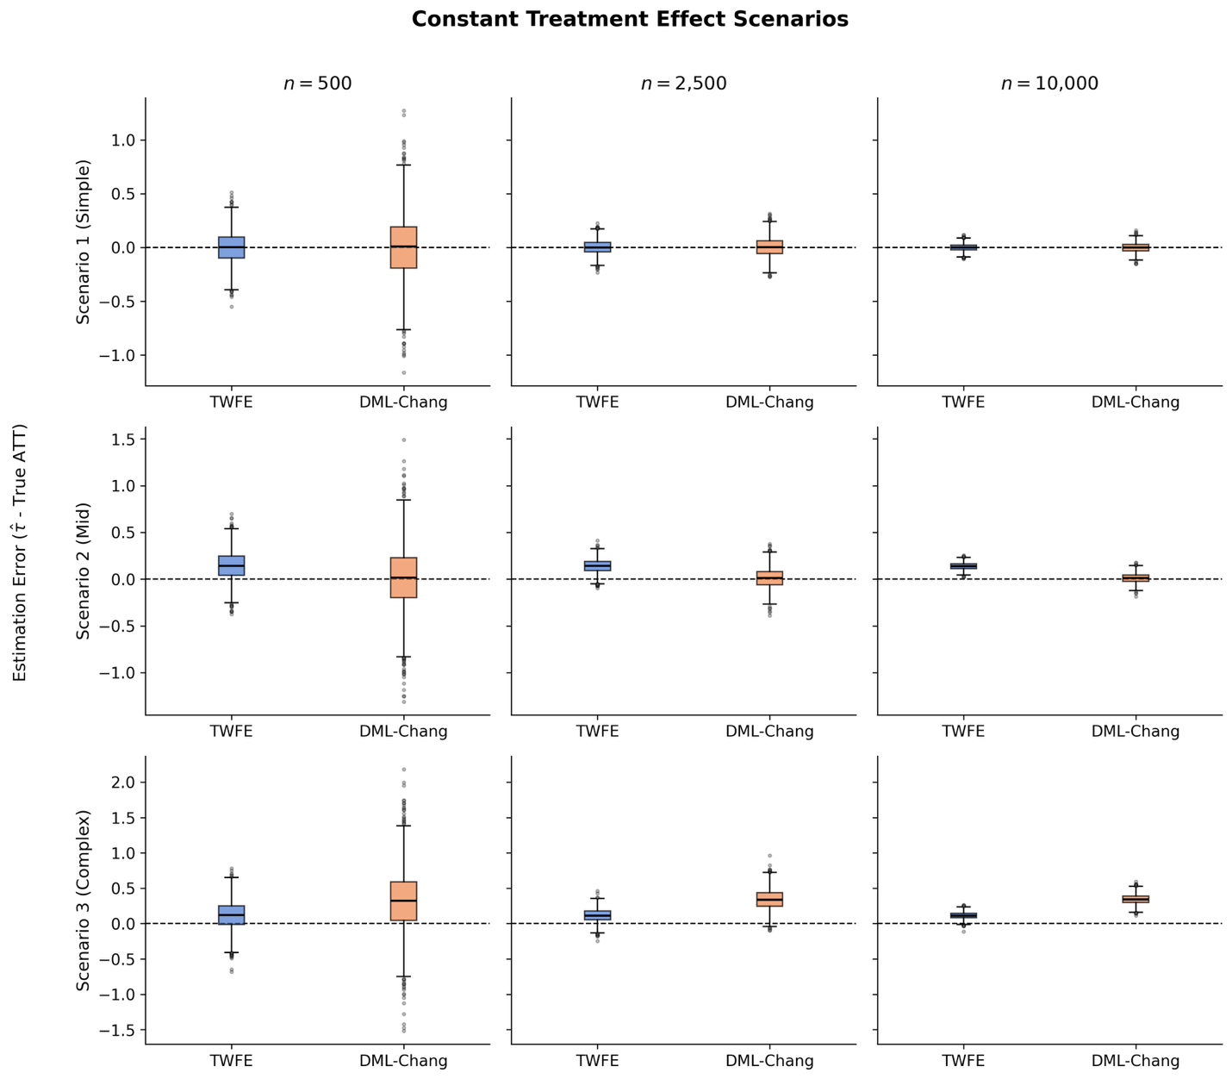
Figure 4: Distribution of estimation errors across simulation scenarios 1,2 & 3 comparing TWFE and DML estimators on simulated data with 500, 2500 & 10000 units. The dashed line at zero indicates unbiased estimation.
Scenario 1 (simple) confirms this: both estimators are unbiased and TWFE maintains a slight RMSE advantage. Scenario 2 (mid) reveals the benefit of removing the mismatch. DML-Chang’s bias drops from $-0.06$ in Scenario 5 to 0.01, and it achieves an RMSE of 0.051 against TWFE’s 0.142 at $n=10,000$ with unbiased results for the three sample sizes, while TWFE is biased. However, in Scenario 3 (complex) remains approximately 0.35 even at $n=10,000$ and both estimators are biased. This confirms that the dominant source of error in complex settings is the ML models’ difficulty in estimating nuisance functions from first-differenced data, not the estimand mismatch.

4.3.2. Two-Period Scenarios (4, 5, 6)
The two-period scenarios (Figure 5) provide the cleanest comparison, since DML-Chang was designed for this setting: the first-differencing step discards no information, and the target parameter aligns exactly with the overall ATT.
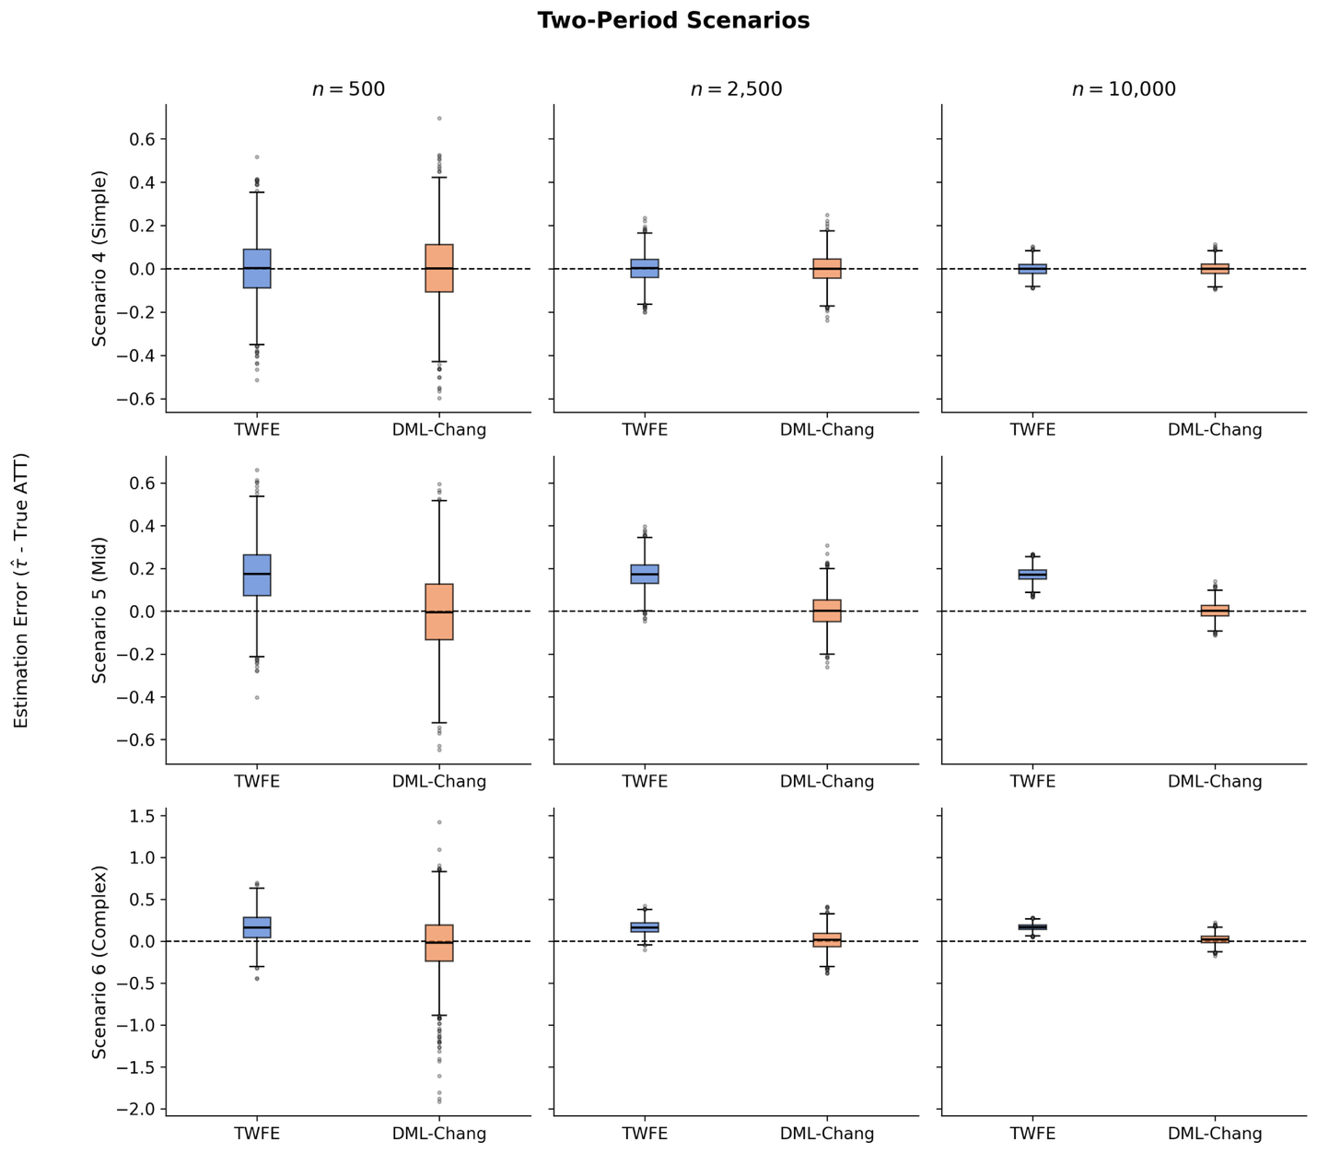
Figure 5: Distribution of estimation errors across simulation scenarios 4, 5 & 6 comparing TWFE and DML estimators on simulated data with 500, 2500 & 10000 units. The dashed line at zero indicates unbiased estimation.
In Scenario 4 (simple confounding), both estimators perform well, with TWFE holding a slight RMSE edge due to its parametric efficiency (0.136 vs. 0.167 at $n=500$). This is expected: with weak linear confounding and no covariate effect in $Y\left(0\right)$, TWFE is correctly specified. As confounding increases, however, DML-Chang pulls ahead. In Scenarios 5 and 6, TWFE carries an irreducible bias of approximately 0.17, while DML-Chang remains nearly unbiased. At $n=500$, DML-Chang’s higher variance still makes its RMSE worse in Scenario 6 (0.355 vs. 0.240). By $n=10,000$, however, the variance has shrunk and DML-Chang achieves an RMSE of 0.059 against TWFE’s 0.170. Across all three scenarios, DML-Chang’s RMSE drops sharply as the sample grows, reflecting improved nuisance function estimates. TWFE’s RMSE in the mid and complex cases, by contrast, is bounded by its bias floor.

4.3.4. Six-Period Non-Staggered Scenarios (7, 8, 9)
These scenarios introduce a structural challenge for DML-Chang. The estimator operates on first-differenced data, using only the last pre-treatment and first post-treatment period. With dynamic treatment effects ($δ_{e}=e$), the ATT at the first post-treatment period is smaller than the average across all post-treatment periods, creating an estimand mismatch. Results are shown in Figure 6.
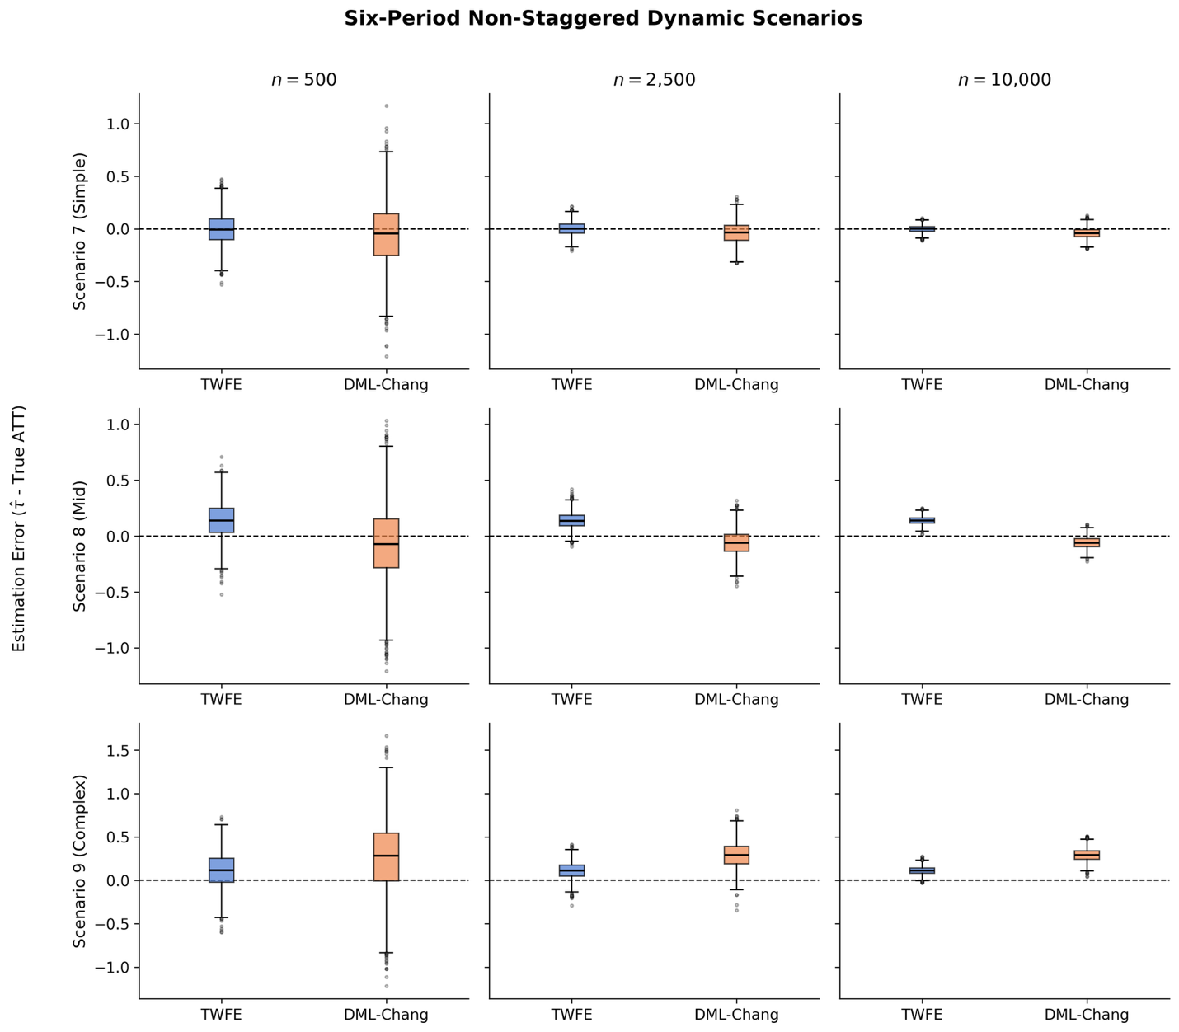
Figure 6: Distribution of estimation errors across simulation scenarios 7, 8 & 9 comparing TWFE and DML estimators on simulated data with 500, 2500 & 10000 units. The dashed line at zero indicates unbiased estimation.
In Scenario 7 (simple confounding), TWFE outperforms DML-Chang: its bias is zero and its RMSE is roughly half of DML-Chang’s at every sample size. DML-Chang exhibits a persistent negative bias of approximately $-0.04$ to $-0.05$, consistent with the estimand mismatch. Scenario 8 (mid confounding) presents a trade-off: both estimators are biased, but TWFE’s bias (approximately 0.14) is larger. DML-Chang overtakes TWFE in RMSE only at $n=10,000$ (0.079 vs. 0.144); neither estimator is fully satisfactory as both are consistently biased.
Scenario 9 (complex confounding) is the most notable result in this block. DML-Chang’s RMSE exceeds TWFE’s at every sample size (0.501 vs. 0.230 at $n=500$; 0.299 vs. 0.122 at $n=10,000$). Here, the bias is driven not only by the estimand mismatch but also by the ML models’ difficulty in capturing complex nonlinear nuisance functions from the limited first-differenced data. This demonstrates that DML is not a universal improvement: when the estimator’s structural assumptions are violated, ML-based nuisance estimation can amplify rather than reduce error. Once again, even if TWFE has an edge on RMSE, both fail to recover the true effect consistently.

4.3.5. Staggered Scenarios (10, 11, 12)
The staggered scenarios (Figure 7) produce the clearest results. DML-Multi achieves near-zero bias across all complexity levels and sample sizes, with RMSE declining from 0.133–0.193 at $n=500$ to 0.026–0.036 at $n=10,000$.
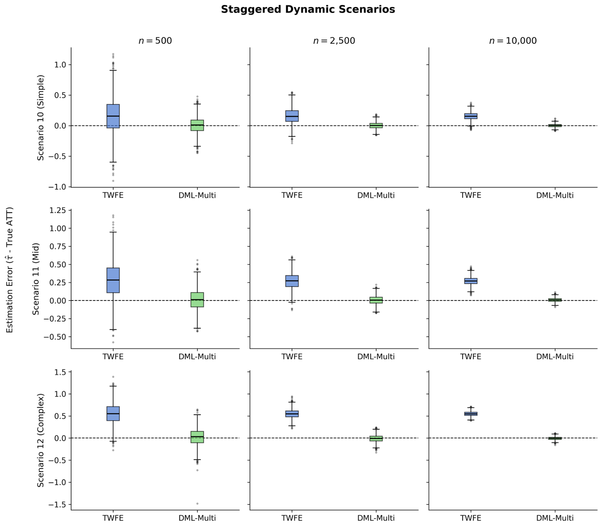
Figure 7: Distribution of estimation errors across simulation scenarios 10, 11 & 12 comparing TWFE and DML estimators on simulated data with 500, 2500 & 10000 units. The dashed line at zero indicates unbiased estimation.
TWFE, by contrast, exhibits substantial bias. Its RMSE barely declines with sample size because the bias floor dominates: from 0.330 to 0.166 in Scenario 10, and from 0.373 to 0.274 in Scenario 11. In Scenario 12, TWFE’s RMSE of 0.550 at $n=10,000$ represents nearly half the magnitude of the true ATT ($-1.195$), while DML-Multi’s RMSE is just 0.036. This result is consistent with the negative weighting problem discussed in Chapter 2. TWFE implicitly uses negative weights on certain group-time effects when treatment adoption is staggered, producing bias even when parallel trends hold unconditionally. DML-Multi avoids this by estimating group-time specific ATTs with proper aggregation weights.

5. Applications
This chapter presents two comparative applications to illustrate how DML estimators compare against traditional estimators for Difference-in-Differences (DiD). Two distinct settings are examined: first, a canonical case where treatment was implemented at a single point in time, and second, a staggered adoption setting where treatment was adopted in different periods. For the first case, the analysis from González (2025) is replicated, which estimates the effect of fracking on environmental regulatory activities using a classic DiD approach. In this setting, significant differences between the methods are not expected because of the number of variables included and the unbiased estimator chosen by the author. In the second case, the impact of Castle Doctrine laws on homicide rates (2013) is analyzed, a well-known example in the literature that highlights the limitations of traditional Two-Way Fixed Effects (TWFE) estimators in staggered adoption designs.
In both applications, several iterations of the DML DiD estimators are run with different random seeds to ensure stability in the estimates, and average results across runs are reported.

5.1. Difference-in-Differences with Treatment in One Period
The analysis begins by reproducing the results from González (2025), specifically the initial sections where the author uses the Difference-in-Differences (DiD) method for estimating the effect of fracking on environmental regulatory activities. The dataset contains 143,275 observations from fracking wells at the zip-code-year level. The data focuses on states where the fracking boom was more pronounced: Arkansas, Louisiana, North Dakota, Oklahoma, Pennsylvania, Texas, and Virginia. In the original paper, three different dependent variables are used, all measured at the zip-code-year level: (1) Actions, the total number of environmental activities; (2) Facilities, the total number of facilities that received at least one regulatory action; and (3) Formal, the total number of formal environmental activities.

5.1.1. Replication of Gonzáles
The author also included county-level employment and total establishments as control variables. These variables serve as proxies for local economic activity and help isolate the impact of fracking on regulation. It is important to note that while the original paper presented estimations both with and without controls, the focus is only on reproducing the estimations that include controls.
More formally and following the structure from the paper, the Two-Way Fixed Effects (TWFE) estimation equation can be expressed as:
$$\begin{aligned}\begin{aligned}log(1+y_{it})&=α+δ {\text{fracked}}_{i}+γ {\text{Post 2005}}_{t} \\ & +θ ({\text{fracked}}_{i}times{\text{Post 2005}}_{t})+vX_{it}+μ_{i}+ν_{t}+ϵ_{it}\end{aligned}\#\left(5.1\right)\end{aligned}$$
where $i$ represents zip codes and $t$ represents years. The dependent variable $y$ it is the log-transformed outcome, using the $log\left(1+y_{it}\right)$ transformation to accommodate zero values for Actions, Facilities, and Formal. Following the notation from previous chapters, our coefficient of interest is $θ$, which represents the DiD estimate, $X$ it is a vector of control variables (employment and establishments). $μ_{i}$ and $ν_{t}$ represent zip-code and year fixed effects, respectively. Finally, $ϵ$ it is the error term. Standard errors are clustered at the zip-code level, the unit at which treatment was assigned. While the model estimates all the parameters described above, our focus is on $θ$, as the other terms (including the main effects $fracked_{i}$ and $Post_{2005t}$) serve to isolate the causal effect.
As the specification shows, the treatment $Post_{2005t}$ occurred in the same year (2005) for all treated zip codes. This date was chosen as it marks when technological advancements made fracking broadly profitable. This scenario represents a classic Difference-in-Differences (DiD) setup, for which the Two-Way Fixed Effects (TWFE) specification above is appropriate.

5.1.2. Double Machine Learning
With this setup, the discussion now turns to the Double Machine Learning approach. The DML DiD estimator, as formally introduced in a previous chapter, is applied to estimate the causal effect of fracking on regulatory activities in the non-energy sector. Following Chang (2020), the DML estimator was adapted to the DiD setting with a single treatment period. The critical difference between PanelOLS (TWFE) and DML DiD is in how covariates $X$ are handled. PanelOLS assumes a linear and additive relationship between controls and the outcome. DML DiD makes no such assumption and instead uses flexible machine learning to capture potentially nonlinear and interactive relationships between controls and outcomes.
As described in the previous chapter, estimating the Average Treatment Effect on the Treated requires nuisance functions obtained via cross fitting. Based on the score function for the ATT, the following functions are estimated using gradient boosting trees: (1) the outcome model $g_{θ(X)}=E[Y_{i1}-Y_{i0}|D=0,X]$ predicts the change that a unit would have experienced without treatment based on covariates $X$. This flexibly models parallel trends conditional on $X$ and (2) the treatment model (propensity score) $m(X)=E[D=1|X]$ predicts the probability that a unit belongs to the treatment group given its covariates.
Given the different nature of the nuisance functions, a regression model is used for $g$ (because the outcome change is numeric) and a classification model for $m$ (because treatment is binary). Concretely, LightGBM (2017) is employed, an efficient implementation of gradient boosting trees (2001) that supports both tasks in a unified framework. This tree based, nonparametric method builds decision trees sequentially, with each new tree trained to correct the residuals of the previous one. To mitigate overfitting, a shrinkage parameter (learning rate) regulates the contribution of each tree.
LightGBM was chosen for its strong predictive performance and computational efficiency. For reference, training the two models with cross fitting took about fourteen seconds on a MacBook Air M3 with twenty-four gigabytes of memory. In this implementation, default hyperparameters from the library performed well, and robustness checks with alternative settings did not yield materially different results.
A further advantage is that gradient boosting trees do not perform explicit variable selection. As noted by Wüthrich and Zhu (2023), methods like Lasso may drop covariates under strong penalization. While acceptable for pure prediction, this can be problematic in causal settings if important controls are removed, leading to biased nuisance function estimates and, in turn, biased treatment effect estimates. Using trees avoids dropping included controls and reduces this risk.

5.1.3. Comparing results
The results of both estimations are compared in Figure 8 and a table with all the results can be found in the appendix. Both estimators yield nearly identical results, with point estimates that are positive and statistically significant across all three outcomes. For Actions, TWFE estimates a coefficient of 0.089 while DML yields 0.088. For Facilities, both methods produce an estimate of 0.086. For Formal activities, TWFE estimates 0.091 and DML estimates 0.090. The confidence intervals are also nearly overlapping across all specifications.
This similarity is expected and instructive for two reasons. First, treatment occurs in a single period for all treated units. In this canonical DiD setting, TWFE is known to provide unbiased estimates of the average treatment effect on the treated under the parallel trends’ assumption. There is no staggered adoption that could introduce the negative weighting problems documented in recent DiD literature. Second, the specification includes only two control variables: county-level employment and total establishments. With such a parsimonious set of covariates, there is limited scope for complex nonlinear or interactive relationships that might be better captured by machine learning methods. The linear specification used in TWFE appears adequate for modeling how these controls relate to the outcome.
The close agreement between TWFE and DML serves as a valuable validity check. It confirms that both approaches appropriately handle this standard DiD design and that the DML implementation is working as intended. Importantly, this result also establishes a baseline for the subsequent staggered adoption analysis, where the methods are expected to diverge. The contrast between the single-period and staggered settings will illustrate when flexible machine learning methods and robust DiD estimators provide meaningful advantages over traditional TWFE specifications.
Figure 8: Treatment effect estimates for the impact of fracking on environmental regulation outcomes using TWFE (blue) and DML (orange) estimators. Point estimates and 95 percent confidence intervals are shown for three outcomes: Actions (total regulatory activities), Facilities (facilities receiving actions), and Formals (formal enforcement activities). All outcomes use log transformations. Both estimators yield nearly identical results, with point estimates that are positive and statistically significant across all three outcomes.

5.2. Staggered difference in differences
This section presents an application in a staggered adoption setting where the treatment is implemented in different periods for different units. The impact of Castle Doctrine laws on homicide is analyzed, a well-known example in the literature that highlights the limitations of traditional Two-Way Fixed Effects (TWFE) estimators in staggered adoption designs.
The dataset contains annual data from 2000 to 2010 for all states in the US. The treatment variable indicates whether a state has implemented a Castle Doctrine law in a given year. Castle Doctrine laws, which expand the right to use deadly force in self-defense within one’s home, were adopted by various states at different times during the study period. This staggered adoption creates a complex treatment landscape that challenges traditional DiD methods.
That is why this section compares the traditional TWFE estimator with the DML DiD estimator adapted for staggered adoption settings. The goal is to assess how each method estimates the causal effect of Castle Doctrine laws on homicide rates, considering the potential biases introduced by staggered treatment timing.

5.2.1. Two-Way-Fixed-Effects
The traditional TWFE model for this staggered adoption setting can be specified as follows:
$$\begin{aligned}y_{it}=β_{1} {\text{CastleDoctrine}}_{it}+β_{2}X_{it}+μ_{i}+ν_{t}+ϵ_{it}\#\left(5.2\right)\end{aligned}$$
where $y_{it}$ represents the homicide rate in state $i$ at time $t$, ${\text{CastleDoctrine}}_{it}$ is a binary indicator of whether the Castle Doctrine law is in effect, $X_{it}$ represents a vector of control variables, $μ_{i}$ and $ν_{t}$ are state and year fixed effects, respectively, and $ϵ_{it}$ is the error term. The coefficient $β_{1}$ captures the average treatment effect of the Castle Doctrine laws on homicide rates.
This is a classic TWFE specification, but as highlighted in recent literature, it may produce biased estimates in staggered adoption settings due to the presence of negative weights and heterogeneous treatment effects. However, is important to notice that when the authors originally analyzed this data, the limitations of TWFE in staggered settings were not yet widely recognized and this model was commonly used. Besides, authors included several robust check s to validate their results.

5.2.2. Double Machine Learning
To address the potential biases of the TWFE estimator in this staggered adoption context, the Double Machine Learning (DML) DiD estimator adapted for staggered treatments is applied. This approach allows for flexibly modeling the relationships between covariates and outcomes while accounting for the complex treatment timing.
Following the framework introduced in a previous chapter, the necessary nuisance functions are estimated using Random Forest (Breiman, 2001a) to capture nonlinearities and interactions among covariates. Once again, given that Random Forest does not select variables, the potential biases that other methods might have are avoided. The key nuisance functions include: (1) the outcome model $g_{θ}\left(X\right)=E\left[Y_{it} | D_{it}=0,X\right]$, which predicts the potential outcome without treatment based on covariates $X$, and (2) the treatment model (propensity score) $m(X)=E[D_{it}=1|X]$, which estimates the probability of treatment given covariates.
With this setup, unbiased estimates of the Average Treatment Effect on the Treated (ATT) in this staggered adoption setting can be presented, mitigating the biases associated with traditional TWFE methods.

5.2.3. Comparing results
compares the estimated effects of Castle Doctrine laws on homicide rates using both the traditional TWFE estimator and the DML DiD estimator adapted for staggered adoption settings. The results reveal notable differences between the two methods. The TWFE estimator with the defined specification showed a positive but non-significant effect of Castle Doctrine laws on homicide rates, with a point estimate close to zero and wide confidence intervals that include zero. This is not consistent to the findings from Cheng and Hoekstra (2013), where the author found a significant increase in homicides after the implementation of Castle Doctrine laws. This discrepancy is attributed to the limitations of TWFE in staggered settings, as is known to produce biased estimates under such conditions, potentially obscuring true treatment effects under certain specifications.
Figure 10: Comparison of the estimated effects of Castle Doctrine laws on homicide rates using the traditional TWFE estimator and the Double Machine Learning DiD estimator adapted for staggered adoption settings. The confidence intervals are presented for both methods, and the horizontal line at zero indicates no effect.
On the other hand, the DML DiD estimator produced a positive and statistically significant effect at 1%, with a point estimate indicating an increase in homicide rates following the implementation of Castle Doctrine laws. The confidence intervals for the DML estimate were narrower and did not include zero, suggesting a more precise estimation of the treatment effect. This finding aligns more with the literature that suggests Castle Doctrine laws may lead to higher homicide rates, buts showing a stronger effect than previously reported. This effect can be attributed to the DML DiD estimator’s ability to flexibly model covariates relationships and properly account for the staggered treatment timing, reducing potential biases present in the TWFE approach. The divergence in results between the TWFE and DML DiD estimators underscores the importance of choosing appropriate methods for causal inference in staggered adoption settings.
Another interesting result emerges when the event study analysis is added to the comparison. This approach allows for assessing the parallel trends assumption and examining the dynamic evolution of treatment effects. Under the parallel trends’ assumption, statistically insignificant estimates in the pre-treatment periods are expected, followed by significant effects in the post-treatment periods if a causal impact exists.
Table (1) presents the dynamic treatment effects of Castle Doctrine laws on log homicide rates relative to the year of adoption, estimated using the Double Machine Learning DiD approach. Statistically significant coefficients at -6 and -1 years prior to adoption are observed. While significant pre-trends can challenge the validity of the design, it is worth noting that these estimates do not exhibit a systematic trend (e.g., a monotonic divergence). Instead, they fluctuate around zero, suggesting that these significance levels may be driven by specific year-state shocks or noise rather than a fundamental violation of the parallel trends’ assumption. The significant coefficient at $t=-1$ might also reflect anticipation effects, where behavior changes shortly before the law’s enactment.
Focusing on the post-treatment period, a consistent pattern is observed: significant positive effects emerge at $t=0$ and persist in subsequent years (1-, 2-, and 4-years post-adoption). Unlike the pre-period fluctuations, the post-treatment coefficients are consistently positive, reinforcing the main DML DiD finding that Castle Doctrine laws are associated with an increase in homicide rates.
Table 3: Event Study Results for Chapter 4: Dynamic treatment effects of Castle Doctrine laws on log homicide rates by years relative to adoption. Estimates from Double Machine Learning DiD with 95% confidence intervals. Significant pre-trends and post-treatment effects are marked with asterisks: *p<0.10, **p<0.05, ***p<0.01
Years | Coef | Std. Err. | $$2.5$$ | $$97.5$$
-7 years | -0.069 | 0.110 | -0.289 | 0.147
-6 years | 0.253*** | 0.114 | 0.044 | 0.476
-5 years | -0.015 | 0.070 | -0.151 | 0.123
-4 years | -0.028 | 0.067 | -0.160 | 0.103
-3 years | 0.008 | 0.061 | -0.105 | 0.127
-2 years | 0.057 | 0.051 | -0.046 | 0.157
-1 years | -0.113** | 0.054 | -0.223 | -0.006
0 years | 0.120** | 0.046 | 0.016 | 0.211
1 years | 0.122* | 0.061 | -0.002 | 0.242
2 years | 0.144* | 0.075 | -0.003 | 0.291
3 years | 0.113 | 0.081 | -0.049 | 0.272
4 years | 0.165** | 0.078 | 0.011 | 0.318
Although the pre-treatment period exhibits some volatility, the structural break in coefficients following adoption suggests a meaningful impact of Castle Doctrine laws. The sustained increase in homicide rates post-treatment aligns with theoretical expectations and corroborates prior empirical findings. Furthermore, the robustness of the overall DML DiD estimate, which aggregates these dynamic effects, supports the conclusion of a positive causal effect. While the pre-trends warrant a cautious interpretation, the contrast between the noisy pre-period and the consistently positive post-period provides evidence that the laws contributed to higher homicide rates. Future research could explore additional robustness checks or alternative specifications to further validate these findings.

6. Conclusion
This thesis has explored the integration of Double Machine Learning (DML) techniques within the Difference-in-Differences (DiD) framework, assessing their potential to enhance causal inference in econometric analyses. By leveraging the predictive power of machine learning algorithms while preserving the interpretability of traditional econometric parameters, DML offers a robust alternative for researchers navigating complex, high-dimensional data settings.
The empirical applications provided a comparative analysis of DML-DiD against traditional Two-Way Fixed Effects (TWFE) estimators. In the canonical single-period treatment setting (fracking regulation), both methods yielded nearly identical results. This suggests that when the data generating process is relatively simple and the set of controls is small, traditional linear specifications remain adequate. However, in the more complex staggered adoption setting (Castle Doctrine laws), the methods diverged significantly. While TWFE failed to detect a significant effect, the DML-DiD estimator uncovered a positive and statistically significant impact on homicide rates. This contrast highlights the specific value of DML: its ability to flexibly model nonlinear nuisance functions and handle complex treatment dynamics where rigid linear assumptions may fail.
These findings underscore that while DML is not a panacea, it is a critical tool for modern applied econometrics, particularly when theoretical guidance on functional forms is limited. Nevertheless, as noted by Pritchett (2024), methodological sophistication cannot substitute for external validity or a deep understanding of the institutional context. DML should therefore be viewed not as a replacement for economic intuition, but as a powerful complement that improves the precision and credibility of causal estimates within a well-defined identification strategy.

References
Breiman, L. (2001a). Random Forests. Machine Learning, 45(1), 5–32. https://doi.org/10.1023/A:1010933404324
Breiman, L. (2001b). Statistical Modeling: The Two Cultures (with comments and a rejoinder by the author). Statistical Science, 16(3), 199–231. https://doi.org/10.1214/ss/1009213726
Callaway, B., & Santa’Anna, P. H. C. (2021). Difference-in-Differences with multiple time periods. Journal of Econometrics, 225(2), 200–230. https://doi.org/10.1016/j.jeconom.2020.12.001
Chang, N.-C. (2020). Double/debiased machine learning for difference-in-differences models. The Econometrics Journal, 23(2), 177–191. https://doi.org/10.1093/ectj/utaa001
Cheng, C., & Hoekstra, M. (2013). Does Strengthening Self-Defense Law Deter Crime or Escalate Violence? Evidence from Expansions to Castle Doctrine. The Journal of Human Resources, 48(3), 821–853.
Chernozhukov, V., Chetverikov, D., Demirer, M., Duflo, E., Hansen, C., Newey, W., & Robins, J. (2018). Double/debiased machine learning for treatment and structural parameters. The Econometrics Journal, 21(1), C1–C68. https://doi.org/10.1111/ectj.12097
Cunningham, S. (2021). Causal Inference: The Mixtape. Yale University Press. http://www.jstor.org/stable/j.ctv1c29t27
Desai, A. (2023). Machine Learning for Economics Research: When What and How? [Papers]. SSRN. https://doi.org/10.2139/ssrn.4404772
Friedman, J. H. (2001). Greedy function approximation: A gradient boosting machine. The Annals of Statistics, 29(5), 1189–1232. https://doi.org/10.1214/aos/1013203451
González, J. P. (2025). Environmental regulation, regulatory spillovers and rent-seeking. Public Choice, 202(1), 217–250. https://doi.org/10.1007/s11127-024-01189-7
Goodman-Bacon, A. (2021). Difference-in-differences with variation in treatment timing. Journal of Econometrics, 225(2), 254–277. https://doi.org/10.1016/j.jeconom.2021.03.014
Hatamyar, J., Kreif, N., Rocha, R., & Huber, M. (2023). Machine Learning for Staggered Difference-in-Differences and Dynamic Treatment Effect Heterogeneity (arXiv:2310.11962). arXiv. https://doi.org/10.48550/arXiv.2310.11962
Ke, G., Meng, Q., Finley, T., Wang, T., Chen, W., Ma, W., Ye, Q., & Liu, T.-Y. (2017). LightGBM: a highly efficient gradient boosting decision tree. Proceedings of the 31st International Conference on Neural Information Processing Systems, NIPS’17, 3149–3157.
Molnar, C. (2025). Interpretable Machine Learning: A Guide for Making Black Box Models Explainable (3rd ed.). https://christophm.github.io/interpretable-ml-book
Mullainathan, S., & Spiess, J. (2017). Machine Learning: An Applied Econometric Approach. Journal of Economic Perspectives, 31(2), 87–106. https://doi.org/10.1257/jep.31.2.87
Pritchett, L. (2024). “Rely (only) on the rigorous evidence” is bad advice. Review of Development Economics, 28(4), 2034–2058. https://doi.org/https://doi.org/10.1111/rode.13037
Shmueli, G. (2010). To Explain or to Predict? Statistical Science, 25(3), 289–310. https://doi.org/10.1214/10-STS330
Varian, H. R. (2014). Big Data: New Tricks for Econometrics. Journal of Economic Perspectives, 28(2), 3–28. https://doi.org/10.1257/jep.28.2.3
Wüthrich, K., & Zhu, Y. (2023). Omitted Variable Bias of Lasso-Based Inference Methods: A Finite Sample Analysis. The Review of Economics and Statistics, 105(4), 982–997. https://doi.org/10.1162/rest_a_01128

Appendix
Table 4: Model Comparison Results for Chapter 2: Classical Difference-in-Differences versus Double Machine Learning estimates (Chang 2020 methodology) for three dependent variables: Actions, Facilities, and Formal employment, showing coefficients and 95% confidence intervals. Significant effects are marked with asterisks: * p<0.10, ** p<0.05, *** p<0.01.
Model | Dep. Var. | Coef. | $$CI_{low}$$ | $$CI_{high}$$
Classic DiD | Actions | 0.2287*** | 0.1954 | 0.2621
Classic DiD | Facilities | 0.1589*** | 0.1362 | 0.1815
Classic DiD | Formal | 0.2092*** | 0.1714 | 0.2470
DML (Chang 2020) | Actions | 0.2333*** | 0.2003 | 0.2663
DML (Chang 2020) | Facilities | 0.1609*** | 0.1385 | 0.1833
DML (Chang 2020) | Formal | 0.2062*** | 0.1689 | 0.2434

Table 5: Model Comparison Results for Chapter 4: Two-Way Fixed Effects (TWFE) versus Double Machine Learning DiD estimates for the Castle Doctrine’s effect on log homicide rates. DML estimates show statistical significance at the 1% level (***), while TWFE estimates are not statistically significant.
Model | Dep. Var. | Coef | $$CI_{low}$$ | $$CI_{high}$$
TWFE | Log homicide | 0.087 | -0.032 | 0.206
DML | Log homicide | 0.130*** | 0.036 | 0.222

Table 6: Simulation results for all scenarios and units, using ‘default' ML set up
Scenario | Model | True ATT | RMSE (500) | RMSE (2,500) | RMSE (10,000)
1 | DML-Chang | 0.040 | 0.568 | 0.123 | 0.047
 | TWFE |  | 0.147 | 0.064 | 0.033
2 | DML-Chang | 0.051 | 0.636 | 0.151 | 0.058
 | TWFE |  | 0.210 | 0.157 | 0.142
3 | DML-Chang | -0.625 | 0.789 | 0.391 | 0.352
 | TWFE |  | 0.233 | 0.145 | 0.121
4 | DML-Chang | 0.118 | 0.262 | 0.076 | 0.032
 | TWFE |  | 0.136 | 0.061 | 0.030
5 | DML-Chang | 0.106 | 0.365 | 0.098 | 0.041
 | TWFE |  | 0.219 | 0.184 | 0.174
6 | DML-Chang | -0.922 | 0.661 | 0.180 | 0.077
 | TWFE |  | 0.240 | 0.181 | 0.170
7 | DML-Chang | 0.079 | 0.593 | 0.141 | 0.067
 | TWFE |  | 0.148 | 0.064 | 0.032
8 | DML-Chang | 0.124 | 0.619 | 0.162 | 0.084
 | TWFE |  | 0.213 | 0.155 | 0.144
9 | DML-Chang | -0.572 | 0.741 | 0.349 | 0.301
 | TWFE |  | 0.230 | 0.145 | 0.122
10 | DML-Multi | -0.050 | 0.154 | 0.058 | 0.027
 | TWFE |  | 0.330 | 0.200 | 0.166
11 | DML-Multi | -0.125 | 0.172 | 0.067 | 0.029
 | TWFE |  | 0.373 | 0.293 | 0.274
12 | DML-Multi | -1.195 | 0.242 | 0.103 | 0.044
 | TWFE |  | 0.596 | 0.555 | 0.550

Table 7: Simulation results for all scenarios and units, using ‘flexible' ML set up.
Scenario | Model | True ATT | RMSE (500) | RMSE (2,500) | RMSE (10,000)
1 | DML-Chang | 0.040 | 1.148 | 0.300 | 0.071
 | TWFE |  | 0.147 | 0.064 | 0.033
2 | DML-Chang | 0.051 | 1.207 | 0.301 | 0.086
 | TWFE |  | 0.210 | 0.157 | 0.142
3 | DML-Chang | -0.625 | 1.189 | 0.465 | 0.356
 | TWFE |  | 0.233 | 0.145 | 0.121
4 | DML-Chang | 0.118 | 0.876 | 0.138 | 0.040
 | TWFE |  | 0.136 | 0.061 | 0.030
5 | DML-Chang | 0.106 | 1.001 | 0.203 | 0.059
 | TWFE |  | 0.219 | 0.184 | 0.174
6 | DML-Chang | -0.922 | 1.372 | 0.315 | 0.103
 | TWFE |  | 0.240 | 0.181 | 0.170
7 | DML-Chang | 0.079 | 1.153 | 0.308 | 0.087
 | TWFE |  | 0.148 | 0.064 | 0.032
8 | DML-Chang | 0.124 | 1.142 | 0.319 | 0.102
 | TWFE |  | 0.213 | 0.155 | 0.144
9 | DML-Chang | -0.572 | 1.166 | 0.444 | 0.308
 | TWFE |  | 0.230 | 0.145 | 0.122
10 | DML-Multi | -0.050 | 0.208 | 0.087 | 0.032
 | TWFE |  | 0.330 | 0.200 | 0.166
11 | DML-Multi | -0.125 | 0.219 | 0.094 | 0.036
 | TWFE |  | 0.373 | 0.293 | 0.274
12 | DML-Multi | -1.195 | 0.285 | 0.134 | 0.058
 | TWFE |  | 0.596 | 0.555 | 0.550

Tables with ‘default’ and ‘flexible’ configurations are provided in the Appendix

