Madilyn Carpenter

Assignment 5.2

1) AVG

This function is used to calculate an average of data specified in the query. This could be utilized to calculate the average of movie ratings.

EX:

SELECT AVG(Rating)

AS average_rating

FROM Movies;

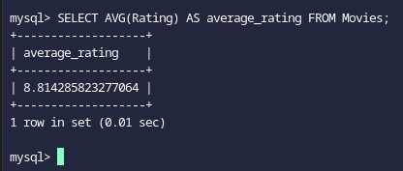

2) COUNT

This function is used to count the amount of rows that match a given condition. This could be used to select the amount of movies listed within the sci-fi genre.

EX:

SELECT COUNT(*)

AS sci_fi_count

FROM Movies

WHERE Genre = 'Sci-Fi';

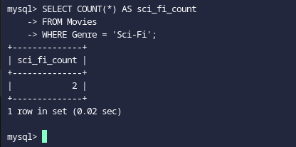

3) UPPER

This function is used to set text into an all uppercase format. This can be used to set all the movie titles into an uppercase format.

EX:

SELECT UPPER(Title)

AS uppercase_title

FROM Movies;

