## Madilyn Carpenter

## Assignment 11.2

Screenshot 1:

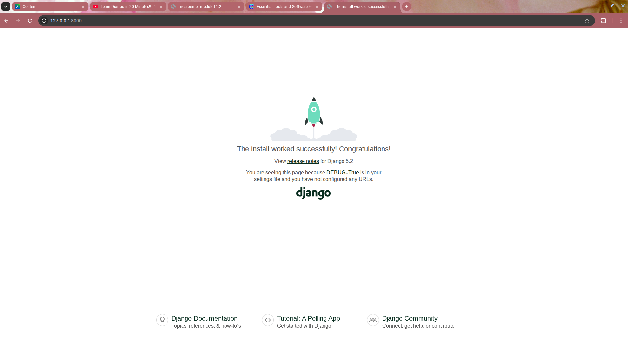

Screenshot 2:

