# Madilyn Carpenter

# Assignment 8.2

Flow Chart:

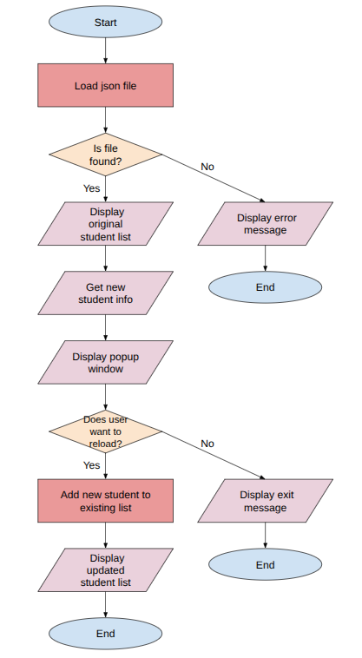  
  
Results terminal view:

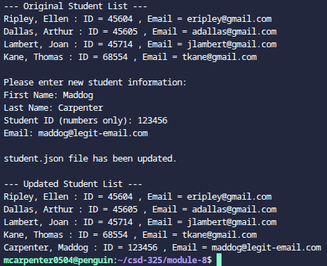

Popup screenshot (Apologies for the poor quality, I had to take the picture with my phone):

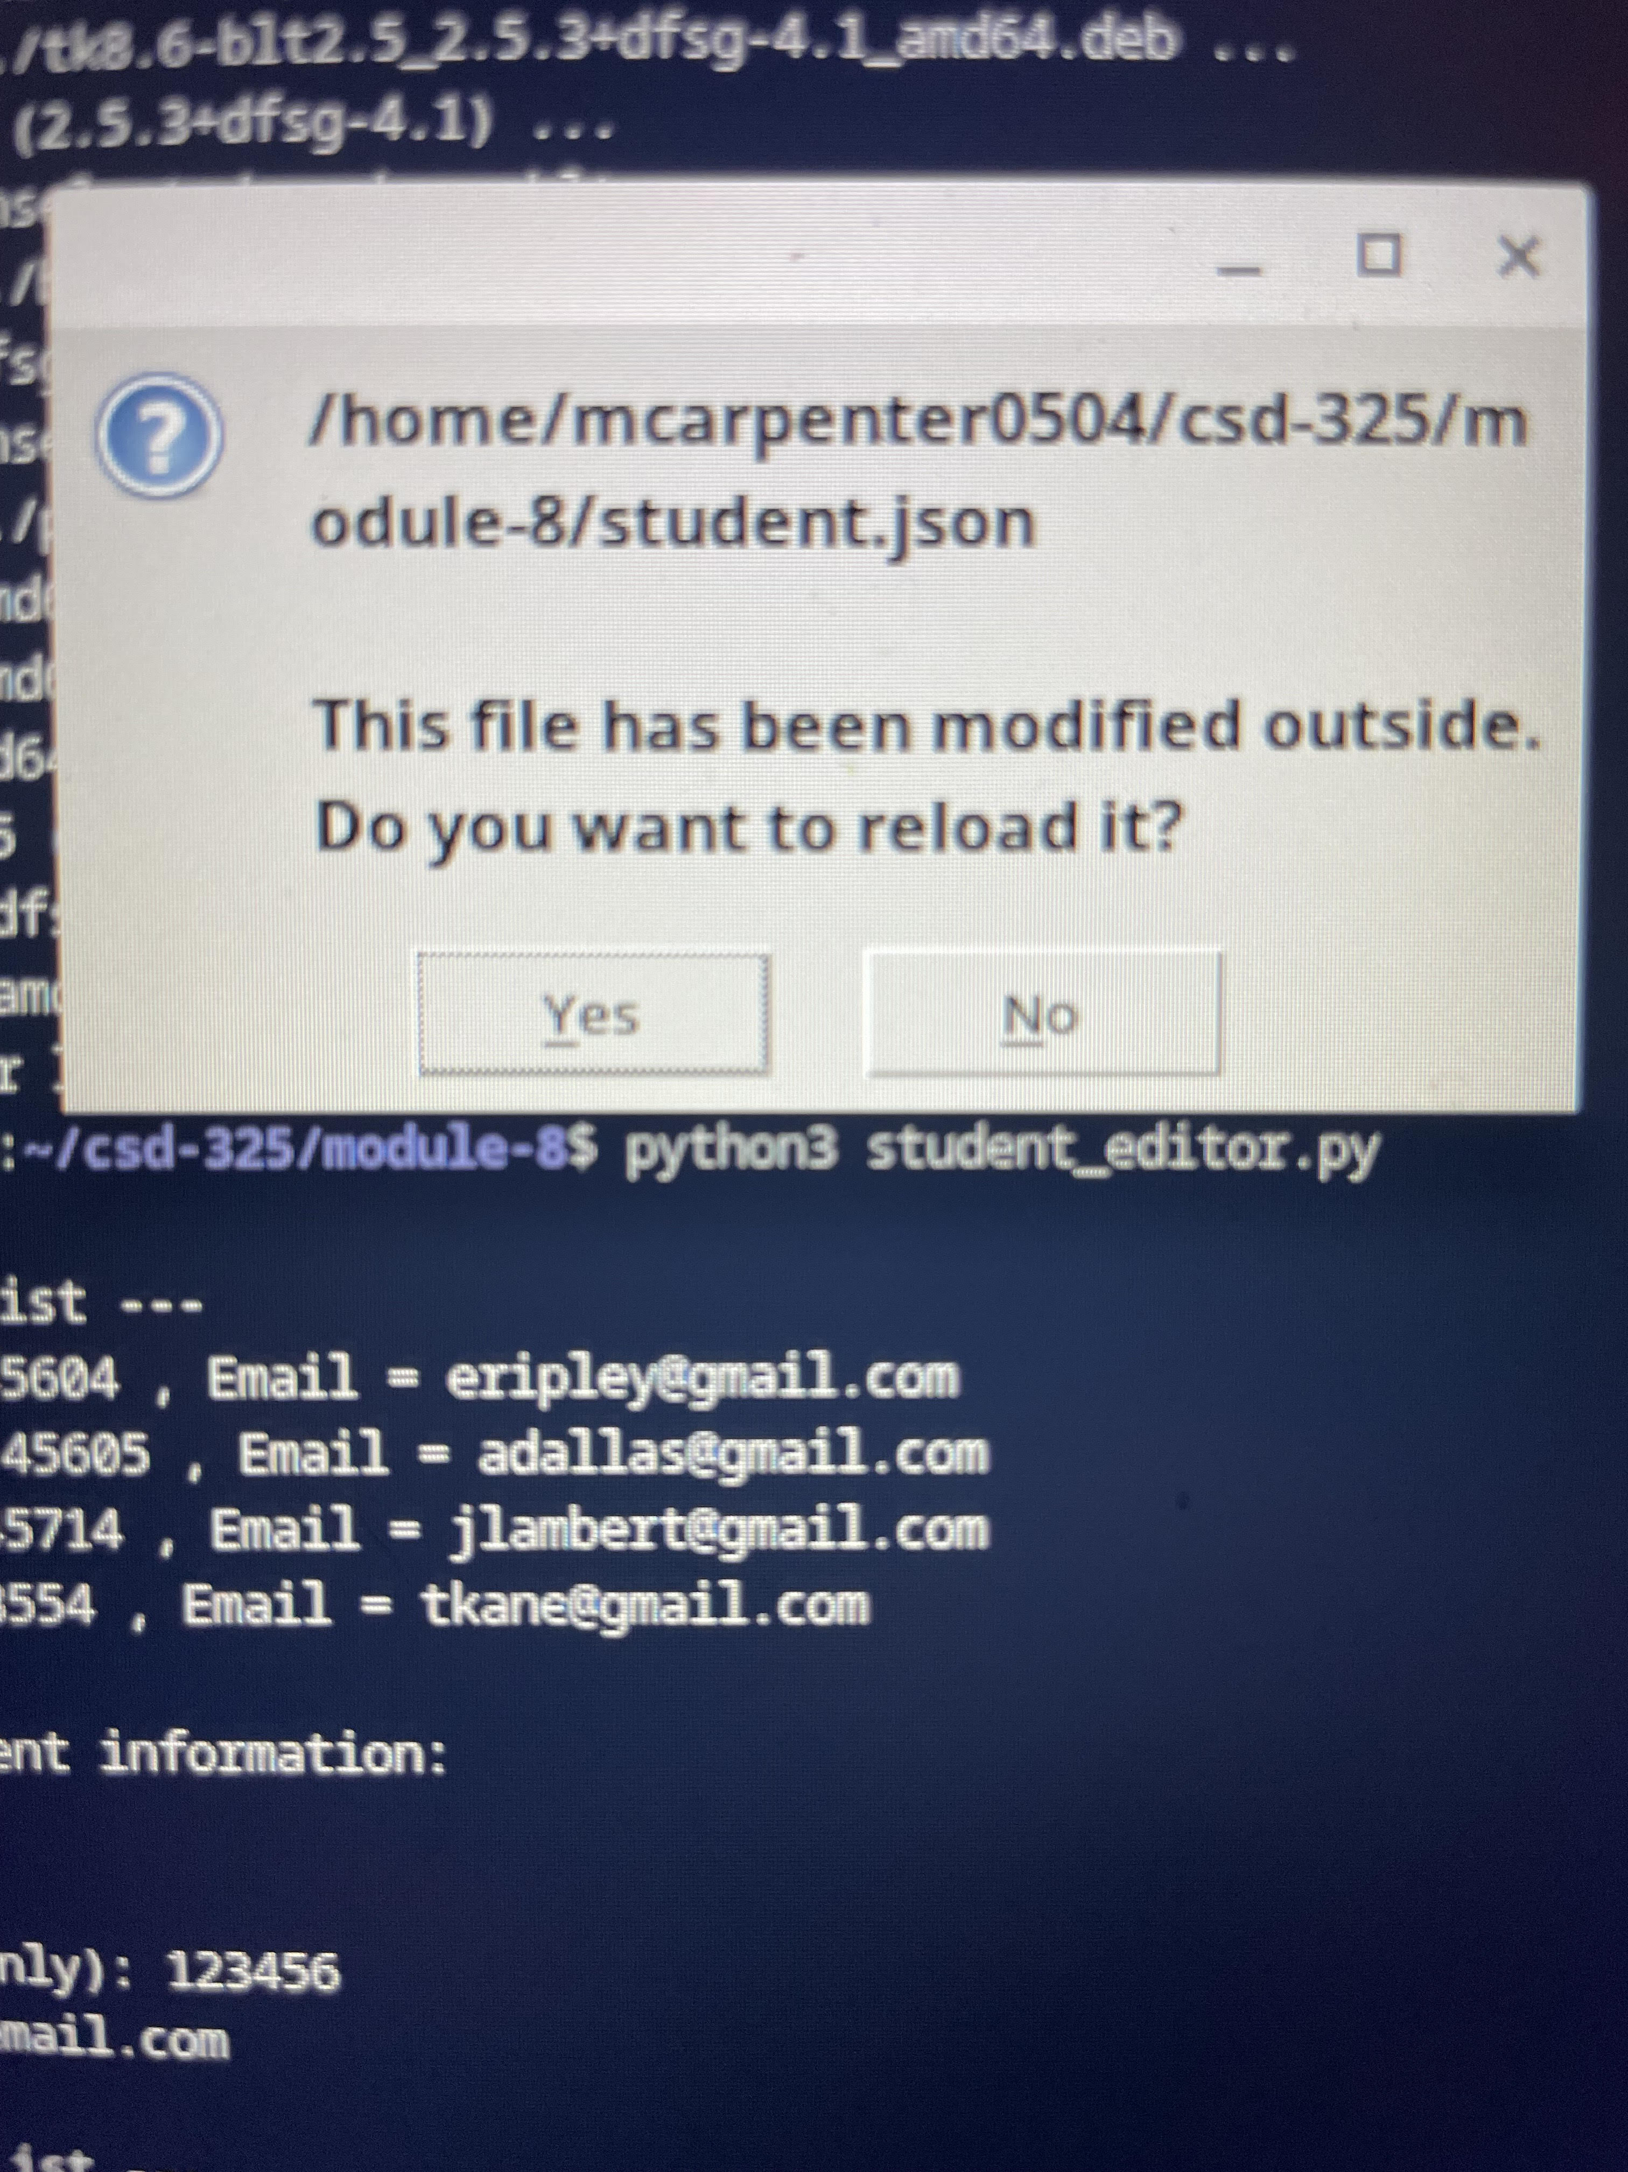

Updated json:

[

{

"F_Name": "Ellen",

"L_Name": "Ripley",

"Student_ID": 45604,

"Email": "eripley@gmail.com"

},

{

"F_Name": "Arthur",

"L_Name": "Dallas",

"Student_ID": 45605,

"Email": "adallas@gmail.com"

},

{

"F_Name": "Joan",

"L_Name": "Lambert",

"Student_ID": 45714,

"Email": "jlambert@gmail.com"

},

{

"F_Name": "Thomas",

"L_Name": "Kane",

"Student_ID": 68554,

"Email": "tkane@gmail.com"

},

{

"F_Name": "Maddog",

"L_Name": "Carpenter",

"Student_ID": 123456,

"Email": "maddog@legit-email.com"

}

]