# Madilyn Carpenter

# Assignment 9.2

Astronauts output:  
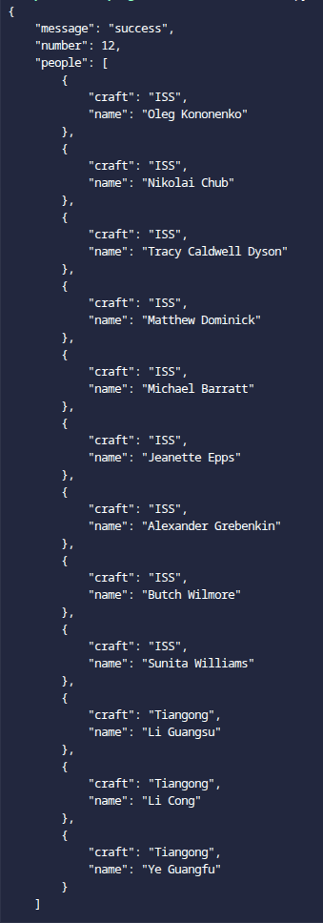

Raw response:

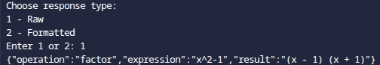

Formatted response:

