SOLS –EQE ideas

# Analytical solution with the simplest step-function approximation:

We consider a solar cell with a concrete EQE (External Quantum Efficiency, i.e. the percentual ability of the cell to convert a photon into an electron). Therefore, this EQE is a function of the wavelength () because the cell has different ability of photon conversion to electricity depending on the energy of the photon. For example, if the energy of the photon is lower than the energy band gap of the active layer (AL) material, the EQE will be as a first approximation 0 as no photon is absorbed at this energy range.

If the EQE is known, one can calculate the photocurrent () of a cell when illuminated with a specific light irradiance (which typically is the AM 1.5G solar spectrum) considering no recombination losses:

Where is the light irradiance expressed in , and is the electric charge of an electron in absolute value. Typically, the AM1.5G solar irradiance is expressed in , and therefore, the relation between both functions is:

Thus, the complete expression is:

In the Rainbow setup measurements, the incident light is a spectral fraction of the AM1.5G solar spectrum. As a first and rude approximation we can express this incident light as a step function with a cutting wavelength ():

Now we can split the integral in two parts, and because the second part corresponding to the defined integral from to infinite is zero, the expression for is:

The derivative of with respect to is the slope of the measured curves in the rainbow setup:

If we discretise the expression, we obtain:

Considering that . Finally, the equation can be rewritten as:

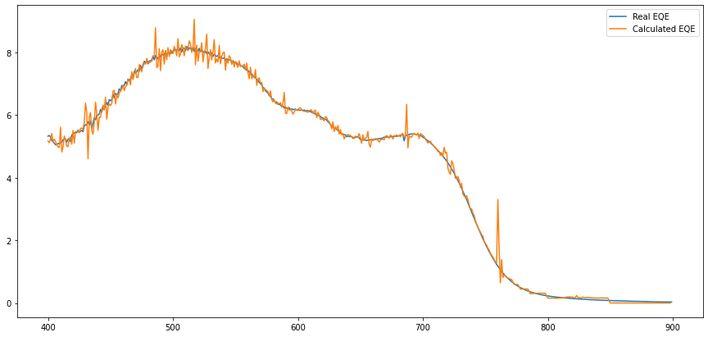

# Analytical solution with approximated Fermi-Dirac distribution

# 

# 

# 

# 

# Numerical solution with equipment-dependent matrix

Considering the same solar cell scenario in where the Jsc could be calculated as:

We assume now a more realistic scenario regarding in where the step function has a certain width and therefore, solving it analytically is more complicated. Thus, one has to think in a numerical solution. In the experiment, we make “n” measures of the Jsc at different cutting wavelengths () ideally evenly distributed in the wavelength dimension () between a low wavelength () and a high wavelength (). We can express the ith Jsc measure as a discrete sum instead of a continuous integral:

Where is the solar spectrum that the cell receives at cutting wavelength. Which is a linear equation with n summands. We can now express in the same way all the Jsc measured, in a way that we finally will have system with n lineal equations:

Therefore, one can express this linear equations system in the matrix form, to easily solve it with numpy.linalg.lstsq function in python.

In other words:

In where is a vector that contains the measured short-circuit currents at the different cutting wavelengths, is the Casademont constant matrix, which contains all the necessary information of the spectra to numerically solve the vector. Notice that matrix depends on the complete solar spectrum () but it also depends on the measuring conditions: , , , red/blue sweap. Therefore, one has to calibrate the equipment with a different for different measuring conditions, but once it is done there is no need for more calibration!

The calibration could be done by (1) measuring the spectra at each cutting wavelength and directly use this measured spectra for each cutting wavelength or (2) expressing the spectra as the convolution of the full spectra and a step function, which parameters (height, FWHM, etc…) can be fitted as a function of the cutting wavelength. This last method could be better in order to reduce the number of measures for calibration.

Here, I plot the result of this method with the Jsc results of the simulations. Notice that both Real EQE (the EQE used for the simulations) and the EQE calculated with the numerical method are exactly the same (the blue line is behind the orange one).

