Intelligent Robotics
University Master’s Degree in Artificial Intelligence
Student document. Proposed Solution

PART 1. MANIPULATION

Location object in the scene
Fill in the following obtained data.

- Blue Robot pose in meters (Cartesian coordinates):
x: -1.5935111793337722
y: -2.0056261395062993
z: 9.561
- Pose of the object to be grasped (Cartesian coordinates):
x: 4.927692616378022
y: 3.547938683792176
z: 9.799

Fill with the code that you have implemented to obtain the position of the target object to be grasped in the scene. Your code must include:

- Subscription to the appropriate topics for obtaining scene data (object information) from the camera
color_image_sub = rospy.Subscriber('/camera/color/image_raw', Image, color_image_callback)
depth_image_sub = rospy.Subscriber('/camera/depth/image_raw', Image, depth_image_callback)
camera_info_sub = rospy.Subscriber('/camera/color/camera_info', CameraInfo, camera_info_callback)

- Image filtering for color segmentation of the pixels which represents the target (object to be grasped)
# Filter red color object (HSV limits)
lower_red = np.array([0, 100, 100])
upper_red = np.array([10, 255, 255])

filtered_obj, centroide_obj, obt_detec = filter_img_objects(color_image,lower_red,upper_red)

# Publish the filtered image of the object
filtered_image_msg = bridge.cv2_to_imgmsg(filtered_obj, encoding="bgr8")
filtered_obj_pub.publish(filtered_image_msg)

- Position in pixels of the target object (represented by its center) in the camera image
fx = camera_matrix[0]
cx = camera_matrix[2]
fy = camera_matrix[4]
cy = camera_matrix[5]

px, py = centroid

x = (px - cx) * depth / fx
y = (py - cy) * depth / fy
z = depth

- Euclidean distance between the target object (represented by its center) and the camera
# Obtain the camera-object distance (depth) of the object and robot in the scene, given the previous description.
# Note: The depth image data must be converted from millimeters to meters.

if (obt_detec):
depth_obj = depth_image[centroide_obj[1], centroide_obj[0]] / 1000.0

if (robot_detec):
depth_blue = depth_image[centroide_blue[1], centroide_blue[0]] / 1000.0

- Real pose in the world of the target object. You will need to use some previously obtained results and obtain the calibration parameters of the camera to transform the coordinates of the object in the camera frame into the coordinates of the object in the world.

XYZ object: 4.992, 3.412, 9.814

Object grasping in the scene
Fill with the code that you have implemented for the following requirements.

- Define the initial pose in which you have decided to place the UR5e Robot:

ROBOT_POSITION = geometry_msgs.msg.Point(x=4.9, y=2.9, z=0)
HOME_JOINT_STATE = [-1.551, -1.630, -1.511 , -1.630, 1.432, 0.010]

- Define the ROS functions that will be required to determine the movements that will allow the UR5e robot to grasp the object.

def grasp_object(self):
try:
# 1. Create approach pose (10cm above object)
approach_pose = geometry_msgs.msg.Pose()
approach_pose.position.x = self.object_position.y - ROBOT_POSITION.y
approach_pose.position.y = ROBOT_POSITION.x - self.object_position.x
approach_pose.position.z = 0.5
approach_pose.orientation = self.move_arm.get_current_pose().pose.orientation

# 2. Move to approach position
if not self.go_to_pose_arm_goal(approach_pose):
rospy.logwarn("Approach failed")
return False

# 3. turn down the arm
approach_pose.position.z = 0.3
if not self.go_to_pose_arm_goal(approach_pose):
rospy.logwarn("Approach failed")
return False

# 4. Close gripper (using your predefined joint values)
self.go_to_joint_gripper_state(CLOSE_JOINT_STATE)
self.attach_object() # Attach for collision checking

# 5. Lift object (20cm up)
lift_pose = copy.deepcopy(approach_pose)
lift_pose.position.z += 0.2
return self.go_to_pose_arm_goal(lift_pose)

except Exception as e:
rospy.logerr(f"Grasp failed: {str(e)}")
return False

def run(self):
# State flags
detected = False
picked = False

#Control loop
rate = rospy.Rate(10)
while not rospy.is_shutdown():
#TODO call the functions to perform the task.
if not detected and self.object_position.z > 0:
print("Object detected.")
self.add_object(self.object_position)
detected = True
elif detected and not picked:
print("Picking up object...")
# Move above the object
print("Aproaching")
picked = self.grasp_object()
rate.sleep()

- Capture a sequence of movements of the UR5e robot from the initial position until the object is grasped, one frame for each of the actions you have used above to carry out the most important planned movements. You must record a video of the simulation obtained from ROS and then you can extract frames as screenshots to capture the next moments:
Initial position  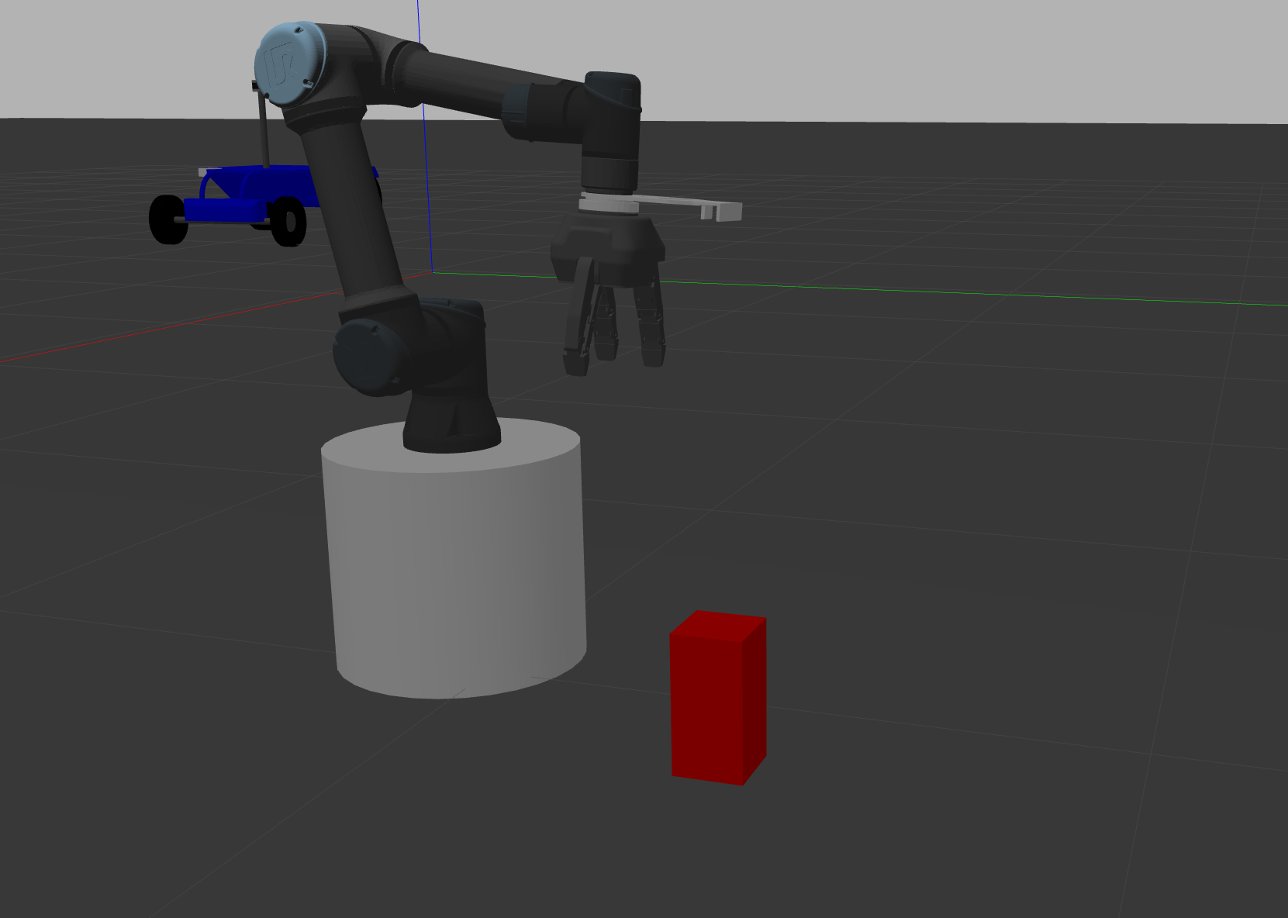 | 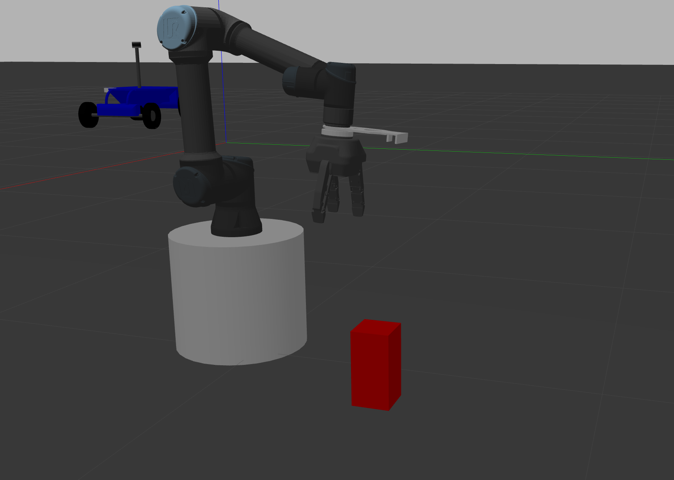  Intermediate position of the robot during approach to the object (Robot away from the object)
Intermediate position of the robot during approach to the object (Robot close to the object)  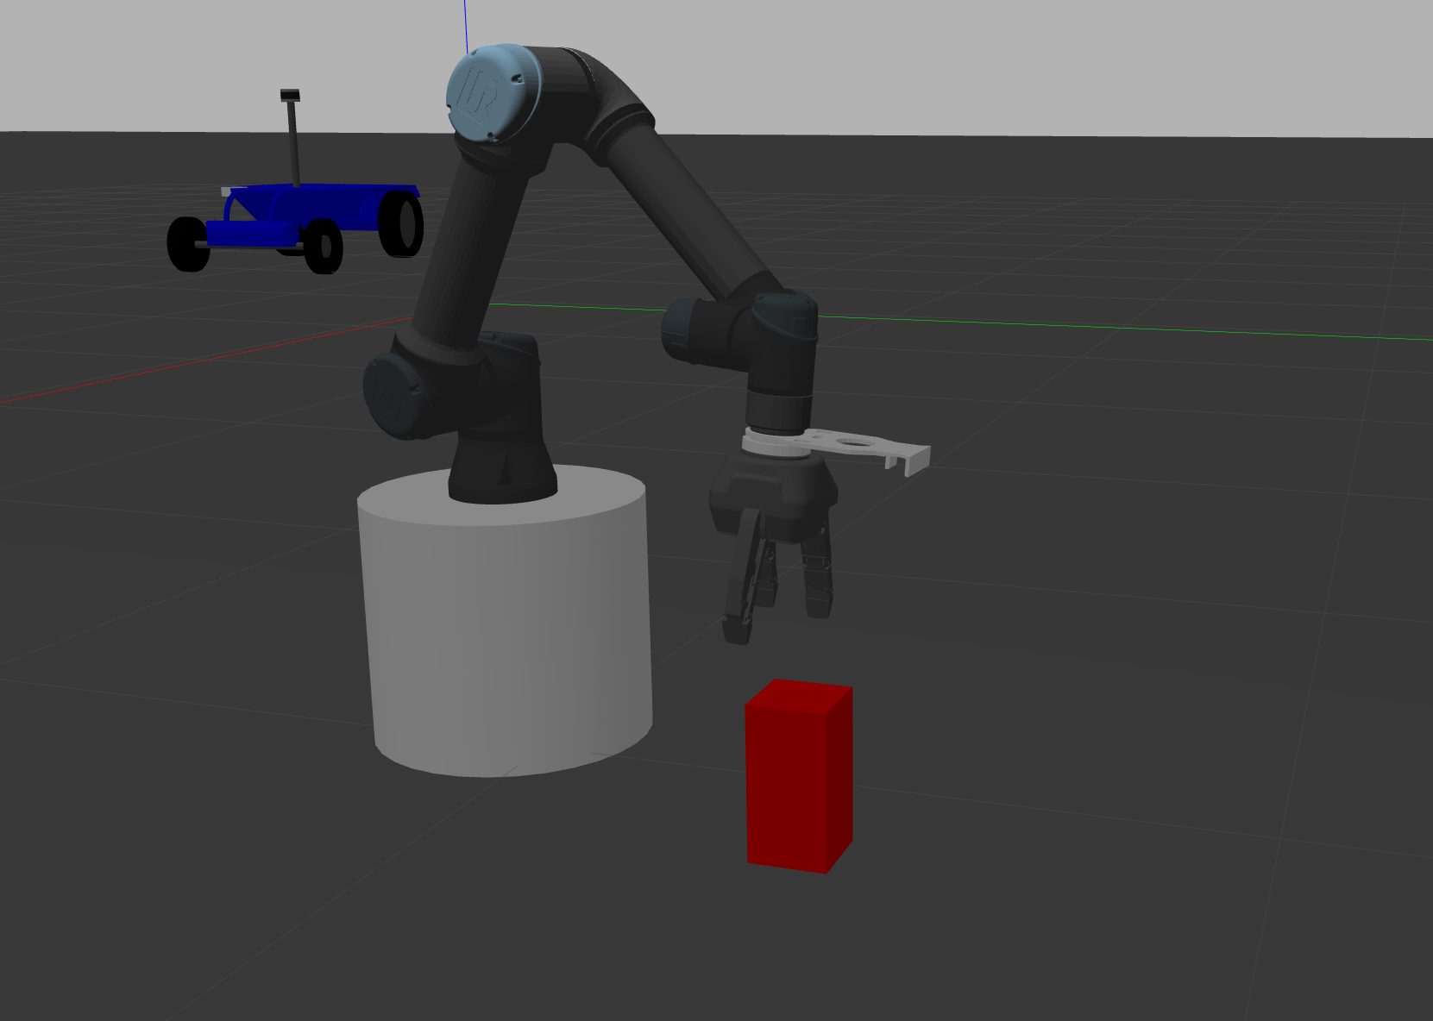 | Pre-grasping pose (Robot ready to grasp and before doing it)  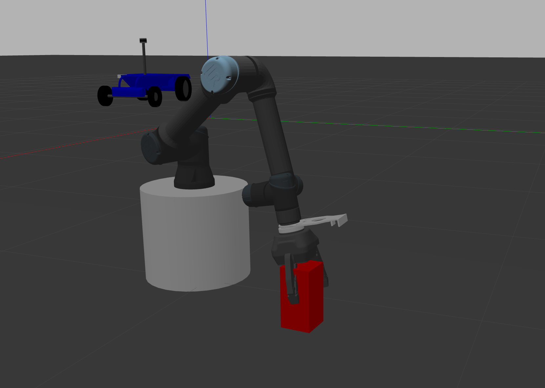
Grasping pose (Robot grasping the object)  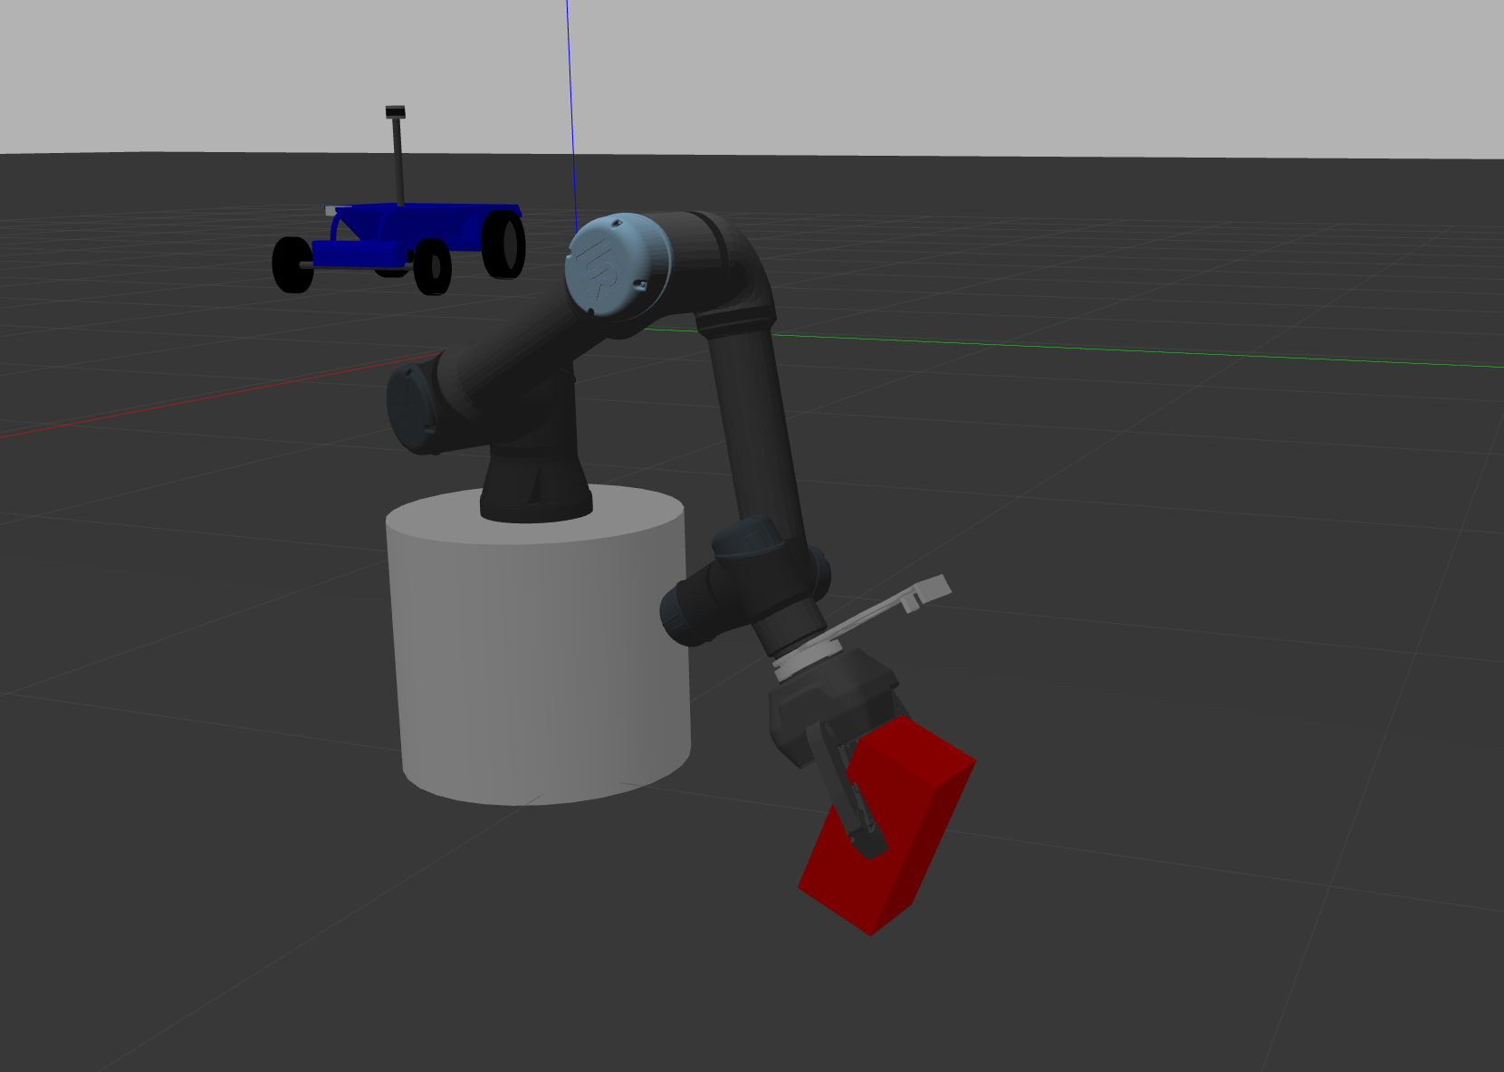 | 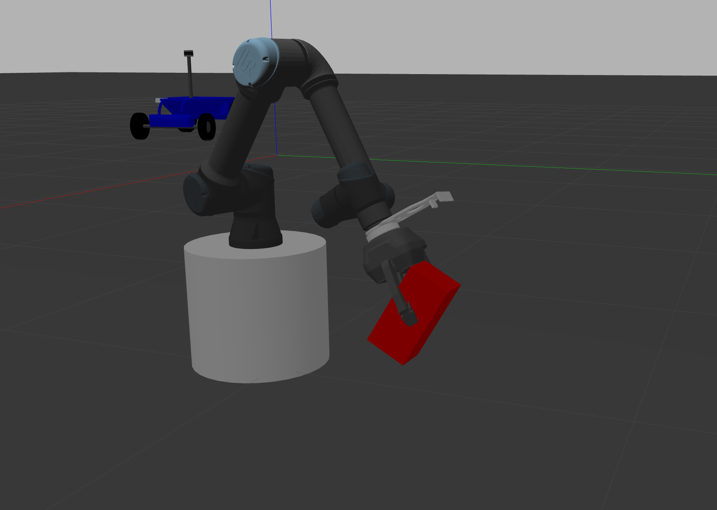  Final position (Robot lifting the object)

PART 2. NAVIGATION

Detection of obstacles
Fill with the code that you have implemented for the following requirements

- Set the appropriate height and radius values to detect obstacles around the robot:
altura = -0.4
radio = 6

- Add the desired points to the variables obstacles_points and free_zone.
if z > altura: # height condition compared to Z

# Add the point to the detected obstacles:
obstacles_points.append([x,y,z])

- Show a screenshot of a scene in Gazebo with an obstacle and its points of obstacles_points and free_zone in Rviz.

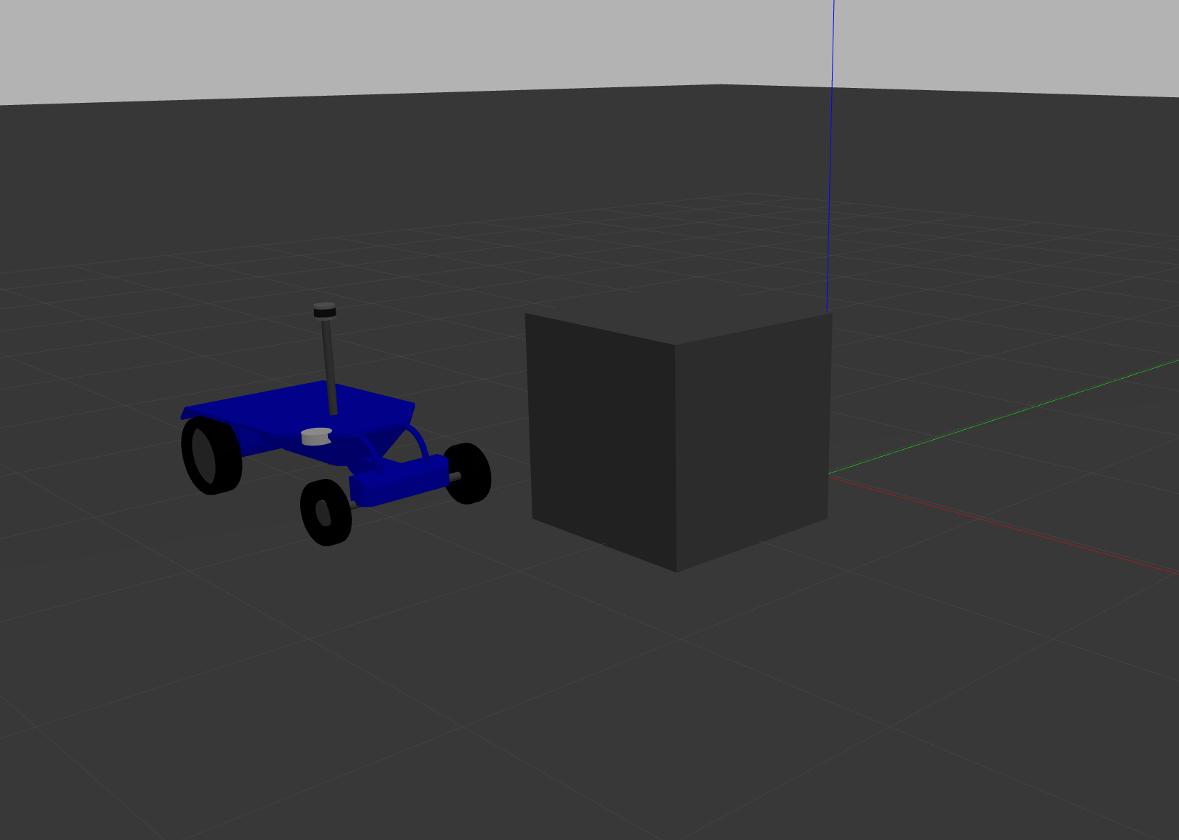

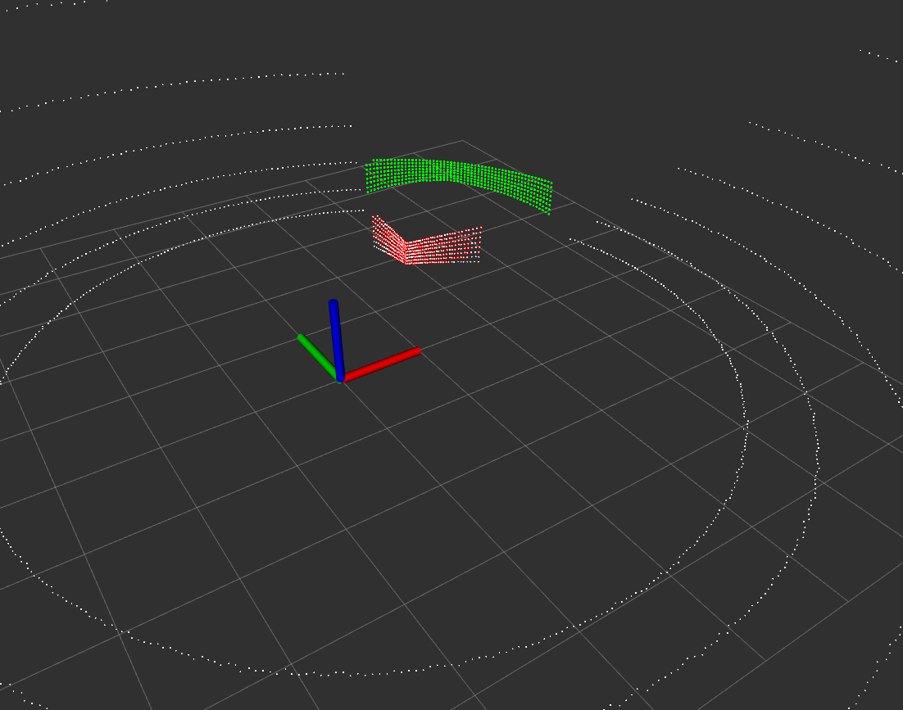

Navigation
- Explain how the target points were selected to accomplish the task.
The target point selected is
X: 4.5
Y: 2.5

A point near the UR5 robot where the arm can move to drop the object on the blue robot.

- Fill with the code to generate the trajectories using the kinematic model, and check if there is any obstacle in the trajectory.
#TODO Calculate turn radius and velocity using the robot kinematics.
R = float('inf') if abs(steer) <0.001 else VEHICLE_LENGHT/tan(steer)
omega = 0.0 if R == float('inf') else dir/R
# Calculate the trajectory using the angle rotation. Several points are sampled from the trajectory over time,
# therefore the sample variable is equivalent to the t variable in the robot kinematic equation.
for sample in np.arange(self.delta_sample, self.max_sample+0.01, self.delta_sample):
local_point=geometry_msgs.msg.Point()

#TODO calculate trajectory points using the robot kinematics.
local_point.x = dir * cos(omega * sample) * sample
local_point.y = dir * sin(omega * sample) * sample
# print(f'LOCAL POINT: {local_point.x}, {local_point.y}')
#TODO Detect collisions risk.
for obstacle in self.obstacles:
if self.distance(local_point, obstacle) < 1:
flag_collision_risk = True
pass

if flag_collision_risk: break

- Show how the score of each trajectory is calculated.

- Explain how the localization of the robot is approximated with the camera.
The object_localization.py publish in the pose_array 2 poses. Filtered with a red mask and a blue mask. The blue robot pose is given by the blue mask, and it is the second item.
We create a subscriber to /pose_array and in the position_callback we initialize the quaternion using the points given by PoseArray.

- Capture a sequence of movements of the mobile robot from the initial position until the UR5, with an obstacle in the path (without obstacle if you did the navigation but not the obstacle avoidance). Add an extra screenshot for each goal if several points were defined to maneuver. You must record a video of the simulation obtained from ROS and then you can extract frames as screenshots to capture the next moments:

The robot near the obstacle before avoiding it. | The robot avoiding the obstacle.
The robot after avoiding the obstacle. | The robot reaching the goal position.

PART 2. COORDINATE BOTH TASKS
- Capture a sequence of movements of the UR5e leaving the object in the mobile robot. You must record a video of the simulation obtained from ROS and then you can extract frames as screenshots to capture the next moments:

After approaching the mobile robot. | After leaving the object

