**Azure Subscription**

A subscription is like a container for your Azure resources. It defines:

* Billing boundary: All costs for resources are tied to a subscription.
* Access control boundary: You can assign roles and permissions at the subscription level.

You can have multiple subscriptions under one Azure account (e.g., for dev, test, and production environments).

**Resource Group**

A resource group is a logical container for related Azure resources. For example:

* A web app, its database, and storage account can all be in one resource group.
* It helps with organization, access control, and lifecycle management.

You can:

* Deploy, update, and delete resources together.
* Apply tags and policies at the group level.

**Resources**

A resource is any manageable item in Azure. Examples include:

* Virtual Machines (VMs)
* Storage Accounts
* SQL Databases
* Web Apps
* Virtual Networks

Each resource belongs to one resource group and one subscription.

**Azure Region**

A region is a geographic location where Azure data centers are located (e.g., East US, West Europe, Southeast Asia).

* You choose a region when creating resources.
* Some services are region-specific for performance and compliance reasons.

**Azure Active Directory (Azure AD)**

Azure AD is Microsoft’s identity and access management service.

* It controls who can access what in your Azure environment.
* Supports Single Sign-On (SSO), Multi-Factor Authentication (MFA), and role-based access control (RBAC).

**Role-Based Access Control (RBAC)**

RBAC lets you assign permissions to users, groups, or applications.

* Roles like Owner, Contributor, and Reader define what actions they can perform.
* You can assign roles at the subscription, resource group, or resource level.

**Tags**

Tags are key-value pairs that help you organize and manage resources.

* Useful for cost tracking, automation, and governance.
* Example: Environment = Production, Department = Finance

|  |  |
| --- | --- |
| Azure Concept | College Analogy |
| Subscription | Entire university's IT budget |
| Resource Group | Each department |
| Resources | Course portals, databases, VMs |
| Region | Data center near the university |
| Azure AD | Student and staff directory |
| RBAC | Access permissions for users |
| Tags | Labels like department, course, owner |

**Step-by-Step Azure Subscriptions Setup for Azure Bootcamp**

* Go to <https://portal.azure.com/#home>
* Sign in with your Azure account
* Search **Subscription** in search bar

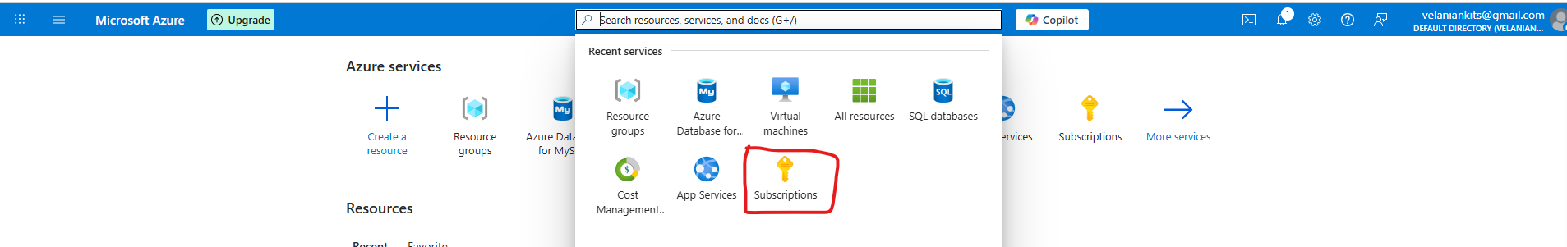

Click on Subscription

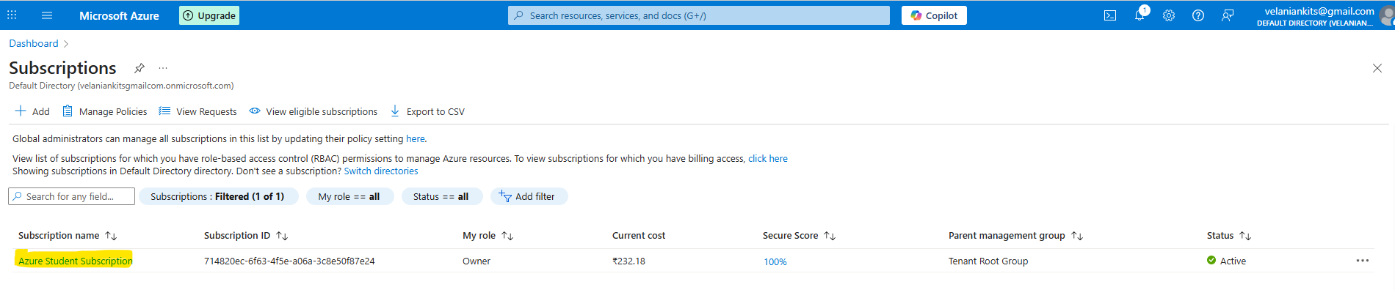

Click on Rename

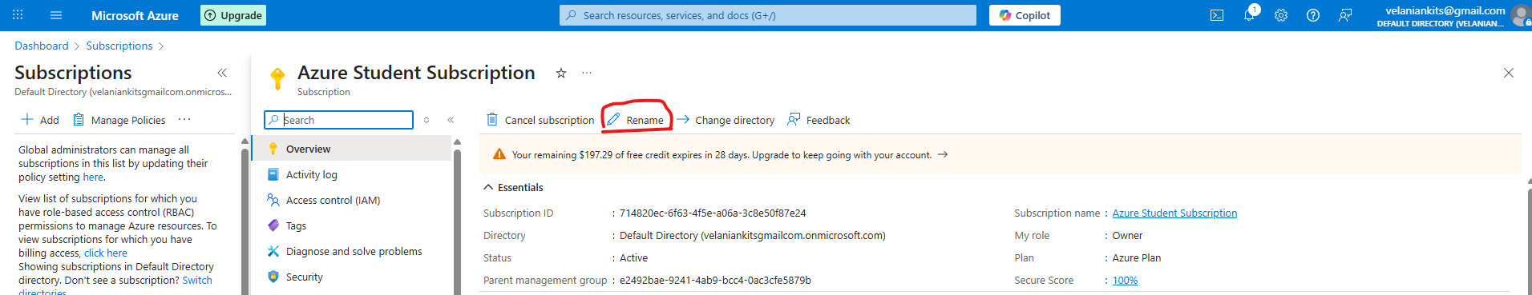

Provide a meaningful subscription name: You can choose any name, but for better clarity, I’m naming the resource group as **SUB-SIT-AZURE-BOOTCAMP**

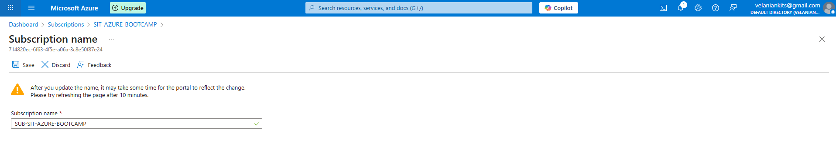

Click on Save

Search **Subscription** in search bar



Update Subscription details available in Azure Portal

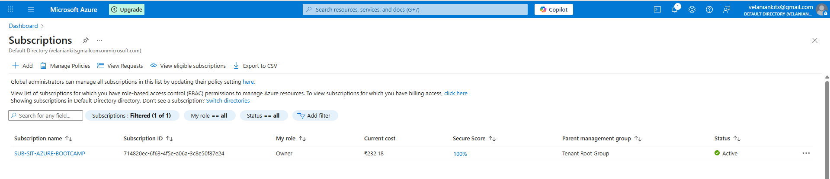

Congratulations! Your Azure subscription details have been successfully updated.

**Resource Groups**

Search Resource Groups in Search bar

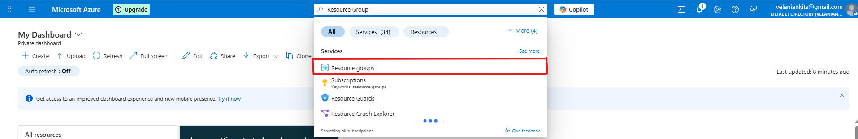

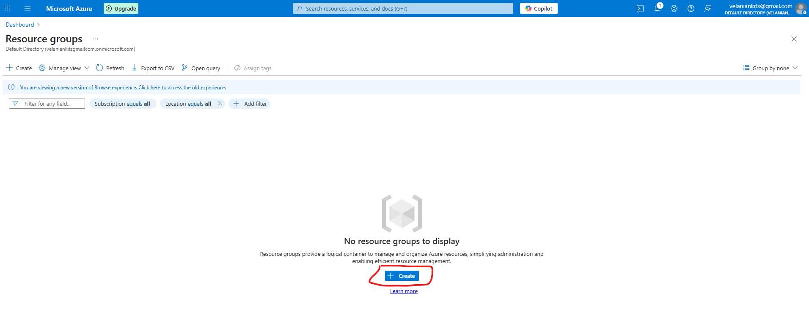

Click on **Create**, to create new Resource Group for bootcamp

Provide a meaningful Resource Group name: You can choose any name, but for better clarity, I’m naming the resource group as **RG-MCA**

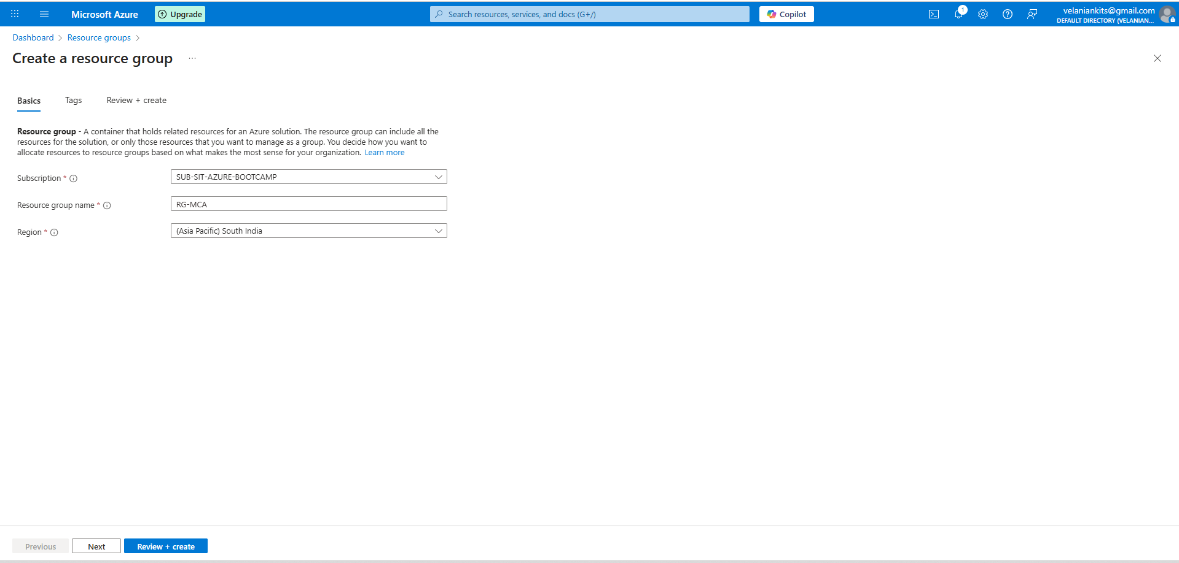

Click on **Next,** add provide Tag for the Resource Group

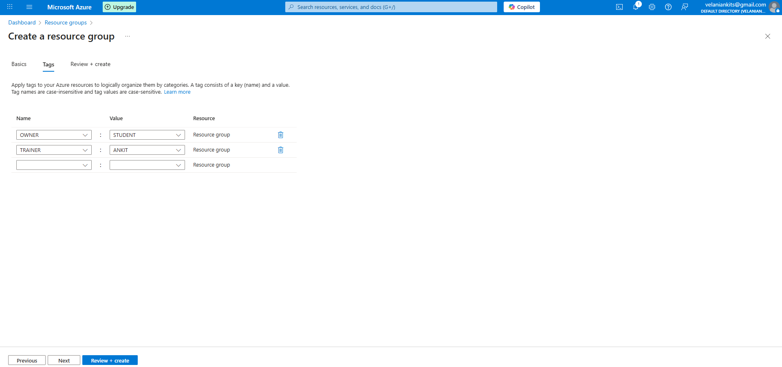

Here are some of the tags created for the Resource Group (RG-MCA)

OWNER: STUDENT

TRAINER: ANKIT

Click on Next

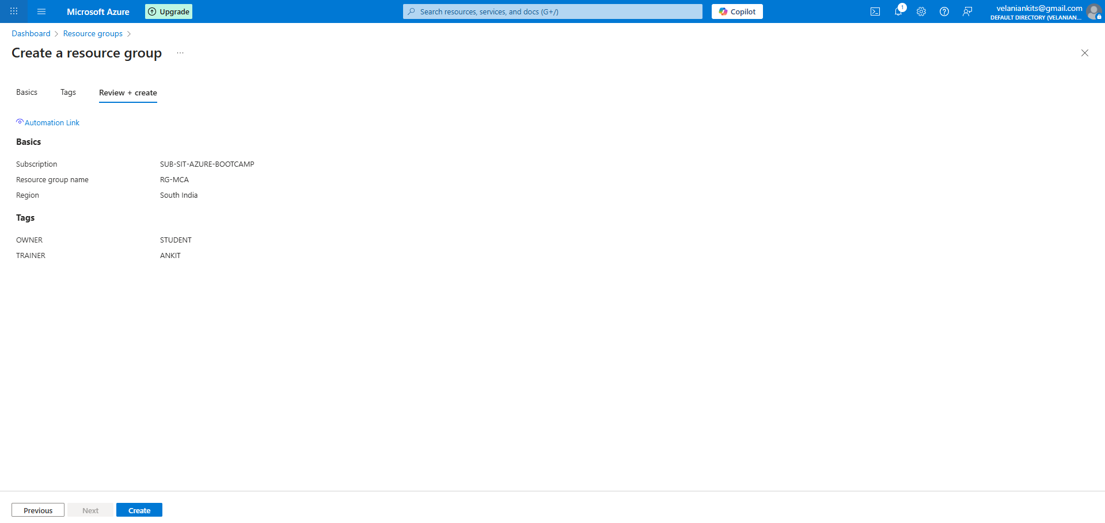

Click on **Create** and complete the resource group creation process

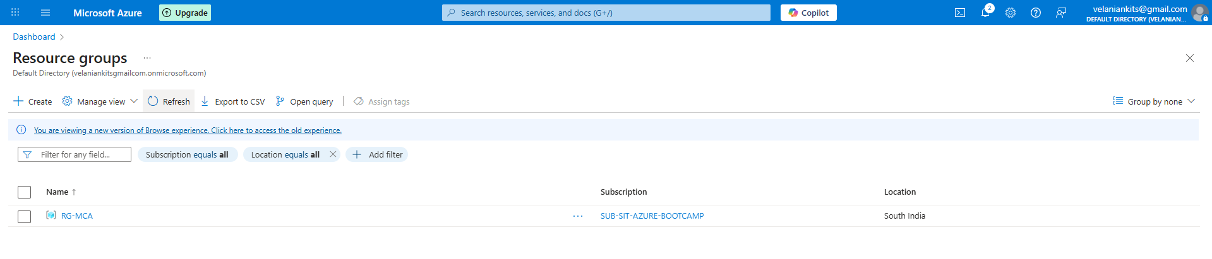

Congratulations! Your Resource group details have been successfully updated.