**Azure Storage Account**

An Azure Storage Account acts as a unique container within Azure, allowing you to store several types of data such as blobs, files, queues, and tables. It serves as a core building block for managing both structured and unstructured data—ensuring secure, durable, and scalable access.

⚠️ Important: Deleting a storage account will permanently remove all associated services and the data stored within them.

**Types of Storage in an Azure Storage Account**

1. **Blob Storage**

Used for storing large amounts of unstructured data such as text, images, videos, backups, and logs. Ideal for cloud-native applications and scalable data lakes.

1. **File Storage**

Provides fully managed file shares in the cloud that can be accessed via the SMB protocol. Suitable for lift-and-shift migrations and shared access across multiple VMs.

1. **Queue Storage**

Enables reliable messaging between application components. Useful for building decoupled and scalable systems using asynchronous communication.

1. **Table Storage**

Offers a NoSQL key-value store for structured data. Great for storing large datasets with flexible schema, such as user profiles or device information.

As the first step in our Azure Bootcamp, we will begin by creating an Azure Storage Account, which will serve as the foundation for storing various types of data in the cloud.

Accessing the Azure Portal and Navigating to Storage Accounts

1. Open your web browser and go to the **Azure Portal**: <https://portal.azure.com/#home>
2. Once you're on the homepage, locate the **search bar** at the top of the page.
3. Type **"Storage Account"** into the search bar and press **Enter**.
4. From the search results, click on **Storage Accounts** to begin creating or managing your storage resources.

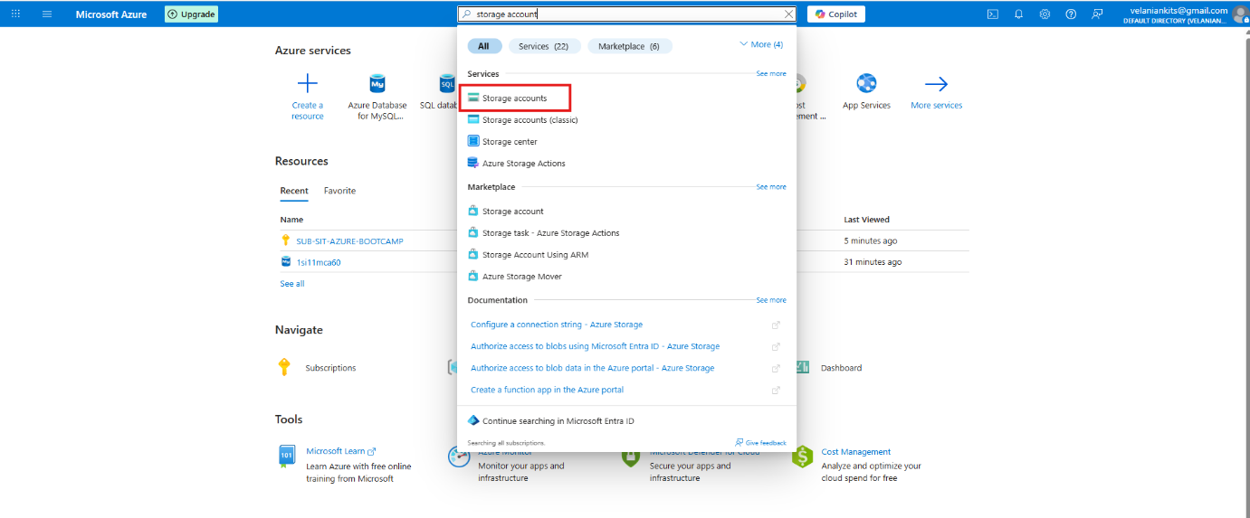

Next, click on the “Create” button to start the process of setting up a new Azure Storage Account.

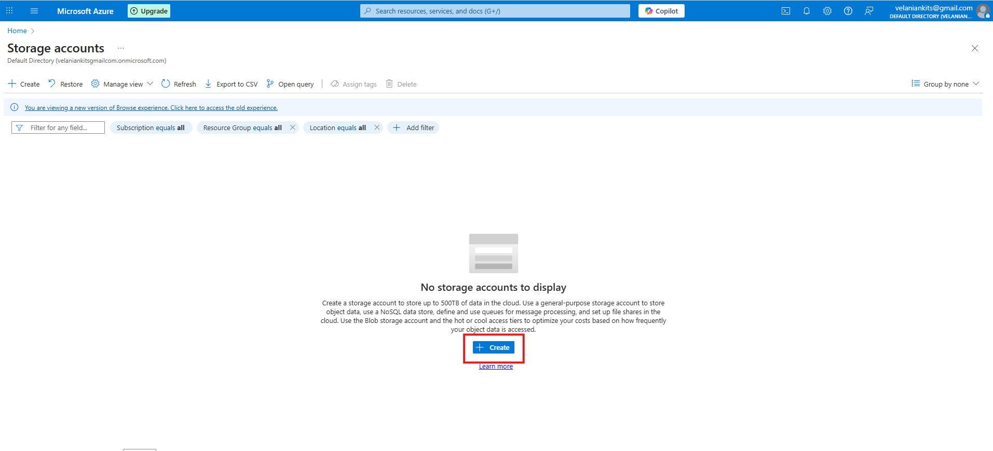

Next step is to:

1. Select or Create a Resource Group
2. Enter a Unique Storage Account Name

💡To keep it simple and identifiable, we recommend using your University Seat Number (USN) — for example: 1si11mca60.

1. Choose Region, Performance, and Redundancy Options
2. Click “Next”

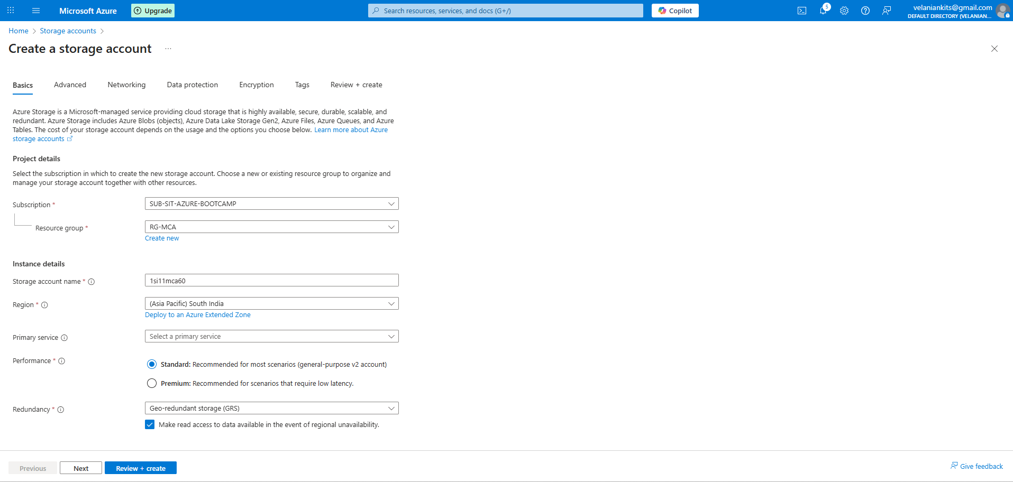

Now, scroll down to the Advanced section where you'll find the Access Tier setting. Select the appropriate tier based on your data usage and storage requirements.

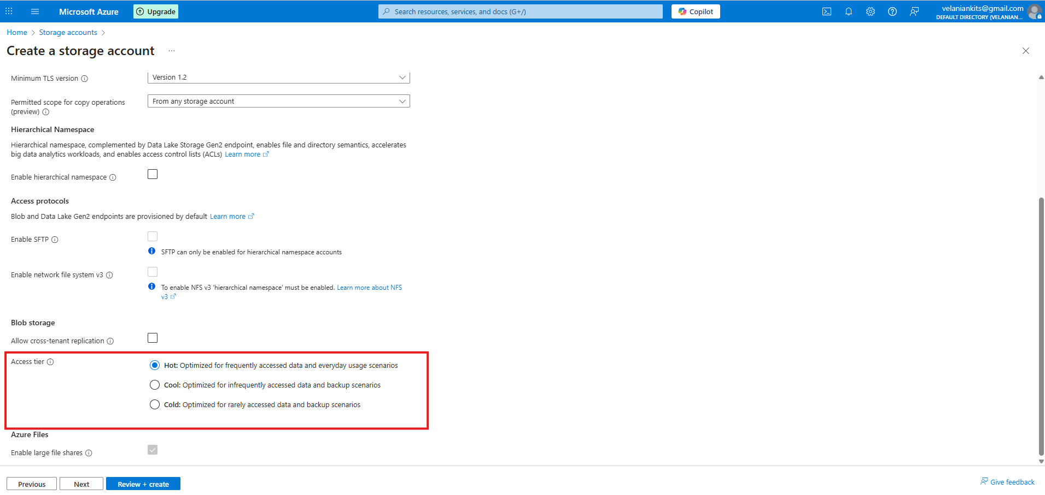

Click on Next and add the Tags.

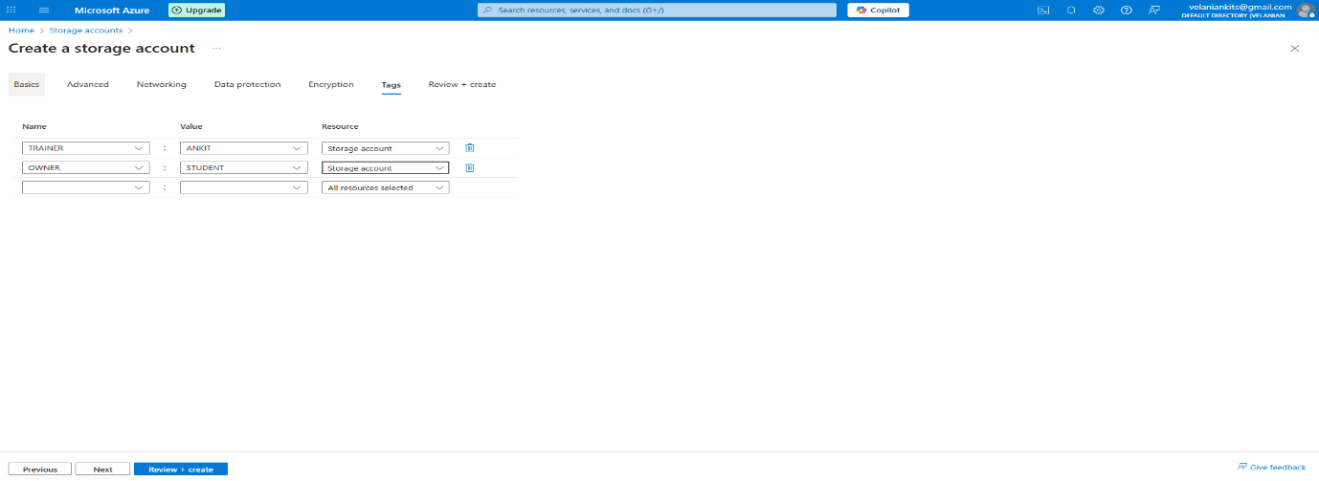

Click on **Review + create**

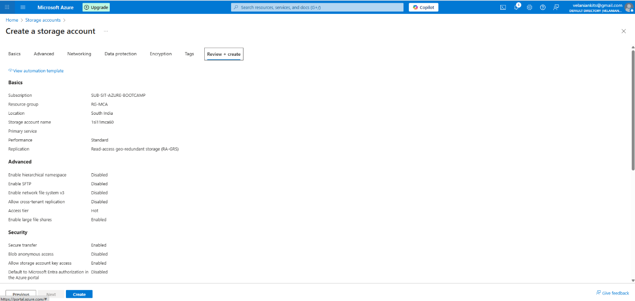

Here, you can review the Storage Account details, including configuration settings, access tier, and available services. Once everything is verified, click on “Create” to initiate the deployment.

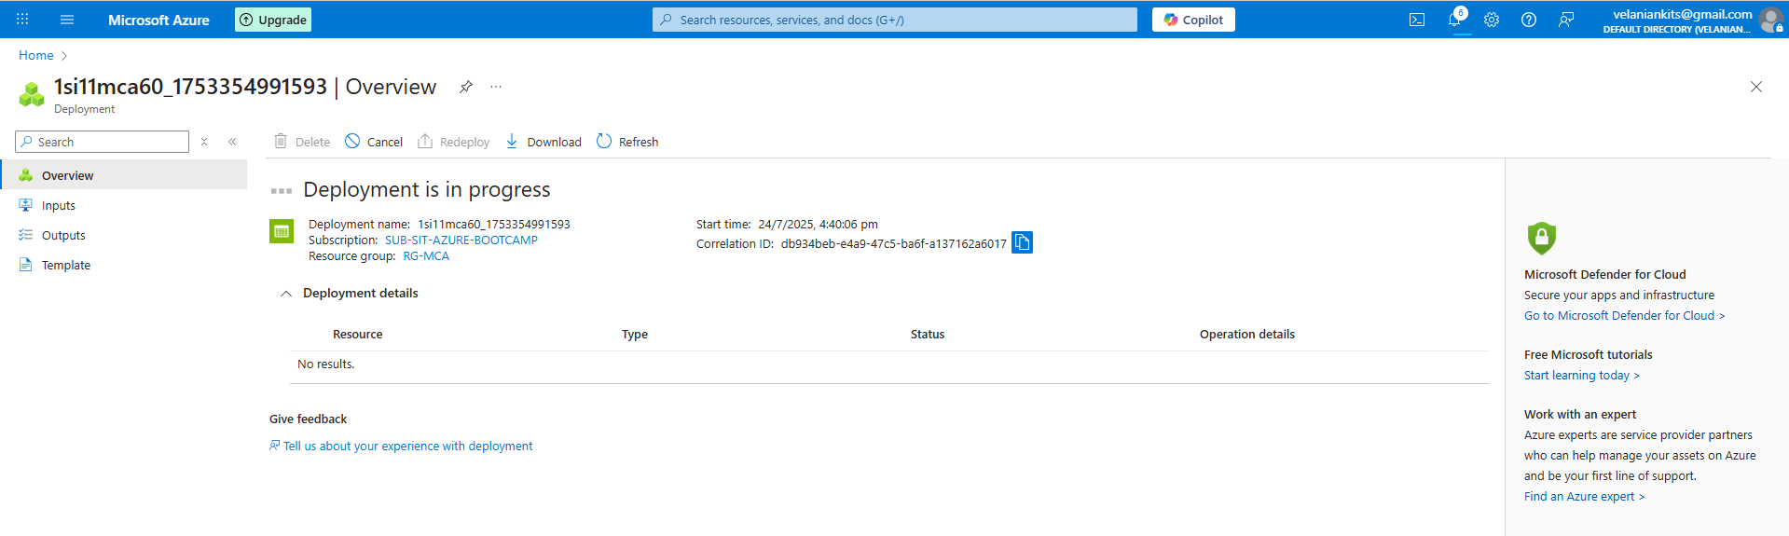

You’ll now see a message indicating that deployment is in progress. This may take a few moments as Azure sets up your Storage Account.

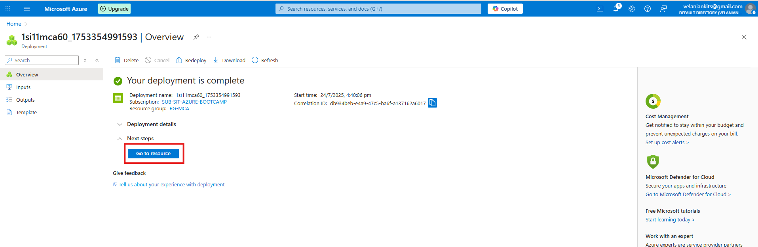

Once the deployment is complete, click on “Go to resource” to access and manage your newly created Storage Account.

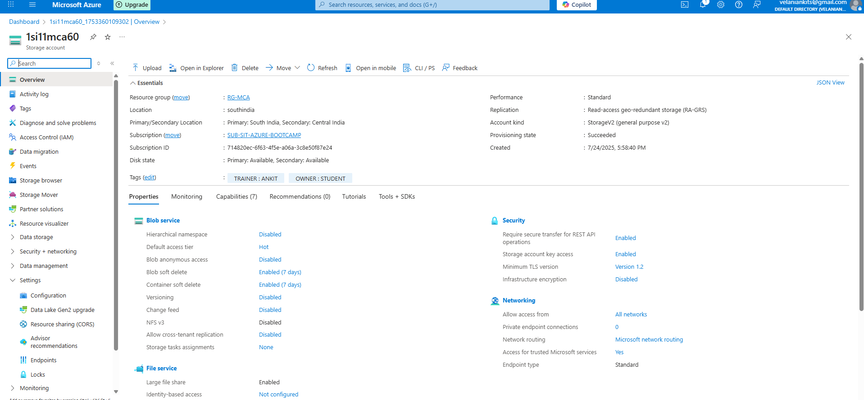

🎉 Congratulations! You have successfully created your Azure Storage Account. You're now ready to start storing and managing data in the cloud.

**Enable Public Access for Blob (Demo Purpose Only)**

For the purpose of this Azure Bootcamp demo, we’ll enable public access to the Blob container. This will allow us to demonstrate file upload and public access to the stored content.

⚠️ Note: Enabling public access is not recommended for real-world projects, as it may expose sensitive data. Always follow best practices for securing your storage in production environments.

**Navigate to Your Storage Account**

1. Go to the **Azure Portal**: https://portal.azure.com
2. Use the **search bar** at the top of the page and type **“Storage Account”**.
3. From the search results, click on **Storage Accounts** to view and manage your existing accounts.



The recently created Storage Account will be displayed in the Azure Portal, typically listed at the top of the Storage Accounts page for easy access.

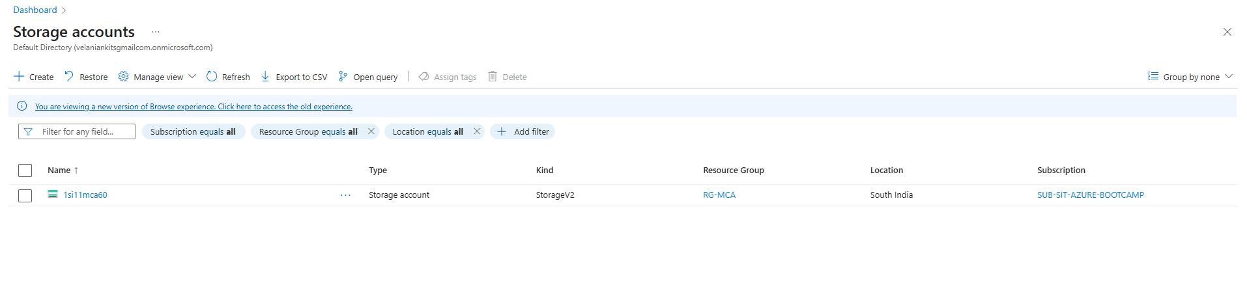

Click on the Storage Account named i.e 1si11mca60 to view its configuration settings, including access tiers, networking options, and data management features. And click on Setting to enable public access.

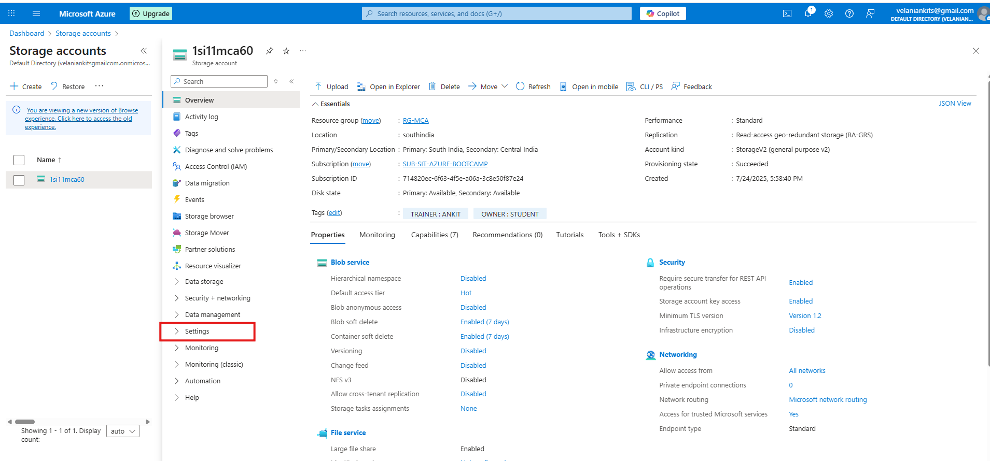

Click on Configuration under the Settings section.

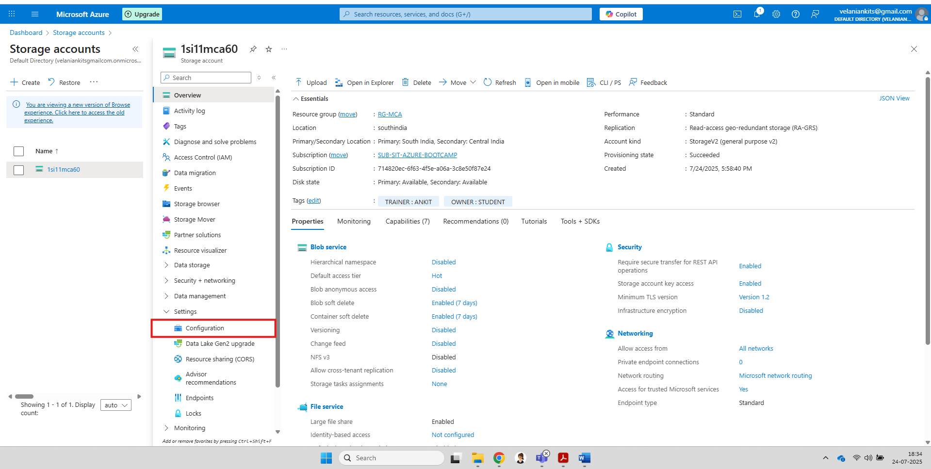

Then, enable the option “Allow Blob anonymous access” to permit public access to blob data for demonstration purposes.

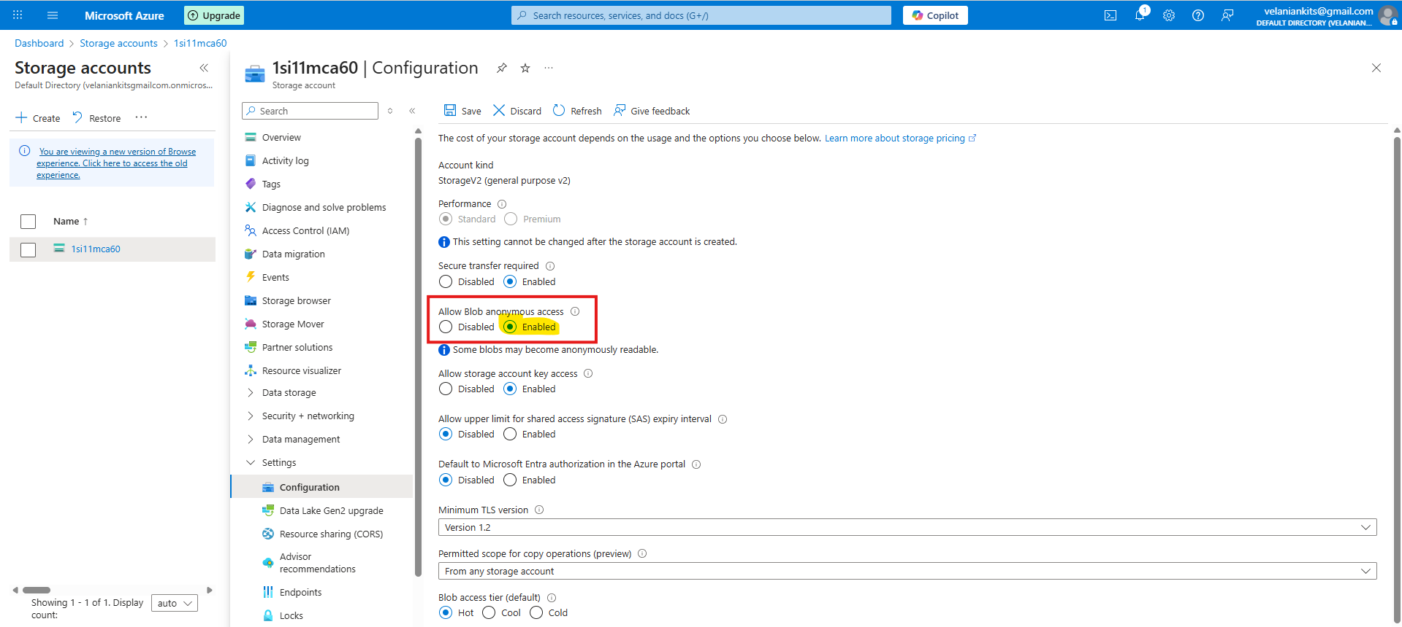

🎉 Great job! Your Storage Account is now configured to allow public access to Blob data over the internet.

🔒 Reminder: This setting is intended only for demo and learning purposes. Avoid enabling public access in real-world projects to ensure data security.

**Creating Container, Blob**

In the Azure portal, locate and select your Storage account. Once inside, click on 'Storage browser' to view and manage your stored data.

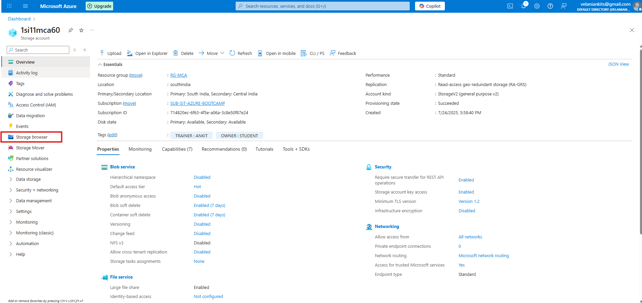

Click on Blob Container to manage Container

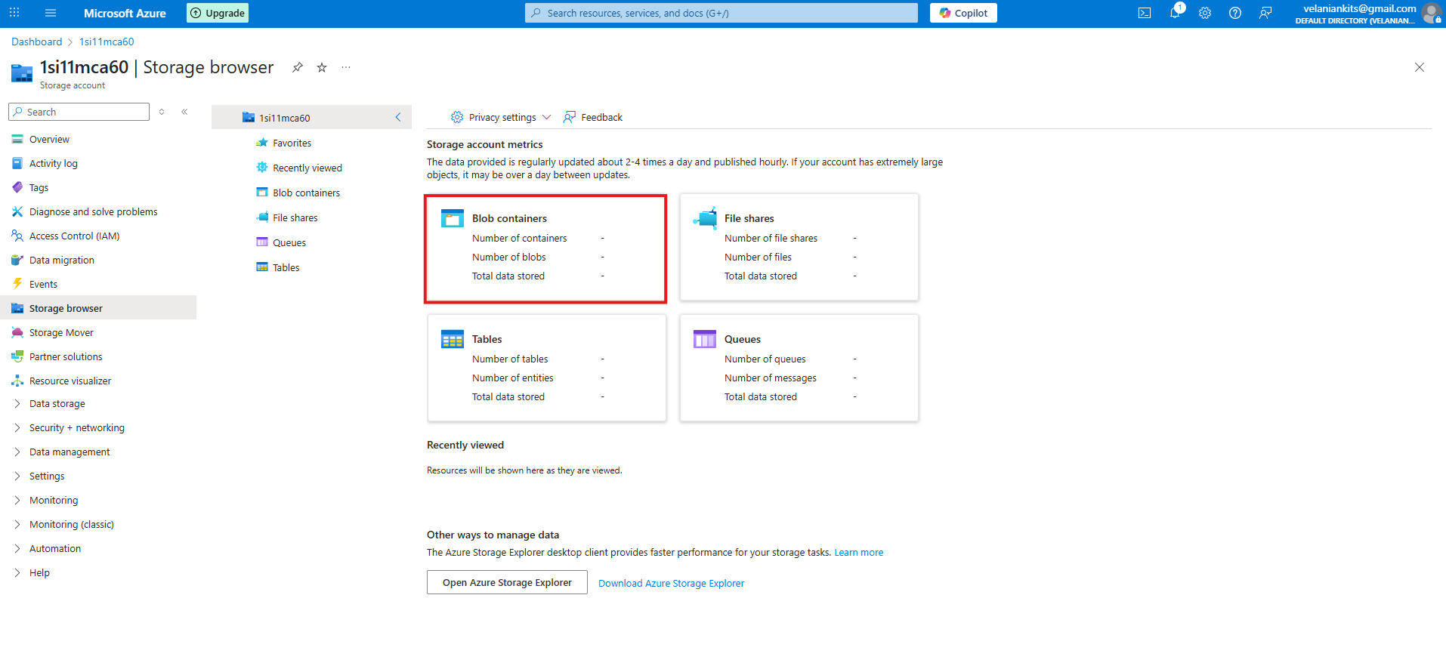

Click on 'Add container' to create a new container, similar to creating folders. For example, you can name them 'Photos', 'Documents', or 'Music' to organize your data

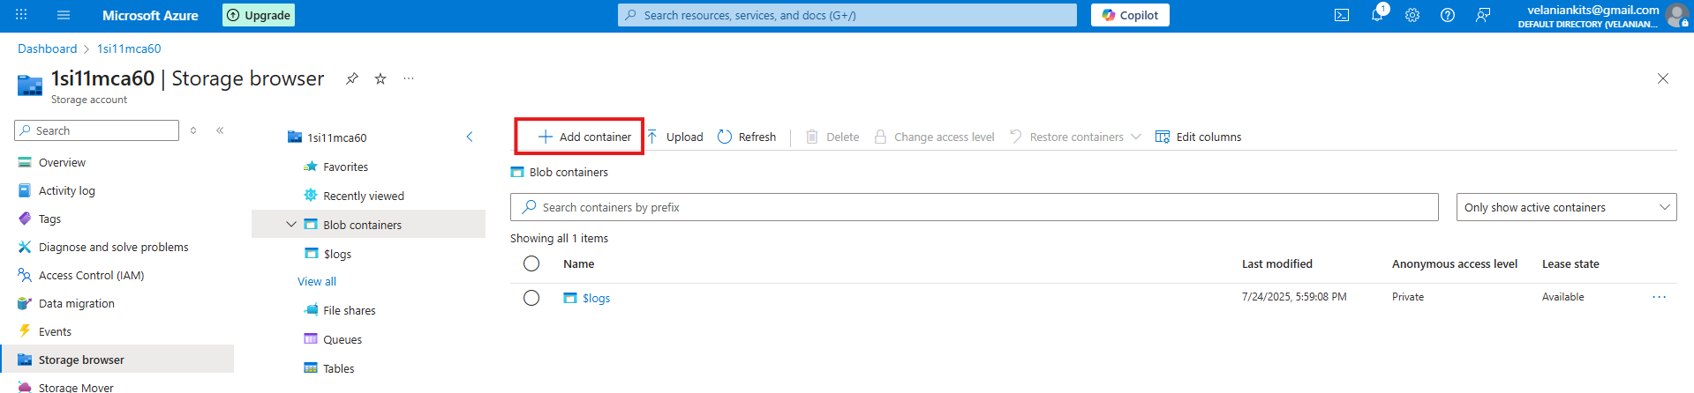

Create two containers in your Storage account named **'photo'** and **'document'** to organize your files accordingly.

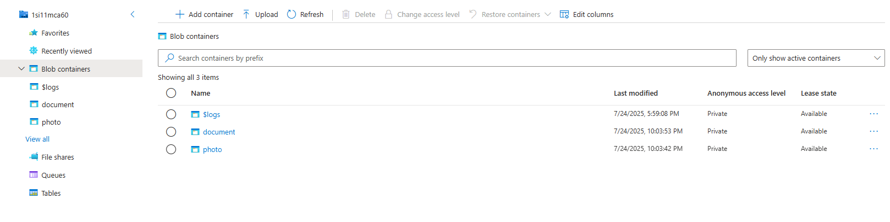

Select the 'photo' container to upload some sample images.

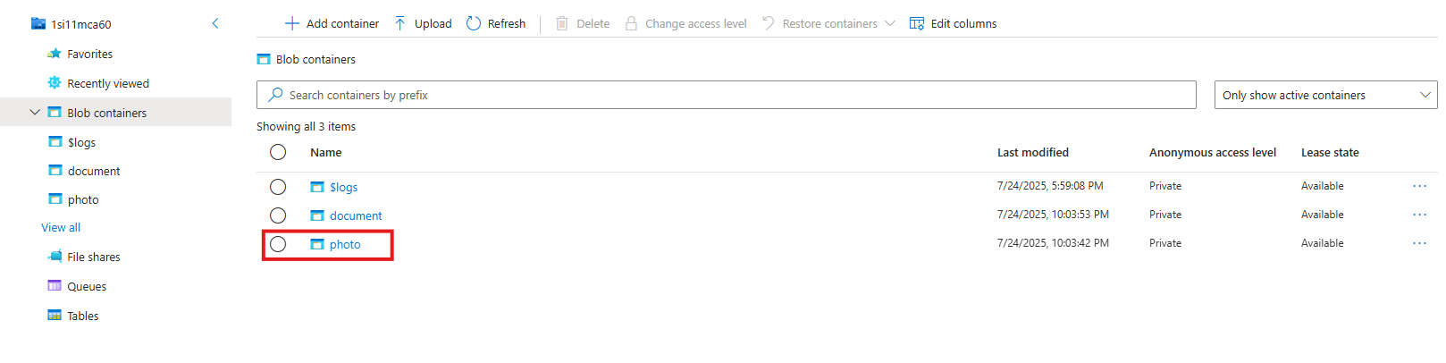

Click on upload to upload few images

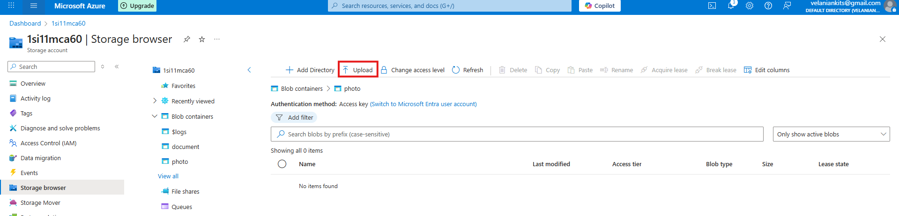

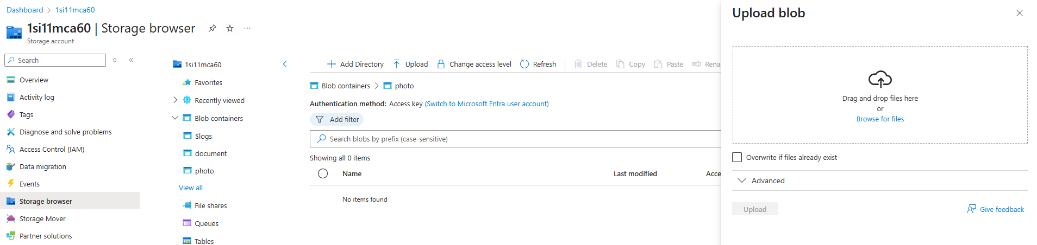

Browse for files -> select the files to be uploaded on BLOB

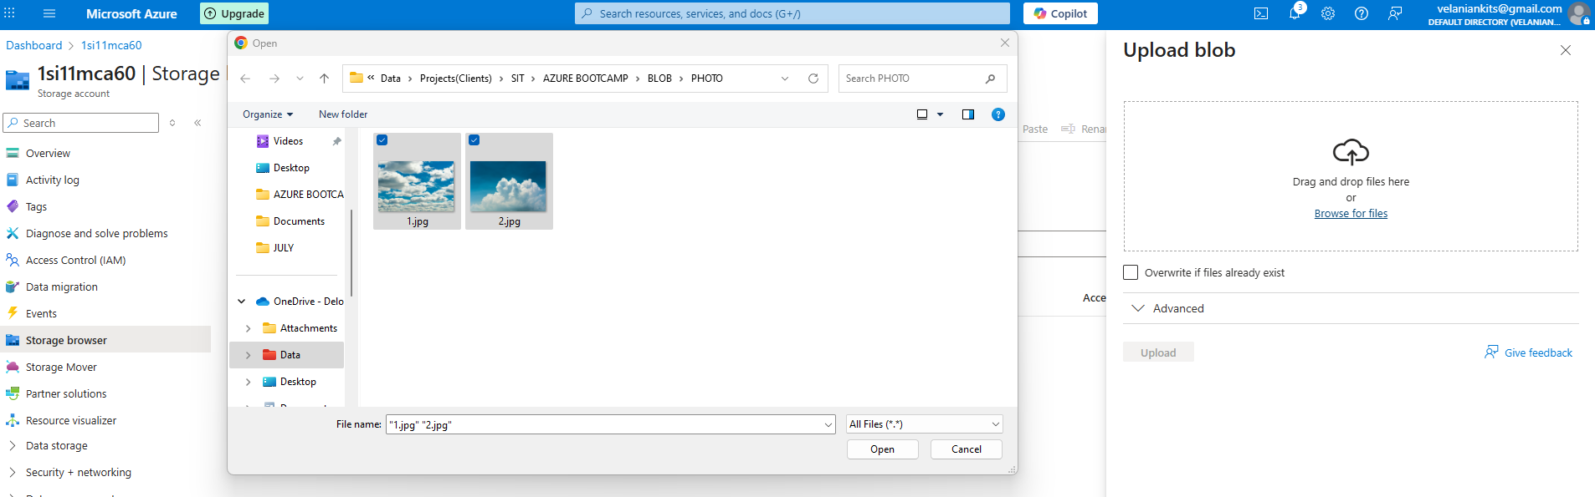

Click on Open -> and then click on Upload.

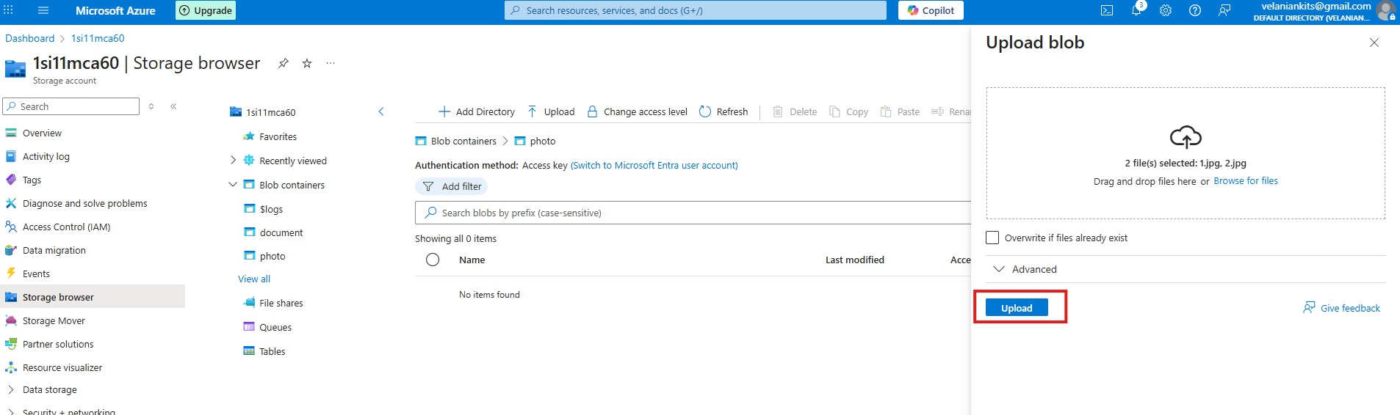

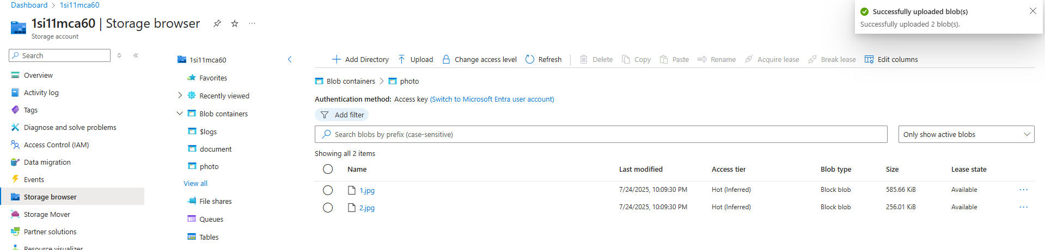

Sample images have been successfully uploaded to the 'photo' container.

**Accessing BLOB**

Select any BLOB from the container to access it through a web browser

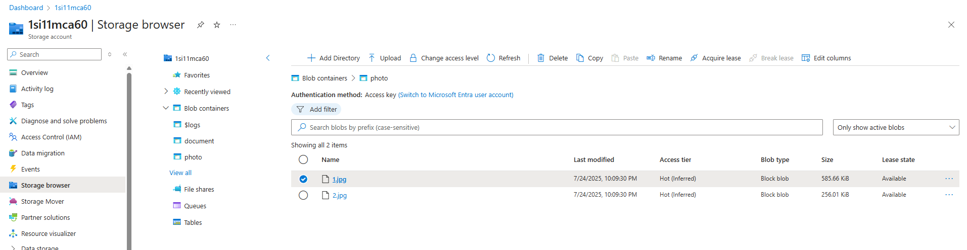

A new popup will appear. Copy the URL provided to access the BLOB through a web browser.

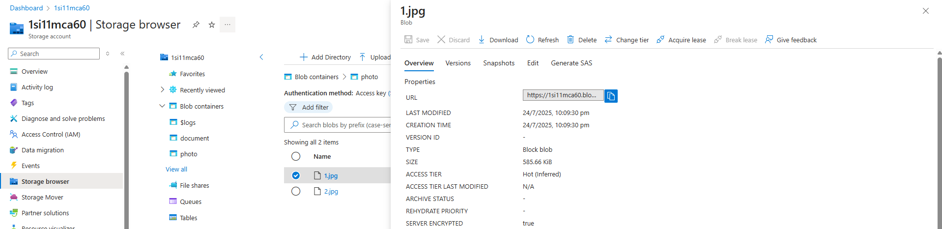

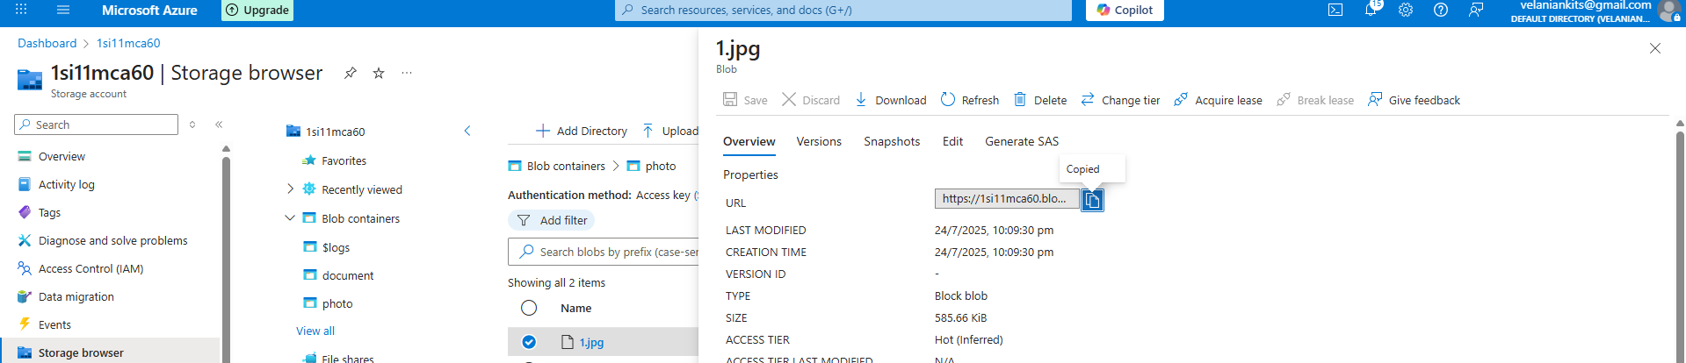

Open a new tab in your web browser and paste the BLOB URL to view or download the file

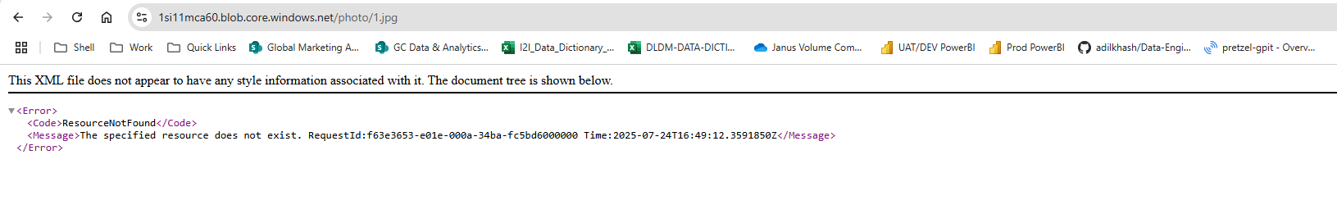

If you try to access the BLOB via its URL, an access error message will appear because the container is private by default.

To make the BLOB publicly accessible, you need to update the container's access level to allow anonymous read access for blobs.

Click on **Change access level**

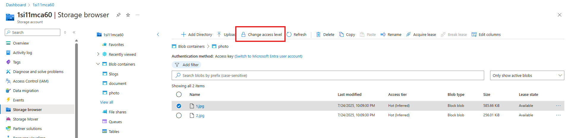

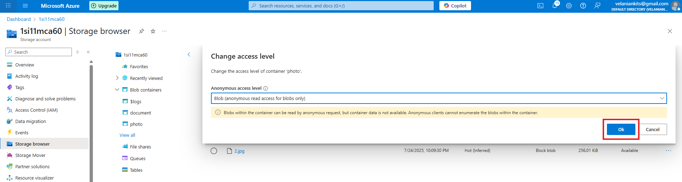

Anonymous access level 🡪 Blob (anonymous read access for blob) 🡪 click **Ok**

Copy BLOB URL again and paste in Web browser to access.



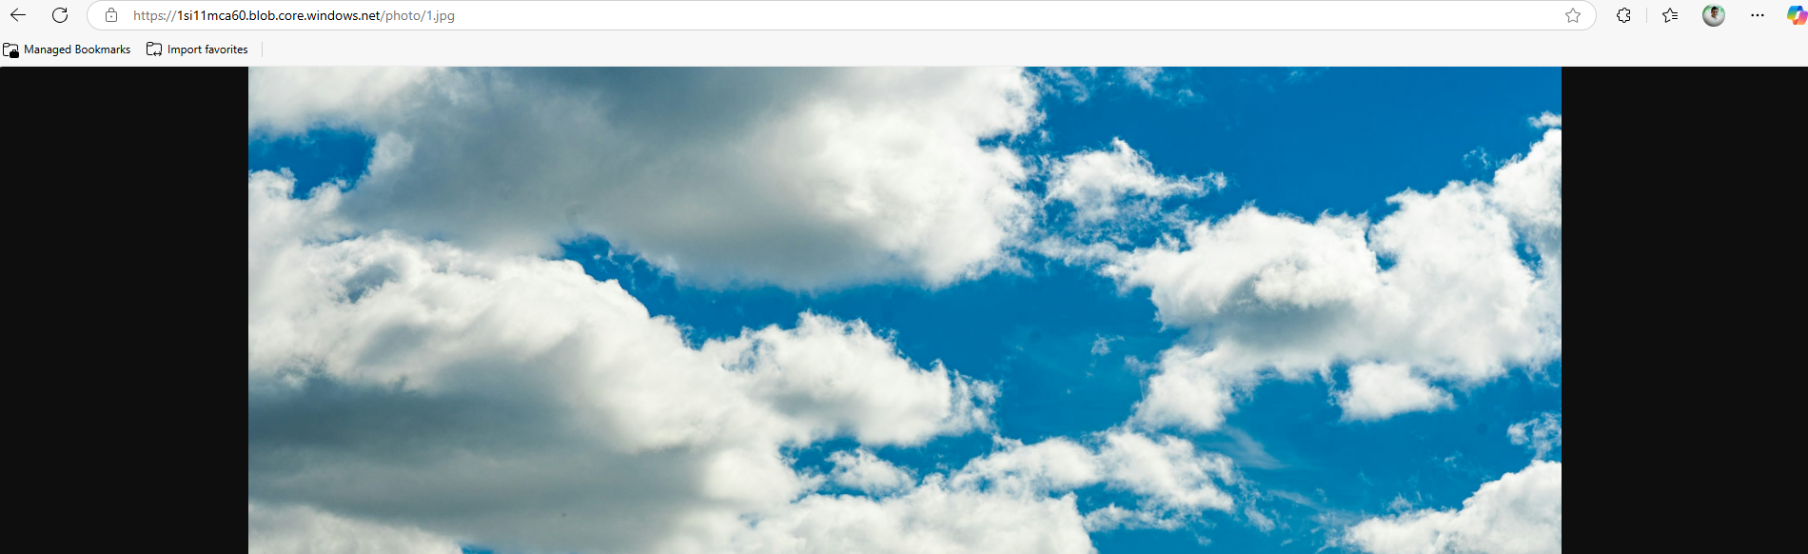

Congratulations! The BLOB is now successfully accessible via its URL.