Backtest submitted
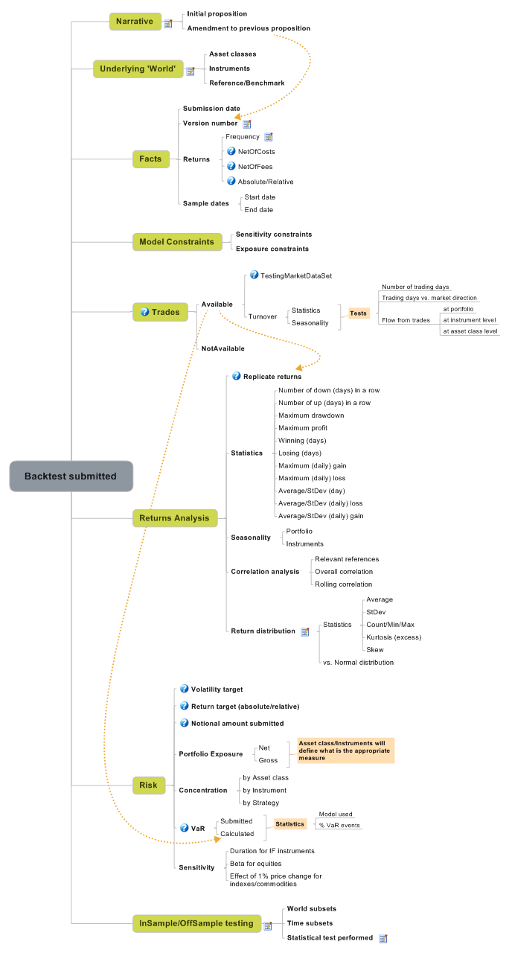
- Narrative
PM will provide some ideas about:
- fund proposition
- fund strategy
- advantage vs. peers
- overview about expected risk and performance
- asset classes and instruments involved
If this is an initial proposition (e.g. looking for seed capital) the PM will focus on the above mentioned bullet points.
If this is an amendment the PM will explain what was changed and why and will provide a comparison between these returns vs. previous version returns.
  - Initial proposition
  - Amendment to previous proposition
See also: Version number
- Underlying 'World'
Using non-fixed income listed products we might have a lot of help from Bloomberg analysis.
Using BBU we can always upload portfolio like we do for paper hedge funds.
We would miss the turnover analysis though.
  - Asset classes
  - Instruments
  - Reference/Benchmark
- Facts
  - Submission date
  - Version number
Crucial if we want to maintain a log
  - Returns
    - Frequency
Shall we ask for a specific frequency (daily) or shall we let this at PM will?
    - NetOfCosts
    - NetOfFees
    - Absolute/Relative
  - Sample dates
    - Start date
    - End date
- Model Constraints
  - Sensitivity constraints
  - Exposure constraints
- Trades
  - Available
See also: Replicate returns, Calculated
    - TestingMarketDataSet
    - Turnover
- Tests
- Number of trading days
- Trading days vs. market direction
- Flow from trades
- at portfolio
- at instrument level
- at asset class level
Statistics
Seasonality
  - NotAvailable
- Returns Analysis
  - Replicate returns
  - Statistics
    - Number of down (days) in a row
    - Number of up (days) in a row
    - Maximum drawdown
    - Maximum profit
    - Winning (days)
    - Losing (days)
    - Maximum (daily) gain
    - Maximum (daily) loss
    - Average/StDev (day)
    - Average/StDev (daily) loss
    - Average/StDev (daily) gain
  - Seasonality
    - Portfolio
    - Instruments
  - Correlation analysis
    - Relevant references
    - Overall correlation
    - Rolling correlation
  - Return distribution
The bell shaped graph.
    - Statistics
Average
StDev
Count/Min/Max
Kurtosis (excess)
Skew
    - vs. Normal distribution
- Risk
  - Volatility target
  - Return target (absolute/relative)
  - Notional amount submitted
  - Portfolio Exposure
- Asset class/Instruments will define what is the appropriate measure
    - Net
    - Gross
  - Concentration
    - by Asset class
    - by Instrument
    - by Strategy
  - VaR
- Statistics
- Model used
- % VaR events
    - Submitted
    - Calculated
  - Sensitivity
    - Duration for IF instruments
    - Beta for equities
    - Effect of 1% price change for indexes/commodities
- InSample/OffSample testing
The PM will split its sample either via cross section or via time split. Model will run on a sample using the optimal parameters coming from the other sample. A test will be performed on the two outcomes to determine if those two returns come from the same distribution.
  - World subsets
  - Time subsets
  - Statistical test performed
e.g. Kolmogorov/Smirnov

