project: FUNDS OFFICIal Data REPOSITORY

SUMMING UP

Objective
We need a single repository for OMAM funds official (who decides which is the “Official source”? Can we use an alternative source if this is more readily available?) When I say “official” I’m not thinking about the source. I’m just enunciating a fairly common wisdom fact: we need to make sure any return number that OMAM delivers is the by-product of well understood calculations based on the officially endorsed dataset. return data. Several fund characteristics can be part of the data model design. (Can the returns calculations change depending on the charactoristics? Is it just the case that just the calculation building blocks are required and no calculation functionality is required? Returns calculations do not depend on the characteristics. Characteristics are relevant if we want to group those returns (AuM may be is more relevant in this instance) alongside a specific dimension (fund manager, fund vehicle, fund strategy, fund asset class to give you some example). Return itself is very simple: R(i,n) = NaV(i)/NaV(i-n) -1. That is the return at time i after n period is equal to …This will allow us to tailor our answers depending on the angle the questions will be asked. You mention elsewhere that this is only for OMAM funds – Does this explicitly exclude Segregated Managed Accounts? We need to deal with SegMandates as well. For completeness.
This project will provide various stakeholders with unique answers to questions related to official funds performances and characteristics.
Does this deliverable relate to the store of data only or an interrogation capability / reporting engine? Are the only charactoristics you expect to retain related to top level fund attributes only or pertaining to any constituent make up (e.g. mix of fund holdings etc.? Not entirely clear to me the second part of the question but: once we have the data in we definitely need to provide all the relevant reports otherwise the exercise is clearly void. Beside this is the interesting bit! If by constituent level you mean what’s inside each portfolio this is only relevant only for FoF when we want to deal with the “double counting beans” issue of our funds included into our FoF.

Benefits
Plenty of MS Excel spreadsheets are currently used to produce our external and internal reporting. They constitute a big source of operational risk and they won’t be needed anymore.
Are you intending that everyone will migrate away from their own spreadsheets – Is this a “push” from you or a “Here is this other source, please use”? i.e. do you propose this to be a mandatory central source? Once we are happy about the new source of reports I would definitely discourage the utilization of excel spreadsheet for official reporting. We should go back using Excel as a glorified HP and not as a source of internal procedures.

Tasks, responsibilities and validation processes will be correctly identified
Related procedures will be centralized, correctly structured and maintained.
What specific deliverables are you expecting i.e. you mention that validation processes will be correctly identified but who decides whether they are “fit for purpose”? The end user; the person currently dealing with the equivalent report produced out of excel spreadsheets. If the end user validates the new report coming from the new framework this is automatically “fit for purpose” and should be used going forward.

Challenges
The complexity of the project is linked to:
- Collecting data from the past (ideally we need to go back to 2004).
- If this is a company wide repository, what if certain funds are required since inception (e.g. for Institutional RFPs) – When you say “We” do you mean Performance and Risk? “We” is OMAM. If the SI time series is required the relevant effort should be made to recover the relevant dataset.
- Making sure all stakeholders have their needs covered. Have you done a specific requirements gathering / gap analysis with anyone or is this your first guess and you assume a requirements gathering step will follow to validate your views? For certain areas is something I’m pretty sure about. This is true for Risk&Performance (bar some question marks on the GIPS composites). The purpose of this document (once approved) is to have it circulating among the stakeholders to verify they are happy. In my experience going around with a blank piece of paper asking question is rarely useful.
- Identify roles and responsibilities for the initial load, update, maintenance and validation of each specific data subset.
- Obtain from all the stakeholders the relevant specifications of the rules we need to use the data we collect (e.g. from net returns to gross returns, HWM calculations).
- Correctly deal with the logic linked to the production of the returns time series (e.g. dealing with funds merge/spin off). What would you expect to see re: funds taken on from other businesses e.g. Gerrard funds? Not really: I’m thinking more along the lines of UKDEF becoming UKDEFOS and still willing to be able to retain UKDEF performance to produce performance statistics for UKDEFOS (e.g. rolling/average statistics over x years) without having a gap.

- Provide efficient download/upload procedures from the selected data providers/to relevant data vendors/clients platforms Do you have a clear idea as to which vendors / clients / platforms. I will scrap this from the document. Is not this project business to decide where the NaV and number of shares comes from and to verify them
- Manage dates/versioning: roles change, objectives change, peer group and benchmark references can change. We have to accommodate for this. Is this a must, should or could have type of requirement? It’s a must because it’s a reality of the business. Our funds evolve, their benchmark change and their objectives vary. We need to be able to say when that happens and correctly represent this in our reports.

Scope
The scope of the project can grow according to the characteristics we want to model and capture.
Although the main objective for this project is to be able to provide funds returns, NaVs and performance against objectives (benchmarks, peer groups), this objective can be expanded including: Can or should be expanded? Can. But ultimately depends on the business
- References to Fund Managers roles and significant dates
- Client custom classifications Are these defined yet? I don’t know anything about this. And to be honest with you it’s very low in my priority list. It’s a sort of “nice to have”.
We are interested in the official data only and not in how they are produced. This is definitely not about portfolios constituents/positions and valuations. Is any of this lower level information required in order to drive any fund charactoristics e.g. % Equity Holdings? i.e. Even if you don’t need this, if this is intended to be a single central source, someone else might? I do not think we are interested in the portfolio constituents. The fund characteristics are broad enough to accommodate for changes in objectives and strategy.
When the fund unit price has been collected and stored, we will assume the basic validation about positions and trades has been already performed. Is this consistent with what you mention elsewhere in the document that correct validation processes will be correctly identified or are you saying that certain validations are in scope but others are not? The only thing we are interested into is to make sure that this number is consistent with what fund performance estimates (as provided by Factset or Vivaldi as an example) were telling us.
I will take out this paragraph from the final version. I will eliminate any reference to the validation process beyond mentionin the fact (in a footnote maybe) that there are sources of daily returns estimates in case we want to use them.

Risks
There are several risks to this project because of:
- Potentially (very) wide scope
- Several stakeholders involved
- Various data sources
- Potential confusion about data validation issues Agreed, this is a point of confusion at the moment I would get rid of this. Not part of this specific project.
- Added burden on some OMAM functions
- Clashes with other projects and potentially creating duplicates inside OMAM hub. While avoiding this is a commendable task I believe being too fanatic about it might lead to big delays: entire lines of work (e.g. Vivaldi) might need to be refactored if we want to be perfect from this point of view. Nevertheless this is something we need to keep in our minds. Are you saying that if necessary you would be happy to use an alternative source of data until such time as the desired source became available? What I’m saying is that somewhere in our hub there might be some relevant information that might be used for this project. There is a tbl_funds in Vivaldi that Vivaldi uses to collect relevant information about each fund. There is a chance that it’s structure is not exactly the one we require for this project. It’s up to IT to decide whether is a good idea to have a new tbl_Funds table inside this project or it’s a good option to use the existing one. As I said ideally you would refactor the existing one to accommodate for the needs of the new project but there are consequences on the development of Vivaldi that has to be taken into account.

DETAILS

Objectives
OMAM products are the funds we sell. And not the ones we manage for others? Seg accounts are part of the project.
Our clients, on top of good performances, expect from us quick and precise answers to all their questions concerning the performances of their investments. Is reporting capability in or out of scope? Definitely in.
OMAM management needs timely, precise updates about our fund performances and their economic impact on the company results. What are your income related expectations? Translating the net results into gross results and being able to manage the fees structures correctly might deliver relevant numbers about how much money OMAM makes producing those funds.
Fund performances and all the ancillary financial calculations can be distributed using several means (XL spreadsheets, PDF reports, PPT presentations, emails) but the production of the underlying calculations needs to be provided by a centralized source. As above – Is this a requirement related to reporting? It is.
Using spreadsheets and different data repositories is:

- Inefficient and potential source of errors: because we end up replicating the same set of data multiple times and out of them we might end up with two different answers to the same question.

- Source of operational risk: because we end up relying on individual efforts and not on established, documented, updated and tested procedures. MS Excel spreadsheets just can’t be the basis of correct enterprise procedures: they are intimately linked to their user/creator and their sharing is always problematic. This is an obvious source of key man risk.
- Source of reputational risk: beside the obvious TCF concerns, being wrong or late could really impact our business negatively.
The relevant story here is: we need a single data source when we try to represent our funds performances.
That has to be the basis of all our reporting and from there we have to upload to the other data vendors or external systems (e.g. Factset/SPAR) when this is relevant. Are you focusing only on performance related systems / vendors or all our touchpoints? I’m focusing on all those instances where we are currently uploading, disseminating our return/AUM numbers on different system using procedures different than “IT procedure upload relevant data in the relevant place”.

The Data Model
The technical basis of the project is to identify the right way of representing the data source underlying all the processes that will be run in order to achieve the various objectives. Who would you expect would decide the right way (i.e. who are the decision makers?) How best to build the model is on IT.
Once this is done we can then split that in various “areas” and allocate tasks and responsibilities accordingly
This is the exercise that Praveen and I have run during the past month. Please refer to Praveen document for the most updated details.
What follows is presented only as a helper. I’d like to provide some visual about what we believe are the most relevant set of information we will need to store in order to provide the essential portion of the project.
These diagram are not necessarily in line with the latest version as presented by the Requirements Specification Document. That is the relevant IT document that will represent the blueprint of the dBase underlying the project.
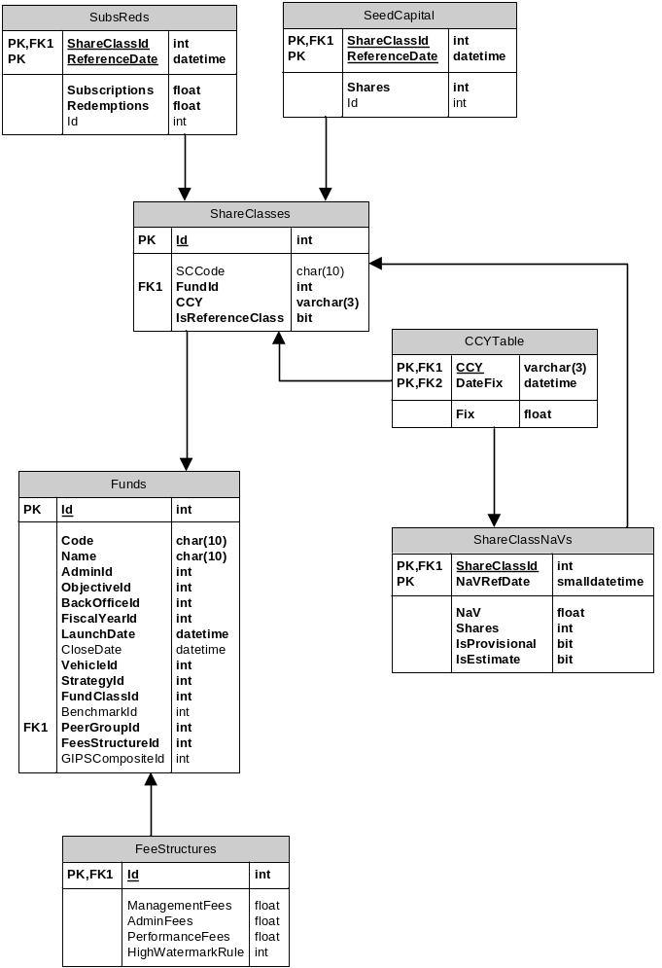
Figure 1: core dataset
Do you have any specific preference for where Subs/Reds; Seed Capital; CCY and FeeStructure information comes from? Not really.The core of the database (Figure 1) is based on the notion that each fund Value can be represented as the sum of all the share classes’ prices time number of shares.
The performance of a fund will be associated with the evolution of the NaV of a selected share class (ShareClasses.IsReferenceClass =TRUE)
Once we get this we will be able to retrieve and distribute the time series of returns for all our funds and we will able to answer question about period returns (gross, net), asset under management, fees impact, fund profitability. Where are you assuming these calculations will be done? These have to be part of the project. Whatever framework IT comes up with they have to be able to embed all the relevant logic as specified by the business.
Another relevant byproduct would be the automation of the GIPS composites construction. Where will this automation be delivered? There are still couple of question marks I have to discuss with Harvarsh about how best specify the requirements around GIPS composites. Will revert on this. In general I’m expecting the framework to be able to deliver what is needed when we need to provide what is required to be GIPS compliant.
Notice as well that, thanks to the IsProvisional and IsEstimate flags in the crucial ShareClassesNaVs table, we will be able to provide those items in a timely fashion based on provisional and/or estimated numbers.
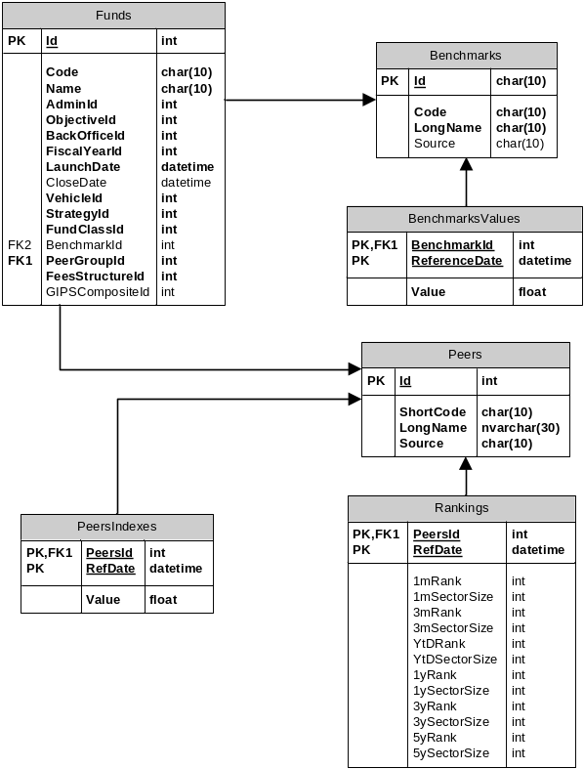
Figure 2: relative performance data
The second essential bit of the database (Figure 2) deals with benchmarks and peers performance data.
The first thing is to define the objective of each fund: this can be beat a benchmark or beat a peer group. There is nothing in the way of measuring each fund performance against both. Where are fund objectives expected to be captured and stored? Those are part of the fund characteristics.
Getting this right means we will be able to automate the production of (as examples):
- Green stripy (weekly)
- MI performance reports
- Traffic lights
- TCF tables
Which of these are Must / Should / Could / out of scope here? All a must.
This is on top of being able to answer all the questions about our range of product performance as an aggregate (e.g. percentage of AUM better than objectives).
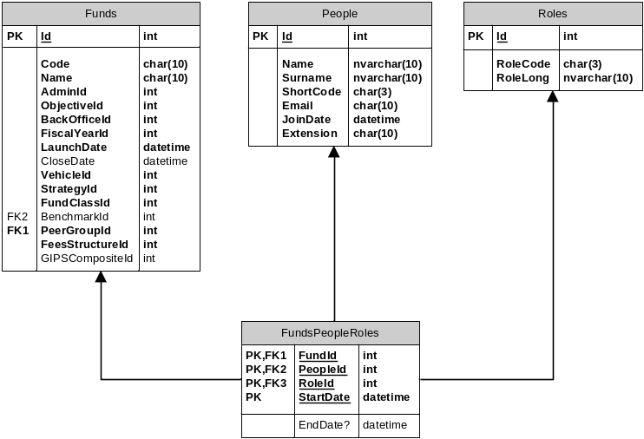
Figure 3: fund roles
This third block (Figure 3) merges fund details and performance with the people running them. If we get this set of information we will be able to answer question like:
- What was the performance of this fund since the fund manager XY took over?
- How much money is a specific desk/fund manager managing?
- What is the performance of funds belonging to a specific desk?

Out of scope
One of the main dangers of the project is overextending its scope. It is very easy to try to fit in all you can think about and, honestly, there are a lot of things that potentially can be part of this.
One thing being mentioned, as an example, is the reference to specific client classifications. While this is a nice to have I do not think it should be part of the initial effort. All requirements will need to be prioritised. Agreed.
What is really crucial instead is to have a good idea about what could be the potential project ramifications and structure the data model accordingly.

Validation (all this to be removed)
Validation plays a crucial role. But is assumed to be done elsewhere / not the focus of this project? We want a unique source of data but we need to make sure it’s right: being always wrong is not better than being somewhere right and somewhere else not so (like it can happen right now).
This project is not about how periodic NaVs are produced: no validation of portfolio positions, market prices, accruals, corporate actions is involved here.
The right place to run all those reconciliation processes is the Ops desk. And this project has nothing to add there. Beside thinkFolio is the right application where all the fund managers can double check their portfolios.
The process starts once we receive the NaV numbers from the relevant providers (RBC, Citi, GlobeOp). The Ops team is our first line of “defence” and ideally the first check about those numbers will be performed there.
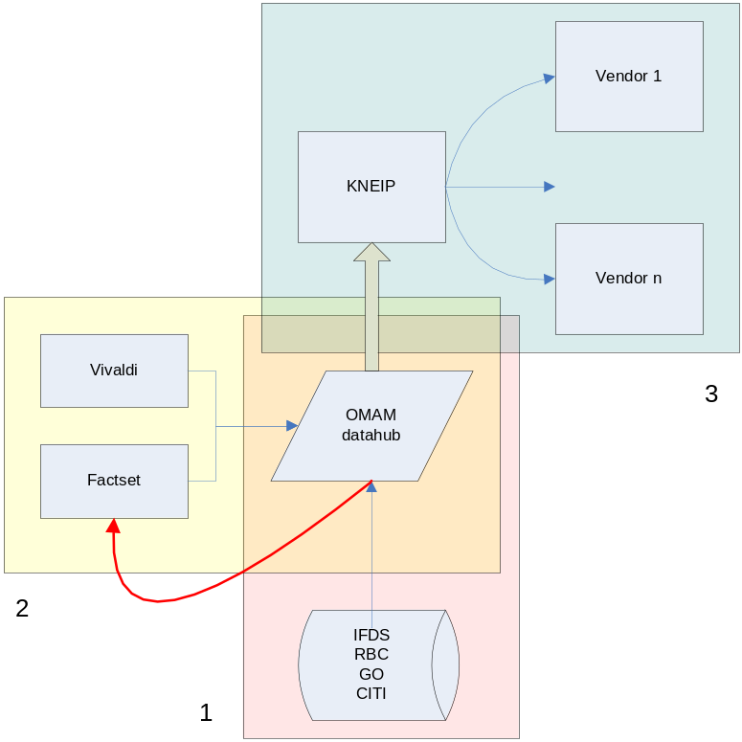
Figure 4: data validation
The above diagram requires amending – E.g. The datahub does not feed Kneip and IFDS feed BMIS, not the Datahub and each of the RBC, GO and Citi feed Kneip directly in addition to OMAM. Kneip also send information directly to Clients. Will be removed as not relevant.Once Ops team uploads them (item 1 on Figure 4) there is a potential second line of “defence” provided by OMAM sources of fund performance estimates: Factset and Vivaldi (item 2 on Figure 4).
Potentially there is an interesting part of validation exercise we might want to perform and this project might help somehow: the number of share as being provided by the TPA is currently not verified beyond making sure that the fund Value (i.e. shares x price) fluctuation is within a certain threshold. i.e. a straight forward units rec or something else?
Technically there will be the option to check that number based on the subscriptions/redemption records. Is a movement on units rec also required?
Thanks to Kneip we have outsourced all the checks with third parties data vendor that publish our NaV numbers and fund details (item 3 on Figure 4).
I believe there is very little value into adding a reverse arrow providing validation of our data from Kneip.

Tasks and responsibilities
Splitting the database in different areas makes it easier to identify tasks and responsibilities. This is a quick outline:

Operations
- Gathering the NaV numbers as supplied by the different providers
- Validate those data both against generic thresholds (i.e. there is a fair chance that a 10% performance on a fixed income fund might be wrong) and early estimates (Vivaldi estimates are available at around 5pm same day, Factset estimates are available early in the morning the following day).
- Uploaded data to the dBase

Risk & Performance
- Provide all the updates for peer group performances (this is done on a weekly basis)
- Provide all the updates for benchmark performances (ideally we could automate that by using the Bloomberg data feed)
- Specify and maintain the GIPS composites
- Define what has to be uploaded to Factset/SPAR database
- Provide Factset estimates of P&L to Ops for their validation process
- Provide Vivaldi estimates of funds P&L to Ops for their validation process

Human resources
- Keep track of the different roles played by OMAM employees as relevant for for each fund. This is basically making sure that what on Figure 3 is always updated.
- Define what is relevant: Fund Managers, Head of Desk, Deputies seem an obvious choice. Should we include analysts as well?
I understand that going back to 2004 and recompile all the relevant information (even for dead funds!) is quite daunting task but this is needed in order to be able to provide answers to all the questions we are asked. People, Fund, Role and dates are needed.

Sales & Marketing
- Make sure all the fund characteristics (benchmarks, peers group among others) are correctly specified and maintained going forward.
- Specify each fund objectives (peer groups, benchmarks)
- Timely update that whenever there is a change
- Provide feedback from client and potential clients

Finance
- Identify all the fee structures by fund and maintain the relevant dBase
- Specify all the relevant rules needed to calculate fees, gross returns Are you expecting that Fees will be calculated within this repository? If you want to translate net returns into gross returns you need that.
- Maintain and create the dataset about fund start/end dates and fiscal year rules

Sales & Marketing support
- Specify factsheets requirements
- Specify clients requirements by funds
- Check the feed to Kneip

IT
- Implementing the dBase design
- Collecting all the relevant specifications for the different rules that have to be implemented
- Implement all those rules
- Provide all the relevant stakeholders with the appropriate interfaces to perform all the Create/Read/Update/Delete operations
- Implement and deliver all the relevant reports as specified by their end users
- Maintain all the logs about who did what and when
- Centralize all the relevant procedures belonging to the relevant activities around the database.

As an example with UKDEFOS replacing UKDEF we should be able to link past UKDEF performance with UKDEFOS one otherwise we will have to wait a long time before being able to provide a decent time series of returns.
For segregated accounts the concept of share classes and number of shares is redundant. But this structure is still valid if we say number of shares=1 for a unique share class. Using a very generic notation we can say:
There is a whole bunch of fees that should be considered: (management, performance, administrative, custodian). On top of this there are plenty of details about caps, floors, hurdles that we might want to consider depending on the degree of precision we want to achieve. Technically there are expenses as well that might be modelled but I’m not sure we want to go down that route.
We have to be careful with those funds that need to beat (benchmark + spread). Libor benchmarks need to be created as well for absolute return funds and for all the hurdle references (crucial for gross/net calculations).
I’m thinking along the lines of a sense check. If the number is abnormal (we can set some sort of thresholds) Ops might raise questions.
The red line refers to the upload from the datahub to Factset/SPAR

