FUNDS PERFORMANCE CENTRAL DataBASE

SUMMING UP

Objective
We need a central repository for OMAM funds return data. That is: we need to be able to provide a unique solution to all the performance related questions that the different business units regularly ask.
Several fund characteristics can be part of the data model design. These are what will allow us to tailor the answers depending on the angle the questions will be asked.
This project will provide various stakeholders with unique answers to questions related to official funds performances and characteristics.

Benefits
Plenty of MS Excel spreadsheets are currently used to produce our external and internal reporting. They constitute a big source of operational risk and they won’t be needed anymore.
Tasks, responsibilities and validation processes will be correctly identified
Related procedures will be centralized, correctly structured and maintained.

Challenges
The complexity of the project is linked to:
- Collecting data from the past: at minimum the time series of returns need to go back to 2004. Ideally we should get all the data since inception for all live products.
- Making sure all stakeholders have their needs covered. The purpose of this document is to have something to circulate among the potential stakeholders and gather all the feedbacks before a complete specs and gap analysis can be performed.
- Identify roles and responsibilities for the initial load, update, maintenance and validation of each specific data subset.
- Obtain from all the stakeholders the relevant specifications of the rules we need to implement and use on the raw data we collect.

- Correctly deal with the logic linked to the production of the returns time series (e.g. dealing with funds merge/spin off). This is limited to when the products started under OMAM.
- Provide efficient download/upload procedures from the selected data providers/to relevant data vendors/clients platforms. It might be a challenge to get the data in (different providers, formats, times); not much to get them out.
- Manage dates/versioning: roles change, objectives change, peer group and benchmark references can change. In one sentence: product characteristics we use to group/slice performances will change and we have to accommodate for this.

Scope
The scope of the project can grow according to the characteristics we want to model and capture.
Although the main objective for this project is to be able to provide funds returns, NaVs and performance against objectives (benchmarks, peer groups), this objective can be expanded including:
- References to Fund Managers roles and significant dates.
- Multiple client custom classifications.
We are interested in the official data only and not in how they are produced. This project is not about portfolios constituents/positions and valuations. We are happy to group our product according to top level classification (i.e. if we classify a fund as an “equity” fund we are not going to check that portfolio constituents are equities).
NaV and share classes number of shares validation is not part of this project either: I´m assuming data uploaded are correct. If there is an issue about validation it will be dealt with elsewhere.

Risks
There are several risks to this project because of:
- Potentially (very) wide scope.
- Clashes with the overall immediate performance related requirements – Ultimately, this project will form the basis of an overall central source of fund related data for MI reporting but the priority should be on delivering the immediate performance related requirements.
- Several stakeholders involved.
- Various data sources.
- Added burden on some OMAM functions
- .

- DETAILS

Objectives
OMAM products are the funds we sell and the segregated account we manage.
Our clients, on top of good performances, expect from us quick and precise answers to all their questions concerning the performances of their investments. The reporting capabilities are part of the project. These can be limited to providing raw data for further publishing or be scaled up to the final design of client reporting.
OMAM management needs timely, precise updates about our fund performances and their economic impact on the company results.
Fund performances and all the ancillary financial calculations can be distributed using several means (XL spreadsheets, PDF reports, PPT presentations, emails) but the production of the underlying calculations needs to be provided by a centralized source. This is the core of the project.
Conversely using spreadsheets and different data repositories, like we are doing at the moment, is:

- Inefficient and potential source of errors: because we end up replicating the same set of data multiple times and out of them we might end up with two different answers to the same question.
Figure 1: MS Excel as an angel or as a devil?

- Source of operational risk: because we end up relying on individual efforts and not on established, documented, updated and tested procedures. MS Excel spreadsheets just can’t be the basis of correct enterprise procedures: they are intimately linked to their user/creator and their sharing is always problematic. This is an obvious source of key man risk.
- Source of reputational risk: beside the obvious TCF concerns, being wrong or late could really impact our business negatively.
Figure 2: Messi - no more Champion Leagues for Barcelona without him?

The relevant story here is:
- we need a single data source when we try to represent our funds performances.
- it has to be implemented by robust and documented procedures governed by a corporate structure.
- it has to be the basis of all our reporting and from there we have to upload to the other data vendors or external systems (e.g. Factset/SPAR) when this is relevant.

The Data Model
The technical basis of the project (what I call the data model) is composed by:
- The design of the data source underlying all the processes that will be run in order to achieve the various objectives.
- The implementation of those processes that will deliver what is required by the different business units.
Once we agree upon what we want to achieve (i.e. what questions we want to answer), we can then split the data model into various “areas” and allocate tasks and responsibilities accordingly.
This is the exercise that Praveen and I have run during the past months. Please refer to Praveen document for the most updated details.
What follows is presented only as a helper. I’d like to provide some visual about what we believe are the most relevant set of information we will need to store in order to provide the essential portion of the project.
These diagrams are not necessarily in line with the latest version as presented by the Requirements Specification Document. That is the relevant IT document that will represent the blueprint of the dBase underlying the project.
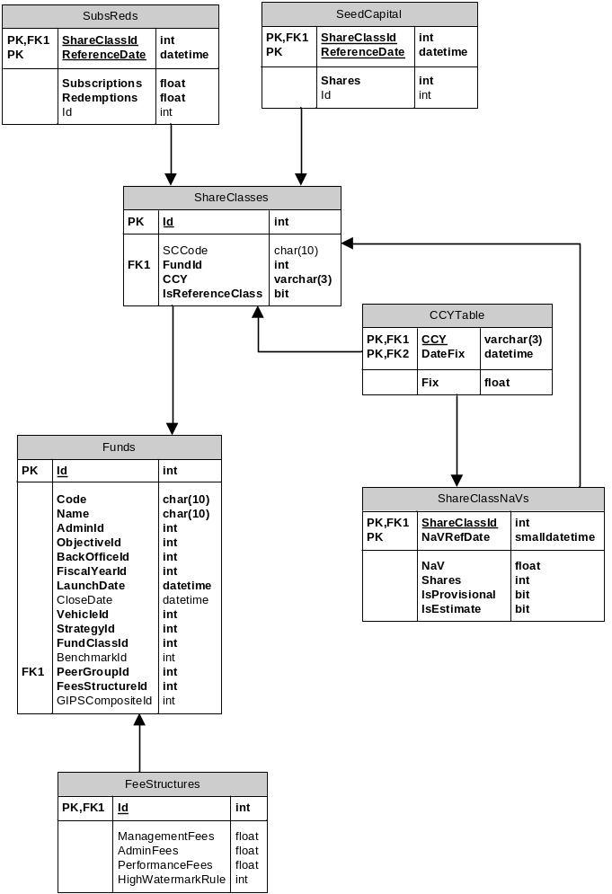
Figure 3: core dataset
The core of the database (Figure 3) is based on the notion that each fund Value can be represented as the sum of all the share classes’ prices time number of shares.
The performance of a fund will be associated with the evolution of the NaV of a selected share class (ShareClasses.IsReferenceClass =TRUE)
Once we get this we can retrieve and distribute the time series of returns for all our funds and we will able to answer question about period returns (gross, net), asset under management, fees impact, fund profitability. These calculations are part of the project.
Another relevant byproduct would be the automation of the GIPS composites returns construction.
Notice as well that, thanks to the IsProvisional and IsEstimate flags in the crucial ShareClassesNaVs table, we will be able to provide those items in a timely fashion based on provisional and/or estimated numbers.
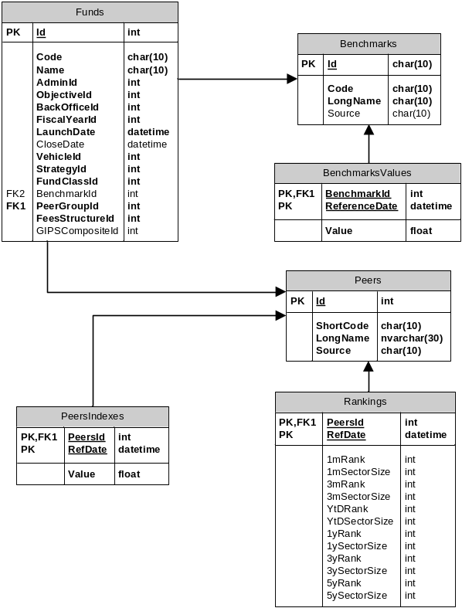
Figure 4: relative performance data
The second essential bit of the database (Figure 4) deals with benchmarks and peers performance data.
The first thing is to define the objective of each fund: this can be beat a benchmark or beat a peer group. There is nothing in the way of measuring each fund performance against both. Fund objectives are part of the fund characteristics.
One important thing to notice is we plan to store calculated results and not the raw data. Because of this we won’t incur in any extra cost.
Getting this right means we will be able to automate the production of (as examples):
- Green stripy (weekly)
- MI performance reports
- TCF tables
This is on top of being able to answer all the questions about our range of product performance as an aggregate (e.g. percentage of AUM better than objectives).
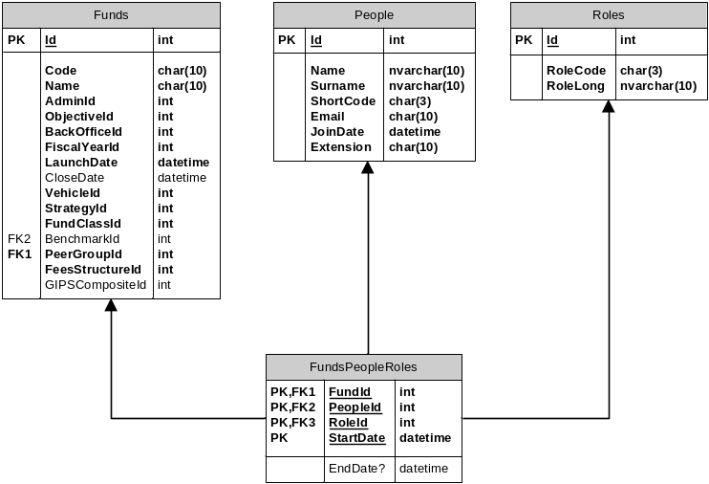
Figure 5: fund roles
This third block (Figure 5) merges fund details and performance with the people running them. If we get this set of information we will be able to answer question like:
- What was the performance of this fund since the fund manager XY took over?
- How much money is a specific desk/fund manager managing?
- What is the performance of funds belonging to a specific desk?

Out of scope
One of the main dangers of the project is overextending its scope. It is very easy to try to fit in all you can think about and, honestly, there are a lot of things that potentially can be part of this.
One thing being mentioned, as an example, is the reference to specific client classifications. While this is a nice to have I do not think it should be part of the initial effort.
All requirements will need to be prioritized.
What is really crucial instead is to have a good idea about what could be the potential project ramifications and structure the data model accordingly.

Tasks and responsibilities
Splitting the database in different areas makes it easier to identify tasks and responsibilities. This is a potential outline:

Operations
- Making sure NaV numbers as supplied by the different providers get loaded into the dBase.

Risk & Performance
- Provide all the updates for peer group performances (this is done on a weekly basis).
- Provide all the updates for benchmark performances (ideally we could automate that by using the Bloomberg data feed).
- Specify the logic around the definition and the output needed for the GIPS composites.
- Define what has to be uploaded to Factset/SPAR database.
- Provide Factset estimates of P&L to Ops in case of uncertainty about the numbers provided by our source point.
- Provide Vivaldi estimates of funds P&L to Ops in case of uncertainty about the numbers provided by our source point.

Human resources
- Keep track of the different roles played by OMAM employees as relevant for for each fund. This is basically making sure that what on Figure 5 is always updated.
- Define what is relevant: Fund Managers, Head of Desk, Deputies seem an obvious choice. Should we include analysts as well?
I understand that going back to 2004/SI and recompile all the relevant information (even for dead funds!) is quite daunting task but this is needed in order to be able to provide answers to all the questions we are asked. People, Fund, Role and dates are needed.

Sales & Marketing
- Make sure all the fund characteristics (benchmarks, peers group among others) are correctly specified and maintained going forward.
- Specify each fund objectives (peer groups, benchmarks).
- Provide feedback from client and potential clients.

Finance
- Identify all the fee structures by fund and maintain the relevant dBase.
- Specify all the relevant rules needed to calculate fees, gross returns. Ideally this data model should be able to perform that calculation as part of the requirements. FMIS might bridge the gap at least initially.
- Maintain and create the dataset about fund start/end dates and fiscal year rules.

Sales & Marketing support
- Specify factsheets requirements.
- Specify clients requirements by funds.
- Provide list of external dBases we should upload our data to:
- Which data
- Which engine
- What frequency

IT
- Implementing the dBase design.
- Collecting all the relevant specifications for the different rules that have to be implemented.
- Implement all those rules.
- Provide all the relevant stakeholders with the appropriate interfaces to perform all the Create/Read/Update/Delete operations.
- Implement and deliver all the relevant reports as specified by their end users.
- Maintain all the logs about who did what and when.
- Centralize all the relevant procedures belonging to the relevant activities around the database.
- Assist users getting what they need.

appendix
- Building blocks and objectives:
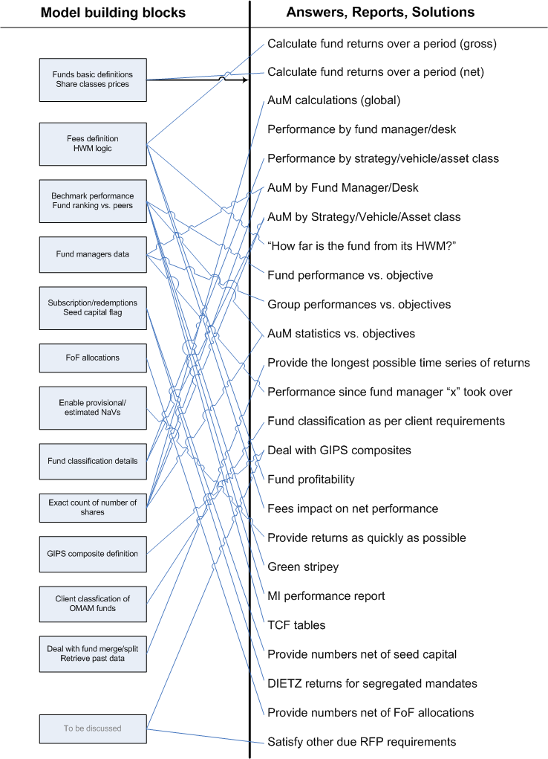

As an example with UKDEFOS replacing UKDEF we should be able to link past UKDEF performance with UKDEFOS one otherwise we will have to wait a long time before being able to provide a decent time series of returns.
I do not think merging OMAM products return history with similar products run by a different investment management company makes a lot of sense (at list in this project). That means we won’t be able to answer questions like: “ what is the performance of Fund Manager x merging the performance of fund I at OMAM with fund J at a different company.
Technically that means we might add extra columns in the product characteristics table if we want to accommodate for something not included initially.
This imply being able to perform simple return calculations and, more importantly, being able to group those performance according to the relevant details requested by the final user. I see providing raw data for a further publishing job as a very good initial outcome of the project.
Translating net returns (the ones provided by default as result of official product prices) into gross returns has as a byproduct the amount of money OMAM makes by producing those products. It’s a matter of going into the fine details of the fee structure in order to define how good those derived numbers are.
It´s crucial to make sure we gather all the relevant information about who is doing what with those other systems/data vendor/client dBases.
If we apply the standard MVC (model-view-controller) architecture I’m talking about the M here.
For segregated accounts the concept of share classes and number of shares is redundant. But this structure is still valid if we say number of shares=1 for a unique share class. Using a very generic notation we can say:
There is a whole bunch of fees that should be considered: (management, performance, administrative, custodian). On top of this there are plenty of details about caps, floors, hurdles that we might want to consider depending on the degree of precision we want to achieve. Technically there are expenses as well that might be modelled but I’m not sure we want to go down that route.
We have to be careful with those funds that need to beat (benchmark + spread). Libor benchmarks need to be created as well for absolute return funds and for all the hurdle references (crucial for gross/net calculations).
For an enhanced list of reports/objectives/answers the project will potentially deliver please refer to the appendix 1Building blocks and objectives:

