Kristina McAteer

February 24, 2021

T FDN 130 A Wi 21

Assignment 06

[mcatek/DBFoundations (github.com)](https://github.com/mcatek/DBFoundations)

Assignment 06 Discussion Topics

# Introduction

The following paragraphs address week 6 discussion topics for Foundations of Databases & SQL Programming: 1) When to Use a SQL View and 2) Differences and Similarities between Views, Functions and Stored Procedures.

# When to Use a SQL View

A SQL View is a *Select* statement that is saved in the database and acts like a virtual table that itself can be used in a *Select* statement. A SQL view is often used in reporting and can also act as an abstraction layer, protecting the integrity of the database.

## Reporting Views

For reporting, a SQL View can pull together relevant information located across multiple tables in the database into one convenient location. For example, an analyst could query a view containing sales and customer data without creating any joins. Who doesn’t love work already done?

## Base Views

A Base View is an exact copy of a table. These are created so that developers and analysts do not need to access the tables directly. If a developer used the tables directly to create applications, a small change to the database could break all the applications. Using a view together with the *SCHEMABINDING* option can prevent this. In this case, altering the table in a way that the view would cease to function results in an error. Thus, the integrity of the applications is protected. In this way, a change can still be made to the database, albeit with more intentionality in preserving existing views; and all can live happily together.

# Views, Functions and Stored Procedures

Views, Functions and Stored Procedures are all SQL statements saved directly in the database and are objects that can be referenced in other queries.

## Views

As discussed previously, Views are used primarily in reporting and as an abstraction layer. Views are created by Select statements and can mirror a single table or combine data from multiple tables. A View can also be used as an object in a *Select* statement. Figure 1 show the syntax for creating and selecting from a View.

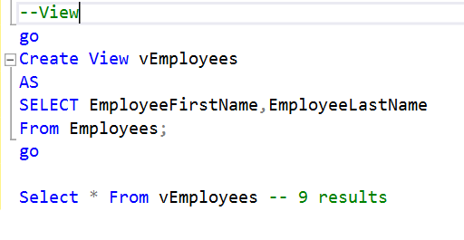

Figure

## Functions

Think of a function like a box that does some work inside: Something goes in the box, the work is done, and it is returned. Like a view, A SQL function can be used as an object in a Select statement, but it is different in the concept of a parameter and a return. The return type needs to be specified, a table of values or a single value, and parenthesis need to be included for the parameter, whether one is being used or not.

Figure 2 shows the syntax of a function, delivering the same results as the view in Figure 1.

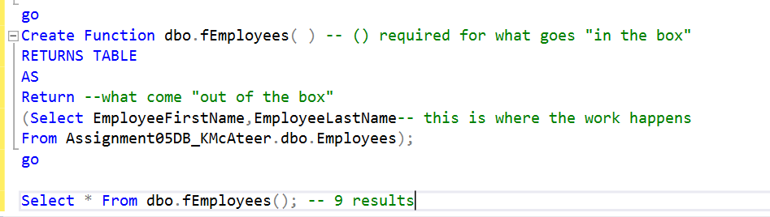

Figure

While returning table results makes the function seem like a view, returning a single result can be more useful. In Figure 3, a function is created to combine two fields to one. This function can then be used to return one name column.

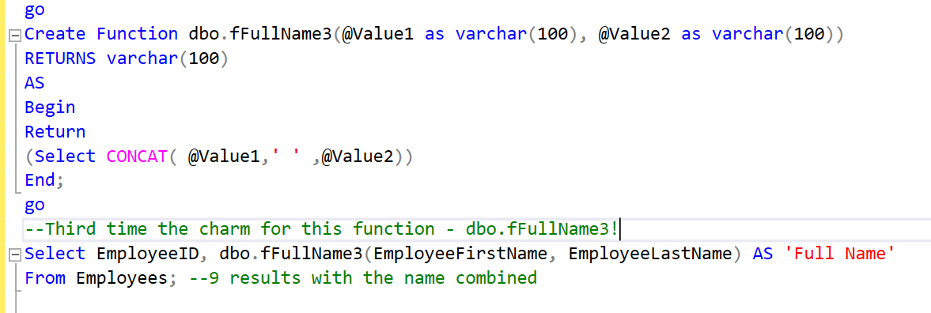

Figure

## Stored Procedures

Stored procedures can contain views and functions creations within them. They could also contain things like inserts and deletions. A stored procedure is basically a whole set of SQL instructions that can be called. Unlike Views and Functions, a stored procedure is not called using the key word *Select*. It is called by *Execute*.

# Summary

Views are used for reporting and for creating an abstraction layer to the tables. Views, functions and stored procedures are all named objects saved directly in the database and can be called to work. In addition to returning table results, a function can return an individual result