PSEUDOCODE

Begin

When ADD TO QUEUE is clicked:

Get Patient Name
Get Age
Get Reason for Visit
Get Patient Type

If Patient Name is empty OR
Age is empty OR
Reason for Visit is empty OR
Patient Type is not selected
Then
Display "Please complete all required fields."
Else
If Patient Type = Emergency
Priority = "EMERGENCY"
Else If Patient Type = Senior
Priority = "SENIOR PRIORITY"
Else If Patient Type = Pregnant
Priority = "PRIORITY"
Else
Priority = "REGULAR"
End If

Queue Number = "Q" + queueCounter formatted as 3 digits

Display Queue Number
Display Patient Type
Display Priority

Increase queueCounter by 1
End If

END

BEGIN

When CLEAR is clicked:

Clear Patient Name
Clear Age
Clear Reason for Visit
Clear Patient Type selection
Clear Queue Number
Clear Patient Type output
Clear Priority output

END

FLOWCHART

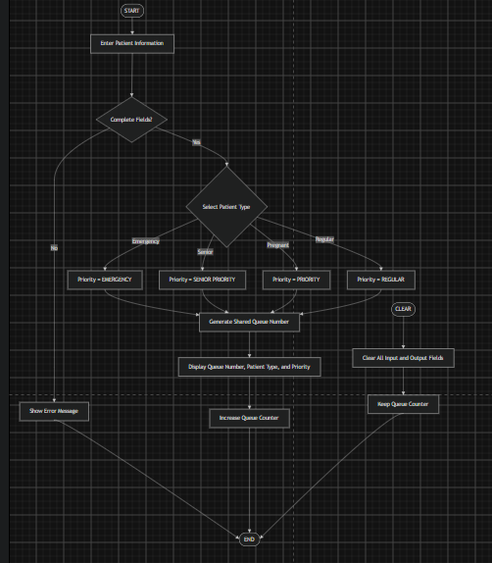

OUTPUT

